https://www.tutorialspoint.com/typescript/typescript_intersection_types.htm
https://www.w3schools.com/typescript/typescript_intro.php
https://www.typescriptlang.org/play/

Browser always supports à html, css, js.
JS: drawbacks à
Var keyword, there is no scope for this keyword.
**** Doesn’t support TYPES./ TYPE CHECKING.

ECMAScript ???
The ECMAScript specification is a standardized specification of a scripting language.
ECMAScript is the standardized specification that forms the foundation of JavaScript and other similar scripting languages. It was created to ensure consistency across different implementations of scripting languages.
Here’s a quick breakdown:
- What is it?
ECMAScript is a language specification maintained by ECMA International (specifically ECMA-262). It defines the core features of the language, such as syntax, types, statements, keywords, and built-in objects.
- Relation to JavaScript:
JavaScript is an implementation of ECMAScript. Other implementations include JScript (by Microsoft) and ActionScript (used in Adobe Flash).
- Versions:
ECMAScript has evolved over time:
- ES3 (1999): Widely adopted early version.
- ES5 (2009): Introduced strict mode and JSON support.
- ES6 / ES2015: Major update with features like let, const, arrow functions, classes, and modules.
- Subsequent versions (ES2016, ES2017, etc.) added async/await, optional chaining, and more.
- Why is it important?
It ensures that JavaScript works consistently across browsers and platforms by following the same specification.

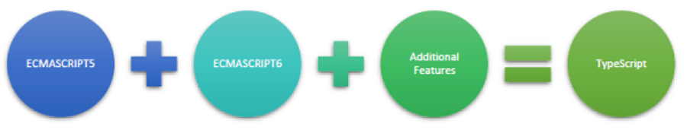

TypeScript language features like Modules and class-based orientation are in line with the EcmaScript 6 specification. Additionally, TypeScript also embraces features like generics and type annotations that arent a part of the EcmaScript6 specification.

- Asynchronous Programming − JavaScript supports asynchronous programming with callbacks, promises, and async/await.

Interfaces
Tells TypeScript what properties, methods, and types an object should have.

Interfaces:
interface MyInterface{
empName: string;
empId: number;
empPANID?: string;
getSalary():string;
qualities?():string; // this is an optional method. We can skip implemetation for this.

}

To make one variable as optional we can add “?” after variable declaration.

//Implementation using extending class
class MyClass implements MyInterface{
empName = "2323";
empId = 1;
getSalary():string{
return this.empName;
}
}

// defining object
var myClass2: MyInterface = {
empId:1,
empName: "",
getSalary() {
return this.empName
}
}

Classes:
class Employee {
empName: string;
constructor(eName: string) {
this.empName = eName;
}
getEmpDetails(): string {
return this.empName;
}
}
var e = new Employee("asasas");

e.getEmpDetails();

In case of TS we declare constructor with “constructor” keyword only. Like above highlighted.

Let& const
TypeScript has the same rules as JavaScript to declare variables. Initially, only the 'var' keyword was used to declare the variable, but in the ES6 version of JavaScript 'let' and 'const' keywords are introduced to declare a variable.
Let variables cannot be re-declared
Variables with the same name in different blocks: Allowed.

Datatypes:

Data type | Keyword | Description
Number | number | Double precision 64-bit floating point values. It can be used to represent both, integers and fractions.
String | string | Represents a sequence of Unicode characters
Boolean | boolean | Represents logical values, true and false
Void | void | Used on function return types to represent non-returning functions
Null | null | Represents an intentional absence of an object value.
Undefined | undefined | Denotes value given to all uninitialized variables
Symbol | symbol | A unique and immutable primitive introduced in ES2015.
Object | object | Represents instances of user-defined classes, arrays, functions, etc.
Never | never | Represents values that never occur.

Do POC on “Symbol” datatype.
Symbol
We can use the symbol type to create the Symbol. Symbol is a primitive data type that creates unique and immutable value. Even though keys are same it will generate unique value only. If try to compare 2 symbol data type result will not same.

Real time use case of symbol
Imaging in large applications where many developers add properties to same object. There is a risk that one developer uses a property name that accidentally overrides another.

Symbols solve this by creating hidden unique keys, which avoid name collisions.
const INTERNAL_ID = Symbol("internalId");
interface User {
name: string;
email: string;
[INTERNAL_ID]?: number; // hidden, safe key
}
let user: User = {
name: "Alex",
email: "alex@example.com",
[INTERNAL_ID]: 101
};
console.log(user[INTERNAL_ID]); // 101
console.log(user["internalId"]); // undefined

Tuple:
Tuple types allow you to express an array with a fixed number of elements whose types are known but need not be the same. This adds a level of safety when dealing with arrays that need to have a specific structure.

let tuple: [string, number] = ["hello", 10]; console.log(tuple); // Output: ["hello", 10]

Type Annotation:
In TS Type Annotation means datatype declaration only. è : number, : string, :void…etc.

Interpolation:
How to do interpolation in TS? è we can make use of tilde, back tick. For string concatenation.
Means instead of using multiple + operators we can use back tick and ${}. Like below.
let myId = 10;
console.log(`This is Kamal...${myId}`);

Function Default Parameter:
The typescript compiler can also infer the type of the function parameters when the parameters are initialized with default values.

Best Common Type: The Union Type:
IN the below example we created on array, but this array may contains either number or string or booelan type values only. Then we can mention type annotations with PIPE symbol like below.

const a: (number | string | boolean)[] = [5, 10, "TypeScript", true,3434,223,false];
console.log(a);

POC: Array Methods practice.

Array Destructuring:
Refers to breaking up the structure of an entity. TypeScript supports destructuring when used in the context of an array.
var arr:number[] = [12,13]
var[x,y] = arr;
console.log(x) console.log(y)

Array traversal loops à for-in.
var arr:number[] = [12,13,3434,23,34,2323]
for(let n in arr){
console.log(arr[n]);
}

,

Tuples:
At times, there might be a need to store a collection of values of varied types. Arrays will not serve this purpose. TypeScript gives us a data type called tuple that helps to achieve such a purpose.

const myTuple: [number, string] = [10,"Hello"];

Difference between Array destructing and touples?
In case of destructing we are adding variable names. In case of tuples we are adding data types on declaration.

Array destructing | tuples
var arr:number[] = [12,13]  var[x,y] = arr; | const myTuple: [number, string] = [10,"Hello"];

Arrays VS tuples??
Both are same only, declaration syntax is different.
Tuple is heterogeneous array, means it can hold any kind of data type values.
arrays | tuples
Const aa:number[] = [232,343,22323,2323]; | const myTuple: [number, string] = [10,"Hello"];

“as” keyword in TS and JS:
let v1: any = "hello world";
console.log(typeof v1);
let lenStr: number = (v1 as string).length;
// let v1: string;
console.log(lenStr);

Type of v1 is undefined why because we declared it as ”any”, but later we assigned string value to that variable.
Now as v1 holds string value v1 datatype became string. I want use that variable as string, directly we can not use it as string, first we need to cast/ convert that any type variable to string. To do this we need to use “as” keyword.

class Employee{
}

let v1: any = new Employee();
console.log(typeof v1);
let lenStr: Employee = (v1 as Employee);
// let v1: string;
console.log(lenStr);

POC: TypeScript – Never;

POC:
TypeScript - null vs. undefined: https://www.tutorialspoint.com/typescript/typescript_null_vs_undefined.htm

Optional Parameters: adding “?” to variables in function declaration.
function disp_details(id:number,name:string,mail_id?:string) {
console.log("ID:", id);
console.log("Name",name);

if(mail_id!=undefined)
console.log("Email Id",mail_id);
}
disp_details(123,"John");
disp_details(111,"mary","mary@xyz.com");

What is the difference between Default parameters and Optional parameters??
function greet(name?: string) {
console.log(`Hello, ${name ?? "Guest"}!`);
}

greet(); // Output: Hello, Guest!
greet("Kamal"); // Output: Hello, Kamal!

the ?? inside ${...} is the nullish coalescing operator in JavaScript/TypeScript.
What ?? does
a ?? b returns:
- a if a is not null or undefined
- b if a is null or undefined

Rest Parameters:
Rest parameters are similar to variable arguments in Java. Rest parameters dont restrict the number of values that you can pass to a function. However, the values passed must all be of the same type. In other words, rest parameters act as placeholders for multiple arguments of the same type.
To declare a rest parameter, the parameter name is prefixed with three periods. Any nonrest parameter should come before the rest parameter.

In java after Datatype we add 3 dots/periods, in TS before variable we add 3 dots/periods. Check below.

TS | JAVA
function addNumbers(...nums:number[]) { // addNumbers(a,b,c)  var i;  var sum:number = 0;  for(i = 0;i<nums.length;i++) {  sum = sum + nums[i];  }  console.log("sum of the numbers",sum)  }  addNumbers(1,2,3)  addNumbers(10,10,10,10,10) | public static void main(String... args) {  int a[] = {12,233,232};  m1(12,23,12,2323,1212);  int[] i = {12122,323,};  m11(i);  }  static void m1(int ...a){  }  static void m11(int a[]){  }
While passing data without creating array and assigning values we can directly pass values to rest parameters function.

Functions:
Creation ways:
// Appraoch: 1 | // Appraoch: 2 | // Appraoch: 3 ==> Lambda/Fat Arraow function.
function TestFunction(){  } | let TestFunction1 = function (){  } | let TestFunction3 = () => {  }

Declaring Function Type Variable: we are declaring type annotation as function.
Please explain below code????
let addFun: (x: number, y: number) => number = function (x:number, y: number): number {
return x + y
}
console.log(addFun(2, 3));
From above yellow highlighted is variable declaration only, it is telling us, addFun requires a function which takes two number parameters and that functions must return number value.
Below is detailed program.
let addFun: (x: number, y: number) => number = testFunction;

console.log(addFun(2, 3));

function testFunction(x:number, y: number): number {
return x + y
}

Specifying Function Parameters as Functions è read below website, you will get more knowledge.
https://www.tutorialspoint.com/typescript/typescript_function_types.htm
function greet (fn: (s: string) => void) {
fn ("Welcome to Tutorials Point!")
}
function print (str: string) {
console.log(str);
}
greet(print);

Function Expression and Function Declaration Are they synonymous?

In JavaScript, function declarations and function expressions are not synonymous. They both define functions, but they differ in when they’re created (hoisting), how they’re used, and where they can appear.

Function declaration:
A function declaration uses the function keyword at the top level (i.e., a statement):
Key characteristics
- Hoisted: The function is hoisted with its body, so you can call it before it appears in the code.
- Name required: Declarations are always named.
- Scope: Defined in the enclosing scope (block in strict mode with ES6 modules, otherwise function/global).

function add(a, b) {  return a + b;  }  console.log(add(2, 3)); // 5 | //after hoisting  // Hoisting example  console.log(sum(1, 2)); // 3  function sum(x, y) {  return x + y;  }

Function expression:
A function expression creates a function as part of a value (e.g., assigning to a variable):
Key characteristics
- Not hoisted (initialized later): The variable is hoisted, but its value (the function) isn’t available until assignment runs. Calling it before the assignment causes an error.
- Can be anonymous or named:
- Anonymous: const f = function () { ... }
- Named (useful for stack traces and recursion):
const factorial = function fact(n) {
return n <= 1 ? 1 : n * fact(n - 1);
};

const multiply = function (a, b) {  return a * b;  };  console.log(multiply(2, 3)); // 6 | // Temporal dead zone example with const  console.log(divide(6, 3)); // ReferenceError: Cannot access 'divide' before initialization  const divide = function (a, b) {  return a / b;  };

Rest Parameter & Spread Operator:
We have discussed about the rest parameters. The spread operator denoted with three dots (...) same as the rest parameters but works differently.
A rest parameter is used to collect the remaining parameters as an array.
The spread operator spreads out the elements of an array into individual elements. It is similar to flatmap in java.
A spread argument must either have a tuple type or be passed to a rest parameter.

const arr1: number[] = [10, 20, 30];  const arr2: number[] = [40, 50, 60];  arr1.push(...arr2);  // spreading array to another array.  console.log(arr1); | const arr1: number[] = [10, 20, 30];  const arr2: number[] = [40, 50, 60];  arr1.push(arr2);  // directly adding array to another array.  console.log(arr1);
Output:  [10, 20, 30, 40, 50, 60] | Output:  [10, 20, 30, [40, 50, 60]]

We can clearly see ouputs of two approaches.
In first approach it spreads the array and combines two arrays as single dimension array.
In second approach it added the array directly as it is and combines as two dimension array.

Rest for passing the parameters for an array.
Spread operator combining the two arrays as single dimension array.

What is the difference between union type VS array destructing VS tuples??

POC: readonly property.
https://www.tutorialspoint.com/typescript/typescript_readonly_properties.htm

https://www.tutorialspoint.com/typescript/typescript_duck_typing.htm

How to compile file with new es6 version?
Below command can compile your file with es6 version.
$ tsc yourfile.ts --target ES6

tsconfig.json:
{
"compilerOptions": {
"target": "es2015",
"outDir": "./js",
"strict": true
},
"include": [
"typescript/*"
]
}

$ npx tsc
When we run the above command, tsc compiler search for tsconfig.json file and start parsing and executing the file instrctions.

If it ddint fine? It will display all tsc commands list.

Angular:
https://www.scholarhat.com/tutorial/angular/angular-18-features

https://www.tektutorialshub.com/angular-tutorial/

https://tutorial.techaltum.com/data-binding.html

Component = html + css + .ts + spec.ts(test cases).

https://tutorial.techaltum.com/two-way-data-binding.html

Angular cli – npm install –g @angular/cli

Command to create angular application: $ ng new <app-name>

Folder structure and files:
basic structure

tsconfig.json --> TypeScript compiler configuration contains common configuration properties
Tsconfig.app.json --> TS config specific to the app
tsconfig.spec.json --> TS config for unit tests
Package.json--> contains dependencies and scripts
Package-lock.jsom--> contains path from where dependencies should have to download
Angular.json--> contains application related configurations
Index.html--> Single page entry point for the app
Main.ts--> Bootstraps the root module (AppModule).
App.ts--> Declares components and imports other modules.
Styles.css--> global css file contains common css properties.

Components:
Components are the building blocks of an Angular application. The primary use of Angular Component is to generate a section of web page called View. By combining different views, a single application is created. Every component will have an associated template and it will be called in order to generate views.

Command to create component: $ ng generate component <component-name>

Once component will generate it contains 4 files.
.html for dilspying content
.ts for business logic
.css for style
.specs.ts for unit testing

Inside .ts file
Decorator (@Component)
- Tells Angular that this class is a component.
- Includes metadata like:
- selector: The HTML tag used to insert the component.
- template or templateUrl: The HTML view.
- styleUrls: CSS files for styling.
We are exporting this class to import in main component or whenever needed to render it as per our requirement.

To do the component chaining or importing other components to the main component we have do below 2 things:
- Add selector into root component/ respective parent component html file
- Also import the new component name into the .ts file of root/respective parent component.

Data Binding:
Using data binding, we can bind data from component class to Template
- String interpolation:
String Interpolation is used using double curly brackets {{}}. We can add dynamic data from component class or any js expression. We can use operators like, +, -, * or %.
We can also sort array or get object property in template directly.
Js file | html
@Component({  selector: 'app-products',  imports: [],  templateUrl: './products.html',  styleUrl: './products.css',  })  export class Products {  title:string = "Product"  } | <p>products works!</p>  <h2>{{title}}</h2>

- Property binding
Binds a native (provided by browser) property of an HTML element to a component property.
Syntax: [property]="expression"
js | html
@Component({  selector: 'app-products',  imports: [],  templateUrl: './products.html',  styleUrl: './products.css',  })  export class Products {  title:string = "Product"  isDisabled= true  } | <button [disabled]="isDisabled">Submit</button>

- Event binding
Captures user actions (click, input, etc.) and calls a component method.
Syntax: (event)="handler"
Js | html
export class Products {  title:string = "Product"  isDisabled= true  onClick(){  console.log("button clicked")  }  } | <button [disabled]="isDisabled" (click)="onClick()">Submit</button>

- Two Way data binding
Two Way Data Binding is the technique where the model and view and interconnected. Synchronizes data between component and view. Means any change in ts file will reflect in html and vice versa.
There are 2 ways to do it:
- Without ngmodel:
Two Way Data binding without ngModel is possible by using event. $event object return event itself.
export class Products {  title:string = "Product"  isDisabled= true  name=""  onClick(){  console.log("clicked");  }  onInput(event:Event)  { this.name= (event.target as HTMLInputElement).value;  console.log((event.target as HTMLInputElement).value)  }  } | <input (input)="onInput($event)">

- With ngModel
Two way data binding with ngModel is possible by combining both Property Binding and Event Binding.
For Property binding, we use [], for event binding we use (). For two way data binding using ngModel, we use [(ngModel)].
For standalone, import FormsModule in app.component.ts and add FormsModule in imports in component decorator.

import { Component } from '@angular/core';  import { FormsModule } from '@angular/forms';  @Component({  selector: 'app-products',  imports: [FormsModule],  templateUrl: './products.html',  styleUrl: './products.css',  })  export class Products {  title:string = "Product"  isDisabled= true  name=""  role=""  onClick(){  console.log("clicked");  }  onInput(event:Event){  this.name= (event.target as HTMLInputElement).value;  console.log((event.target as HTMLInputElement).value)  }  } | <input placeholder="enter role" [(ngModel)]="role">

Routing:
In App.ts below classes imports are important
If and only if we import the RouterLink and RouterOutlet in app.ts file then only routing will work.
App.ts
import { Component} from '@angular/core';
import { RouterLink, RouterOutlet } from '@angular/router';

@Component({
selector: 'app-root',
imports: [RouterOutlet,RouterLink],
templateUrl: './app.html',
styleUrl: './app.css'
})
export class App {
}

Routes.ts | App.html
export const routes: Routes = [  {  path: 'employee',  component: Employee  },  ]; | <a routerLink="/employee" href="#">Employee</a> <br>  <router-outlet></router-outlet>

Routing with parameters:
If we want to pass path variables in the request then we go for this approach. Eg. http://localhost:8080/employee/1234
here 1234 is path variable.
- Routing without parameters-->
<a routerLink="/employee" href="#">Employee</a>
- Routing with parameters-->
<a [routerLink]="['<endpoint>',path_variable]" href="#">Address</a>
This endpoint (<endpoint>) alsways should be in single quotes and this path variable should have to declare in .ts file.
export const routes: Routes = [  {  path: 'employee',  component: Employee  },  {  path: 'address/:pin',  component: Address  }  ]; | <a routerLink="/employee" href="#">Employee</a> <br>  <a [routerLink]="['address',empId]" href="#">Address</a>  <router-outlet></router-outlet>

If you want capture the data which we are passing through URL like :pin, we need to make use of “ActivatedRoute” in that corresponding path URL component constructor. Here for :pin Address is the component.

After that using this ActivatedRoute This reference we need to access the data like below.
export class Address {
constructor(private activatedRoute: ActivatedRoute){

console.log(activatedRoute.snapshot.params['pin']); // this is for getting values from single param.

//OR

this.activatedRoute.params.subscribe(params => {
console.log(Object.keys(params));

});

}
}

Now my requirement is , when i submit my request, based on the input or output i want to redirect to other page.
For this we need to make use of “Router” in corresponding component class constructor, we need to declare it in constructor, and we need to navigate to target component.

Routing .ts file | Address component class. Ts file.
export const routes: Routes = [  {  path: 'employee',  component: Employee  },  {  path: 'address/:pin/:name',  component: Address  },  {  path:"success",  component: Success  }  ]; | export class Address {  constructor(public activatedRoute: ActivatedRoute, public router: Router) {  console.log(activatedRoute.snapshot.params['pin']);  let pin = activatedRoute.snapshot.params['pin'];  console.log(typeof pin);  if (pin == '12345') {  this.router.navigate(["/success"]);  }  }  }

Auxiliary routes angular: OR Named routes in angular.

Now requirement is like, once if we click on hyperlinks data is getting relapced by other compoennts.
But i want to display routing details in defferent section in the same html page, how to do it?

App routes | App.html
{  path:"contacts",  outlet: "contactsRef",  component: Contacts  } | <a style="padding: 20px;"[routerLink]="[{ outlets: { contactsRef: ['contacts'] } }]">Contacts 2 </a>  <router-outlet ></router-outlet>  <div style="padding: 50px;">  <router-outlet name="contactsRef"></router-outlet>  </div>

Auxiliary routes with parameters:
Additionally we are going to send paramter in the URL, that approach we have already learned.
Changes required.
- In routes file in the path add /:paramName
- In the routerLink while calling the component we need to pass the values along with routeroutlet.
[routerLink]="[{ outlets: { contactsRef: ['contacts',contactId] } }]

App routes | App.html
{  path:"contacts/:contactId",  outlet: "contactsRef",  component: Contacts  } | <a style="padding: 20px;"[routerLink]="[{ outlets: { contactsRef: ['contacts',contactId] } }]">Contacts 2 </a>  <router-outlet ></router-outlet>  <div style="padding: 50px;">  <router-outlet name="contactsRef"></router-outlet>  </div>

Auxiliary with parameters Redirecting to other page:

App html | App ts | Routes ts
<button (click)="redirect()" value="Redirect">Redirect</button> | constructor(private router: Router) {  }  redirect() {  this.router.navigate([{ outlets: { contactsRef: ['contacts', 123] } }]);  } | {  path:"contacts/:contacdId",  outlet: "contactsRef",  component: Contacts  }

Angular Signals: ==> for state management.
Angular Signals is a relatively new reactive primitive introduced in Angular v16 to simplify state management and reactivity without relying heavily on RxJS Observables.

Signals are reactive values that notify Angular when they change, allowing automatic UI updates. They are similar to BehaviorSubject in RxJS but much simpler and synchronous.
- A signal holds a value.
- When the value changes, Angular automatically re-renders any component that depends on it.
- No need for async pipes or manual subscriptions.
Advantages Over RxJS
- No need for subscribe() or unsubscribe().
- No async pipe required.
- Easier for local component state.

Inter Communication between components: ==> @Input, @Output.
- Sending data from Parent component to child Component.

Sending data from Parent component to child Component.
This can be done in two ways. Older version of angular is having one approach and newer angular version have different approaches.
We see both approaches here.

- OLD APPRAOCH: the classic decorator @Input() (works as before), and
- NEW APPROACH: the new signal-based API input() / input.required() that exposes inputs as read-only Signals.

OLD approach:
Changes required at Parent side:
- Decide the properties that you want pass to child component.
- In the parent component html, we need to add child component selector.
- In the child component selector we need to add child component properties in property binding manner and we need to assign parent component properties to it.

Parent component changes.
Parent component ts file | Parent component html file
export class Parent {  message: string = "message from Parent component";  parentId: number = 12;  employeeObject = {empName: "kamal", empId:12};  } | <app-child [childMessage]="message" [parentId]="parentId" [employeeObject]="employeeObject"></app-child>

Changes required at Child side:
- Create some fields in the child component ts file class equivalent to parent components fields which we are passing to here. We can create fields with same name or different name.
- Each fields you create in child component assign with @Input() decorator.
- to capture the values which we got from parent component, we need to use angular life cycle hook method ngOnChanges(changes: SimpleChanges){} and there we can log or use values.

Child component ts file
export class Child {
@Input()
childMessage: string = "";

@Input()
parentId: number = 0;

@Input()
employeeObject: any;

ngOnChanges(changes: SimpleChanges) {
console.log(this.childMessage);
console.log(this.parentId);
console.log(this.employeeObject);
}
}

New angular approach: parent to child data passing.

Key points:
- Parent component side we dont need to change anything.
- Only at child component side we need to remove @Input decorator and we need to use input signals.
- While accessing the input signals we need to access like methods by adding () at the property end.

Parent component side changes:
NO CHANGES.

Child component side changes.
Child component ts file
import { Component, input, SimpleChanges } from '@angular/core';

export class Child {

childMessage = input<string>('Default message')
parentId = input<number>(0)
employeeObject = input<any>({})

ngOnChanges(changes: SimpleChanges) {
console.log(this.childMessage()); // while accessing fields we need to use () - parenthesis.
console.log(this.parentId());
console.log(this.employeeObject());
}
}
From above input is predefined property from angular library.

Sending data to a parent component:

In case of parent to child we are using property binding. But in case of child to parent communication we use event binding.

In case of child to parent communication, we perfrom some event at child side, in that event method we are going to emit the data which we want to send it to parent component. That is the reason we are doing event binding at parent html side.

Child to parent communication also have older angular version approach and newer approach.
- We use @Output decorator with the help of EventEmitter calls emit() method.
- output<>(); signals. --> calls emit() method.

OLD APPRAOCH:
Changes required at child component side.
Child.html | Child component ts file.
<button (click)="childM1()">Click Me from Child Component</button> | @Output()  dataChanged = new EventEmitter<{}>();  childObject: ChildPojo = {eName: "Vaish", eId: 123};  childM1(): void{  console.log("childM1()");  this.dataChanged.emit(this.childObject);  }  export class ChildPojo{  eName:string;  eId: number;  constructor(eName:string, eId: number){  this.eId = eId;  this.eName = eName;  }  }

Parent side changes:
Parent html file | Parent component ts file.
<app-child [parentId]="parentId" [employeeObject]="employeeObject"  (dataChanged)="childEventMethod($event)"></app-child> | childEventMethod(event: Object){  let childRef = event as ChildPojo;  console.log(childRef);  }

Child side we need to perform event and parent html we need to perform event binding.

NEW APPROACH:
From above example only from child component ts file remove @Output decorator and add output<>() signal.
No other changes required use same code from above example.

In input() signal also we have emit() method, when we perfrom event at child side we are going to emit the changes to parent component.
Child component ts file.
dataChanged = output<ChildPojo>();

childM1(): void{
console.log("childM1()");
this.dataChanged.emit(this.childObject);
}

Angular - Dependency Injection:
Instead of we are creating the object and injecting, angular server will create the objects and will inject into component classes.

This approach helps applications achieve loose coupling and reduce tight coupling between different parts of the application.

In Angular, dependency injection is used to inject services and other dependencies into components and other classes.

Service Creation: First, define a service using the @Injectable decorator. Inside this decorator use providedIn and give it a value root which will provide the service at the root level (means whole application).
Injecting the Service: In the component's constructor, declare the service as a parameter. Angular will inject the required instance of the service automatically.
Usage: Once injected, you can use the service in your component or other classes.
Scope of the Service: By default, services provided in the root are singleton, which means only one instance is shared across the application. However, services can also be provided at different levels if you want different instances for different parts of the application.
Step1:
Create service
/> ng g s services/emp-service

This command will generate two files.
- emp-service.ts
- emp-service.spec.ts
Now changes required in component and html to display service method data.
Emp-service.ts | App componen.ts | App.html
@Injectable({  providedIn: 'root',  })  export class EmpService {  constructor() {  }  getData() {  return ['Red', 'Orange', 'Violet', 'Yellow', 'Saffron'];  }  } | empData: string[] = [];  constructor(private router: Router, private empService: EmpService ) {  console.log(empService.getData());  this.empData = empService.getData();  } | <div *ngIf="empData?.length">  <div *ngFor="let emp of empData">  {{ emp }}  </div>  </div>  ------------------  @if (empData?.length) {  <ul>  @for (emp of empData; track emp) {  <li>{{ emp }}</li>  } @empty {  <li>No cities found.</li>  }  </ul>  }

1) @if (empData.length > 0) { ... }
- This renders the block only when empData.length > 0.
- ⚠️ Pitfall: If empData is null/undefined, accessing .length will throw an error. Use empData?.length to be safe.

@empty { ... }
- This block renders when the iterable is empty.
- Important: @empty only applies to the immediately preceding @for and will show only if the @for runs and finds no items.

What does track emp do exactly?
- It’s the new shorthand for trackBy.
- track emp ≈ trackBy: (index, emp) => emp
- Best practice:
- Primitives (strings/numbers) → track emp is fine.
- Objects → track emp.id (or any stable unique key) to avoid re-rendering list items unnecessarily.
POC: Please learn if and for related older angular version and newer version.

ngFor – iterating data
*ngFor only works with iterables (arrays, sets, maps).

Single object can not iterate still If you want to use it for Object you can make use of angular “keyvalue” pipe

<li *ngFor="let kv of childObj | keyvalue">
{{ kv.key }} : {{ kv.value }}
</li>

Please read below to get more and clear knowledge on if and for loops in angular.
https://tutorial.techaltum.com/ngFor-in-angular.html

Angular is Module based also. Means which ever the classes, interfaces, pipes, directives, components, services…etc we are using all are part of any one of the Module.

So, first we need to configure those Module related configurations in “app.config.ts” file. Which looks like below.

App.confgi.ts
export const appConfig: ApplicationConfig = {
providers: [
provideBrowserGlobalErrorListeners(),
provideZoneChangeDetection({ eventCoalescing: true }),
provideRouter(routes), provideClientHydration(withEventReplay())
]
};

@for
Angular 17 introduced @for block to iterate over iterators instead of ngFor directive. @for can iterate Array, JSON ,strings, but not objects as objects are not iterators in javascript.

cars=["swift","baleno","fronx"]; | @for (item of cars; track $index) {  <p>{{$index}} : {{item}}</p>  }

$index we can use in @for() line only, and rest below we can use inside @for loop.
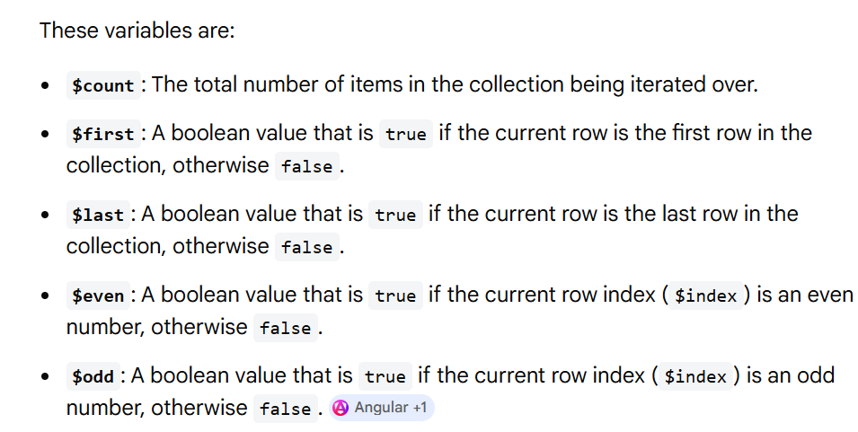

cars=["swift","baleno","fronx"]; | @for (item of cars; track $index) {  @if ($odd) {  <p style="background-color: pink;">{{$first}} : {{item}}</p>  }@else{  <p>{{$first}} : {{item}}</p>  }  }

We can use @empty also, but it has to be used immediately after @for closing tag.
@for (item of cars; track $index) {
<li>{{$index}} : {{item}}</li>
}
<!-- no code should be written here in between @for and @empty directives -->
<!-- above @for dont enclose in any other tags also. -->

@empty {
<p>No cars found</p>
}

@for doesn't iterate over JS objects as objects are not iterables. A simples solution is to make use “keyvalue” pipe.
Angular Service is a class which is defined outside but injected inside component or another service for modularity and reusability. Component can assign certain tasks to service like fetching data from server, logging, authentication and then fetch the output.
Service is a singleton class, means there is only one instance of service to avoid memory leakage, to improve performance and for reusability of code. It is injected in component or another service by Angular Dependency Injection.
Service are used for various tasks like
- API
- Authentication
- logging
- Authorization
Some build in services are
- HttpClient
- Router
- Title

Life cycle: From component object creation to component object destruction some life cycle methods angular has added. Those are called as angular life cycle hooks.

Angular HttpClient:
Angular HTTPClient is a class available in Angular to use web services or Web APIs. Web APIs are used in frontend to communicate with backend. We can use http verbs like get, post, put, patch and delete for CRUD operations.

There are two ways to use http services in Angular:
- Fetch API
- HttpClient

Fetch
Fetch API is one of the easiest way to use Web Services in both Angular and Vanilla JS. Fetch is Promise based, so syntax is less and comes with modern features,

using fetch api in angular:
https://fakestoreapi.com/docs
https://jsonplaceholder.typicode.com/posts
https://dummyjson.com/
https://fakestoreapi.com/

Component class | html
ngOnInit() {  console.log(`ngOnInit( ) called in App component!!`);  fetch("https://fakestoreapi.com/products").then(i => i.json()).then(i => {  this.data = i;  console.table(this.data);  });  } | @for (item of data; track $index) {  <li>{{$index}} : {{item.title}} - {{item.price}}</li>  }  @empty {  <p>No cars found</p>  }

If you work with Spring boot to avoid CORS issue, please add below code on spring controller, like below.
TestController.java
@RestController
@CrossOrigin(origins = {"*"})
public class TestController{

}

fetch("http://localhost:8080/fetch-all-employees").

HttpClient:
Angular use HttpClient service to fetch data across web server or API. HttpClient is use in service.ts file. In component, we need to use HttpClientModule to use service. The response from Web Server or API is always in the form of Observable. Observables are better choice as they make it easier to work with asynchronous data.

Use http.get() method for http get API.

To make http calls in angular we need to make use of HttpClient class.
We need to create separate service class and there we will inject this HttpClient class and using this reference we are going to call external services.

Emp-web-service.ts | App component ts file | App html file
@Injectable({  providedIn: 'root'  })  export class EmpWebService {  constructor(private http: HttpClient) {  }  fetchAllEmployees() {  return this.http.get("http://localhost:8080/fetch-all-employees");  }  } | export class App {  data: any;  constructor(private empWebServiceL: EmpWebService) {  }  ngOnInit() {  this.empWebServiceL.fetchAllEmployees()  .subscribe(employee => {  console.table(employee);  });  }  } | @for (emp of data; track $index) {  <li>{{$index}} : {{emp.empId}} - {{emp.empName}}</li>  }  @empty {  <p>No cars found</p>  }

IMPORTANT NOTE:
Directly HttpClient will NOT work as we do DI in service class, we will get some error like below.
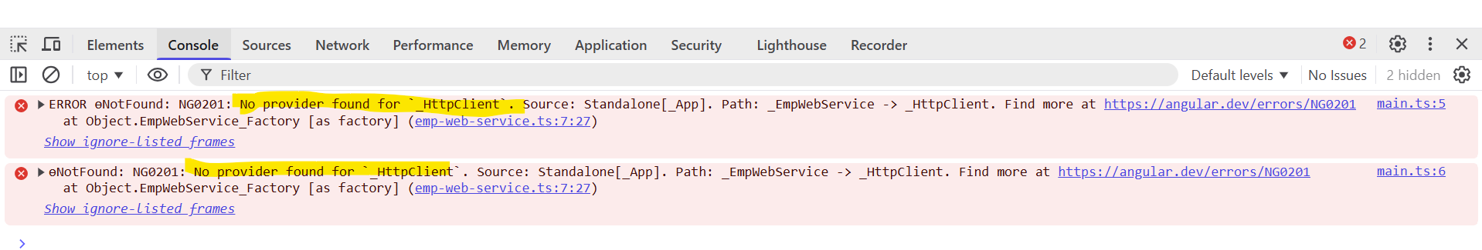
To avoid this error.
We need to add HttpCleint related provider in app.config.ts file. Check below.
export const appConfig: ApplicationConfig = {
providers: [
provideHttpClient(),
provideBrowserGlobalErrorListeners(),
provideZoneChangeDetection({ eventCoalescing: true }),
provideRouter(routes), provideClientHydration(withEventReplay())
]
};

provideHttpClient
provideHttpClient is a new way introduced in Angular 15 for standalone applications. It replaces the previous HttpClientModule to provide more flexibility and modular approach for standalone applications.

What is meant by localStorage and sessionStorage?

Get() with parameters:

Get() method all available options.
(method) HttpClient.get(url: string, options?: {
headers?: HttpHeaders | Record<string, string | string[]>;
context?: HttpContext;
observe?: "body";
params?: HttpParams | Record<string, string | number | boolean | ReadonlyArray<string | number | boolean>>;
reportProgress?: boolean;
responseType?: "json";
withCredentials?: boolean;
credentials?: RequestCredentials;
keepalive?: boolean;
priority?: RequestPriority;
cache?: RequestCache;
mode?: RequestMode;
redirect?: RequestRedirect;
transferCache?: {
includeHeaders?: string[];
} | boolean;
}): Observable<Object> (+14 overloads)

Now lets start using some of the options in “options” object.
For example lets send request now with “observe” and “responseType” like below.
fetchAllEmployees() {
return this.http.get("http://localhost:8080/fetch-all-employees", {
'observe': 'body',
'responseType': 'json'
});
}

What are the other options available for “observe”?
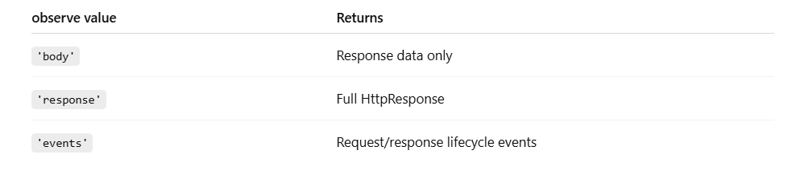
What are the other options available for “'responseType'”?
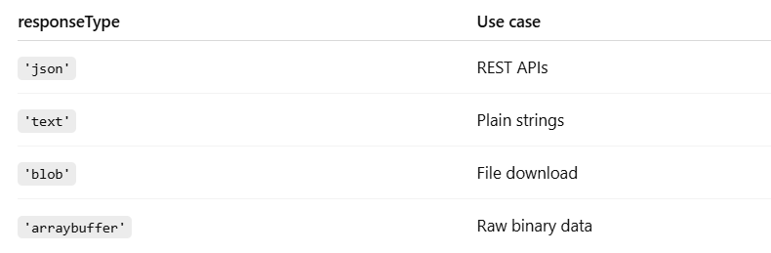

https://chatgpt.com/c/697d5e6b-98fc-8324-899b-83e0b91a7f24

How to use params and headers in GET request?
Sending Query Parameters in GET request. /employees?page=1&size=10
Using HttpParams (BEST PRACTICE) | Passing params as an object (shortcut) | ❌ Not Recommended: Manual URL building
fetchEmployees(page: number, size: number) {  const params = new HttpParams()  .set('page', page)  .set('size', size);  return this.http.get(  'http://localhost:8080/employees',  { params }  );  } | fetchEmployees() {  return this.http.get(  'http://localhost:8080/employees',  {  params: {  page: '1',  size: '10'  }  }  );  } | this.http.get(  'http://localhost:8080/employees?page=1&size=10'  );  ❌ Hard to maintain  ❌ No encoding  ❌ Error-prone

Sending Path Variables (Not Params), we need to use backtick.
getEmployeeById(id: number) {
return this.http.get(
`http://localhost:8080/employees/${id}`
);
}
✔ Path variables are part of URL
✔ NOT sent via HttpParams

Sending Headers in GET request
Headers are used for:
- Authorization (JWT)
- Content type
- Custom headers

Examples:

Using HttpHeaders | Headers as JSON object (shortcut)
import { HttpHeaders } from '@angular/common/http';  getEmployees() {  const headers = new HttpHeaders()  .set('Authorization', 'Bearer my-token')  .set('X-Request-Source', 'web');  return this.http.get(  'http://localhost:8080/employees',  { headers }  );  } | getEmployees() {  return this.http.get(  'http://localhost:8080/employees',  {  headers: {  Authorization: 'Bearer my-token',  'X-Request-Source': 'web'  }  }  );  }

Sending Params + Headers together: we need make use of backtick in Bearer token.
Sending Params + Headers together | Real-world example (JWT + Pagination)
getEmployees(page: number) {  const params = new HttpParams()  .set('page', page)  .set('sort', 'name');  const headers = new HttpHeaders()  .set('Authorization', 'Bearer my-token');  return this.http.get(  'http://localhost:8080/employees',  {  params,  headers  }  );  } | getEmployees(page: number, size: number) {  const params = new HttpParams()  .set('page', page)  .set('size', size);  const headers = new HttpHeaders()  .set('Authorization', `Bearer ${localStorage.getItem('token')}`);  return this.http.get<Employee[]>(  'http://localhost:8080/employees',  { params, headers }  );  }

Best Practice 💡 (IMPORTANT)
🔹 Use Interceptor for headers (JWT)
Instead of adding headers everywhere:
@Injectable()
export class AuthInterceptor implements HttpInterceptor {
intercept(req: HttpRequest<any>, next: HttpHandler) {
const token = localStorage.getItem('token');

const authReq = req.clone({
setHeaders: {
Authorization: `Bearer ${token}`
}
});

return next.handle(authReq);
}
}

