RDS with MYSQL:

AWS search RDS
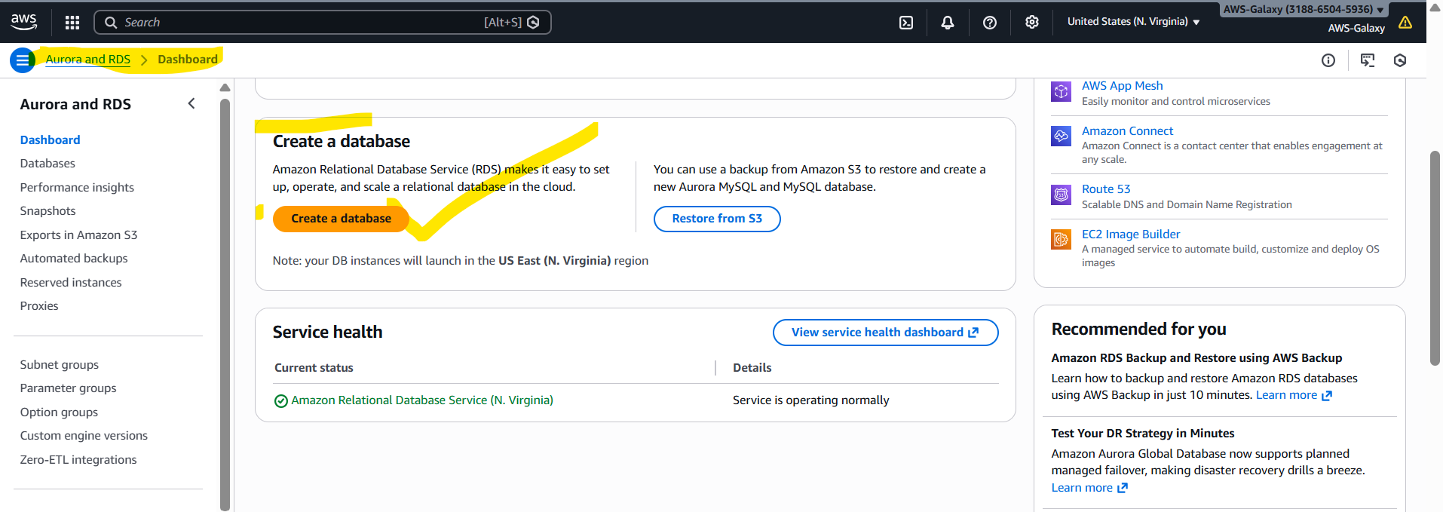
Click on Create a database:
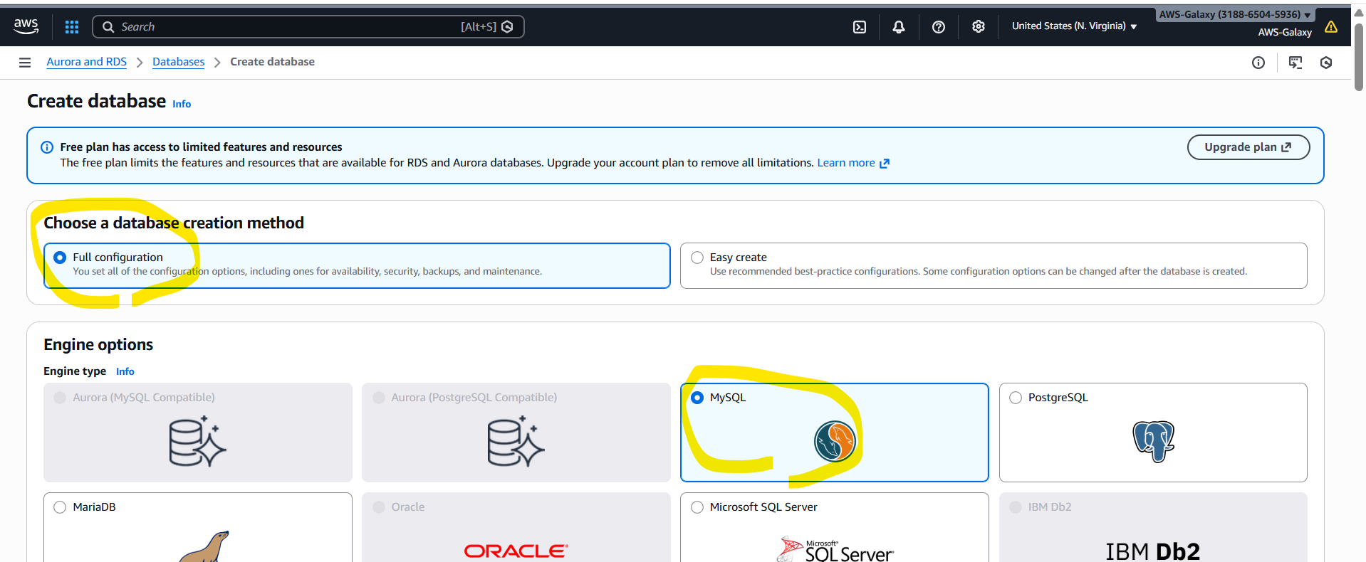

Maximum default values only we are going to use, only give password manually any values in file 8+ characters.
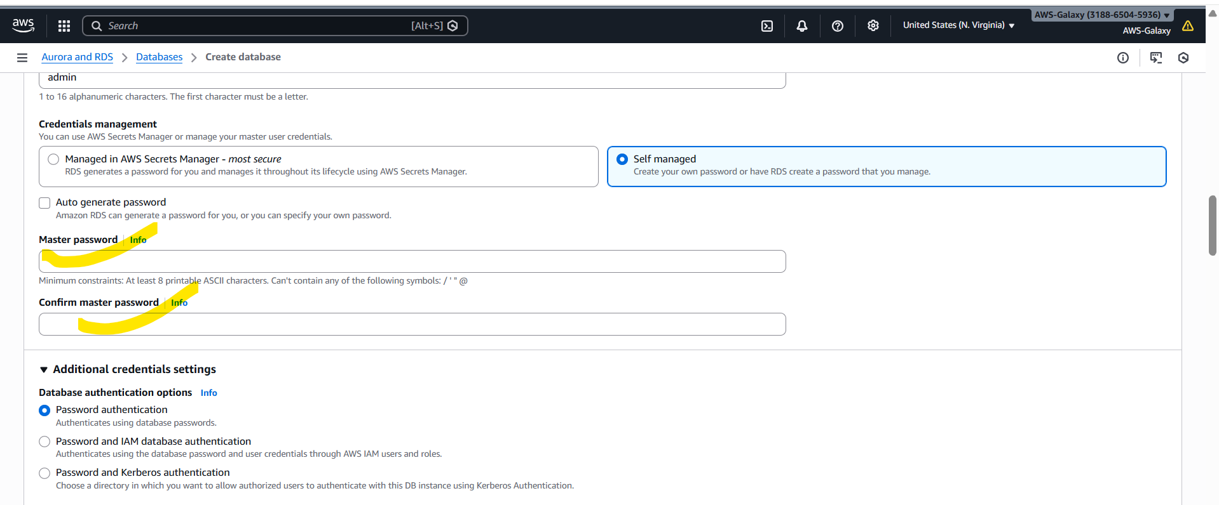
Now create Database. It will take sometime, wait patiently. Status need to come as “available”.

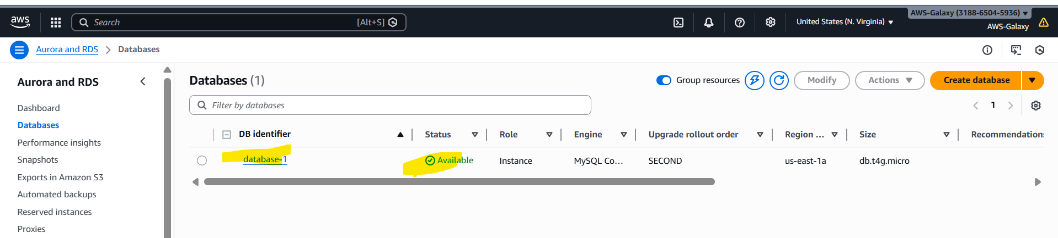

Next go to created database database1 Connectivity & security Security group rules click on default inbound rule go inside security group ID Edit inbound rules Add rule Below all screenshots are added please check.

Add below details in inbound rules:
Field | Value
Type | MySQL/Aurora
Protocol | TCP
Port | 3306
Source | My IP 0.0.0.0/0

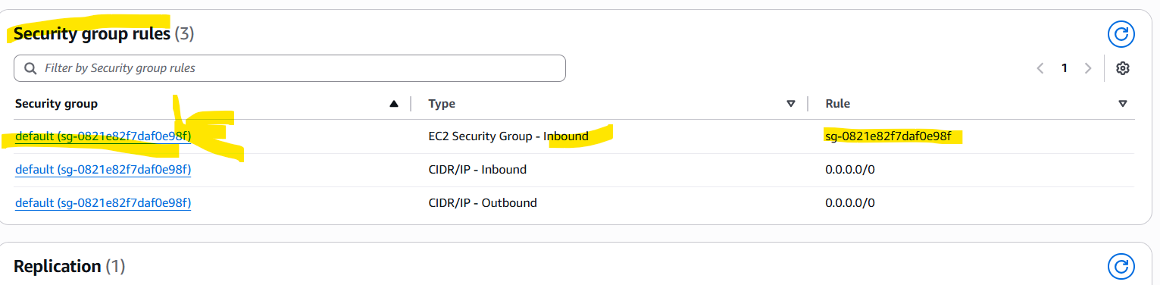

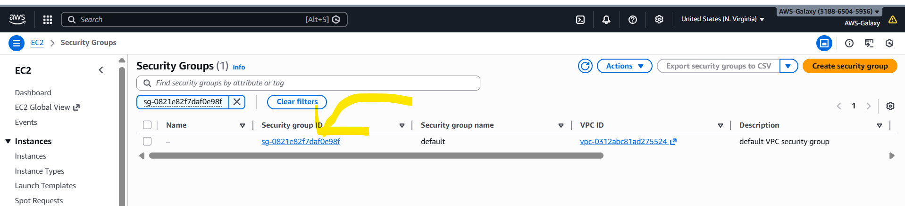

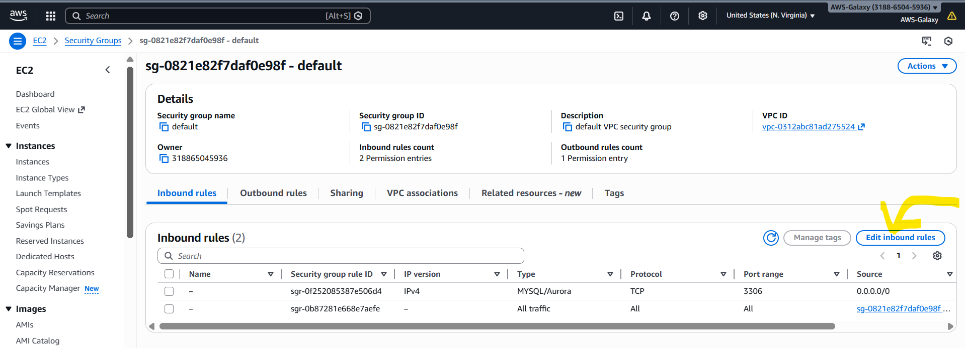

We will not be able to connect rds DB if we don’t add these in bound rules.
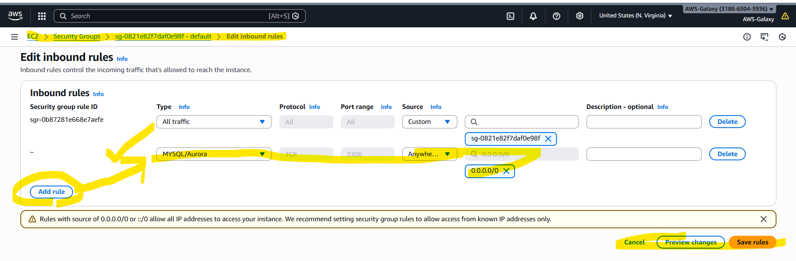
After adding inbound rules only we are able to connect to RDS MYSQL.

mySQl work bench:
Mysql workbench menu databases manage connections new
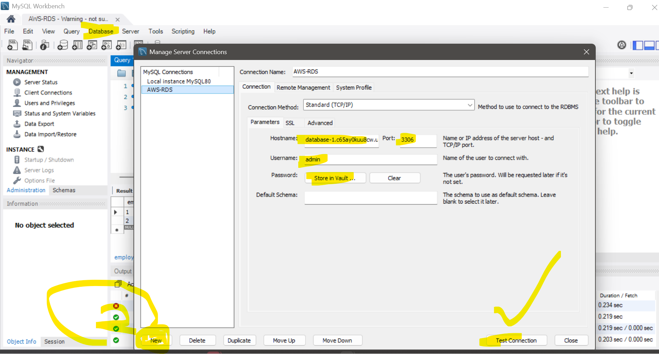

Once after connecting to mysql work bench use below commands and create testdb and then create table etc..
create database testdb;
use testdb;

MYSQL workbench:
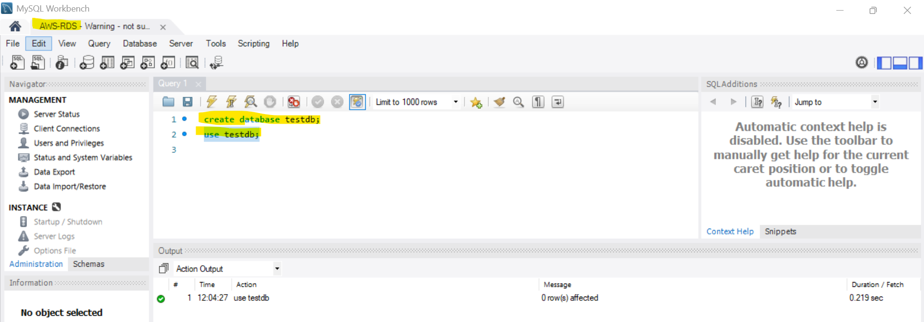

application-rds.yaml
spring:
datasource:
driver-class-name: com.mysql.jdbc.Driver
url: jdbc:mysql://database-1.c65ay0kuu8cw.us-east-1.rds.amazonaws.com:3306/testdb
username: admin
password: rootroot
jpa:
database: mysql
show-sql: true
database-platform: org.hibernate.dialect.MySQLDialect
hibernate:
ddl-auto: update
data:
jpa:
repositories:
enabled: true

For local applications we use | For AWS RDS applications we use
url: jdbc:mysql://localhost:3306/testdb | url: jdbc:mysql://<AWS_DOMAIN>:3306/testdb

Spring boot dependencies:
build.gradle:
dependencies {
implementation 'org.springframework.boot:spring-boot-starter-data-jpa'
runtimeOnly 'com.mysql:mysql-connector-j'
testImplementation 'org.springframework.boot:spring-boot-starter-data-jpa-test'
}

Create java entiry class and repository classes and use repo class in service class.
EmployeeEntity.java | EmployeeRepository.java
import jakarta.persistence.*;  import java.util.Date;  @Entity  @Table(name = "employees")  public class EmployeeEntity {  @Id  @GeneratedValue(strategy = GenerationType.IDENTITY)  @Column(name = "emp_id")  private Integer empId;  @Column(name = "emp_name", nullable = false, length = 100)  private String empName;  @Temporal(TemporalType.DATE)  @Column(name = "emp_doj")  private Date empDOJ;  @Column(name = "emp_salary")  private Double empSalary;  @Column(name = "is_permanent_emp")  private Boolean isPermenentEmp;  // default CTR/ para cter…  // setters, getters. Tostring, equals…. | @Repository  public interface EmployeeRepository extends JpaRepository<EmployeeEntity, Integer> {  // All basic CRUD methods are available from JpaRepository:  // save, findById, findAll, deleteById, existsById, count, etc.  }

EmployeeServiceImpl.java
@Service
@Transactional
public class EmployeeServiceImpl {
private final EmployeeRepository repo;
public EmployeeServiceImpl(EmployeeRepository repo) {
this.repo = repo;
}
// Create
public EmployeeEntity createEmployee(com.skh.models.Employee e) {
EmployeeEntity emp = new EmployeeEntity(null, e.getEmpName(), e.getEmpDOJ(), e.getEmpSalary(), e.getIsPermenentEmp());
/**
* Above dont assign/set empId to the EmployeeEntity class, why because we are using @GeneratedValue(strategy = GenerationType.IDENTITY)
* in entity class.
*/
return repo.save(emp);
}
// Read all
public List<EmployeeEntity> getAllEmployees() {
return repo.findAll();
}
// Read by id
public Optional<EmployeeEntity> getEmployeeById(Integer id) {
return repo.findById(id);
}
// Update (full replace)
public EmployeeEntity updateEmployee(Integer id, EmployeeEntity updated) {
return repo.findById(id)
.map(existing -> {
existing.setEmpName(updated.getEmpName());
existing.setEmpDOJ(updated.getEmpDOJ());
existing.setEmpSalary(updated.getEmpSalary());
existing.setIsPermenentEmp(updated.getIsPermenentEmp());
return repo.save(existing);
})
.orElseGet(() -> {
// If not found, set id and create new (optional behavior)
updated.setEmpId(id);
return repo.save(updated);
});
}
// Delete
public void deleteEmployee(Integer id) {
repo.deleteById(id);
}
// Exists helper
public boolean exists(Integer id) {
return repo.existsById(id);
}
}

How to Get out Public IP address Git Bash & modern Windows)
In Git Bash / cmd prompt:
$ curl ifconfig.me

For RDS automatic backup is enables automatically.
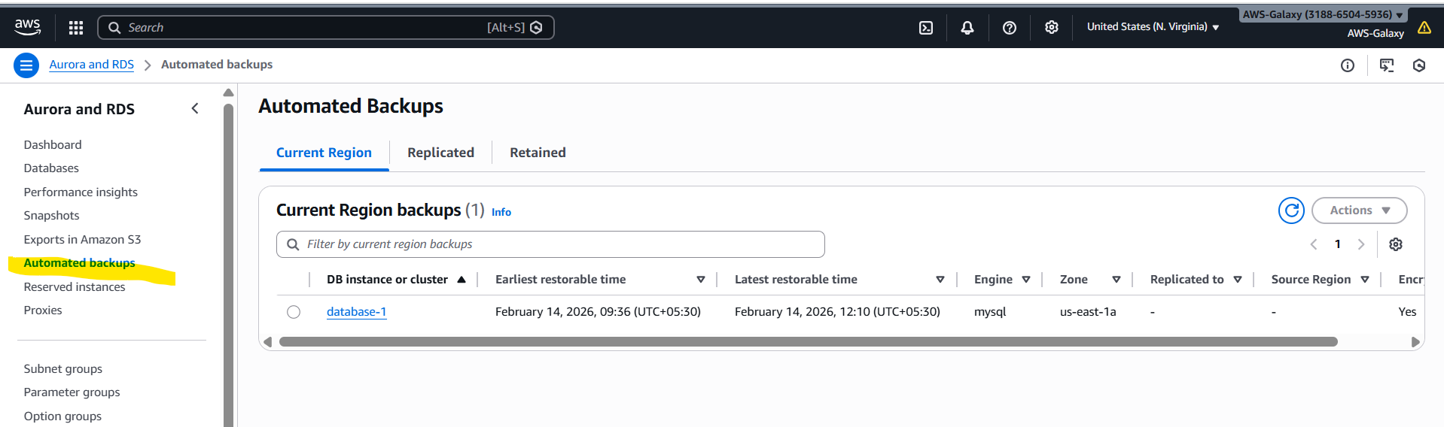

If we select our database we created and click on Action drop down we are will get so many options we need to learn all those options.
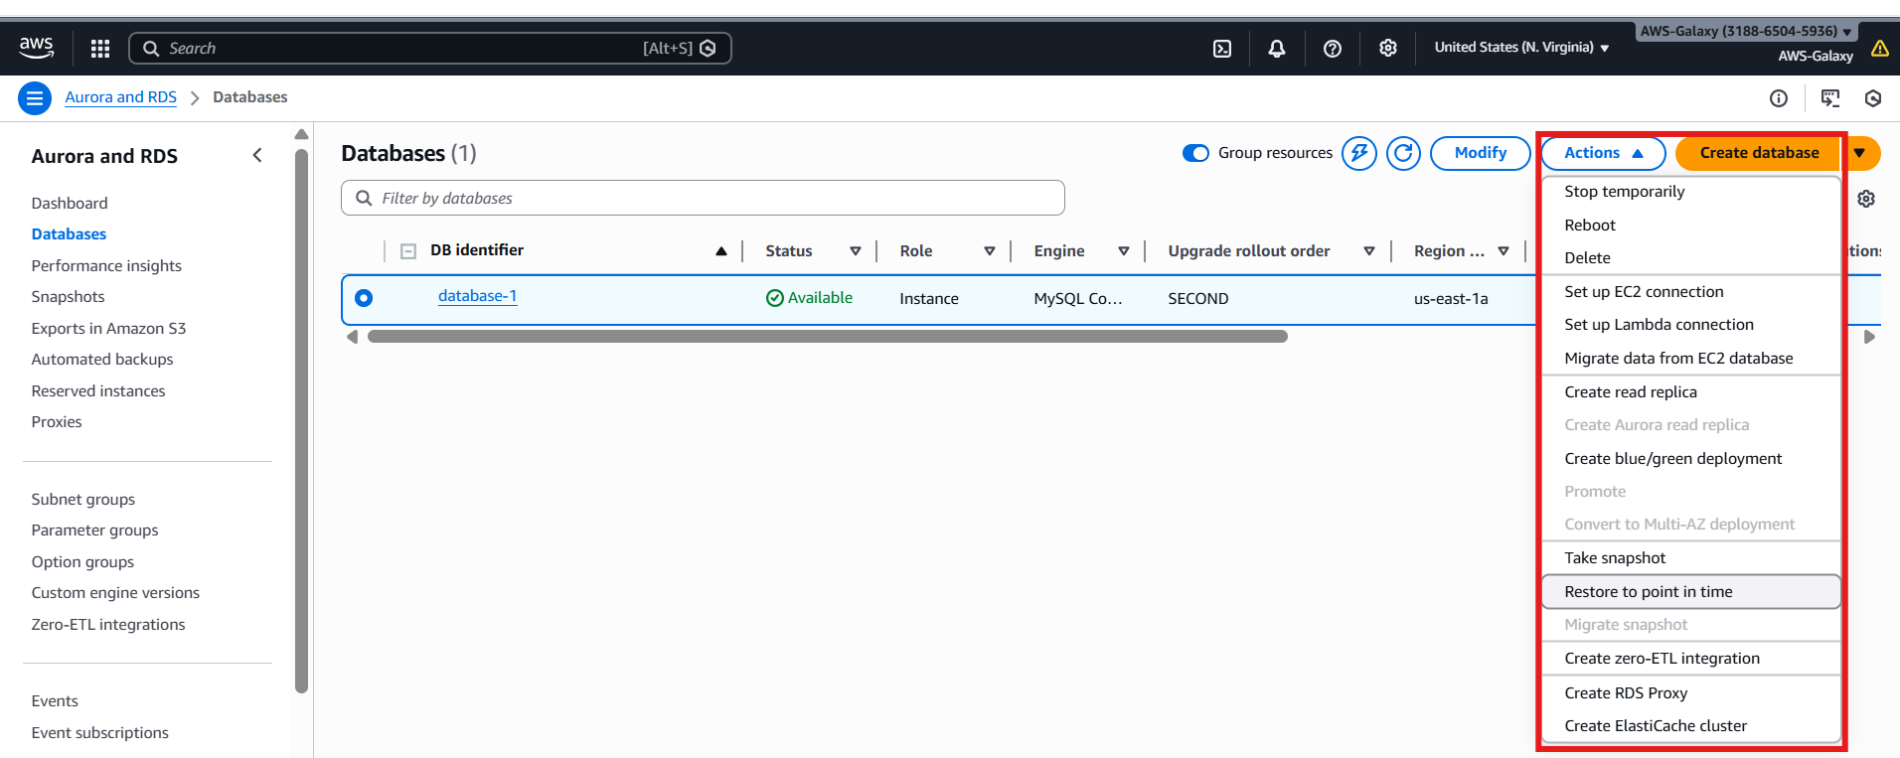

Restore point in time?

