if you are an EC2 machine, whenever we are adding an additional volume, that particular volume is called as EBS volume. If we are using only a default one which we are getting, that one is called as root volume. And if you are adding an additional volume, that particular volume is called as EBS volume.

We create one Linux EC2 machine with multiple volumes. One is with root volume and one is with EBS volume.

While creating EC2 instance we can add EBS volume.
AWS EC2 enter all required details go to Configure Storage Add new Volume 5GB Launch Instane.
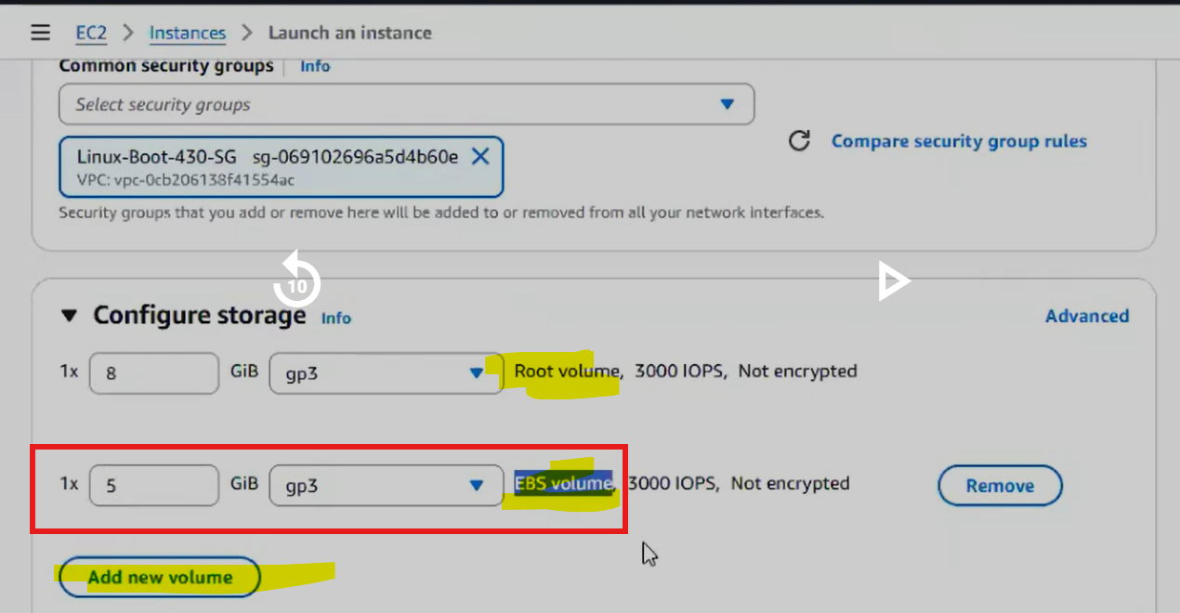

We can see there are 2 volumes we attached.
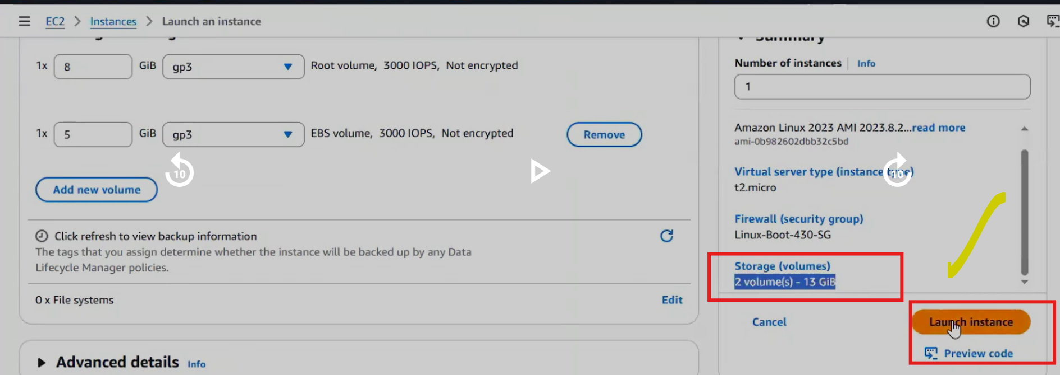

After launch:
Go to:
EC2 → Storage → Volumes.
You will see:
Volume 1 → 8GB → Root
Volume 2 → 5GB → Additional EBS

Both are attached to the instance.

What is an EBS Volume?
EBS (Elastic Block Store) is a network storage disk used with an Amazon EC2 instance.
Think of it like:
- Hard disk attached to a virtual machine

When you create an EC2 instance:
Volume Type | Description
Root Volume | Default disk containing OS
Additional Volume | Extra disk added manually (EBS volume)

Example:
Volume | Size | Purpose
Root volume | 8 GB | OS + system files
Additional EBS | 5 GB | Data storage

Both are technically EBS volumes, but the first one is specifically called root volume.

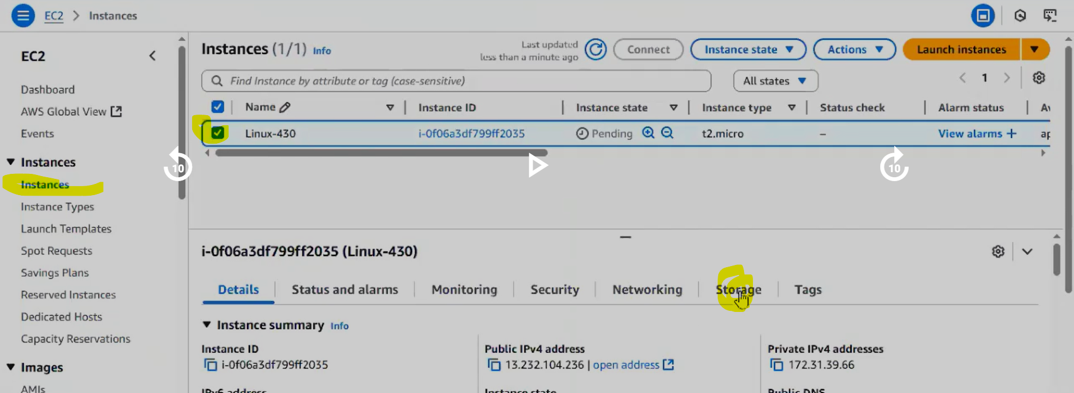

We can see EBS volumes in AWS EC2 Elastic Block store out volumes.
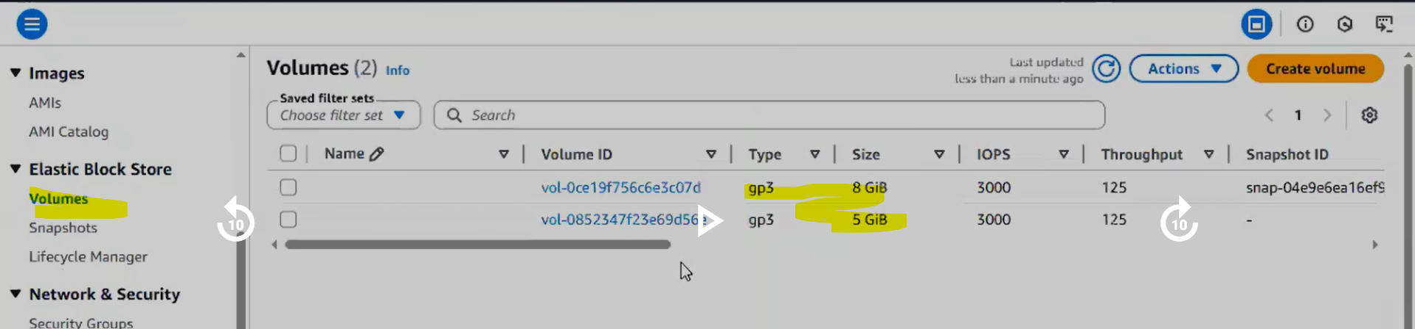

These both the volumes are attached to our EC2 machine.
Right now we can't store data, but we have to do some more steps. Then only we can store some data in that particular volume.
Once after crating the EBS volume can we store data in tat volume? NO.
Why We Cannot Store Data Immediately?
Even though the volume is attached, Linux cannot use it yet.
Because:
- It has no filesystem
- It is not mounted
So the OS does not know where to access it.
We have to mount the volume.
Connect to EC2 machine using gitbash.
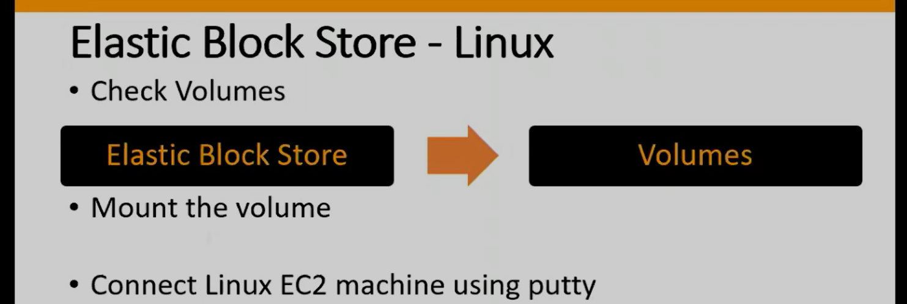

Check Mounted Volumes? With the below command we can see the only volumes which are mounted.
$ df -h
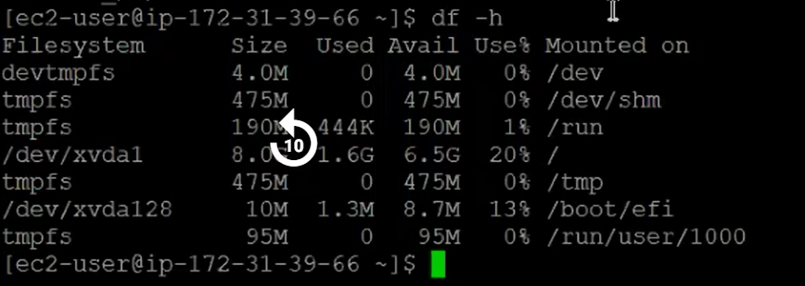

From above we can not see the EBS volume we extra added, we can see oly root volume. 8GB. Why because 5GB EBS volume not yet mounted.
Only root volume is visible.
Your 5GB volume will NOT appear.

To mount new volume first we need to know that volume name, then how to find that umounted volume name? we can use below command.

$ lsblk
Identify New Volume
Run: $ lsblk
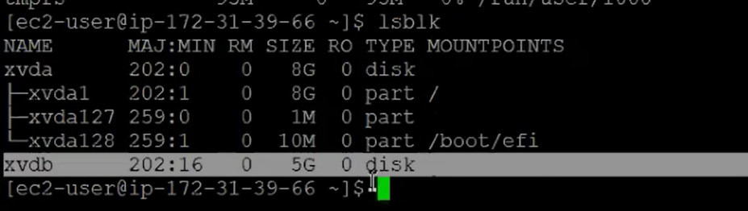
Above we can see newly created EBS volume. With the name xvdb wit 5GB. This may name differ every time we create EBS volume in EC2 machine.

Once after knowing the name we have to do some process.
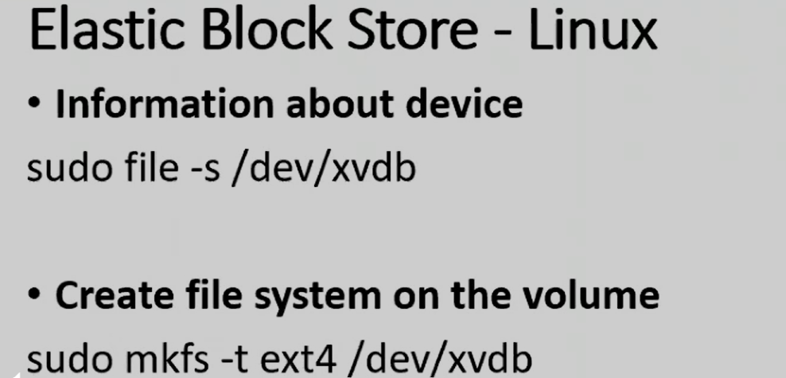

$ sudo file -s /dev/vxdb this step is optional.

Create Filesystem
Before using a disk, Linux needs a filesystem.
Example: ext4

$ sudo mkfs -t ext4 /dev/xvdb
Run this command on gitbash. One question why /dev? How it came here?

Meaning:
Part | Meaning
mkfs | Make filesystem
ext4 | Linux filesystem type
/dev/xvdb | Disk name
This is the first step I am going to do it, I am going to install file system. Now what are these file systems? File system is like a software we are going to install in our volume, based on that this particular volume is going to be compatible for Linux based operating system. And which file system we are installing, the name of the file system is called as ext4. And here is the name of the volume, the last xvdb.
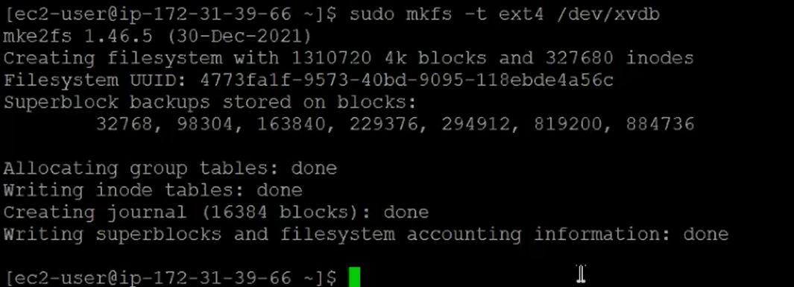

Next step creating a directory. Any name we can give it, anywhere we can create it.
$ mkdir test
Why we created this directlry? Volume we created that is we are going to link to this directory.
Create Directory (Mount Point)
Create a folder that will represent the disk.
This folder will act as the entry point to the disk.
It means if I am going to do any work under this directory, if I am going to create any file under this directory, it means that particular file is actually created in our volume. That particular file is going to create under our volume.

Now Mount the Volume:
$ sudo mount /dev/xvdb test
This means Attach disk → to directory.
/dev/xvdb → /test

Now to check mounted volumes we need to use $ df -h
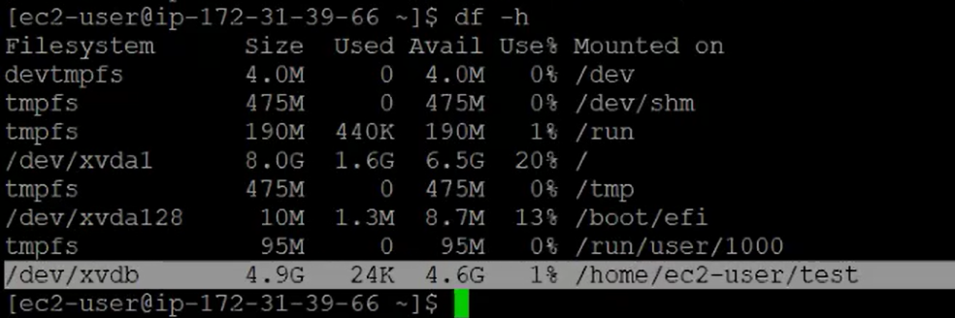
Now we can see our newly mounted EBS volume.
Above we can see volume path and directory path.

Now if I go to test directory and create some files, actually those created files will come under volume.
$ cd test
$ touch f1 f2 f3 f4
This file is stored in the EBS volume, not the root disk.
We are not consuming the space of ROOT volume we are using EBS volume space.
This is how we can create volume and mount that volume to EC2 machine.

$ df -hT check the disk space usage.

Why Use Separate EBS Volumes?
Advantages:
Benefit | Explanation
Data persistence | Data survives instance restart
Easy scaling | Increase volume size
Move between servers | Attach to another EC2
Backup | Snapshots

Now lets assume there is an requirement removing EBS volume from first ec2 machine to 2nd ec2 machine, is it possible? YES it is possible.
Moving Volume to Another EC2
Yes, this is possible.
Example requirement:
Move 5GB volume
EC2-A → EC2-B

First we need to remove from first ec2 machine, here removal means UNMOUNT. First we have mounted, now we are unmounting.
Unmount is 2 step process.
- Come out of test directory and run unmount command.
  - $ sudo unmount test
  - $ df -h
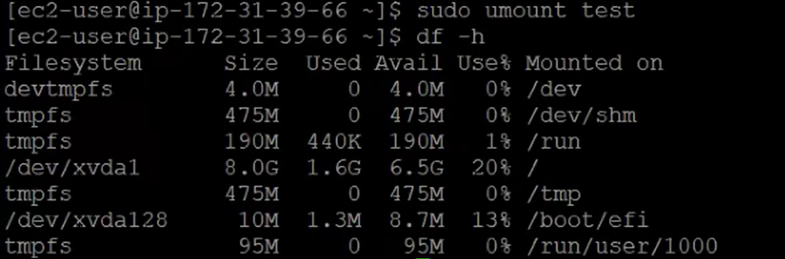
- Remove value from our ec2 machine.
AWS Elastic Block storage Volumes select our EBS volume with 5GB Action drop down detach volume.
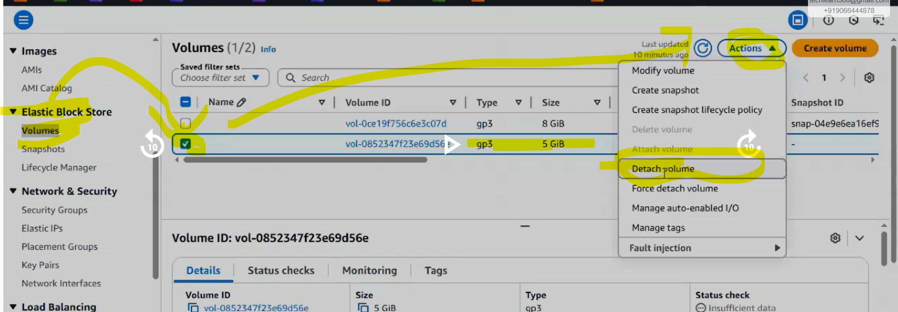
** After sometime it shows available then attach to another ec2 machine. But make sure that EC2 machine is also in same availability zone. It is Mandatory to have EBS volume and EC2 machine in same AZ.
If it is in different AZ it is not possible to attach to EC2 machine.

Now create new EC2 edit network settings there we need to add AZ which is similar to Volume AZ. launch EC2 instance.
Note: while creating new EC2 machine we can not attach old Volume, if we try to attach a new volume while creating Ec2 machine it is going to create new Volume. Still we don’t have option to attach existing volume to newly creating Ec2 machine.

So while creating new Ec2 instance we don’t need to attach any new EBS volume if you want to use existing volume.

❌ You cannot attach an existing EBS volume during EC2 creation.
You can only create new volumes during launch.
Existing volumes must be attached after instance creation.

Now after creating new Ec2 machine go to EBS volumes select OLD volume action drop down attach volume select our Ec2 machine newly created device name can be anyName randomly displayed below. attach volume
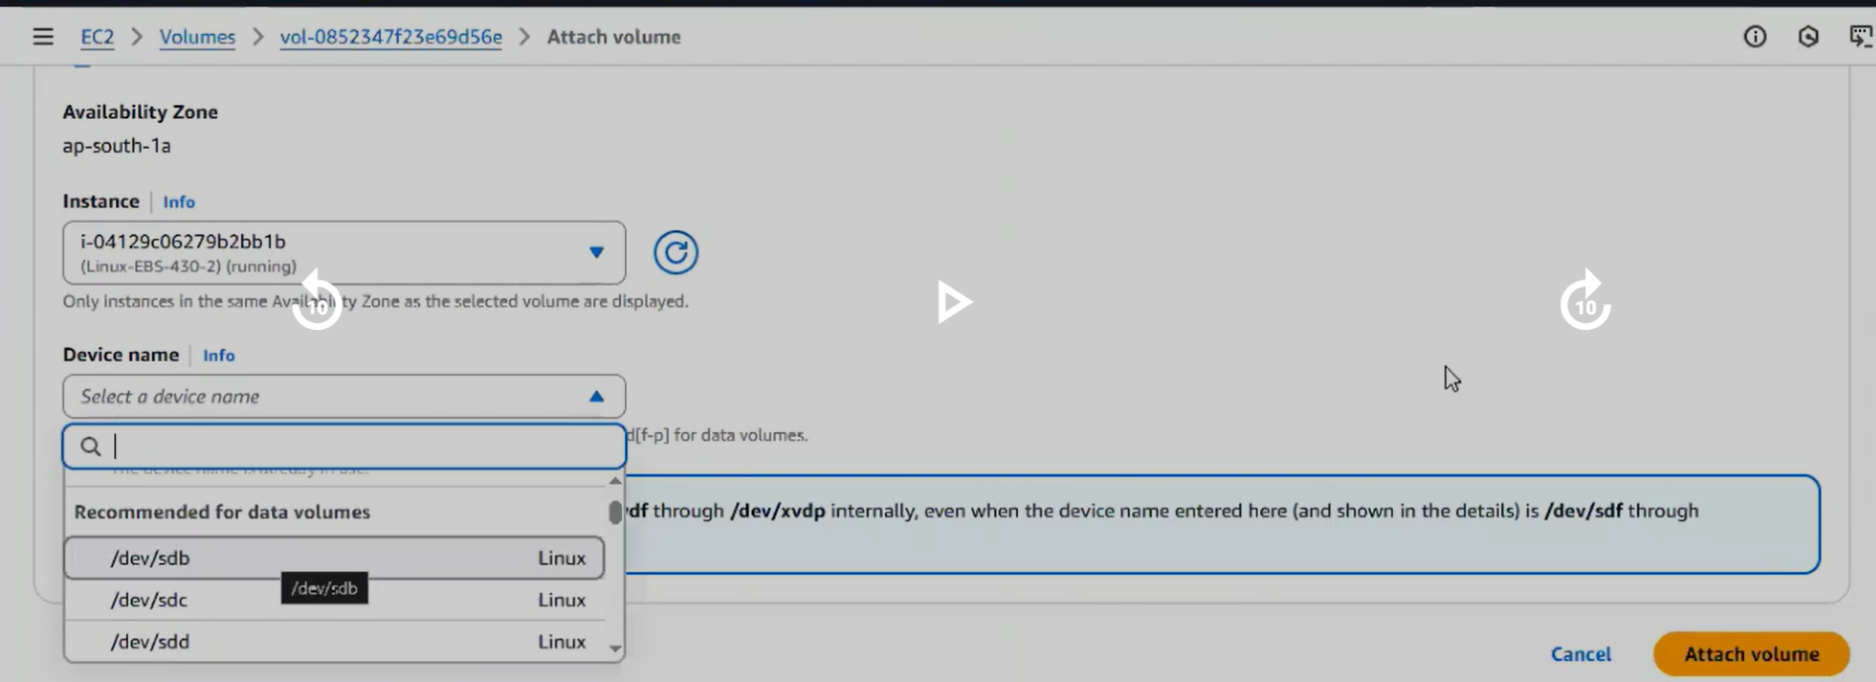
Now we are able to attach out volume to 2nd ec2 machine.

Now do we need to follow all steps before we did?
No, only 2 steps we need to follow. $ mkfs not required as already file system available we created earlier.
- Create directory.
- Link directory to volume.(mounting)

$ mkdir trainings
$ lsblk
$ sudo mount /dev/xvdb training
$ df -h

Since filesystem already exists, do NOT run mkfs again.
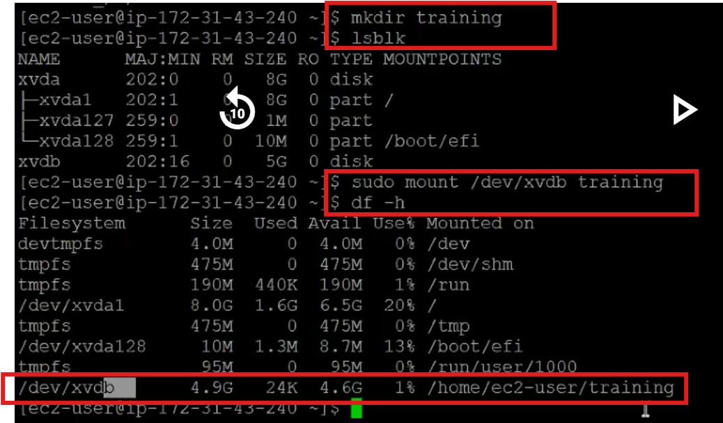
Now we can go inside training directory and add files.
Question: are we going to see previously created f1 f2 f3 files in the trainings directory? YES.
Go inside training directory and do $ ls, we can see all previously creates files there.
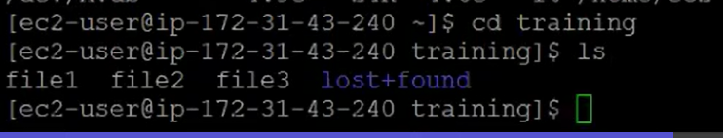

Why? Test directory is just a path for volume, file are not going to store there permanently. If you detach volume with old ec2 machine, then those files removed from test directory and available in volume which we detached.

If we attach that volume to new ec machine, there we can see those files.

Files always stored in EBS volume not in ec2 machine directory.

Think of EBS volume like a USB drive.
Laptop A → USB drive attached
Files created:
resume.doc
photo.jpg
notes.txt
Now unplug USB and connect to: Laptop B
You still see the same files.
Same concept in AWS.

