**How to create user in Linux?**

For creating a new user we will use “adduser” command in linux machine.

If you login as norma user and try to add user we will get below error.

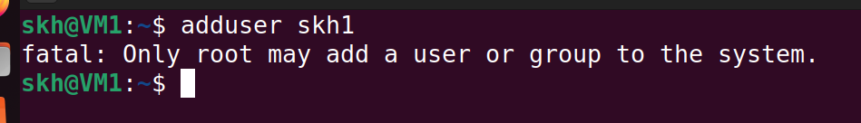

Crating user can be done by “root” user or any “sudoer” user. A normal user cannot create another user.

Step1: first switch to root user account using

**$ sudo su root** 🡺 enter password of current VM.

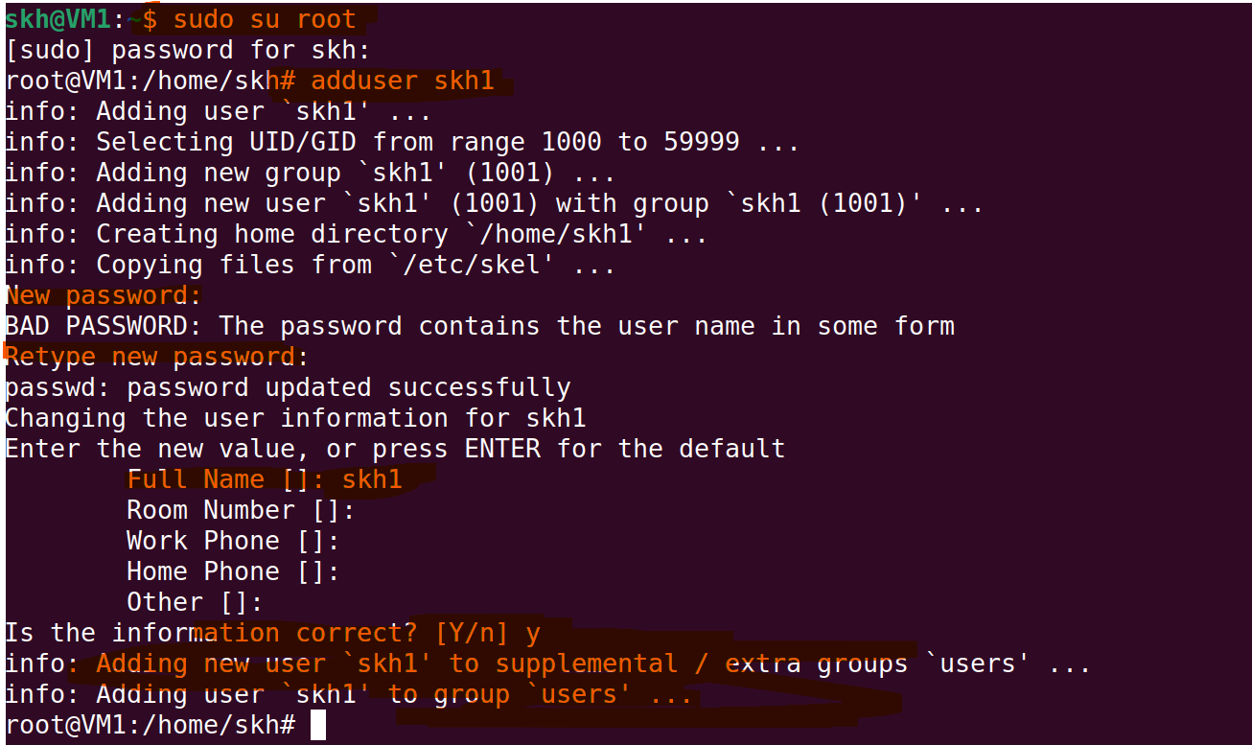

|  |
| --- |
| **$ sudo su root** 🡺 enter current VM password. Switching to root user account.  **$ adduser** <username> [it works if and only if you are in root user account or add “sudo” if normal account.]  Eg:  **$ sudo adduser** skh1 |

From above we can see that newly created user is added to new group called “users”.