Carbon Reduction Plan
Supplier Name: AFJ Limited
Publication Date: 23/12/2024

Commitment to Achieving Net Zero
AFJ Limited is committed to achieving Net Zero emissions by 2050. This Carbon Reduction Plan outlines our current carbon footprint, emissions reduction targets, and the strategies we will adopt to meet our Net Zero commitment.

Baseline Emissions Footprint
Baseline emissions are the reference point against which future emissions reductions will be measured. As this is our first Carbon Reduction Plan, the financial year 2023-24 (April 2023 – March 2024) has been selected as our baseline year.
Baseline Year: 2023-24
Additional Details: This baseline reflects our operational activities, including home-to-school transport and non-emergency patient transport services, as well as emissions from electricity usage.

Baseline Year Emissions:
Emissions Source | Total (tCO₂e)
Scope 1: Direct emissions from company-owned vehicles (ambulances and minibuses) | 1083.03
Scope 2: Indirect emissions from purchased electricity | 17.12
Scope 3: Indirect emissions from value-chain activities (e.g., employee commuting, waste, and supply chain)* | 200.80
Total Emissions | 1,300.95
*Scope 3 emissions include estimates based on employee commuting (152 tCO₂e), waste management (42 tCO₂e), local supplier deliveries (2 tCO₂e), and international shipments (4 tCO₂e). Future improvements will refine these calculations.

Current Emissions Reporting
For the baseline year, emissions are as follows:
Scope 1: Direct emissions from company-owned vehicles | 1083.03
Scope 2: Indirect emissions from purchased electricity | 17.12
Scope 3: Indirect emissions from value-chain activities | 200.80
Total Emissions | 1,300.95

Emissions Reduction Targets
To achieve our Net Zero goal by 2050, we have set annual targets for emissions reductions. We aim to reduce emissions evenly each year to ensure a realistic and achievable pathway.
- By 2026: Reduce total emissions by 6% from the baseline.
- By 2027: Reduce total emissions by 12% from the baseline.
- By 2029: Reduce total emissions by 18% from the baseline.
- By 2031: Reduce total emissions by 24% from the baseline.
- By 2033: Reduce total emissions by 30% from the baseline.
- By 2035: Achieve a 40% reduction in total emissions.
- By 2037: Reduce total emissions by 50% from the baseline.
- By 2039: Reduce total emissions by 60% from the baseline.
- By 2041: Reduce total emissions by 70% from the baseline.
- By 2043: Reduce total emissions by 80% from the baseline.
- By 2045: Reduce total emissions by 90% from the baseline.
- By 2050: Achieve Net Zero.
Progress against these targets will be reviewed and updated annually.

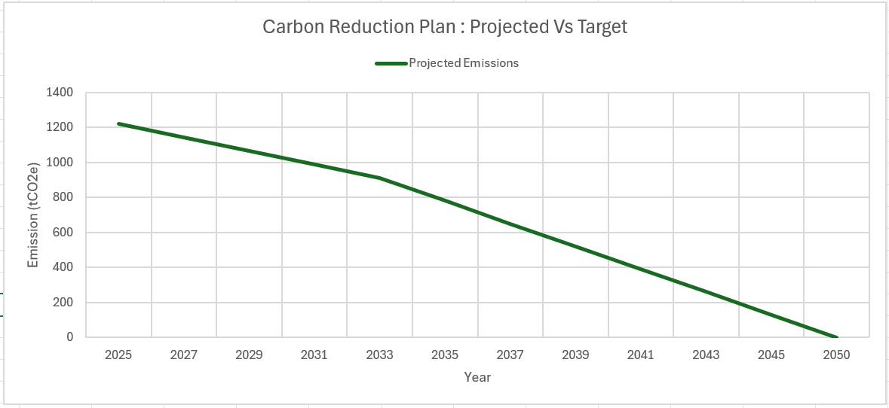

Carbon Reduction Projects

Completed Carbon Reduction Initiatives
AFJ Limited has already undertaken the following measures to reduce carbon emissions:
- Upgraded majority of our vehicles to Euro VI standards to improve fuel efficiency and reduce emissions.
- Collaborated with universities and in-house maintenance teams to develop fleet management systems for optimizing fuel usage.

Future Carbon Reduction Initiatives
We plan to implement the following measures to further reduce our emissions:
-Route Optimization: Developing an ERP system to optimize transport routes and minimize fuel consumption. This system will also digitalize processes, reducing paper usage significantly.
-Fleet Electrification: Gradually transitioning our vehicle fleet to electric vehicles, starting with smaller numbers and scaling up over time.
-Improved Data Tracking: Expanding our reporting capabilities to include Scope 3 emissions, focusing on employee commuting, waste management, and supplier activities.
-Promoting Sustainable Commuting: Introducing carpooling programs and incentivizing public transport usage to reduce emissions from employee commuting.
-Waste Reduction Strategies: Enhancing waste segregation processes and collaborating with suppliers to use more recyclable materials.
-Sustainable Procurement: Partnering with local suppliers to minimize transport-related emissions and encouraging sustainable practices.
-Efficient Waste Management: Implementing systems to reduce waste volumes and ensure effective recycling practices, targeting reductions in the 42 tCO₂e associated with waste management.

Declaration and Sign Off
This Carbon Reduction Plan has been completed in accordance with PPN 06/21 and associated guidance. Emissions have been reported in line with the GHG Reporting Protocol corporate standard, using the appropriate Government emission conversion factors for greenhouse gas company reporting. Scope 1 and Scope 2 emissions have been reported in accordance with SECR requirements, and Scope 3 reporting will be developed in line with the Corporate Value Chain (Scope 3) Standard.
This plan has been reviewed and signed off by the board of directors.

Signed on behalf of AFJ Limited:
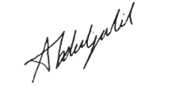
Director: Abdul Jalil
Date: 23.12.2024

