1. **Use Azurerm resource provider**

# Configure the Microsoft Azure Provider

provider "azurerm" {

  tenant_id       = "415a8c7e-86007-4b46-b291-00000000"

  subscription_id = "c355ece9-9b00a-46ce-9c84-000000000"

  client_id       = "09a66f62-4a78-4008-b60d-0000000000"

  client_secret   = "xlG7Q~9BM-yu1000QAd_00000000000"

  features {}

}

# Specify the version of the AzureRM Provider to use

terraform {

  required_providers {

    azurerm = {

      source  = "hashicorp/azurerm"

      version = "=3.0.0"

    }

  }

}

# Create a resource group

resource "azurerm_resource_group" "example" {

  name     = "example-resources"

  location = "West Europe"

}

---------------------------------------------------------------------------------------------------------------------------------------------------

**Terraform init :-**

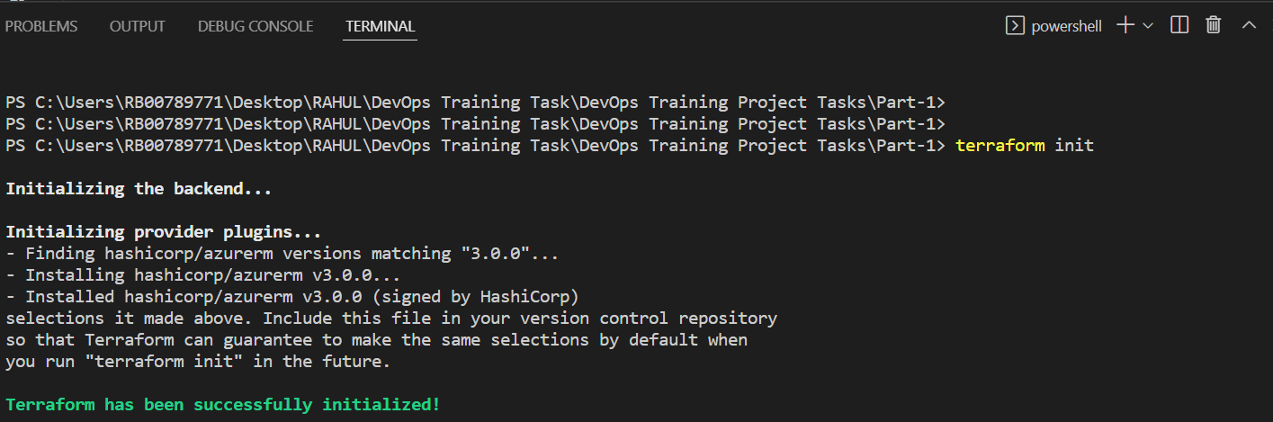

**Terraform plan :-**

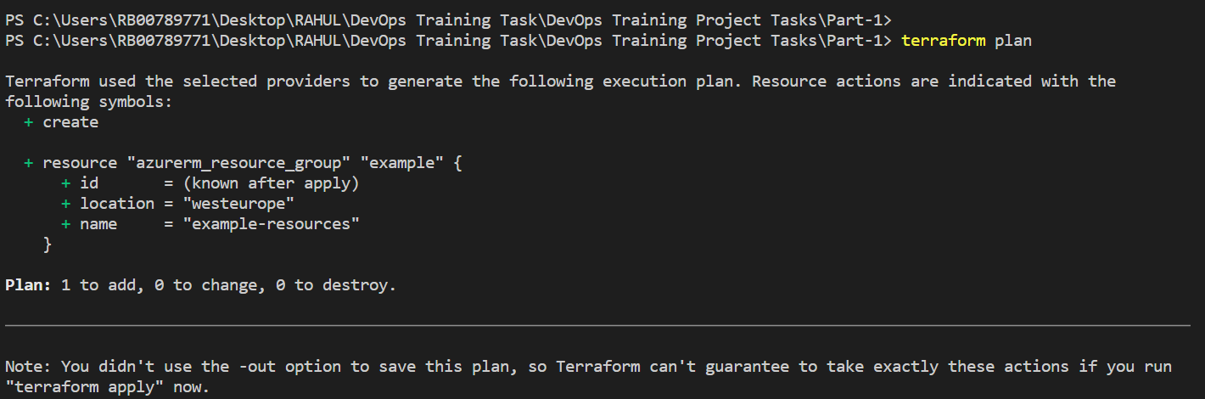

**Terraform apply :-**

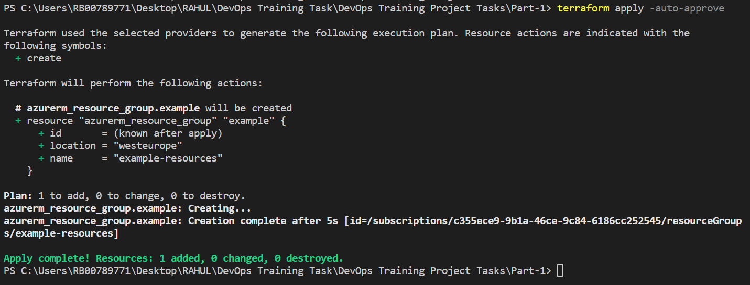

**Azure Portal Output :-**

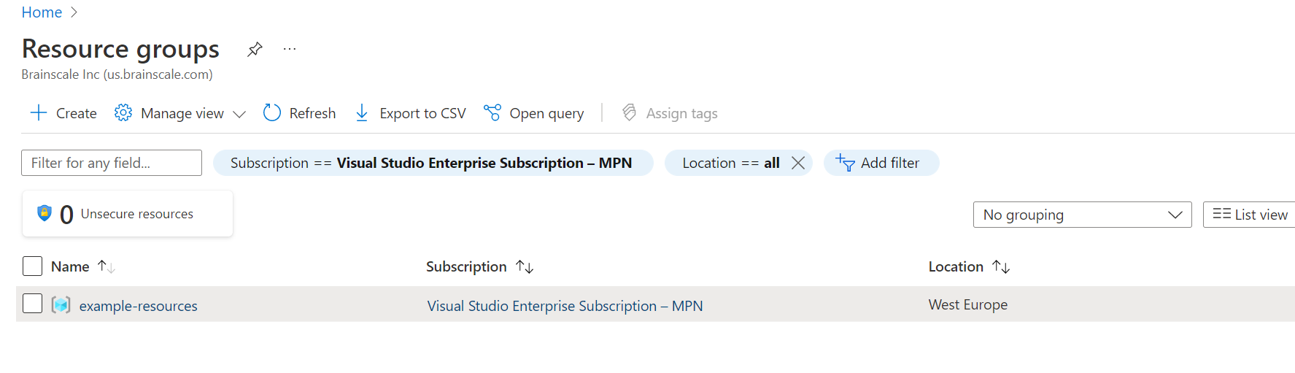

1. **Create required Vars.tf to create two VMs in Azure**

# Configure the Azure Provider

# Configure the Microsoft Azure Provider

provider "azurerm" {

tenant_id = "415a8c7e-8647-4b46-b291-000000000000"

subscription_id = "c355ece9-9b1a-46ce-9c84-000000000000"

client_id = "09a66f62-4a78-4dd8-b60d-0000000000"

client_secret = "xlG7Q~9BM-yu1xPtrQAd_0000000000000"

features {}

}

# Create a resource group

resource "azurerm_resource_group" "example_rg" {

name = "${var.resource_prefix}-RG"

location = var.node_location

}

# Create a virtual network within the resource group

resource "azurerm_virtual_network" "example_vnet" {

name = "${var.resource_prefix}-vnet"

resource_group_name = azurerm_resource_group.example_rg.name

location = var.node_location

address_space = ["10.2.0.0/16"]

}

# Create a subnets within the virtual network

resource "azurerm_subnet" "example_subnet" {

name = "${var.resource_prefix}-subnet"

resource_group_name = azurerm_resource_group.example_rg.name

virtual_network_name = azurerm_virtual_network.example_vnet.name

address_prefixes = ["10.2.1.0/24"]

}

# Create Linux Public IP

resource "azurerm_public_ip" "example_public_ip" {

count = var.node_count

name = "${var.resource_prefix}-${format("%02d", count.index)}-PublicIP"

#name = "${var.resource_prefix}-PublicIP"

location = azurerm_resource_group.example_rg.location

resource_group_name = azurerm_resource_group.example_rg.name

allocation_method = var.Environment == "Test" ? "Static" : "Dynamic"

tags = {

environment = "Test"

}

}

# Create Network Interface

resource "azurerm_network_interface" "example_nic" {

count = var.node_count

#name = "${var.resource_prefix}-NIC"

name = "${var.resource_prefix}-${format("%02d", count.index)}-NIC"

location = azurerm_resource_group.example_rg.location

resource_group_name = azurerm_resource_group.example_rg.name

ip_configuration {

name = "internal"

subnet_id = azurerm_subnet.example_subnet.id

private_ip_address_allocation = "Dynamic"

public_ip_address_id = element(azurerm_public_ip.example_public_ip.*.id, count.index)

}

}

# Virtual Machine Creation — Linux

resource "azurerm_virtual_machine" "example_linux_vm" {

count = var.node_count

name = "${var.resource_prefix}-${format("%02d", count.index)}"

location = azurerm_resource_group.example_rg.location

resource_group_name = azurerm_resource_group.example_rg.name

network_interface_ids = [element(azurerm_network_interface.example_nic.*.id, count.index)]

vm_size = "Standard_A1_v2"

delete_os_disk_on_termination = true

storage_image_reference {

publisher = "OpenLogic"

offer = "CentOS"

sku = "7.5"

version = "latest"

}

storage_os_disk {

name = "myosdisk-${count.index}"

caching = "ReadWrite"

create_option = "FromImage"

managed_disk_type = "Standard_LRS"

}

os_profile {

computer_name = "linuxhost"

admin_username = "rahul"

admin_password = "Password@1234"

}

os_profile_linux_config {

disable_password_authentication = false

}

tags = {

environment = "Prod"

}

}

**Variable.tf :-**

variable "node_location" {

type = string

default = "EastUS2"

}

variable "resource_prefix" {

type = string

default = "linuxnode"

}

variable "Environment" {

type = string

default = "Prod"

}

variable "node_count" {

type = number

default = "2"

}

--------------------------------------------------------------------------------------------------------------------------------------------------

**Terraform init :-**

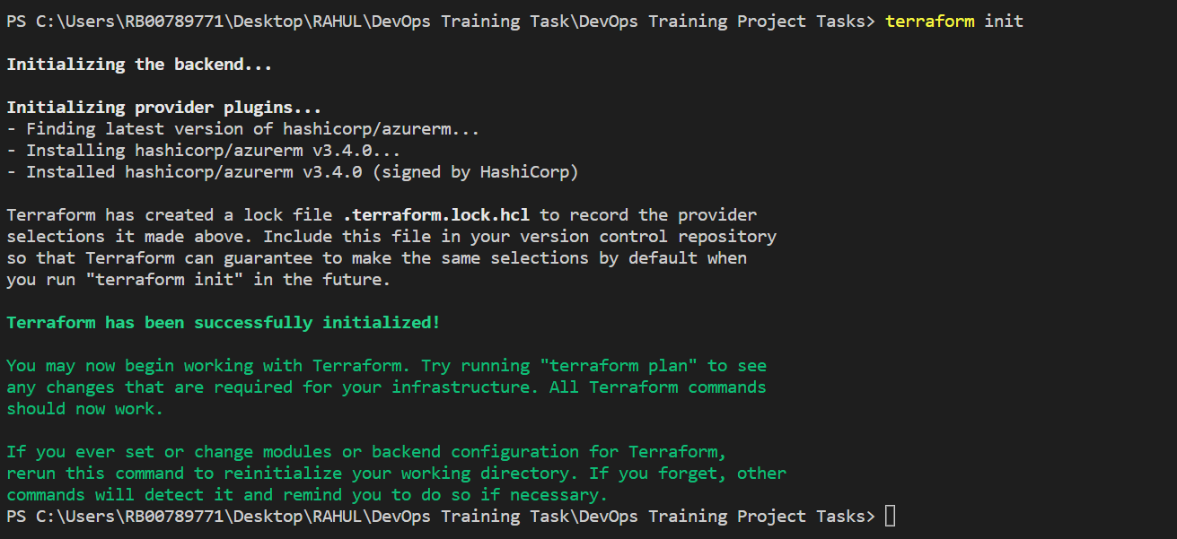

**Terraform Plan :-**

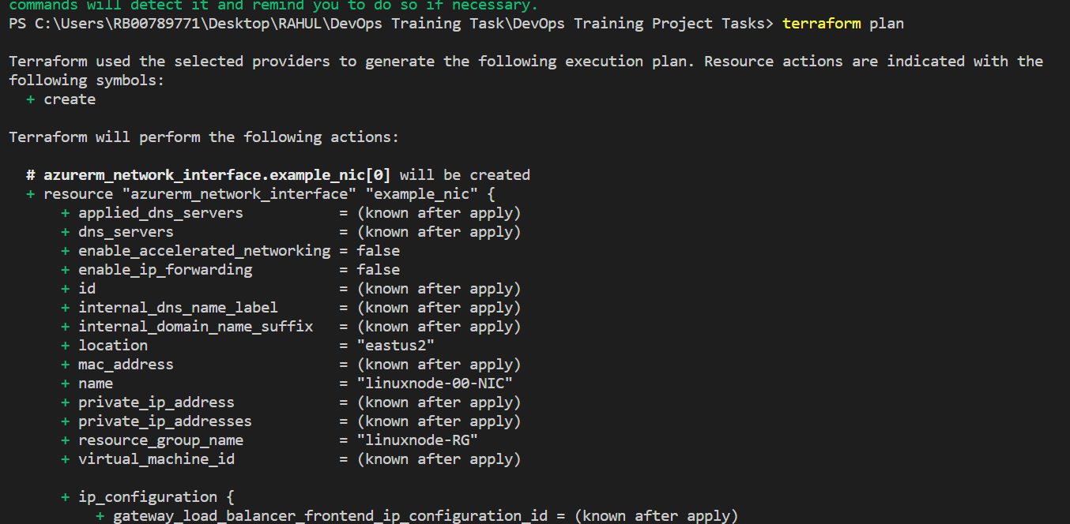

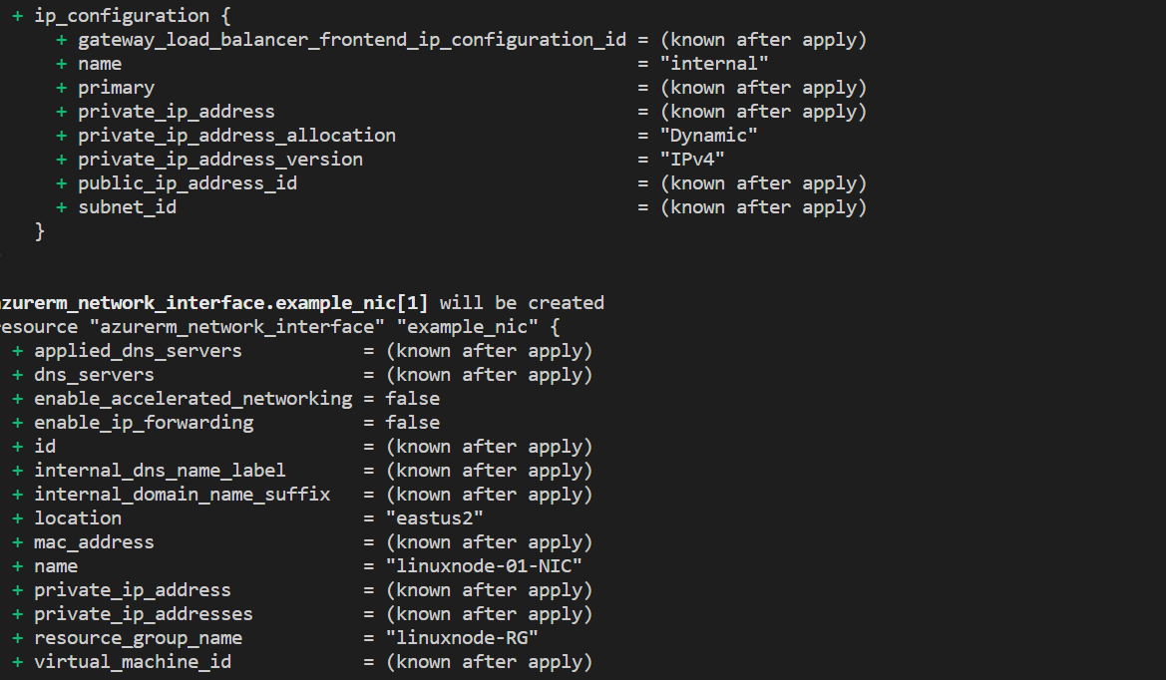

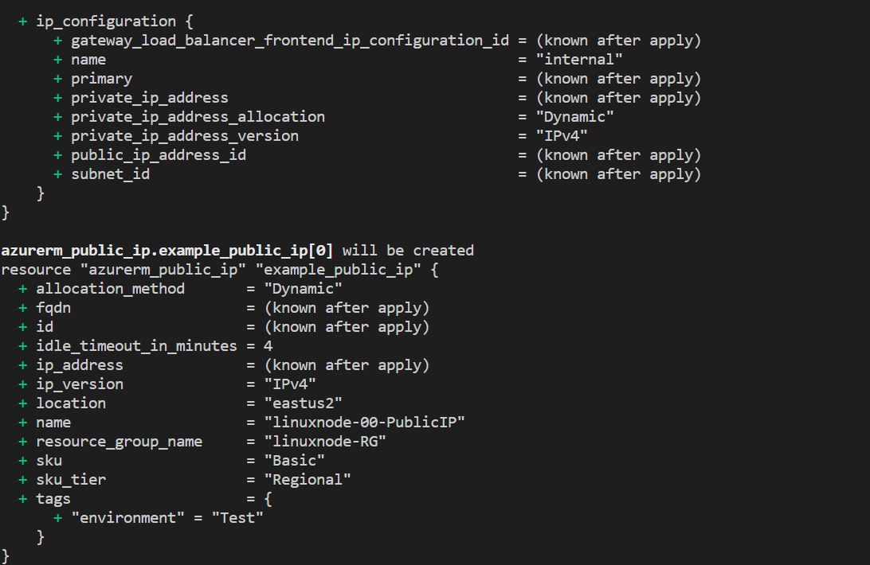

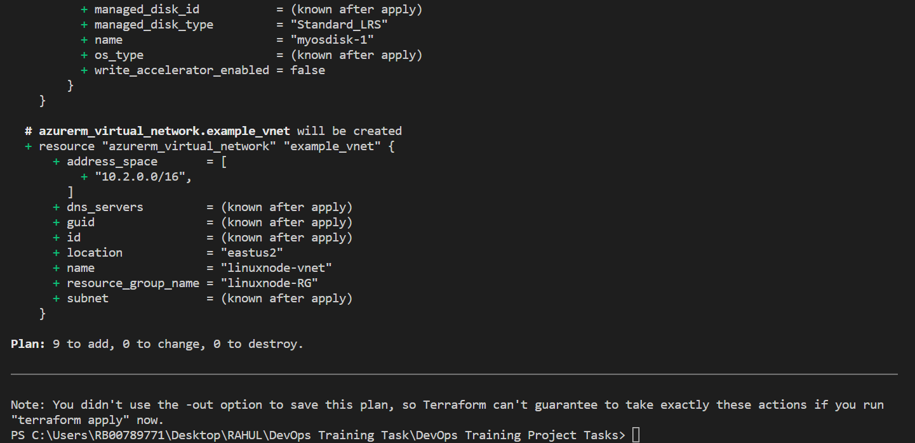

**Terraform Apply :-**

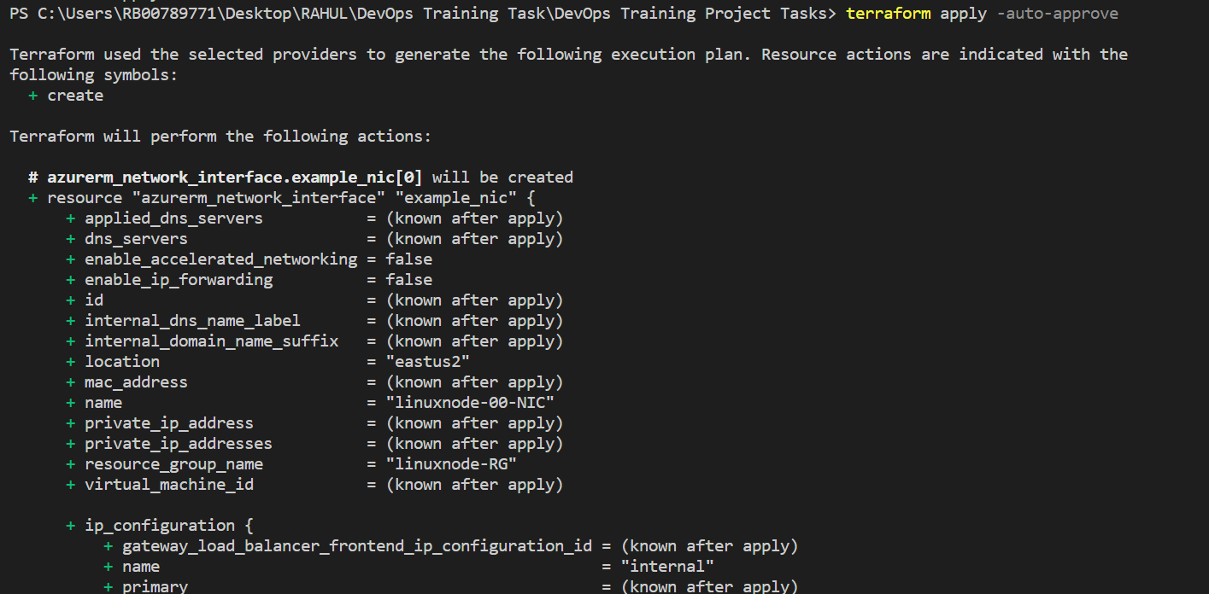

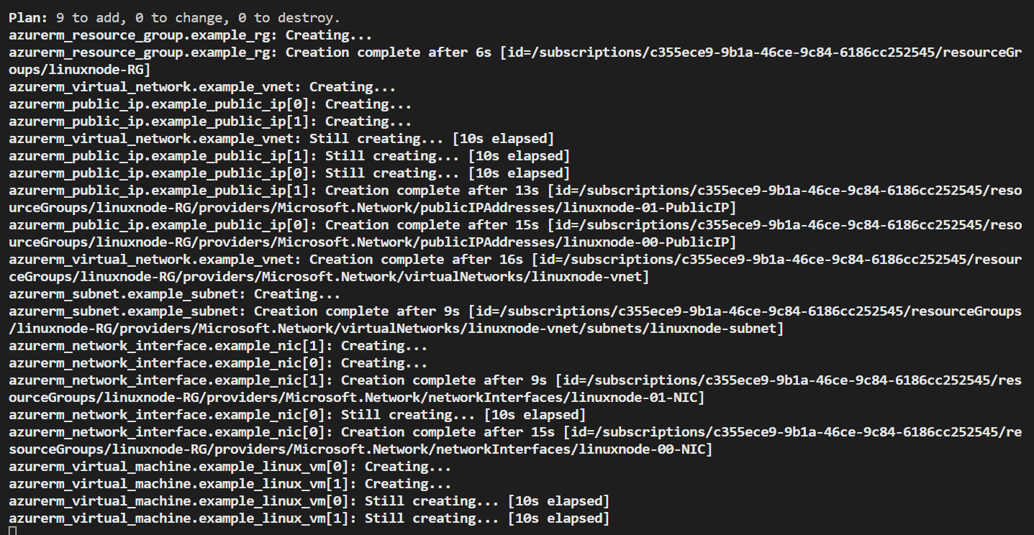

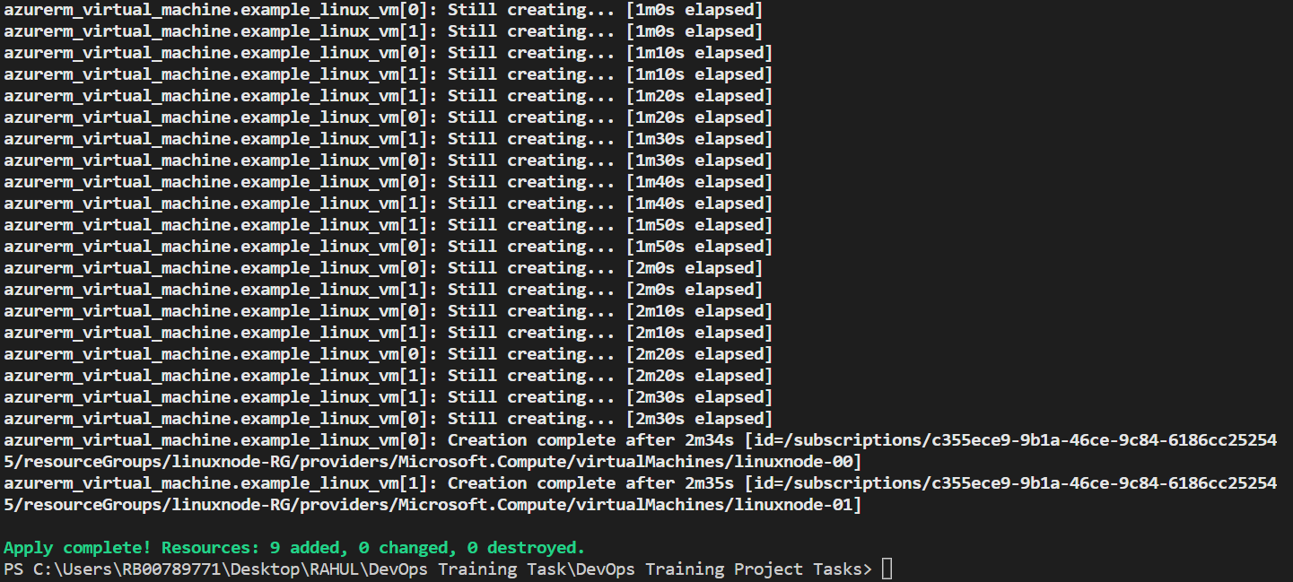

**Azure Portal :-**

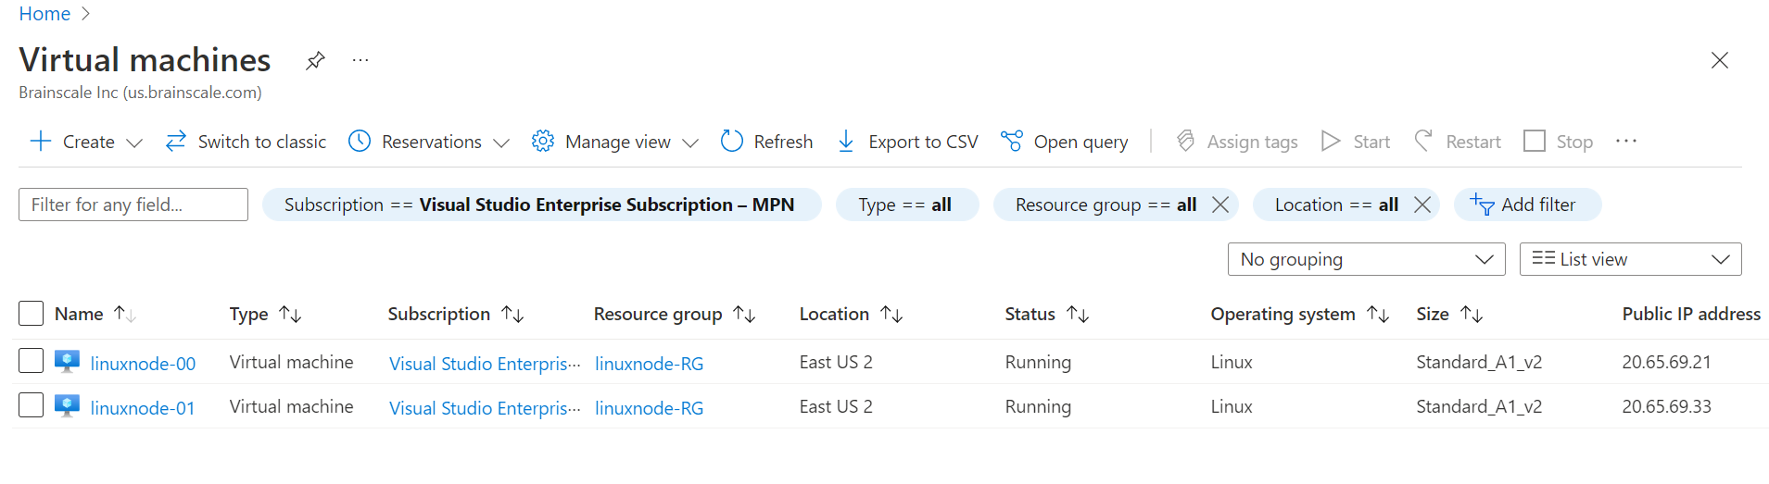

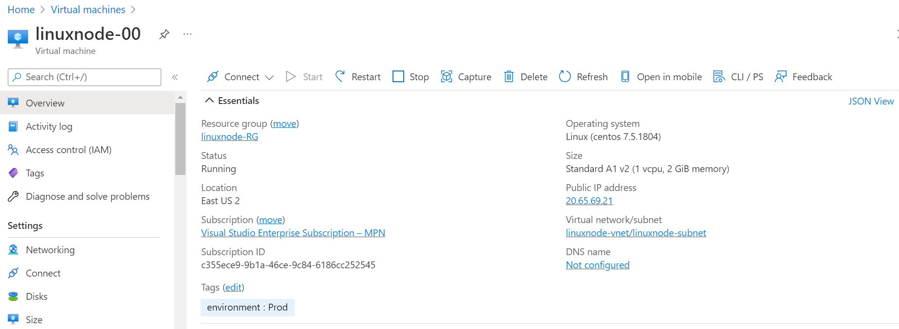

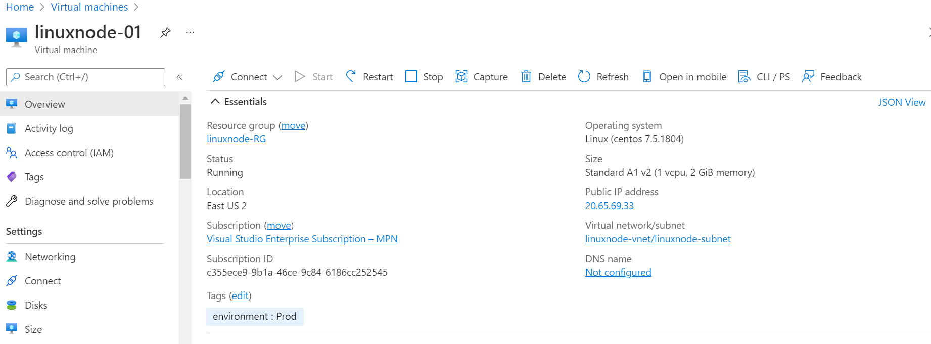

1. **Create main.tf to create two Linux VMs**

# Configure the Microsoft Azure Provider

provider "azurerm" {

  tenant_id       = "415a8c7e-8647-4b46-b291-00000000000"

  subscription_id = "c355ece9-9b1a-46ce-9c84-00000000000"

  client_id       = "09a66f62-4a78-4dd8-b60d-00000000000"

  client_secret   = "xlG7Q~9BM-yu1xPtrQAd_00000000000"

  features {}

}

# Specify the version of the AzureRM Provider to use

terraform {

  required_providers {

    azurerm = {

      source  = "hashicorp/azurerm"

      version = "=3.0.0"

    }

  }

}

# Create a resource group

resource "azurerm_resource_group" "test" {

   name     = "acctestrg"

   location = "EastUS2"

 }

resource "azurerm_virtual_network" "test" {

   name                = "acctvn"

   address_space       = ["10.0.0.0/16"]

   location            = azurerm_resource_group.test.location

   resource_group_name = azurerm_resource_group.test.name

 }

 resource "azurerm_subnet" "test" {

   name                 = "acctsub"

   resource_group_name  = azurerm_resource_group.test.name

   virtual_network_name = azurerm_virtual_network.test.name

   address_prefixes     = ["10.0.2.0/24"]

 }

 resource "azurerm_public_ip" "test" {

   name                         = "publicIPForLB"

   location                     = azurerm_resource_group.test.location

   resource_group_name          = azurerm_resource_group.test.name

   allocation_method            = "Static"

 }

 resource "azurerm_lb" "test" {

   name                = "loadBalancer"

   location            = azurerm_resource_group.test.location

   resource_group_name = azurerm_resource_group.test.name

   frontend_ip_configuration {

     name                 = "publicIPAddress"

     public_ip_address_id = azurerm_public_ip.test.id

   }

 }

 resource "azurerm_lb_backend_address_pool" "test" {

   loadbalancer_id     = azurerm_lb.test.id

   name                = "BackEndAddressPool"

 }

 resource "azurerm_network_interface" "test" {

   count               = 2

   name                = "acctni${count.index}"

   location            = azurerm_resource_group.test.location

   resource_group_name = azurerm_resource_group.test.name

   ip_configuration {

     name                          = "testConfiguration"

     subnet_id                     = azurerm_subnet.test.id

     private_ip_address_allocation = "Dynamic"

   }

 }

 resource "azurerm_managed_disk" "test" {

   count                = 2

   name                 = "datadisk_existing_${count.index}"

   location             = azurerm_resource_group.test.location

   resource_group_name  = azurerm_resource_group.test.name

   storage_account_type = "Standard_LRS"

   create_option        = "Empty"

   disk_size_gb         = "1023"

 }

 resource "azurerm_availability_set" "avset" {

   name                         = "avset"

   location                     = azurerm_resource_group.test.location

   resource_group_name          = azurerm_resource_group.test.name

   platform_fault_domain_count  = 2

   platform_update_domain_count = 2

   managed                      = true

 }

 resource "azurerm_virtual_machine" "test" {

   count                 = 2

   name                  = "acctvm${count.index}"

   location              = azurerm_resource_group.test.location

   availability_set_id   = azurerm_availability_set.avset.id

   resource_group_name   = azurerm_resource_group.test.name

   network_interface_ids = [element(azurerm_network_interface.test.*.id, count.index)]

   vm_size               = "Standard_DS1_v2"

   # Uncomment this line to delete the OS disk automatically when deleting the VM

   # delete_os_disk_on_termination = true

   # Uncomment this line to delete the data disks automatically when deleting the VM

   # delete_data_disks_on_termination = true

   storage_image_reference {

     publisher = "Canonical"

     offer     = "UbuntuServer"

     sku       = "16.04-LTS"

     version   = "latest"

   }

   storage_os_disk {

     name              = "myosdisk${count.index}"

     caching           = "ReadWrite"

     create_option     = "FromImage"

     managed_disk_type = "Standard_LRS"

   }

   # Optional data disks

   storage_data_disk {

     name              = "datadisk_new_${count.index}"

     managed_disk_type = "Standard_LRS"

     create_option     = "Empty"

     lun               = 0

     disk_size_gb      = "1023"

   }

   storage_data_disk {

     name            = element(azurerm_managed_disk.test.*.name, count.index)

     managed_disk_id = element(azurerm_managed_disk.test.*.id, count.index)

     create_option   = "Attach"

     lun             = 1

     disk_size_gb    = element(azurerm_managed_disk.test.*.disk_size_gb, count.index)

   }

   os_profile {

     computer_name  = "hostname"

     admin_username = "testadmin"

     admin_password = "Password1234!"

   }

   os_profile_linux_config {

     disable_password_authentication = false

   }

   tags = {

     environment = "staging"

   }

 }

---------------------------------------------------------------------------------------------------------------------------------------------------

**Terraform Init :-**

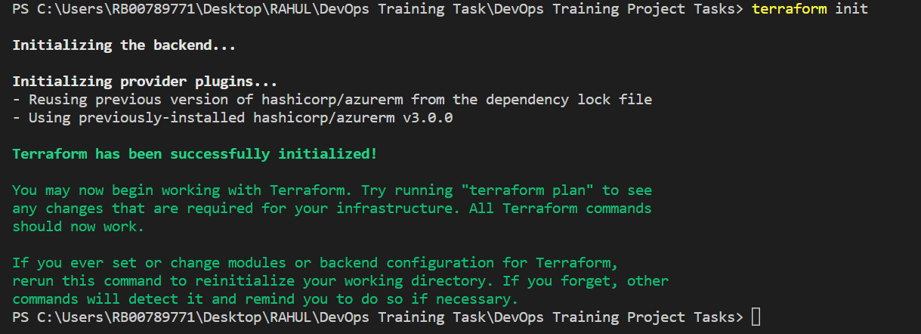

**Terraform plan :-**

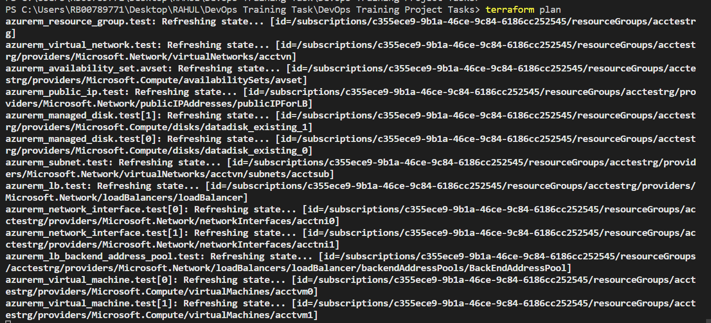

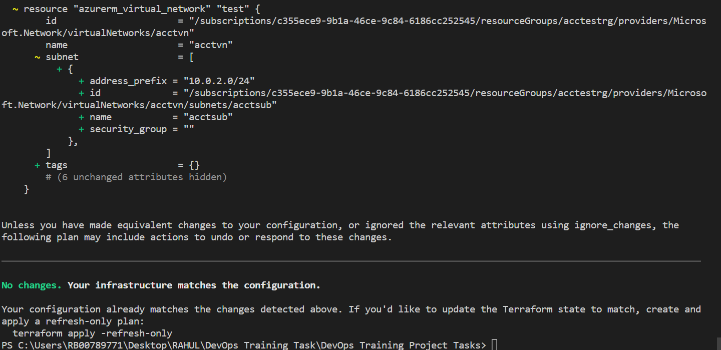

**Terraform apply :-**

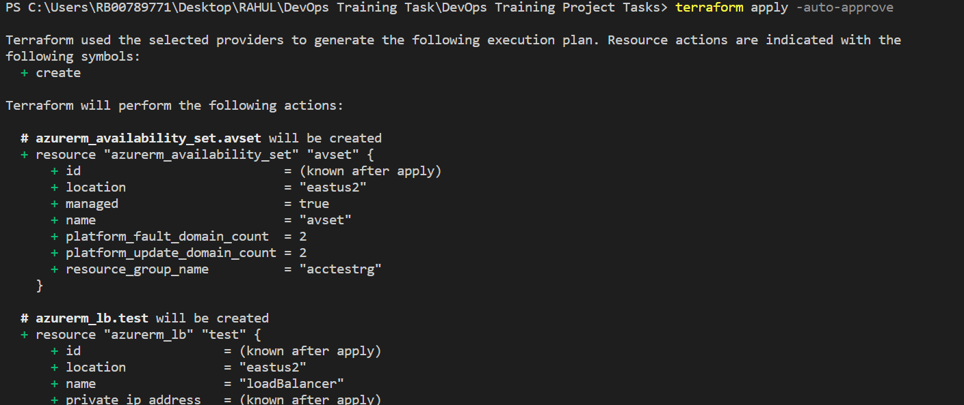

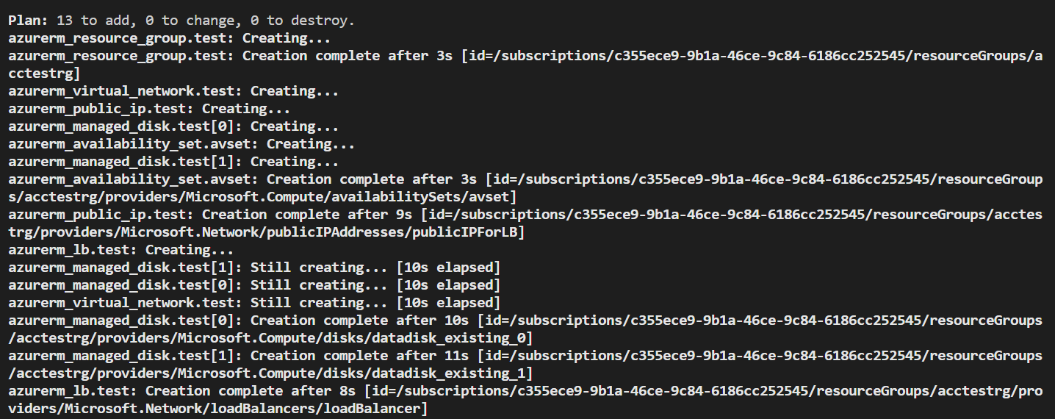

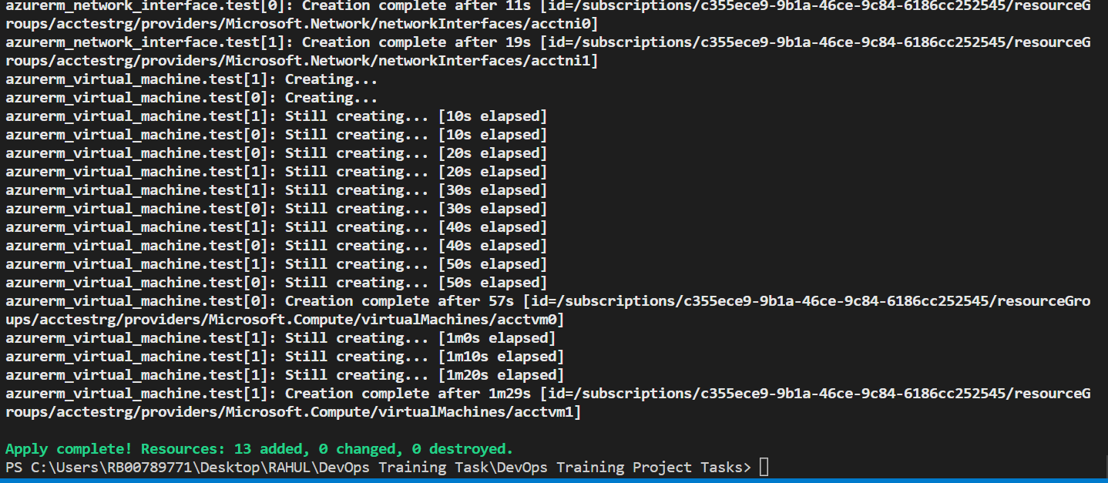

**Azure Portal :-**

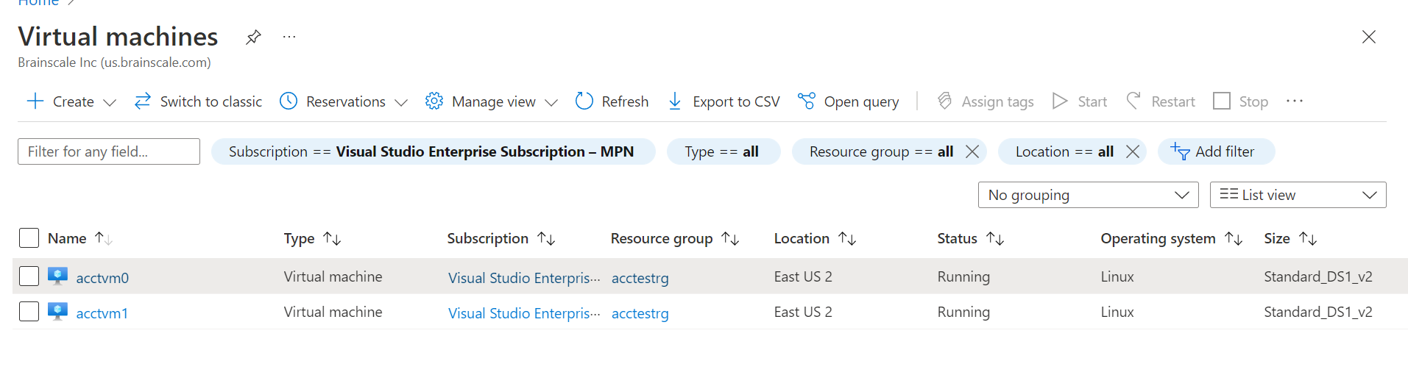

1. **Init,Plan and Apply Terraform Script**

Terraform init :-

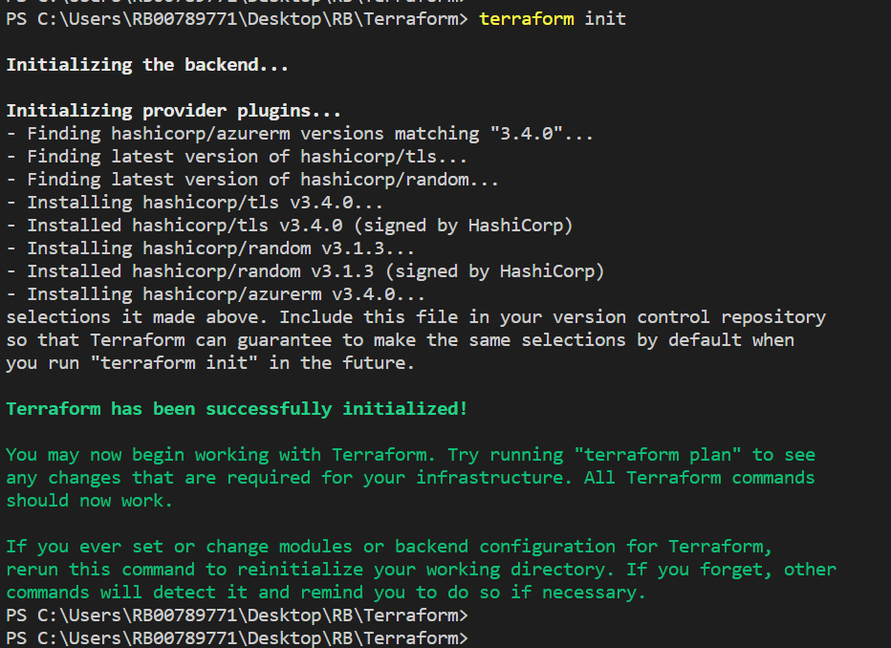

Terraform plan :-

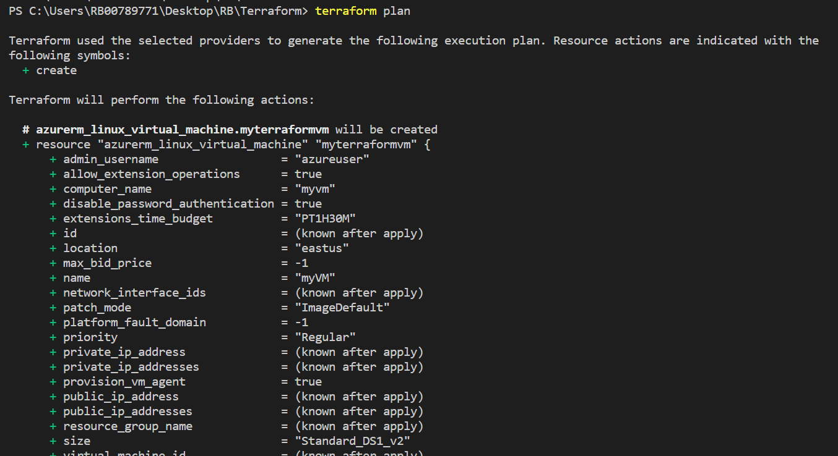

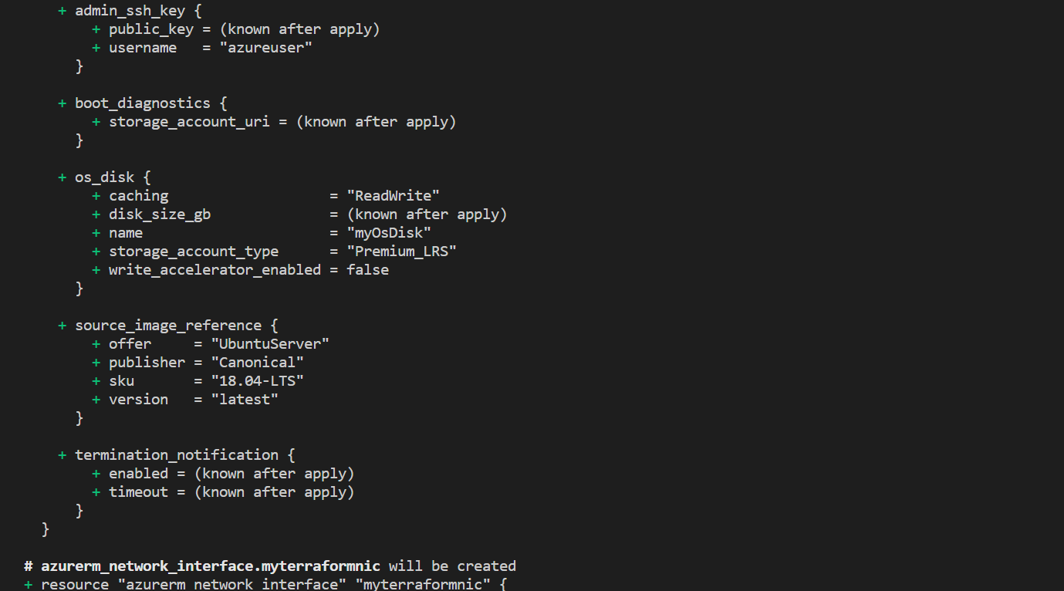

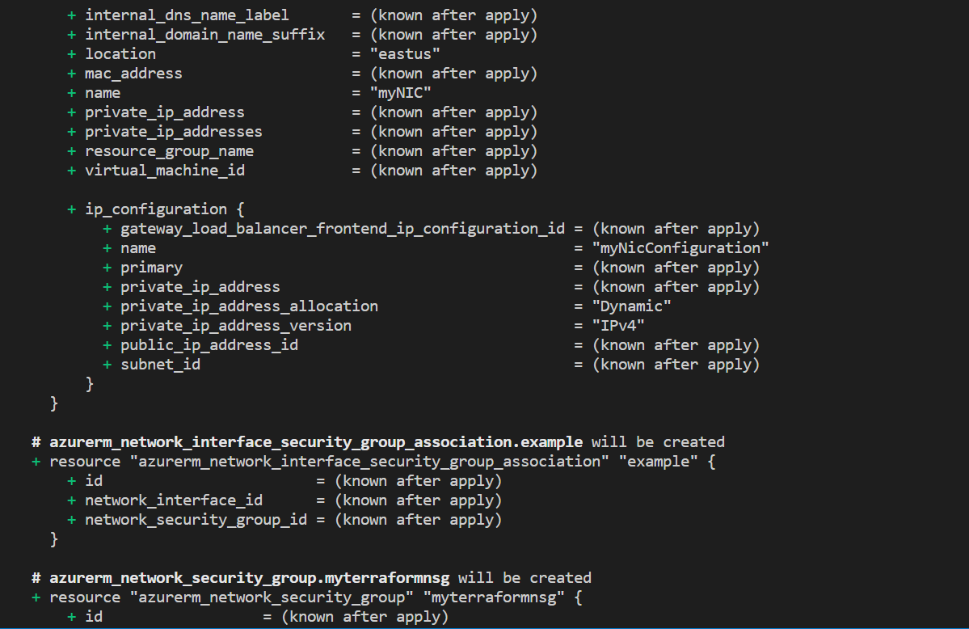

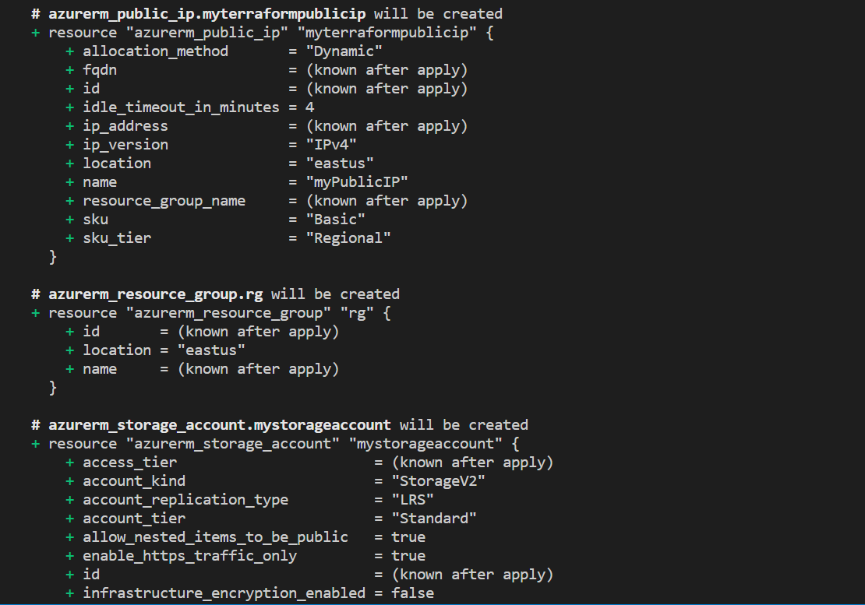

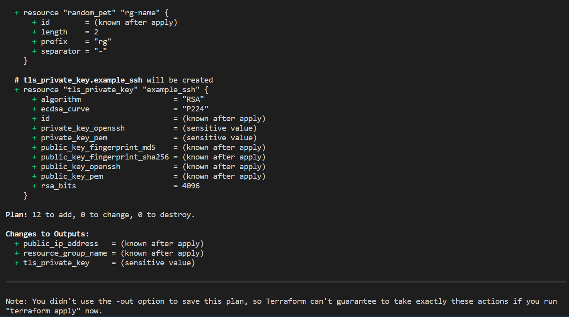

Terraform apply :-

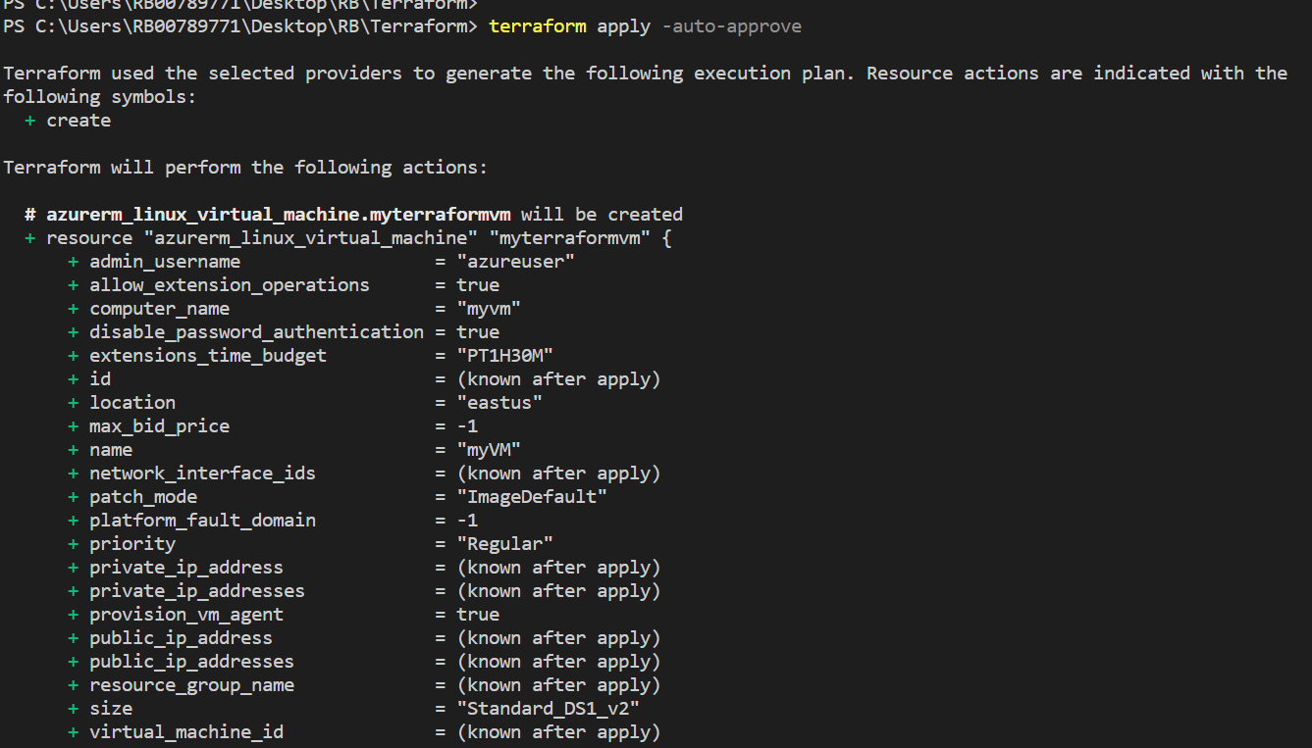

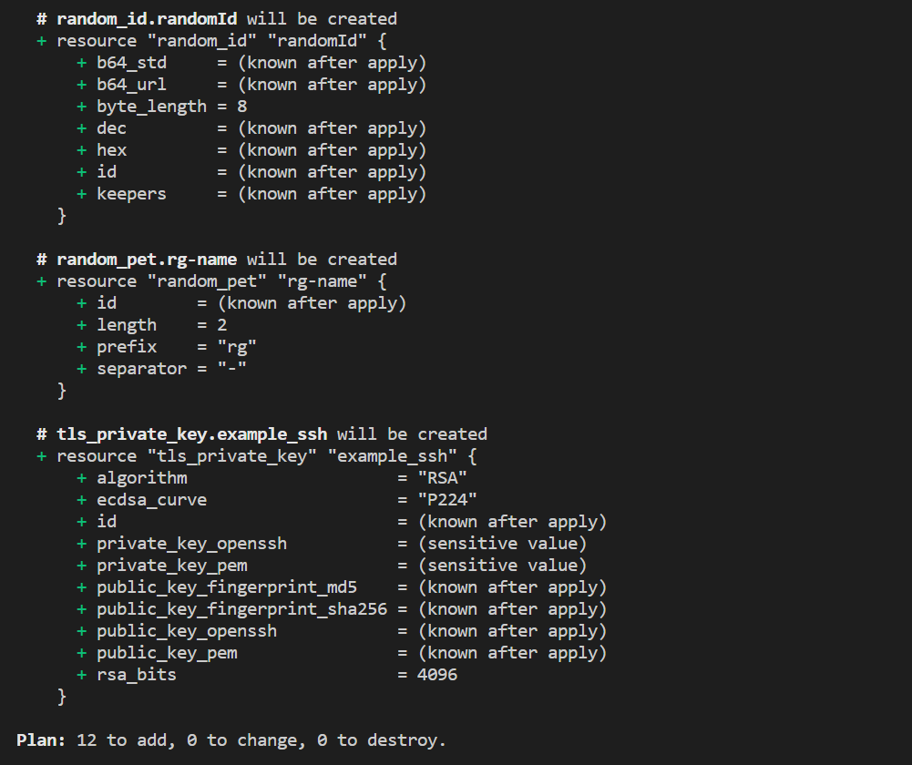

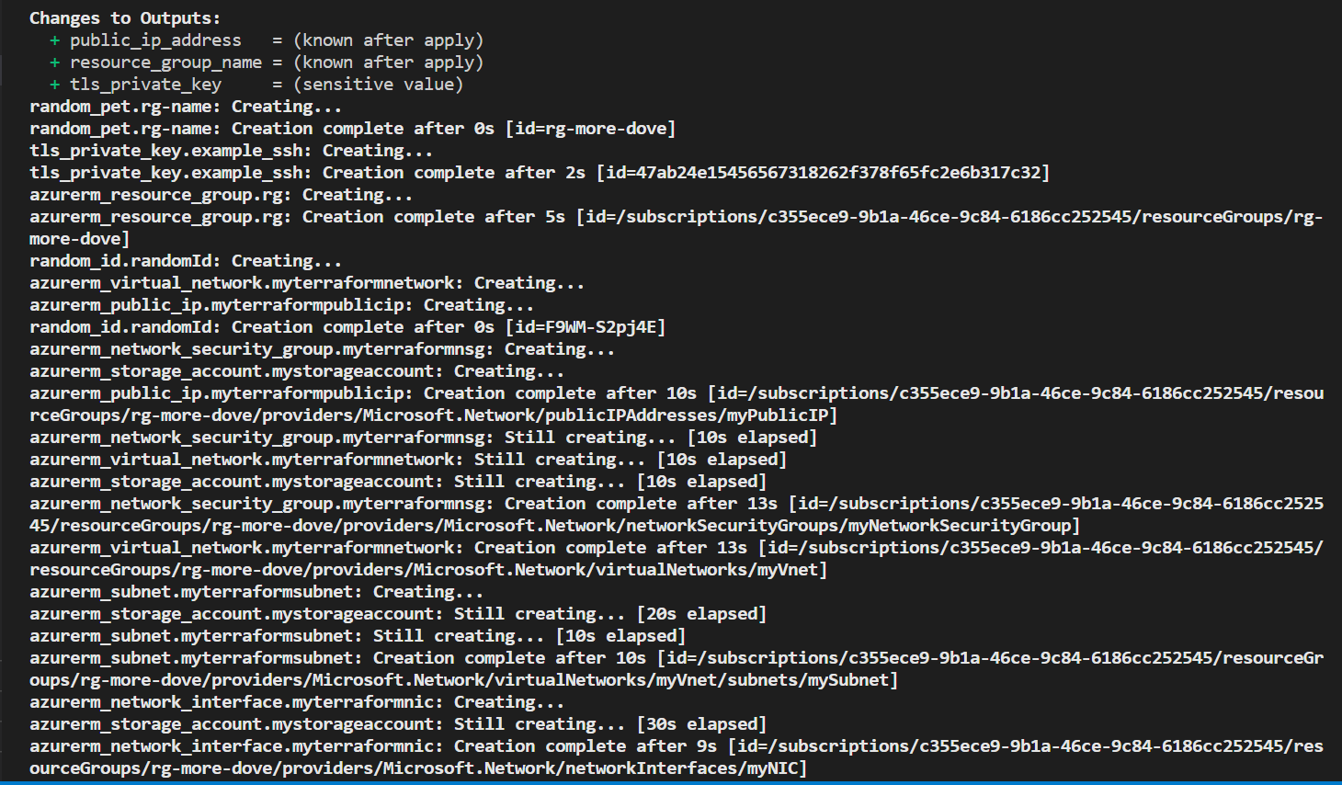

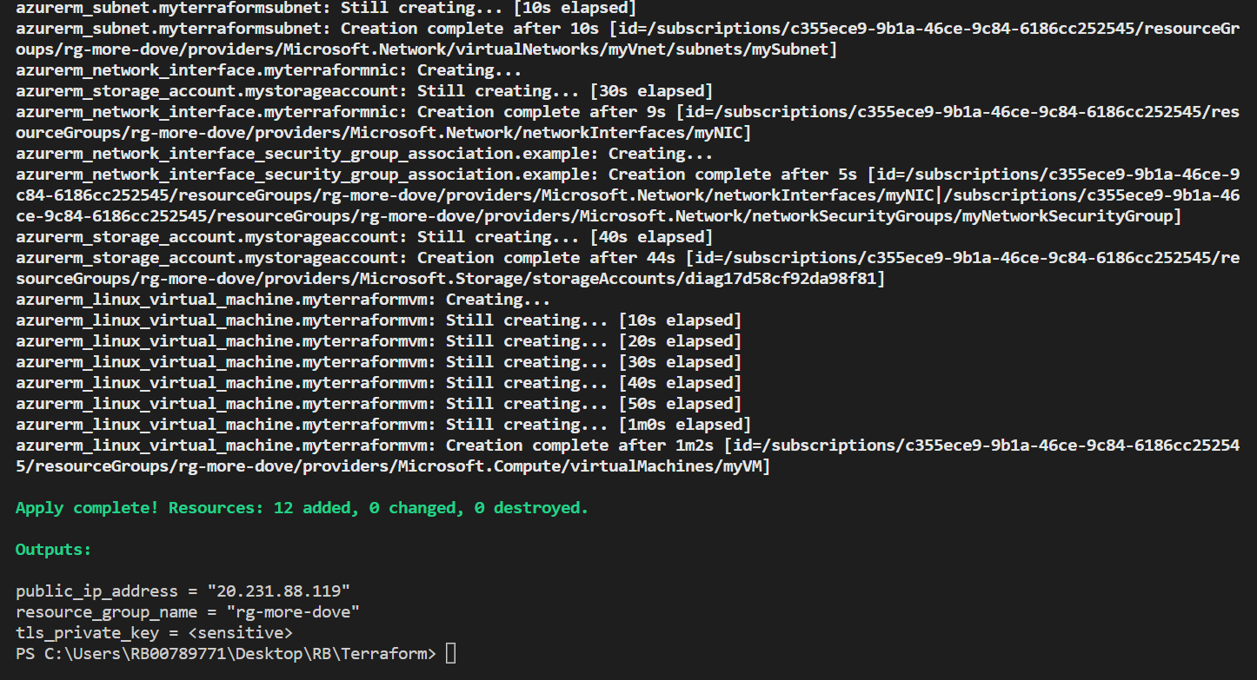

1. **Manually Start Jenkins and configure required Plug-ins and Master Slave Configuration**

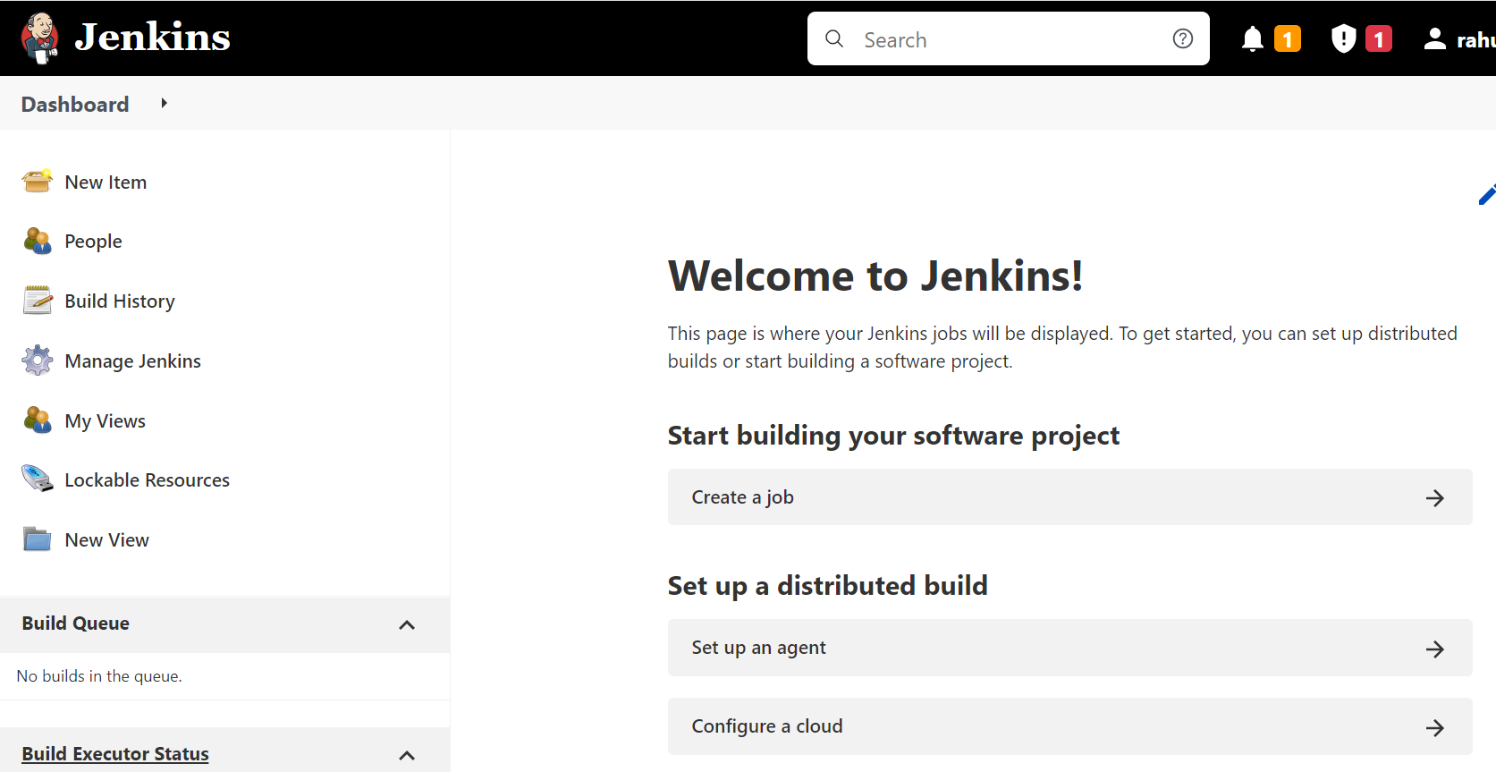

configure required Plug-ins :-

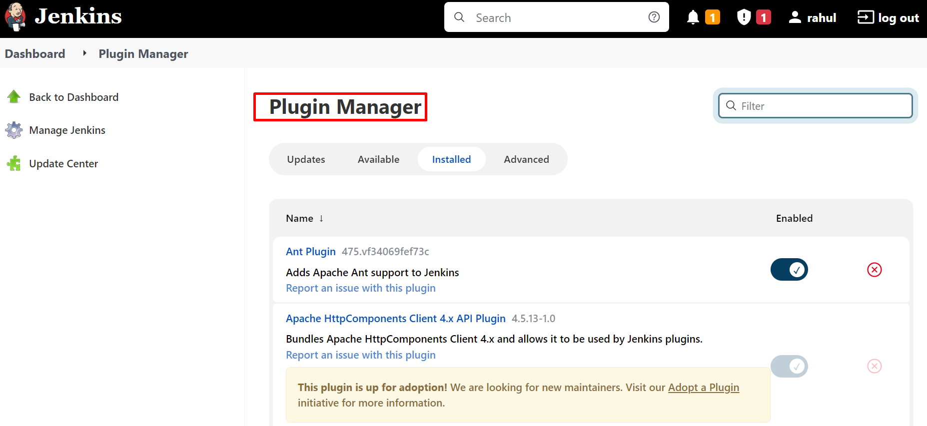

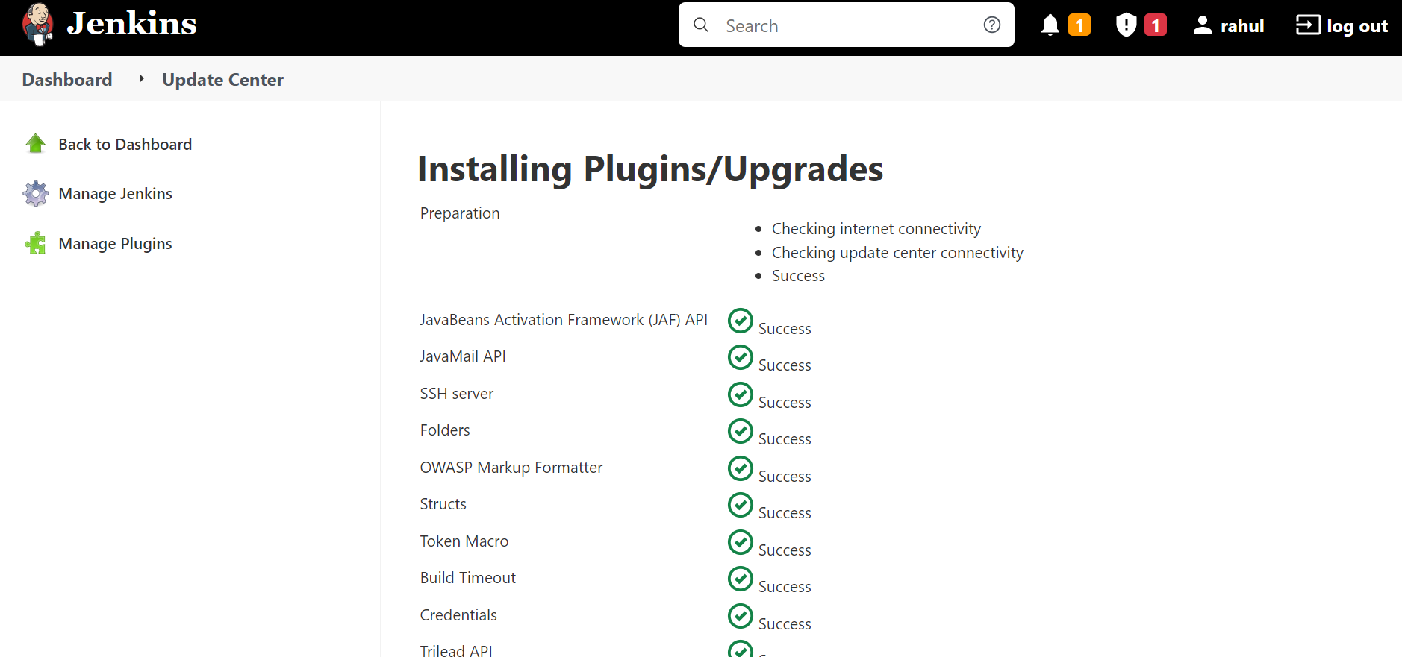

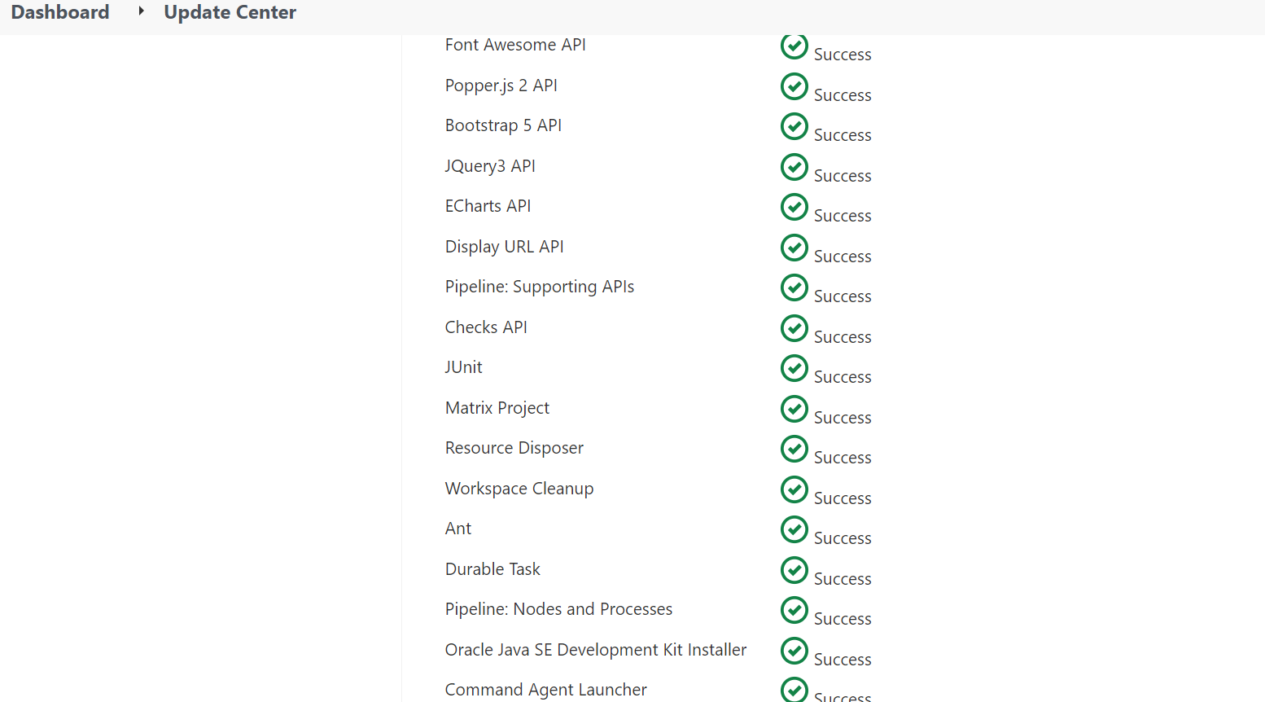

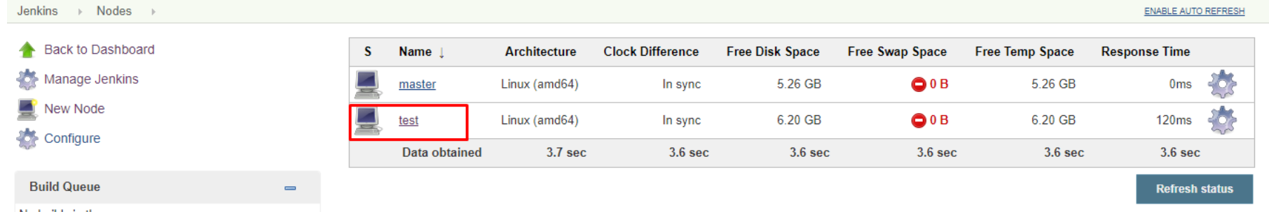

**Generate Service Principle for Terraform in Azure**