Your logo here

Network Assessment for

Client Name

Completed on date
Summary

This template is designed to help you create a custom report for your prospect or client, upon completion of their network assessment. It includes sample findings and recommendations for illustrative purposes, along with instructions (indicated with gray, italicized text) on where to get and export the data from within Auvik. Be sure to remove all instructions including these paragraphs, and update the sample findings, images, and recommendations before presenting to your prospect or client.

On this Summary page, you’ll want to provide a concise overview of their network issues and accompanying recommendations. This essentially serves as a “cheat sheet” and can help to differentiate your offering and facilitate conversations that get your prospect or client to the next step.

Contents

State of the Network 4
• Inventory 4
• Firmware / Software Versions 5
• Architecture 6
• Performance 7
• Misconfigurations 8
• Security 9
Remediation Actions Taken 10
Recommendations 10

State of the Network

[MSP Name] has taken a detailed inventory of your network to understand its current state. Included below are details on how your network is architected, how your network devices are connected, and an initial network performance review.

Inventory
How to get this information: Home Dashboard > Export. Open up the file and go to the Devices sheet. Select columns B-E. Summarize the quantity and types of devices, noting any dated gear or inconsistencies with makes and models. Point out possible deficiencies, but don’t provide a recommendation just yet.
In our initial network discovery, we found the following list of network devices. This list includes 2 firewalls, 10 switches, and 2 access points. All devices are Cisco enterprise-grade gear, some of which are older models.

Device Name | Type | Make & Model | IP Address(es)
Access-Point-1 | Access Point | Thin Access Point | 10.235.238.183
Access-Point-4 | Access Point | Thin Access Point | 10.235.238.222
Device@10.235.226.114 | Switch | Cisco | 10.235.226.114
Device@10.235.226.116 | Switch | Cisco | 10.235.226.116
Firewall-1 | Firewall | Cisco ASA 5515 | 1.1.1.2, 10.235.223.251, 10.235.226.251,
Firewall-2 | Firewall | Cisco ASA 5515  SAMPLE IMAGE | 2.2.2.1, 10.225.226.252, 10.254.255.253,
Layer-3-Switch-1 | Layer 3 Switch | Cisco Catalyst 3560 8PC | 10.225.235.244
Layer-3-Switch-2 | Layer 3 Switch | Cisco Catalyst 3560 8PC | 10.235.235.221
Layer-3-Switch-3 | Layer 3 Switch | Cisco Catalyst 3560 8PC | 10.235.235.242
Layer-3-Switch-4 | Layer 3 Switch | Cisco Catalyst 3560 8PC | 10.235.235.230
Switch-1 | Switch | Cisco Catalyst 2960 24PC | 10.235.235.239
Switch-10 | Switch | Cisco Catalyst 3700 series | 10.225.165.254, 10.225.226.254,
Switch-11 | Switch | Cisco Catalyst 2900 series | 10.235.235.236
Switch-12 | Switch | Cisco Catalyst 2960 24PC | 10.235.235.234

Firmware / Software Versions
How to get this information: Home Dashboard > Export. Open the file and go to the Devices sheet. Select columns B, H, I, and J. Summarize their standardization of firmware, noting any inconsistencies and dated versions. Point out possible deficiencies, but don’t provide a recommendation just yet.
The majority of these devices are Cisco and have an iOS version of 12.2x, as detailed below. The current firmware version supported on these devices is 12.2z.

Device Name | Software Version | Serial Number | Firmware Version
Access-Point-1 | Unknown | Unknown | Unknown
Access-Point-4 | Unknown | Unknown | Unknown
Device@10.235.226.114 | Unknown | Unknown | Unknown
Device@10.235.226.116 | Unknown | Unknown | Unknown
Firewall-1 | Unknown | Unknown | Unknown
Firewall-2 | Unknown | Unknown  SAMPLE IMAGE | Unknown
Layer-3-Switch-1 | 12.2(35)SE5 | FOC1412V3R7 | 12.2(35)SE5
Layer-3-Switch-2 | 12.2(50)SE5 | FOC1509V22D | 12.2(50)SE5
Layer-3-Switch-3 | 12.2(35)SE5 | FOC1323V46H | 12.2(35)SE5
Layer-3-Switch-4 | 12.2(35)SE5 | FOC1323V41D | 12.2(35)SE5
Switch-1 | 12.2(44)SE6 | FOC1321W7DY | 12.2(44)SE6
Switch-10 | 15.0(1)SE2 | FDO1611P12U | 15.0(1)SE2
Switch-11 | 12.2(55)SE5 | FOC1650Y213 | 12.2(55)SE5
Switch-12 | 12.2(44)SE6 | FOC1322W02V | 12.2(44)SE6

Architecture
How to get this information: Export your choice of map from the main dashboard. We like the Network Elements Only view but you may want to show other important areas of the network, depending on the prospect or client and their environment.

Below is a map illustrating how your network is physically connected. Note that there are High Availability (HA) firewalls at the perimeter, along with a core switch located at Switch-16. Your access layer consists of approximately 20 switches, some of which are four layers deep. There are two wireless access points, both connected to switch-24 covering <xyz> areas of your building.
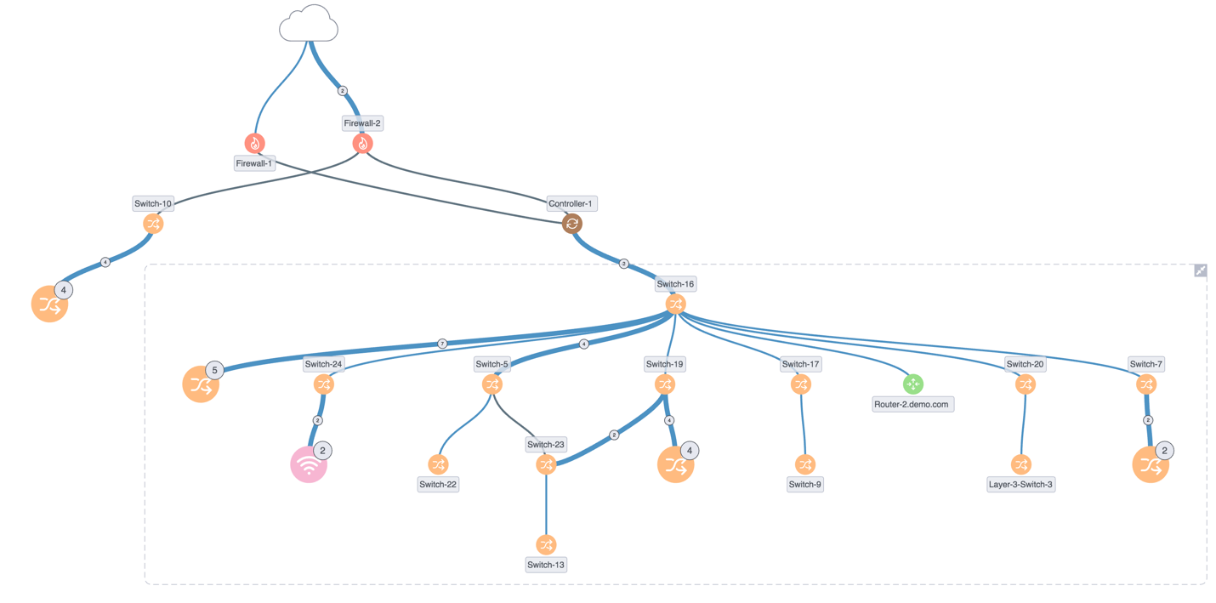

SAMPLE IMAGE

You could highlight one or more important connections, if relevant.

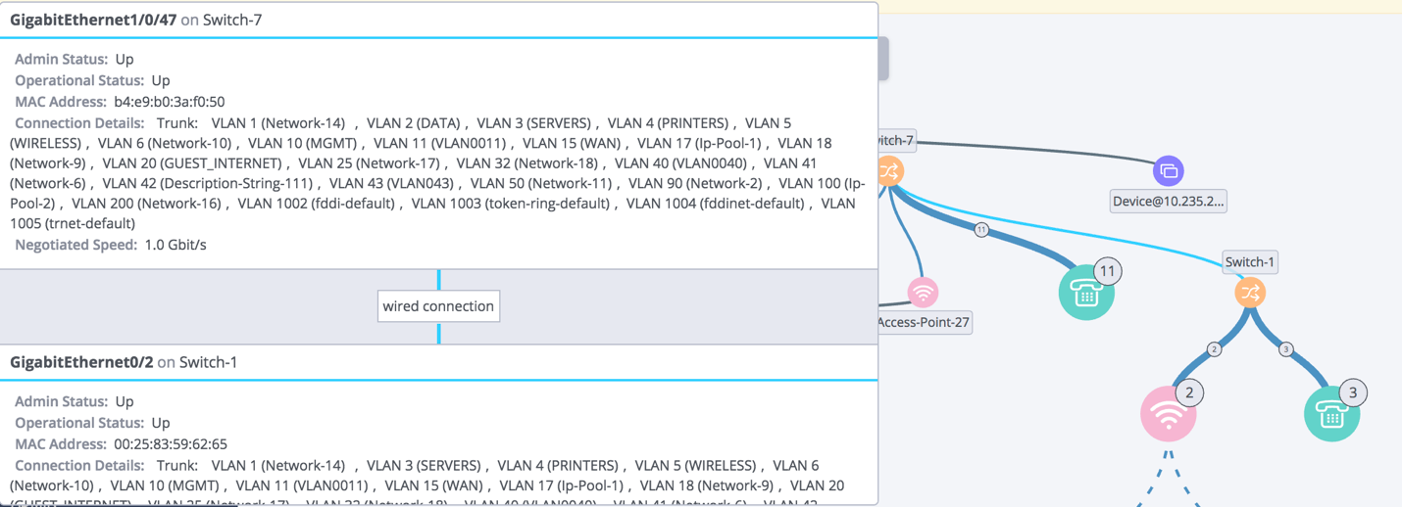
SAMPLE IMAGE

Performance

Throughout the evaluation period, we observed the following:

Internet Utilization
How to get this information: Go to Documentation > Reports > Network Device Utilization report. Set the calendar view to Past Week. Screenshot the internet utilization section and summarize their bandwidth utilization, noting any peaks and how their average compares to their total available bandwidth. Point out possible deficiencies, but don’t provide a recommendation just yet.

Utilization of the primary firewall peaked during business days at XX Mbit/s, which is
YY% of your dedicated bandwidth. Note that your average utilization was much less
at ZZ Mbit/s overall.

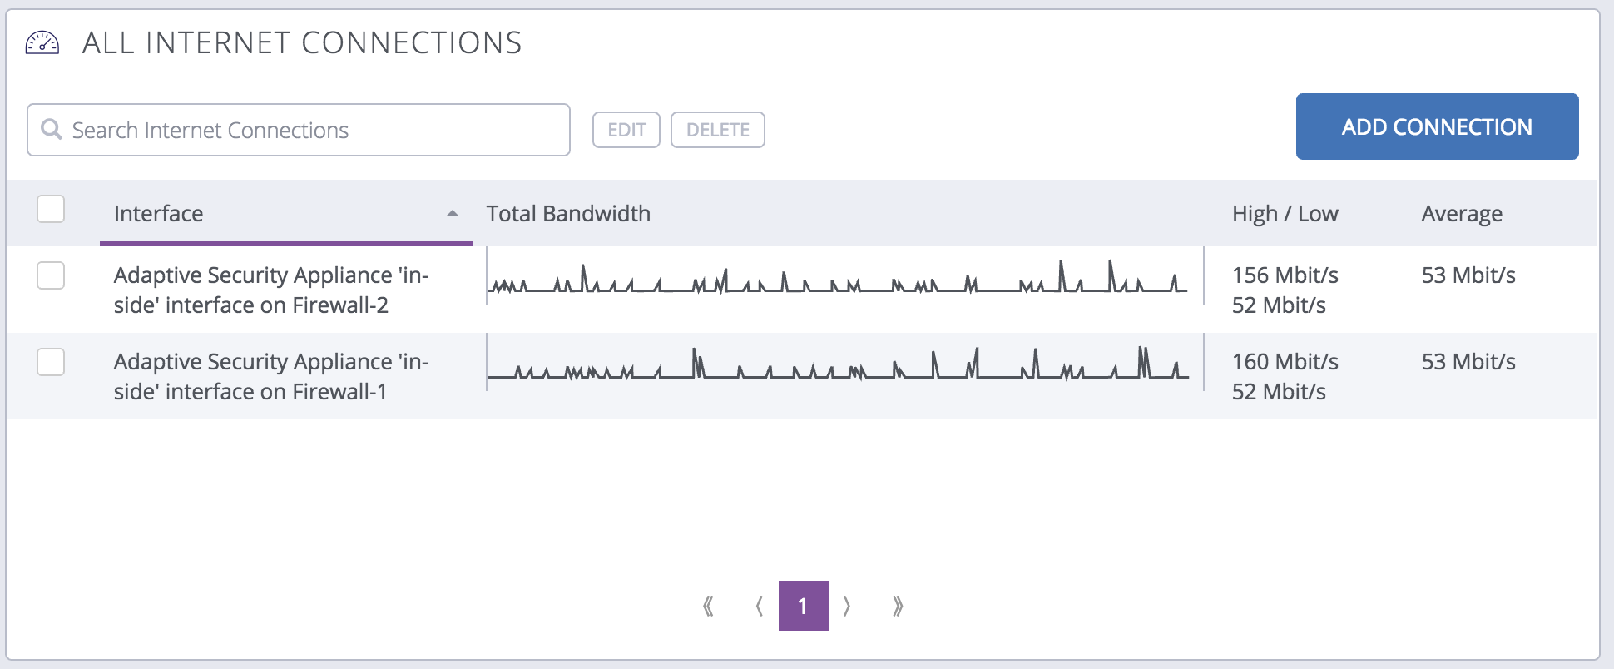

SAMPLE IMAGE

Network Device Utilization
How to get this information: Go to Documentation > Reports > Network Device Utilization report. Set the calendar view to Past Week. Filter for network elements and take a screenshot. Or export the report, go to the Network Devices tab, and pull the relevant details. Summarize the uptime percentage, what the throughput is compared to the total available throughput on the devices, and the device health metrics (i.e., CPU, storage, and memory utilization). Point out possible deficiencies, but don’t provide a recommendation just yet.

All network devices had 100% uptime during the evaluation. Switch 3 is showing consistently high memory utilization, while the remaining network devices show normal CPU, memory and storage utilization.
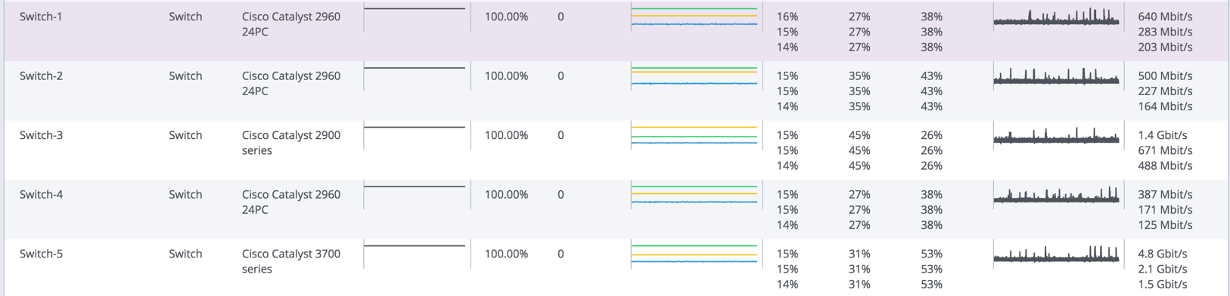

SAMPLE IMAGE

Misconfigurations
How to get this information: Review informational alerts over the past week (or for whatever interval the collector has been running). Summarize any informational alerts that Auvik has triggered, and what the potential impact is to the client. Point out possible deficiencies, but don’t provide a recommendation just yet.
Three misconfigurations were immediately observed during the evaluation:

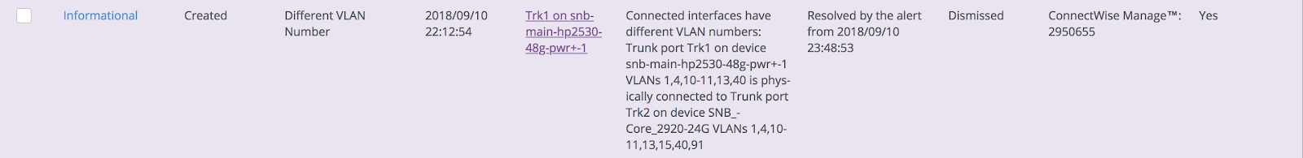
SAMPLE IMAGE

This misconfiguration is indicating that VLAN 91 is not configured on port Trk1 on the core switch. It was observed that this VLAN is actively in use. Due to this misconfiguration, some devices that are connected on this VLAN may not be able to communicate properly across the network.

Security

SNMP Credentials
How to get this information: Go to Discovery > Manage Credentials > SNMP Credentials and take a screenshot. Summarize which credentials are in use across the environment. Point out any default credentials or credential reuse that may impact the security posture of the network, but don’t provide a recommendation just yet.

All observed network devices are configured with SNMP. Currently, all are set to use SNMP version 2 with the default community string “private” and a custom community string set as <commString>.

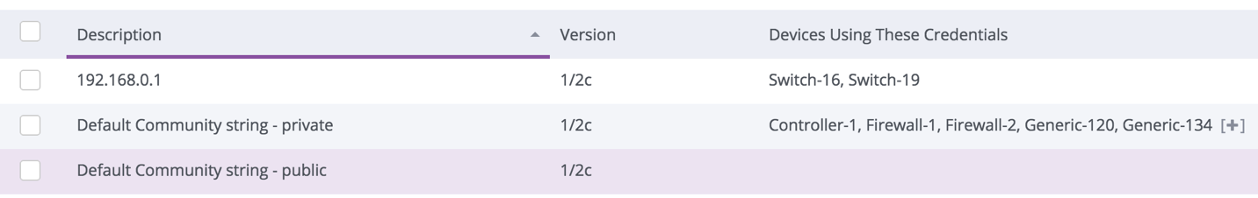
SAMPLE IMAGE

Passwords
How to get this information: Go to Discovery > Manage Credentials > Login Credentials and take a screenshot. Summarize which credentials are in use across the environment. Point out any default credentials or credential reuse that may impact the security posture of the network, but don’t provide a recommendation just yet.

We used the credentials you gave us to access and configure the network devices. We observed that no devices have default credentials such as “admin/admin” and “cisco/cisco”.

All network devices are using the same Username-2 with the same password, as
shown below.
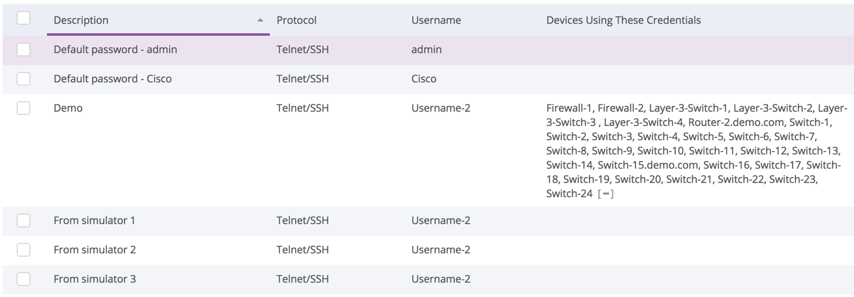

SAMPLE IMAGE

Remediation Actions Taken
List any actions you’ve already taken to remedy anything from the initial observations.

- VLAN mismatch updated on switch XYZ.
- Interface was changed from a hard coded 100 Mbit/s to an auto-negotiate and is now running at 1 Gbit/s.

Recommendations
List here anything you recommend as a result of this report that hasn't been
immediately resolved.

High
Priority
Medium
Priority
Low
Priority

Severity | Recommendation
 | Update SNMP credentials on network devices X, Y, and Z to a non-standard community string.
 | Update device credentials on device M to use something other than the default “admin/admin”.
 | Update device credentials on devices A, B, and C to use a non-shared, randomized credential.
Upgrade firmware versions on devices X, Y, and Z. Currently running version 12.02 and have a version 123.123 available that fixes the following:
- Really cool stuff that the version fixes
 | A low priority recommendation.

Your logo here

MSP name
MSP address
MSP phone number

http://www.yourdomain.com/

