FOR CIMB USE



FOR CIMB USE

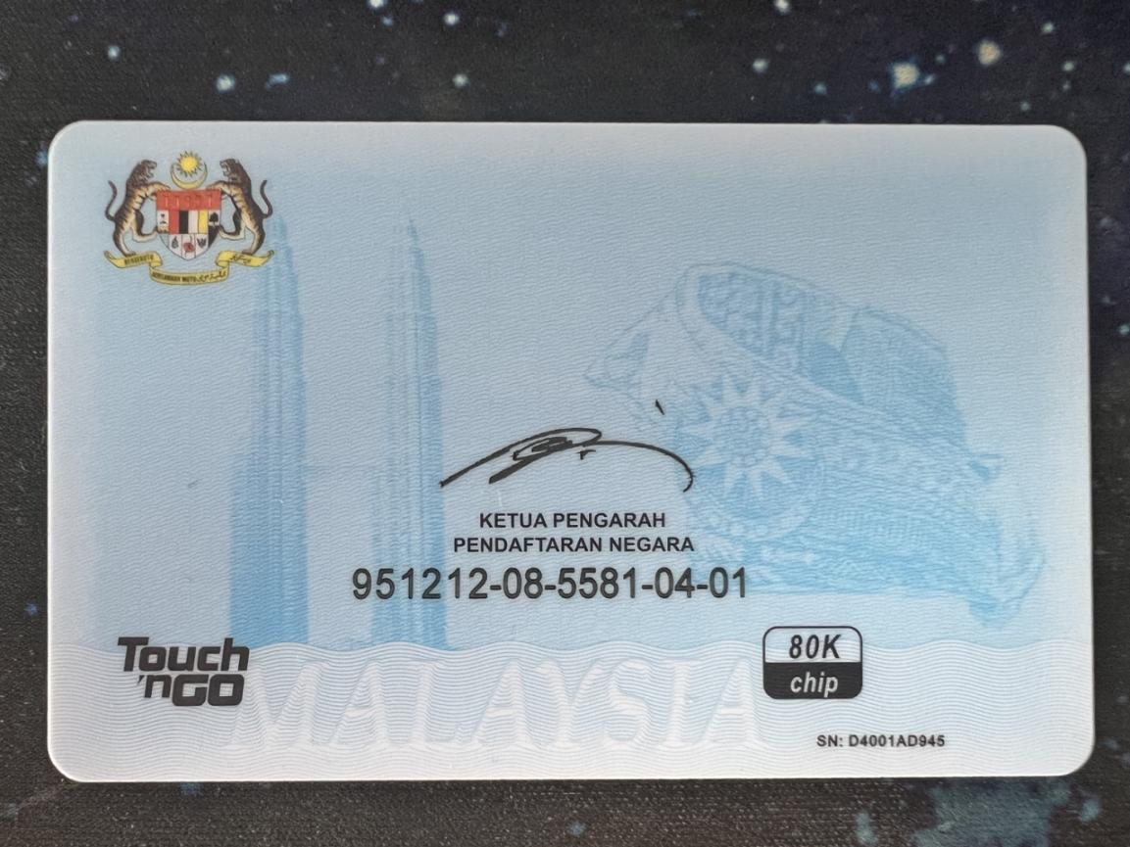

FOR CIMB USE

FOR CIMB USE