AURA: Autonomous Unsupervised Feature-Tracking for Real-Time Deep-Space Navigation
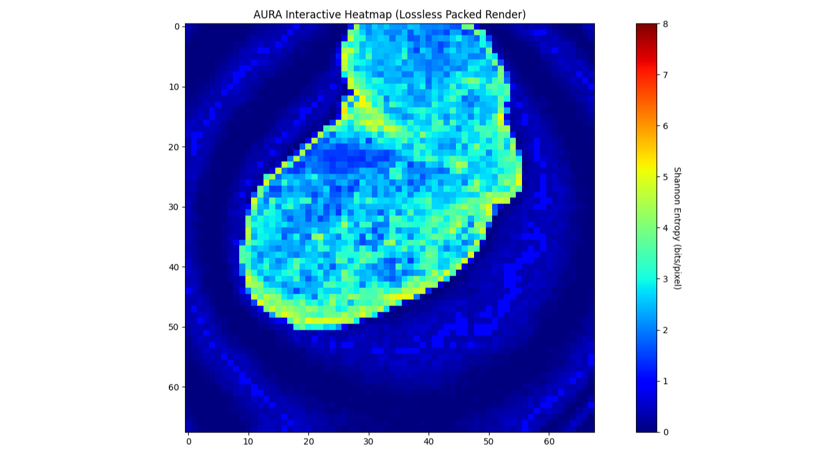
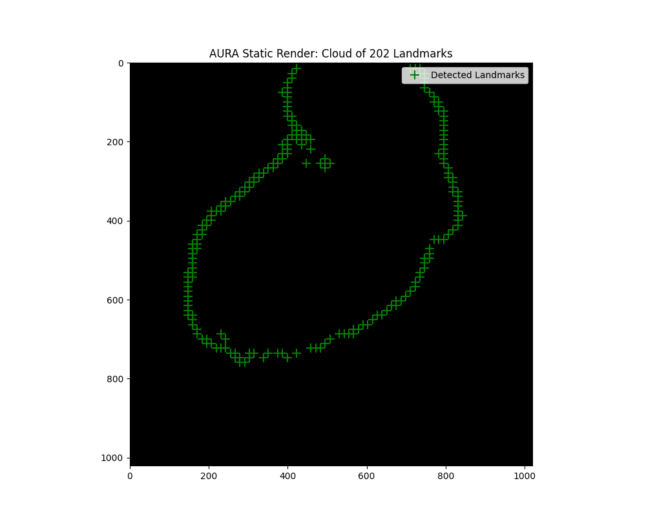
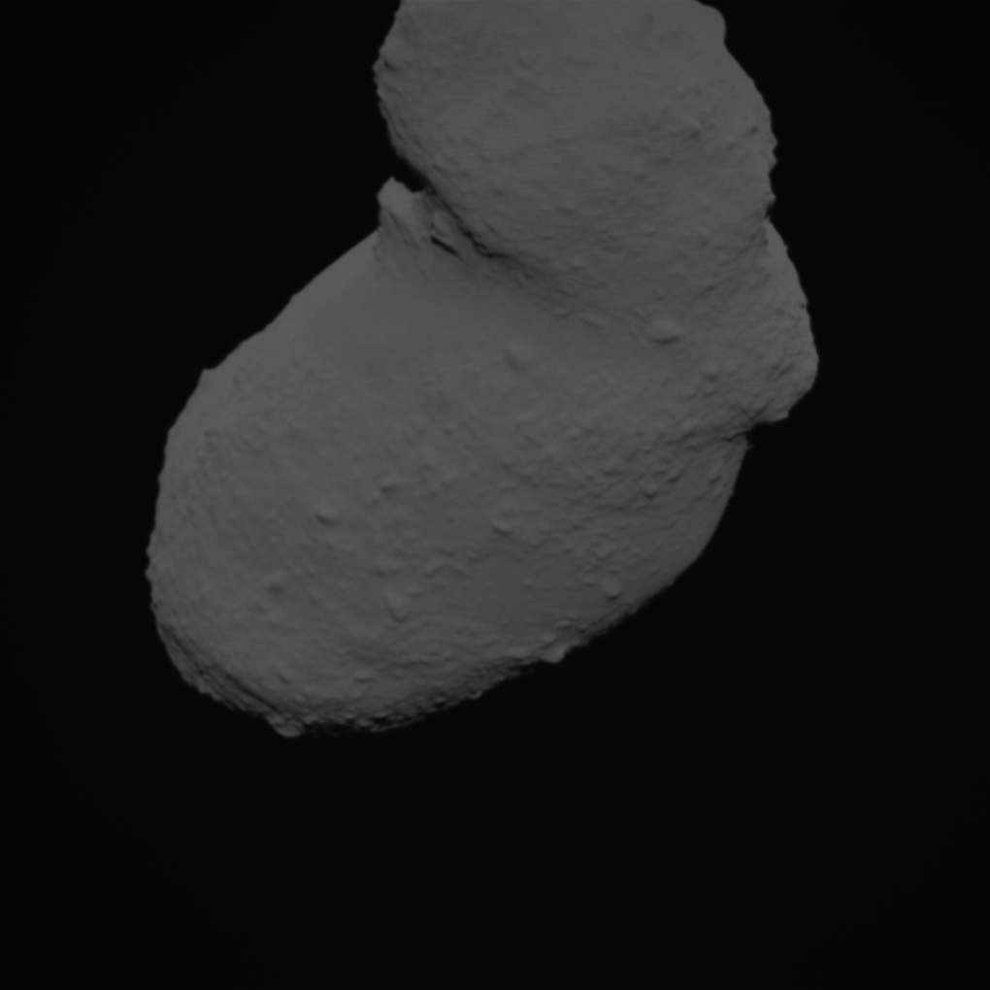
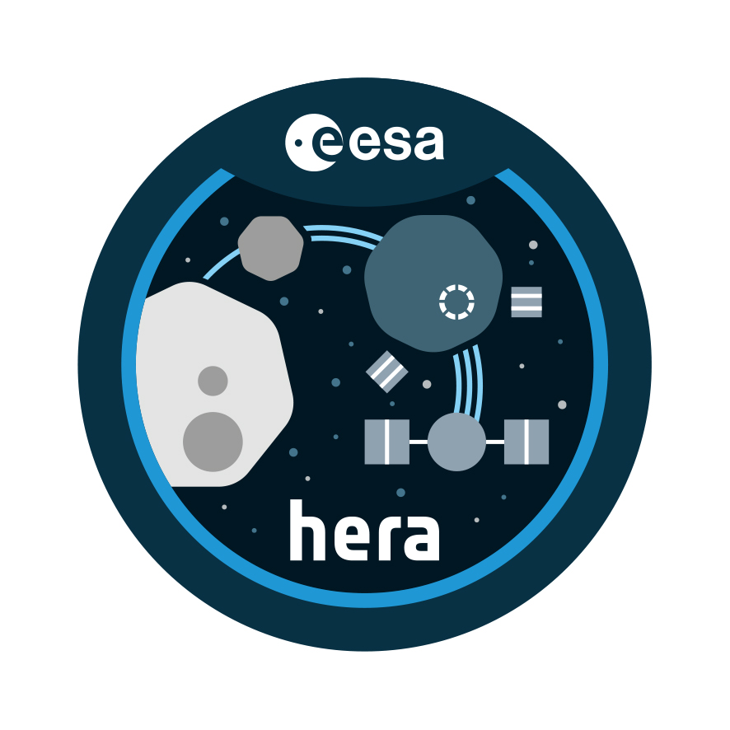
The image of the sky body was provided as part of the ESA program - The Open Space Innovation Platform (OSIP).
Who Am I?
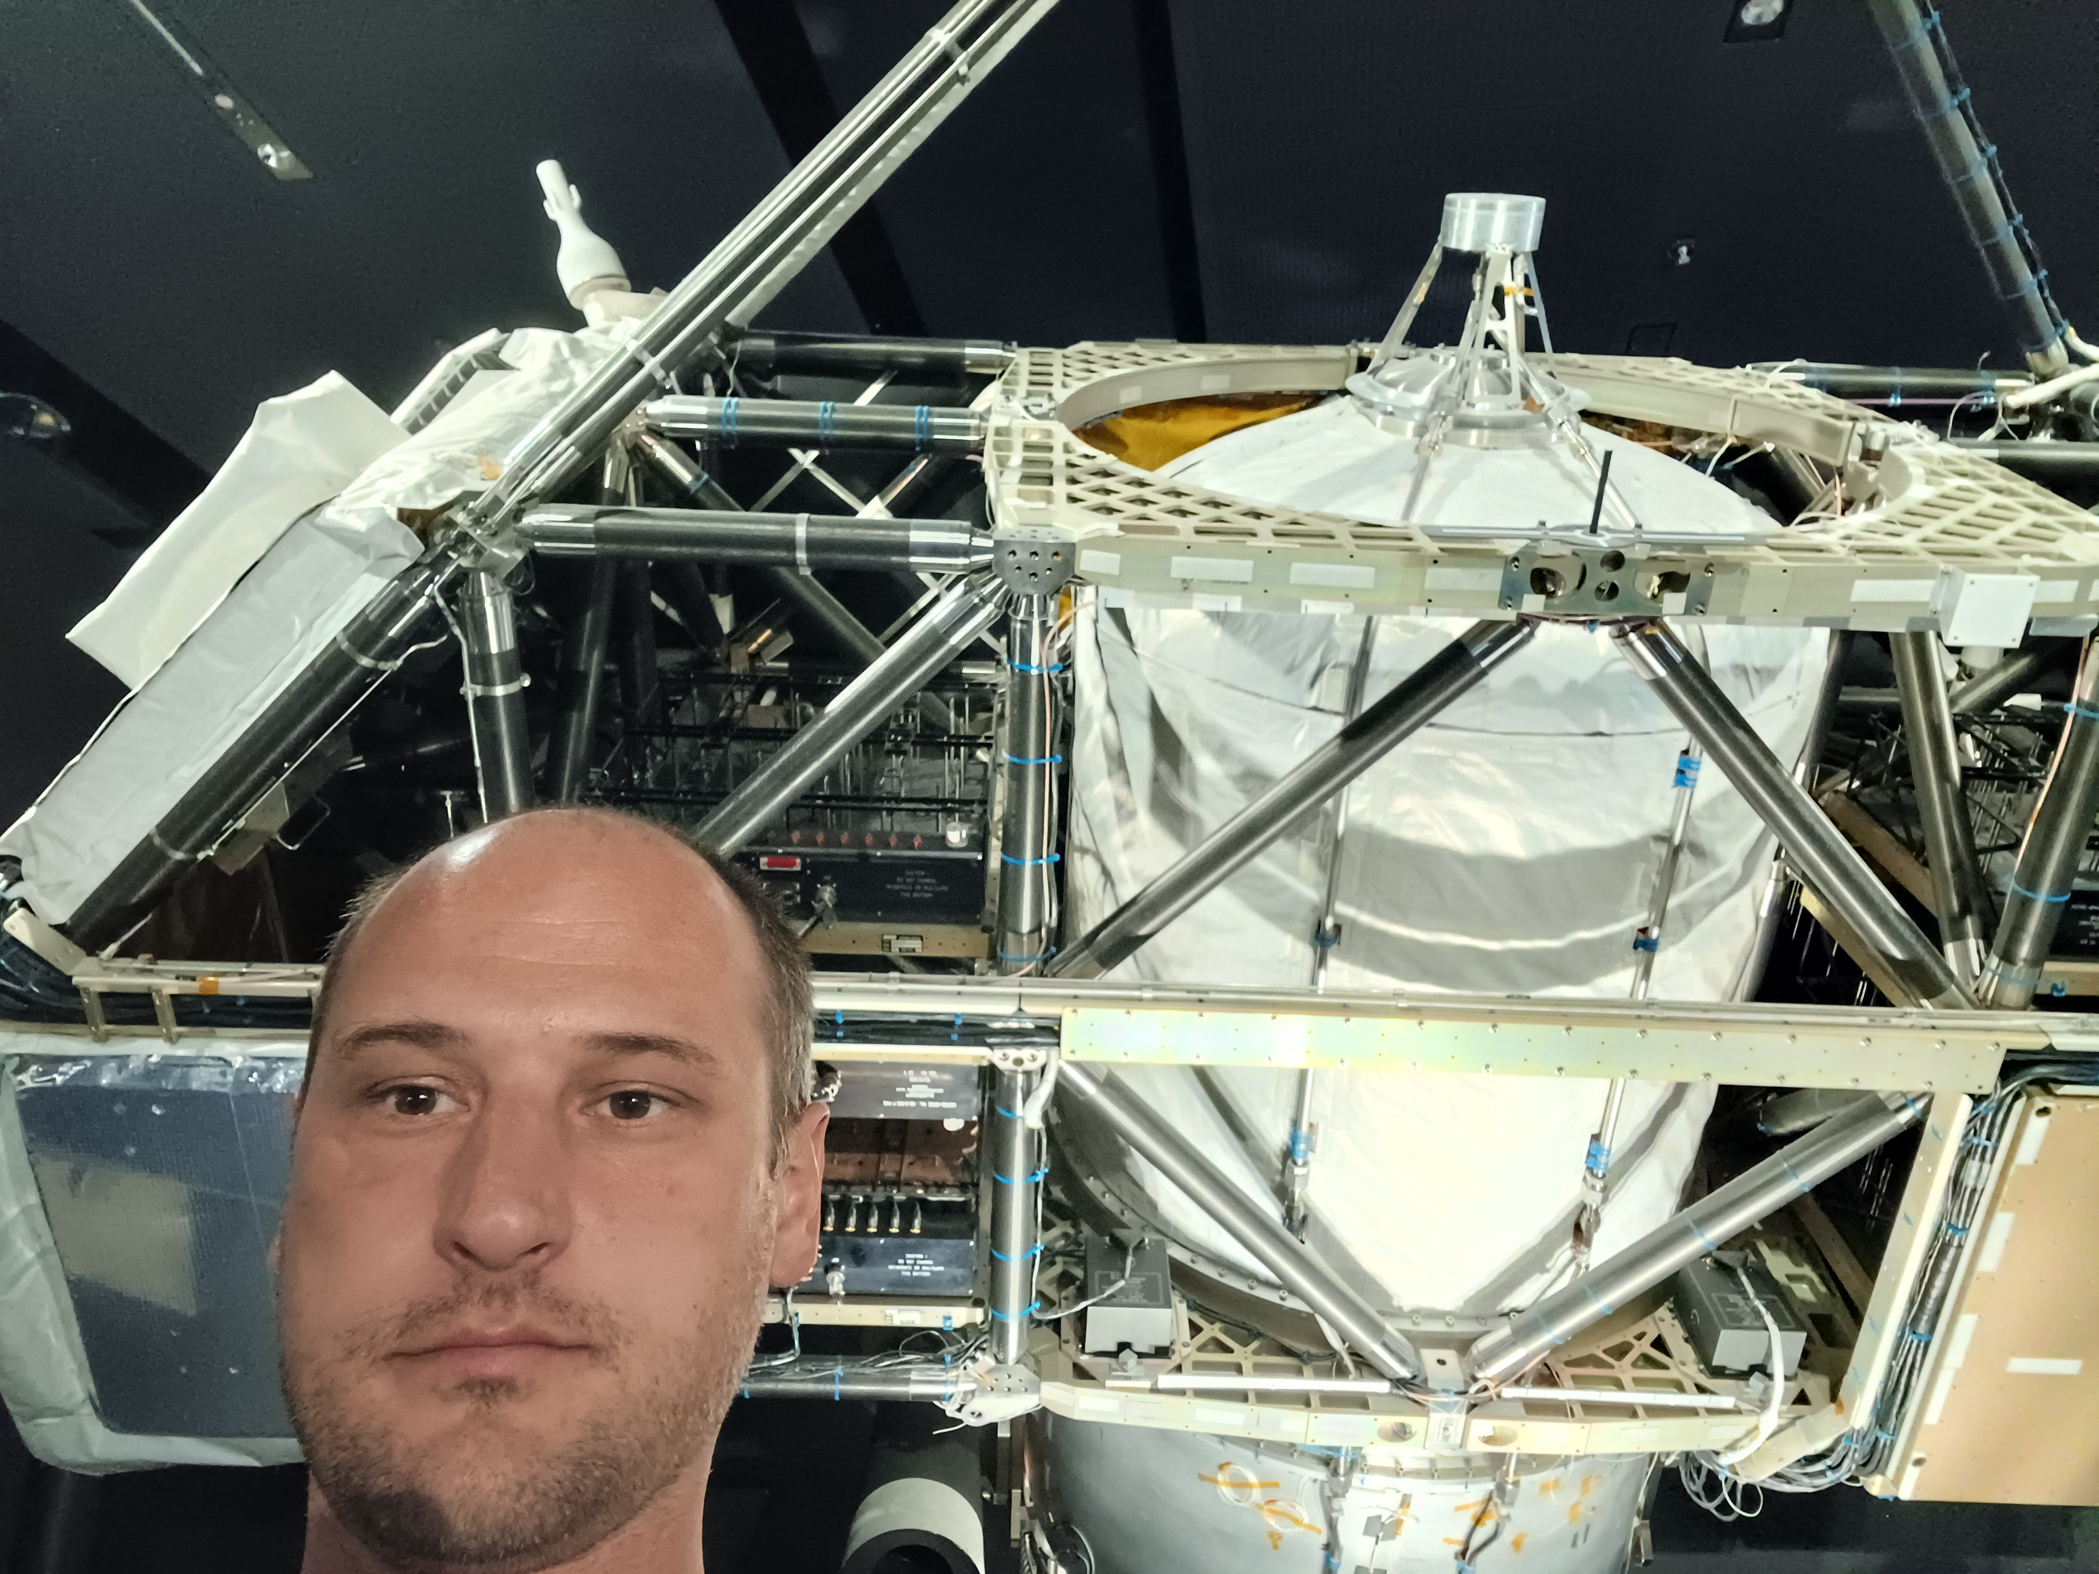
Serhii Trush Embedded Systems Engineer | Electronics Developer
- GitHub: https://github.com/techn0man1ac/
- LinkedIn: https://www.linkedin.com/in/techn0man1ac/
- YouTube: https://www.youtube.com/@Techn0man1ac

Education
- Computer Systems Engineer(Bachelor degree)
- Engineering background(Commercial / Industrial electronics)
I'm standing next to the CRISTA-SPAS at the Deutsches Museum.
- Electronics and embedded systems
- Software development

Experience
- 10+ years in electronics
- Embedded development
- Hardware design
- Software engineering

Origin of the Name “AURA”
The name was selected during an AI-assisted brainstorming process.
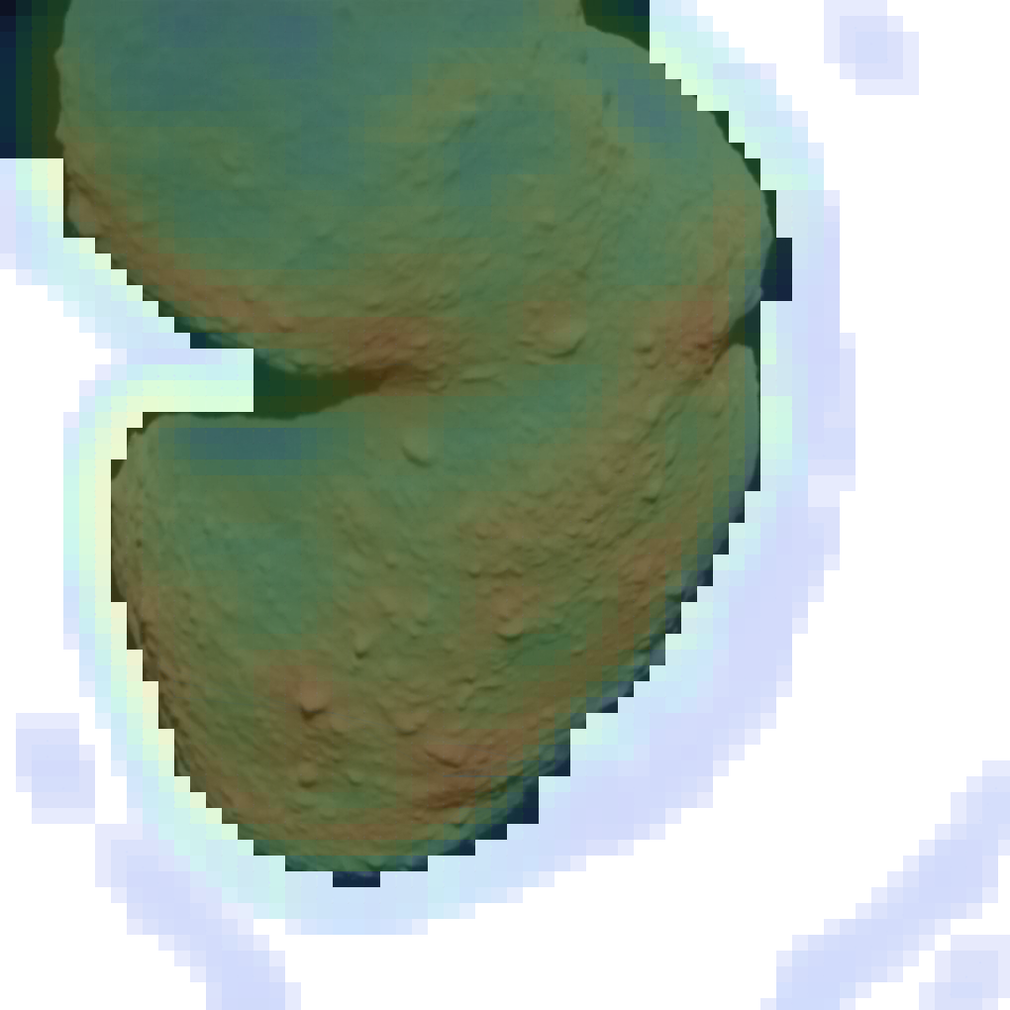
It resonated because it reflects the central idea of the project:
- Information awareness
- Detection of hidden structures
- Environmental perception
- Prioritization of meaningful information

Project Connection
AURA attempts to identify and prioritize meaningful information inside large sensor datasets.
Instead of treating all pixels equally, the system focuses on regions carrying the highest informational value.
Removing image blocks with low information

Interpretation
The term AURA can be viewed as the informational footprint of an observed environment.

Connection to the Project
AURA attempts to identify and prioritize meaningful information inside large sensor datasets.

Why Hera?

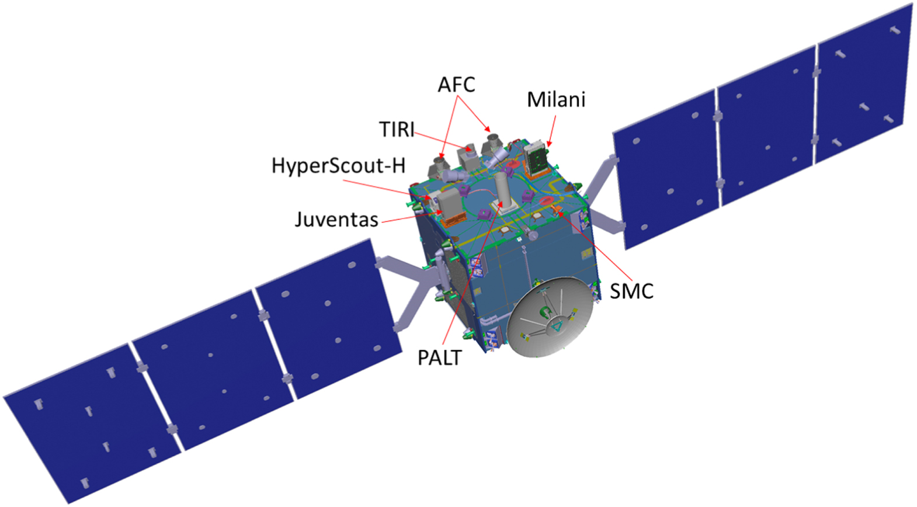
ESA Hera Mission
- Asteroid exploration
- Planetary defense
- Autonomous spacecraft operations
Hera follows the Open Science philosophy.
The mission encourages:
- Scientific collaboration
- Transparency
https://en.wikipedia.org/wiki/Hera_(space_mission)

- Publicly accessible research

Personal Motivation
AURA was inspired by challenges faced by deep-space missions such as Hera.

The Communication Problem
~1040 KBytes
~600 KBytes

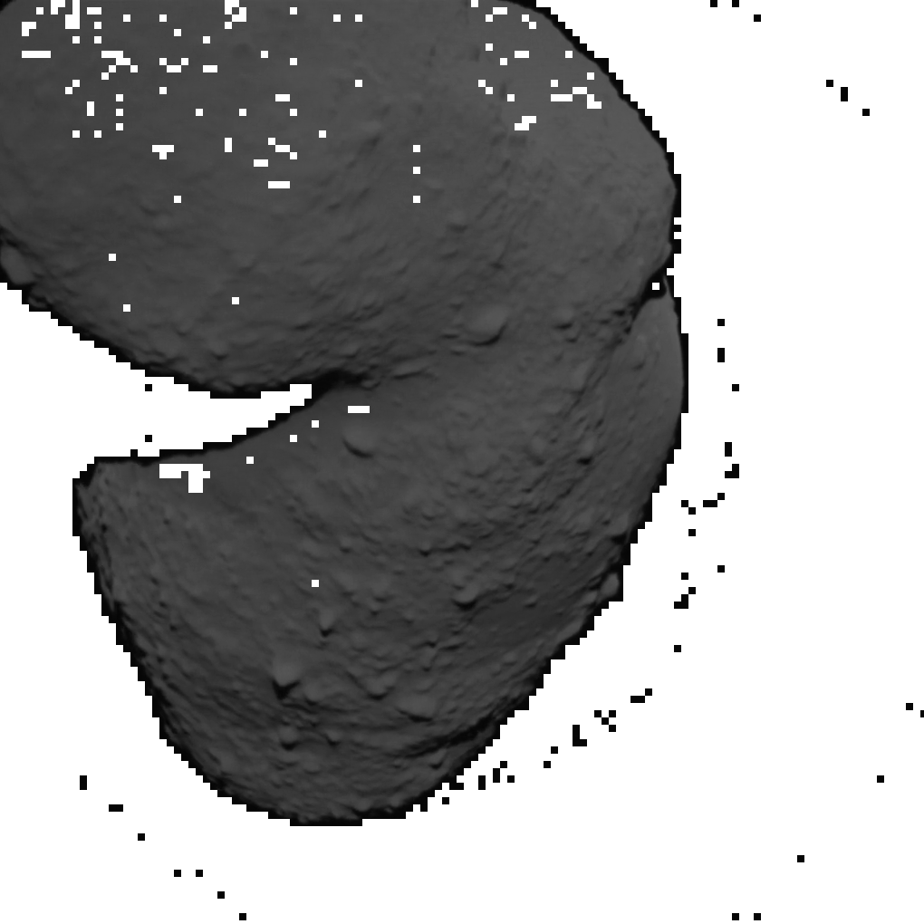
Deep Space Constraints
- Long communication delays
- Limited bandwidth
- Limited onboard computing resources
- Power constraints

Example
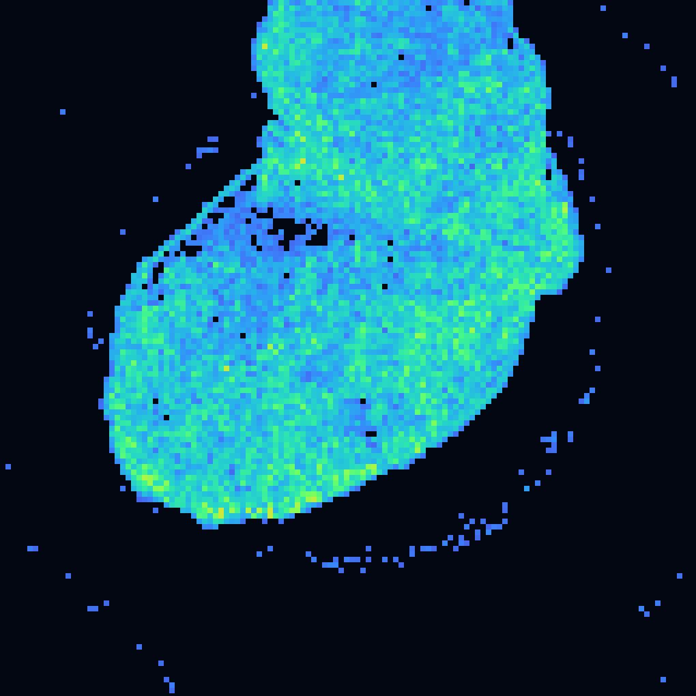
Transmitting a full image may require significantly more resources than transmitting a compact information summary.

Research Question
Can a spacecraft decide what information is worth transmitting before sending the full image?
~ 60 KBytes

Core Idea
Can pixels control everything? Can entropy take responsibility?
Not all pixels carry the same amount of information.

AURA Workflow

Cameras image → Information Analysis → Feature Point Cloud → Entropy Map → Decision → Data Transmission


AURA goal:
- Reduce unnecessary data transmission while preserving scientific value.

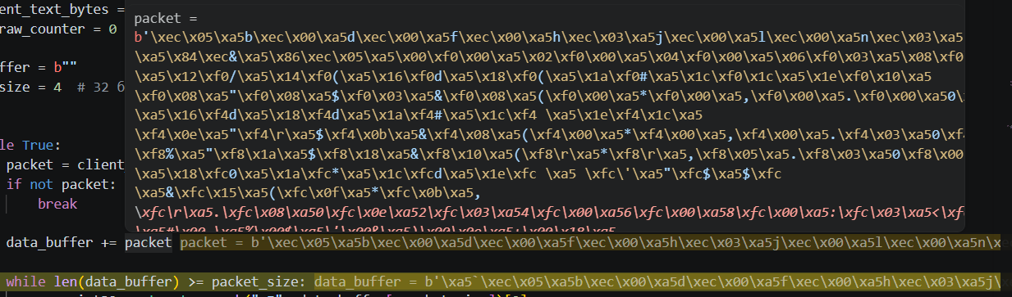
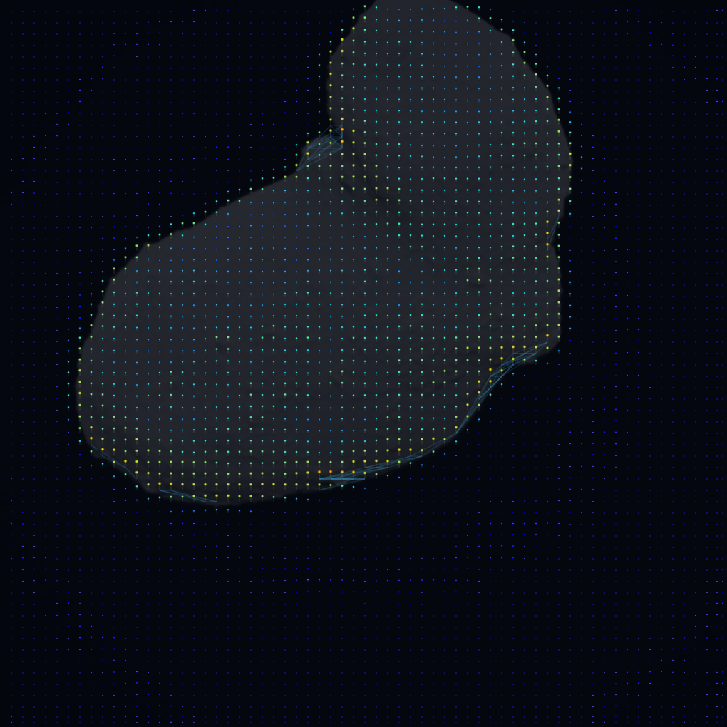
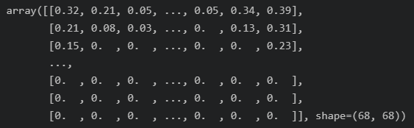
Next is space navigation?
Can entropy-derived representations support spacecraft perception and decision making?

Google AI Studio Sandbox
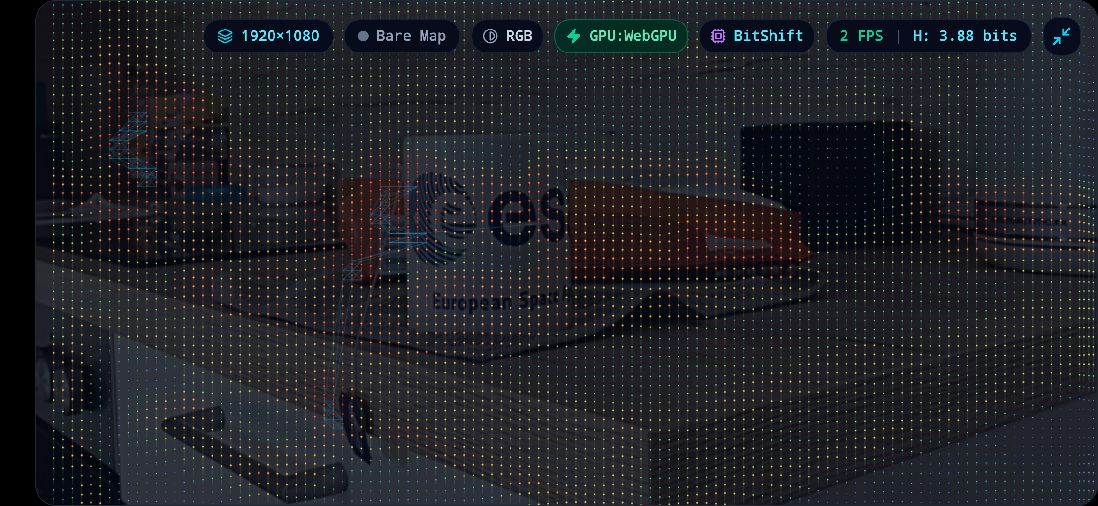
Purpose? | Why It Matters?
Fast experimentation environment for:  - Entropy visualization  - Feature extraction  - Point cloud generation  - Constellation generation  - Concept demonstration | Allows rapid iteration before implementing ideas on embedded hardware.  - Real-time entropy mapping  - Point cloud(Constellation visualization)  - Quick idea validation

Technical Details

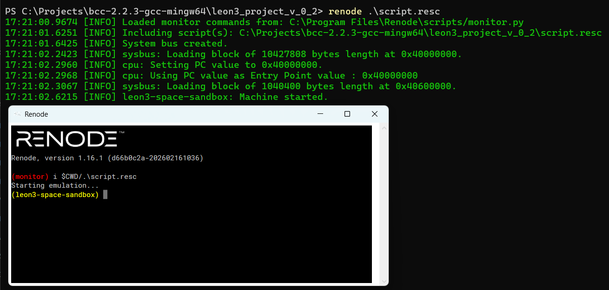
Image Processing
- Local entropy calculation
- Contrast maxima detection
- Sparse feature extraction

Embedded Optimizations
- Bit-wise operations
- Memory-aware design
- LEON3 compatibility
LEON3 CPU support in Renode

- Low computational overhead

Current Status
- Emulator implementation
- Functional prototype
- Experimental visualizations

Development Road map(up to TRL7)

Today TRL4
Concept → Software prototype → LEON3 emulation

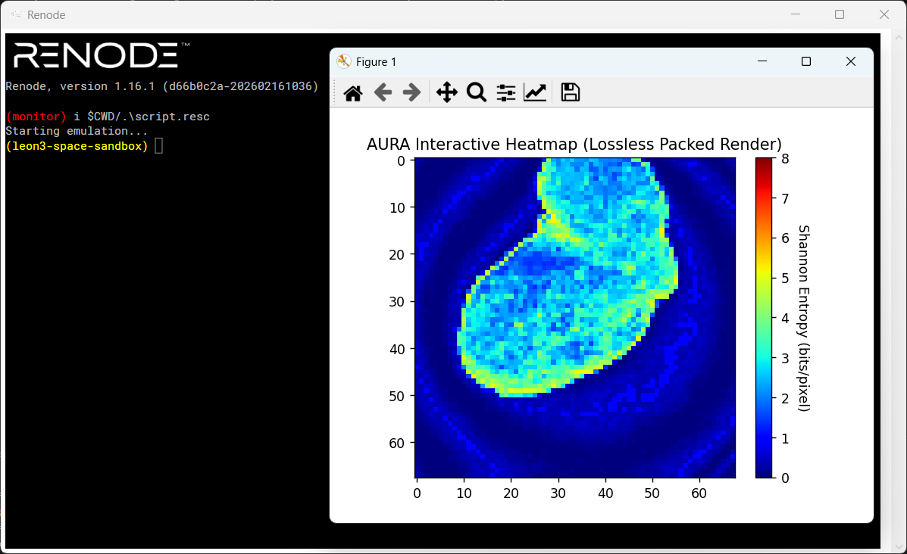
Next Steps
- Hardware validation
- Radiation-tolerant platforms
- Integration testing
- Mission-relevant datasets
Research Branches
- Progressive telemetry
- Information filtering
- Visual navigation
- Joint entropy sensor fusion

Long-Term Goal
TRL progression toward operational space systems.

Why a PhD?

Scientific Questions
Can entropy-based representations:
- Can information-theoretic representations improve autonomous spacecraft operations?
- Reduce bandwidth requirements?
- Improve onboard decision making?
- Support visual navigation?
- Enable multi-sensor information fusion?

Research Potential
AURA currently opens several research branches:
- Data prioritization
- Information compression
- Visual navigation
- Joint entropy across sensors

Beyond Technology

Personal Goal
Build a long-term academic and professional future in Germany.

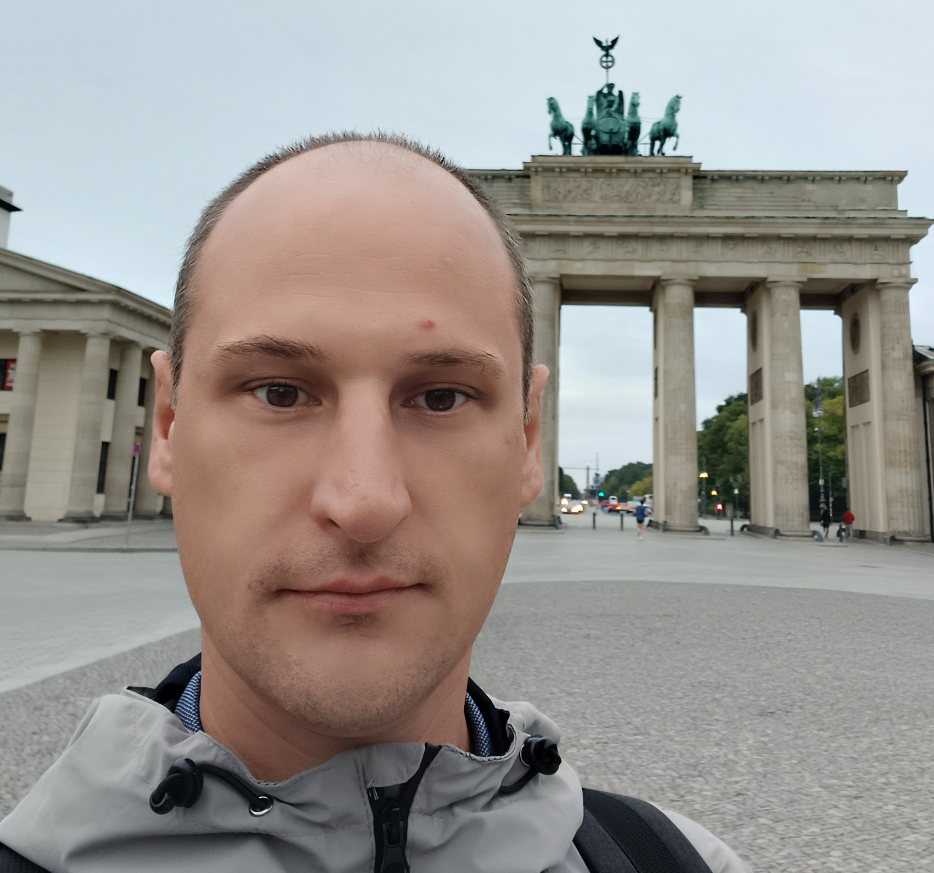
Motivation
- Contribute to German research
- Participate in European space projects
- Collaborate with universities and industry

Long-Term Vision
Growing together with the German scientific and engineering community.

AURA

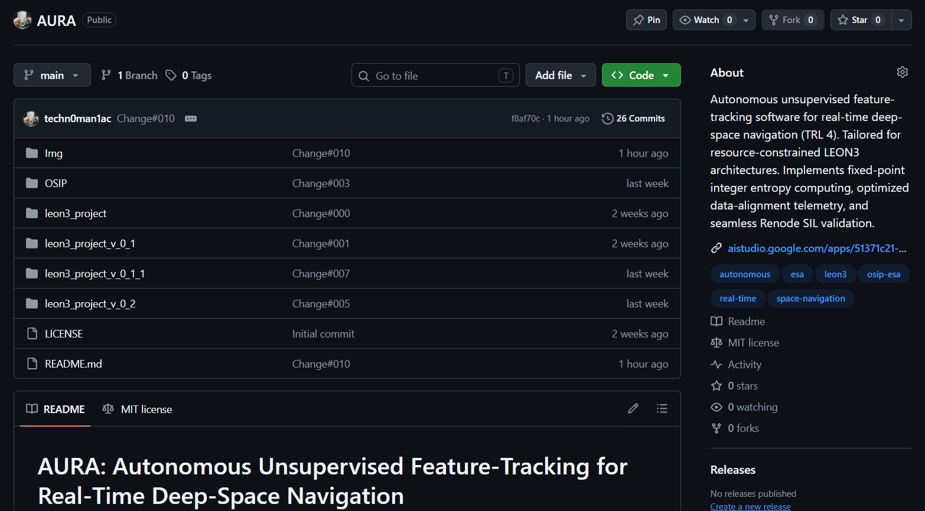
Current Status
- Working prototype
- Clear research direction
- Open-source development(MIT license)
- Potential space applications

https://github.com/techn0man1ac/AURA/

Key Message
AURA explores how information itself can become a resource for autonomous space systems.

Thank You

