GIT + GITHUB
SY OPEN SOURCE • INTERVIEW • CI/CD PLAYBOOK
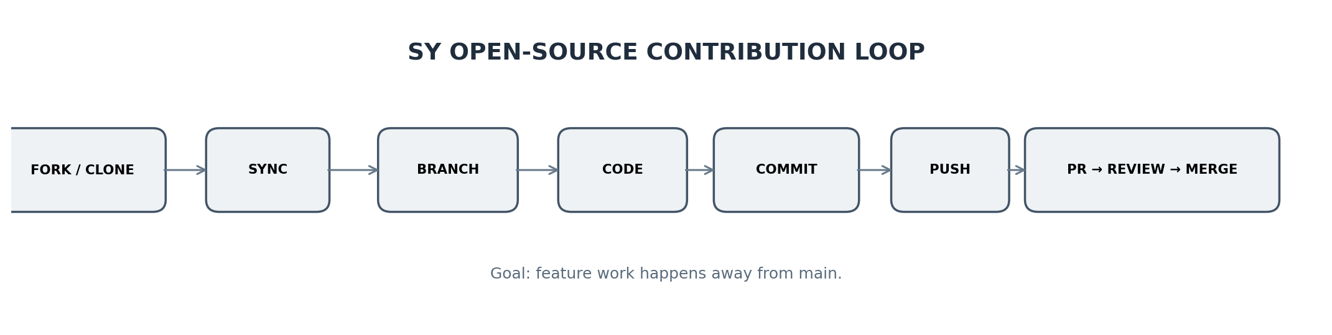
THE SY MINDSET
FY = “I can push my project.”
SY = “I can work safely with other developers, contribute through PRs, handle conflicts, explain Git in interviews, and understand how pushes trigger CI/CD.”

1. The Big Picture: What Changes in SY?
- Git becomes a collaboration workflow, not just a list of commands.
- main is usually the shared/stable branch; feature work happens on separate branches.
- Open source commonly uses fork → clone → branch → commit → push → Pull Request → review → merge.
- In interviews, explain the reason behind a command, not only its syntax.
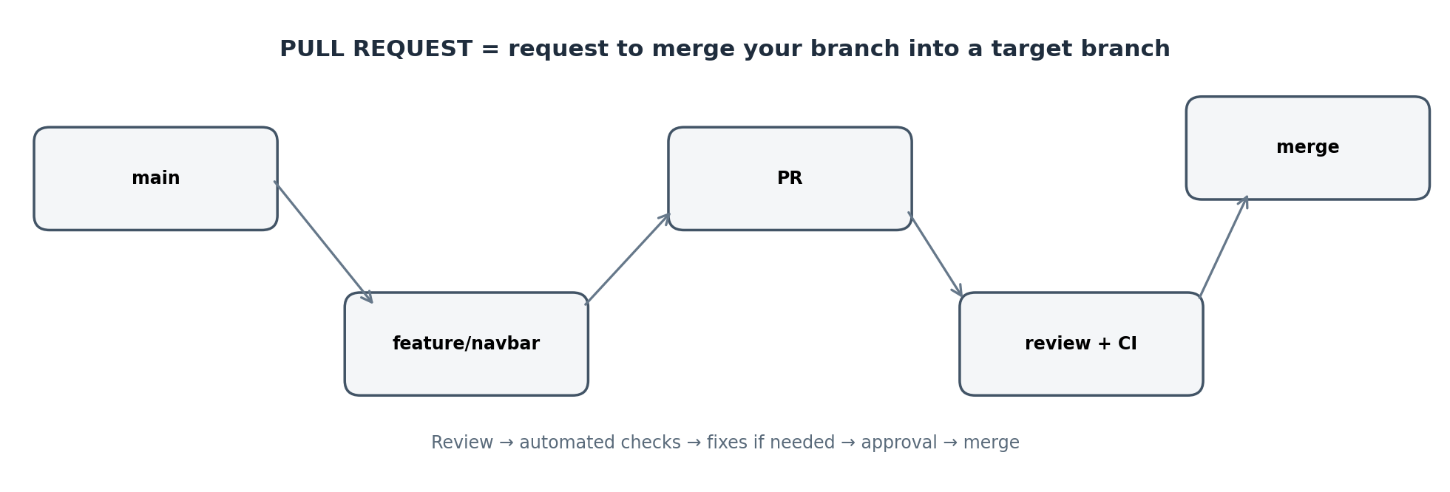

2. Your Core SY Workflow
Workshop workflow
git switch main
git pull origin main
git switch -c feature/navbar
# make changes
git add .
git commit -m "Add navbar"
git push -u origin feature/navbar
STEP | COMMAND | WHY | WHEN
1 | git switch main | Move to shared baseline | Before new work
2 | git pull origin main | Get latest main | Before branch creation
3 | git switch -c feature/navbar | Create + switch branch | Every feature/fix
4 | git add . | Stage changes | After coding
5 | git commit -m ... | Save local snapshot | Logical change ready
6 | git push -u origin feature/navbar | Publish branch | First push of new branch
GOLDEN RULE
Do not start feature work directly on main. A branch isolates your work and makes review, collaboration and rollback easier.

3. Command Deep Dive

git switch main
- WHAT: Switch to an existing branch.
- WHEN: Returning to the shared main branch.
- VARIATIONS:
git checkout main (older syntax)
- REMEMBER: Do not use -c when main already exists.

git pull origin main
- WHAT: Fetch remote changes and integrate them into the current branch.
- WHEN: Getting the latest main before work.
- VARIATIONS:
git pull; git pull origin main
- REMEMBER: Uncommitted changes can make pulls harder to integrate.

git switch -c feature/navbar
- WHAT: Create and switch to a new branch.
- WHEN: New feature, bug fix, docs change, etc.
- VARIATIONS:
git switch -c fix/login-bug
git switch -c docs/readme
- REMEMBER: Use descriptive names.

git add .
- WHAT: Stage detected changes under the current directory.
- WHEN: When you intentionally want all relevant changes staged.
- VARIATIONS:
git add file.js
git add src/
- REMEMBER: Check status first; avoid staging secrets/unrelated files.

git commit -m "Add navbar"
- WHAT: Create a local snapshot from staged changes.
- WHEN: After one logical unit of work is ready.
- VARIATIONS:
git commit -m "Fix login validation"
git commit -m "Update README"
- REMEMBER: Message should describe the change.

git push -u origin feature/navbar
- WHAT: Upload branch and set upstream tracking.
- WHEN: First push of a new branch.
- VARIATIONS:
git push
git push origin feature/navbar
- REMEMBER: After -u, later pushes can usually be git push.

4. Fork vs Clone vs Branch — Interview Favourite
CONCEPT | MEANS | OPEN-SOURCE USE
Fork | Your GitHub copy of another repository | Useful when you cannot push directly to the original repo.
Clone | Download a repository to your computer | Creates your local working copy.
Branch | Separate line of development | Feature/fix work without changing main directly.
Remote | Named connection to another repository | origin is a common default remote name.
Pull Request | Request to merge one branch into a target branch | Main collaboration/review mechanism on GitHub.
Typical open-source contribution
git clone https://github.com/OWNER/REPO.git
cd REPO
git switch main
git pull origin main
git switch -c fix/navbar-spacing
# code...
git add .
git commit -m "Fix navbar spacing"
git push -u origin fix/navbar-spacing
# Open a Pull Request on GitHub.

5. Open Source: From Issue to Merged PR
- Read the issue, contribution guidelines and existing discussion.
- Check that the issue is not already assigned or actively being solved.
- Fork the repository if the project uses a fork-based workflow.
- Clone your fork locally.
- Create a focused branch such as feature/navbar or fix/login-validation.
- Make the smallest useful change that solves the issue.
- Run the project's tests, lint, build or other required checks.
- Commit with a clear message.
- Push the branch to your fork.
- Open a Pull Request against the project's target branch.
- Respond to review comments by changing the same branch and pushing again.
- After approval and passing checks, the maintainer can merge the PR.

6. Pull Request Anatomy
A GOOD PR ANSWERS 4 QUESTIONS
1. WHAT changed?
2. WHY was it changed?
3. HOW was it tested?
4. IS there anything reviewers should specifically check?
PR SECTION | WHAT TO WRITE
Title | Specific: Fix navbar overlap on mobile
Description | Problem → solution → important implementation details
Testing | Commands run + manual verification
Screenshots | Useful for UI changes
Related issue | Link/reference the issue when project conventions require it
Checklist | Tests passed, docs updated, no secrets committed

7. What If main Changes While You Work?
One straightforward sync pattern
git fetch origin
git switch main
git pull origin main
git switch feature/navbar
git merge main
- git fetch updates remote-tracking information without changing your working files.
- git pull performs a fetch and then integrates changes into the current branch.
- git merge combines histories. Conflicts occur when Git cannot safely combine competing changes.
- Some teams prefer rebase; follow the project's contribution guidelines.

8. Merge Conflict — What Actually Happens?
<<<<<<< HEAD
your version
=======
main's version
>>>>>>> main
# edit the file to the correct final content
# remove conflict markers
git add path/to/file
git commit -m "Resolve merge conflict"
INTERVIEW LINE
“A merge conflict happens when Git cannot automatically reconcile competing changes. I resolve it manually, test the result, stage the resolved files, and complete the merge.”

9. Useful SY Commands You Should Know
COMMAND | USE | INTERVIEW ANGLE
git status | Branch + staged/unstaged/untracked state | How do you know what Git sees?
git log --oneline | Compact commit history | How do you inspect commits?
git diff | Unstaged differences | How do you review changes before staging?
git diff --staged | Staged differences | What exactly will be committed?
git branch | List local branches | How do you inspect branches?
git branch -a | Local + remote-tracking branches | How do you see remote branches?
git remote -v | Remote URLs | What does origin point to?
git fetch origin | Update remote-tracking info | Fetch vs pull?
git stash | Temporarily store uncommitted changes | How can you switch tasks safely?
git clone URL | Create local copy of a remote repo | How do you start on an existing project?

10. Git vs GitHub — Say This in an Interview
SHORT ANSWER
Git is a distributed version control system used to track changes and manage source-code history. GitHub is a platform that hosts Git repositories and provides collaboration features such as Pull Requests, Issues, Reviews and Actions.
- Git can work locally without GitHub.
- GitHub is a collaboration/hosting platform built around Git repositories.
- Git and GitHub are related, but they are not the same thing.

11. Interview Questions — Beginner → Practical → Scenario

Q1. What is Git?
A distributed version control system used to track changes and collaborate on code.

Q2. Git vs GitHub?
Git is the version-control tool; GitHub is a hosting/collaboration platform.

Q3. Why use branches?
To isolate work from the stable/shared branch and support parallel development and review.

Q4. What is a commit?
A recorded snapshot of staged changes in local Git history.

Q5. What is a Pull Request?
A request to merge changes from one branch into a target branch, usually with review and checks.

Q6. git fetch vs git pull?
fetch downloads remote-tracking information; pull fetches and then integrates changes into the current branch.

Q7. git add vs git commit?
add stages changes; commit records the staged snapshot.

Q8. Why -u in git push -u origin feature/navbar?
It sets the upstream tracking branch, so later git push/pull can usually omit remote and branch.

Q9. What is origin?
A conventional name for a configured remote repository.

Q10. What causes merge conflicts?
Git encounters changes it cannot safely combine automatically.

Q11. What do you do before starting a new feature?
Update main, then create a new feature branch.

Q12. PR has review comments. New PR?
Usually no. Update the same branch and push; the existing PR updates.

Q13. Why should secrets not be committed?
Git history can retain them even after deletion. Exposed credentials should be rotated and handled using proper secret management.

Q14. What is CI?
Automated validation such as tests, linting and builds triggered by repository events.

Q15. What is CD?
Automated delivery/deployment of validated software, depending on the project's setup.

12. CI/CD: Where Does Git Fit?
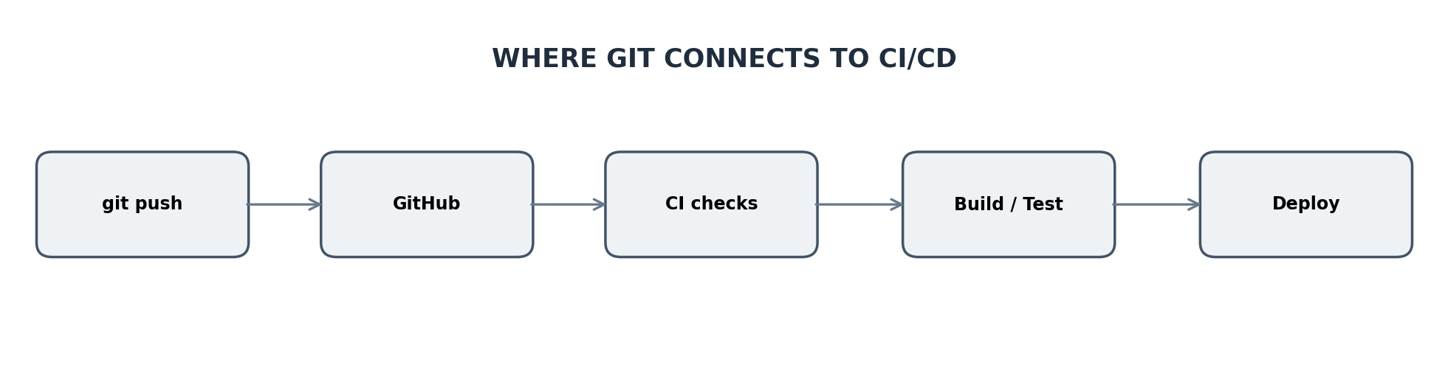
- A push or Pull Request can trigger an automated workflow.
- CI commonly runs linting, tests, builds and other quality checks.
- CD can package and deploy code after required checks or approvals.
- GitHub Actions is one example of a CI/CD automation platform integrated with GitHub.
Conceptual flow — actual steps depend on the repository
git push origin feature/navbar
# A workflow may then:
# → install dependencies
# → lint
# → test
# → build
# → report status on the PR
# → optionally deploy

13. Scenario Challenge — What Would YOU Do?

SCENARIO A
SITUATION
You are asked to add a login page. main has new commits since yesterday.
THINK LIKE A DEVELOPER
Update main → create feature branch → code → test → commit → push → PR.

SCENARIO B
SITUATION
Your PR reports a merge conflict.
THINK LIKE A DEVELOPER
Sync with the target branch → resolve carefully → test → commit/push → PR updates.

SCENARIO C
SITUATION
You have unfinished navbar changes but urgently need another branch.
THINK LIKE A DEVELOPER
Use git stash when appropriate, switch safely, then restore the work.

SCENARIO D
SITUATION
Reviewer asks for a UI change and another test.
THINK LIKE A DEVELOPER
Modify the same PR branch and push again; the existing PR updates.

SCENARIO E
SITUATION
.env was accidentally committed.
THINK LIKE A DEVELOPER
Do not assume deletion fixes it. Rotate exposed secrets and follow the project's security procedure; history may retain the secret.

14. 60-Second Revision Sheet
START
git switch main
git pull origin main
git switch -c feature/<name>
WORK
git status
git diff
git add .
git commit -m "Describe the change"
PUBLISH
git push -u origin feature/<name>
COLLABORATE
PR → tests → review → update branch → merge
SYNC
git fetch origin
git switch main
git pull origin main
INSPECT
git status
git log --oneline
git diff --staged
git remote -v
THE STORY
SYNC → BRANCH → CODE → TEST → COMMIT → PUSH → PR → REVIEW → MERGE

15. Mini Practical — Do This Yourself
- Clone a practice repository.
- Create feature/profile-card.
- Build a small profile-card UI.
- Run git status and git diff.
- Stage and commit the change.
- Push the feature branch.
- Open a Pull Request.
- Review your own diff like a maintainer.
- Make one improvement and push again; observe the same PR update.
- Identify which CI checks run and explain why they exist.
FINAL TEST
If you can explain WHY each command exists, how a PR works, what happens during a conflict, and how a push can trigger CI checks, you understand the workflow rather than memorising commands.

