Session 0.1 – Introduction to Cloud Computing
🎯 Learning Objectives
By the end of this session, students will be able to:
✅ Define cloud computing and its core characteristics.
✅ Differentiate between Public, Private, Hybrid, and Community cloud deployment models.
✅ Recognize examples of each deployment model in real-world scenarios.
📝 Outline
1. What is Cloud Computing?
➔ “Cloud computing is the on-demand delivery of IT resources over the internet with pay-as-you-go pricing.”
➔ Instead of owning data centers or servers, organisations rent computing power, storage, and databases as needed.
➔ Like electricity: pay for what you use without managing power plants.
2. Essential Characteristics of Cloud Computing (NIST Model)
Characteristic | Explanation
On-Demand Self-Service | Provision computing resources as needed automatically, without human intervention (e.g., creating a VM in Azure).
Broad Network Access | Available over the network and accessible through standard mechanisms (e.g., internet, APIs).
Resource Pooling | Multi-tenancy model; resources are pooled to serve multiple customers.
Rapid Elasticity | Quickly scale out or scale in resources based on demand.
Measured Service | Usage is monitored, controlled, and reported for transparency and billing.

3. Cloud Deployment Models
🌐 Public Cloud
- Definition: Owned and operated by third-party providers. Resources shared among multiple tenants.
- Examples: Microsoft Azure, AWS, Google Cloud Platform.
- Use Case: Hosting web applications accessible globally.

🏢 Private Cloud
- Definition: Cloud infrastructure dedicated to a single organisation, managed either internally or by a third party.
- Examples: On-premise private cloud built on VMware, Hyper-V; Azure Stack
- Use Case: Financial institutions or government agencies requiring full control over data

🔗 Hybrid Cloud
- Definition: Combines public and private clouds, allowing data and applications to move between them.
- Examples: Using Azure for backups while keeping sensitive data on-prem.
- Use Case: Gradual cloud migration, disaster recovery, burst to cloud scenarios.

🤝 Community Cloud
- Definition: Shared between organisations with similar requirements (e.g., security, compliance).
- Examples: Government bodies sharing a regulated cloud environment
- Use Case: Healthcare organisations needing HIPAA compliance collectively

💻 4. Real-World Examples
Organisation | Use Case | Deployment Model
Startup hosting a web app | Hosting in AWS | Public Cloud
Government agency with security compliance | Private Azure Stack | Private Cloud
Large retailer with on-prem ERP integrating with Azure AI services | Hybrid integration | Hybrid Cloud
Regional universities sharing research cloud resources | Education sector community cloud | Community Cloud

📝 5. Quick Class Activity (Example):
- A bank hosts its core banking systems in its data center but uses Azure for analytics workloads.
➔ Answer: Hybrid Cloud

🔑 6. Key Takeaways
- Cloud computing enables on-demand, scalable, and cost-efficient IT services.
- Deployment models differ in ownership, security, and use cases.
- Choosing the right model depends on business, security, and compliance needs.

🖥️ 7. Suggested Demo (5 minutes) (Azure Portal):
- Create a resource group (public cloud example)
- Briefly mention Azure Stack in documentation as a private cloud solution
- Highlight the Azure Arc hybrid management option

Session 0.2 – Cloud Service Models
🎯 Learning Objectives
By the end of this session, students will be able to:
✅ Define the three main cloud service models: IaaS, PaaS, SaaS
✅ Differentiate between them using practical examples
✅ Identify scenarios for choosing each model in real-world applications

📝 Outline
1. Introduction to Cloud Service Models
➔ Cloud services are categorised based on the level of control, management, and responsibility shared between provider and consumer.
Three Main Models:
- IaaS – Infrastructure as a Service
- PaaS – Platform as a Service
- SaaS – Software as a Service

2. The Responsibility Model (Diagram)

Component | On-Prem | IaaS | PaaS | SaaS
Networking | ✅ | 🔄 | 🔄 | 🔄
Storage | ✅ | 🔄 | 🔄 | 🔄
Servers | ✅ | 🔄 | 🔄 | 🔄
Virtualization | ✅ | 🔄 | 🔄 | 🔄
OS | ✅ | ✅ | 🔄 | 🔄
Middleware | ✅ | ✅ | ✅ | 🔄
Runtime | ✅ | ✅ | ✅ | 🔄
Application | ✅ | ✅ | ✅ | ✅
Data | ✅ | ✅ | ✅ | ✅

3. Service Models Explained
🖥️ IaaS – Infrastructure as a Service
- Definition: Provides virtualised computing resources over the internet.
- What you manage: OS, applications, runtime, data
- Provider manages: Virtualisation, servers, storage, networking
Examples:
- Azure Virtual Machines
- AWS EC2
- Hosting .NET backend APIs on Windows Server VM
Use Cases:
- Migrating legacy apps to cloud
- Custom enterprise software requiring OS-level configuration
- Hosting databases with OS control (e.g. SQL Server on VM)

🔧 PaaS – Platform as a Service
- Definition: Provides an environment with a managed platform to develop, run, and deploy applications.
- What you manage: Application code and data
- Provider manages: OS, middleware, runtime, scaling
Examples:
- Azure App Service (Web Apps, API Apps)
- AWS Elastic Beanstalk
- Google App Engine
Use Cases:
- Rapid API development without worrying about OS patching
- Hosting .NET Core web APIs with built-in auto-scaling
- Application logic with no server maintenance

📧 SaaS – Software as a Service
- Definition: Software is delivered over the internet, fully managed by the provider. Users only use the application.
- What you manage: Application configurations and usage
- Provider manages: Everything else
Examples:
- Office 365 / Microsoft 365
- GitHub / GitLab
- Gmail
Use Cases:
- Email services
- CRM solutions
- Developer collaboration tools

Session 1.1 – Azure Blob Storage Deep Dive
🎯 Learning Objectives
By the end of this session, students will be able to:
✅ Understand what Azure Blob Storage is and its purpose
✅ Differentiate between Block, Append, and Page Blobs
✅ Explain storage tiers (Hot, Cool, Archive)
✅ Implement data encryption and access control mechanisms
✅ Know tools for data transfer to and from Blob Storage

📝 Outline
1. What is Azure Blob Storage?
- Definition:
- “Blob” = Binary Large Object = term (any piece of data, any size, any format)
- It just means any file or data stored as a big block of bytes, without caring about its format.
- Object storage solution for the cloud to store massive amounts of unstructured data (images, videos, backups, logs).

- Key Features:
➔ Durable (triple replication within region).
➔ Scalable (petabytes).
➔ Accessible via HTTP/HTTPS with REST APIs and SDKs.

- Real-World Use Cases:
  - Hosting images and videos for a web app.
  - Backup and archive of application data.
  - Storing logs for analytics pipelines.

☁️ Azure Blob Storage – Blob Types:
- Block Blob:
✅ What is it?
- The most common type.
- Used to store files like images, videos, documents, backups.

✅ How it works?
- Your file is split into blocks (chunks).
- Each block is uploaded separately and can be managed individually.
- At the end, Azure combines them to form a complete file (blob).
- Each block is stored separately in Azure’s distributed storage system.

💡 Why split into blocks?
To upload large files efficiently, because:
- You can upload multiple blocks in parallel (faster).
- If upload fails halfway, only failed blocks are re-uploaded, not the entire file.
📏 Size limits:
- Each block: up to 100 MB (latest APIs)
- Max total file size: ~4.75 TB

📝 Example Use Cases:
- Website images
- Video files
- Backup files
- Documents for download

2. Append Blob
✅ What is it?
- Similar to block blob but optimised for appending data at the end.

✅ How it works?
- You can only add (append) new blocks at the end of the blob.
- You cannot modify or delete existing blocks.

💡 Why use it?
Ideal for logs or audit data that keeps growing over time.

📏 Size limits:
- Each block: up to 4 MB
- Total size: up to ~195 GB

📝 Example Use Cases:
- Application logs
- Telemetry data
- Continuous stream data that needs to be stored sequentially

3. Page Blob
✅ What is it?
- Designed for random read/write access within the file.

✅ How it works?
- Data is stored in pages of 512 bytes.
- You can read or write to any page directly, without reading the whole file.

💡 Why use it?
Best for Virtual Hard Disks (VHDs) used by Azure Virtual Machines.
➡ Because an OS or disk frequently reads/writes small parts randomly.
📏 Size limits:
- Max size: 8 TB

📝 Example Use Cases:
- Virtual machine disks (OS disks, data disks)
- Files needing fast read/write at specific locations

☁️ Azure Blob Storage Tiers
✅ Storage tiers in Azure Blob Storage help you optimise cost based on how often you access your files.

🔷 1. Hot Tier
💡 What is it?
- Optimised for data that is accessed frequently.

💰 Cost Structure:
✔ Higher storage cost (per GB per month)
✔ Lowest access cost (read/write operations are cheaper)

📈 When to use?
✅ Files that are:
- Accessed daily or multiple times a week
- Needed for live apps, websites, APIs

📝 Examples:
- Images and videos on your website
- Documents accessed daily by employees
- Application configuration files

🔷 2. Cool Tier
💡 What is it?
- Optimised for data that is infrequently accessed, but still needs to be read immediately when needed.

💰 Cost Structure:
✔ Lower storage cost than Hot
✔ Higher access cost than Hot

➡ You save on storage, but pay more per read/write operation.

📈 When to use?
✅ Files that are:
- Accessed once a month or less frequently
- Needed for backup, disaster recovery, or archival with occasional read

📝 Examples:
- Monthly backup files
- Old project documents you keep for reference
- Customer data that must be retained but is rarely used

🔷 3. Archive Tier
💡 What is it?
- Optimised for data that is rarely accessed, intended for long-term storage at minimal cost.

💰 Cost Structure:
✔ Very low storage cost (cheapest tier)
✔ Highest access cost (to read data)
✔ Retrieval latency: Hours (not instant)
➡ Data is stored in an offline state and must be rehydrated before you can read it.

📈 When to use?
✅ Files that are:
- Almost never accessed
- Needed only for compliance or regulatory requirements
- Retained for years

📝 Examples:
- Compliance records (7+ years retention)
- Old tax documents
- Inactive customer data

💡 Lifecycle Management Policies (by configuration)
1. Upload daily backups to Hot tier
- After 30 days ➔ Move to Cool tier to save cost
- After 6 months ➔ Move to Archive tier for long-term retention

✔ Tiering only moves your data to cheaper storage classes based on rules.

🛠 What is it used for in applications?
✅ Blob Storage is mainly used for:
- Attachments: User profile photos, Uploaded documents, Videos or media files.
- Backups & Archives: Database backups (.bak), Application logs, Long-term archived data.
- Big Data / ML Inputs: Storing data files for processing

🔒 Azure Blob Storage – Encryption
🎯 Why is encryption needed?
✔ To protect your data from unauthorized access
✔ To ensure compliance with security standards like GDPR, HIPAA, PCI-DSS

🔷 Two Types of Encryptions in Blob Storage
1. Encryption At Rest
✅ Protects your files while stored in Azure data centers.
💡 How does it work?
✔ Azure automatically encrypts all blobs when saved.
✔ Uses 256-bit AES encryption (strong industry standard).
➡ You don’t need to write any code – it is enabled by default.

🔑 Key Management Options
✔ Microsoft-managed keys (default):
- Azure handles everything.
- Keys are rotated and managed automatically.

✔ Customer-managed keys (CMK):
- You manage encryption keys in Azure Key Vault.
- Gives you full control, required by some compliance standards.

➡ Example: You upload a file ➔ Azure encrypts it using your Key Vault key.

🔷 2. Encryption In Transit
✅ Protects your data while moving between your app and Azure.

💡 How does it work?
✔ Uses HTTPS (TLS) connections to upload/download files securely.
✔ Prevents anyone on the network from reading your data.
➡ You enforce HTTPS in:
- Azure Portal settings (disable HTTP access)
- Your application code by specifying https:// endpoints

🔧 Advanced Option – Double Encryption
✔ In high-security scenarios, Azure supports double encryption:
- Uses two layers of encryption with independent keys.
- Enabled by default for Azure Storage in many regions.
First encryption layer:
- Your data is encrypted using storage service encryption (SSE) with a key (managed by Microsoft or by you via Key Vault).
Second encryption layer:
- The encrypted data from the first step is encrypted again with another encryption mechanism and key.

Access Control
- To secure your files so only authorised users or applications can access them.
- To enforce least privilege principle in cloud security.

🔷 Access Control Options in Azure Blob Storage
1. Azure AD-based Role-Based Access Control (RBAC)
✅ What is it?
- Uses Azure Active Directory identities (users, groups, or managed identities).
- You assign roles with specific permissions to them for storage access.

💡 Example Roles
Role | Permission
Storage Blob Data Reader | Can read blobs
Storage Blob Data Contributor | Can read and write blobs
Storage Blob Data Owner | Full access to blobs

🔑 When to use?
✔ For enterprise applications that authenticate using Azure AD.
✔ When you want centralised identity-based access control (recommended best practice).

2. Shared Access Signature (SAS)
✅ What is it?
A token (URL) that grants limited access to a blob or container.
You can specify:
✔ Permissions: Read, Write, Delete, List
✔ Expiry time: e.g., valid for 10 minutes or 1 day
✔ IP address range: Restrict to specific clients
✔ Protocol: HTTPS only

💡 Types of SAS
Type | Scope
Service SAS | Grants access to a specific blob, container, queue, or table
Account SAS | Grants access to multiple services in a storage account
User Delegation SAS | Uses Azure AD credentials to create SAS (more secure)

🔑 When to use?
✔ When you need to share files temporarily with clients or apps without giving full storage account access.
✔ E.g., generating a download link for a client that expires in 1 hour.
3. Storage Account Keys
✅ What is it?
  - Each storage account has two access keys (primary and secondary).
  - Provides full administrative access to the entire storage account.

✔ Anyone with the key can:
  - Read, write, delete everything in the storage account
  - Rotate keys to block compromised access
🔷 Why are there two keys?
✅ 1. Redundancy / Rotation
  - So you can rotate keys without downtime.
➡ Example:
  - Your app is using the primary key to access storage.
  - You decide to regenerate (reset) the primary key for security.
✅ During rotation:
  - You temporarily switch your app to use the secondary key.
  - Regenerate the primary key to invalidate old access.
  - Switch your app back to the new primary key if desired.

Tools and Services for Azure Blob Storage Data Transfer
🎯 Why are these tools important?
- To upload or download files efficiently.
- To handle large data migrations, backups, automation, and operational tasks.

🔷 1. Azure Portal Upload/Download
✅ What is it?
- Simple browser-based method to upload/download files directly to blob storage.
✔ When to use:
- Quick testing
- Uploading small files (<250 MB) via the portal UI
❌ Limitations:
- Not practical for automation or large files
- Slow for big datasets

🔷 2. Azure Storage Explorer
✅ What is it?
- Free GUI tool from Microsoft.
- Runs on Windows, Mac, and Linux.
✔ Features:
- Browse storage accounts, containers, and blobs
- Upload, download, delete, rename files
- Generate SAS tokens
- Manage tables, queues, and files in storage accounts
💡 When to use:
- Developer daily operations
- Uploading or managing files manually
- Viewing blob structures without writing code
➡ Example: Upload project assets or download logs easily via drag and drop.

🔷 3. Azure Data Box
✅ What is it?
- Physical appliance (hardware) provided by Microsoft to transfer large datasets offline.
✔ How it works:
- Order a Data Box (e.g. 100 TB appliance).
- Microsoft ships it to your data center.
- Copy your data to the Data Box via high-speed local connection.
- Ship it back to Microsoft.
- Data is uploaded to your storage account.
💡 When to use:
- Massive data migrations (TBs to PBs) where network transfer is impractical.
- Data center migration to Azure Blob Storage.
- Initial big data ingestion before incremental online transfers.

🔷 4. AzCopy
✅ What is it?
- A command-line utility for Windows, Linux, and Mac.
✔ Features:
- High-performance data transfer tool
- Supports upload, download, sync, and copy between storage accounts
- Automates data transfers in scripts
💡 When to use:
- Automating uploads/downloads in deployment scripts
- Large file transfers (TB-scale)
- Syncing local folders to blob storage
🔧 Example Command:
azcopy copy "C:\MyData" "https://mystorageaccount.blob.core.windows.net/mycontainer?SAS" --recursive
✔ Uploads all files from C:\MyData to the container.

🔷 5. Azure Data Factory (Advanced)
✅ What is it?
Azure Data Factory is a fully managed cloud-based ETL (Extract, Transform, Load) and data integration.
✔ Features:
- Copy data between on-premises and Azure Blob Storage
- Schedule and orchestrate data pipelines
- Transform data before storing
💡 When to use:
- Building data integration pipelines
- Moving data from databases, APIs, or files into Blob Storage
- Automating daily or hourly data loads
✔ Data orchestration
- Schedule and coordinate multiple data workflows with dependencies
- Trigger pipelines on schedule, event, or manually

Azure Queue Storage – Concepts and Types
🎯 What is Queue Storage in cloud computing?
✅ A queue is a storage service for messages that allows communication between application components asynchronously.

🎯 Why use queues in cloud applications?
✔ To decouple application components, allowing:
✔ Decoupling: Producer and consumer don’t have to run at the same time.
✔ Load leveling: Handle traffic spikes by processing at your own pace.
✔ Reliability: Messages are stored safely until processed.

🔑 Core Concepts
Term | Meaning
Queue | A storage structure to hold messages in FIFO order (first-in-first-out).
Message | A piece of data (string or encoded data) placed in the queue to be processed later.
Producer | App/service that sends messages to the queue.
Consumer | App/service that reads messages from the queue to process them.

🔷 Queue Message Lifecycle
✅ Step by step flow:
- Enqueue ➔ Add a message to the queue
- Dequeue ➔ Retrieve and process the message
- Delete ➔ After successful processing, delete the message from the queue

🔷 Message Properties
Property | Description
Message size | Up to 64 KB per message
Retention period | By default, messages live until deleted, or up to 7 days if not dequeued
Visibility timeout | Period after dequeue when message is invisible to others

🔷 Message Expiration
✔ Each message has a Time-To-Live (TTL) set when enqueued.
➡ TTL defines how long the message stays in the queue if not processed.
Behaviour | Details
Default TTL | Infinite – message stays until processed (deleted).
Custom TTL | Set during enqueue (up to 7 days max).
Maximum retention | Azure Queue Storage automatically deletes messages older than 7 days, even if TTL was not set.

🔷 Polling
Your application repeatedly checks the queue for new messages.
✔ Azure Queue Storage is passive:
- It does not push messages to consumers automatically.
- Your app/service must ask for messages at intervals

Types of Polling Approaches
Approach | Description | Pros | Cons
Tight Loop Polling | Continuously polls with no or minimal delay | ✔ Lowest latency (immediate processing) | ❌ High transaction costs, can hit Azure limits
Interval Polling | Polls at fixed intervals (e.g. every 5 seconds) | ✔ Reduces costs and throttling risk | ❌ Increases latency (message waits up to polling interval)
Backoff Polling | Polling interval increases gradually when no messages are found | ✔ Cost efficient, scalable | ❌ Slightly more complex to implement

🔷 Operations on Messages
  - Enqueue (Add message)
✅ What it does?
- Adds a message to the end of the queue.
- Message remains stored until processed or expired.
Example: Your app places a file processing task in the queue.

Producer | Description
Web Application | Adds a task message after user action (e.g. file uploaded).
Azure Function | Sends messages to queue for downstream processing.
Background Service | Periodic job enqueues tasks to be processed asynchronously.
IoT Device Gateway | Pushes telemetry data to queue for later processing.
Mobile App Backend | Enqueues user requests for processing by other services.
On-premise application | Uses Azure SDK or REST API to enqueue messages to cloud queue.

  - Peek
✅ What it does?
- Reads the next message in the queue WITHOUT removing or hiding it.
- Used to inspect messages without processing.
Example: Checking the next job in queue to monitor workloads.

  - Dequeue (Get message)
✅ What it does?
- Retrieves and temporarily hides the message from other consumers for processing.
- Hiding period = visibility timeout (default 30s, configurable).
✔ When your app dequeues a message:
- Azure returns:
  - Message ID
  - Pop Receipt (needed for delete or update)
  - Message Content
- The message becomes hidden from other consumers for a period, called visibility timeout.

  - Delete
✅ What it does?
- Permanently removes the message after successful processing.
➡ Always delete a message after processing to avoid duplicate work

  - Update (Advanced)
✅ What it does?
- Updates message content or changes its visibility timeout while it’s invisible.
➡ Useful for renewing lock time if processing takes longer.

🔷 Access Control Options
Azure Queue Storage offers three main ways to control access:

✅ a. Storage Account Keys
✔ Master keys for the entire storage account.
Pros | Cons
Easy for quick testing | ❌ Full admin access if leaked  ❌ Not secure for production
➡ Best practice: Avoid using keys in production apps.

✅ b. Shared Access Signature (SAS)
✔ Generate time-bound, permission-limited URLs for clients to:
- Add messages (enqueue)
- Read messages (peek, dequeue)
- Delete messages

💡 Example:
- Generate a SAS token allowing enqueue permission for 1 hour.
- Send this token to a client app to upload messages securely without exposing your storage account keys.

✅c. Stored Access Policies
✔ Access Policies (Stored Access Policies) are named permission rules that you define on a queue to:
- Manage permissions centrally
- Control expiry times
- Allow easy revocation or updates of multiple SAS tokens referencing the policy

With Access Policies:
- You create a stored access policy on the queue, specifying: (The source of truth)
- Permissions (Read, Add, Update, Process)
- Start time
- Expiry time
- You generate SAS tokens linked to this policy.
➡ If you need to revoke or change the SAS:
- Modify or delete the access policy, and all SAS tokens referencing it become invalid or updated immediately.

🔑 Best Practice
✅ Use Azure AD RBAC (where possible with premium features) or SAS tokens + stored access policies for secure, granular access control.
🔷 Azure monitoring options for Queue Storage
Feature | Purpose
Azure Metrics | Track queue length, ingress/egress requests, latency, success/failure counts
Azure Monitor Alerts | Notify on queue length thresholds (e.g. if >1000 messages)
Storage Analytics Logs | Detailed logs for requests, errors, performance diagnostics

🔷 Diagnosing issues
Issue | Diagnostic approach
Message stuck (never processed) | Check visibility timeout too short and dequeue/delete logic
Duplicate processing | Ensure processing is idempotent; duplicates happen if delete fails before visibility timeout expires
High latency or cost | Optimise polling interval or switch to event-driven alternatives

🔷 Tools for monitoring
Tool | Use case
Azure Monitor | Create alerts on queue metrics
Azure Diagnostics Logs | Enable logging of queue transactions for audit and troubleshooting
Application Insights | Monitor your consumer app’s processing logic, errors, and performance

🔷 Limitations of Azure Queue Storage
Limitation | Details
Message size | Max 64 KB per message
Queue size | Virtually unlimited number of messages, limited only by storage account quota
Retention period | Messages retained for up to 7 days maximum
Throughput | No formal throughput SLA; suitable for moderate workloads, not high-throughput enterprise messaging
No advanced features | ❌ No dead-letter queues ❌ No duplicate detection ❌ No transactions across queues ❌ No sessions for ordered processing
No Pub/Sub model | Only simple FIFO queue; for pub/sub use Service Bus Topics

❓ What does “no formal SLA” mean here?
✔ Azure Queue Storage does not promise a guaranteed number of messages per second.
➡ It works well for moderate usage (hundreds or low thousands per second), but:
❌ If you suddenly push huge loads (e.g. tens of thousands per second):
- Performance may slow down
- You might see delays or throttling

🔷 No Advanced Features
Here are 4 advanced features Queue Storage does NOT support – explained simply:

🔴 a. No Dead-Letter Queue
✅ What is it?
✔ A special queue where failed messages are moved after multiple processing failures.
➡ Helps avoid endlessly retrying bad data.

💡 Analogy
Imagine you run a restaurant:
- If an order keeps failing (e.g. wrong phone number for delivery), you move it to a “problem orders” basket instead of trying forever.

🔴 b. No Duplicate Detection
✅ What is it?
✔ Automatically detects if the same message is sent twice and keeps only one.
➡ Prevents double processing, which is critical for:
- Payments
- Billing
- Inventory updates

💡 Analogy
Imagine your bank processed your same deposit request twice – that’s a big problem.

🔴 c. No Transactions Across Queues
✅ What is it?
✔ Ability to send or receive multiple messages atomically (all succeed or all fail together).
➡ Useful when:
- Your app updates multiple queues as part of one business operation.

💡 Analogy
Imagine a bank transfer:
- Withdraw from Account A
- Deposit to Account B
➡ Both must succeed or both fail.

🔴 d. No Sessions (Ordered Processing)
✅ What is it?
✔ A way to group related messages and process them in order.
➡ Important for workflows like:
- Step 1 ➔ Step 2 ➔ Step 3

💡 Analogy
Imagine a pizza order:
- Make dough
- Add toppings
- Bake
➡ The steps must happen in order.

Azure Service Bus Queues
✅ Azure Service Bus Queues are a messaging infrastructure that allows different parts of a distributed application to communicate asynchronously through a first-in, first-out (FIFO) message delivery system.

🔑 Key Characteristics:
- Brokered messaging: Messages are stored durably in the queue until consumed
- Asynchronous communication: Senders and receivers don't need to be active at the same time
- Load leveling: Helps balance workloads between producers and consumers
- Temporal decoupling: Components can be updated/maintained independently

🔷 Queue Properties
- Size: Up to 1GB (standard), 80GB (premium)
- Message TTL (Time to Live): Default 14 days, configurable up to 14 days
- Duplicate detection: Optional feature to detect and eliminate duplicates
- Dead-letter queue: Stores messages that couldn't be processed

🔷 Message Handling Features
1. Dead-letter Queues (DLQ)
✅ A special sub-queue used to store messages that cannot be delivered or processed successfully.

🔑 When does a message go to DLQ?
- Exceeds Max Delivery Count (default 10 attempts)
      - We can configure Max Delivery Count
      - The maximum number of delivery attempts allowed for a message.
- Message expires (TTL reached) if dead-lettering on expiration is enabled
- Application explicitly dead-letters it (e.g. validation failure)

🔧 How does it work practically?
➡ Each queue has an associated DLQ.
➡ Messages in DLQ don't expire (no TTL)
➡ Can be peeked, received, or deleted like regular queues
➡ Messages in DLQ are not processed automatically ➔ You must read and handle them manually.

➡ Move messages again from DLQ to main queue (BY APPLICATION)
Read from DLQ ➔ Send to main queue ➔ Complete in DLQ

The message inserted as a new message to the original queue

➡ Scenario:
- E-commerce app queues orders for processing.
- Some messages fail due to:
- Invalid customer addresses
- Payment authorization failure
- Operations team reviews DLQ periodically to correct data and repost orders if needed.

2. Duplicate Detection
✅ A feature that automatically identifies and discards duplicate messages based on MessageId.

✔ When Duplicate Detection is enabled:
- Each message must have a MessageId set by the producer.
- Service Bus stores a cache of processed MessageIds for a configured deduplication window (max 7 days).
- If a new message arrives with the same MessageId within the window, Service Bus:
- Discards it silently
- Does not deliver it to consumers
🔑 Key Property: Duplicate Detection History Time Window
Setting | Meaning
Duration | Time period to keep track of processed MessageIds (default: disabled, max: 7 days)
Scope | Per queue

💡MessageId is used by the broker only for duplicate detection.

➡ Scenario:
- User submits payment request.
- Due to network timeout, client resends the payment message.
- First message is processed ➔ Payment succeeds.
- Duplicate message with same PaymentID is discarded silently ➔ Prevents double charging.

3. Message Deferral
✅ It allows a consumer to postpone the processing of a message to a later time, without deleting or putting it back in the queue.

🔷 Step by Step Practical Flow
Step | Action
1 | Consumer receives message.
2 | Determines it cannot process now (e.g. step dependency missing).
3 | Calls DeferAsync() ➔ message is deferred and return SequenceNumber.
4 | Later, consumer calls ReceiveDeferredMessageAsync(sequenceNumber) to retrieve and process it.
5 | Processes and completes the message.

✔ SequenceNumber is required to retrieve deferred messages.
➡ You must store SequenceNumber in a database or app memory to process later.
✔ When you defer a message:
- Its peek-lock is released.
- It is no longer locked by your app.
- It becomes invisible to normal Receive operations.

❓ What happens if it is deferred and never read?
✔️ The message remains in the queue in a deferred state indefinitely, unless:
- The message expires (TTL) if TimeToLive is set.
After TTL elapses ➔ message is dead-lettered or dropped, depending on queue configuration.
- You explicitly dead-letter or delete it using code or administrative action.
4. Scheduled Delivery
✅ Scheduled Delivery allows producers to send messages to Service Bus with a future delivery time.

🔷 Why is Scheduled Delivery useful?
✔ To implement time-based workflows such as:
- Delayed task execution
- Scheduled reminders and notifications
- Retry mechanisms after specific intervals
- Timed release of jobs

🔷 How does it work practically?
- Producer sends a message with a ScheduledEnqueueTimeUtc property set to a future timestamp.
- Service Bus stores the message invisibly until that time.
- At the scheduled time, the message becomes visible to consumers like any other normal message.

💡 Key Points
Behaviour | Explanation
Scheduled message is hidden | Not visible to normal consumers until scheduled time
Can we cancel before scheduled time? | ✅ Yes, using CancelScheduledMessageAsync(sequenceNumber)
Does it become visible before scheduled time? | ❌ No, it remains hidden until either cancelled or scheduled time is reached

🔷 Limitations of scheduling
Limitation | Details
Max schedule duration | Up to 7 days in the future
No recurring scheduling | Service Bus does not support recurring schedules natively
No cron-based scheduling | Must implement recurring scheduling logic in your application or orchestrator (e.g. Azure Functions Timer Trigger)

➡ Scenario:
- Healthcare booking system sends SMS reminders to patients 1 day before appointment.
- Reminders are queued now but delivered to consumers exactly at scheduled time, triggering SMS sending via the notification service.

🔷 Access Control in Azure Service Bus
✔ Service Bus contains sensitive enterprise messages, so secure authentication and authorization are critical to:
- Prevent unauthorized access
- Enforce least-privilege principles
- Ensure compliance with security standards

🔷 1. Authentication Methods
Method | Description | Best Use
Shared Access Signature (SAS) policies | Key-based authentication using tokens signed with a policy key | Quick integration, shared environments
Azure Active Directory (Azure AD) RBAC | Identity-based authentication for managed identities or user/service principals | Enterprise security, no secrets rotation burden

✅ SAS (Shared Access Signature) is a token-based authentication mechanism that allows clients to connect to Service Bus with specific permissions and time-limited access, without sharing the namespace's master keys.

🔷 SAS policies can be created at two scopes:
Scope | Description
Namespace level | Policy applies to all queues and topics in the namespace
Entity level | Policy applies to specific queue or topic only (BEST)

🔷 Components of a SAS Policy
Component | Description
Policy Name (KeyName) | The unique identifier for the policy
Key (Primary/Secondary) | Secret cryptographic key used to sign SAS tokens
Permissions (Rights) | Manage, Send, Listen
Manage = Can create, delete, and manage entities; includes Send and Listen
🔷 How does SAS authentication work?
- Create a SAS policy in Azure Portal or via CLI/ARM on :
Entity level (queue or topic) or Namespace level.

- This policy defines:
Property | Description
Name (KeyName) | Unique policy identifier
Permissions | Send, Listen, or Manage
Keys | Primary and Secondary cryptographic keys

- App(.NET) retrieves the policy key (Primary or Secondary) for the policy created.
- App(.NET) generates a SAS token by signing:
    - Specifying the resource URI (queue or topic endpoint).
    - Setting expiry time (how long the token is valid)
    - Signing this information using the policy key (HMAC-SHA256)

- App(.NET) uses a SAS token to Connects to
- Service Bus using SDK.
- Provides the SAS token in the Authorization header

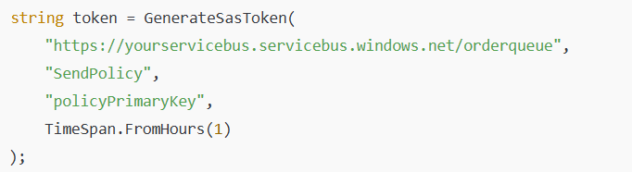

6. Client presents the SAS token in its connection request (HTTP header or AMQP negotiation),
to connect to orderqueue.

Cannot receive messages because SendPolicy has only Send permission

🔷 SAS Token Structure
SharedAccessSignature sr={resourceURI}&sig={signature}&se={expiry}&skn={policyName}

🔷Service Bus validates on each request
✔ When app sends a request:
- Service Bus reads skn (SendPolicy) from token
- Retrieves SendPolicy details (key, permissions)
- Validates signature
- Checks expiry time
- Authorizes operation if allowed by policy

✅ RBAC (Role-Based Access Control) uses Azure Active Directory (Azure AD) identities to authenticate and authorize access to Service Bus resources.

✔ RBAC roles can be assigned to:
- Individual users (Azure AD accounts)
- Groups (Azure AD security groups)
- Service principals (app registrations)
- Managed identities (of Azure resources like Functions, VMs, App Services)

✔ Roles can be assigned at:
- Namespace level ➔ applies to all queues and topics within
- Queue or topic level ➔ fine-grained control

🔷 Step by step flow:
  - Your app authenticates to Azure AD using:
- Managed Identity
- Service Principal
- User credentials
  - Azure AD issues an access token for Azure Service Bus.
  - Your app uses this token in its request to Service Bus.
  - Service Bus validates the token and checks the app’s assigned RBAC role to determine what operations are allowed.

Data Security in Azure Service Bus
✅ Service Bus handles business-critical and sensitive data (e.g. orders, payments, user events), so:
- Encryption in transit protects against interception.
- Encryption at rest protects against data breaches from storage compromise.

🔷 1. Encryption In Transit
➡ All data sent to and from Azure Service Bus is encrypted using TLS (Transport Layer Security).
Details | Explanation
Protocols used | TLS 1.2 or higher
Applies to | Connections over HTTPS (REST) and AMQP (recommended)
Who manages it? | Azure Service Bus automatically enforces TLS encryption for all clients

🔷 2. Encryption At Rest
➡ Azure Service Bus automatically encrypts all messages and metadata stored in the service.
Details | Explanation
Encryption type | Microsoft-managed keys by default (server-side encryption)
Algorithm | Uses 256-bit AES encryption, a strong industry standard
Scope | Applies to all data persisted in Service Bus queues, topics, and subscriptions

🔷 3. Customer-Managed Keys (Bring Your Own Key – BYOK)
✔ For additional security or compliance needs (e.g. financial, healthcare), you can configure:
✅ Customer-managed keys (CMK) with Azure Key Vault integration.
➡ This allows you to:
- Control the encryption keys yourself
- Rotate or revoke keys per your security policies

How to enable CMK (BYOK)?
- Create a Key Vault key (RSA).
- Grant Service Bus access to Key Vault via managed identity.
- Configure the Service Bus namespace to use your Key Vault key for encryption.

➡ Available only in Premium SKU.

🔷 4. Encryption for Message Properties and Payload
✔ All parts of a message are encrypted at rest:
- Message body (payload)
- System properties (e.g. SequenceNumber, TTL)
- Custom application properties (e.g. user-defined headers)

Monitoring and Diagnosing Azure Service Bus
🔷 1. Built-in Monitoring Options
✅ a. Azure Metrics (Platform Metrics)
➡ Service Bus emits standard platform metrics, viewable in:
- Azure Portal ➔ Metrics blade
- Azure Monitor
- Dashboards

Metric | Explanation
Incoming/Outgoing Messages | Number of messages sent to / received from the queue/topic
Active Messages | Number of messages in the queue that are active (not dead-lettered or deferred)
Dead-lettered Messages | Number of messages in DLQ
Scheduled Messages | Count of messages scheduled for future delivery
Size | Total size (bytes) used by queue or topic
Throttled Requests | Count of requests throttled due to exceeding quotas

✅ b. Azure Diagnostic Logs (Resource Logs)
➡ Service Bus can emit detailed operational logs to:
- Log Analytics Workspace
- Event Hub
- Storage Account

✔ What do diagnostic logs include?
- Operational logs: Management plane operations (e.g. queue created, policy updated)
- Audit logs: Security-relevant operations for compliance
- Event Hub Capture (if enabled) for Event Hub namespaces

✅c. Azure Monitor Alerts
✔ You can create alerts based on metrics thresholds, e.g.:
Alert Condition | Use Case
Active Messages > 1000 | Queue backlog growing beyond acceptable SLA
Dead-lettered Messages > 0 | Processing failures need investigation
Throttled Requests > 0 | Exceeding Service Bus capacity or hitting premium tier limits

➡ Alerts can trigger email, SMS, ITSM, Logic Apps, or auto-scaling functions.

✅ d. Application Insights Integration
- Azure Application Insights is an Application Performance Monitoring (APM) service.
- It helps you monitor the health, performance, and usage of your applications in real time.

✔ Using Azure.Messaging.ServiceBus SDK instrumentation, you can:
- Track dependency telemetry for send/receive operations.
- Monitor latency, success/failure rates, and exceptions per operation.
- It registers as a middleware in .net application.

🔷 2. Diagnosing Issues – Practical Troubleshooting
✔ Diagnosing means identifying the root cause of issues and failures in your system
Issue | Diagnostic Approach
Growing queue length | Check Active Messages metric ➔ ensure consumers are running ➔ check lock durations and Max Delivery Count ➔ inspect DLQ
High dead-letter count | Retrieve DLQ messages ➔ analyze reasons ➔ implement poison message handling or fix app logic
Throttled requests | Check SKU limits ➔ upgrade to Premium if needed ➔ optimize connection multiplexing
Message lock lost exceptions | Ensure lock duration > processing time ➔ implement lock renewal logic
Unauthorized errors | Verify SAS token validity or Managed Identity role assignments
High latency | Monitor send/receive duration metrics ➔ check app dependencies and network latency

💡 Advanced Practice
✔ For critical systems:
- Build dashboards combining Service Bus metrics with consumer app health.
- Implement alerting and automated DLQ reprocessing pipelines for failed messages.

🔷 3. Tools for Monitoring and Diagnostics
Tool | Use Case
Azure Portal Metrics | Visual real-time monitoring
Log Analytics Workspace | Query and analyze logs and metrics
Azure Monitor Alerts | Proactive incident detection
Application Insights | Dependency telemetry, tracing, exceptions
Service Bus Explorer / Azure Storage Explorer | Manual inspection of queues and DLQs
Grafana with Azure Monitor plugin | Advanced enterprise dashboards

✅ Monitoring = Observability (metrics + logs + traces).
✅ Diagnosing = Using observability data + app insights + queue state analysis to identify and resolve issues proactively.

Azure Service Bus Queue Limitations
✅ To design robust, scalable, and compliant solutions, you must understand:
- Maximum supported sizes
- Throughput capacity
- Operational constraints

🔷 1. Message Size Limitations
SKU | Maximum message size
Standard | 256 KB
Premium | 1 MB
✔ Includes message body + system and custom properties.
💡 Implications
❌ Cannot use Service Bus queues for large binary data.
✅ Best practice: Store large payloads in Blob Storage and send a reference URL in the message.

🔷 2. Queue Size Limitations
SKU | Maximum queue size
Standard | Up to 80 GB total (across queues/topics) in a namespace
Premium | Configurable: 1 GB, 2 GB, 3 GB, 4 GB, 5 GB, or 80 GB per entity depending on pricing tier

💡 Design consideration
✔ Monitor Active Messages and queue size metrics to avoid hitting quota, which leads to rejected incoming messages.

🔷 3. Throughput Limitations
SKU | Limitation
Standard | No formal throughput SLA. Suitable for moderate workloads. Max ~1,000-2,000 msgs/sec.
Premium | Dedicated resources per messaging unit (MU). Scales up with more MUs to handle high throughput.

💡 Practical meaning
✅ For enterprise-scale messaging (thousands of messages per second), use Premium SKU with appropriate number of MUs.

🔷 4. Lock Duration Limitations (Deferred Message)
Feature | Default | Maximum
Lock duration | 30 seconds | 5 minutes

✔ Peek-Lock (default receive mode) locks messages to prevent other consumers from processing simultaneously, and you can set lock duration when creating the queue or via SDK

🔷 5. Message TTL (Time-To-Live) Limitations
Feature | Default | Maximum
TTL | No expiry by default | Maximum TTL = TimeSpan.MaxValue (~49 days)
✔ After TTL expires, if dead-letter on expiry is enabled, message moves to DLQ.

🔷 6. Duplicate Detection History Window
Feature | Limit
Max deduplication window | 7 days
✔ Messages older than this window are not checked for duplicates.
🔷 7. Scheduled Message Limitations
Feature | Limit
Max scheduled delay | 7 days
✔ Cannot schedule messages for delivery beyond 7 days in future.
🔷 8. Transaction and Feature Limitations
Feature | Limitation
Transactions across queues/topics | Only within the same namespace
Cross-namespace transactions | ❌ Not supported
FIFO ordering with sessions | Requires session-enabled queues/topics

Security Tools - Azure Key Vault
📝 1. Introduction to Azure Key Vault
✅ What is Azure Key Vault?
- Centralizes secrets management to store:
Secrets: Secrets can be any sensitive data that you do not want exposed in your code or infrastructure.
➔ app-to-app or app-to-service secrets
➔ passwords, API keys, connection strings, Storage account keys (access keys).

Keys: cryptographic keys for encryption/decryption or sign/verify jwt signing keys.
➔ Storage Service Encryption (SSE)
➔ Customer Managed Keys (CMK)

Certificates: SSL/TLS certificates for apps or services.
- A cloud service for storing and accessing secrets, keys, and certificates.

🛠️ 2. Creating and Managing Secrets & Keys
🏗️ 1. Creating a Key Vault (Portal & CLI)
✔️ Using Azure Portal
- Go to Azure Portal ➔ Create a resource ➔ Security + Identity ➔ Key Vaults ➔ + Create.
- Fill details:
  - Name: mytrainingvault
  - Region: (e.g. East US)
  - Pricing tier: Standard is fine
  - Access policy (configure yourself as secret/key/certificate administrator)
- Click Review + Create, then Create (Using Azure CLI).
-> The vault name must be globally unique.

🔐 2. Creating and Managing Secrets
2.1 Adding a Secret via Portal
- Go to your Key Vault ➔ Secrets ➔ + Generate/Import.
- Enter:
  - Name: DBPassword
  - Value: P@ssw0rd123
- Click Create.
💡 Explain
- Secrets can have an expiry date and can be disabled without deleting.

2.2 Retrieving a Secret via Portal
- Click on the secret name (DBPassword).
- Click Current Version ➔ Show Secret Value

🔑 3. Creating and Managing Keys
3.1 Adding a Key via Portal
- Go to your Key Vault ➔ Keys ➔ + Generate/Import.
- Select:
  - Method: Generate
  - Key Type: RSA
  - Key Size: 2048
- Click Create.
💡 Explain
- Keys can be used by applications for encryption and decryption.
- You can choose software-protected (default) or HSM-protected (hardware security module) for compliance.

🌀 3. Secret Versioning
✅ Every time you set a new value for the same secret name, Azure Key Vault creates a new immutable version.
✅ You can:
- Roll back to previous secrets if needed or new value causes app failures.
- Audit changes over time so you can maintain a history of secret changes for security reviews.

✅ Seamless update:
- Applications retrieving the secret without specifying a version automatically get the latest version.

✅ Example:
- DBPassword (current version): NewPassword456
- DBPassword (previous version): OldPassword123

✅ Accessing versions:
- You can access all versions via CLI or .Net app.
- You can get specific version by version-ID.

🔄 4. Key Attributes
✅ Every key in Key Vault has properties (metadata) and attributes that define its state, usability, and categorization.

✅ Attributes to Show
- Enabled/Disabled: Control usage without deleting.
- Expiry date: Key becomes invalid after this date.
- Not before date: Key can’t be used before this date (activation timing).
- Tags: For categorizing keys it’s a key-value dictionary (Organize keys by app, environment, owner, or compliance label).

✅ Why do we use Tags on Keys?
- Organization
  - Example: You have hundreds of keys in Key Vault.
Tags help you know which key is for which project, app, or environment.
- Management
  - Example: You want to rotate (renew) keys every 90 days, but only for production keys.
If you tag keys with env=prod, your automation can find and rotate only those.
- Compliance
  - Example: Some keys are used for PCI-DSS compliant apps.
You tag them with compliance=PCI to identify them for audits.
- Ownership
  - Example: Tag keys with owner=api-team so everyone knows who manages that key.

✅ Use tags when you want to:
- Categorize keys by environment (dev/test/prod).
- Identify which team or app owns the key.
- Mark keys for specific compliance needs.
- Automate scripts that rotate keys based on tags.
- Filter or search keys quickly in large vaults.

🔄 5. Key Rotation
✅ Key rotation is the process of replacing an existing cryptographic key with a new one.
- By generating a new key version (same key name, new cryptographic material), or
- Replacing it with a completely new key (new name) if desired.

- What is key rotation?
  - Creating a new cryptographic key version periodically.
- Why?
  - Limits damage if a key is compromised.
  - Meets security and compliance requirements.

✅ Why is Key Rotation Important?
Reason | Explanation
Security Best Practice | If a key is compromised, rotation limits how long an attacker can use it.
Compliance Requirements | Standards like PCI DSS, HIPAA, NIST mandate periodic key rotation (e.g. annually).
Reduced Risk Exposure | Rotating keys reduces the window of vulnerability, even if a key leak goes undetected for some time.
Forward Secrecy | Data encrypted with old keys stays secure if new keys are compromised later.

✅ Types of Key Rotation
1. Manual Key Rotation
✔️ You manually create a new version of the key when needed.
🔄 Steps:
- Create new key version
  - Generate a new key version with the same name.
- Update dependent apps
  - Ensure apps use the new version if they call specific versions.
  - If apps call by name only, they automatically use the latest version.

2. Automatic Key Rotation
✔️ Azure Key Vault can auto-rotate keys based on a policy you set.
🔄 Steps:
- Define a rotation policy with:
  - Expiry time (e.g. 2 years)
  - Lifetime action (e.g. rotate 30 days before expiry)
- Key Vault auto-generates a new key version before expiry.

Design apps to retrieve current versions by name only unless you have strict pinning requirements

🔄 6. Key Rotation vs Key Rollover
Rotation | Rollover
Creates a new key version with new cryptographic material under the same key name. | Replaces the key entirely with a new key (new name or ID), then re-encrypts all data with the new key.
Old versions remain for decryption. | Old keys are retired after re-encryption is complete.
Easier operationally; often automated in Azure. | More complex; involves decrypting and re-encrypting all data.
Meets many compliance standards if old versions remain protected. | Required by strict compliance when full cryptographic separation is mandated.

🔑 7. Backup and Restore Keys
✔️ Key Vault backups:
✅ Reasons for backup:
Accidental deletion: If you delete the key, backup lets you restore it.
Migration: You want to move it to another Key Vault in the same tenant.

✅ When you back up a key:
Azure creates an encrypted blob file containing:
- All versions of the key
- Key material (the cryptographic information)
- Attributes and tags

✅How to back up a key (Azure CLI)
az keyvault key backup --vault-name MyVault --name MyKey --file MyKeyBackupFile
✅We can back up a key by .net app using (SDK)
✅ Where is the backup file stored?
- Typically saved in:
  - Local disk
  - Secure storage (e.g. Azure Blob Storage with encryption and access controls)

✅ When you restore a key:
- Azure takes that backup file and decrypts the blob internally.
- It recreates the key in the specified Key Vault with:
- All original versions
- All attributes and tags

✅How to restore a key (Azure CLI)
az keyvault key restore --vault-name MyVault --file MyKeyBackupFile
✅We can restore a key by .net app using (SDK)

🔐8. How to set and retrieve secrets & keys programmatically in applications?
✅ Azure Key Vault allows applications to:
- Set (store) secrets & keys
- Retrieve (read) secrets & keys

🔐 Why?
- Avoid storing sensitive info in code or config files.
- Centralize and control access securely.

✅ Before coding:
- Key Vault created
- App registered with permissions to Key Vault, using:
  - Managed Identity (best practice)
  - Or Client ID + Secret (App Registration)
- Install Azure SDK packages in your project.

📝 NuGet Packages
dotnet add package Azure.Identity
dotnet add package Azure.Security.KeyVault.Secrets
dotnet add package Azure.Security.KeyVault.Keys

✅ To programmatically set/retrieve secrets & keys:
- Create SecretClient or KeyClient with DefaultAzureCredential.
- Call SetSecret() / GetSecret() for secrets.
- Call CreateRsaKey() / GetKey() for keys.

🔐 This ensures your app reads sensitive data securely at runtime without storing them in code.

✅ Setting a Secret
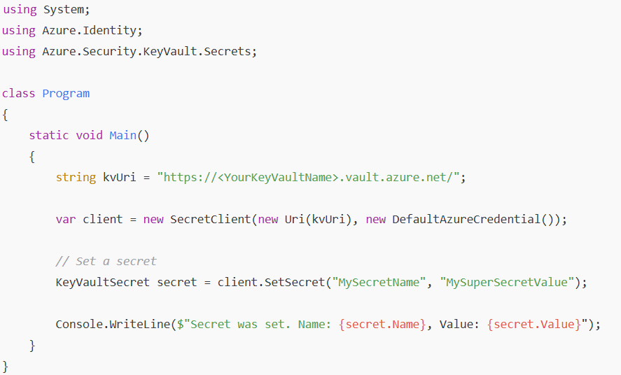

✅ Retrieving a Secret

✅ Creating a Key
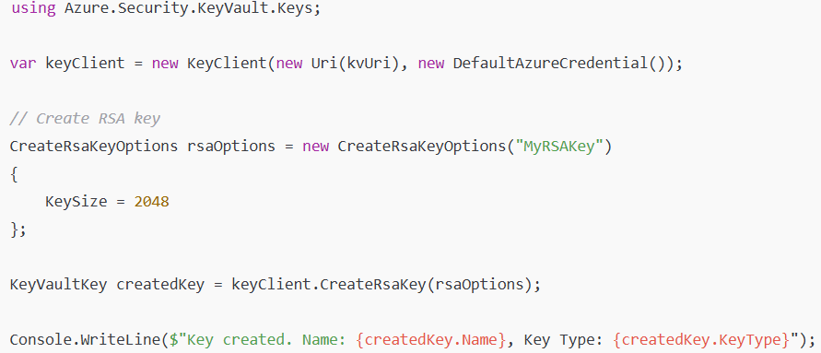
✅ Retrieving a Key

🔷 When to use Azure Storage Queue
✅ Use it when you need a (simple, cost-effective queue) without advanced messaging features.

Real Business Use Cases:
- Image Processing Pipeline
  - Users upload images to Blob Storage.
  - Your app places a message with image details in Storage Queue.
  - Azure Function (Queue Trigger) processes the image (resize, compress) and stores the output.
- Background Notification Sending
  - App writes notification tasks (email, SMS) to Storage Queue.
  - Functions read messages and call SendGrid or Twilio APIs to send notifications.
- Order Data Import Jobs
  - Bulk CSV data imported from partners generates tasks to parse and process each row.
  - Tasks added to Storage Queue and processed in parallel by Functions or VMs.
🔑 Why?
- No need for FIFO ordering or transactions
- Low cost for high volume workloads
- Simple decoupling suffices

🔷 When to use Azure Service Bus Queue
✅ Use it when you need advanced messaging features (dead-letter queues, duplicate detection, message deferral, and scheduled delivery)

Real Business Use Cases:
- Order Processing with Payment and Inventory Microservices
  - E-commerce app places an order message on Service Bus Queue.
  - Order Processing Function picks up, validates payment, updates inventory, all within a transaction.
  - Uses dead-letter queue to handle failed orders for manual review.
- Payment Processing Requiring FIFO (Sessions)
  - User initiates multiple sequential payment steps (e.g. wallet top-up then purchase).
  - Messages are processed in strict order using Service Bus Sessions.
- Delayed Notifications or Reminders
  - HR system schedules onboarding emails for new employees to be sent 3 days later.
  - Uses scheduled messages in Service Bus Queue to deliver at the exact future time.
- Financial Transaction Pipelines with Exactly-Once Processing
  - Banking apps process transactions where duplicate detection and exactly-once delivery are critical to prevent duplicate withdrawals or credits.
- Enterprise Microservices Communication with Complex Workflows
  - ERP system sends messages to multiple microservices with topics and subscriptions (pub/sub pattern) for different departments (finance, logistics, analytics).
🔑 Why?
- Needs FIFO, dead-lettering, scheduled messages, transactions, duplicate detection
- Integrates well with enterprise systems using AMQP protocol
- Ensures high reliability and messaging guarantees beyond what Storage Queue offers

Monitoring and Management
✅Azure Application Insights is an APM (Application Performance Management) tool to monitor live applications by collecting telemetry data.
✅Azure Application Insights resource/service you configured via Instrumentation Key or Connection String.
✅Telemetry data is automated runtime data sent by a lived application to give you observability into your application’s performance, usage, and failures.

✅ Use cases:
✔ Detect performance bottlenecks
- Identify slow dependencies or operations.
✔ Diagnose failures
- View unhandled and handled exceptions with stack traces.
✔ Capacity planning
- Use metrics to plan scaling (e.g. requests/sec trends).
✔ Usage outcomes:
- Ops team monitors API health, performance, and error rates.
- Business team views daily order counts and sales metrics in dashboards.
- Developers debug failures with exact traces and stack traces in App Insights.
🔷How to instrument application to send telemetry data to Application Insights?
✅ Adding Application Insights SDK and configurations so that your app automatically sends telemetry data to Application Insights.
✔ Step 1. Install NuGet package
dotnet add package Microsoft.ApplicationInsights.AspNetCore

✔ Step 2. Configure in Program.cs
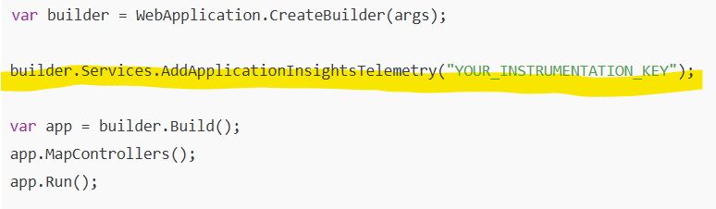
➡ Replace YOUR_INSTRUMENTATION_KEY with the key from your Application Insights resource ➔ Overview.

✅ Once instrumented, your app will automatically send telemetry data like requests, dependencies, and exceptions to Application Insights.

Type | What it includes | How it is sent
Default telemetry | Requests, dependencies, unhandled exceptions, performance metrics, traces (if using ILogger) | ✅ Automatically sent by the SDK to Application Insights
Custom telemetry | Your own events, metrics, traces, handled exceptions | ❌ Manually sent using TelemetryClient SDK calls in your app code

🔷 Different Types of Telemetry Data Collected
🔷 1. Requests (Default)
✅ Captures incoming HTTP requests to your app.
Includes | Example
Name | GET /api/products
Timestamp | When request was received
Duration | 300 ms
Response code | 200, 404, 500
Success flag | true/false
Cloud role instance | Server or container handling request
✅ Use cases:
- Analyze API performance
- Identify slow requests
- Monitor request failure rates
- Monitor API performance ➔ Identify slow endpoints affecting users.

✅ Collected Automatically once we installed the SDK, but we can configure it.
✅Filter requests (example: ignore health check endpoint)

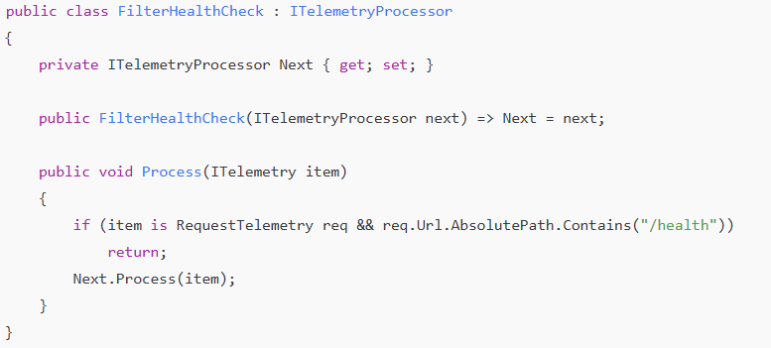

🔷 2. Dependencies (Default)
✅ Captures outgoing calls your app makes to other services.
Dependency Type | Example
SQL | Querying Azure SQL Database
Service Bus | Sending or receiving messages
HTTP | Calling external REST APIs
Redis | Reading from Azure Cache for Redis

Includes | Example
Name | SELECT * FROM Products
Target | SQL server name
Duration | 120 ms
Success flag | true/false
Dependency type | SQL, HTTP, Azure Service Bus
✅ Use cases:
- Identify slow or failing dependencies
- Optimize latency-critical dependencies
- Diagnose if SQL slowness or Service Bus issues cause overall API latency.

✅ Collected Automatically once we installed the SDK, but we can configure it.
✅ Disable SQL dependency tracking
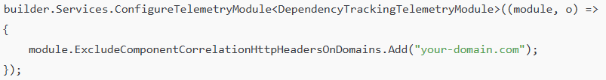
✅ Add custom properties to dependencies
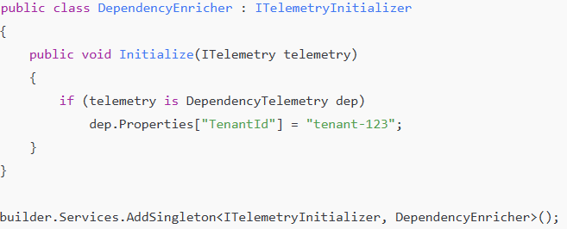

🔷 3. Exceptions
✅Captures unhandled (Default) and handled exceptions (Custom) thrown by your app.
Includes | Example
Type | SqlException
Message | Timeout expired
Stack trace | Line-level code trace
Outer/inner exceptions | Full exception hierarchy
Severity level | Error, Warning, etc.

✅Use cases:
- Debug errors with full stack traces
- Analyze frequency of specific exceptions
- Prioritize critical fixes based on failure rates

✅ Collected Automatically once we installed the SDK, Unhandled exceptions.
✅ How to track handled exceptions (Ensure TelemetryClient is injected via DI).
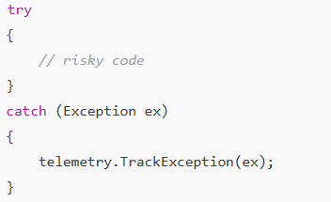

🔷 4. Traces
✅ Captures log statements from your app (Equivalent to logs but stored as telemetry items)
Includes | Example
Message | “Order processing started.”
Severity level | Verbose, Information, Warning, Error, Critical
Properties | Custom key-value data

✅ Use cases:
- Analyze app behavior with log data.
- Correlate traces with requests, dependencies, and exceptions.

✅ Collected Automatically once we installed the SDK, but we can configure it.

🔷 5. Page Views (Client-side apps)
✅Captures web page visits in front-end JavaScript apps.
Includes | Example
Page URL | /products/details
Duration | Time spent on page
User/session ID | Identify visitor

✅ Use cases:
- Analyze user navigation
- Optimize frontend UX performance

✅ Requires JS SDK integration

🔷 6. Performance Counter
✅Specific system Numeric values tracked over time (low-level resource utilization data).
Counter | Description
Processor Time (%) | CPU usage
Available Memory (MB) | Free RAM
Request Execution Time | ASP.NET request processing time
Exceptions Thrown/sec | .NET CLR exceptions rate

✅Use cases:
- Analyze performance counters
- Track business KPIs via custom metrics

✅ Collected Automatically once we installed the SDK, but we can configure it.

🔷 7. Custom Events
✅Your own defined business or application events for deeper insights.
Example Event | Properties
OrderPlaced | OrderId, CustomerId, TotalAmount
PaymentFailed | OrderId, ErrorCode, Reason
UserLoggedIn | UserId, Method (OAuth, Password)

✅Use cases:
- Track critical business workflows
- Analyze user behavior flows
- Monitor specific app milestones

✅ Must be implemented explicitly.
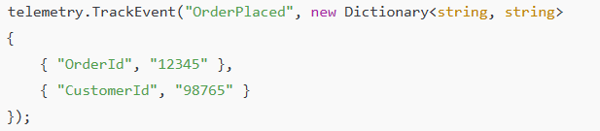

🔷Writing and Sending Custom Telemetry Data
✅Default telemetry (requests, dependencies, exceptions) gives operational insights.
✅Custom telemetry enhances visibility into:
- Business-specific events ➔ e.g. OrderPlaced, PaymentFailed
- App-specific metrics ➔ e.g. OrdersProcessedPerMinute
- Custom traces with enriched context ➔ for detailed diagnostics
✅This drives better monitoring, troubleshooting, and business analytics.

🔷What types of custom telemetry can you send?
Type | Use Case
Custom Events | Track business milestones, workflows, user actions
Custom Metrics | Track KPIs and numeric data over time
Custom Exceptions | Log handled exceptions for debugging
Custom Traces | Log app flow or debugging information with custom properties

🔷How to implement custom telemetry in .NET
✅Inject or instantiate TelemetryClient.
    - Custom Events.
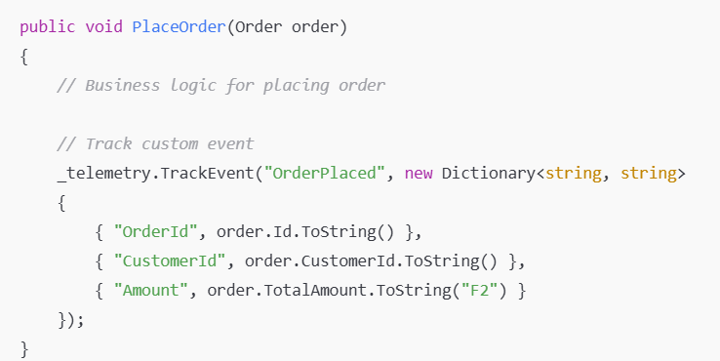
    - Custom Metric.
    - Custom Exception.
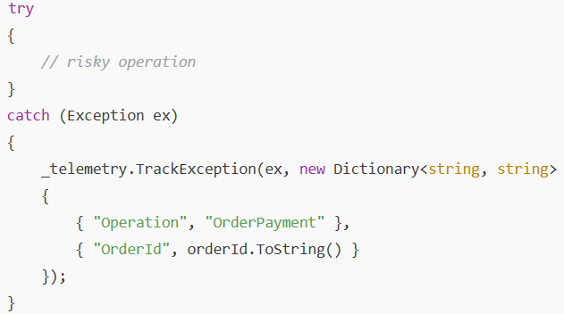
    - Custom Trace.
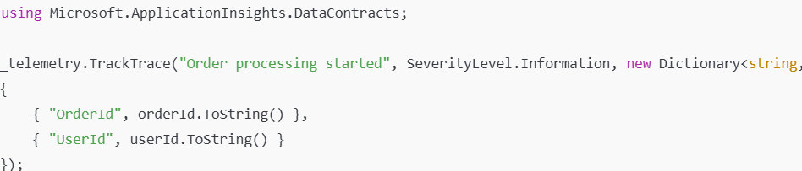

🔷Monitoring Tools
💡 1. Application Map – Visualize dependencies and bottlenecks
🔷 Application Map shows a topology diagram of your application components (App Services, APIs, SQL Databases, Cosmos DB, external services) and their interactions, with health and performance status.

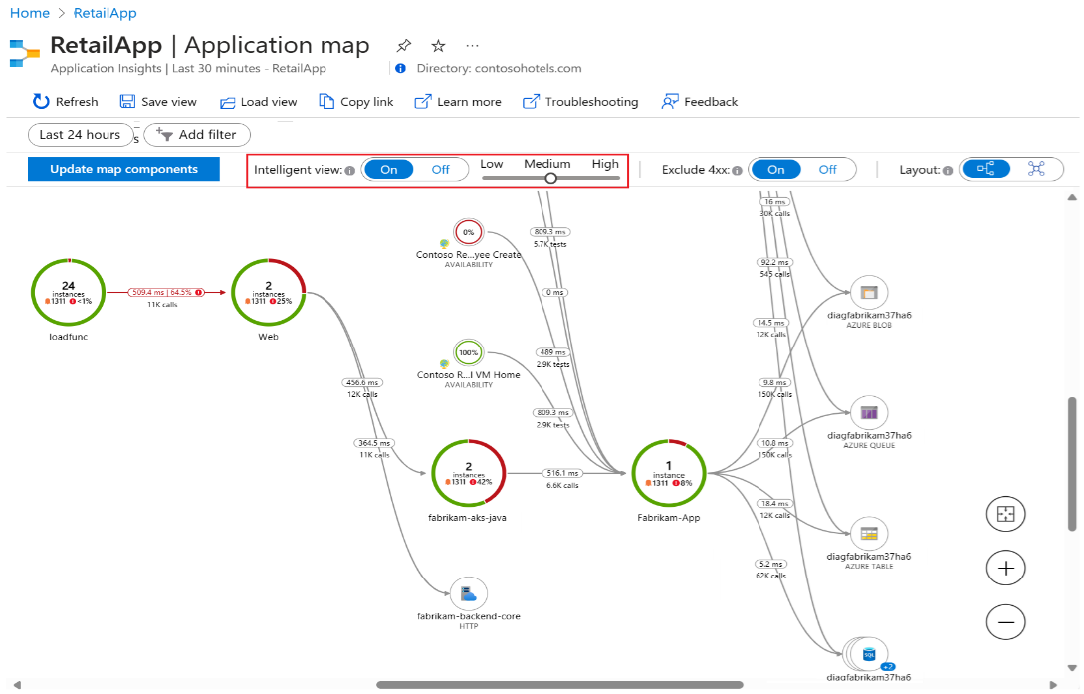

🔷 Usage:
- Go to Application Insights > Application Map in Azure Portal.
- You will see nodes representing components, with lines indicating dependency calls.
- Key insights:
  - Node health (success rate, failures, performance issues).
  - Dependency latency and failure patterns.
  - Click any node for detailed drill-down (average duration, call count, failed calls).

🔷 Mastery Tips:
- Identify which dependency or microservice is slowing down requests by checking high average durations.
- Use "Performance" tab inside a node to identify hot paths or inefficient operations.
- Look for unexpected external dependencies indicating misconfigurations (e.g., wrong endpoints or regions).

🔷 Example Use Case:
Your API is slow. Application Map shows that SQL Database dependency has an unusually high average duration. Drill into that node → open SQL dependency details → view query durations and failed queries → resolve by indexing or query optimization.

💥 2. Failures – Diagnose exceptions and failed requests
🔷 Purpose:
The Failures tab helps you pinpoint why requests fail, identifying:
- Exception types
- Failed operations
- HTTP response codes

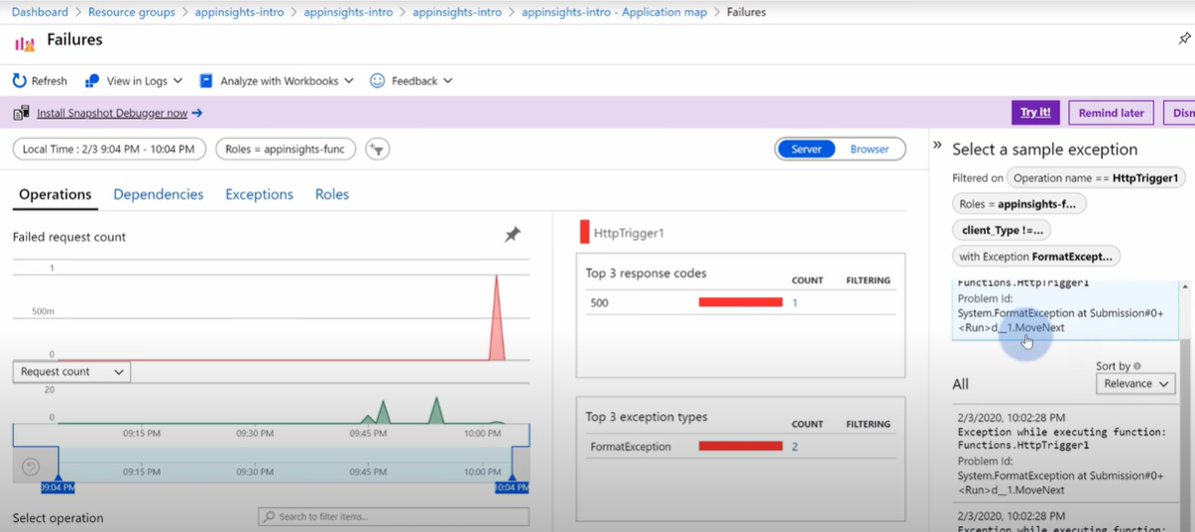
🔷 Usage:
- Go to Application Insights > Failures.
- View top failed operations, response codes, and failure trends.
- Click on an operation to:
  - See sample failed requests
  - View exception stack traces
  - Identify affected endpoints or user sessions

🔷 Mastery Tips:
- Sort by impact and count to prioritize critical failures.
- Check "Related Items" to find dependencies involved during failures.
- Filter by operation name or response code to isolate root causes.
- Use end-to-end transaction diagnostics (Enable full Application Insights Profiler) to trace failures through multiple services.
🔷 Example Use Case:
A POST endpoint returns 500 errors. Failures tab shows frequent SqlException: timeout expired. Drill into dependency calls to identify slow SQL queries causing the server error. Apply query tuning or database performance improvements.

🚀 3. Performance – Analyze and improve response times
🔷 Purpose:
Performance tab shows:
- Average response times
- Slowest operations
- Operation performance distribution

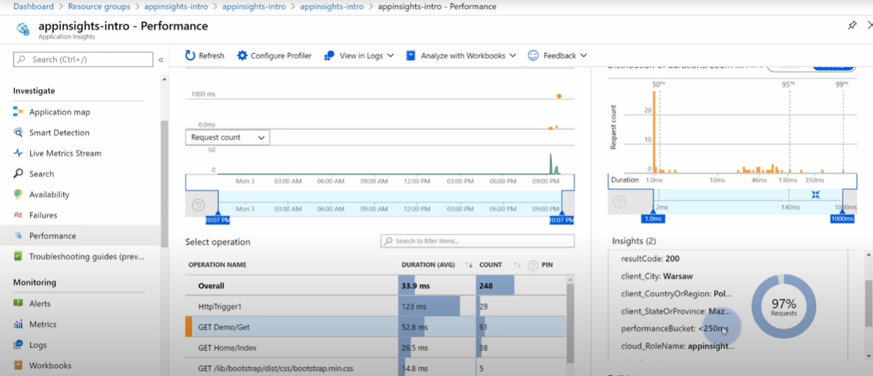

🔷 Usage:
- Go to Application Insights > Performance.
- View operations sorted by average duration or percentile distribution.
- Click an operation:
  - View detailed response time samples
  - See dependency calls contributing to response time
  - Use "End-to-end transaction details" to trace bottlenecks.

🔷 Mastery Tips:
- Focus on 95th percentile performance to improve user experience under load.
- Investigate operations with:
  - High average duration
  - High variance (some requests fast, some extremely slow)
- Enable Application Insights Profiler to capture code-level traces and pinpoint slow methods or loops.

🔷 Example Use Case:
Your API’s GET endpoint has an average of 150ms but a 95th percentile of 3s. Click the operation, open slow sample traces, identify the specific dependency or internal method causing spikes, and optimize accordingly.

Serverless Computing
✅Serverless computing is a cloud execution model where the cloud provider manages the infrastructure, scaling, and server management, letting developers focus purely on code.
✅Developers deploy code as functions, and these functions are executed in response to events or triggers without the need to manage the underlying infrastructure.
📝 “Serverless” does not mean there are no servers; it means servers are abstracted away from the developer.
🔍 Serverless Differs from Traditional Cloud Computing
Aspect | Traditional Cloud Computing (IaaS/PaaS) | Serverless (FaaS)
Infrastructure Management | Developers/ops teams manage VMs, OS patches, runtime environments (IaaS) or at least configure runtime and scaling rules (PaaS). | You deploy functions; Entirely managed by cloud provider. No server/OS/runtime management.
Provisioning | Resources are provisioned upfront (VMs, App Service Plans) and remain allocated even if idle. | No upfront provisioning. Functions are instantiated dynamically only when invoked.
Scaling Model | Manual or auto-scaling needs to be configured, and scaling units are typically VMs or containers. | Auto-scales instantly and granularly per function execution.
Billing Model | Pay for provisioned resources regardless of usage (per hour or per second for VMs/containers). | Pay only per execution: based on number of requests and execution duration (GB-s).
Deployment Unit | Applications or services packaged as VMs, containers, or app services. | Functions: single-purpose pieces of code tied to events.
Use Cases Fit | Long-running applications, stateful systems, traditional web apps. | Event-driven workloads, microservices, APIs, stream processing, automation scripts.

🚀Benefits of Serverless Computing
🔷 1. Scalability
- Automatic and granular scaling: Each function execution is handled by a separate instance if needed. If there are 1 million events, the cloud provider will scale to handle them concurrently (within service limits).
- No need for manual scaling rules or overprovisioning.

🔷 2. Reduced Operational Overhead
- No server provisioning, patching, or maintenance.
- The cloud provider handles runtime updates, scaling infrastructure, and availability.
- Developers focus only on business logic, reducing DevOps complexity.

🔷 3. Cost-effectiveness
- Pay-per-use pricing model:
  - You pay for the exact number of invocations.
  - Billed based on execution time and memory consumption (GB-s).
- No costs when idle (unlike provisioned VMs or containers that incur costs even if idle).

🔷 Situations where traditional cloud is better
Use Case | Why traditional cloud is needed
Long-running processes | Serverless functions have time limits (e.g. Azure Functions default is 5 mins, max 60 mins in Premium). For tasks running for hours (e.g. video rendering, scientific compute), VMs or containers are required.
Stateful applications | Serverless is stateless. Apps needing persistent memory between requests (e.g. in-memory cache-heavy apps) fit better on VMs or containers.
Heavy, predictable workloads | If your application has consistent, high resource usage 24/7, provisioning dedicated VMs or App Services might be cheaper than pay-per-use pricing.
Legacy applications | Apps built with older technologies not supported in serverless environments require VMs (e.g. legacy Windows apps needing .NET Framework or specific OS configurations).
Custom runtime requirements | Some apps require custom OS libraries, drivers, or configurations that cannot run in restricted serverless environments.
Specific compliance or network requirements | Certain regulatory requirements or VPN integrations are easier to manage in VM or container-based architectures.
Control over environment | Traditional cloud gives you full control over OS, network configs, runtime versions, and software installations. Serverless abstracts these away (both benefit and limitation).

✔️ Serverless = best for event-driven, short-running, scalable, cost-effective workloads without managing infrastructure.
✔️ Traditional cloud (IaaS/PaaS) = best for long-running, predictable, stateful, legacy, or highly customized workloads requiring control over environment.

🔷Azure Functions allow you to write less code
✅ Event-driven, binding-based programming
Azure Functions integrate triggers and bindings, which abstract away the repetitive boilerplate code needed to connect to services.

🔻 Example Without Azure Functions (Traditional App Service or VM)
You would need to:
- Write full web server code (e.g. Express.js for Node.js, ASP.NET controllers for C#).
- Handle HTTP server setup and routing.
- Install and manage SDKs for every service you integrate (e.g. Azure Storage SDK to read blobs).
- Implement authentication and middleware manually.

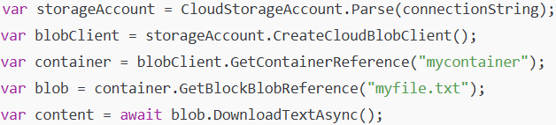

🔻 With Azure Functions:
- Write only the business logic, because:
  - Triggers handle how the function is invoked (e.g. HTTP, timer, queue).
  - Bindings handle reading/writing data to services automatically, without full SDK code.

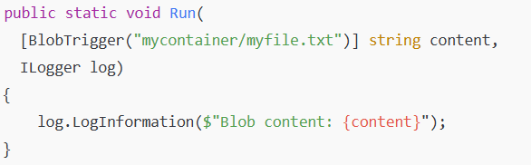

🔷 Azure Functions allow you to maintain less infrastructure
✅ Serverless nature:
- No VM provisioning
- No OS or runtime patching
- No App Service plan configuration for consumption tier

✅ Azure maintains:
- Compute infrastructure
- Load balancing
- Scaling (up and down to zero automatically)
- Runtime environment updates and security

Task | Traditional (VM/App Service) | Azure Functions
OS updates | You manage | Azure manages
Runtime updates | You manage versions & compatibility | Azure manages (you select runtime version only)
Scaling configuration | You define scaling rules & instances | Auto-scales per request with no config
Health monitoring | You setup and maintain | Azure manages compute health

🔷 Azure Functions save costs
✅ Pay-per-use pricing model
Traditional App Service Plan | Azure Functions (Consumption Plan)
Pay for the compute plan (e.g. B1: ~$55/month) regardless of traffic. | Pay only when function is executed. Cost = executions x execution time x allocated memory.
Always incurring cost, even at 0 usage. | Zero cost when no requests occur.

✅ Cost example
If your function:
- Runs 1 million times per month
- Takes 500ms per execution
- Allocated memory 512MB

🔹 Azure Functions (Consumption plan):
- Approx cost = $0.20 per million executions + $0.000016/GB-s (price example)
- Total could be < $2/month.
🔹 Compare with App Service Plan (~$55/month) or VM ($20-$100/month) even if idle.
🔹Additional cost efficiency features
✔️ Auto scaling to zero: No idle cost
✔️ No over-provisioning: Always enough compute to meet demand
✔️ Integrated with Event Grid, Service Bus, Blob Storage: Reduces architecture complexity and maintenance cost
✅ Because Azure Functions provides:
- Triggers: Automatically handle how the function is invoked
- Bindings: Automatically handle how to get data in/out of other services
You focus only on core business logic, not boilerplate setup.

🔷 What is a Trigger in Azure Functions?
✅ A trigger is an event source that causes your function to execute.
✅ Each function must have exactly one trigger.
✅ Different triggers connect to different services.

🔷 Types of Triggers
🚀 (a) HTTP Trigger
🔑 Executes your function when an HTTP request is received (GET, POST, PUT, DELETE).
🔹 Use cases:
- Create REST APIs
- Webhook receivers
- Serverless microservice endpoints

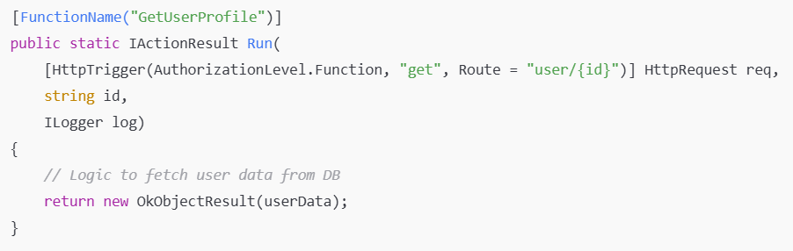

✅ Can define route parameters for clean URLs.
✅ Supports different authorization levels (Anonymous, Function, Admin).

🚀 (b) Timer Trigger
🔑 Executes your function on a scheduled interval using a CRON expression.
🔹 Use cases:
- Scheduled jobs (daily database cleanups)
- Sending periodic reports
- Health checks
🔹 Example:
- Runs every day at 9 AM UTC:

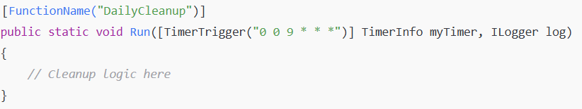

✅ Uses CRON syntax (second, minute, hour, day, month, day-of-week).
✅ Runs even if no external event occurs.

🚀 (c) Queue Trigger
🔑Executes when a new message is added to an Azure Storage Queue.
🔹 Use cases:
- Decoupled background processing
- Order processing systems
- Thumbnail generation after image upload
🔹 Example:
    - Process order messages from a queue:
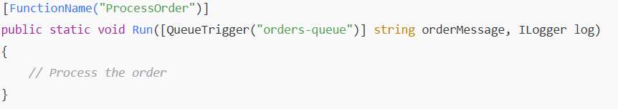
✅ Provides at-least-once delivery (messages may be retried if failures occur).
✅ Good for asynchronous workloads to offload heavy processing.
🚀 (d) Blob Trigger
🔑 Executes when a blob is added or modified in Azure Blob Storage.
🔹 Use cases:
- Image resizing after upload
- File format conversion
- Data ingestion pipelines (e.g. process CSV files uploaded to storage)
🔹 Example:
- Run function when a new image is uploaded:
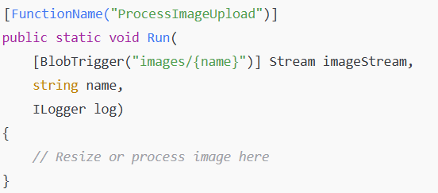
✅ Monitors specified containers for new or updated files.
🚀 (e) Service Bus Trigger
🔑 Executes when a message is added to an Azure Service Bus Queue or Topic Subscription.
🔹 Use cases:
- Enterprise message-driven workflows
- Order or payment processing pipelines
- Event-based microservice communication
🔹 Example:
- Process messages from Service Bus queue:
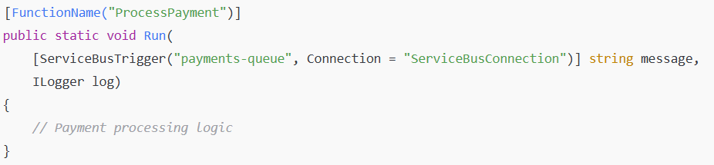
✅ Supports:
- Queues, Topics + Subscriptions
✅ Useful for enterprise-scale messaging patterns with decoupled microservices.
🔷 Bindings in Azure Functions
✅ Bindings are declarative connections to external services that:
- Input binding: Pull data from an external source into your function
- Output binding: Send data from your function to an external service
✔️ They abstract away SDK code – Azure Functions runtime handles the integration.

🔷 Why are bindings powerful?
✅ You don’t write full SDK setup and calls.
✅ You just define attributes in your function signature, and the runtime injects data or handles output operations.

🚀 Types of Bindings
🔷 (a) Blob Storage Binding
✔️ Input Binding: Reads blob content
✔️ Output Binding: Writes data to a blob
🔹 Use cases:
- Processing uploaded files (images, CSVs)
- Saving processed data to storage

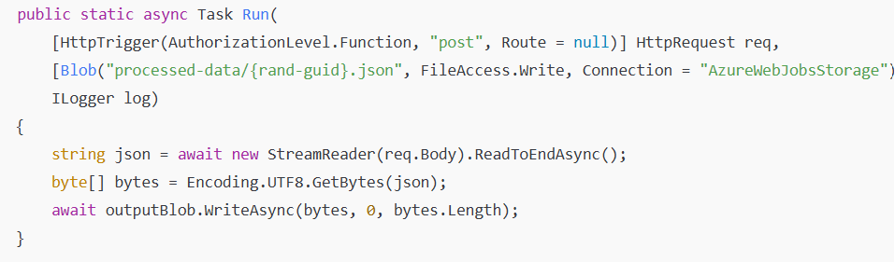
✅ Writes incoming HTTP body to a blob with a random GUID filename.
🔷 (b) Queue Storage Binding
✔️ Input Binding: Queue Trigger itself (e.g. processing messages)
✔️ Output Binding: Places a message into a queue
🔹 Use cases:
- Decoupling tasks into asynchronous pipelines
- Sending notifications or next-step processing messages

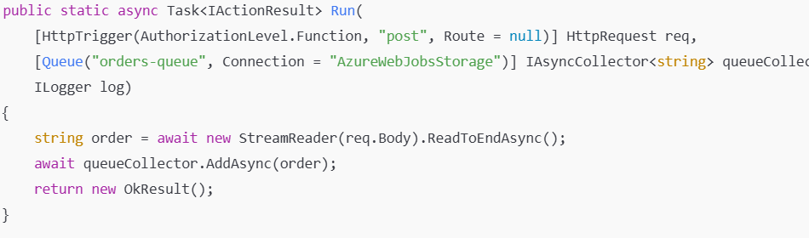
✅ Receives an HTTP POST request and adds body content to a queue.

🔷 (c) SendGrid Binding
✔️ Output Binding only
🔹 Use cases:
- Sending emails (confirmations, alerts) without writing SMTP client code

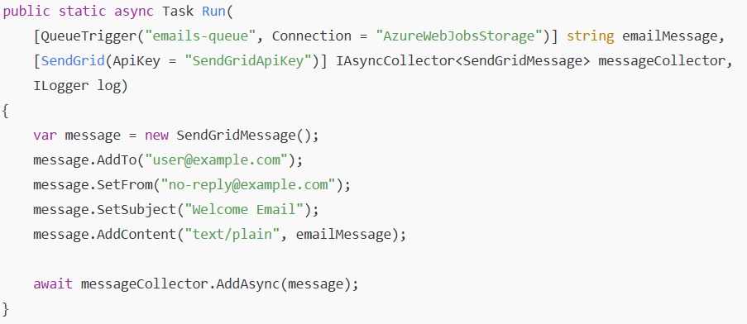
✅ Reads message from queue trigger
✅ Sends an email using SendGrid binding with minimal code

🔷 (d) Service Bus Binding
✔️ Input Binding: Triggers when a message arrives in Service Bus queue or topic
✔️ Output Binding: Sends a message to Service Bus
🔹 Use cases:
- Enterprise event-driven architectures
- Microservices integration with decoupled messaging

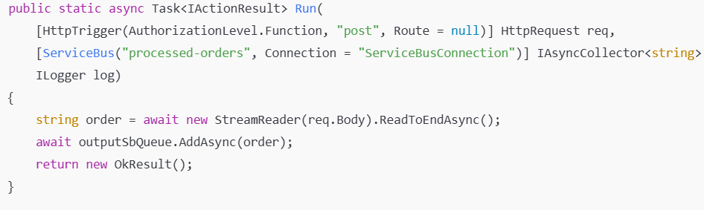
✅Receives HTTP POST request
✅Adds the order data to a Service Bus queue named processed-orders

🔷 Binding Direction
✅ Binding Direction specifies how your function interacts with the external service:
- Input binding: Brings data into your function.
- Output binding: Sends data from your function to an external service.
- Both: Some bindings support both directions (read and write).

🚀 Types of Binding Directions
🔷 (a) Input Binding
🔑 Provides data to your function before execution. The function can then use it as an input parameter.
Example: Reading blob contents.
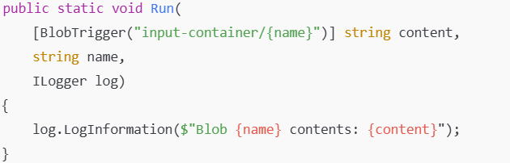
✅ The blob trigger itself is an input binding.
✅ The blob content is injected as string content before function logic runs.

🔷 (b) Output Binding
🔑 Sends data from your function to an external service after execution.
Example: Writing to a queue.
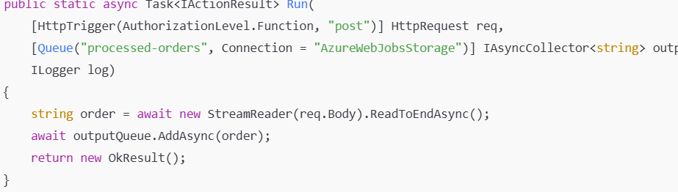
✅ outputQueue is an output binding that sends messages to a queue.

🔷 (c) Both (Input + Output) Binding
🔑 Some bindings (like Cosmos DB) allow both reading and writing in the same binding definition.
Example: Cosmos DB binding used to read a document and optionally write an updated document back.
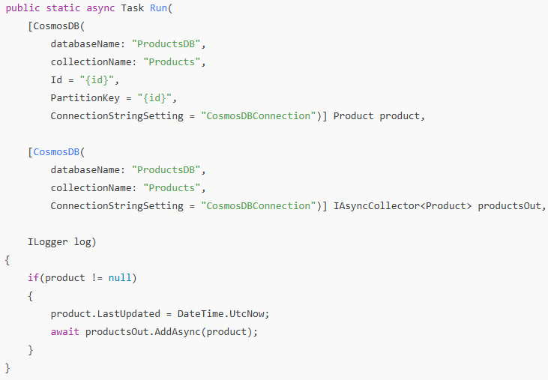
✅ The first binding is input: retrieves product by ID.
✅ The second binding is output: writes updated product back to Cosmos DB.
🔷 Multiple Binding
✅ In Azure Functions, you can use multiple bindings in a single function to:
- Receive data from multiple input bindings
- Send data to multiple output bindings
This allows you to integrate different services without writing extensive SDK code, creating clean, efficient, event-driven workflows.

✅ Why use multiple bindings?
✔️ Combine input and output operations in one function
✔️ Simplify your code by declaring service connections declaratively
✔️ Achieve atomic processing logic (e.g. process data → store result → notify)

🔑 Key points for multiple bindings:
✔️ A function can have only one trigger but multiple input/output bindings.
✔️ Bindings are declared in function parameters or configuration (function.json).
✔️ Use IAsyncCollector<T> for output bindings to add multiple items asynchronously (e.g. queues, emails).

✅ Scenario (Process an order message from a queue):
  - Trigger: Queue message arrives
QueueTrigger: Starts function when a new order message arrives.

  - Input binding: Read product details from Cosmos DB
Cosmos DB Binding: Reads product details by order ID.

  - Output binding 1: Save processed order to Blob Storage
Blob Storage Binding: Writes processed order data as JSON file.

  - Output binding 2: Send order confirmation email via SendGrid
SendGrid Binding: Sends order confirmation email.
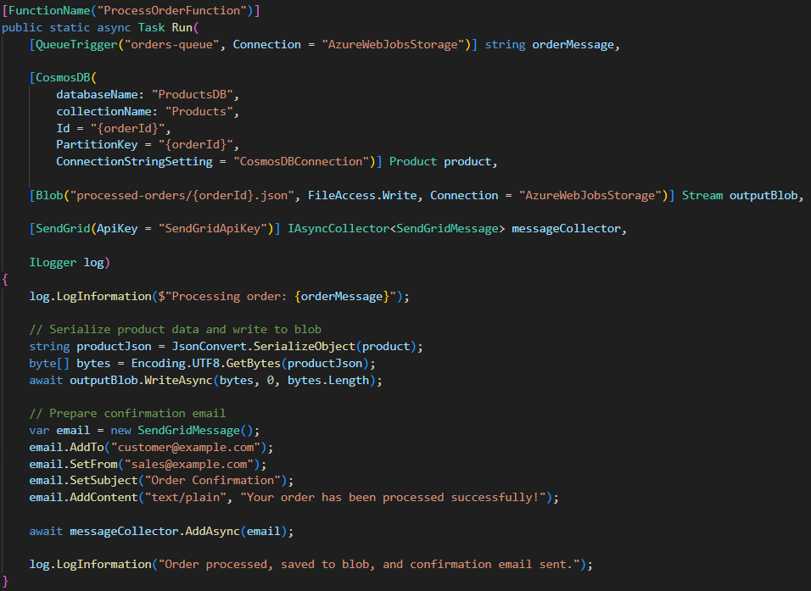
🔷 Integrating Azure Functions with DLLs
Approach A. Direct project reference.
dotnet add reference ../MyLibrary/MyLibrary.csproj

Approach B. Referencing external DLLs directly (without NuGet packages)
- Place the DLL files in a folder within your function project (e.g. libs/).
- In Visual Studio, right-click each DLL → Properties → Copy to Output Directory → Copy Always.
- Add references to them in your .csproj:
- When you publish the function, these DLLs are included and accessible at runtime.

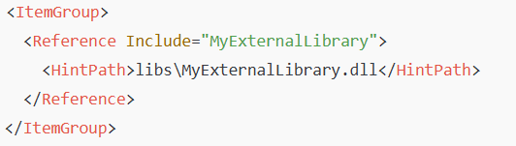

✅ Notes:
- If the DLLs have dependencies, ensure their dependency DLLs are also copied and referenced.
- Check for compatibility with your runtime (e.g. targeting .NET 6 runtime when using .NET Standard 2.0 DLLs).

Approach C. Using NuGet packages (preferred for third-party libraries)
Whenever possible, use NuGet packages instead of raw DLLs.
- They handle transitive dependencies automatically.
- They are optimized for compatibility and easier upgrades in CI/CD.

