Angular
✅ Angular is a TypeScript-based web framework developed by Google to build:
- Single Page Applications (SPAs)
- Large-scale web apps with structured architecture
- Reusable components with strong typing and reactive state

✅Angular CLI (Command Line Interface) is a tool to create, build, test, and deploy Angular projects efficiently.

🔎 Commands
Creating a new project | ng new my-app
Build and serve your app | ng serve
Run tests | ng test

✅Angular Component
A component is a building block of an Angular app. It has:
- TypeScript class → defines logic and data
- HTML template → defines what is shown
- CSS styles → defines how it looks

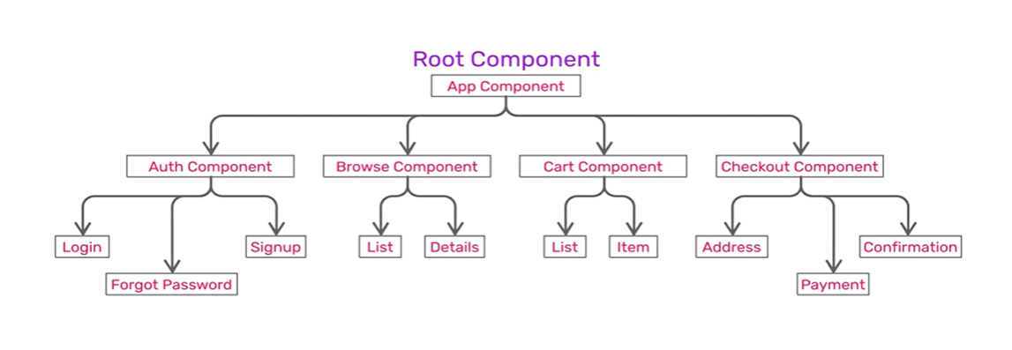
➡️ Components = reusable, reactive UI pieces with logic, template, and style.

✅Component Metadata
Metadata is the configuration passed to @Component() decorator. It tells Angular how to use, render and process the component at the runtime.
✅@Component() is a directive decorator, Whenever Angular renders the directive, it changes the DOM according to the instructions given by the directive.
Property | Purpose | Example Value
selector | The HTML tag name for this component | 'app-user-profile'
template | Inline HTML template | <p>Hello</p>
templateUrl | Path to external HTML template file | './user-profile.html'
styles | Inline CSS styles | [p { color: red; }]
styleUrls | Path(s) to external CSS file(s) | ['./user-profile.css']
imports | Other standalone components/pipes used here | [CommonModule]
standalone | Declares if the component is standalone | true
encapsulation | ViewEncapsulation mode (Emulated, ShadowDom) | ViewEncapsulation.None

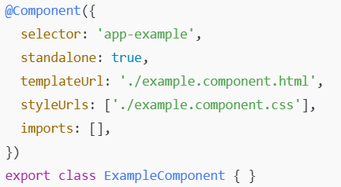

✅ Interpolation in Angular is a way to bind data from your TypeScript class in the HTML template using {{ }} syntax.

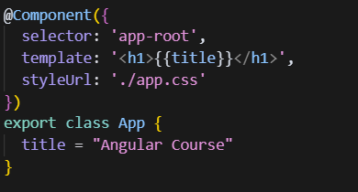

➡️ Explanation
- {{ userName() }} displays the reactive userName signal value.
- You can use pipes (like date) inside interpolation.

💡If the title is null or undefined will display an Empty.
💡Interpolation treats all data types as a String.

💡Example: Display sum of two values
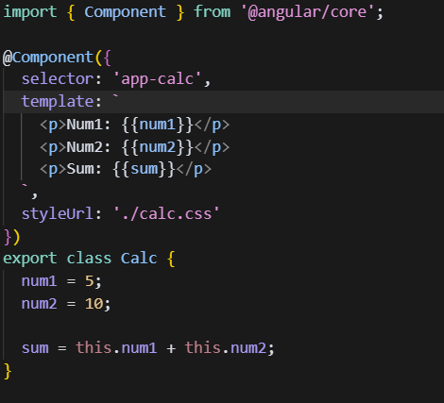

✅Property binding sets HTML element or directive properties dynamically from component class properties. [property]="expression"

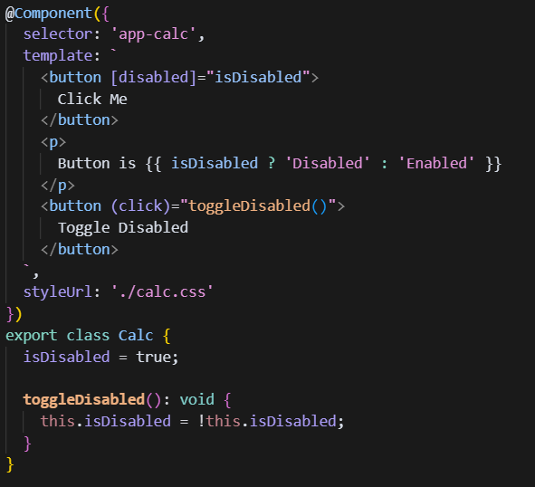
➡️ Explanation
- [disabled]="isDisabled" binds the button's disabled property to the signal value.
✅Event binding allows your template to listen to DOM events (like click, input, change) and execute component methods when they occur. (event)="method()"
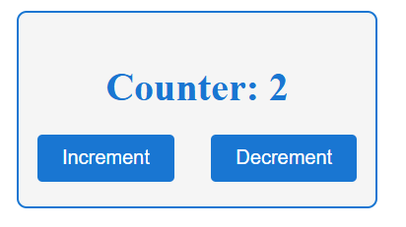
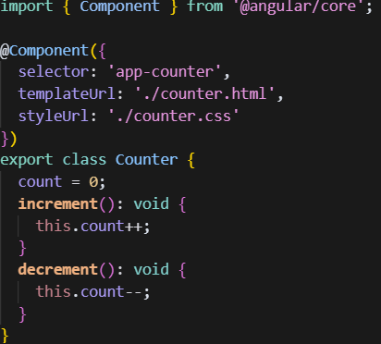
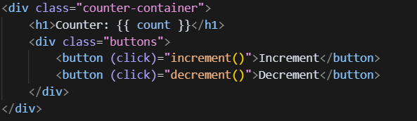
➡️ Explanation
- (click)="increment()" binds the button’s click event to the increment() method.

💡 Event Types
(click) (dbclick) (mouseover) (mouseleave)
(mousedown) (mouseup)

✅Keyboard event: You can bind to keyboard events (keydown, keyup, keypress, keyup.enter) in your templates to handle user input dynamically.
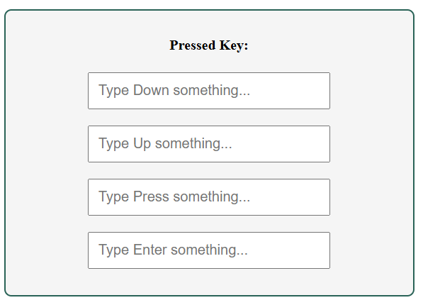
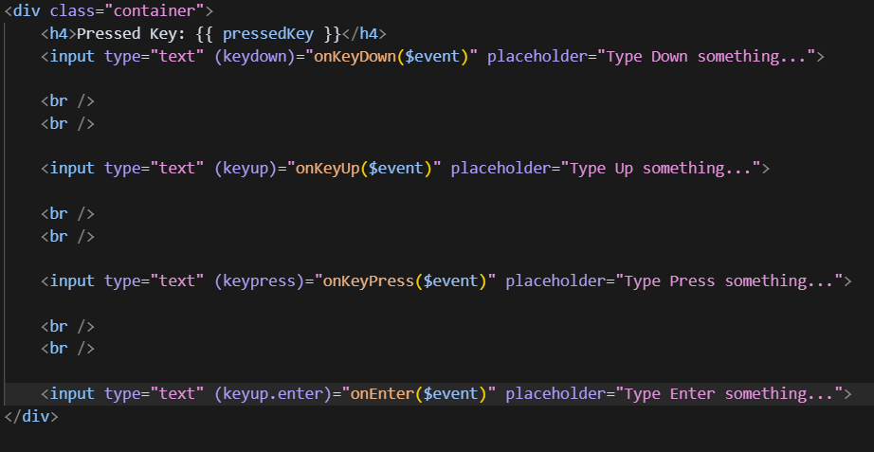
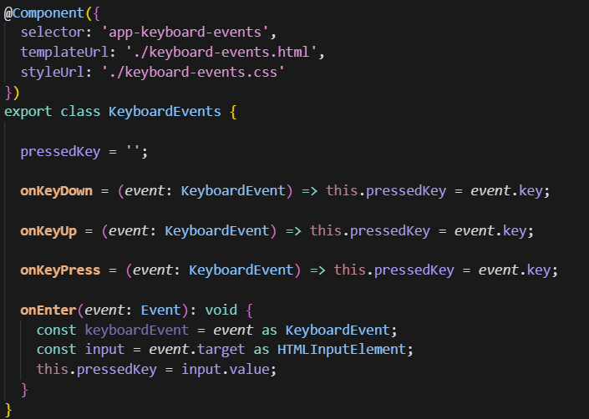

➡️ Explanation
- (keydown)="onKeyDown($event)": binds the keydown event and passes the event object.
- event.key: retrieves the key pressed by the user.
- pressedKey is a string holding the latest pressed key reactively.
✅ $event is a reserved keyword to handle events in angular & contains a lot of information when the event is raised.
✅ It represents the DOM event object that is passed to an event handler when an event is triggered.

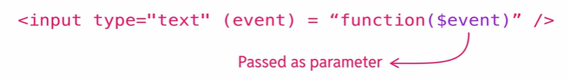

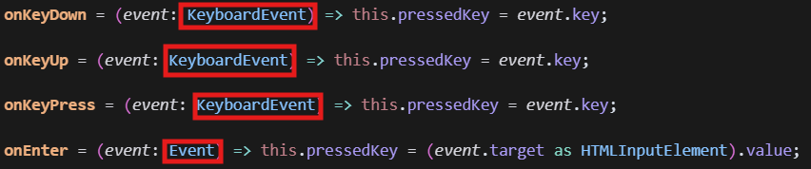

✅ Using $event to prevent default behavior.

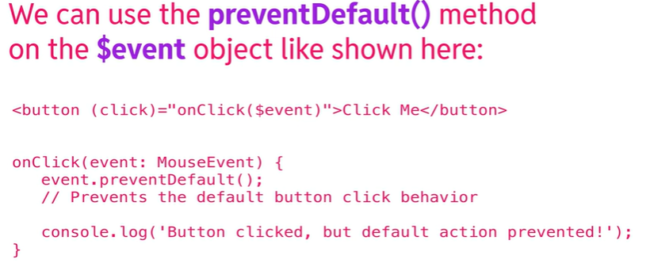

✅ Two-way binding links data from your component class to the template and back, keeping them in sync automatically.

🔎 Syntax
- Using [(ngModel)] directive: <input [(ngModel)]="property">
- This is called banana-in-a-box syntax

💡 FormsModule must be imported for ngModel to work.

➡️ Explanation
- [(ngModel)]="name" binds the input value to name property both ways:
  - Updates the input when name changes
  - Updates name when input changes

