CPENTv2 EXAMINATION REPORT
Active Directory Range
Report Date: 09 September 2026
Assessment Type | CPENTv2 Examination — Active Directory Range
Domain | CPENTv2025.com
Range | 172.25.170.0/24
Primary Systems Referenced | RANGEADSERVER19 (.12), AD-WIN (.50), WINDOWS11 (.140), ADRANGEBASE22 (.200)
Assessment Platform | Kali Linux

Question 1 — Local Administrator Password Identification
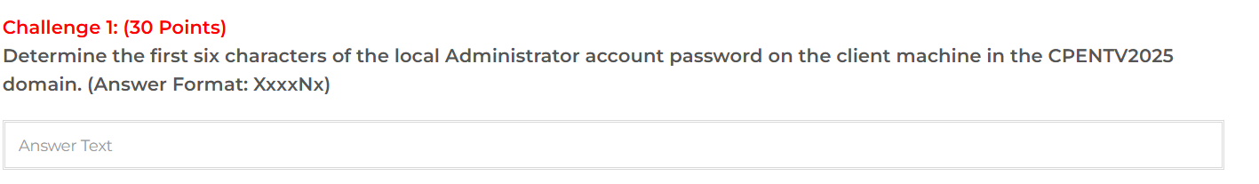
Assessment date: 09 September 2026 | Points: 30
Objective: Determine the first six characters of the local Administrator account password on the Windows 11 client in the CPENTV2025 domain.
Target: 172.25.170.140 (WINDOWS11) | Windows 11 Build 22000 x64 | SMB/445

Methodology

SMB enumeration identified the Windows 11 client. Administrative access was subsequently used to enumerate the local SAM database and identify local accounts. The local Administrators group was also enumerated to distinguish the intended local administrative account.
Relevant SAM result:
Administrator (RID 500) -> 31d6cfe0d16ae931b73c59d7e0c089c0
Admin (RID 1002) -> 3dedf452f612c78c21685d2696614848
Chasity (RID 1009) -> bef7b51c0b60cf2c2415db091c2648a3
The Admin account (RID 1002) was identified as a member of the local Administrators group. Its NTLM hash was recovered as Pott3r@123, giving the first six characters Pott3r.
Answer
Pott3r
Format validation: Pott3r matches the required XxxxNx pattern.
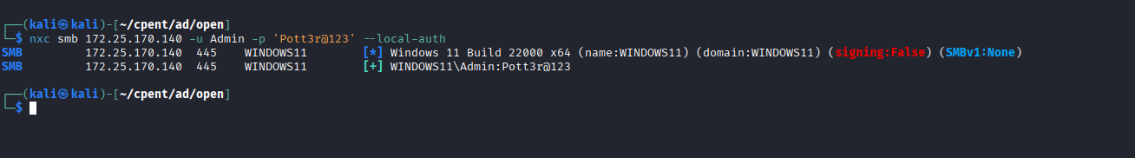

Security impact: A recoverable local administrative password can provide administrative control of the endpoint.
Recommendation: Use unique, high-entropy local administrator passwords, deploy Windows LAPS, minimize local Administrators membership, and monitor abnormal administrative SMB activity.

Question 2 — Stewart Account Password Identification
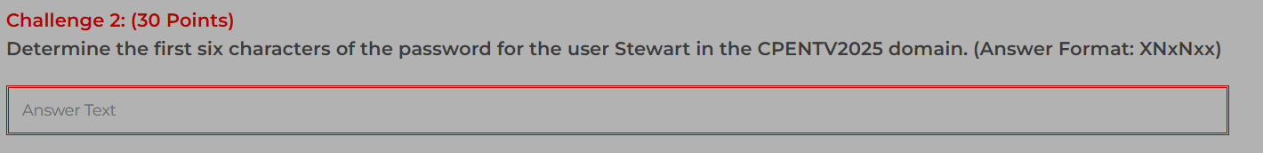
Assessment date: 09 September 2026 | Points: 30
Objective: Determine the first six characters of the password for the domain user Stewart.
Target: 172.25.170.12 (RANGEADSERVER19) | SMB/445 | Domain: CPENTv2025.com

Methodology
Domain user enumeration identified Stewart and other accounts on the target. The discovered Stewart account was then tested against the wordlist supplied within the CPENT examination environment using SMB authentication.
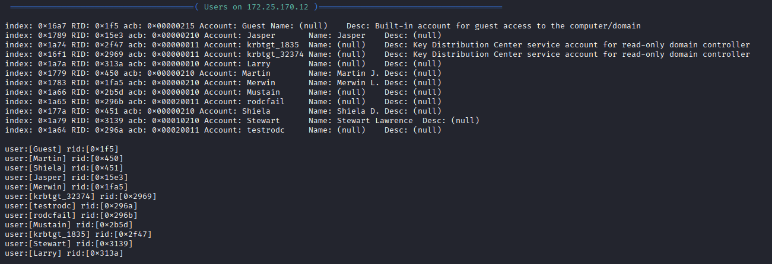
Figure 1 Enum4linux evidence identifying Stewart and Mustain on 172.25.170.12.
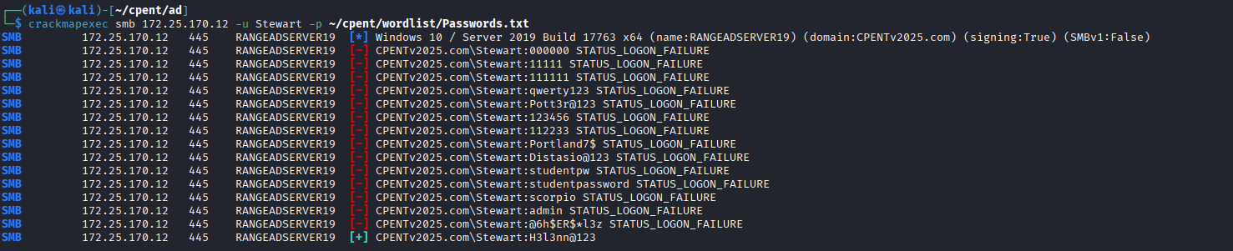
Figure 2 SMB authentication testing using the examination-provided Passwords.txt wordlist; successful Stewart authentication is shown.

Recovered credential
CPENTv2025.com\Stewart:H3l3nn@123
Answer: H3l3nn
Security impact: Weak or predictable domain passwords can provide an initial foothold for unauthorized authentication.
Recommendation: Enforce strong unique domain passwords, prevent common-password use, monitor repeated SMB authentication failures, and apply appropriate authentication controls.

Question 3 — Identification of the George-Managed RODC

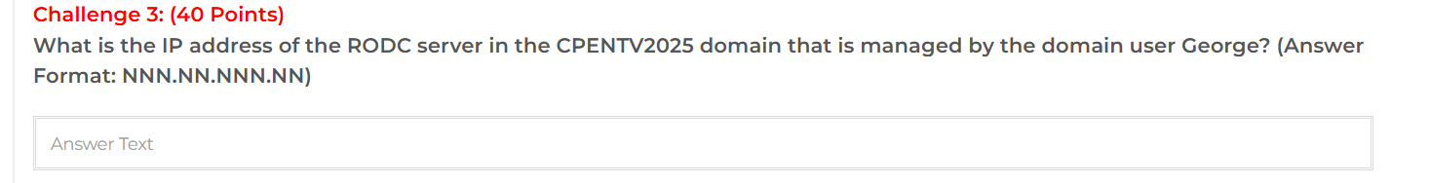
Assessment date: 09 September 2026 | Points: 40
Objective: Identify the IP address of the RODC in the CPENTV2025 domain that is managed by the domain user George.
Target identified through LDAP: RANGEADSERVER19

LDAP Enumeration
LDAP filter: (objectClass=computer)
RANGEADSERVER19
userAccountControl: 83890176
dNSHostName: RangeADServer19.CPENTv2025.com
managedBy: CN=George,CN=Users,DC=CPENTv2025,DC=com
The LDAP results identify RANGEADSERVER19 as the computer object managed by George, with the supplied userAccountControl value corresponding to the RODC configuration in the examination evidence.

IP Address Validation
Nmap scan result:
Nmap scan report for RANGEADSERVER19 (172.25.170.12)
Host is up (0.087s latency)
Key AD-related services observed: 88/tcp, 389/tcp, 445/tcp, 636/tcp, 3268/tcp, 3269/tcp, 9389/tcp

Answer: 172.25.170.12
Security impact: Correct identification of an RODC can support targeted enumeration and subsequent credential-access activities.
Recommendation: Restrict administrative exposure of domain controllers, monitor LDAP/SMB enumeration, and review RODC configuration and credential caching policies.

Question 4 — Joshua Domain Administrator Password Identification
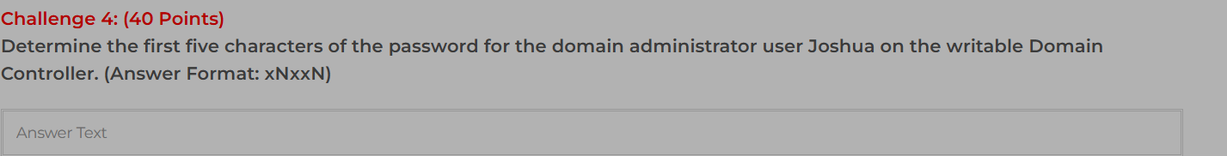
Assessment date: 09 September 2026 | Points: 40
Objective: Determine the first five characters of the password for the domain administrator user Joshua on the writable Domain Controller.
Writable DC: 172.25.170.200 (ADRangeBase22)

Credential Extraction
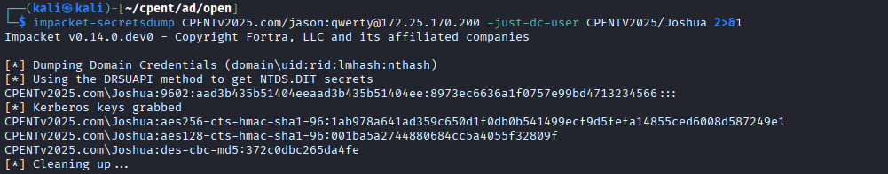
Extracted account: CPENTv2025.com\Joshua
RID: 9602
NTLM: 8973ec6636a1f0757e99bd4713234566
The supplied terminal evidence confirms use of the DRSUAPI method to obtain NTDS credential material. The extracted Joshua NTLM hash was subsequently recovered as c3ll0@123.
Answer derivation
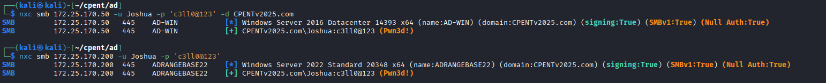

Password: c3ll0@123
First five characters: c3ll0
Answer: c3ll0
Security impact: Compromise of a domain administrator credential can provide extensive control over Active Directory resources.
Recommendation: Protect privileged accounts with strong unique credentials, MFA where supported, tiered administration, PAM, and monitoring for abnormal directory-replication activity.

Question 5 — RODC Cached Credential — Jade
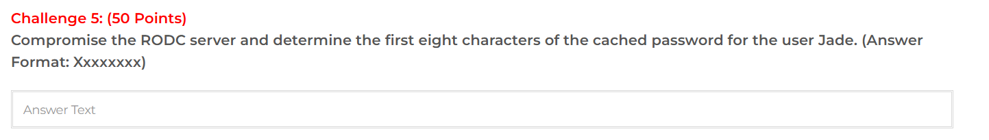
Assessment date: 09 September 2026 | Points: 50
Objective: Compromise the RODC at 172.25.170.12 and determine the first eight characters of the cached password for the user Jade.
Important account mapping: LDAP identifies CN=Jade while the sAMAccountName is Mustain.

Account Mapping Evidence
LDAP query result:
dn: CN=Jade,CN=Users,DC=CPENTv2025,DC=com
cn: Jade
sAMAccountName: Mustain
This mapping explains why credential extraction output for Mustain corresponds to the Jade account.
Credential Material
Mustain:11101:aad3b435b51404eeaad3b435b51404ee:746e12d158e767e95d8502d99050004c:::
The supplied extraction output successfully retrieved credential material for Mustain/Jade. The examination evidence records the recovered password as Distasio@123 and the first eight characters as Distasio.
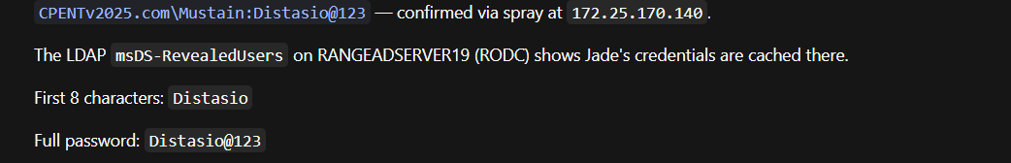

Answer: Distasio
Recommendation: Review RODC credential caching, limit which users' credentials may be cached, protect RODC administrative access, and monitor directory/credential access activity.

Question 6 — RODC Bypass — Jade NTLM Hash Analysis
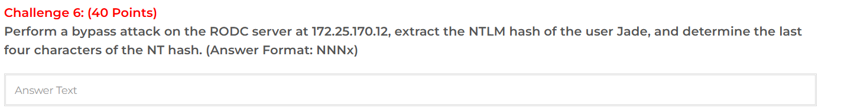

Assessment date: 09 September 2026 | Points: 40
Objective: Perform the RODC bypass attack against 172.25.170.12, extract the NTLM hash of Jade, and determine the last four characters of the NT hash.
Account mapping: Jade → sAMAccountName Mustain

Hash Extraction
Mustain:11101:aad3b435b51404eeaad3b435b51404ee:746e12d158e767e95d8502d99050004c:::
The extracted NTLM hash is 746e12d158e767e95d8502d99050004c. The final four characters are 004c.
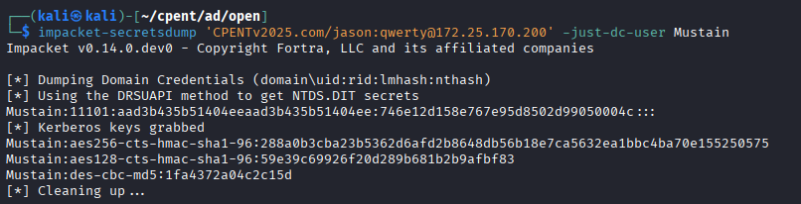

Answer: 004c
Recommendation: Monitor and restrict directory replication/credential extraction activity, harden RODCs, and review replication privileges and administrative paths.

Question 7 — RODC Number 32374
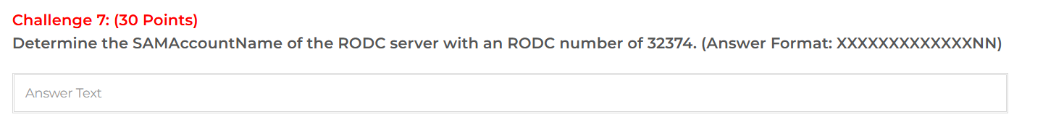
Objective: Determine the SAMAccountName of the RODC server associated with RODC number 32374.
Target/DC used for enumeration: 172.25.170.200 (ADRANGEBASE22), queried through LDAP with the authorized examination credentials.

Methodology
LDAP enumeration was used to inspect Active Directory computer/domain-controller objects. The relevant examination evidence maps the RODC Kerberos target identifier krbtgt_32374 to RANGEADSERVER19. The corresponding computer account uses the trailing '$' convention for its SAMAccountName.
The supplied LDAP output additionally confirms ADRANGEBASE22 as the writable domain controller and shows its own computer-account SAMAccountName as ADRANGEBASE22$. This output was used as supporting directory evidence; the specific krbtgt_32374 mapping is shown below .
RANGEADSERVER19: msDS-KrbTgtLink: CN=krbtgt_32374 — this is the RODC with number 32374
AD-WIN: msDS-KrbTgtLink: CN=krbtgt_1835 — this is the other RODC
RANGEADSERVER19$ (SAMAccountName of the RODC with RODC number 32374)
Answer: RANGEADSERVER19$

Question 8 — MsCacheV2 Account Identification

Methodology
The supplied examination evidence displays the relevant MsCacheV2 values and identifies the account associated with the value ending in 262e11.
Answer: Stewart
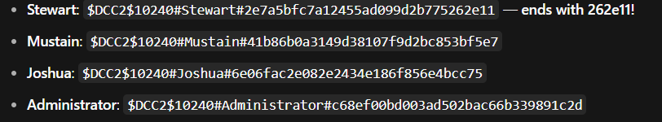

Question 9 — Client VM Fully Qualified Device Name

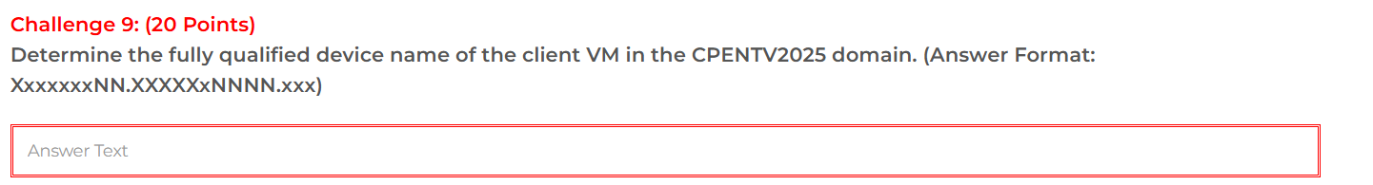
Objective: Determine the fully qualified device name of the client VM in the CPENTV2025 domain.

Methodology
Active Directory computer-object enumeration identified the client computer object as WINDOWS11. The dNSHostName and service-principal-name evidence establish its fully qualified device name.
Relevant evidence: dNSHostName = Windows11.CPENTv2025.com; SPNs include TERMSRV/Windows11.CPENTv2025.com, HOST/Windows11.CPENTv2025.com, and RestrictedKrbHost/Windows11.CPENTv2025.com.
From the BloodHound data, the client VM's service principal names and name show:
- "name": "WINDOWS11.CPENTV2025.COM"
- SPNs: TERMSRV/Windows11.CPENTv2025.com, RestrictedKrbHost/Windows11.CPENTv2025.com, HOST/Windows11.CPENTv2025.com
The fully qualified device name is Windows11.CPENTv2025.com
Answer: Windows11.CPENTv2025.com

Question 10 — RODC Managed-By User

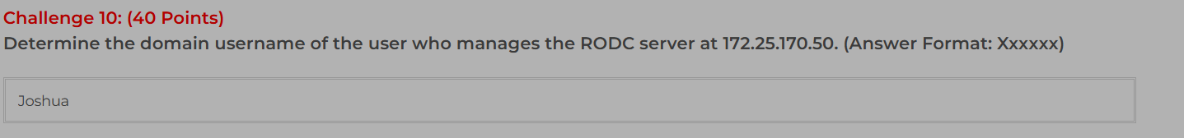
Objective: Determine the domain username of the user who manages the RODC server at 172.25.170.50.

Methodology
LDAP computer-object enumeration was used to inspect the managedBy attribute of the AD-WIN domain-controller object. The object is associated with the user Joshua.
Relevant relationship: CN=AD-WIN,OU=Domain Controllers,DC=CPENTv2025,DC=com → managedBy: CN=Joshua,CN=Users,DC=CPENTv2025,DC=com.
Answer: Joshua

Question 11 — Allowed RODC Password Replication Policy Entries
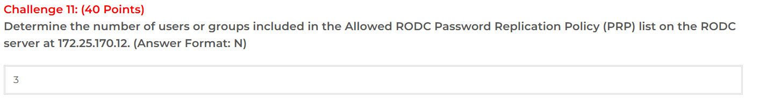
Objective: Determine the number of users/groups included in the Allowed RODC Password Replication Policy list on the RODC at 172.25.170.12.

Methodology
The examination evidence shows the msDS-RevealOnDemandGroup attribute for the RODC and lists three configured entries:
Allowed RODC Password Replication Group
Domain Users
S-1-5-11 (ForeignSecurityPrincipals)
The resulting count is three entries.
Answer: 3

