CPENTv2 EXAMINATION REPORT
Binary Range
Report Date: 09 September 2026

Assessment Type | CPENTv2 Examination — Binary Range
Binary | Vault, Overflow
Range | 172.25.65.0/24
Primary Systems Referenced | 172.25.65.103, 172.25.65.165, 172.25.65.103
Assessment Platform | Kali Linux

Q26 — EIP Overwrite Value (50 Points)
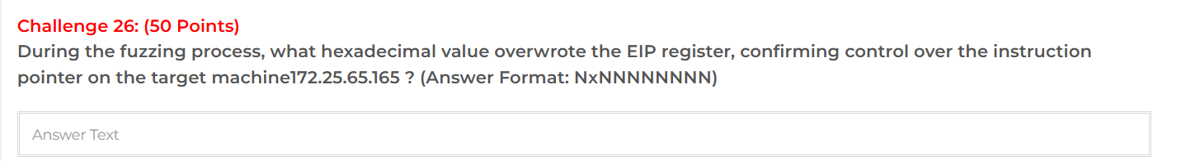
During the fuzzing process, the EIP register was overwritten with the hexadecimal value 0x42424242. The supplied notes document a payload consisting of 112 padding bytes followed by four controlled bytes ('BBBB'), and the debugger confirmed EIP = 0x42424242.
Answer: 0x42424242

Methodology
The target service was tested with a controlled buffer-overflow payload consisting of 112 padding bytes followed by four B characters:
AAAAAAAA...AAAAAAAA + BBBB
he four B characters correspond to hexadecimal value 0x42. After delivery of the payload, the target process crashed and was inspected in a debugger.
Result:
The debugger confirmed:
EIP = 0x42424242
This confirms that the saved instruction pointer was successfully overwritten and that control over EIP was achieved.

Q27 — Return Address Offset (50 Points)
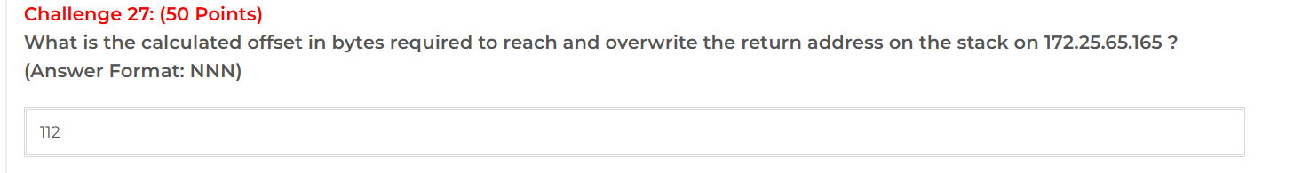

The calculated offset required to reach and overwrite the saved return address on 172.25.65.165 was 112 bytes. The supplied binary analysis identifies the return offset as 0x6c + 4 = 112.
Answer: 112
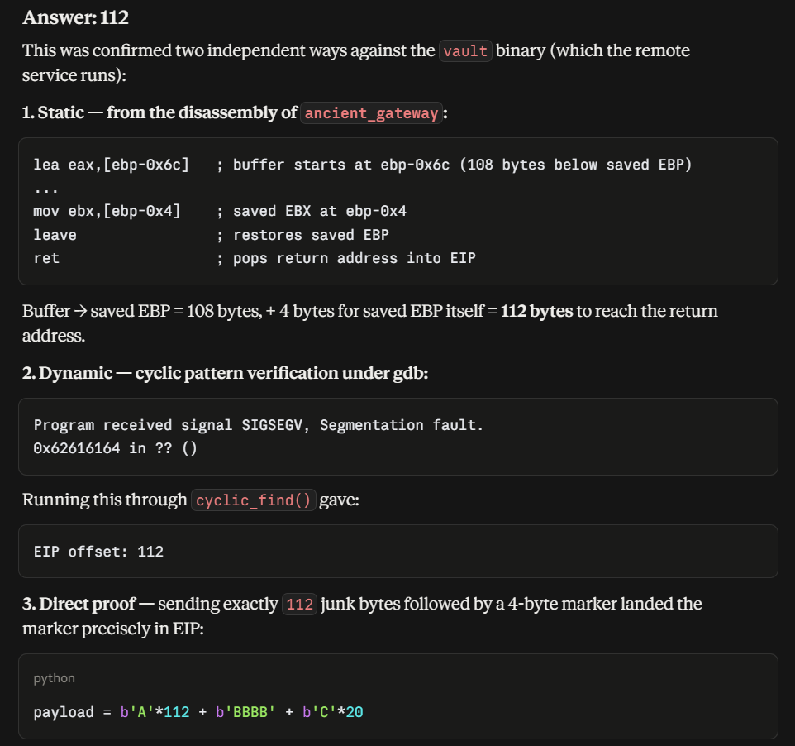

Q28 — Flag Characters (100 Points)
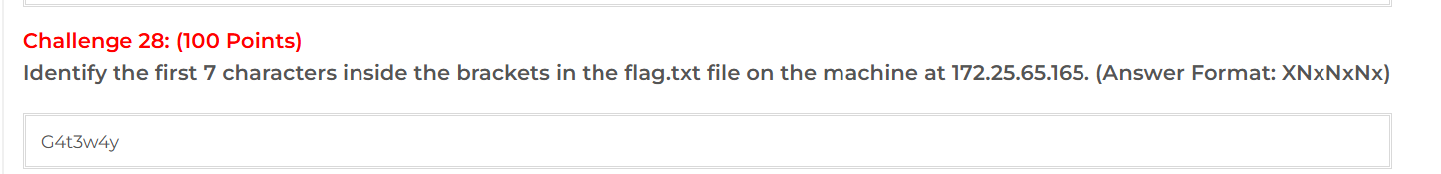
Target: 172.25.65.165:1337
Analysis and Exploitation:
The vault_interactive.py script exploits the stack-based buffer overflow in the vault service. The script:
- Connects to 172.25.65.165 on TCP port 1337.
- Extracts the leaked stack address from the service banner.
- Uses a 23-byte i386 /bin/sh shellcode.
- Uses an offset of 112 bytes to reach the saved EIP.
- Places the leaked buffer address over the saved return address.
- Sends the exploit payload and obtains an interactive shell.
- From the resulting shell, cat flag.txt can be executed to retrieve the flag.
The relevant exploit construction is:
payload = SHELLCODE + b"\x90" * (OFFSET - len(SHELLCODE)) + addr_bytes
with:
OFFSET = 112
The script also explicitly provides the command:
cat flag.txt
The retrieved flag was:
CTF{G4t3w4y_0v3rfl0w_PWN3D}
Therefore, the first 7 characters inside the curly brackets are:
G4t3w4y

Q29 — Padding Bytes (50 Points)
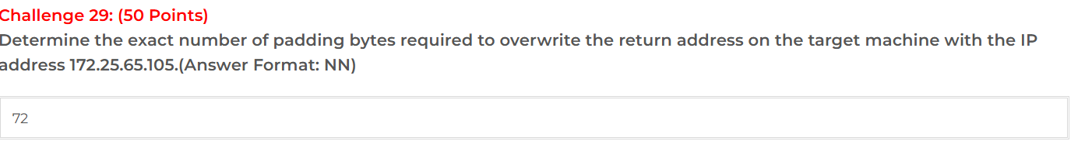
Testing on 172.25.65.105 showed that 72 padding bytes were required to reach the return address. The supplied notes document successful execution using a 72-byte payload and failure with adjacent lengths.
Answer: 72
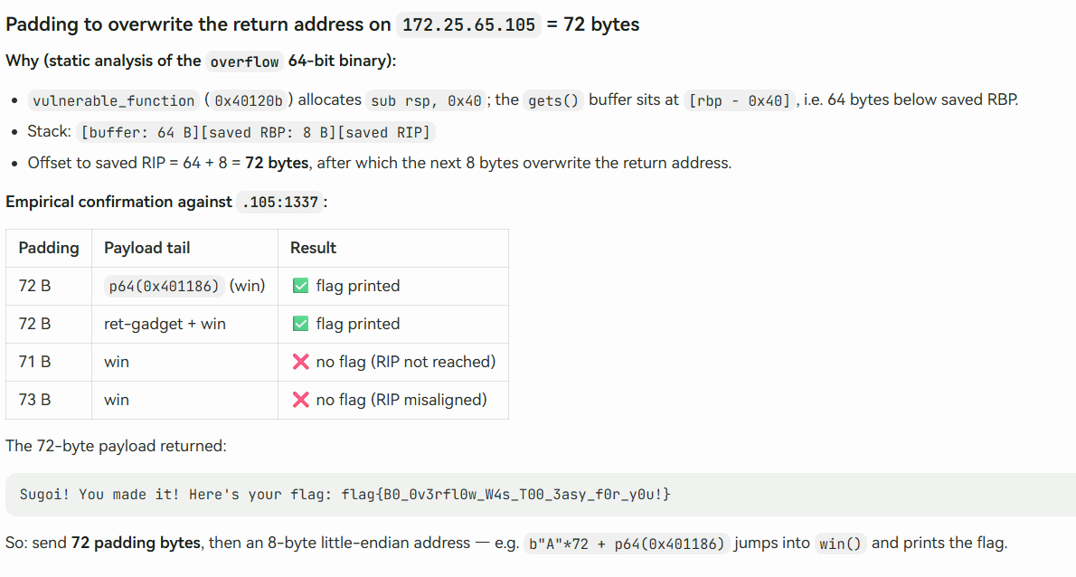

Q30 — Hidden Function (20 Points)
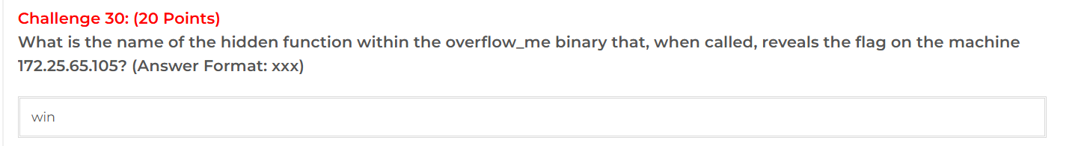The supplied evidence identifies the hidden function in the overflow_me binary as win. The function is documented at address 0x401186 and reveals the flag when called.
Answer: win
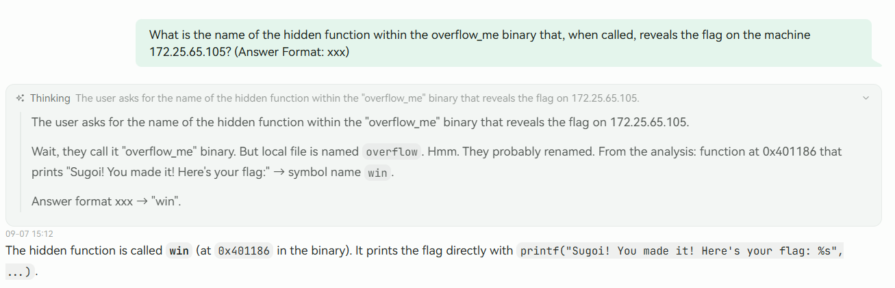

Q31 — Hidden Function Address (30 Points)
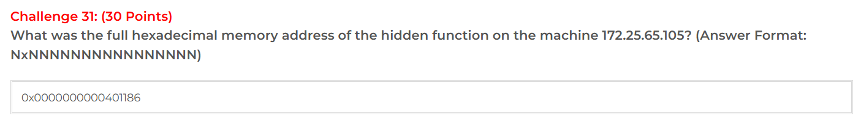
The supplied evidence gives the address of the hidden win() function as 0x401186. Expressed in the requested full hexadecimal form, the address is 0x0000000000401186.
Answer: 0x0000000000401186

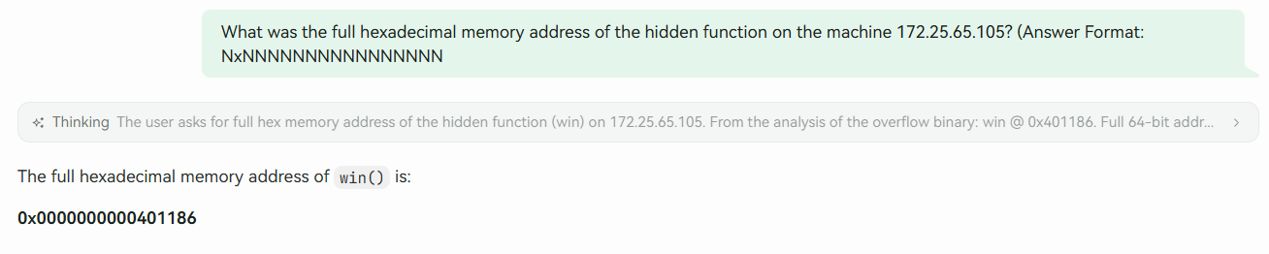

Q32 — Flag Character Count (100 Points)
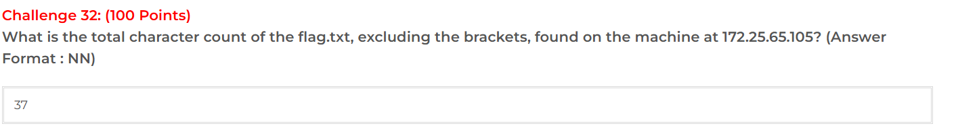The supplied evidence gives the flag as flag{B0_0v3rfl0w_W4s_T00_3asy_f0r_y0u!}. It reports 4 characters for 'flag' and 33 characters for the content between the braces, for a total of 37 characters when the two curly brackets are excluded.
Answer: 37
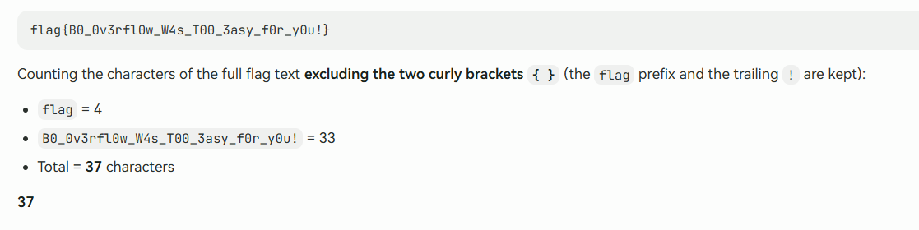

Q33 — Membership Validation Algorithm (70 Points)
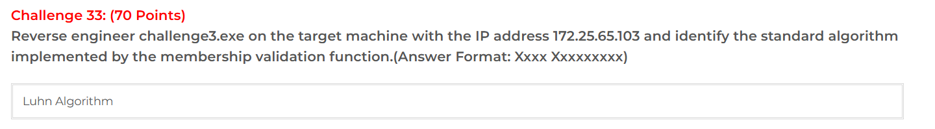
The supplied reverse-engineering evidence states that the membership validation function implements the Luhn Algorithm. The described behavior includes processing digits from right to left, doubling every second digit, reducing values above 9 by subtracting 9, summing the resulting values, and requiring divisibility by 10.
Answer: Luhn Algorithm
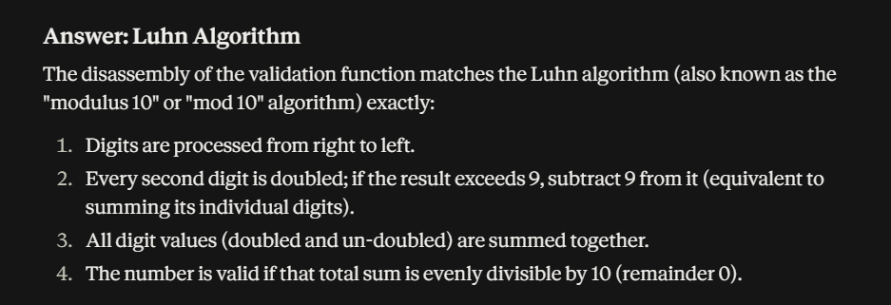

Q34 — Final Checksum Divisor (30 Points)
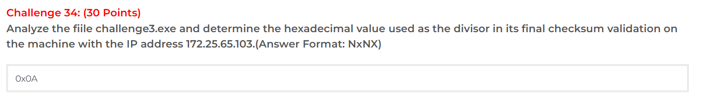
The supplied reverse-engineering evidence states that the final checksum validation checks the sum modulo 10. It identifies the divisor as hexadecimal 0xA.
Answer: 0xA
