CPENTv2 EXAMINATION REPORT
IOT Range
Report Date: 09 September 2026

Question 13 - What is the block size of the IOT.bin file in bytes?

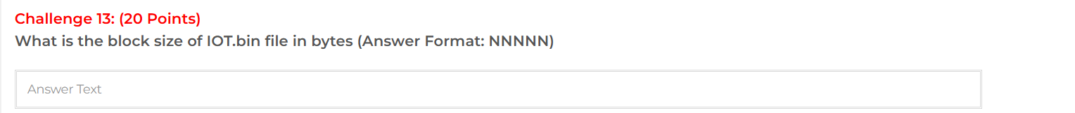
Answer
65536
Assessment Methodology
The firmware image was analyzed with binwalk. The identified SquashFS filesystem reports a block size of 65,536 bytes
ubuntu@ubuntu-Virtual-Machine:~$ binwalk /home/ubuntu/IOT.bin

DECIMAL HEXADECIMAL DESCRIPTION
--------------------------------------------------------------------------------
0 0x0 BIN-Header, board ID: 1550, hardware version: 4702, firmware version: 1.0.0, build date: 2012-02-08
32 0x20 TRX firmware header, little endian, image size: 7753728 bytes, CRC32: 0x436822F6, flags: 0x0, version: 1, header size: 28 bytes, loader offset: 0x1C, linux kernel offset: 0x192708, rootfs offset: 0x0
60 0x3C gzip compressed data, maximum compression, has original file name: "piggy", from Unix, last modified: 2016-03-09 08:08:31
1648424 0x192728 Squashfs filesystem, little endian, non-standard signature, version 3.0, size: 6099215 bytes, 447 inodes, blocksize: 65536 bytes, created: 2016-03-10 04:34:22

Question 14 - What is the CPU architecture of the IOT2.bin file?
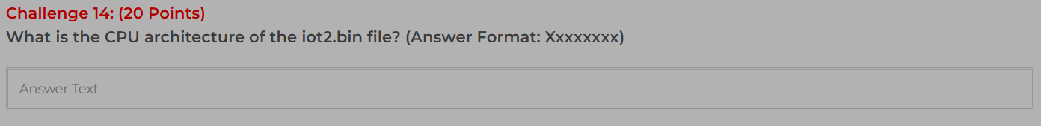
Answer
Blackfin
Assessment Methodology
The file utility was executed against IOT2.bin. The output identifies the image as a Linux/Blackfin u-boot legacy uImage.

Question 15 - Determine the Linux version compatible with the IOT2.bin file.

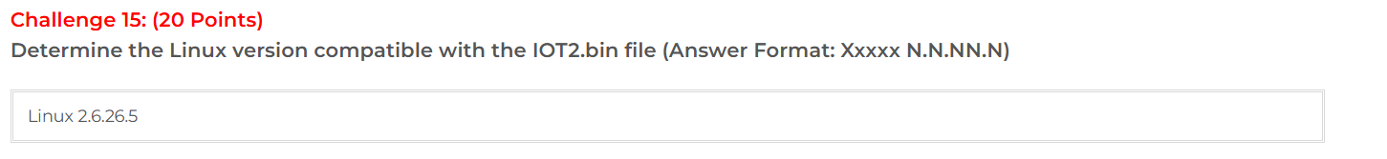

Answer
Linux 2.6.26.5
Assessment Methodology
The strings output from IOT2.bin contains the kernel identifier Linux-2.6.26.5-ADI-2009R1-pre-gd, establishing the Linux kernel version as 2.6.26.5.
ubuntu@ubuntu-Virtual-Machine:~/Downloads$ strings /home/ubuntu/Downloads/IOT2.bin | grep Linux
Linux-2.6.26.5-ADI-2009R1-pre-gd

Question 16 - Determine the file format of the extracted file 813682 from IOT3.bin.
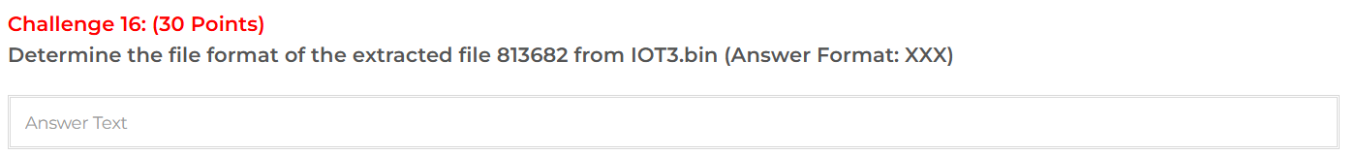

Answer
ELF
Assessment Methodology
The file utility classifies 813682 as an ELF 32-bit LSB relocatable ARM EABI5 binary. The required file format is therefore ELF.
ubuntu@ubuntu-Virtual-Machine:~/Downloads/_IOT3.bin.extracted$ file 813682
813682: ELF 32-bit LSB relocatable, ARM, EABI5 version 1 (SYSV), missing section headers at 176772

Question 17 - Determine the offset value of the extracted file D8232C within IOT3.bin.

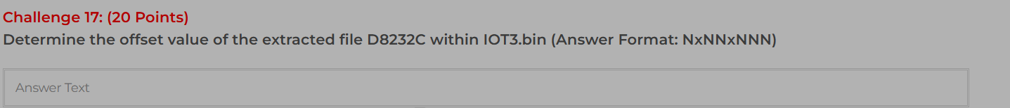

Answer
14x164x780
Assessment Methodology
Binwalk identifies the relevant embedded data at hexadecimal offset 0xD8232C, equivalent to decimal 14,164,780. The value is formatted according to the required answer format as 14x164x780
binwalk: 14164780 0xD8232C xz compressed data (next @0xD9AD5F)
hex: 0xD8232C = dec: 14164780
carved: D8232C.xz 22,256,288 -> D8232C 102,315 TrueType Font (ELf->TTF)
dd if=IOT3.bin bs=1 skip=14164780 count=256 | hexdump -C -> fd 37 7a 58 5a (xz)
Offset D8232C = 0xD8232C (8 chars) = 14164780 dec (NxNNxNNN = 14,164,780 / 14x164x780)

Question 18 - What is the IP address of the device named DSP-W215 found in the database file of IOT4.bin?

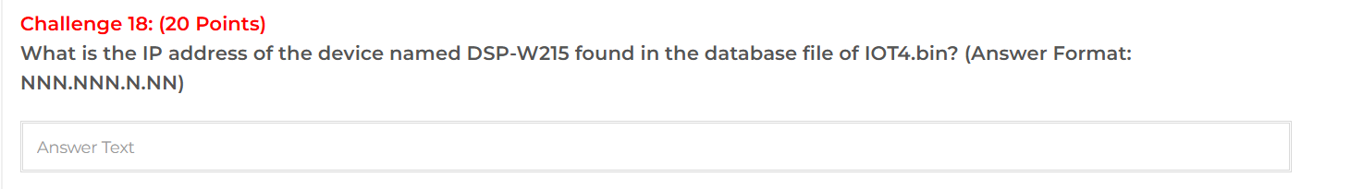
Answer
192.168.0.60
Assessment Methodology
The extracted config.sqlite database was queried for NetworkSettings. The record for device DSP-W215 contains IPAddr=192.168.0.60.
ssh ubuntu@172.25.120.110
binwalk -e -C /tmp/iot4 /home/ubuntu/Downloads/IOT4.bin # -> squashfs @0xE0048
ls /tmp/iot4/_IOT4.bin.extracted/squashfs-root/mnt/*.sqlite
strings /tmp/iot4/.../config.sqlite | grep DSP
python3 -c "import sqlite3; con=sqlite3.connect('/tmp/iot4/_IOT4.bin.extracted/squashfs-root/mnt/config.sqlite'); cur=con.cursor(); cur.execute('SELECT * FROM NetworkSettings'); print(cur.fetchall())"
IOT4.bin:2051 (8d890439) E0048.squashfs:1 config.sqlite:1 / default_config.sqlite:1:
NetworkSettings: Mode=1 IPAddr=192.168.0.60 SubnetMask=255.255.255.0 DeviceName=DSP-W215
DHCP: 192.168.0.80-192.168.0.99
Answer: 192.168.0.60 (NNN.NNN.N.NN)

Question 19 - What is the version of BusyBox used in IOT4.bin?
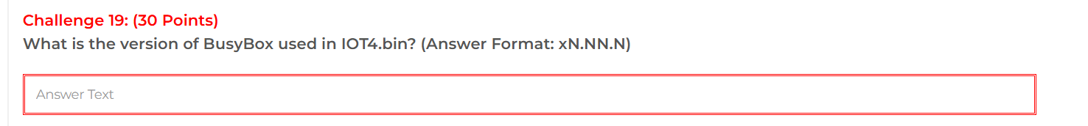

Answer
1.21.1
Assessment Methodology
The extracted BusyBox binary was examined with strings. The output identifies BusyBox v1.21.1.
ssh ubuntu@172.25.120.110
binwalk -e -C /tmp/iot4 /home/ubuntu/Downloads/IOT4.bin # squashfs @0xE0048
file /tmp/iot4/_IOT4.bin.extracted/squashfs-root/bin/busybox # MIPS 32-bit MSB
strings /tmp/iot4/_IOT4.bin.extracted/squashfs-root/bin/busybox | grep -i "BusyBox v"
squashfs-root/bin/busybox:1 (577K, MIPS MSB):
BusyBox v1.21.1--LSDK-10.2-00082-4 (2017-12-05 14:05:07 CST)
syslogd started: BusyBox v1.21.1--LSDK-10.2-00082-4
Answer: v1.21.1 (1.21.1 bare) - format xN.NN.N

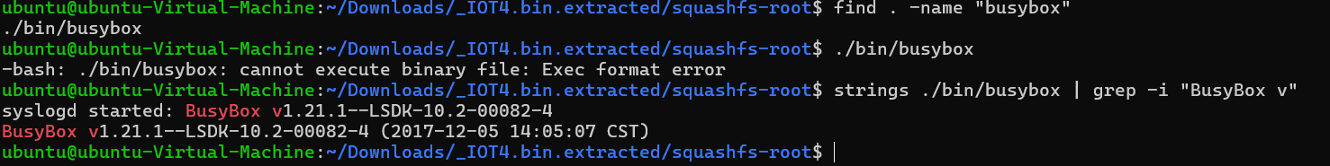

Question 20 - What is the GCC version used to compile the file located at offset 464A28 in the IOT5.bin image?
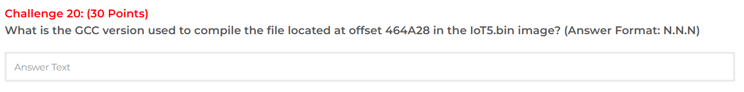
Answer
4.3.1
Assessment Methodology
The gzip-compressed data at offset 0x464A28 was extracted and inspected. The Linux metadata reports gcc version 4.3.1.
ssh ubuntu@172.25.120.110
binwalk /home/ubuntu/Downloads/IOT5.bin # 0x464A28=4606504 gzip
dd if=/home/ubuntu/Downloads/IOT5.bin bs=1 skip=4606504 count=2471384 | gunzip -c > /tmp/out
strings /tmp/out | grep GCC
IOT5.bin:2051 (7b96dd59, 0x20000 zImage, 0x464A28 gzip:2015-11-25 -> 0x6C0000 JFFS2):
gzip @0x464A28 -> /tmp/out: Tower/XP rel3
strings: Linux version 2.6.35 (svcj@eater-x) (gcc version 4.3.1 20080521 (prerelease) [gcc-4_3-branch revision 135713] (GCC 4.3.1 Axis release R11/1.1)) #1 PREEMPT Wed Nov 25 08:53:34 CET 2015
Answer: 4.3.1 (GCC 4.3.1 Axis R11/1.1)

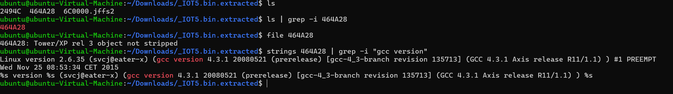

Question 21 - Analyze IOT5.bin in 172.25.120.110 and determine its filesystem.
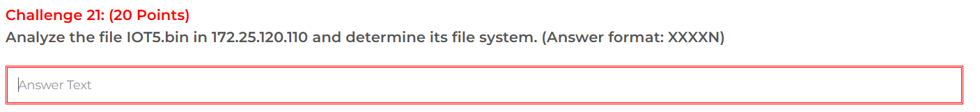
Answer
JFFS2
Assessment Methodology
The firmware analysis identifies the filesystem as JFFS2 (Journalling Flash File System version 2), supported by the JFFS2 magic bytes.
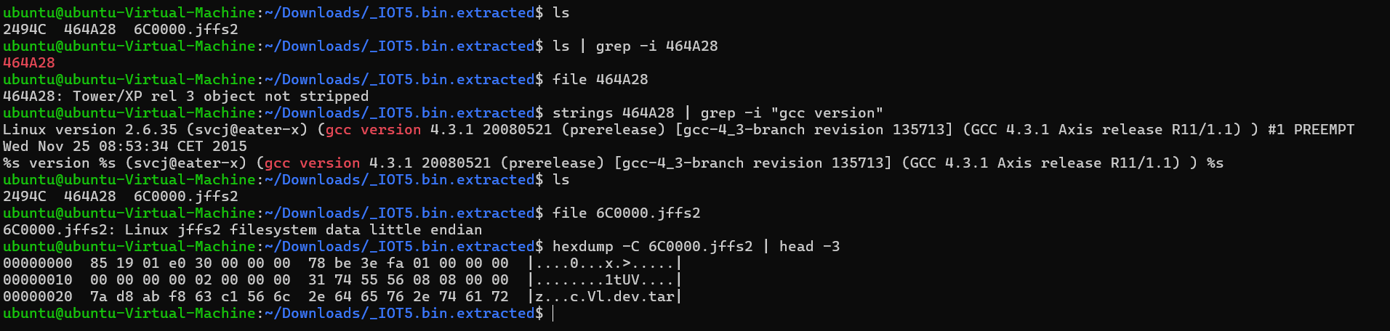

Question 22 - On 172.25.120.100, analyze FileOne.bin and determine the image size.
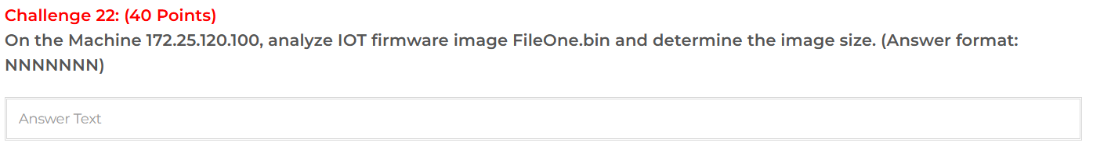
Answer
7754752
Assessment Methodology
The firmware directory listing reports FileOne.bin with a size of 7,754,752 bytes
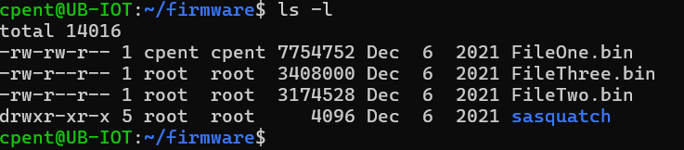

Question 23 - What is the starting address of the file system in FileTwo.bin on 172.25.120.100?
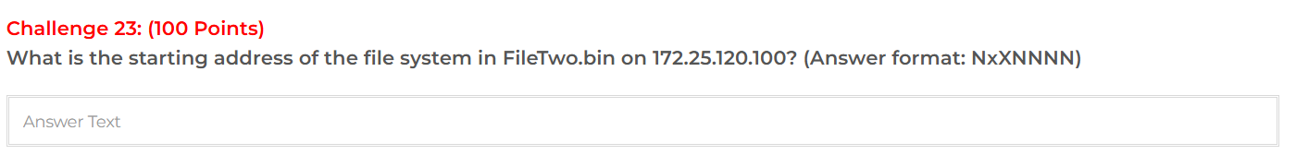
Answer
E0080
Assessment Methodology
Binwalk identifies the SquashFS filesystem at hexadecimal offset 0xE0080, so the starting address is E0080.
ssh cpent@172.25.120.100
binwalk /home/cpent/firmware/FileTwo.bin
hexdump -C /home/cpent/firmware/FileTwo.bin | grep -n hsqs
dd if=/home/cpent/firmware/FileTwo.bin bs=1 skip=917632 count=16 | od -An -tx1
FileTwo.bin:2053 (2c1187aa:3174528):
0x30 Unix path /dev/mtdblock/2
0x60 uImage MIPS Linux Kernel lzma 878029 bytes @0x80000000
0xA0 LZMA 5D 33554432->2956312
0xE0060 PackImg --PaCkImGs-- 0x700022 LE / 0x2256896 BE
0xE0080 Squashfs le v3.0 non-standard 2256151 bytes 1119 inodes blocksize 65536 hsqs
hex @0xE0080: 73 68 73 71 5f 04 00 00 ... (shsq)
FS start: 0xE0080 (917632 dec) - PackImg tag 0xE0060 (917600) - NxXNNNN = 0xE0080
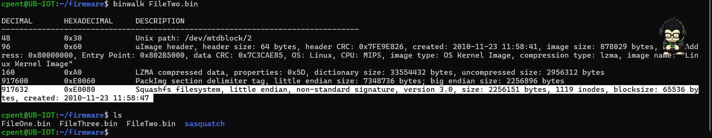

Question 24 - On 172.25.120.110, in IOT6.bin, which file contains the root user's password?
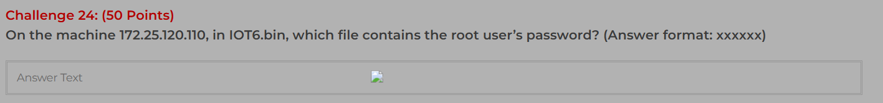
Answer
passwd
Assessment Methodology
The extracted IOT6.bin filesystem was searched for files named passwd. The relevant password file was identified as passwd, with the evidence showing the /etc/passwd path

Question 25 - On 172.25.120.110, what is the firmware device for the IOT6.bin firmware?
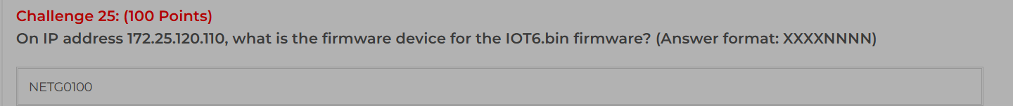
Answer
NETG0100
Assessment Methodology
Firmware metadata identifies HW_ID NETG01 and model D6000. The product presetting maps D6000 to the required 8-character identifier NETG0100.
On 172.25.120.110:110 /home/ubuntu/Downloads/IOT6.bin:1 (2RDH @0x00):
HW_ID:NETG01
MODELNAME:D6000
profile.cfg: AYECOM_MODELNAME="D6000" AYECOM_HWID="NETG01"
product_presetting.sh: D6000 -> NETG0100
- Short MODEL = D6000
- HW_ID = NETG01
- Full 8-char XXXXNNNN = NETG0100 (NETG0101 alt)
- Concatenated common name = NETGD6000
If question wants strict XXXXNNNN (4 letters +4 numbers): put NETG0100 (and D6000 if they ask MODEL only). NETGD6000 is just NETG+D6000 combined 9-char casual.

