EXT: fesyslang
Extension Key: my_extension_key
Copyright 2000-2002, Ralph Schuster, <rs.eschborn@gmx.de>

This document is published under the Open Content License
available from http://www.opencontent.org/opl.shtml

The content of this document is related to TYPO3
- a GNU/GPL CMS/Framework available from www.typo3.com

Table of Contents
EXT: My Extension 1
Introduction 1
What does it do? 1
Screenshots 1
Users manual 1
FAQ 1
Adminstration 1
FAQ 2
Configuration 2
FAQ 2
Reference 2
Tutorial 2
Known problems 2
To-Do list 2
Changelog 2

Introduction

What does it do?
Have you ever noticed that frontend users must switch to their preferred language when they return to your website? This is especially annoying if they bookmarked your site with another language.
This frontend library keeps track of the language the user chose and saves preferences in user's profiles. When the user returns and logs in s/he gets redirected to the previously saved, preferred language.
All activities take place without interaction of users or administrators.

Screenshots
No screenshots necessary.

Users manual
Just install the extension. There is nothing more to do.

FAQ
Q: Can I configure language parameter name?
A: Yes. See Configuration section.

Configuration

Reference
Property: | Data type: | Description: | Default:
langParam | String | URL parameter name for setting language | L

Example
plugin.tx_fesyslang.langParam = LANG

Known problems
No problem known

To-Do list
No items

Changelog
V1.0.0:
- Stable version

Important guidelines

Issues with Open Office documentation for TYPO3
There are a few important points to make about writing documentation for TYPO3 in Open Office. Please makes sure to follow these.

Inserting images
When you insert images you can either:
- Make a copy/paste from eg. Photoshop, but it's REALLY IMPORTANT that you insert the image into Open Office by the menu “Edit > Paste Special” and then select “Bitmap”. If you don't do it in this way the image cannot be shown (since it will not be stored as a PNG internally in the SXW file)

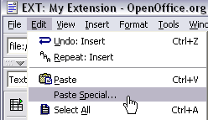
- Alternatively you can use the traditional way “Insert > Graphics > From file” and insert an image from your harddrive. In particular use this if the image is photographic (JPG) since the internal storage as PNG is not good for photographs.
Generally please use copy/paste only for screendumps with large areas of similar color (good png-compression) and JPG-files for photographic images. Go for small images, 72 dpi, medium quality.

Paragraph styles
- Use the paragraph style “Text body” for bodytext
- Use “Heading 1” to “Heading 5” for headers. “Heading 1-3” will be recognized as “sections” on typo3.org. “Heading 4-5” is subheaders, where “Heading 5” is preferrably for “Examples”.
- For code listings, use the style “Preformatted Text” (found under “HTML Styles”). For codelistings in tables there is a custom style called “Table Contents/PRE”.
This screenshot shows the only paragraph styles allowed in the documents. The ones grayed out are paragraph styles that are used by default for such as the index table or the footer. The others are the ones you are allowed to use.
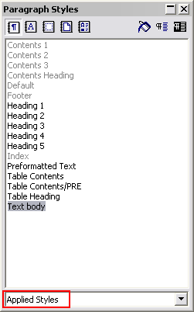

Linking
You can make hyperlinks in the documents as absolute URLs. Use menu “Insert > Hyperlink”

Meta data and updates
There are three fields of meta-data you have to fill in. First of all go to “File > Properties...”.
- In the “Description” screen you enter the title of the document. Extension manuals are prefixed “EXT: [extension title]”
- In the “User defined” screen you enter your email address as the first field (named “Email” / ”Info 1”)
- In the “User defined” screen you enter your full name as the second field (named “Author” / ”Info 2”)
Finally you should also insert the correct extension key in the text below the document title, but this is not a meta-data field, just regular text.

For more information you can go to typo3.org.

