**Tomcat Exec Error-  
  
Error** **-**   
tomcat.service lacks both ExecStart= and ExecStop= setting. Refusing.

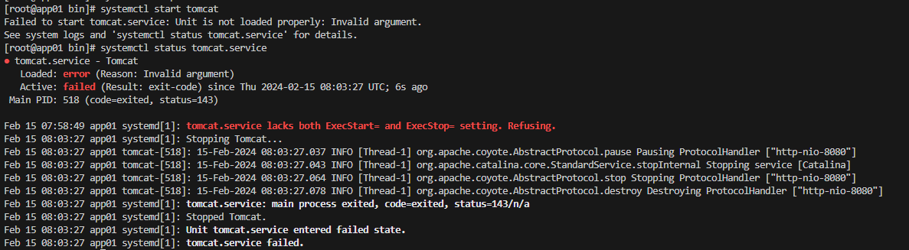 **Analysis –** tomcat.service file didn’t had the below lines

|  |
| --- |
| **ExecStart=/usr/local/tomcat/bin/catalina.sh run**  **ExecStop=/usr/local/tomcat/bin/shutdown.sh**  **SyslogIdentifier=tomcat-%i** |

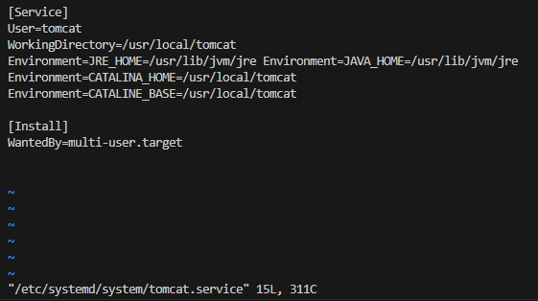

**Solution –** Edit and give the correct path on tomcat.service

|  |
| --- |
| ExecStart=/usr/local/tomcat/bin/catalina.sh run  ExecStop=/usr/local/tomcat/bin/shutdown.sh  SyslogIdentifier=tomcat-%i |

