**Tomcat [Status=203/EXEC]-  
  
Error** **-**   
Active: failed (Result: exit-code) since Thu 2024-02-15 08:06:23 UTC; 3s ago

Process: 718 ExecStart=/tmp/apache-tomcat-9.0.75/bin/startup.sh (code=exited, status=203/EXEC) 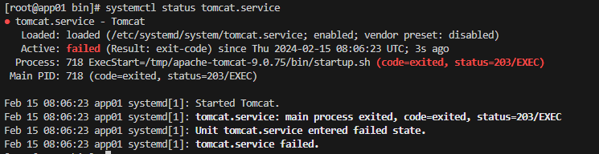 **Analysis –** tomcat.service file had wrong path

|  |
| --- |
| **ExecStart=/tmp/apache-tomcat-9.0.75/bin/startup.sh**  **ExecStop=/tmp/apache-tomcat-9.0.75/bin/shutdown.sh**  **SyslogIdentifier=tomcat-%i** |

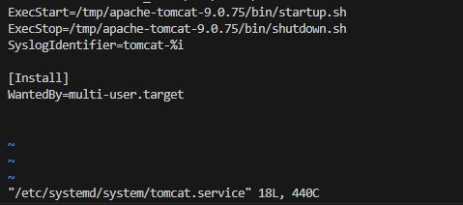

**Solution –** Edit and give the correct path on tomcat.service

|  |
| --- |
| ExecStart=/usr/local/tomcat/bin/catalina.sh run  ExecStop=/usr/local/tomcat/bin/shutdown.sh  SyslogIdentifier=tomcat-%i |

