**Vagrant Plugin Error -  
  
Error** **-** Unable to resolve Dependency: user requested 'vagrant-hostmanager (=1.8.10)'

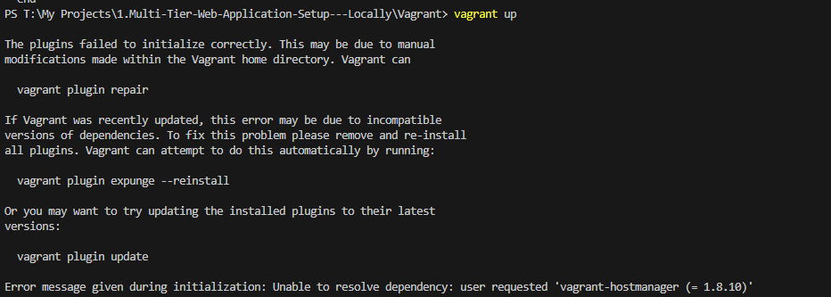 **Analysis -** Declared a plugin variable inside the vagrant file, but the plugin was not installed

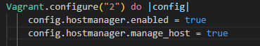 **Solution –**

Execute : vagrant plugin install vagrant-hostmanager

vagrant plugin list

