**VPROFILE PROJECT SETUP**

## Prerequisite

1. Oracle VM Virtualbox
2. Vagrant
3. Vagrant plugins

Execute below command in your computer to install hostmanager plugin

$ vagrant plugin install vagrant-hostmanager

1. Git bash or equivalent editor

# VM SETUP

1. Clone source code.
2. Cd into the repository.
3. Switch to the main branch.
4. cd into vagrant/Manual_provisioning Bring up vm’s

$ vagrant up

NOTE: Bringing up all the vm’s may take a long time based on various factors. If vm setup stops in the middle run “vagrant up” command again.

INFO: All the vm’s hostname and /etc/hosts file entries will be automatically updated.

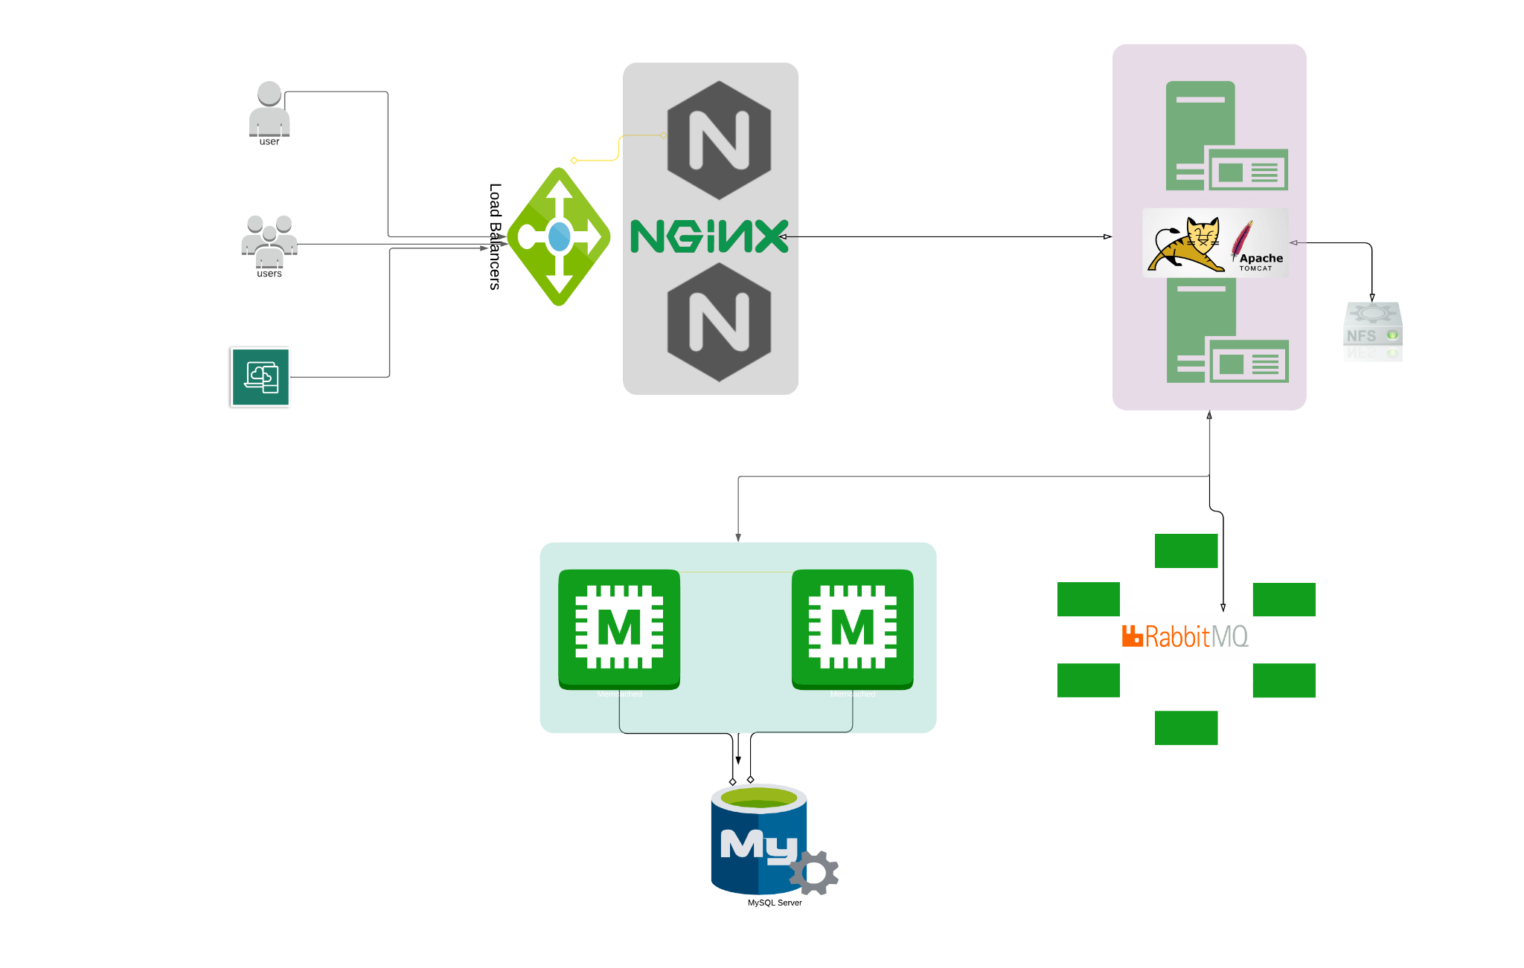

# PROVISIONING

### Services

1. Nginx
2. Tomcat
3. RabbitMQ
4. Memcache

=> Web Service

=> Application Server

=> Broker/Queuing Agent

=> DB Caching

1. ElasticSearch => Indexing/Search service
2. MySQL => SQL Database

Setup should be done in below mentioned order

**MySQL**

**(Database SVC)**

**Memcache (DB Caching SVC)**

**RabbitMQ (Broker/Queue SVC) Tomcat (Application SVC) Nginx (Web SVC)**

## MYSQL Setup

Login to the db vm

$ vagrant ssh db01

Verify Hosts entry, if entries missing update the it with IP and hostnames

# cat /etc/hosts

Update OS with latest patches

# yum update -y

Set Repository

# yum install epel-release -y

Install Maria DB Package

# yum install git mariadb-server -y

Starting & enabling mariadb-server

# systemctl start mariadb # systemctl enable mariadb

RUN mysql secure installation script.

# mysql_secure_installation

***NOTE****: Set db root password, I will be using* ***admin123 as password***

Set root password? [Y/n] **Y**

New password:

Re-enter new password:

Password updated successfully! Reloading privilege tables..

... Success!

By default, a MariaDB installation has an anonymous user, allowing anyone to log into MariaDB without having to have a user account created for

them. This is intended only for testing, and to make the installation go a bit smoother. You should remove them before moving into a

production environment.

Remove anonymous users? [Y/n] **Y**

... Success!

Normally, root should only be allowed to connect from 'localhost'. This ensures that someone cannot guess at the root password from the network.

Disallow root login remotely? [Y/n] **n**

... skipping.

By default, MariaDB comes with a database named 'test' that anyone can access. This is also intended only for testing, and should be removed before moving into a production environment.

Remove test database and access to it? [Y/n] **Y**

* Dropping test database...

... Success!

* Removing privileges on test database...

... Success!

Reloading the privilege tables will ensure that all changes made so far will take effect immediately.

Reload privilege tables now? [Y/n] **Y**

... Success!

Set DB name and users.

# mysql -u root -padmin123

mysql> create database accounts;

mysql> grant all privileges on accounts.* TO 'admin'@'%' identified by 'admin123'; mysql> FLUSH PRIVILEGES;

mysql> exit;

Download Source code & Initialize Database.

# git clone -b main https://github.com/hkhcoder/vprofile-project.git # cd vprofile-project

# mysql -u root -padmin123 accounts < src/main/resources/db_backup.sql # mysql -u root -padmin123 accounts

mysql> show tables; mysql> exit;

Restart mariadb-server

# systemctl restart mariadb

Starting the firewall and allowing the mariadb to access from port no. 3306

# systemctl start firewalld # systemctl enable firewalld

# firewall-cmd --get-active-zones

# firewall-cmd --zone=public --add-port=3306/tcp --permanent # firewall-cmd --reload

# systemctl restart mariadb

Login to the Memcache vm

# MEMCACHE SETUP

$ vagrant ssh mc01

Verify Hosts entry, if entries missing update the it with IP and hostnames

# cat /etc/hosts

Update OS with latest patches

# yum update -y

Install, start & enable memcache on port 11211

# sudo dnf install epel-release -y # sudo dnf install memcached -y

# sudo systemctl start memcached # sudo systemctl enable memcached # sudo systemctl status memcached

# sudo memcached -p 11211 -U 11111 -u memcached –d

# ss –tunlp | grep 11211

# sudo systemctl restart memcached

Starting the firewall and allowing the port 11211 to access memcache

# sed -i 's/127.0.0.1/0.0.0.0/g' /etc/sysconfig/memcached  
# firewall-cmd --add-port=11211/tcp

# firewall-cmd --runtime-to-permanent

# firewall-cmd --add-port=11111/udp

# firewall-cmd --runtime-to-permanent

# RABBITMQ SETUP

Login to the RabbitMQ vm

$ vagrant ssh rmq01

Verify Hosts entry, if entries missing update the it with IP and hostnames

# cat /etc/hosts

Update OS with latest patches

# yum update -y

Set EPEL Repository

# yum install epel-release -y

Install Dependencies

# sudo yum install wget -y # cd /tmp/

# dnf -y install centos-release-rabbitmq-38

# dnf --enablerepo=centos-rabbitmq-38 -y install rabbitmq-server # systemctl enable --now rabbitmq-server

Setup access to user test and make it admin

*# sudo sh -c 'echo "[{rabbit, [{loopback_users, []}]}]." > /etc/rabbitmq/rabbitmq.config' # sudo rabbitmqctl add_user test test*

*# sudo rabbitmqctl set_user_tags test administrator*

*# sudo systemctl restart rabbitmq-server*

Starting the firewall and allowing the port 5672 to access rabbitmq

# firewall-cmd --add-port=5672/tcp

# firewall-cmd --runtime-to-permanent

# sudo systemctl start rabbitmq-server # sudo systemctl enable rabbitmq-server # sudo systemctl status rabbitmq-server

# TOMCAT SETUP

Login to the tomcat vm

$ vagrant ssh app01

Verify Hosts entry, if entries missing update the it with IP and hostnames

# cat /etc/hosts

Update OS with latest patches

# yum update -y

Set Repository

# yum install epel-release -y

Install Dependencies

# dnf -y install java-11-openjdk java-11-openjdk-devel

# dnf install git maven wget -y

Change dir to /tmp

*# cd /tmp/*

Download & Tomcat Package

*# wget https://archive.apache.org/dist/tomcat/tomcat-9/v9.0.75/bin/apache-tomcat-9.0.75.tar.gz*

# tar xzvf apache-tomcat-9.0.75.tar.gz

Add tomcat user

# useradd --home-dir /usr/local/tomcat --shell /sbin/nologin tomcat

Copy data to tomcat home dir

# cp -r /tmp/apache-tomcat-9.0.75/* /usr/local/tomcat/

Make tomcat user owner of tomcat home dir

# chown -R tomcat.tomcat /usr/local/tomcat

Setup systemctl command for tomcat

Create tomcat service file

# vi /etc/systemd/system/tomcat.service

Update the file with below content

[Unit]

Description=Tomcat

After=network.target

[Service]

User=tomcat

WorkingDirectory=/usr/local/tomcat

Environment=JRE_HOME=/usr/lib/jvm/jre Environment=JAVA_HOME=/usr/lib/jvm/jre

Environment=CATALINA_HOME=/usr/local/tomcat Environment=CATALINE_BASE=/usr/local/tomcat

ExecStart=/usr/local/tomcat/bin/catalina.sh run ExecStop=/usr/local/tomcat/bin/shutdown.sh

SyslogIdentifier=tomcat-%i

[Install]

WantedBy=multi-user.target

Reload systemd files

# systemctl daemon-reload

Start & Enable service

# systemctl start tomcat # systemctl enable tomcat

Enabling the firewall and allowing port 8080 to access the tomcat

# systemctl start firewalld # systemctl enable firewalld

# firewall-cmd --get-active-zones

# firewall-cmd --zone=public --add-port=8080/tcp --permanent # firewall-cmd --reload

## CODE BUILD & DEPLOY (app01)

Download Source code

# git clone -b main https://github.com/hkhcoder/vprofile-project.git

Update configuration

# cd vprofile-project

# vim src/main/resources/application.properties # Update file with backend server details

### Build code

Run below command inside the repository (vprofile-project)

# mvn install

Deploy artifact

# systemctl stop tomcat

# rm -rf /usr/local/tomcat/webapps/ROOT*

# cp target/vprofile-v2.war /usr/local/tomcat/webapps/ROOT.war # systemctl start tomcat

# chown tomcat.tomcat /usr/local/tomcat/webapps -R # systemctl restart tomcat

Login to the Nginx vm

# NGINX SETUP

$ vagrant ssh web01

$ sudo -i

Verify Hosts entry, if entries missing update the it with IP and hostnames

# cat /etc/hosts

Update OS with latest patches

# apt update # apt upgrade

Install nginx

# apt install nginx -y

Create Nginx conf file

# vi /etc/nginx/sites-available/vproapp

Update with below content

*upstream vproapp { server app01:8080;*

*}*

*server {*

*listen 80; location / {*

*proxy_pass* [*http://vproapp;*](http://vproapp/)

*}*

*}*

Remove default nginx conf

# rm -rf /etc/nginx/sites-enabled/default

Create link to activate website

# ln -s /etc/nginx/sites-available/vproapp /etc/nginx/sites-enabled/vproapp

Restart Nginx

# systemctl restart nginx