**Normalisation**

For product table:

There is no multivalued item here. Nothing is removed.

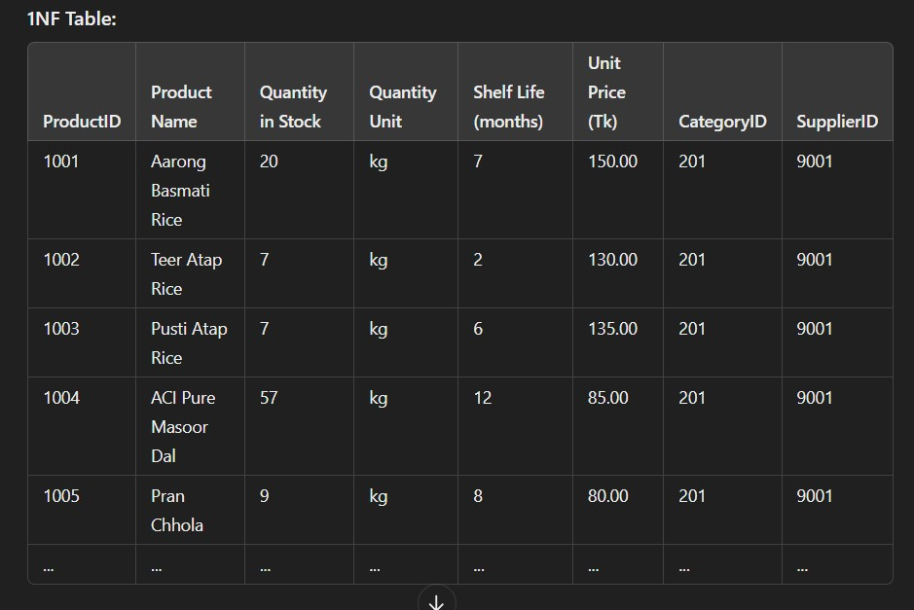

2NF table: Partial dependencies are removed.

1. Product table:

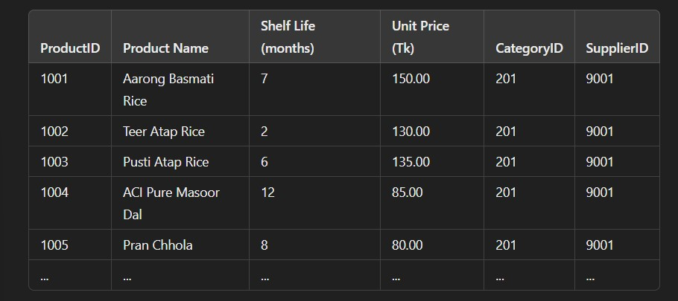

1. Inventory table:

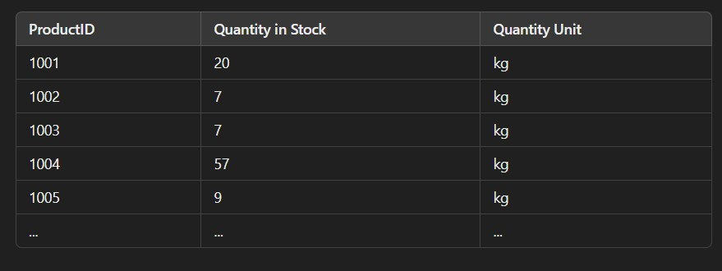

1. Category table:

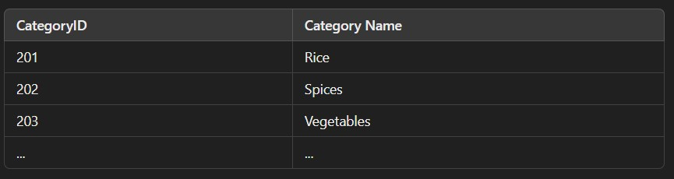

1. Supplier Table:

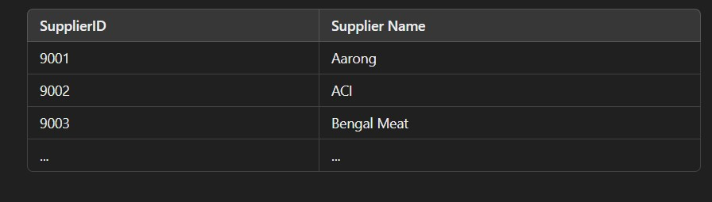

3NF table: No transitive dependency.

**Normalisation for category:**

Unnormalized table:

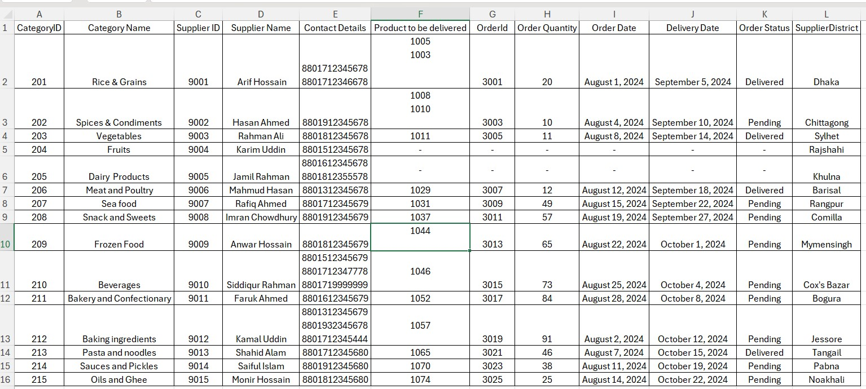

1NF:

Multivalued columns are individualised.

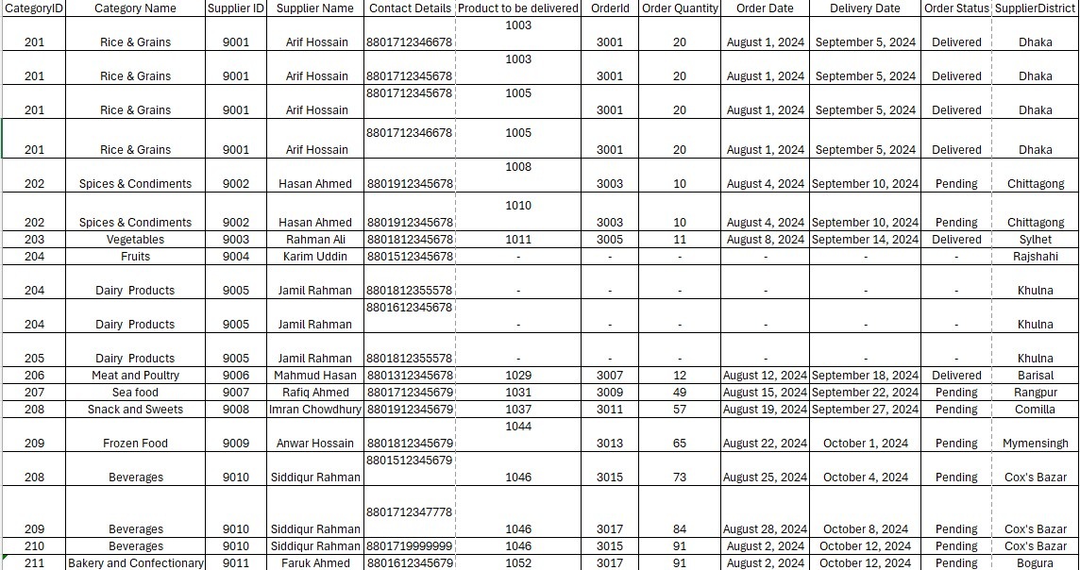

2NF:

Partial dependencies are removed.

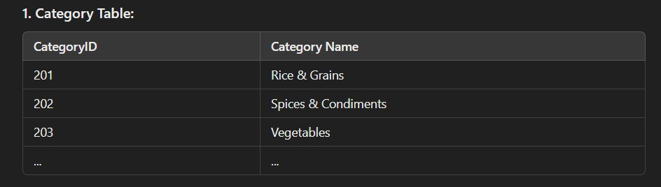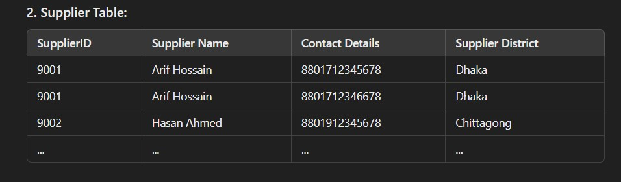

1. Restocking order table:

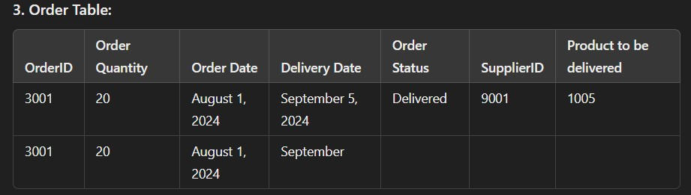

3NF:

Category & order table remains unchanged.

The supplier table has a few more divisions, removing transitive dependency:

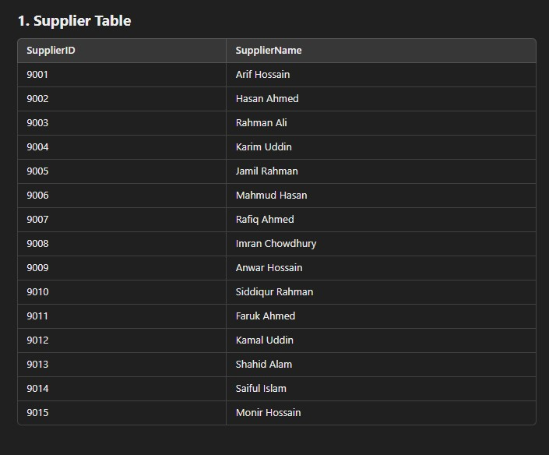

1. Supplier contact details:

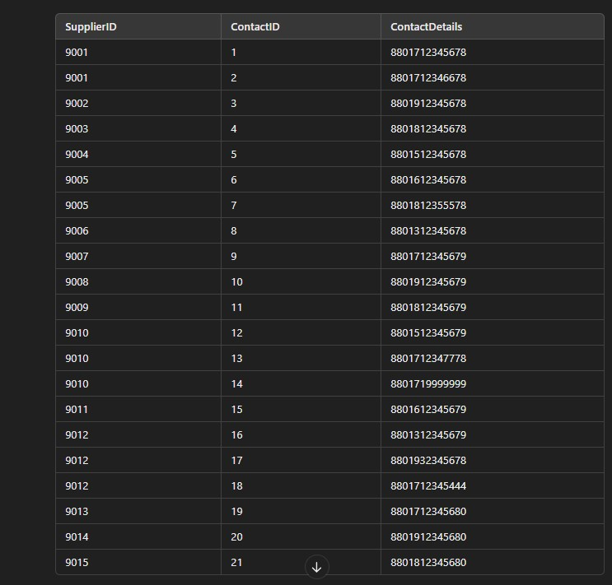

1. Supplier District table:

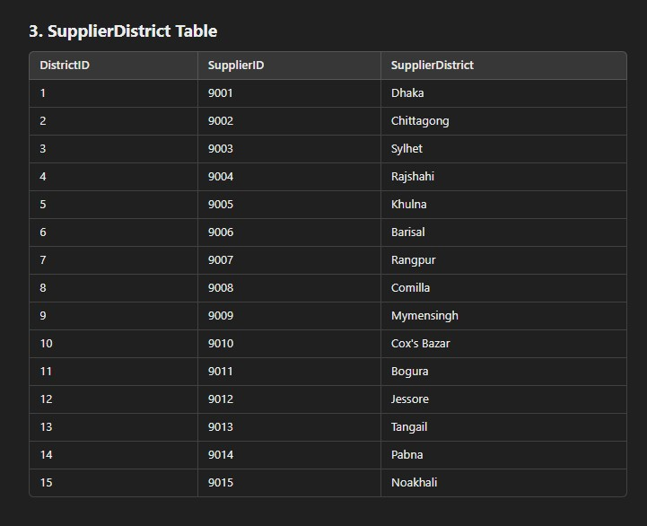

**Normalisation for storebranch:**

1NF no multivalued data:

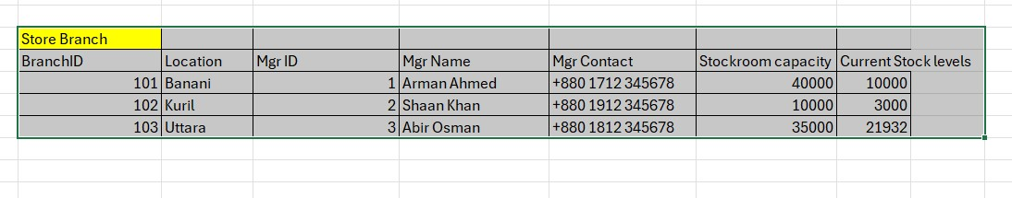

2NF: Parital dependency is removed.

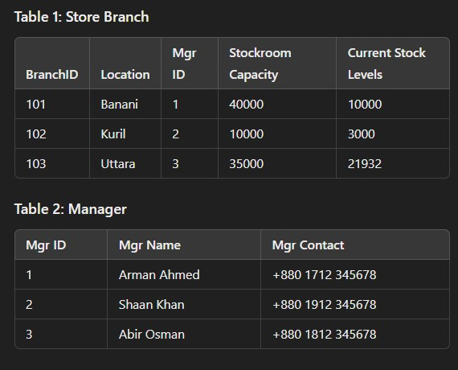

3NF: no change