

CARDLOGIX
AI-Driven Business Development Blueprint
Executive Summary

2  Tracks: your own IT + a channel partnership | 3 waves  MFA mandates: federal → state/local → private (insurance) | ~$31K  Entry program, Year 1 | 5 min  Apart in the Irvine Spectrum

CardLogix makes the credentials that secure identity — PIV, FIDO2, FRAC, and BIOSID. This summary distils a two-track plan: a small co-managed IT engagement for CardLogix’s own team now, and a phishing-resistant-MFA channel partnership where Technijian wraps managed services — including the certificate authority — around CardLogix’s cards for the customers now required to adopt them. Grounded in our May 29 conversation; the full plan is ready on request.

Prepared for CardLogix Corporation | Technijian | 2026-05-30

The Opportunity

Two distinct openings sit in front of CardLogix, and the plan treats them as parallel tracks — one fast and close to home, one strategic.

 | Track A — Your Own IT | Track B — MFA / CA Partnership
What | Co-managed IT for a lean internal team | CardLogix supplies the credentials; Technijian wraps managed IT, SOC, compliance, and the certificate authority for end customers
Confidence | High — this is what co-managed IT is for | Validated on our May 29 call — Nick confirmed it as a joint, customer-facing service
Time | Weeks once scoped | A few quarters — needs one joint pilot

Why Now — MFA Went From Recommended to Required, in Three Waves
Federal first (≈3 years ago), then state and local — including law enforcement under CJIS 5.9.5, mandatory as of October 1, 2024 — and now private companies, pushed by cyber-insurance renewals that require MFA to be in place.
And the kind of MFA matters: phone-based codes (Cisco Duo, Okta) are being displaced because phones get compromised. CardLogix’s PIV and FIDO2 cards are the phishing-resistant answer — riding the badge people already carry.
What customers still need is a partner to deploy and operate it — the managed-services + certificate-authority wrap CardLogix does not bring today.
Honest note: Technijian runs eight compliance frameworks but not yet CJIS. We treat CJIS as a near-term build adjacent to our existing CMMC practice — triggered by exactly this partnership, never claimed as completed work.

How AI Powers Both Tracks

This is account-based, not broad lead generation. AI sits underneath the relationship layer — it surfaces the right accounts, arms the conversation, and automates the compliance evidence. The human trust between CardLogix, Technijian, and a customer still closes the deal.
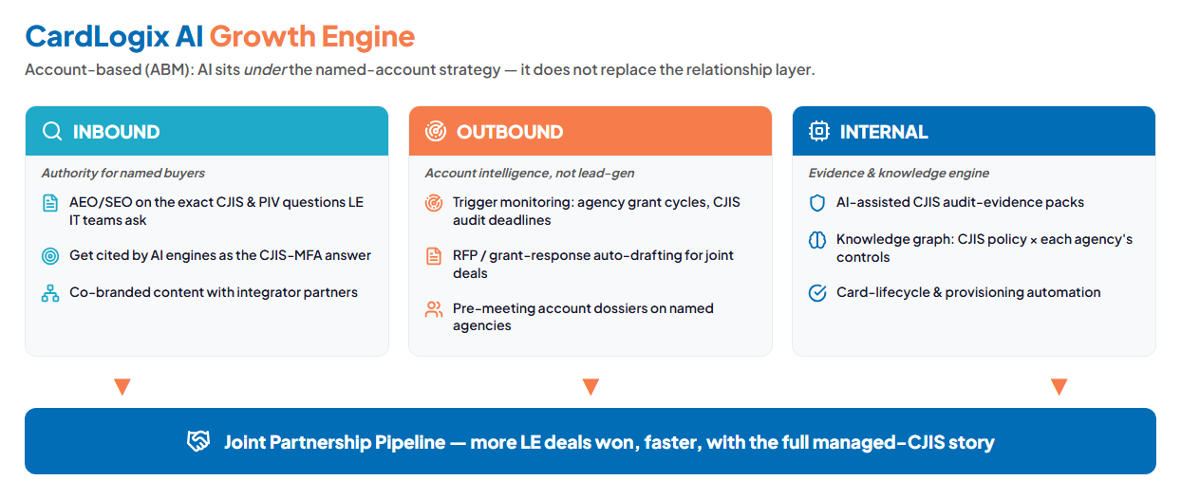
Inbound authority · Outbound account intelligence · Internal evidence — feeding one joint pipeline

Three Motions
Get cited: authority content answering the exact MFA, CJIS, and smart-card questions buyers ask.
Reach the right accounts: AI account intelligence and trigger monitoring on named agencies, private targets, and the integrators that serve them.
Remove the drag: AI-assisted compliance audit-evidence packs and card-lifecycle automation.
The Entry Program

The plan is built land-and-expand: a small, easy-to-approve entry that solves Track A now, with the larger partnership engine built later, once the entry proves the working relationship. Only the entry is shown here; the full Service Investment Map is reserved for the discovery call. Every figure is estimated and confirmed at discovery.

Service | Scope | Est. Y1
My IT — Co-Managed | Coverage, monitoring, patching, senior support for a lean team (per the 2026 rate card) | ~$14,400
My SEO — Tier 3 | Authority content on the MFA, CJIS + smart-card questions buyers ask | $12,000
My AI — Readiness Workshop | One-time: map the joint go-to-market + CJIS build path | ~$5,000
ENTRY PROGRAM (Y1) | The land — no large build | ~$31,400

We model the return as a range, not a single optimistic number. The Very Conservative floor assumes the partnership lands nothing in Year 1 (the entry pays back in recovered time and a stronger posture); the Likely case counts one joint managed-MFA/CA win, which Nick confirmed CardLogix wants to offer:

Year-1 ROI vs. entry | Very Conservative | Likely | Upside
Estimated Y1 value | +$15,000 | +$55,000 | +$95,000
Modeled ROI | Cost-recovered | ~1.8× | ~3.0×

The entry is small on purpose. The real economics live in the expansion — the managed CA on cloud HSM, the CJIS practice, the account-intelligence engine — against a market widening from federal and law enforcement into private companies. The bigger build comes later, once the entry proves the lift.

Start Free — Nexus Assess
Before any commitment, Technijian runs a free Nexus Assess security assessment: internal vulnerabilities (devices, Active Directory, patches, EOL systems), external exposure (perimeter scan + dark-web credential check), and a Microsoft 365 review (MFA coverage, risky sign-ins, admin roles, sharing).
It returns a prioritized remediation roadmap and maps to CJIS, HIPAA, SOC 2, PCI, and NIST — so the free run doubles as a head start on the CJIS gap map. No contract, no spend.

The Roadmap
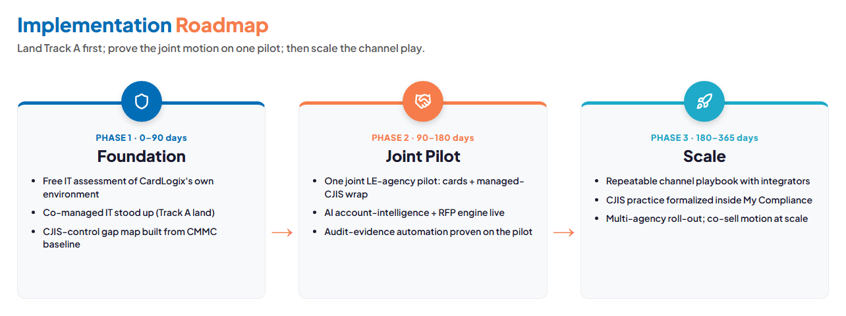
Foundation (0–90 days) → Joint Pilot (90–180) → Scale (180–365)

Two tracks, one local partner — five minutes away in the Spectrum.
Use the Book a Meeting button in my signature to set up a time to discuss this and all the AI strategies Technijian is putting into place for itself and its clients.
Ravi Jain, Technijian | RJain@technijian.com | 949.379.8499

