

MBC AQUATIC SCIENCES
AI Growth & Integration Strategy · Executive Summary
Prepared by Technijian for Shane Beck, President · 2026-06-03
1969  Founded — CA eelgrass-science pioneer | 57  Years in Business (2026) | 600+  Major Scientific Reports | 27 yrs  Avg Project-Mgmt Tenure

The Opportunity
The Opportunity

MBC has the hard things: fifty-seven years of field-defining marine and environmental science, a founder still on staff, a senior bench whose depth no niche competitor can match, an in-house toxicity laboratory, and a reputation that wins work. The growth and continuity question is somewhere else, and three forces define it — each one a place where AI is the right lever for a firm whose value is its expertise.
First, the memory is the moat, and it is aging. The firm’s value lives in the judgment of its most-tenured people, and it is almost entirely undocumented. Every retirement on a twenty-seven-year-average bench moves irreplaceable knowledge closer to the door. Second, the proposal is the bottleneck. A specialized firm wins on qualifications and response speed, and a lean senior team’s capacity to produce strong statements of qualifications quietly caps how much of the right work it even pursues. Third, the firm is hard to find. When an agency project manager or an AI assistant asks who does eelgrass restoration, Clean Water Act §316(b) studies, or marine toxicity testing in Southern California, a field-defining firm sits below the citation surface.
None of the three is a science problem; each is a memory, speed, or visibility problem — exactly where a right-sized firm can deploy AI faster than a global competitor can, and turn its accumulated expertise into a durable, compounding asset.

The Science-First Boundary
AI drafts the proposal, indexes fifty-seven years of reports and data, tracks the permitting calendar, runs a quality check on a draft, and remembers every project — with sources cited.
AI never makes a scientific determination, never signs or certifies a regulatory submittal, and never replaces a licensed professional’s judgment. The scientist owns the analysis, the signature, and the regulatory call.

How AI Transforms MBC’s Growth & Integration
How AI Transforms MBC’s Growth & Integration

The engine runs three motions at once — the institutional brain on the left feeds the proposal engine and the pursuit funnel, with each motion detailed beneath the diagram.
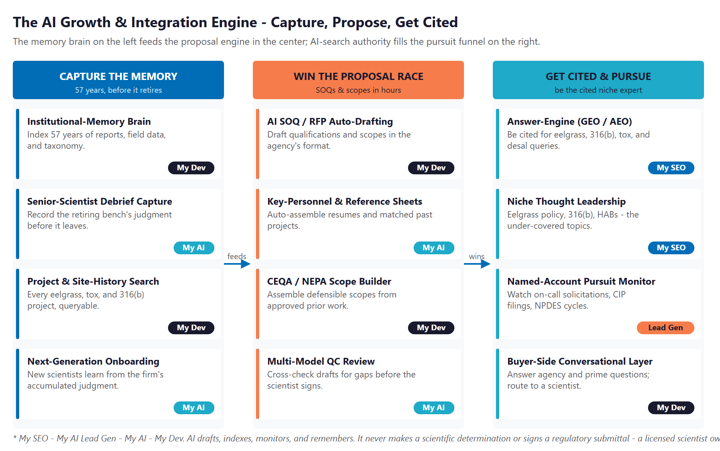
The Engine: Capture the Memory, Win the Proposal Race, and Get Cited & Pursue

Capture the Memory
Index fifty-seven years of reports, field data, toxicity records, taxonomic keys, and — through structured debriefs — the founder’s and senior scientists’ own judgment into a secure, queryable institutional brain. The next generation onboards on the firm’s accumulated expertise instead of reinventing it, and a key-person risk becomes a durable, transferable asset.

Win the Proposal Race
Draft statements of qualifications, scopes, key-personnel resumes, and reference packages from the institutional brain, in the agency’s format, in hours instead of days. A multi-model quality check flags gaps before the scientist’s final review. The firm pursues more of the right work — at the same win rate — without adding headcount.

Get Cited & Pursue
Own the AI-search citations on eelgrass, §316(b), toxicity, and desalination queries, and publish the under-covered authority content that signals depth. Watch the named-account solicitation calendar — on-call cycles, capital-improvement and CEQA filings, NPDES renewals — and arrive at each pursuit with a dossier ready.

The Program — Start Small, Expand as It Proves Out
The Program — Start Small, Expand as It Proves Out

The program leads with a small, low-commitment entry that pays for itself on the highest near-term levers — AI-search authority, named-account pursuit intelligence, and a strategy workshop — with no large build to begin. The institutional-memory brain and the proposal engine come second, once the entry proves the lift. The figures below are estimated and conservative; the full plan walks through every assumption and calibrates after a short discovery call.

Entry Program — Phase 1 | Monthly | Y1
My SEO — Niche AI-Search Authority + Reputation | $1,250 | $15,000
My AI Lead Gen — Named-Account Pursuit (Starter) | $1,000 | $12,000
My AI — Executive AI Workshop (one-time) | — | $5,000
ENTRY PROGRAM (start here) | $2,250/mo + workshop | ~$32,000

Y1 Lever (Estimated, Conservative) | Conservative | Target | Aggressive
Added revenue from faster, better proposals | +$55K | +$135K | +$275K
On-call renewal value protected | +$40K | +$70K | +$110K
Total Y1 value (entry program) | +$95K | +$205K | +$385K
Modeled ROI vs. $32K entry | ~3.0x | ~6.4x | ~12.0x

The ratio is modeled against the entry program only. The expansion build — the institutional-memory brain and the proposal engine — adds further gains the entry ratio does not count, including the succession and key-person risk it retires. All figures are projected, not guaranteed.

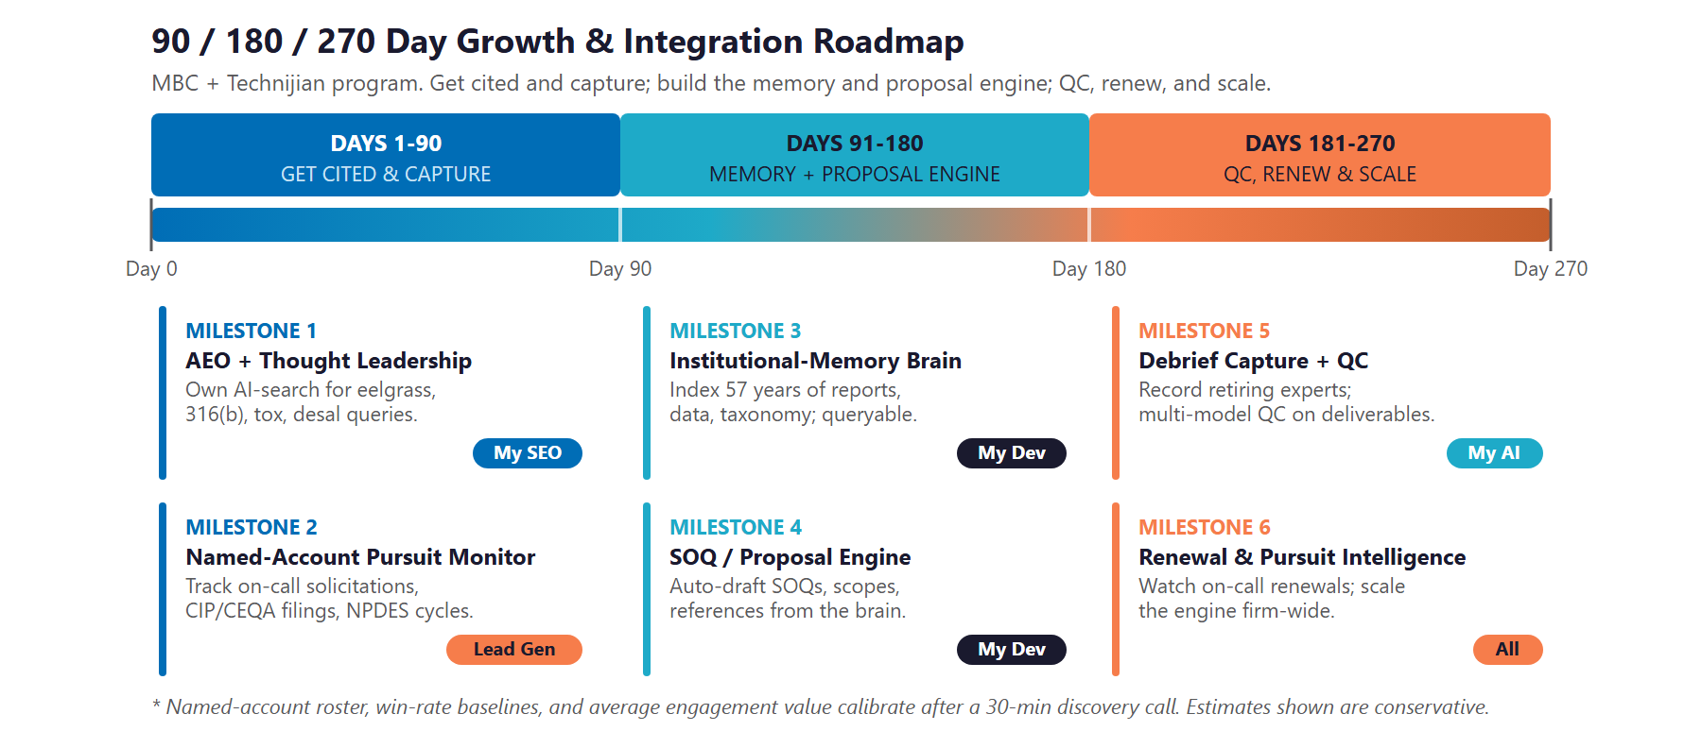
90 / 180 / 270-Day Roadmap

Next Step — 30 Minutes
A short discovery call to confirm scope and calibrate the plan against MBC’s actual numbers — and to talk candidly about the succession and scaling questions underneath it.
Ravi Jain, Technijian | RJain@technijian.com | 949.379.8499

