

ROBINSON FACIAL PLASTIC SURGERY
Dr. Ernest B. Robinson, MD · drface.com
AI Growth Blueprint — Patient Demand + Referral Lead Generation

Prepared by Technijian | 2026-05-22
Aliso Viejo, California · Orange County

CONFIDENTIAL — Prepared exclusively for Robinson Facial Plastic Surgery

01 Executive Summary
01 Executive Summary

21+  Years of Facial Surgery | Dual  Board-Certified · RealSelf Top Doctor | 4.8★  Google — but only ~32 reviews | 2  Growth Engines to Build

Robinson Facial Plastic Surgery is, by any clinical measure, an elite practice: Dr. Ernest B. Robinson is a dual board-certified, fellowship-trained facial plastic and reconstructive surgeon with 21+ years of results, a RealSelf Top Doctor, and an exclusive Allergan provider. The practice already runs a My SEO program. Yet two things hold the business below its potential — and both are fixable.
First, the digital reputation does not match the surgical one. The practice shows 4.8★ on Google but only about 32 reviews after 21 years, while the dominant Orange County names carry hundreds. Thousands of happy patients exist; they were simply never asked. Second — and the reason for this blueprint — is the question on the table: can AI Lead Gen grow the business? It can, but the honest answer depends on which of two growth engines you point it at.
This blueprint frames the practice around those two engines. Engine A is consumer demand capture — patients searching for procedures — which grows by extending the existing My SEO with GEO, on-site capture, consult-to-surgery nurture, and a reputation engine. Engine B is professional-referral growth — other practices that send surgical cases — and that is exactly where My AI Lead Gen fits: it harvests, scores, and courts the named referral universe (dermatologists, Mohs surgeons, med spas, and more). The plan builds Engine A first, then stands up Engine B.

The Core Opportunity — and the Honest Answer
Can My AI Lead Gen help? Yes — for the referral engine. It cannot (and should not) cold-prospect individual patients for elective surgery, but it is purpose-built to harvest and court the local practices that refer cases.
The fastest win is reputation: closing the 32-vs-hundreds review gap lifts every local ranking and the trust a patient feels at the moment they compare surgeons.
Dr. Robinson performs Mohs reconstruction — which makes every Orange County dermatologist and Mohs surgeon a natural, high-intent referral target the referral engine can pursue first.
Note on figures: the practice’s internal metrics (consult volume and conversion, referral counts, average case value, current My SEO scope) were not available for this draft. Every projection below is labeled estimated and calibrates to real numbers after a short discovery call — the questions are listed in Section 13.

02 The Two Growth Engines
02 The Two Growth Engines

Every growth dollar for a facial plastic surgery practice comes from one of two engines, and they could not be more different in how they work. Confusing them is the most common — and most expensive — marketing mistake in aesthetics. This blueprint keeps them separate on purpose, because the right tool for one is the wrong tool for the other.

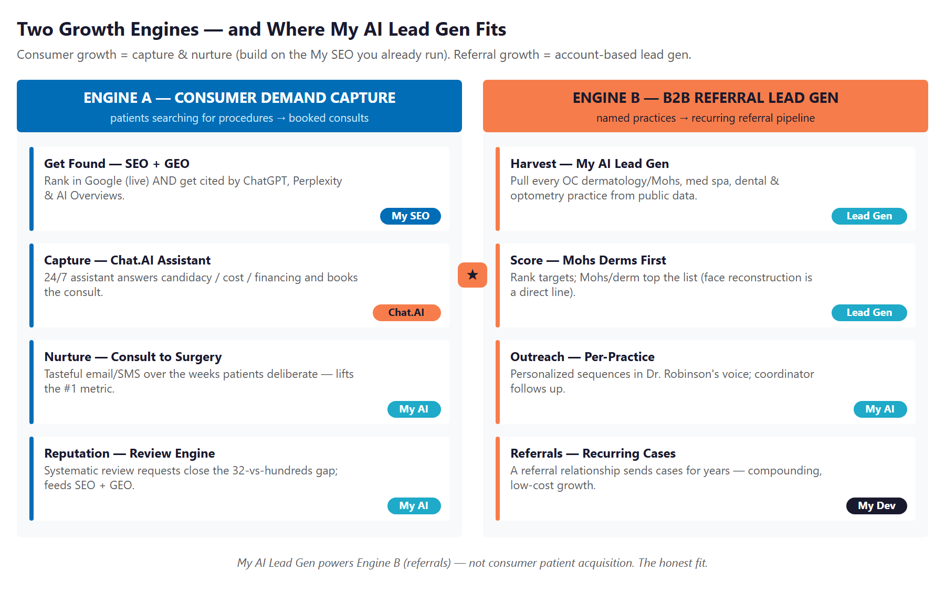
Figure 2.0 — The Two Growth Engines, and where My AI Lead Gen fits

Dimension | Engine A — Consumer Demand Capture | Engine B — B2B Referral Lead Gen
Who | Individual patients researching a procedure | Other practices that send surgical cases
How they arrive | They search, compare, and deliberate (often for weeks) | A trusted provider refers them directly
Right motion | Be found, capture, nurture, and earn reviews | Harvest, score, and court named practices
Right tools | My SEO (live) + GEO + Chat.AI + nurture + reputation | My AI Lead Gen (account-based outreach)
Wrong tool | Outbound prospecting — you cannot cold-sell a facelift | Mass advertising — referrers want a relationship
Pace | Compounds steadily as content + reviews build | Each relationship sends cases for years

The rest of this blueprint follows that structure: Section 4 answers the lead-gen question directly, Section 5 details the referral engine (Engine B), and Section 6 details the consumer engine (Engine A) on top of the My SEO already in place.

03 Where the Demand Lives
03 Where the Demand Lives

Before tactics, it helps to see exactly where the next patient comes from. Consumer demand is large, searchable, and already partly served by the practice’s My SEO. Referral demand is smaller in count but far more valuable per relationship — and almost entirely uncaptured today.

Consumer Demand — What Patients Search
Patient Search | Value | How Robinson Wins It
"best facelift surgeon Orange County" | Very high | SEO (live) + GEO + reviews + before/after proof
"deep plane facelift near me" | Very high | A procedure-specific page that ranks and gets AI-cited
"rhinoplasty Orange County" / revision rhinoplasty | High | Visual gallery + surgeon credentials + consult capture
"eyelid surgery / blepharoplasty cost" | High | Cost + candidacy explainer the assistant can answer
"Botox / filler near me Aliso Viejo" | Recurring | Local SEO + offers + the recurring-revenue base
"Mohs reconstruction surgeon" | High | A page that serves BOTH patients and referring derms

Referral Demand — The Practices That Send Cases
A facial plastic surgeon earns a meaningful share of surgical volume from other providers. This universe is finite, local, and listed in public records — which is what makes it a perfect fit for My AI Lead Gen (Section 5):
Referral Source | Why They Refer | Priority
Dermatologists / Mohs surgeons | Mohs skin-cancer excisions on the face need reconstruction — Dr. Robinson does this | ★★★★★
Non-surgical med spas | Take Botox/filler revenue but refer surgical cases (facelift, eyes, nose) up | ★★★★
Dentists / oral & maxillofacial | Chin and jaw work, facial trauma, cosmetic facial referrals | ★★★
Optometry / ophthalmology | Droopy-lid (ptosis) and cosmetic/functional eyelid cases | ★★★
PCP · OB-GYN · estheticians / salons | General cosmetic referrals from trusted local relationships | ★★

04 Can My AI Lead Gen Help? The Honest Answer
04 Can My AI Lead Gen Help? The Honest Answer

This is the question that prompted the blueprint, so it deserves a direct answer rather than a sales pitch: yes — but for one engine, not both. Getting this right is what separates a program that works from money spent in the wrong place.

For Consumer Patients — No (and here’s why)
My AI Lead Gen is an outbound engine: it harvests named targets from public business data, enriches them, and runs personalized outreach. That model does not fit individual patients. You cannot ethically or practically build a list of "people who want a facelift," privacy and HIPAA aside — and nobody chooses an elective $15K–$40K surgery because they received a cold message. Consumer growth is won by being found and trusted at the moment someone is already searching, then nurturing them to a booked consult. That is Engine A (Section 6), built on the My SEO already running — not outbound lead gen.

For Professional Referrals — Yes, and It’s a Strong Fit
Referral sources are exactly what My AI Lead Gen was built to find. Every dermatology, Mohs, med-spa, dental, and optometry practice in Orange County is a named business in public records (the NPI registry, Google Business, and more). My AI Lead Gen harvests that universe, enriches and scores it, and delivers outreach-ready, personalized sequences — replacing the cold-list tax of tools like Apollo or ZoomInfo. Pointed at referrers, it builds a pipeline of relationships, each of which can send cases for years.

The Mohs Reconstruction Wedge
Dr. Robinson performs Mohs reconstruction — repairing the face after a dermatologist removes skin cancer. That is a direct, recurring, high-intent referral line.
My AI Lead Gen can surface every Mohs surgeon and dermatology practice in Orange County and put them at the top of the outreach list — a channel almost no competitor systematically pursues.
This is account-based and relationship-first: AI builds the list and drafts the outreach; Dr. Robinson and the coordinator build the trust. The tool supports the relationship; it does not replace it.

05 The Referral Engine (Engine B)
05 The Referral Engine (Engine B)

This is the new growth channel My AI Lead Gen opens. The diagram below shows the referral universe it harvests and the priority order it works — with dermatologists and Mohs surgeons first, because facial reconstruction is a direct line into Dr. Robinson’s operating room.

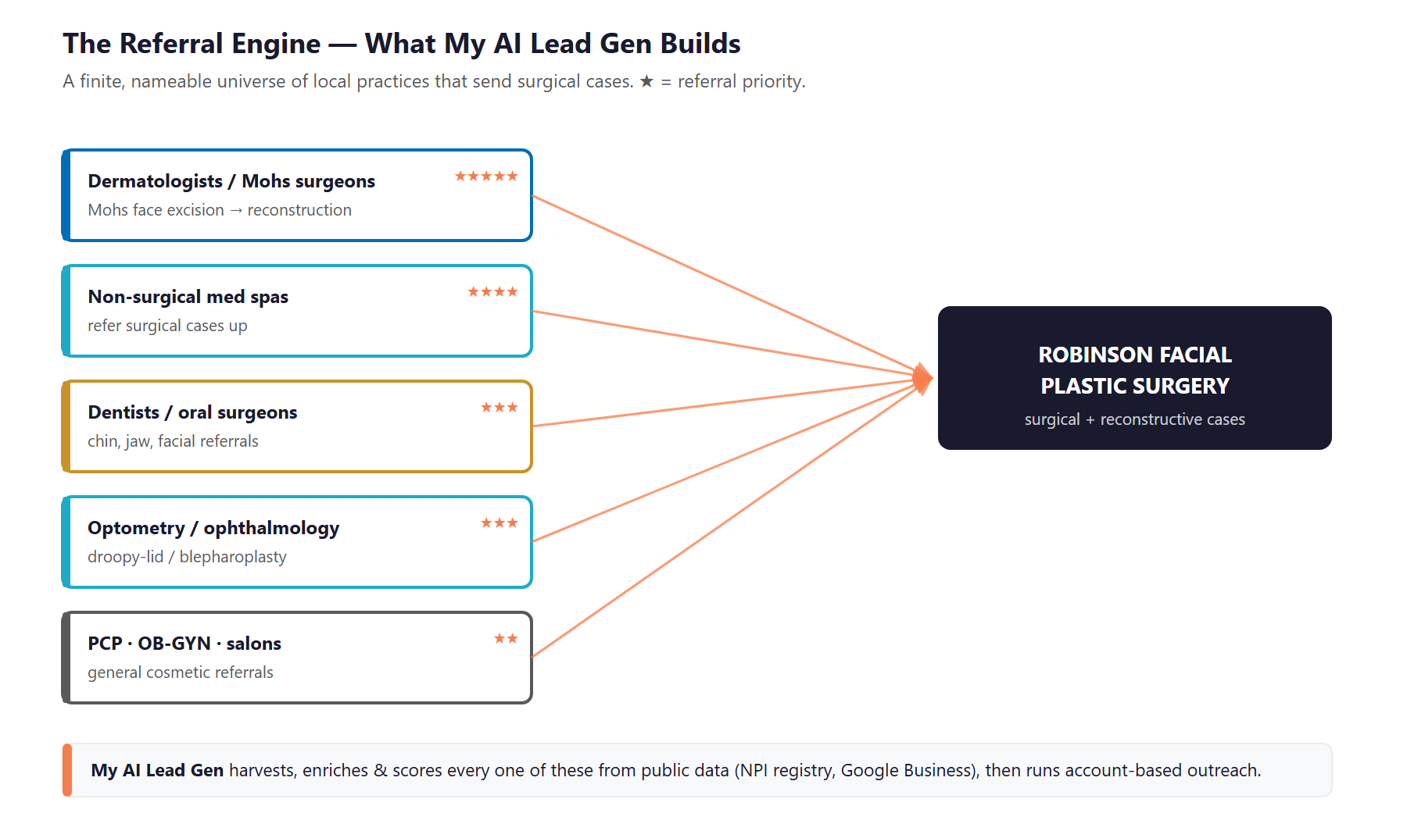
Figure 5.0 — The Referral Engine: the practices My AI Lead Gen harvests, scores, and courts

How My AI Lead Gen Runs It
Stage | What Happens | Output
Harvest | Pull every OC dermatology/Mohs, med-spa, dental, and optometry practice from public data (NPI registry, Google Business) | A complete named-target list
Enrich | Add practice size, services, decision-maker, and contact details | Outreach-ready records
Score | Rank by referral fit — Mohs/derms first, then med spas, then the rest | A prioritized queue
Deliver | Personalized outreach in Dr. Robinson’s voice; coordinator follows up; track responses | Booked referral meetings

Why This Channel Compounds
A consumer ad stops working the day you stop paying. A referral relationship, once earned, sends cases for years — at near-zero ongoing cost.
The universe is finite: there are only so many dermatology and Mohs practices in Orange County. Working the full list systematically is achievable, not endless.
It is a wedge no competitor is pressing. The big Newport Beach names compete loudly for consumers; few are quietly building the referral base Dr. Robinson’s Mohs work makes natural.

06 The Consumer Engine (Engine A) — Building on My SEO
06 The Consumer Engine (Engine A) — Building on My SEO

The practice already runs My SEO, so this engine is about extending what’s working — not starting over. Four additions turn existing search visibility into more booked surgeries, and the first is the highest-ROI move available to the practice today.

Addition | What It Does | Why It Matters
Reputation engine | Systematically request reviews from happy patients (post-visit SMS/email) | Closes the 32-vs-hundreds gap; lifts local ranking AND trust at compare-time
GEO (on top of My SEO) | Make procedure pages the source AI assistants cite | Patients now ask ChatGPT/Perplexity "best facelift surgeon OC" before they call
Chat.AI consult assistant | 24/7 assistant answers candidacy / cost / financing and books the consult | Aesthetics sites bounce; an assistant converts visits into consults
Consult-to-surgery nurture | Tasteful email/SMS over the weeks a patient deliberates | Lifts the single biggest revenue metric — consult-to-surgery conversion

The Reputation Gap Is the Quick Win
21 years and thousands of patients have produced only ~32 Google reviews. The reviews are not missing because patients were unhappy — they were never asked.
A systematic post-visit review request can multiply that count within 90 days, directly improving how Robinson ranks against Newport Beach competitors and how a comparing patient perceives the practice.
This single move costs little, builds on the existing My SEO, and pays back faster than anything else in the plan.

07 Competitive Landscape
07 Competitive Landscape

Orange County facial plastic surgery is one of the most competitive aesthetic markets in the country, concentrated in Newport Beach. Robinson’s clinical credentials are fully competitive; the gap is digital reputation and visibility — which is precisely what this program closes.

Competitor | Market / Focus | Digital Posture
Dr. Kevin Sadati | Newport Beach — facelift, "natural" look | 700+ 5-star reviews; "Best Facial Cosmetic Surgeon OC" — the dominant brand
Dr. Ali Sajjadian | Newport Beach — rhinoplasty authority | ~5,000 nose procedures, 30 yrs; strong rhinoplasty SEO
Dr. Rami Batniji | Newport Beach / Beverly Hills — deep-plane facelift | Orange Coast Top Doctor 2026; polished brand
Dr. Ali Sepehr | Newport Beach / Tustin | Fellowship-trained (U Toronto); active content
Dr. Timothy Miller | Orange County — eyelid + face/neck | Established; less aggressive digital
Dr. Jonathan Zelken | Newport Beach | NewBeauty Top Doctor; social-forward

Where Robinson Wins — The White Space
Reputation velocity: 32 reviews vs. competitors’ hundreds is the single biggest, most fixable gap. The quality is there; the reviews were never collected.
South-OC ownership: the big names cluster in Newport Beach. Robinson can own Aliso Viejo, Laguna, Mission Viejo, San Clemente, and Dana Point local search instead of fighting Newport head-on.
The Mohs-reconstruction referral niche: a clinical credential most cosmetic-only competitors don’t emphasize — and a B2B referral wedge nobody is systematically courting.
GEO first-mover: almost no OC surgeon is optimized to be the answer AI assistants cite. Robinson can claim it.

08 The Patient & Referral Customer
08 The Patient & Referral Customer

Robinson serves a handful of distinct segments across the two engines. Each is reached differently — which is the whole point of separating consumer capture from referral lead gen.

1 — The Surgical Self-Investor (Engine A)
Profile | Affluent, 45–65, considering a facelift, neck lift, or eyelid surgery. The highest-value patient.
Mindset | Researches for weeks or months; reads reviews; compares 3–4 surgeons; "do it for myself."
Decision Driver | Trust and natural results. Reviews, before/after proof, and surgeon credentials win the consult.
How AI Helps | GEO + reviews put Robinson in the consideration set; nurture and the consult assistant convert the deliberation into a booking.
Technijian Hook | My SEO (live) + GEO + My AI reputation/nurture + Chat.AI consult capture.

2 — The Rhinoplasty Patient (Engine A)
Profile | Often 20s–30s, highly visual and social-media-driven; primary or revision rhinoplasty.
Mindset | Studies galleries and surgeon specialization closely; wants proof of nose-specific expertise.
Decision Driver | Portfolio depth and credibility for the specific procedure.
How AI Helps | Procedure-specific SEO/GEO pages + visual proof + an assistant that answers cost/candidacy.
Technijian Hook | My SEO + GEO + Chat.AI; before/after content engine.

3 — The Injectables Regular (Engine A)
Profile | Returns 2–4×/year for Botox and filler; the recurring-revenue base and a referral source.
Mindset | Convenience and trust; often the entry point to a future surgical case.
Decision Driver | Local, easy booking, consistent results, fair offers.
How AI Helps | Local SEO + offers + recall reminders keep them coming back and upgrade them over time.
Technijian Hook | My SEO (local) + My AI recall/nurture.

4 — The Referring Dermatologist / Mohs Surgeon (Engine B)
Profile | A local derm or Mohs surgeon who removes facial skin cancers and needs a reconstruction partner.
Mindset | Wants a reliable, skilled surgeon who makes them and their patient look good — and communicates back.
Decision Driver | Surgical skill, responsiveness, and a relationship. The #1 B2B target.
How AI Helps | My AI Lead Gen surfaces and scores them; personalized outreach + Dr. Robinson’s Mohs credential opens the door.
Technijian Hook | My AI Lead Gen (account-based) + My Dev referral-status touchpoints.

5 — The Med-Spa Referrer (Engine B)
Profile | A non-surgical med spa that performs injectables but refers surgical cases out.
Mindset | Wants a trusted surgeon to send facelift/eyelid/nose cases to without losing the patient relationship.
Decision Driver | Trust and a clean hand-off; reciprocal respect.
How AI Helps | My AI Lead Gen identifies non-surgical spas in the area and runs partnership outreach.
Technijian Hook | My AI Lead Gen (account-based outreach).

6 — The Out-of-Town Guest (Engine A)
Profile | A patient traveling to Orange County for a specific procedure; the site already has an out-of-town page.
Mindset | Needs logistics confidence (travel, recovery, aftercare) on top of surgeon trust.
Decision Driver | Reputation + a concierge-grade experience that removes travel friction.
How AI Helps | GEO captures destination searches; the consult assistant answers logistics and books the virtual consult.
Technijian Hook | My SEO + GEO + Chat.AI (virtual consult capture).

Figure 8.0 maps each segment by revenue value and volume — blue for consumer patients (Engine A) and orange/gold for referral sources (Engine B, the My AI Lead Gen targets).

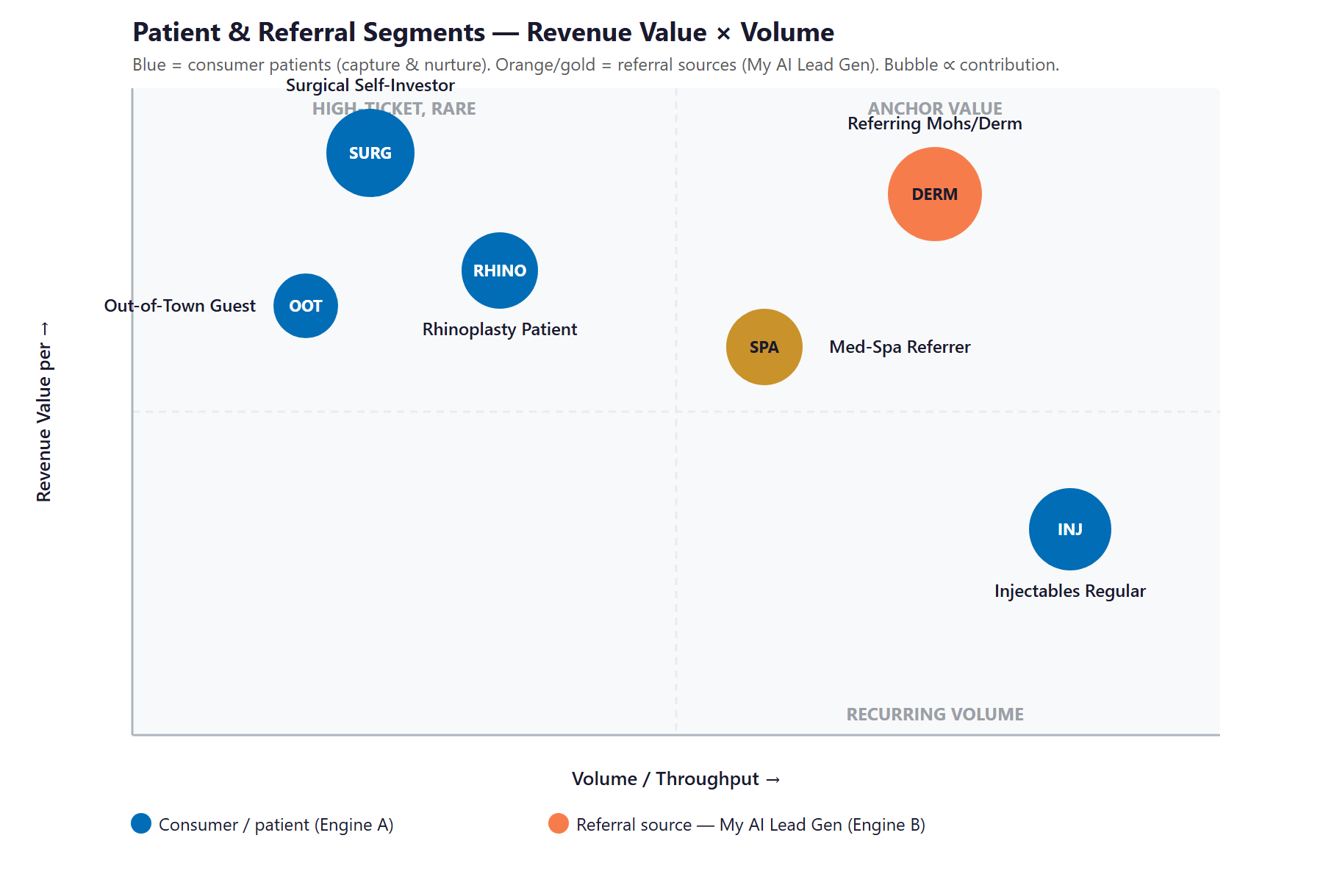
Figure 8.0 — Patient & Referral Segments: Revenue Value vs. Volume

09 Technijian Capability Proof
09 Technijian Capability Proof

Robinson already knows Technijian delivers — the My SEO program is live. The platforms below are the rest of the toolkit, each delivered and operating for real clients, and each mapped to a specific engine in this plan.

Proven Build 1 — Multi-Agent SEO + GEO Platform (extends your live My SEO)
What Technijian Built: Technijian operates a multi-agent platform (Claude, GPT-4o, and Gemini with MCP, plus SEMrush, GA4, and Perplexity) that ranks content in Google and positions clients as the answer the AI assistants cite.
How This Applies to Robinson Facial: It layers GEO onto the My SEO already running — so "best facelift surgeon Orange County" and the procedure searches win in both Google and ChatGPT / Perplexity / Google AI Overviews.

Proven Build 2 — My AI Lead Gen: Account-Based Outbound (the referral engine)
What Technijian Built: My AI Lead Gen harvests high-fit targets from public data, enriches and scores them, and delivers outreach-ready personalized sequences — replacing the Apollo / ZoomInfo subscription tax.
How This Applies to Robinson Facial: It builds the referral engine: every OC dermatology/Mohs, med-spa, dental, and optometry practice, scored with Mohs derms first, with personalized outreach in Dr. Robinson’s voice. This is the answer to the lead-gen question.

Proven Build 3 — AI Review & Reputation Engine
What Technijian Built: Technijian built an AI review and reputation system that requests, monitors, and responds to reviews across Google and the directories local search ranks on.
How This Applies to Robinson Facial: It closes the 32-vs-hundreds review gap with systematic post-visit requests — the single highest-ROI move available, lifting both local ranking and patient trust.

Proven Build 4 — Chat.AI Conversational Capture
What Technijian Built: Chat.AI is Technijian’s enterprise AI platform; as a website assistant it answers visitor questions in natural language around the clock and hands qualified inquiries to a person.
How This Applies to Robinson Facial: On drface.com it answers candidacy, cost, and financing questions for nervous prospective patients and books the consult — turning visits into consults instead of bounces.

Proven Build 5 — AI-Native Custom App Delivery (My Dev)
What Technijian Built: Technijian’s AI-native SDLC delivers custom web apps 3–5x faster than traditional development — funnels, integrations, and automations built around a real workflow.
How This Applies to Robinson Facial: It builds the consult-to-surgery nurture flows, the booking/lead routing, and the referral-status touchpoints that keep referring practices informed and loyal.

10 Business Impact & Service Investment
10 Business Impact & Service Investment

The model below is built from public and industry benchmarks because Robinson’s internal numbers were not available for this draft. Every figure is estimated and conservative; the discovery questions in Section 13 replace them with real baselines. Because a single facial surgery case is high-value, the ROI holds at modest case counts — the two engines simply need to add a handful of cases each.

Projected KPI Lift (Estimated)
KPI | Estimated Current | With the Program | Direction
Google reviews | ~32 (after 21 yrs) | Hundreds within a year | Ranking + trust
GEO citations (ChatGPT, Perplexity, AI Overviews) | None | Cited for key procedures | Durable visibility
Consult → surgery conversion | Unmanaged | Nurtured | More surgeries, same consults
Active referring practices | Ad hoc / few | A worked, growing list | Recurring case flow
Visitor → consult capture | Form only | Chat.AI assistant + funnel | More from same traffic

Year-1 ROI Model (Estimated, Conservative Assumptions)
Model Input | Conservative | Target | Aggressive
Incremental cases — referral engine (Y1) | +12 | +24 | +40
Incremental cases — consumer engine (Y1) | +8 | +16 | +28
Avg case value* | $12,000 | $12,000 | $12,000
Total additional annual revenue | +$240,000 | +$480,000 | +$816,000
Technijian Program Investment (Y1) | ~$96,200 | ~$96,200 | ~$96,200
Modeled ROI Ratio | 2.5x | 5.0x | 8.5x

* Blended placeholder across surgical procedures; conservative — facelifts and rhinoplasty run well above $12,000. Excludes recurring injectables uplift. All figures projected, not guaranteed.

Technijian Service Investment Map
Service | Scope | Monthly | Y1 Total
My SEO — GEO Extension | Add GEO/AI-citation + procedure content on top of the My SEO already running | $750/mo | $9,000
My AI — Reputation + Nurture | Review-velocity engine + consult-to-surgery nurture flows | $1,500/mo | $18,000
My AI Lead Gen — Referral Engine | Harvest/enrich/score/outreach to OC referral practices (Professional tier) | $3,499/mo | $42,000
My Dev — Capture & Funnel Build | Chat.AI consult-assistant integration, booking funnel, lead routing (one-time) | — | $20,000
My Dev — Managed Services | Hosting, monitoring, and ongoing optimization | $600/mo | $7,200
YEAR-1 TOTAL (added program) | Recurring $6,349/mo + build |  | ~$96,200

My SEO is already in place and is not re-billed here — this map shows the added program. Chat.AI is integrated within the My Dev build. All amounts confirm against scope at the discovery call.

The Math That Matters
A single facelift or rhinoplasty case can be worth $15,000–$40,000. At a conservative $12,000 blended, just eight added cases a year cover the full program — and the model targets far more.
The reputation engine and the referral engine both produce results that compound: reviews and relationships keep paying long after the work to build them.
The program is phased — reputation + capture first (fast payback), then the referral engine — which lowers the entry point and proves return before the full spend.

11 Implementation Roadmap
11 Implementation Roadmap

The roadmap runs on a 90 / 180 / 365-day cadence: strengthen the consumer engine first (where the fastest wins are), stand up the referral engine next, then scale both. Meaningful results — more reviews, more captured consults — are visible inside the first 90 days.

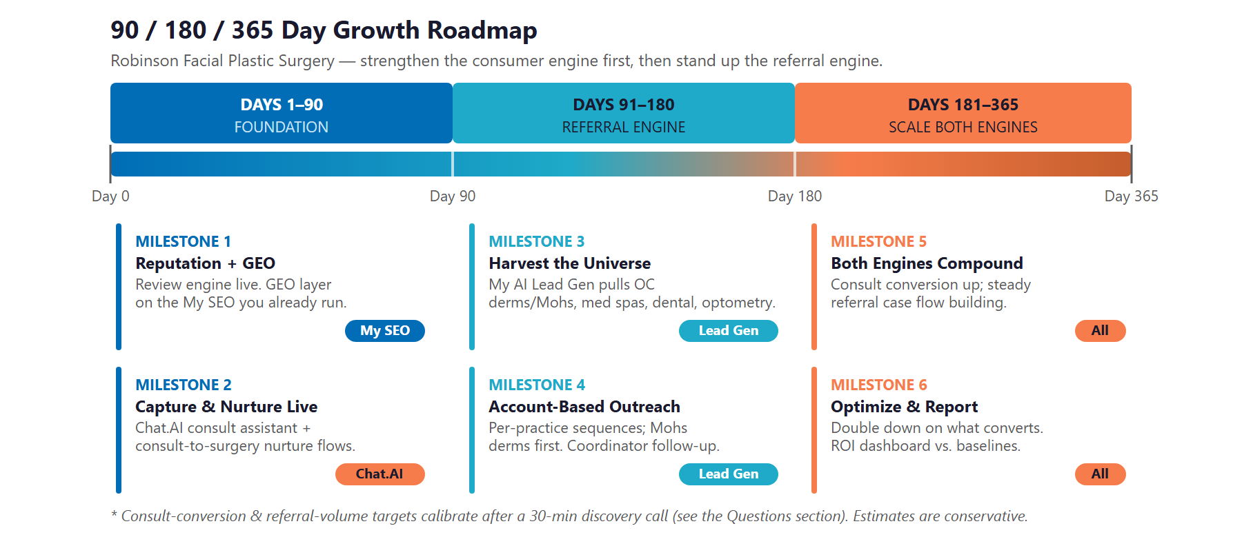
Figure 11.0 — Robinson Facial Plastic Surgery: 90 / 180 / 365-Day Roadmap

Phase 1 — Foundation (Days 1–90)
Strengthen the consumer engine on top of the live My SEO — and capture the demand it already creates.
Milestone | Deliverables
1.1 — Reputation + GEO | Launch the review-velocity engine (post-visit requests). Layer GEO and procedure content onto the existing My SEO.
1.2 — Capture & Nurture Live | Deploy the Chat.AI consult assistant on drface.com. Stand up consult-to-surgery nurture flows and lead tracking.

Phase 2 — Referral Engine (Days 91–180)
Stand up Engine B — the answer to the lead-gen question.
Milestone | Deliverables
2.1 — Harvest the Universe | My AI Lead Gen pulls every OC dermatology/Mohs, med-spa, dental, and optometry practice; enriches and scores it (Mohs derms first).
2.2 — Account-Based Outreach | Personalized outreach in Dr. Robinson’s voice; coordinator follow-up; first referral meetings booked.

Phase 3 — Scale Both Engines (Days 181–365)
Compound what is working across both engines.
Milestone | Deliverables
3.1 — Both Engines Compounding | Consult-to-surgery conversion rising; a steady, growing referral case flow from the worked list.
3.2 — Optimize & Report | Double down on the procedures and referrers that convert. ROI dashboard delivered against the Section 13 baselines.

12 Quick Wins — Start This Week
12 Quick Wins — Start This Week

Five actions Robinson Facial can take immediately — before any new engagement. Each creates value this week and leads into the larger program.

1 — Text Your Last 50 Happy Patients for a Review
The 32-review gap is the biggest, cheapest fix in the practice. Have the coordinator text the last 50 satisfied surgical patients a one-tap Google review link. Even 20 new reviews shifts local ranking and compare-time trust within weeks.

2 — Claim and Complete the Google Business Profile
Verify the Aliso Viejo Google Business Profile; add full procedure descriptions, hours, photos, and before/after imagery. This is free local visibility that patients and referrers both check.

3 — Build the Mohs / Dermatology Target List
Open Google Maps and list every dermatology and Mohs practice within 20 miles. This is the seed of the referral engine — and Dr. Robinson’s reconstruction credential is the reason to reach out.

4 — Add a Consult CTA + Assistant to Every Procedure Page
Make "Request a Consultation" unmissable on every procedure page, and add a simple chat/booking prompt. Capture the visitor while their interest is high instead of relying on a single contact form.

5 — Publish One Before/After-Rich Procedure FAQ
Pick the top procedure (facelift or rhinoplasty) and publish a page answering the real questions — cost, recovery, candidacy — with before/after proof. This is the seed of the GEO content AI assistants cite.

13 Questions to Calibrate This Plan
13 Questions to Calibrate This Plan

This blueprint was built from public information. The numbers in Sections 10 and 11 are deliberately conservative — a short discovery call replaces them with Robinson’s real baselines and sharpens the whole program. These questions move the model the most:

Topic | What We’d Confirm | Why It Matters
Consult funnel | Monthly consult volume and consult → surgery conversion rate | The #1 consumer-engine lever and ROI input
Referrals today | Current referral volume and which practices send cases | Sizes Engine B and seeds the target list
Case value | Average surgical case value and surgical vs. non-surgical mix | Sets the revenue lines in the ROI model
My SEO scope | What the existing My SEO program covers today | So we extend it, not duplicate it
Lead handling | Who answers calls / inquiries now, and how fast | Designs the capture + nurture layer
Reviews | Any existing review-request process or platform | Calibrates the reputation engine
Paid ads | Any Google / Meta / Instagram spend running now | Determines where capture plugs in
Systems | Practice-management / CRM system in use | Defines the integration surface for nurture + routing
Locations | Confirm Aliso Viejo + Laguna Hills — and whether Temecula is active | Scopes local SEO + geographic targeting
Brand | Robinson Facial Plastic Surgery vs. the DrFace brand — which leads? | Aligns SEO/GEO and outreach naming

How to Use This Section
None of these questions block starting — the Quick Wins and Phase 1 foundation proceed regardless.
A single 30-minute call answers most of them and lets Technijian return a calibrated ROI model and a fixed-scope Statement of Work.
The goal is a plan built on Robinson’s real numbers — not on our conservative estimates.

14 What Happens Next
14 What Happens Next

Robinson Facial Plastic Surgery has the hardest thing to build already: 21 years of dual-board-certified, fellowship-trained results. What it is missing is a digital reputation that matches that surgical one, and a referral engine worthy of Dr. Robinson’s Mohs-reconstruction credential. Both are buildable now, on top of the My SEO already in place and on systems Technijian has already delivered.
And the question that started this is answered: yes, My AI Lead Gen can grow the business — as the referral engine, courting the dermatologists, Mohs surgeons, and med spas that send surgical cases, while the consumer engine captures and converts the patients already searching. Two engines, each with the right tool.

Recommended Next Steps
Step 1: A 30-minute discovery call to answer the Section 13 questions and confirm scope against the existing My SEO program.
Step 2: Technijian returns a calibrated ROI model and a fixed-scope Statement of Work within 5 business days.
Step 3: Phase 1 kickoff — review engine, GEO layer, and the Chat.AI consult assistant — live inside 14 days of signature.

Ready to turn 21 years of results into reviews and referrals?
Contact Ravi Jain, Technijian | RJain@technijian.com | 949.379.8500
technijian.com | Irvine, CA

15 About Technijian
15 About Technijian

Technijian is an AI-native managed services and technology firm headquartered in Irvine, California, serving small and mid-sized businesses since 2000. We build and operate the AI systems that help local businesses compete at scale — and Robinson Facial already runs our My SEO program.

Service | What It Delivers for Robinson Facial
My SEO | The live program — extended with GEO so the practice ranks in Google AND gets cited by the AI assistants for the procedures patients search
My AI Lead Gen | The referral engine — harvest, enrich, score, and court the dermatology/Mohs, med-spa, and dental practices that send surgical cases
My AI | The reputation engine (close the review gap) and consult-to-surgery nurture
My Dev | Chat.AI consult-assistant integration, the booking funnel, lead routing, and referral-status touchpoints

Contact | Detail
Account Executive | Ravi Jain — RJain@technijian.com
Office | 18 Technology Dr., Suite 141, Irvine, CA 92618
Phone | (949) 379-8500
Web | technijian.com

A Appendix — Sources
A Appendix — Sources

Market and practice intelligence gathered via public web research conducted May 22, 2026. Review counts, credentials, and competitor claims are from publicly available sources and to be confirmed with the practice before external use.

1. Robinson Facial Plastic Surgery — official website: drface.com (Home, About, Surgical & Non-Surgical Procedures, Aesthetic NP, Photos & Stories, Contact, Blog)
2. drface.com — procedures, team, locations (Aliso Viejo + Pacific Hills Surgery Center, Laguna Hills), badges (RealSelf Top Doctor, AAFPRS, Allergan)
3. Web research — Orange County facial plastic surgery competitive set (Sadati, Sajjadian, Batniji, Sepehr, Miller, Zelken)
4. My AI Lead Gen — mechanics + pricing (Harvest → Enrich → Score → Deliver; Starter $1,499 / Professional $3,499 / Enterprise $6,999 per month)
5. Mohs reconstruction referral pattern — dermatology / Mohs surgery to facial reconstructive surgeon (clinical referral line)
6. Technijian service pricing — My SEO, My AI, My AI Lead Gen, My Dev, Chat.AI rate cards; Technijian SEO + GEO strategy methodology

