

TALLEY & ASSOCIATES
Government Relations · Public Affairs · Association Management
AI-Driven Growth Blueprint

Prepared by Technijian | 2026-05-26
Laguna Hills, California | talleyassoc.com

CONFIDENTIAL — Prepared exclusively for Talley and Associates, Inc.

01 Executive Summary
01 Executive Summary

1981  Firm Founded | 45 Years  MHP & Land-Use Advocacy | 100+  Named Clients & Associations | 4 Counties  OC, LA, Riverside & San Bernardino

Talley and Associates is a relationship business. For 45 years it has won land-use entitlements for property owners, guided mobile-home-park owners through conversions and closures, and managed the trade associations and political action committees of the housing and commercial-real-estate industry — all on the strength of relationships at the staff and elected-official levels of local government that few firms can match. The asset is not a product or a process. It is who the firm knows, what it remembers, and the property-rights reputation it has earned across Orange, Los Angeles, Riverside, and San Bernardino counties.
That asset has three exposures, and each is exactly what AI is built to address. First, the firm’s 45 years of expertise is effectively invisible online: talleyassoc.com forwards to a free do-it-yourself website, so the property owners and association boards now searching for help find competitors instead. Second, the regulatory ground the firm watches — the California Legislature, the FPPC, and the agendas of roughly eighty city and county bodies — moves faster and wider than any small team can track by hand. Third, and most important, the institutional knowledge that makes the firm valuable lives in the heads of two senior principals, undocumented.
This blueprint is a focused, account-based program with three moves: get known (make the firm’s expertise findable where buyers and the public now search), monitor and mobilize (watch every bill and agenda that can touch a client and surface it the week it moves), and capture and scale (turn 45 years of relationships and matter history into a knowledge base, and automate the association and compliance work that consumes senior time). It is deliberately account-based — Talley already knows who its targets are — and the relationships, the judgment, and the presence at the dais stay exactly where they belong, with the team.

The Core Opportunity
Talley’s moat is 45 years of relationships and a property-rights, mobile-home-park, and land-use mastery few can claim — but that knowledge lives in two people’s heads, and the firm’s online presence (a free DIY site) tells none of it.
The firm wins on depth and timing: knowing which council to call, which bill threatens which client, which jurisdiction is about to change an ordinance. AI watches the Legislature, the FPPC, and roughly eighty local agendas continuously, so nothing affecting a client slips by.
No competitor owns the “California mobile-home-park conversion / property-rights” conversation online. The digitally strong firms are Los Angeles generalists; the local land-use specialists are invisible. That corner is open, and Talley is the firm that has actually earned it.
A note on figures: this blueprint was built from public information. The firm’s internal numbers — active retainer clients, the association and PAC book, the number of jurisdictions tracked, and filing volume — were not available for this draft. Every projection below is labeled estimated and conservative, and calibrates to real numbers after a short discovery call. The specific questions are in Section 14.

02 The Firm — Three Pillars of Practice
02 The Firm — Three Pillars of Practice

Any growth plan for Talley starts with how the firm actually earns, because three distinct practices share one engine. The engine is a set of relationships and a regulatory fluency built since 1981; the practices are the three ways the firm puts it to work. They reinforce each other — the same property owners, housing associations, and commercial-real-estate players move between all three — which is why a single AI program lifts the whole firm rather than one service line.

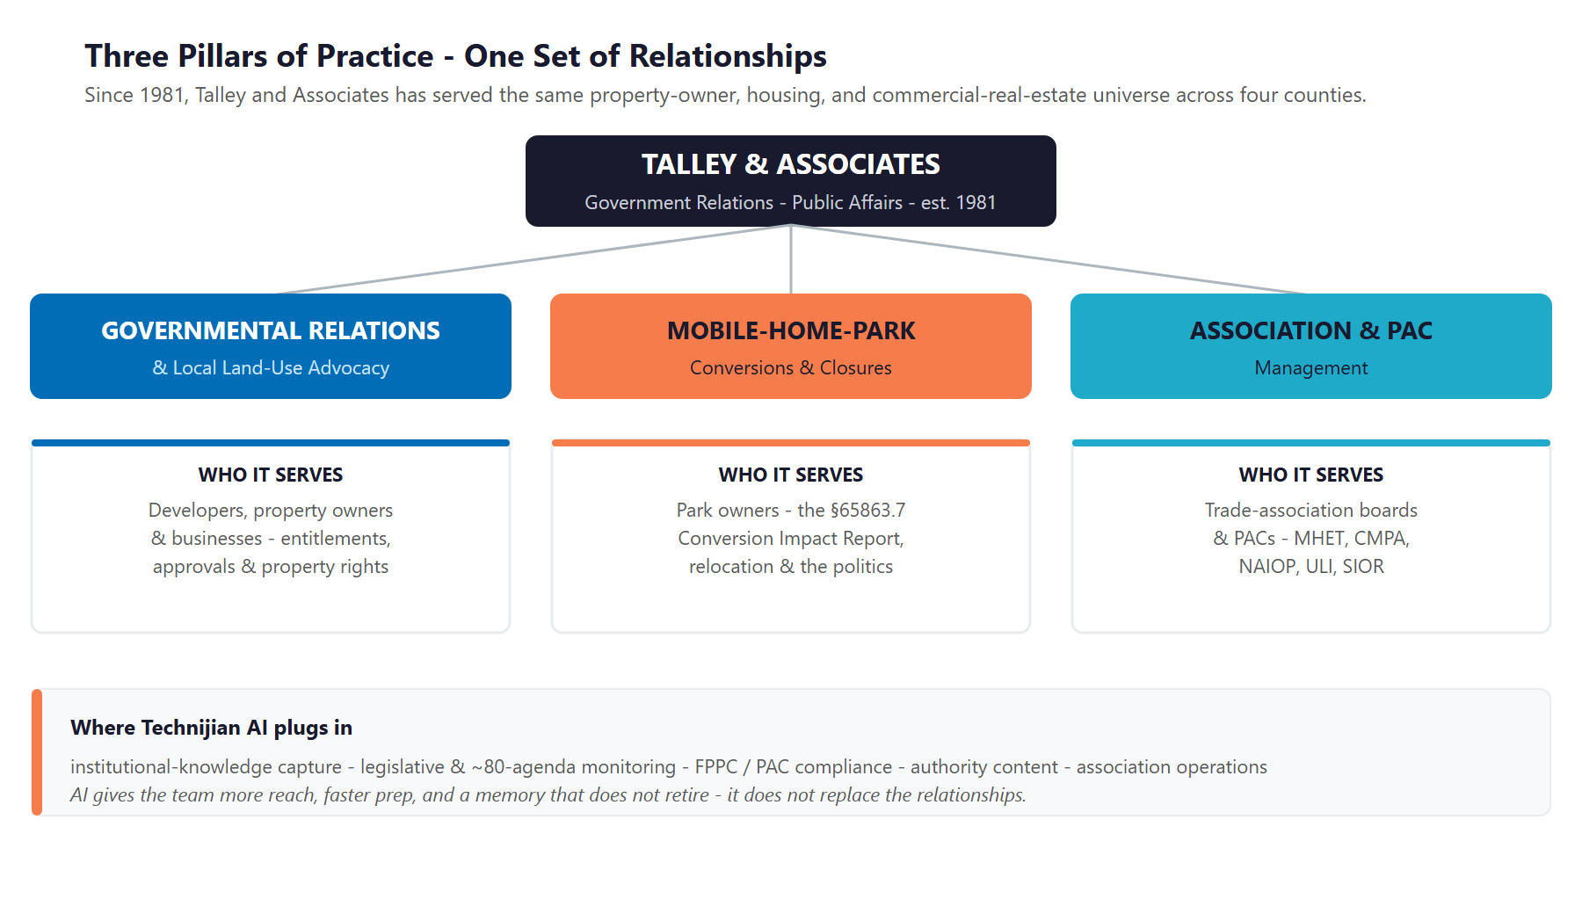
Figure 2.0 — Three pillars of practice, one set of relationships, serving the same property-owner and housing universe

Governmental Relations & Land-Use Advocacy
The firm represents private property owners, developers, and businesses at the local level — entitlements, approvals, and property-rights matters before city councils and planning commissions across four counties. Founder Vickie Talley brings the inside view: she served the City of Cypress as Mayor, Councilmember, and Planning Commissioner, and worked in the Los Angeles City Planning Department. Advisor Bill Talley served as city manager for Anaheim, Mission Viejo, Dana Point, Rancho Santa Margarita, Oceanside, and San Clemente. The team’s value is knowing how each jurisdiction actually decides.

Mobile-Home-Park Conversions
This is the firm’s deepest specialty: representing park owners through the conversion or closure of a mobile-home park since 1981. The work spans the strategy, the preparation of the Conversion Impact Report required under Government Code section 65863.7, tenant mitigation and relocation, and the public and governmental-relations process with the jurisdiction and the community. Vickie Talley qualifies as an expert witness on mobile-home-park conversions and closures and on rental-assistance programs. Few firms in California have done this work longer or know its politics better.

Association & PAC Management
The firm provides full-service management for non-profit trade associations and their political action committees — a dedicated team and office at a fraction of the cost of a stand-alone operation. The named book is substantial: the Manufactured Housing Educational Trust and its PAC, the California Mobilehome Parkowners Alliance, the NAIOP commercial-real-estate chapters and their PACs, the Urban Land Institute and SIOR district councils, and apartment- and housing-industry associations across Orange County and the Inland Empire. The firm runs the membership, the governance, the events, the reporting, and the advocacy.

The Asset Is the Relationships — and the Memory Behind Them
The firm’s record is concrete: more than a hundred named property-owner, developer, and association clients; ten city governments served; and two ballot campaigns run and won (Proposition 199 in 1996 and Huntington Beach’s Measure EE in 2002).
Across the team, that is more than 75 years of relationships at the staff and elected-official levels of local government — the kind of access that is earned over decades and cannot be bought.
Everything in this blueprint is designed to protect that asset and extend its reach — never to replace the relationships that are the firm’s real product.

03 The Regulated Environment
03 The Regulated Environment

Talley operates inside three bodies of regulation, and each is document-heavy, deadline-driven, and spread across many jurisdictions — which is precisely the kind of work AI handles well, with a person reviewing and signing anything sworn. Understanding the load is the first step to removing most of it.

Political Reform Act, the FPPC, and Local Lobbying Rules
Lobbying and PAC work in California is governed by the Political Reform Act of 1974 and administered by the Fair Political Practices Commission. The obligations are recurring and exact: lobbying registration and quarterly disclosure (Forms 604, 615, 625, and 635), and campaign and committee reporting for PAC clients (Forms 460 and 461). Local government advocacy is regulated separately and city by city — Los Angeles, Orange County, Anaheim, and many others maintain their own lobbyist registries and quarterly reports — so a firm working dozens of jurisdictions carries a compliance matrix, not a single calendar. Late or inaccurate filings carry penalties (a late Form 460 accrues a daily fine, and enforcement penalties can reach $5,000 per violation).

Mobile-Home-Park Conversion Law
A park conversion or closure runs on its own statutory track. Government Code section 65863.7 requires the proponent to prepare a Conversion Impact Report addressing the relocation of residents, deliver it to residents well before the hearing, and address relocation costs — a statutory minimum that local agencies often build on. The Mobilehome Residency Law (Civil Code section 798 and following) governs the landlord-tenant relationship in the park, and recent law (AB 2782, 2020) tightened how long-term leases interact with local rent stabilization. The result is a document-heavy, discretionary, and politically charged process — exactly the niche the firm has worked for four decades.

Land Use, CEQA, and Housing Mandates
The firm’s developer and property-owner clients move through CEQA review, housing-element and RHNA mandates, and a fast-changing body of state housing law — the 2025 CEQA reforms (AB 130 and SB 131), transit-oriented upzoning, and ADU streamlining among them — all decided in the same council and planning-commission rooms where the firm already works. Every new bill and ordinance is both a risk to manage and a reason a client picks up the phone.

The Compliance Boundary — Assist, Never Auto-File
This is disclosure and recordkeeping compliance, not automated decision-making — a far lower-risk place for AI than, say, credit underwriting. Lobbying disclosures are public record, so monitoring and drafting carry little confidentiality risk.
But filings are sworn and penalized. So AI drafts the forms, tracks every state and local deadline, and runs an accuracy check — and a person at the firm reviews and signs every filing. The technology removes the burden and the deadline risk; it never replaces the signature.
The same principle holds for legislation: AI summarizes a bill and flags what it means for a client, and the firm decides what to do about it.

04 Where the Growth Lives
04 Where the Growth Lives

Because Talley sells to a finite, nameable set of buyers — property owners, park owners, association boards, and businesses that need a local-government voice — this is an account-based program, not a marketing campaign. The firm’s next engagement comes from four pools, and the team already knows most of the names. The job of AI is to make the firm easy to find when a buyer first searches, to surface the moment a named account needs help, and to free senior time for the relationships that close the work.

Growth Pool | Who / What | How Talley Captures It
Land-use & entitlement clients | Developers and property owners facing a city-hall approval or a property-rights fight | Reputation, referrals, and visible authority in the niche — found first when a buyer searches, then won on the relationship
Mobile-home-park owners | Owners converting or closing a park, or fighting a rent-control ordinance | The 45-year specialist with the expert-witness record and the Conversion Impact Report process — surfaced the moment a hostile bill or ordinance appears
Association & PAC contracts | Trade-association and PAC boards in housing and commercial real estate | Industry fluency plus the MHET and CMPA track record — and the capacity to run a board turnkey, now extended by automation
Deeper service to the existing book | The 100-plus property owners, developers, and associations already with the firm | Capacity freed from admin and monitoring, plus proactive alerts that surface a client’s next need before they ask

Account-Based by Design — No Shotgun Marketing
Talley already knows who its targets are: the property-owner, housing, and commercial-real-estate universe across four counties. The value of AI is depth, timing, and capacity on those named accounts — not a broad consumer funnel.
There is one honest exception, and it is inbound: when a park owner first searches “how to close a mobile home park in California,” the firm should be the cited expert that comes up. That is authority, not lead-gen — it earns the relationship that does the rest.
The relationship stays central throughout. AI surfaces the account and drafts the first pass; the team makes the call, walks the hall, and wins the work.

05 The Talley Client
05 The Talley Client

Four buyer types account for nearly all of the firm’s work. They differ in how often they hire, how much an engagement is worth, and what they worry about — but they share one trait that defines the strategy: each is a named, knowable account, reached through reputation and relationship rather than broad advertising. The cards below profile each buyer, and the matrix places them by engagement volume and strategic value to the firm.

1 — The Real-Estate Developer / Property Owner
Role | A developer or owner who needs an entitlement, approval, or property-rights outcome from a city council or planning commission.
Pain Points | Political and CEQA risk, hostile or unpredictable councils, and timelines that slip when the politics are misread.
Decision Driver | Track record and access — a firm that knows how this jurisdiction actually decides and who has to be persuaded.
AI Opportunity | Account dossiers and stakeholder maps on the council and jurisdiction; agenda monitoring; first-pass position letters.
Technijian Hook | My AI Lead Gen — account intelligence on named jurisdictions. My Dev — the agenda monitor and dossier system.

2 — The Mobile-Home-Park Owner
Role | An owner converting or closing a park, or defending one against a rent-control ordinance — the firm’s core client.
Pain Points | Navigating section 65863.7, surviving local ordinances, relocation compliance, resident organizing, and hostile bills like SB 749.
Decision Driver | Deep specialization — the firm with 45 years of mobile-home-park wins and the expert-witness credibility.
AI Opportunity | Monitoring every mobile-home-park bill and local ordinance; drafting the Conversion Impact Report; tracking the politics jurisdiction by jurisdiction.
Technijian Hook | My AI — document drafting and legislative monitoring. My SEO — own the “mobile-home-park conversion” niche online.

3 — The Trade-Association Board
Role | A volunteer board (MHET, CMPA, NAIOP, ULI) that wants its association run turnkey, without hiring staff.
Pain Points | Administrative burden, member retention and dues, event and symposium logistics, board reporting, and PAC compliance.
Decision Driver | Industry fluency and trust — a manager who speaks the members’ language and delivers Sacramento advocacy.
AI Opportunity | Automating member communications, dues and event workflows, board-report generation, and PAC-filing support.
Technijian Hook | My Dev — a member portal and ops automation. My AI — newsletters, reporting, and filing assistance.

4 — The Business / Coalition Needing a Local Voice + PAC
Role | A company or coalition that needs a sustained voice at city and county level and a compliant political action committee.
Pain Points | Cannot track every jurisdiction’s agenda; needs to mobilize fast on a threat; carries campaign-finance compliance risk.
Decision Driver | Coverage and reliability — a firm that watches the rooms they cannot and keeps the PAC clean.
AI Opportunity | Multi-jurisdiction agenda monitoring with trigger alerts, and PAC compliance tracking across filings.
Technijian Hook | My AI Lead Gen — jurisdiction monitoring and triggers. My Security — data governance behind the compliance work.

Figure 5.0 maps each buyer by engagement volume and strategic value to the firm — showing which are anchor retainers, which are high-value but episodic, and which represent recurring volume worth deepening.

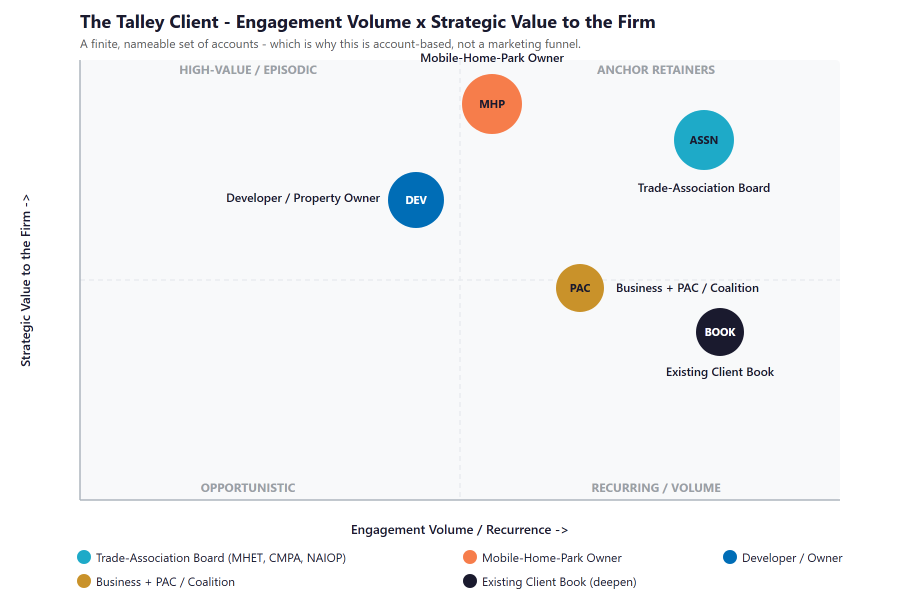
Figure 5.0 — The Talley Client: Engagement Volume vs. Strategic Value to the Firm

06 Competitive Landscape
06 Competitive Landscape

Talley competes against two kinds of firm: the large Los Angeles and statewide public-affairs generalists that are polished and visible online, and the local Orange County land-use specialists that share Talley’s lane but run thin websites. The pattern across all of them is the opportunity — none pairs Talley’s depth in mobile-home-park and property-rights work with a visible, authoritative online presence.

Firm | Lane | Posture vs. Talley
Curt Pringle & Associates | Anaheim — local land-use entitlement & government affairs | The most direct overlap with Talley’s lane — strong local relationships, but a thin brochure website and no content
Englander Knabe & Allen | Los Angeles — land-use entitlements, ballot measures, crisis comms | A digitally sophisticated generalist; the online bar to clear, but not a mobile-home-park or Orange County specialist
Cerrell Associates | Los Angeles — California’s oldest public-affairs firm (1966) | Deep brand and a content-rich site; a generalist whose niche is reputation, not property-rights land use
Townsend Public Affairs | Newport Beach — advocacy & grant-writing for public agencies | Modern, multi-office, strong online — but serves public agencies, a different client base than Talley’s owners
California Strategies | Statewide — bipartisan state & local advocacy | Polished site and named partners; a large-account, statewide player, not an Orange County land-use specialist
The Lew Edwards Group | Oakland — local ballot- and tax-measure campaigns | Campaign specialists for public agencies; adjacent to, not competing in, Talley’s property-owner lane
Renne Public Policy Group | San Francisco Bay Area — state legislative advocacy | Public-agency policy focus; little overlap with mobile-home-park or local entitlement work
Probolsky Research | Newport Beach — opinion polling & community surveys | A complement more than a rival — the research a campaign buys, with a strong, active online presence

Specialization & Digital-Authority Scorecard
Reduced to the two things that decide whether a searching buyer finds and trusts a firm — how specialized it is in Talley’s exact lane, and how visible and authoritative it is online — the picture is clear, and it shows Talley holding the specialization no generalist can copy while ceding the digital ground entirely.
Player | OC / MHP Specialization | Digital & Content Authority | Verdict
Cerrell / Englander K&A | Low | High | LA generalist, strong online
Townsend / Cal Strategies | Low | High | Statewide / public-agency, strong online
Probolsky Research | Medium | High | Research complement, visible
Curt Pringle & Associates | High | Low | Closest rival, thin online
Talley (today) | Highest | None | Deep specialist, invisible online

Figure 6.0 plots the field on those two axes. Talley sits where its depth is greatest and its visibility is lowest — the bottom-right. The move is straight up: keep the specialization, add the online authority, and own a corner no rival holds.

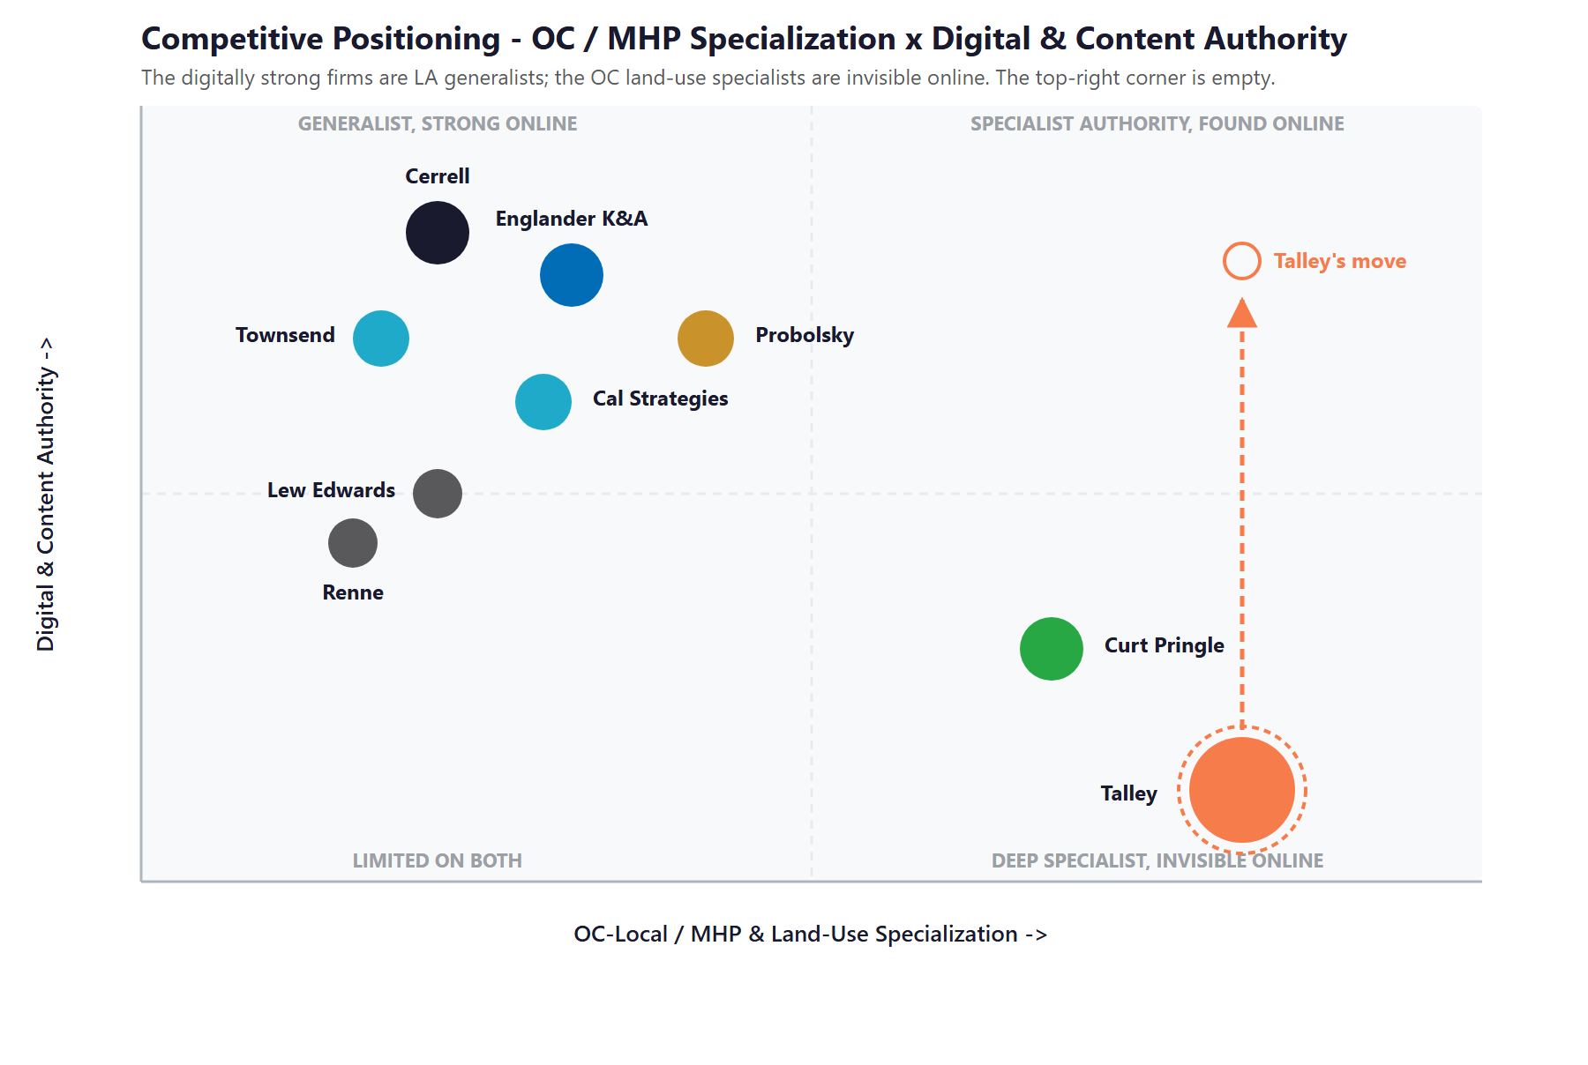
Figure 6.0 — Competitive Positioning: OC / MHP & Land-Use Specialization vs. Digital & Content Authority

Where Talley Wins — The White Space
The top-right corner — deep Orange County, mobile-home-park, and land-use specialization paired with visible online authority — is empty. The digitally strong firms are Los Angeles generalists; the local land-use specialists are invisible online. Talley can hold a corner neither reaches.
No firm owns the “California mobile-home-park conversion” and “property-rights land use” conversation in search or AI answers. Talley has the deepest real expertise in it — it simply has never published.
The nearest rival, Curt Pringle & Associates, shares the lane but runs a thin site with no content. A modest authority program puts daylight between the two.

07 Brand & Digital Presence Audit
07 Brand & Digital Presence Audit

For a 45-year firm with a named book of more than a hundred clients and fifteen-plus associations and PACs, the digital presence materially under-represents the practice — and it matters precisely when a buyer’s first move is an online search and an association board vets a manager on the web before the referral conversation ever happens.

Digital Asset | Current State | Gap / Opportunity
Website | talleyassoc.com forwards to a free do-it-yourself site — thin pages, no team bios, no case results | Undercuts credibility with sophisticated buyers and is nearly invisible to search and AI answer engines
Authority content | No articles, explainers, or thought leadership on mobile-home-park law or land use | The exact questions buyers search return competitors or nothing — 45 years of expertise earns no search authority
Answer-engine (GEO) presence | Not cited by Google AI, ChatGPT, or Perplexity for the niche | As buyers shift to AI answers, an invisible firm is left out of the shortlist before a call is ever made
Institutional knowledge | Relationships, park histories, and jurisdiction playbooks held in two principals’ heads | A continuity and enterprise-value risk — addressed directly in Section 08
Association web presence | Member experience for MHET and CMPA is light and largely manual | Member growth and engagement left on the table; a clear automation opportunity
Pipeline & monitoring | No system tying the named-account universe or jurisdiction agendas together | Monitoring and outreach are manual and reactive rather than continuous

The Presence Gap Is the On-Ramp
None of this requires changing the business — only making a proven, four-decade practice look and work as modern as it already is.
A real website, niche authority content, and a knowledge base are low-cost, compounding moves that raise credibility with property owners, developers, and boards alike.
They are also the natural first ninety days: fix the foundation and the story, then build the monitoring and knowledge engine on top of it.

08 The Institutional-Knowledge Risk
08 The Institutional-Knowledge Risk

This section names the risk that matters most, because it is the one that is hardest to see and most expensive to ignore. Talley’s entire value is concentrated in the experience and relationships of two senior principals. That is the strength of a relationship firm — and its single point of failure.

Research on relationship-based professional-services firms is blunt about the pattern: the knowledge that runs the business lives in the founder’s head, not in documented processes, and clients hold their relationship with the principal, not the firm. That makes any transition fragile and personal. For Talley, the irreplaceable knowledge is specific and deep — which city managers and councilmembers to call across roughly eighty cities, how each jurisdiction actually handles a mobile-home-park conversion, the history and the players in every park fight and entitlement since 1981, and the relationships behind every association and PAC on the books.

The mitigation is not dramatic, and it does not change how the firm works. It is to institutionalize and automate: capture the relationship history, the regulatory playbooks, and the case precedents into a secure, queryable knowledge base before they walk out the door. Done well, it protects continuity, makes a junior associate productive in months instead of years, and protects the enterprise value of the firm itself — the value that any future transition or sale depends on.

Capture the Knowledge Before It Walks Out the Door
The firm’s balance sheet is its relationships and its memory. Today both are undocumented and concentrated in two people — an exposure no insurance policy covers.
A private, secure AI knowledge base turns 45 years of files, matters, and relationships into something the whole team can query: “What happened the last time we converted a park in this city? Who was on the council? What did the Impact Report argue, and what worked?”
It is succession insurance, a training accelerator, and an enterprise-value protector at once — and it is the cleanest, highest-conviction place to start.

09 Technijian Capability Proof
09 Technijian Capability Proof

This section separates two things plainly. First are proven builds — systems Technijian has actually built and operates. Then come the productized services Talley would engage. Each is labeled for what it is, and each maps to a specific Talley use case. The flagship is first, because it is the firm’s highest-conviction need.

Proven Builds — Systems Technijian Has Built
Enterprise Knowledge & Memory System (Weaviate + Obsidian)
What Technijian Built: Technijian built a private enterprise knowledge and memory system on Weaviate and Obsidian that turns an organization’s files, history, and people-knowledge into a secure, queryable resource the whole team can search in plain language.
How This Applies to Talley and Associates: This is the direct answer to the institutional-knowledge risk: turn 45 years of relationships, park histories, and jurisdiction playbooks into a secure knowledge base the team can query — succession insurance and a training accelerator in one.

AI Document Intelligence for FINRA Broker-Dealers
What Technijian Built: Technijian deployed AI document intelligence that auto-populates complex due-diligence questionnaires for FINRA-registered broker-dealers, cutting response time from days to minutes with 60–80% less manual review.
How This Applies to Talley and Associates: Pointed at the firm’s document load, the same approach drafts a first-pass Conversion Impact Report, summarizes staff reports and ordinances, and prepares position letters in minutes — the team finalizes and signs.

Multi-Agent SEO & Answer-Engine Platform
What Technijian Built: Technijian built a multi-agent content platform (Claude, GPT-4o, and Gemini with live search and analytics integrations) that produces authoritative, well-researched content and cut content production time by roughly 70%.
How This Applies to Talley and Associates: This is how Talley gets known: a steady stream of mobile-home-park and land-use explainers that make the firm the cited expert in Google AI, ChatGPT, and Perplexity for a niche no competitor has claimed.

ScamShield — Multi-Model Review (LLM Council)
What Technijian Built: Technijian architected ScamShield using a three-model LLM Council (Claude, GPT-4o, and Gemini) with risk scoring and persistent memory — a design that cross-checks each conclusion instead of trusting a single pass.
How This Applies to Talley and Associates: That cross-checked review is the right pattern for sworn work: an accuracy QA on FPPC and PAC filings and on Conversion Impact Reports before a person at the firm reviews and signs.

Productized Services Talley Would Engage
My AI Lead Gen — Account & Legislative Intelligence
The Technijian Service: My AI Lead Gen is Technijian’s productized account-intelligence service — it harvests and enriches high-fit targets and signals from public data and delivers prioritized, monitored account lists rather than a generic data subscription.
How This Applies to Talley and Associates: For Talley it watches the named-account universe and the regulatory field — the Legislature, the FPPC, and roughly eighty jurisdiction agendas — and surfaces the trigger events (a hostile bill, a new ordinance) that mean a specific client needs the firm now.

My Dev — Custom Application Development
The Technijian Service: My Dev is Technijian’s custom application development service, built on an AI-native development lifecycle that integrates Claude Code, Figma Make, GitHub, and CI/CD to ship portals, trackers, and integrations around a client’s actual process.
How This Applies to Talley and Associates: This builds the working tools: the legislative and agenda monitor, the multi-jurisdiction FPPC and PAC compliance tracker, the institutional-knowledge base, and a member portal for the associations.

My Security — Security & Compliance, Built In
The Technijian Service: My Security is Technijian’s managed security service: every system is designed security-first, with role-based access, audit trails, and SOC 2, HIPAA, PCI-DSS, and GDPR-aligned controls built in rather than bolted on.
How This Applies to Talley and Associates: For Talley this keeps client strategy and the knowledge base private and access-controlled — the data governance that sits behind any AI-assisted compliance and document work.

10 How AI Transforms Talley’s Growth Engine
10 How AI Transforms Talley’s Growth Engine

The engine runs three motions at once: get known (make 45 years of expertise findable where buyers and the public now search), monitor and mobilize (watch every bill and agenda that can touch a client and surface it the week it moves), and capture and scale (institutionalize the firm’s knowledge and automate the association and compliance work that consumes senior time). The first builds authority, the second is the account-based engine, and the third protects and scales the firm.

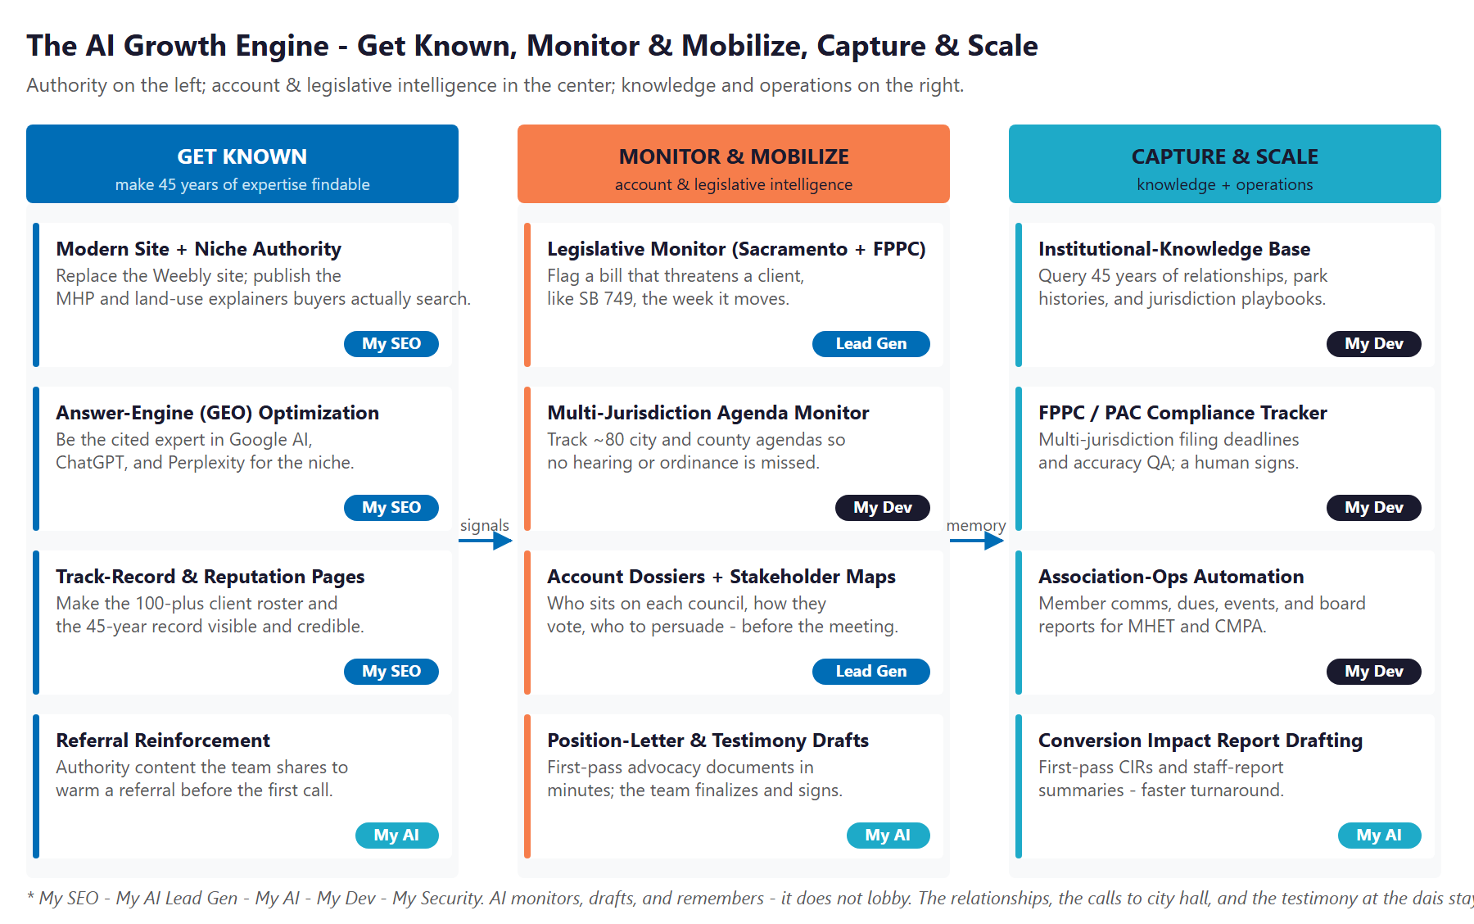
Figure 10.0 — The Engine: Get Known, Monitor & Mobilize, and Capture & Scale

Motion | Tool | What It Does | Metric | Technijian Service
Get Known | Modern site + niche authority content | Replace the DIY site and publish the MHP and land-use explainers buyers search | Search citations | My SEO
Get Known | Answer-engine (GEO) optimization | Become the cited expert in Google AI, ChatGPT, and Perplexity for the niche | AI-answer mentions | My SEO
Get Known | Track-record & reputation pages | Make the 100-plus client roster and 45-year record visible and credible | Inquiries | My SEO
Monitor & Mobilize | Legislative monitor (Sacramento + FPPC) | Flag a bill that threatens a client, like SB 749, the week it moves | Threats caught early | My AI Lead Gen
Monitor & Mobilize | Multi-jurisdiction agenda monitor | Track roughly eighty city and county agendas — no hearing or ordinance missed | Agendas tracked | My Dev
Monitor & Mobilize | Account dossiers + stakeholder maps | Who sits on each council, how they vote, who to persuade — before the meeting | Prep time saved | My AI Lead Gen
Monitor & Mobilize | Position-letter & testimony drafts | First-pass advocacy documents in minutes; the team finalizes and signs | Hours recovered | My AI
Capture & Scale | Institutional-knowledge base | Query 45 years of relationships, park histories, and jurisdiction playbooks | Continuity protected | My Dev
Capture & Scale | FPPC / PAC compliance tracker | Multi-jurisdiction filing deadlines and accuracy QA — a human signs | Penalties avoided | My Dev
Capture & Scale | Association-ops automation | Member comms, dues, events, and board reports for MHET and CMPA | Admin hours recovered | My Dev
Capture & Scale | Conversion Impact Report drafting | First-pass Impact Reports and staff-report summaries — faster turnaround | Turnaround time | My AI

The Human Boundary
AI monitors, drafts, and remembers — it does not lobby. The relationships, the calls to city hall, and the testimony at the dais stay with Vickie and the team. AI gives them more reach, faster preparation, and a memory that does not retire.
For anything sworn — every FPPC and PAC filing, every Impact Report — a person at the firm reviews and signs. The technology removes the burden and the deadline risk; it never replaces the judgment or the signature.
That boundary is the point: Talley gets the reach and the capacity without putting its name on anything it has not checked.

11 Business Impact & Service Investment
11 Business Impact & Service Investment

The model below is built from public information and conservative assumptions, because the firm’s internal numbers were not available for this draft. Every figure is estimated; the discovery questions in Section 14 replace them with real baselines. The logic is deliberately modest — a relationship firm does not need a flood of leads, it needs capacity, memory, and reach — and it holds across a wide range of inputs.

Projected KPI Lift (Estimated)
KPI | Estimated Current | With the Program | Direction
Jurisdictions monitored | A few, manually | Legislature + FPPC + ~80 agendas | Nothing slips
Time to draft a letter or Impact Report | Hours to days, manual | Minutes, AI-drafted first pass | Capacity freed
Client trigger alerts (bill / ordinance) | Reactive | Proactive, same-week | Threats caught early
Filing deadlines (state + local) | Manual calendar | Tracked and accuracy-checked | Penalties avoided
Association admin hours | Senior-time heavy | Automated workflows | Margin and scale
Online authority in the niche | Invisible | Cited expert | New inquiries
Institutional knowledge | In two principals’ heads | Queryable knowledge base | Continuity protected

Year-1 ROI Model (Estimated, Conservative Assumptions)
Model Input | Conservative | Target | Aggressive
New retained engagements (Y1) | +2 | +4 | +6
Illustrative blended value per engagement* | $60,000 | $60,000 | $60,000
Incremental revenue (Y1) | +$120,000 | +$240,000 | +$360,000
Technijian Program Investment (Y1) | ~$108,600 | ~$108,600 | ~$108,600
Modeled ROI Ratio | 1.1x | 2.2x | 3.3x

* The blended annual value of a new engagement — a retainer plus project work for an entitlement client, a park conversion, or an association-management contract — is an illustrative, deliberately conservative placeholder of about $60,000, to be replaced with Talley’s actual retainer economics in discovery. The ratio counts only new engagements. It does not count the value the program also delivers: senior capacity recovered from admin and monitoring, filing penalties avoided (a daily fine plus up to $5,000 per violation across many jurisdictions), clients retained because a threat was caught early, and the firm’s enterprise value protected by capturing its institutional knowledge. All figures are projected, not guaranteed.

Technijian Service Investment Map
Service | Scope | Monthly | Y1 Total
My AI — Fractional AI Advisor | AI program leadership, the institutional-knowledge-capture program, and AI governance | $2,000/mo | $24,000
My AI Lead Gen — Account & Legislative Intelligence | Monitoring the Legislature, the FPPC, and named-jurisdiction agendas; trigger alerts and account dossiers (Starter to Professional) | $1,499/mo | $17,988
My SEO — Authority & Answer-Engine (GEO) | A modern website plus MHP and land-use authority content to own the niche in search and AI answers | $1,500/mo | $18,000
My Dev — Managed App Services | Hosting, monitoring, and ongoing enhancement of the monitor, tracker, and portal | $800/mo | $9,600
My Dev — Custom Build (one-time, phased) | The legislative and agenda monitor, the multi-jurisdiction FPPC / PAC compliance tracker, the institutional-knowledge base, and an association member portal | — | $34,000
My AI — Executive AI Workshop (one-time) | A leadership session plus the knowledge-capture kickoff | — | $5,000
YEAR-1 TOTAL INVESTMENT | Recurring $5,799/mo + builds |  | ~$108,600

The Math That Matters
A relationship firm does not need more leads; it needs capacity, memory, and reach. Two to four new engagements a year — an entitlement client, a park conversion, a new association contract — cover the program, and the firm already knows who those prospects are.
The program pays back in ways the ratio does not count: senior hours recovered from admin and monitoring, penalties avoided on multi-jurisdiction filings, and clients retained because a threat was caught the week it was introduced, not the month it passed.
It is phased — start with the knowledge base, the site, and the monitoring, prove the capacity gains, then scale — which lowers the entry point and de-risks the spend.

12 Implementation Roadmap
12 Implementation Roadmap

The roadmap runs on a 90 / 180 / 365-day cadence suited to a regulated professional-services firm: capture the knowledge and fix the foundation first, then stand up the monitoring and the authority content, then scale the operations and turn the knowledge base into a true succession asset. Real gains — a working knowledge base, a credible site, live monitoring — are visible inside the first ninety days; the deeper builds are given realistic runway.

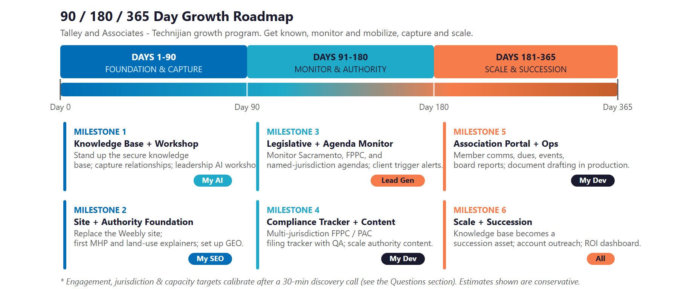
Figure 12.0 — Talley Growth Program: 90 / 180 / 365-Day Roadmap

Phase 1 — Foundation & Capture (Days 1–90)
Start with the highest-conviction move — capturing the knowledge — and fix the digital foundation.
Milestone | Deliverables
1.1 — Knowledge Base & Workshop | Stand up the secure institutional-knowledge base and begin capturing relationships, park histories, and jurisdiction playbooks. Run a leadership AI workshop to align on priorities and governance.
1.2 — Site & Authority Foundation | Replace the do-it-yourself site with a modern, credible website; publish the first mobile-home-park and land-use explainers; and set up the firm’s answer-engine (GEO) presence.

Phase 2 — Monitor & Authority (Days 91–180)
Turn on the account-based engine and build the authority cadence.
Milestone | Deliverables
2.1 — Legislative & Agenda Monitor Live | Stand up monitoring of the California Legislature, the FPPC, and named-jurisdiction agendas, with trigger alerts mapped to each client’s interests.
2.2 — Compliance Tracker & Content | Launch the multi-jurisdiction FPPC and PAC filing tracker with deadline and accuracy support, and scale the authority-content cadence in the niche.

Phase 3 — Scale & Succession (Days 181–365)
Scale the operations and convert the knowledge base into lasting enterprise value.
Milestone | Deliverables
3.1 — Association Portal & Ops Automation | Bring member communications, dues, events, and board reporting automation into production for MHET and CMPA, and put document drafting (Impact Reports, position letters) to work.
3.2 — Scale & Succession | Deepen the knowledge base into a true succession asset; run account dossiers and targeted outreach across the named universe; and deliver an ROI dashboard against the Section 14 baselines.

13 Quick Wins — Start This Week
13 Quick Wins — Start This Week

Five actions Talley can take immediately — before any Technijian engagement. Each creates value this week and leads naturally into the larger program.

1 — Claim the Google Business Profile and Fix the Redirect
Make sure a property owner searching “Talley and Associates” or “mobile home park consultant Orange County” finds a complete, credible listing — and that talleyassoc.com resolves to a real page, not a forward. It is the first thing a buyer sees, and it costs nothing.

2 — Set Alerts on the Threats That Matter
Set Google Alerts on SB 749, on “mobile home park rent control” for your key cities, and on your top clients’ names. A hostile bill or a new ordinance should land in the inbox the week it moves, not the month after it passes.

3 — Publish One Plain-Language Explainer
Write a single page answering the question a park owner actually searches: what it takes to close or convert a mobile-home park in California. It seeds the authority content and starts earning the search trust competitors have left on the table.

4 — Start the Knowledge Inventory
List the top fifty relationships and the last twenty park or entitlement matters in one document. It costs nothing, and it is the first deposit into the knowledge base that protects the firm’s most valuable and least-documented asset.

5 — Put Every Filing Deadline on One Calendar
Pull every state and local FPPC and PAC filing deadline for every association and PAC client onto a single, shared calendar. It is a free way to de-risk the penalties now, before the system automates the tracking later.

14 Questions to Calibrate This Plan
14 Questions to Calibrate This Plan

This blueprint was built from public information. The numbers in Sections 11 and 12 are deliberately conservative estimates — a short discovery call replaces them with Talley’s real baselines and sharpens the entire program. These are the questions that move the model the most:

Topic | What We’d Confirm | Why It Matters
Client & engagement mix | Active retainer clients, new engagements per year, and typical retainer and project values | Calibrates the ROI model
Association book | Which associations and PACs are managed today, their size and dues, and confirming the scope of Orange County Housing Providers | Sizes the association-automation opportunity
Jurisdictions | How many city and county agendas the team tracks today, and how | Scopes the monitoring build
Compliance load | The number of FPPC and PAC filings per cycle and the current process | Sizes the compliance-tracker payback
MHP pipeline | Active conversion or closure matters and current Impact Report turnaround | Sizes the document-intelligence value
Team & succession | Headcount, who holds which knowledge, and any continuity plan | Shapes the knowledge-capture priority
Systems | Current CRM, document, and association-management tools | Defines the build and integration surface
Marketing ownership | Who, if anyone, owns the website and outreach today | Defines the authority-content workflow

How to Use This Section
None of these questions block starting — the Quick Wins and the Phase 1 foundation proceed regardless.
A single 30-minute call answers most of them and lets Technijian return a calibrated ROI model and a fixed-scope Statement of Work.
The goal is a plan built on Talley’s real numbers — not on our conservative estimates.

15 What Happens Next
15 What Happens Next

Talley already has the hard things: 45 years of relationships at the staff and elected level, a mastery of mobile-home-park and land-use law few firms can match, and a named book of property owners, developers, and associations across four counties. What it has not yet done is make that expertise visible where buyers now search, watch every bill and city hall that can affect a client, or capture the institutional knowledge that today lives in two people’s heads.
The opportunity is concrete: get known as the cited authority in a niche no competitor has claimed, monitor and mobilize across every jurisdiction so nothing affecting a client slips by, and capture and scale the firm’s knowledge and association work so senior time goes to the relationships that win. A focused, account-based program does all three — and the relationships, the judgment, and the presence at the dais stay exactly where they belong, with the team.

Recommended Next Steps
Step 1: A 30-minute discovery call to answer the Section 14 questions and confirm program scope.
Step 2: Technijian returns a calibrated ROI model and a fixed-scope Statement of Work within 5 business days.
Step 3: Phase 1 kickoff — the knowledge base, the new site, and the legislative monitoring — live inside 30 days of signature.

Ready to make 45 years of relationships impossible to lose — and impossible to miss?
Contact Ravi Jain, Technijian | RJain@technijian.com | 949.379.8500
technijian.com | Irvine, CA

16 About Technijian
16 About Technijian

Technijian is an AI-native managed services and technology firm headquartered in Irvine, California, serving small and mid-sized businesses since 2000. We build and operate the AI systems that help regional firms compete at scale — with security and compliance built in, not bolted on.

Service | What It Delivers for Talley and Associates
My AI | AI strategy and builds — the institutional-knowledge base, document drafting for Impact Reports and position letters, and filing accuracy QA, with governance throughout
My AI Lead Gen | Account and legislative intelligence — monitoring the Legislature, the FPPC, and roughly eighty jurisdiction agendas and surfacing the trigger events that matter to named clients
My Dev | Custom, AI-native builds — the legislative and agenda monitor, the multi-jurisdiction compliance tracker, the knowledge base, and the association member portal
My SEO | A modern website and mobile-home-park and land-use authority content that make the firm the cited expert in search and AI answers
My Security | Privacy and access control for client strategy and the knowledge base — the governance behind AI-assisted compliance and document work

Contact | Detail
Account Executive | Ravi Jain — RJain@technijian.com
Office | 18 Technology Dr., Suite 141, Irvine, CA 92618
Phone | (949) 379-8500
Web | technijian.com

A Appendix — Sources
A Appendix — Sources

Market and firm intelligence gathered via public web research conducted May 2026. Firm details (founding year, leadership, client and association roster, and contact information) are drawn from public sources and the firm’s own website and should be confirmed with Talley before external use.

1. Talley and Associates — talleyassoc.com (forwarding to talleyassoc.weebly.com): Home, Who We Are, Governmental Relations, MHP Conversions, Association Management, Clients, and Contact pages.
2. Leadership & history — Vickie Talley (founder; former Mayor, Councilmember, and Planning Commissioner of Cypress; former Los Angeles City Planning Department; Executive Director of MHET) and Bill Talley (advisor; former city manager of Anaheim, Mission Viejo, Dana Point, Rancho Santa Margarita, Oceanside, and San Clemente). Firm founded 1981.
3. Clients & associations — MHET and MHET PAC, California Mobilehome Parkowners Alliance (CMPA), CMHCA, NAIOP Inland Empire and SoCal chapters and PACs, ULI and SIOR district councils, AAGIE, SCAA, IEHC; city clients (Anaheim, Chino Hills, Dana Point, Garden Grove, Mission Viejo, Newport Beach, Oceanside, Rancho Mirage, Rancho Santa Margarita, San Clemente); ballot campaigns (Proposition 199, 1996; Huntington Beach Measure EE, 2002).
4. Competitors — Curt Pringle & Associates, Englander Knabe & Allen, Cerrell Associates, Townsend Public Affairs, California Strategies, The Lew Edwards Group, Renne Public Policy Group, and Probolsky Research.
5. Regulation — California Political Reform Act of 1974 and the FPPC (lobbying Forms 604/615/625/635; campaign Forms 460/461); local lobbying ordinances (Los Angeles Ethics Commission, Orange County, Anaheim); Government Code section 65863.7 (Conversion Impact Report); Mobilehome Residency Law (Civil Code section 798 et seq.); AB 2782 (2020).
6. Legislative & market context — SB 749 (2025–26), SB 610 (2025), AB 2399 / AB 2387 / AB 2247 (2024); CEQA reform AB 130 / SB 131 (2025); industry bodies WMA, MHI, and CMHI; and the AMC Institute association-management model.
7. Technijian service pricing — My AI Lead Gen (Starter $1,499 / Professional $3,499 / Enterprise $6,999), My AI, My SEO, My Dev, and My Security rate cards.

