

CHRISTIAN BROTHERS
Flooring & Interiors — San Diego County
AI-Driven Growth Blueprint

Prepared by Technijian | 2026-05-27
Lakeside, California | cbinteriors.net

CONFIDENTIAL — Prepared for Christian Brothers Flooring & Interiors

01 Executive Summary
01 Executive Summary

1988  Family-Owned Since | 37  Years in San Diego County | 2  Growth Channels | A+  BBB Rated

Technijian already runs Christian Brothers’ IT and security. This blueprint is about a different kind of partnership: turning that same trusted stack into a growth engine. Christian Brothers has spent thirty-seven years building a flooring and finishes business in San Diego County, earning a BBB A+ and the 2023 BIA San Diego ICON Award for finish work — and it has built something most flooring shops have not: a new-home design-center program that runs the buyer-personalization process for homebuilders.
That gives Christian Brothers two ways to grow, and they call for two playbooks. The homeowner channel — remodels and flooring, the steady revenue base — is won the way every local home-services business is won today: showing up in Google with strong reviews, a deep visual portfolio, and a way for a buyer to picture the floor in their own room. The homebuilder channel — the higher-margin differentiator — is won account by account, by knowing which builders are starting which communities and being the design-center partner they choose. AI moves both.
This is a focused program with three motions: get found (fix the local-search foundation, build review velocity, merchandise the portfolio, and add a room visualizer), win builders (account intelligence on San Diego construction plus a proof library that wins the design-center relationship), and convert and serve (capture and nurture leads, speed the designer selections, and automate quoting). Because Technijian already supports the systems and security underneath, this deploys faster and with less risk than it would for any outside firm.

The Core Opportunity
A self-inflicted, free fix: the design-center site currently brands Christian Brothers as "Orange County’s #1" while the company operates entirely in San Diego County — a local-search own-goal that caps Google visibility and is correctable day one.
Win on what homeowners actually choose by: reviews, a visual portfolio, and a room visualizer. Christian Brothers sits at roughly 37 reviews where the strongest San Diego rivals have 200 to 369, and rivals already offer "see-your-floor-in-your-room" visualization. These are catch-up moves with outsized payoff.
Grow the high-margin builder channel deliberately: AI account intelligence on new San Diego communities and starts turns a lumpy, reactive pipeline into a proactive target list — and the existing IT relationship means the whole program is lower-risk and faster to stand up.
A note on figures: Christian Brothers’ internal numbers (lead volume, average project value, close rate, review velocity, and the builder pipeline) were not available for this draft. Every projection below is labeled estimated and conservative, and calibrates to real numbers after a short discovery call — the specific questions are in Section 14.

02 The Two-Channel Model
02 The Two-Channel Model

A growth plan has to start with how Christian Brothers actually wins work, because there are two distinct channels and each is won differently. The homeowner channel is a local home-services business: a remodeling homeowner or new-home buyer finds Christian Brothers through search, reviews, and the Lakeside showroom, then selects flooring and finishes. The homebuilder channel is account-based: a builder outsources its design center, and Christian Brothers runs the buyer-personalization process inside the builder’s construction schedule — using the Studio Chateau selection tool the company already deploys.

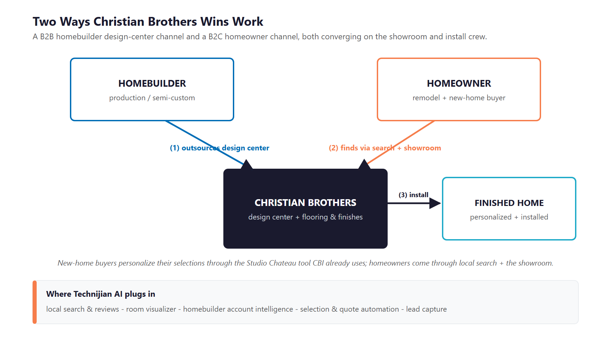
Figure 2.0 — Two channels: a B2C homeowner channel and a B2B homebuilder design-center channel, both converging on the showroom and install crew

Two Channels, Two Playbooks
- Homeowner channel (the steady base): remodel-heavy, luxury-vinyl-led, won through local search, online reviews, a visual portfolio, and the showroom and shop-at-home experience.
- Homebuilder channel (the high-margin differentiator): "turn builders into New Home Retailers" by running their design center — online selections, the four-plus designer meetings, and the move-in walkthrough. Win one builder and you earn recurring buyer flow across a whole community.

Why the Model Rewards AI
The homeowner channel is decided online before anyone calls: 91% of homeowners check reviews, and Google plus a visual portfolio shape the shortlist. Whoever shows up — with proof and a way to picture the result — wins the lead.
The builder channel is high-margin but lumpy: new construction is a small share of San Diego home sales, so the relationships are worth pursuing deliberately, not waiting for. Account intelligence makes the pursuit proactive.
And the same selections, quotes, and design meetings that the work runs on are exactly the repetitive, high-volume tasks AI accelerates — freeing designers to sell and serve.

03 The Growth Equation
03 The Growth Equation

Christian Brothers grows three ways, and each is gated by something fixable. This is the spine the rest of the plan hangs on.

Growth Lever | What Gates It Today | The AI Play
Get found by homeowners | A San Diego company tagged "Orange County" in search; thin reviews; no room visualizer; split brands | Geo-corrected local SEO, a review engine, a unified visual portfolio, and a "see-your-floor" visualizer
Win more builder partnerships | A reactive, lumpy pipeline; the award and builder work are under-used online | Account intelligence on new communities and starts, plus a searchable design-center proof library
Convert and serve faster | Manual lead follow-up, manual selections and quoting; designers do admin instead of selling | Lead capture and nurture, AI mood-boards, and selection/quote automation around Studio Chateau

Why Christian Brothers Is Positioned to Win This
The cheapest gains are the most certain: correcting the geography, building reviews, and merchandising a portfolio Christian Brothers already photographs are low-cost moves with fast, measurable payoff.
The builder channel is a real moat: a 37-year reputation, in-house install, a showroom, and a BIA ICON award are hard for a software-only competitor to match — they just need to be made findable and provable.
The IT partnership de-risks all of it: Technijian already knows and secures the systems, so the program plugs in rather than starting from scratch.

04 The Market & Where It’s Going
04 The Market & Where It’s Going

Two market realities shape the plan: the homeowner remodel channel is the larger, steadier base, while the builder channel is higher-margin but smaller and lumpier — and homeowners now decide largely online before they ever visit a showroom.

Market Forces (2024–2026)
Force | What’s Happening | Implication for Christian Brothers
Remodel is the base | Renovation spending is growing slowly but steadily; luxury vinyl dominates and repair-and-remodel is the majority of flooring spend | The homeowner channel is the dependable engine — win it with local search, reviews, and visualization
New construction is lumpy | San Diego permitted ~8,800 homes in 2024, but new construction is only ~2-3% of home sales | The builder channel is high-value per deal but must be pursued deliberately, account by account
Design centers are profit centers | Builders earn more on personalized, built-to-order homes; online selection tools are now standard | Christian Brothers’ design-center program is the differentiator — make it findable and provable
Homeowners decide online | 91% rely on reviews; Google plus visual platforms (Houzz, Instagram, Pinterest) shape the shortlist | Review volume and a visual portfolio are not optional — they are how the lead is won
Visualization is expected | Room-visualizer tools convert materially more shoppers; a San Diego rival already offers one | A "see-your-floor-in-your-room" tool closes the most visible product gap

The Market’s Verdict
The homeowner channel rewards the firm that is most findable and most trusted online — and that is a position Christian Brothers can take in San Diego with focused, low-cost work.
The builder channel rewards the firm that shows up first with proof when a community breaks ground — which is an account-intelligence problem AI is built to solve.
Both point the same way: make a strong, proven, 37-year operation look and work as modern online as it already is in person.

05 Where the Growth Lives
05 Where the Growth Lives

The next dollar comes from a few clear pools. The homeowner pools are won with visibility and trust; the builder and developer pools are won account by account. The program serves all of them.

Growth Pool | Who / What | How Christian Brothers Captures It
Remodel homeowners (base) | San Diego homeowners replacing flooring or refreshing finishes | Local SEO + reviews + visual portfolio + a room visualizer + the showroom
New-home buyers (via builders) | Buyers personalizing a new home through the design center | A smoother selection experience (Studio Chateau + AI mood-boards) that lifts attach and upgrade revenue
Homebuilder partnerships | Production and semi-custom builders starting San Diego communities | Account intelligence on starts and permits + a proof library that wins the design-center relationship
Referral multipliers | Realtors, designers, and general contractors who send work | Stay top-of-mind and easy to refer with a strong, current online presence and proof
Multifamily / commercial (adjacent) | Apartment and commercial flooring projects they already do some of | Targeted outreach and a portfolio that shows the commercial capability

Two Playbooks, One Program
The homeowner pools are demand that already exists — people are searching for flooring in San Diego today; the job is to be found, trusted, and easy to picture.
The builder and developer pools are won by relationship and timing — AI surfaces the right accounts and arms the team with proof, but the showroom, the install crew, and the 37-year reputation close them.
The two reinforce each other: a stronger public presence and portfolio also make Christian Brothers a more credible design-center partner to builders.

06 The Christian Brothers Customer
06 The Christian Brothers Customer

Christian Brothers serves two kinds of buyer — homeowners and homebuilders — plus the referral partners who feed both. The cards below profile the relationships that matter, and the matrix places each by project value and how strategic and recurring it is.

1 — The Production / Semi-Custom Homebuilder
Role | A builder that wants to sell more homes and offload the design-center and personalization process — the highest-value, most recurring relationship.
Pain Points | Personalization is operationally heavy; a slow or clunky design center frustrates buyers and leaves option revenue on the table.
Decision Driver | A partner who runs the design center smoothly, lifts option attach rates, and makes the builder look good to buyers.
AI Opportunity | Account intelligence flags which builders are starting communities; a proof library and faster selections win and keep the relationship.
Technijian Hook | My AI Lead Gen — builder account intelligence. My SEO — the design-center proof library.

2 — The Remodeling Homeowner
Role | A San Diego homeowner replacing flooring or refreshing finishes — the steady volume base.
Pain Points | Hard to judge quality and trust; wants to picture the result and not get burned on the install.
Decision Driver | Reviews, a visible portfolio, an easy way to picture the floor, and a dependable install.
AI Opportunity | Local SEO + reviews get found; a room visualizer de-risks the choice; lead capture and nurture convert the inquiry.
Technijian Hook | My SEO — local search, reviews, portfolio. My Dev — the room visualizer and lead capture.

3 — The New-Home Buyer
Role | A buyer personalizing a new home through the builder’s design center that Christian Brothers runs.
Pain Points | Overwhelmed by options and deadlines; wants confidence the selections will look right together.
Decision Driver | A guided, confidence-building selection experience that makes personalization feel easy.
AI Opportunity | AI mood-boards and concept palettes accelerate the designer meetings and lift attach and upgrade revenue.
Technijian Hook | My AI — mood-boards and concepts. My Dev — selection automation around Studio Chateau.

4 — The Referral Source
Role | Realtors, interior designers, and general contractors who send homeowner and project work.
Pain Points | Will only refer a firm that makes them look good and is easy to find and vouch for.
Decision Driver | A current, credible online presence and proof they can point a client to.
AI Opportunity | A strong portfolio, reviews, and proof library make Christian Brothers the easy, safe referral.
Technijian Hook | My SEO — portfolio, reviews, and proof that earn and hold referrals.

Emerging & High-Value Segments
5 — The Multifamily / Commercial Developer
Role | Apartment and commercial projects — high-value flooring work Christian Brothers already does some of.
Pain Points | Needs reliable, at-scale install and a partner who can show comparable commercial work.
Decision Driver | Proven commercial capability, dependable timelines, and competitive pricing.
AI Opportunity | Targeted outreach plus a portfolio that surfaces the commercial work win more of these projects.
Technijian Hook | My AI Lead Gen — project and developer targeting. My SEO — commercial portfolio.

6 — The Whole-Home Move-Up Homeowner
Role | A higher-end homeowner doing a whole-home flooring and finishes project — a high-value niche.
Pain Points | Wants design guidance and a coordinated result across the whole home, not just a product sale.
Decision Driver | Design expertise, a strong portfolio of comparable homes, and a guided experience.
AI Opportunity | Mood-boards and visualization elevate the design consult; portfolio content attracts the look-alike buyer.
Technijian Hook | My AI — visualization and mood-boards. My SEO — high-end project content.

Figure 6.0 maps each by project value and strategic/recurring value — the anchor builder relationships, the strategic referral multipliers, the high-value projects, and the transactional volume base.

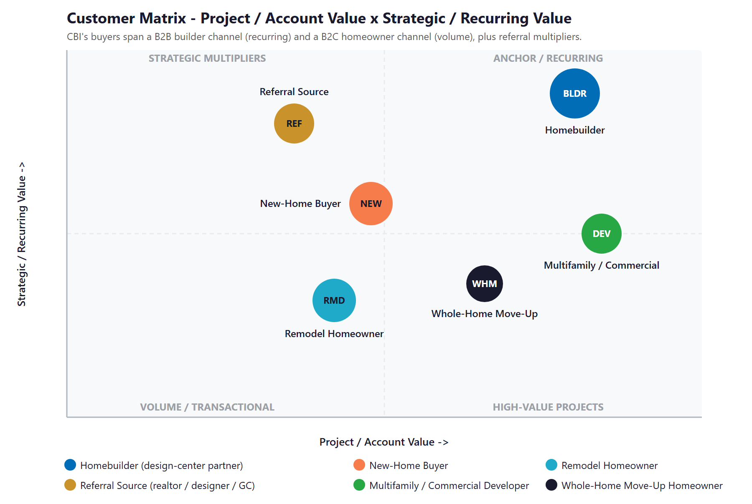
Figure 6.0 — Customer Matrix: Project / Account Value vs. Strategic / Recurring Value

07 Competitive Landscape
07 Competitive Landscape

Christian Brothers competes on two fronts. Among San Diego flooring retailers, the leaders win online with review volume, deep visual portfolios, and room visualizers. In the builder design-center channel, the category leader is Chateau Interiors — which, notably, owns the very Studio Chateau software Christian Brothers licenses. Christian Brothers cannot out-scale these players, but it can out-modernize the local field and counter the builder incumbent with something software alone cannot offer: local San Diego presence, in-house install, and a showroom.

Competitor | Segment | Posture vs. Christian Brothers
Metro Flooring | San Diego flooring retailer-installer | The B2C digital benchmark — ~199 reviews, strong Houzz, large online catalog; the bar for findability and trust
West Coast Flooring Center | North County multi-showroom retailer | Very strong online — ~369 reviews and a Union-Tribune "Best" award; the North County threat
Geneva Flooring | San Diego hardwood + flooring | Strong visual presence — deep Houzz portfolio and steady reviews; a visual-merchandising benchmark
Floor Store & Design Center | San Diego "design center" retailer | Already runs a room visualizer and uses "design center" language — direct positioning overlap
Empire Today | National shop-at-home | National scale and ad spend, but mixed trust — beatable on craftsmanship and local reputation
Chateau Interiors & Design | Builder design-center (B2B) leader | The SoCal category leader — and the owner of the Studio Chateau tool CBI licenses; counter with local presence + in-house install + showroom, not scale

Scale & Digital-Maturity Scorecard
Reduced to the two things that decide who gets the lead — reach and digital/AI maturity (reviews, portfolio, visualization) — the picture is clear, and it shows the move available to a smaller, well-run local firm.
Player | Reach | Reviews | Visualizer | Verdict
West Coast Flooring | Multi-site | ~369 | Strong | Scale + digital leader
Metro Flooring | Regional | ~199 | Catalog | B2C digital benchmark
Floor Store | Multi-site | Mid | Roomvo | Has the visualizer CBI lacks
Chateau Interiors | SoCal (B2B) | n/a | Owns tool | Builder-channel leader
Christian Brothers (today) | Local | ~37 | None | Room to out-modernize locally

Figure 7.0 plots the field. Christian Brothers sits in the local/emerging corner — small and early on the digital signals homeowners use. The realistic move is straight up: out-modernize on reviews, visual portfolio, and a visualizer, and let local trust win the lead.

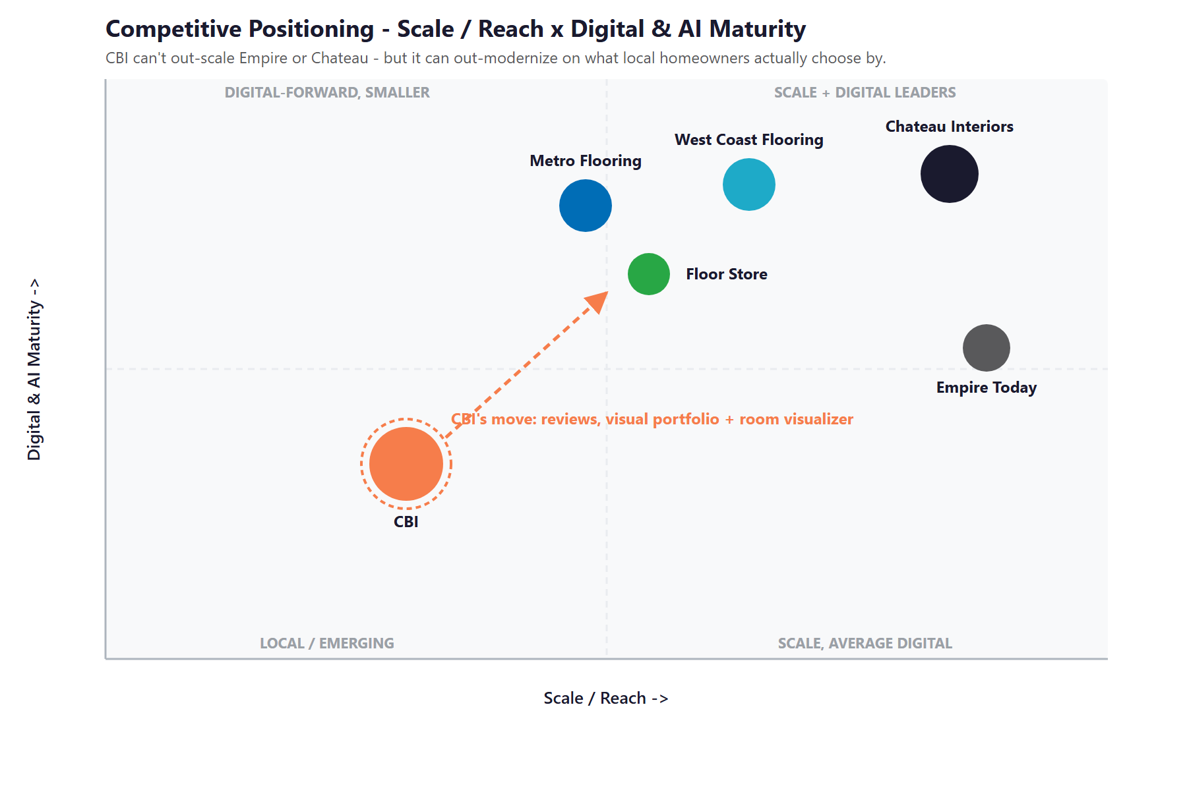
Figure 7.0 — Competitive Positioning: Scale / Reach vs. Digital & AI Maturity

Where Christian Brothers Wins
On the homeowner side, the leaders win on review volume, portfolio depth, and a room visualizer — all of which Christian Brothers can build quickly, and one of which (the geo-corrected local presence) is a free fix.
On the builder side, the category leader owns the software but not the local relationship: Christian Brothers’ San Diego presence, in-house install, showroom, and BIA ICON award are advantages software cannot replicate — they just need to be made findable.
The same content and proof that win homeowners also make Christian Brothers a more credible design-center partner to builders, so the two fronts compound.

08 Brand & Digital Presence Audit
08 Brand & Digital Presence Audit

For a 37-year, award-winning firm, the online presence under-represents the operation — and a few fixes are unusually high-return because the audiences (homeowners and builders) decide largely online.

Digital Asset | Current State | Gap / Opportunity
Geography in search | The design-center site brands the company "Orange County’s #1" while it operates in San Diego County | A geo-SEO own-goal that caps local ranking and credibility — correct it to San Diego day one
Two brands / two sites | cbinteriors.net (design center) and cbfloorsinc.com (flooring) run as separate brands and Instagram handles | Split domain authority and a diluted presence — consolidate or cross-link to compound, not divide
Online reviews | ~37 Yelp reviews despite 37 years; strong rating but thin volume | Top rivals carry 200-369 — a review engine closes the single biggest trust gap
Room visualizer | None | A San Diego rival already offers "see-your-floor-in-your-room" — the most visible product gap
Visual portfolio / social | Thin, split Instagram; no Pinterest; no Houzz reviews | A visual category under-merchandised where homeowners actually look — a fast content win
Proof of the builder work | The BIA ICON Award and builder projects are barely surfaced | Under-used proof that should anchor the design-center pitch to builders

The Presence Gap Is the On-Ramp
None of this requires changing the business — only making a strong, proven operation look and work online as modern as it is in the showroom.
The geography fix, a review engine, and a unified portfolio are low-cost, compounding moves with fast returns — and Christian Brothers already photographs the work.
They are also the natural first ninety days: fix the foundation, then build the visualizer and the builder-intelligence engine on top.

09 Technijian Capabilities — Proven Builds & Services
09 Technijian Capabilities — Proven Builds & Services

Technijian already runs Christian Brothers’ IT and security, so we know the systems, the data, and the people — which makes everything here faster and lower-risk to deploy. This section separates two things plainly: proven builds Technijian has actually delivered, and the productized services Christian Brothers would engage. Each is labeled for what it is, and each maps to a specific use case.

Proven Builds — Systems Technijian Has Built
Multi-Agent SEO + Answer-Engine Platform
What Technijian Built: Technijian operates a multi-agent platform (Claude, GPT-4o, and Gemini with MCP servers, plus SEMrush, GA4, and Perplexity) that produces authority content, ranks it in Google, and positions clients as the cited source inside AI assistants — cutting content-production time roughly 70%.
How This Applies to Christian Brothers: This is the engine that gets Christian Brothers found: correct the geography, build city-by-product pages ("luxury vinyl Carlsbad," "new-home design center San Diego"), and merchandise the portfolio so homeowners and referral partners find the firm in Google and AI answers.

AI Document Intelligence (Days to Minutes)
What Technijian Built: Technijian deployed AI document intelligence that auto-populates complex vendor questionnaires for FINRA-registered broker-dealers, cutting response time from days to minutes with 60–80% less manual review.
How This Applies to Christian Brothers: Pointed at the design workflow, the same approach speeds selection sheets, estimates, and quotes — and assembles builder proposals from past projects, so designers spend time selling and serving rather than on paperwork.

Productized Services Christian Brothers Would Engage
My SEO — Local Search, Reviews & Visual Portfolio
The Technijian Service: My SEO is Technijian’s local and answer-engine search service — Google Business Profile optimization, city and product landing pages, review generation, and content/portfolio merchandising.
How This Applies to Christian Brothers: For Christian Brothers it fixes the "Orange County" geo-defect, builds review velocity toward the rivals’ levels, and merchandises the project portfolio across the web, Houzz, Instagram, and Pinterest.

My AI Lead Gen — Homebuilder Account Intelligence
The Technijian Service: My AI Lead Gen is Technijian’s productized outbound service — it harvests high-fit targets from public data, enriches and scores them, and delivers outreach-ready, prioritized account lists.
How This Applies to Christian Brothers: For the builder channel it monitors new San Diego communities, starts, and permits, ranks the builders worth pursuing (and flags low-fit ones), and arms the team with a per-builder profile to win the design-center relationship.

My Dev — Custom Application Development
The Technijian Service: My Dev is Technijian’s custom application development service, built on an AI-native development lifecycle (Claude Code, Figma Make, GitHub, and CI/CD) to ship the tools and integrations a business actually runs on.
How This Applies to Christian Brothers: For Christian Brothers it builds the room visualizer, AI mood-boards, lead capture and CRM nurture, online booking, and the selection-and-quote automation that wraps around the Studio Chateau tool the company already uses.

10 How AI Grows Christian Brothers
10 How AI Grows Christian Brothers

The engine runs three motions at once: get found (capture homeowner demand with local search, reviews, portfolio, and a visualizer), win builders (account intelligence and proof that grow the high-margin design-center channel), and convert and serve (capture and nurture leads, speed the selections, and automate quoting). Every part of it builds on the IT and security foundation Technijian already runs for Christian Brothers.

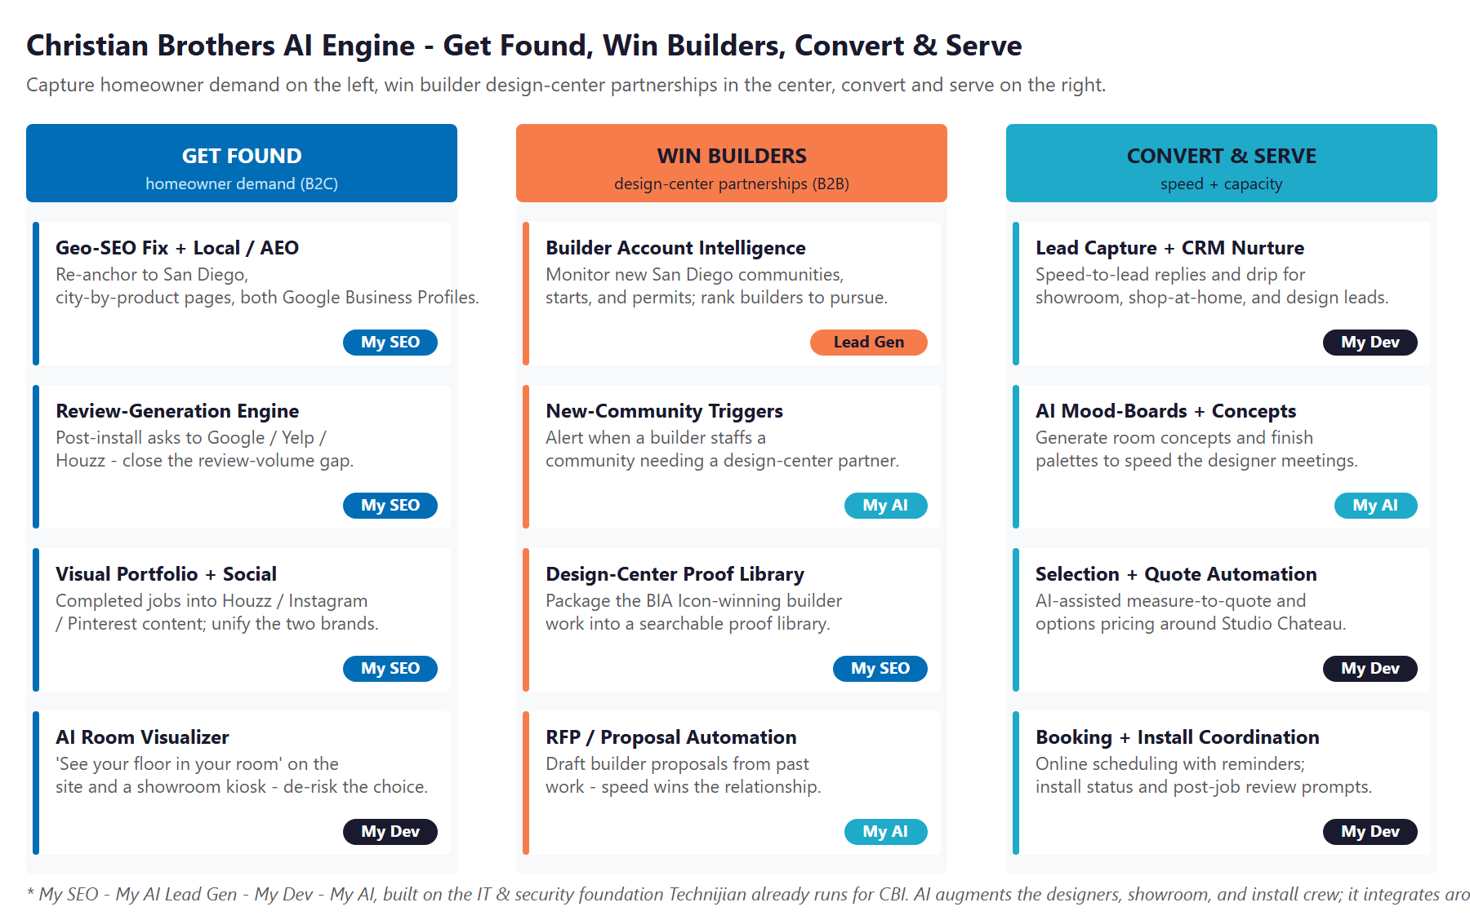
Figure 10.0 — The Engine: Get Found, Win Builders, and Convert & Serve

Motion | Play | What It Does | Metric | Service
Get Found | Geo-SEO fix + local/AEO | Re-anchor to San Diego; city-by-product pages; both Google profiles | Local rankings | My SEO
Get Found | Review-generation engine | Post-install asks to Google / Yelp / Houzz | Review volume | My SEO
Get Found | Visual portfolio + social | Completed jobs into Houzz / Instagram / Pinterest | Portfolio reach | My SEO
Get Found | AI room visualizer | "See your floor in your room" on the site + showroom | Engagement, leads | My Dev
Win Builders | Builder account intelligence | Monitor new communities, starts, permits; rank targets | Qualified builders | My AI Lead Gen
Win Builders | New-community triggers | Alert when a builder staffs a design-center need | Triggered outreach | My AI
Win Builders | Design-center proof library | Package the BIA-award builder work to win RFPs | Win rate | My SEO
Convert & Serve | Lead capture + CRM nurture | Speed-to-lead replies and drip for every channel | Lead-to-consult rate | My Dev
Convert & Serve | AI mood-boards + concepts | Room concepts and palettes to speed designer meetings | Attach / upgrade rate | My AI
Convert & Serve | Selection + quote automation | Measure-to-quote and options pricing around Studio Chateau | Quote turnaround | My Dev
Convert & Serve | Booking + install coordination | Online scheduling, reminders, post-job review prompts | No-shows, reviews | My Dev

The Honest Boundary
AI augments the designers, the showroom relationship, and the install crew — it does not replace them. The visualizer and mood-boards speed and de-risk the human design consult; people still design and install.
Technijian integrates around the Studio Chateau tool Christian Brothers already uses — it enhances that workflow, it does not replace it.
And every play runs on the IT and security foundation Technijian already provides, so the growth program is built on a stack we already know and protect.

11 Business Impact & Service Investment
11 Business Impact & Service Investment

The model below is built from public and industry benchmarks because Christian Brothers’ internal numbers were not available for this draft. Every figure is estimated and conservative; the discovery questions in Section 14 replace them with real baselines. The logic holds across a wide range of inputs, because the two levers — more homeowner projects and more builder partnerships — are large relative to the program cost.

Projected Lift (Estimated)
Measure | Estimated Current | With the Program | Direction
Local search visibility | Mis-tagged "Orange County" | Re-anchored to San Diego + city pages | Found locally
Online reviews (volume) | ~37 | Growing velocity | Trust + ranking
Room visualizer | None | Live on site + showroom | Engagement + conversion
Visual portfolio reach | Split + thin | Unified + active | Shortlist visibility
Homeowner leads to consults | Manual follow-up | Captured + nurtured | More booked jobs
Builder partnerships | Reactive | Account-intelligence-driven | More communities
Selection / quote turnaround | Manual | Automated | Designer capacity

Year-1 ROI Model (Estimated, Conservative Assumptions)
Model Input | Conservative | Target | Aggressive
New homeowner projects (Y1) | +18 | +40 | +80
Est. average project value* | $9,000 | $9,000 | $9,000
Homeowner revenue | +$162,000 | +$360,000 | +$720,000
Builder design-center revenue (won / deepened)** | +$90,000 | +$190,000 | +$300,000
Total incremental revenue | +$252,000 | +$550,000 | +$1,020,000
Technijian Program Investment (Y1) | ~$100,000 | ~$100,000 | ~$100,000
Modeled ROI Ratio | 2.5x | 5.5x | 10.2x

* Placeholder average flooring/finishes project value, blended across remodel and new-home work — calibrates to Christian Brothers’ actual average in discovery. ** Estimated incremental revenue from builder design-center partnerships won or deepened (recurring across a community’s homes). Revenue is attributed to the program, not guaranteed; all figures depend on actual close rate, project value, and builder pipeline.

Technijian Service Investment Map
Service | Scope | Monthly | Y1 Total
My SEO — Local Search, Reviews & Portfolio | Geo-fix + city/product pages, both Google profiles, review engine, and portfolio across Houzz / Instagram / Pinterest | $1,500/mo | $18,000
My AI Lead Gen — Builder Account Intelligence | Monitor San Diego communities, starts, and permits; rank and profile builders to pursue (Starter tier) | $1,499/mo | $18,000
My AI — Fractional AI Advisor | Program lead across the visualizer, automation, and search work | $2,000/mo | $24,000
My Dev — Custom Build (one-time, phased) | Room visualizer, AI mood-boards, lead capture and CRM, online booking, and selection/quote automation | — | $35,000
My AI — Executive AI Workshop (one-time) | Leadership alignment and an AI roadmap | — | $5,000
YEAR-1 TOTAL INVESTMENT | Recurring $4,999/mo + builds |  | ~$100,000

The Math That Matters
The cheapest wins come first: the geo-fix, review engine, and portfolio are low-cost and start paying back in homeowner leads within the first quarter — before the bigger builds.
Winning even one or two new builder design-center partnerships adds recurring revenue across whole communities — a single relationship can cover much of the program on its own.
And because Technijian already runs the IT, there is no new outside firm to onboard and no integration starting from zero — the program plugs into a stack we already manage and secure.

12 Implementation Roadmap
12 Implementation Roadmap

The roadmap runs on a 90 / 180 / 365-day cadence: fix the foundation and the public front door first, then capture homeowner demand with the visualizer and portfolio, then grow the builder channel and automate. The cheapest, highest-visibility wins land in the first ninety days; the bigger builds get realistic runway.

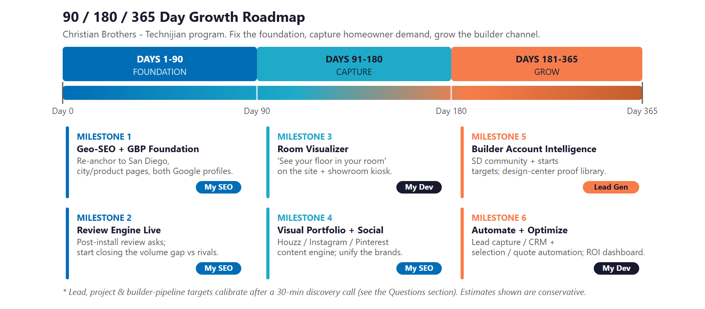
Figure 12.0 — Christian Brothers Growth Program: 90 / 180 / 365-Day Roadmap

Phase 1 — Foundation (Days 1–90)
Fix the free things and turn on the trust engine.
Milestone | Deliverables
1.1 — Geo-SEO & Profile Foundation | Correct the "Orange County" geography to San Diego, build the first city-by-product pages, and optimize both Google Business Profiles (flooring and design center).
1.2 — Review Engine Live | Turn on post-install review requests to Google, Yelp, and Houzz, and start closing the review-volume gap against the leaders.

Phase 2 — Capture (Days 91–180)
Give homeowners a reason to choose and a way to picture it.
Milestone | Deliverables
2.1 — Room Visualizer | Launch a "see-your-floor-in-your-room" visualizer on the site and a showroom kiosk to de-risk the buying decision.
2.2 — Visual Portfolio + Social | Stand up the content engine that turns completed jobs into Houzz, Instagram, and Pinterest assets, and unify the two brands.

Phase 3 — Grow (Days 181–365)
Grow the high-margin builder channel and automate the work.
Milestone | Deliverables
3.1 — Builder Account Intelligence | Turn on monitoring of San Diego communities, starts, and permits, and build the design-center proof library to win partnerships.
3.2 — Automate & Optimize | Bring lead capture and CRM nurture and selection/quote automation into production, and deliver the ROI dashboard against the Section 14 baselines.

13 Quick Wins — Start This Week
13 Quick Wins — Start This Week

Five actions Christian Brothers can take immediately — before any expanded engagement. Each creates value this week and leads naturally into the larger program.

1 — Fix the "Orange County" Tagline
Change "Orange County’s #1 Interior Design House" on cbinteriors.net to reflect San Diego County. It is a free, same-day edit that stops actively mis-signaling your location to Google and removes a credibility gap with local buyers.

2 — Turn On a Review Ask After Every Install
Text or email every finished customer a one-tap link to leave a Google review. You sit at roughly 37 where rivals have 200-plus; starting the habit this week begins closing the single biggest trust gap, at no cost.

3 — Claim and Complete Both Google Business Profiles
Make sure the flooring showroom and the design center each have a complete, photo-rich Google Business Profile with services and the San Diego service-area cities. This is free local visibility the leaders already own.

4 — Post Five Recent Before-and-After Projects
Put five recent installs on Houzz, Instagram, and Pinterest. You already photograph the work; flooring is a visual-discovery category, and evergreen project photos are exactly what homeowners shortlist on.

5 — Build One "For Homebuilders" Proof Page
Create a single page that features the 2023 BIA ICON Award and your best builder design-center work. It anchors the design-center pitch and gives a prospective builder something concrete to evaluate.

14 Questions to Calibrate This Plan
14 Questions to Calibrate This Plan

This blueprint was built from public information. The numbers in Sections 11 and 12 are deliberately conservative estimates — a short discovery call replaces them with Christian Brothers’ real baselines and sharpens the whole program. These are the questions that move the model the most:

Topic | What We’d Confirm | Why It Matters
Channel mix | The split between homeowner flooring and builder design-center revenue | Sets where the program leans and the ROI weighting
Project economics | Average project value and close rate, by channel | The primary inputs to the revenue model
Lead sources | Where leads come from today and the showroom / shop-at-home conversion | Calibrates the get-found and convert plays
Builder pipeline | Which builders Christian Brothers serves and the current win rate | Scopes the account-intelligence work
Reviews & marketing | Current review volume and velocity, and who owns marketing | Sizes the review and portfolio program
Brand architecture | Whether to consolidate cbinteriors.net and cbfloorsinc.com or keep them separate | Decides the SEO and brand approach
Systems | Studio Chateau usage, the CRM and booking tools, and current visualization | Defines the build and integration surface
IT scope | Confirm the current Technijian IT footprint | So the growth program plugs in cleanly

How to Use This Section
None of these questions block starting — the Quick Wins and the Phase 1 foundation proceed regardless.
A single 30-minute call answers most of them and lets Technijian return a calibrated ROI model and a fixed-scope Statement of Work.
The goal is a plan built on Christian Brothers’ real numbers — not on our conservative estimates.

15 What Happens Next
15 What Happens Next

Christian Brothers has the hard things: thirty-seven years, a BBB A+, a BIA ICON award, in-house install, a showroom, and a design-center program most flooring shops do not have. What it has not yet done is make that strength as visible and as easy to act on online as it is in person — and that is exactly where AI helps.
The opportunity is concrete and low-risk: fix a free geography defect, build the reviews and visual portfolio homeowners choose by, add the visualizer rivals already have, and pursue the builder relationships deliberately with account intelligence. Because Technijian already runs the IT and security underneath, this is the rare growth program that starts on a stack the partner already knows and protects.

Recommended Next Steps
Step 1: A 30-minute discovery call to answer the Section 14 questions and confirm program scope.
Step 2: Technijian returns a calibrated ROI model and a fixed-scope Statement of Work within 5 business days.
Step 3: Phase 1 kickoff — the geo-SEO fix, both Google profiles, and the review engine — live inside 30 days.

We already run your IT. Let’s turn it into a growth engine.
Contact Ravi Jain, Technijian | RJain@technijian.com | 949.379.8500
technijian.com | Irvine, CA

16 About Technijian
16 About Technijian

Technijian is an AI-native managed services and technology firm headquartered in Irvine, California, serving small and mid-sized businesses since 2000 — and already Christian Brothers’ IT-support partner. We build and operate the AI systems that help regional businesses compete at scale, with security and compliance built in, not bolted on.

Service | What It Delivers for Christian Brothers
My IT (in place) | The managed IT and security Technijian already provides — the trusted foundation the growth program builds on
My SEO | Local and answer-engine search, review generation, and the visual portfolio that get Christian Brothers found and trusted by San Diego homeowners and referral partners
My AI Lead Gen | Homebuilder account intelligence — monitoring San Diego communities and starts to win design-center partnerships
My Dev | Custom, AI-native builds — the room visualizer, lead capture and CRM, online booking, and selection/quote automation around Studio Chateau
My AI | AI strategy and builds — mood-boards and concepts, and the program leadership that ties it together

Contact | Detail
Account Executive | Ravi Jain — RJain@technijian.com
Office | 18 Technology Dr., Suite 141, Irvine, CA 92618
Phone | (949) 379-8500
Web | technijian.com

A Appendix — Sources
A Appendix — Sources

Market and company intelligence gathered via public web research conducted May 2026. Company details (founding year, ownership, locations, services, awards) are drawn from public sources and the company’s own materials and should be confirmed with Christian Brothers before external use.

1. Christian Brothers — cbinteriors.net and cbfloorsinc.com (About, Homebuilder, Homebuyer, Location, Reviews); BuildZoom (entity, officers, license #939936); BBB (A+, founded 1988); BIA San Diego 2023 ICON Awards; Yelp / Houzz / Birdeye / Angi; Instagram (@cbflooringinc, @christianbrothersinteriors)
2. Studio Chateau (studiochateau.com) — the licensed new-home option-selection tool; Chateau Interiors & Design (Irvine) — its parent and the SoCal design-center category leader
3. Competitors — Metro Flooring, West Coast Flooring Center, Geneva Flooring, Floor Store & Design Center, Empire Today, Express Flooring; Roomvo (room-visualizer benchmark)
4. Industry — Inside San Diego (8,782 permits, 2024); Oakwood Escrow (new-construction share of sales); Mordor / Data Insights (vinyl flooring market); Harvard JCHS LIRA (renovation spending); True Future Media / ACHR (91% rely on reviews; discovery channels)
5. Technijian capabilities & service pricing — My SEO, My AI Lead Gen, My Dev, My AI, and My IT; documented Proven Results (Multi-Agent SEO + Answer-Engine Platform; AI Document Intelligence for FINRA broker-dealers)

