

ALGRO INTERNATIONAL
AI Growth Plan · Executive Summary
Prepared by Technijian · 2026-05-28
1969  Parent BIEL Founded | 11–50  US Team · Irvine / NJ / BC | 18%  US Tariff after 2025 swing (10→50→18%) | 2028  FSMA 204 Enforcement

The Opportunity
The Opportunity

Algro has a competitive product, a 57-year Bharat Industrial milling base behind it, three certified North American facilities, USDA NOP organic certification, and an existing Technijian managed-services and cybersecurity relationship. The growth gap is somewhere else. Premium-rice procurement in 2026 is governed by three forces a thirteen-person US team cannot keep up with by hand, and AI is the lever on each one.
First, a documentation tax that runs into hundreds of buyer-requested artifacts per active account per year, including FSVP, HARPC, organic chain of custody, lot COAs, kosher and halal letters, sustainability scorecards, and per-SKU technical responses. Second, a tariff environment that swung from 10 percent to 50 percent to a settled 18 percent on Indian basmati inside one year and remains politically live. And third, a multi-origin compliance surface across India, Thailand, and US-domestic supply that the FDA Food Traceability Rule will codify in 2028 but that the major retailers are already requiring in supplier agreements today.
The category at scale, LT Foods and KRBL and Riviana and Tilda and Olam, is uniformly behind on AI-enabled buyer-experience, AI-search visibility, and category thought leadership on exactly that triangle. A right-sized Irvine team can deploy AI faster than a multi-billion-dollar competitor can re-platform, and that is the opening.

The Compliance Boundary
AI auto-drafts, indexes, monitors, and remembers, with sources cited and inside the documentation rules each buyer audit applies.
AI never makes the GFSI or food-safety determination, never approves a lot release, and never sets pricing in any antitrust-sensitive arrangement. A person owns the safety decision, the lot release, and the pricing.

How AI Transforms Algro’s Growth Engine
How AI Transforms Algro’s Growth Engine

The engine runs three motions at once. The first fills the top of the named-account funnel by getting Algro cited in the AI answers procurement researchers now read first. The second is the documentation core that decides which supplier responds to the next big RFP in days instead of weeks. The third protects the order book and reuses the same engine across the Simply So consumer brand and the BIEL parent’s 54-country export markets.

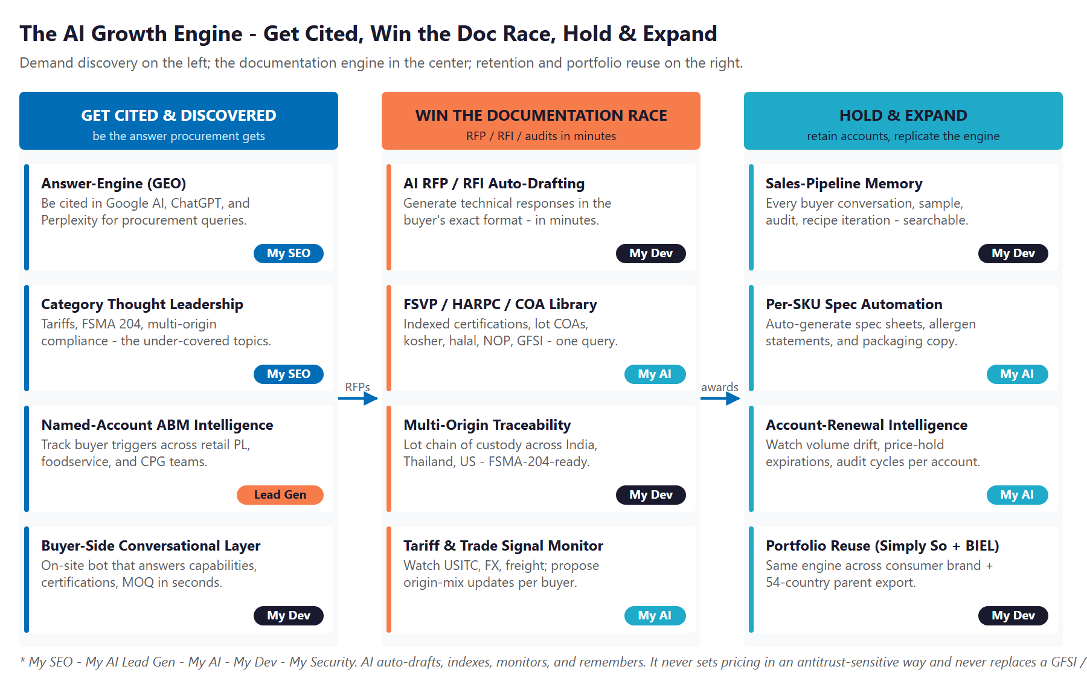
The Engine: Get Cited & Discovered, Win the Documentation Race, and Hold & Expand

Get Cited & Discovered
Own AI-search citations on procurement queries like USDA NOP organic basmati private-label supplier, FSMA-204-ready rice importer, and multi-origin organic chain of custody. Publish category authority content on tariffs and FSMA. Track the named-account universe across retail PL, foodservice, and industrial CPG.

Win the Documentation Race
Auto-draft RFP and RFI responses in the buyer’s exact format from an indexed library of FSVP plans, HARPC controls, lot COAs, kosher and halal letters, and prior responses. Run multi-origin chain of custody across India, Thailand, and US supply. Watch the tariff signal and propose origin-mix updates per buyer.

Hold the Account & Expand
Keep every buyer conversation, sample shipment, audit finding, and recipe-development discussion in a searchable memory. Watch renewal triggers proactively. Reuse the same engine for the Simply So consumer brand and the BIEL parent export markets.

The Program — Start Small, Expand as It Proves Out
The Program — Start Small, Expand as It Proves Out

The program leads with a small, low-commitment entry that pays for itself on the highest near-term levers, faster RFP responses and renewal protection, with no large build to begin. The expansion build comes second, once the entry proves the lift. The Simply So consumer brand and the BIEL export are reuses of the same engine, not a separate ask.

Service | Monthly | Y1
My SEO — AI-Search Authority + Reputation | $1,250 | $15,000
My AI Lead Gen — Named-Account ABM (Starter) | $1,000 | $12,000
My AI — Executive Workshop (one-time) | — | $5,000
ENTRY PROGRAM — Phase 1 (start here) | $2,250/mo + workshop | ~$32,000

Y1 Lever (Estimated, Conservative) | Conservative | Target | Aggressive
Added revenue from faster RFP response | +$40K | +$90K | +$160K
Renewal value protected from churn | +$30K | +$80K | +$150K
Total Y1 value (entry program) | +$70K | +$170K | +$310K
Modeled ROI vs. $32K entry | ~2.2x | ~5.3x | ~9.7x

All figures are estimated and conservative; the full 38-page plan walks through every assumption and calibrates after a short discovery call. The expansion build (the buyer-documentation engine, multi-origin traceability layer, tariff signal monitor, and fractional AI advisor) adds further gains the entry ratio does not count.

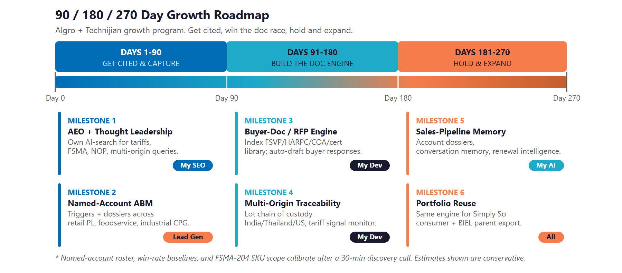
90 / 180 / 270-Day Roadmap

Next Step — 30 Minutes
A short discovery call to confirm scope and calibrate the plan against Algro’s actual book.
Ravi Jain, Technijian | RJain@technijian.com | 949.379.8500

