

DISRUPTIX TALENT SOLUTIONS
AI Growth Plan · Executive Summary
Prepared by Technijian · 2026-05-28
25+ yrs  SoCal Acct/Finance Market | 48–72 hrs  Typical Contract Placement | SD + OC  Markets Served Today | KeyMatch  Proprietary Client Portal · Live

The Opportunity
The Opportunity

DisruptiX has the rare hard things in this category. A CPA founder who served as Managing Partner of Vaco Orange County and speaks the language of both sides of every conversation. A proprietary client portal, KeyMatch, that already promises full visibility into the recruitment process. A 48-to-72-hour contract-placement velocity that sits ahead of the boutique average. And a tagline, "Driving excellence through transparency," that is rare in a category where most firms still run a black-box ATS.
The growth gap is somewhere else. Boutique accounting and finance staffing in 2026 is governed by three forces a one-to-ten-person team cannot keep up with by hand, and AI is the lever on each one. The search bandwidth ceiling that forces silent triage of the harder mandates. The SoCal mid-market trigger queue, where new fundings, CFO transitions, IPO filings, PE acquisitions, and audit-firm changes decide who calls first when a finance seat opens. And the compliance surface around AI in hiring, where EEOC technical assistance, NYC Local Law 144, the proposed California SB 7, and the RealPage doctrine on algorithmic pricing all draw a clear line between AI that augments a recruiter and AI that replaces one.
The category at scale, Robert Half and Vaco and Kforce and Randstad, has the scale and a partial AI investment but is uniformly behind on transparency-as-tech and on AI-buyer-experience velocity. The SoCal boutique field has neither. A CPA-led boutique with the right tagline and a working KeyMatch portal can deploy AI inside the EEOC, NYC LL 144, and antitrust boundary in 2026; a multinational cannot re-platform inside that same boundary in less than two years. That is the opening.

The Compliance Boundary
AI auto-drafts the job spec, indexes the candidate library, summarizes the reference call, watches the leadership-change signal, and remembers every prior engagement, with sources cited and inside the review-in-the-loop the regulator expects.
AI never makes the hiring decision, never adjudicates a protected-class question, and never sets a rate in an antitrust-sensitive way. The recruiter and the client own each decision, in writing, outside the regulatory and antitrust risk entirely.

How AI Transforms DisruptiX’s Growth Engine
How AI Transforms DisruptiX’s Growth Engine

The engine runs three motions at once. The first fills the top of the named-account funnel by getting DisruptiX cited in the AI answers SoCal CFOs and operating partners now ask for first. The second is the matching and screening core that turns KeyMatch into a platform the giants cannot match inside the EEOC and NYC Local Law 144 boundary. The third protects supply and demand together, holding the consultant pool warm between placements and the employer accounts past the first search.

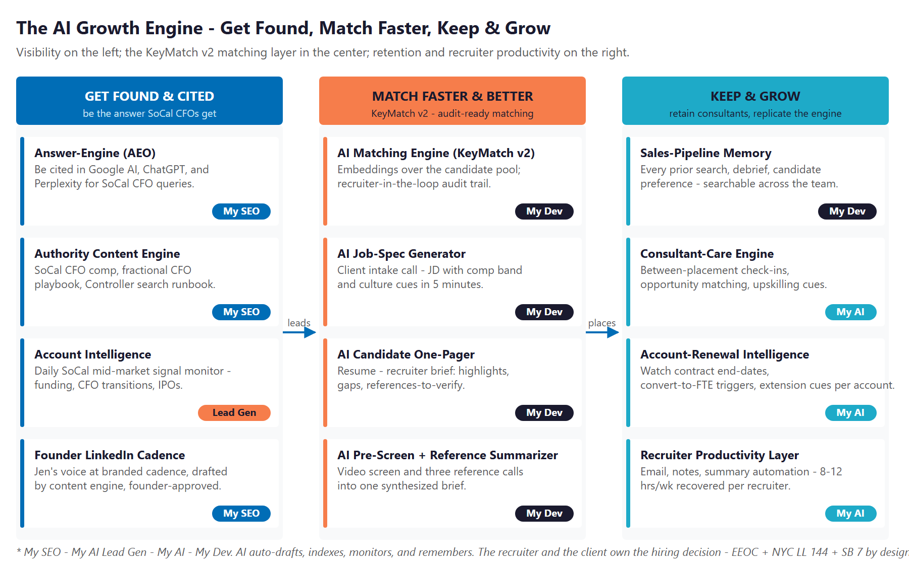
The Engine: Get Found & Cited, Match Faster & Better, and Keep & Grow

Get Found & Cited
Own AI-search citations on the procurement queries that matter: best CFO recruiter Orange County, fractional Controller Costa Mesa, SOX consultant Southern California, interim CFO Newport Beach. Publish category authority content on SoCal CFO compensation, the fractional CFO playbook, and the first-CFO hiring runbook. Lift the founder LinkedIn cadence with Jen’s voice on the topics that compound.

Match Faster & Better — KeyMatch v2
Extend KeyMatch with an AI matching engine over the candidate pool, with recruiter-in-the-loop review and an audit-logged rationale for every match. Add an AI job-spec generator that turns an intake call into a JD in five minutes, an AI candidate one-pager that turns a resume into a recruiter brief, and an AI pre-screen and reference summarizer that turns three calls into one synthesized brief. NYC Local Law 144-ready bias-audit posture from day one.

Keep & Grow
Keep every prior search debrief, candidate preference, client comp note, and reference summary in a searchable team memory. Stand up a consultant-care engine that holds the supply side warm between placements. Watch account-renewal triggers and recover eight to twelve recruiter hours per week. The boutique punches above weight class without expanding headcount.

The Program — Start Small, Expand as It Proves Out
The Program — Start Small, Expand as It Proves Out

The program leads with a small, low-commitment entry that pays for itself on the highest near-term levers, additional placements won and recruiter hours recovered, with no large build to begin. The KeyMatch v2 expansion build comes second, once the entry proves the lift. Productizing KeyMatch as a sellable SaaS for peer boutiques is the Phase-3 upside, not the Year-1 ask.

Service | Monthly | Y1
My SEO — AI-Search Authority + Founder LinkedIn Cadence | $1,250 | $15,000
My AI Lead Gen — Named-Account ABM (Starter) | $1,000 | $12,000
My AI — Readiness + Executive Workshop (one-time) | — | $5,000
ENTRY PROGRAM — Phase 1 (start here) | $2,250/mo + workshop | ~$32,000

Y1 Lever (Estimated, Conservative) | Conservative | Target | Aggressive
Added direct-hire revenue (+2/+4/+7 wins × $22K) | +$44K | +$88K | +$154K
Added contract-consulting margin (+3/+6/+10 × $12K) | +$36K | +$72K | +$120K
Recruiter hours recovered (loaded at ~$80/hr) | +$15K | +$35K | +$66K
Total Y1 value (entry program) | +$95K | +$195K | +$340K
Modeled ROI vs. $32K entry | ~3.0x | ~6.1x | ~10.6x

All figures are estimated and conservative; the full 40-page plan walks through every assumption and calibrates after a short discovery call. The KeyMatch v2 expansion build adds further gains the entry ratio does not count: AI matching, AI job-spec generator, AI pre-screen and reference summarizer, sales-pipeline memory, and the fractional AI advisor.

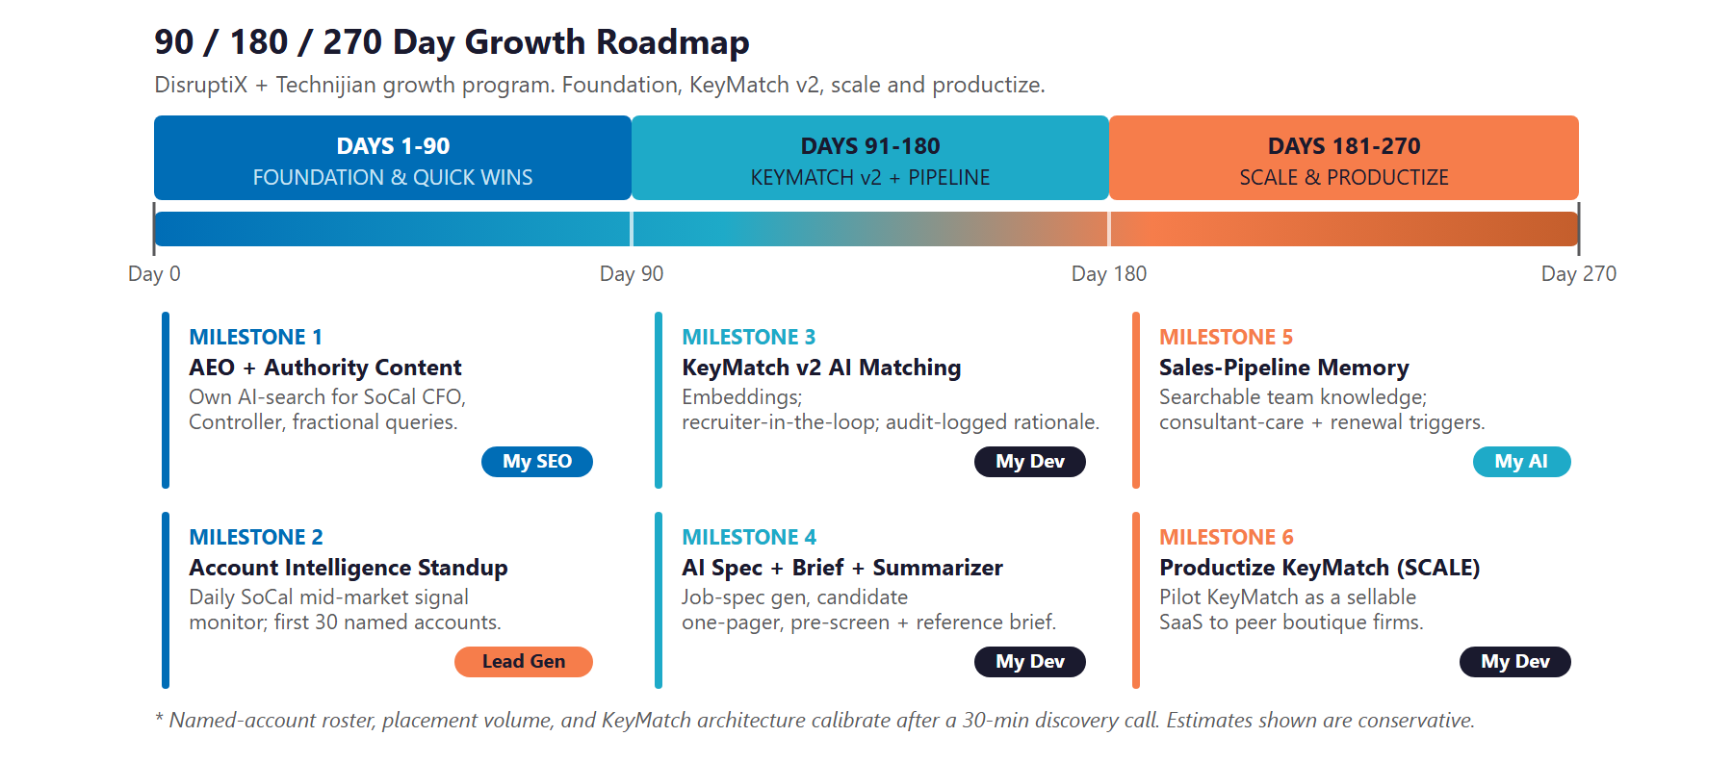
90 / 180 / 270-Day Roadmap

Next Step — 30 Minutes
A short discovery call to confirm scope and calibrate the plan against DisruptiX’s actual book.
Ravi Jain, Technijian | RJain@technijian.com | 949.379.8500

