

DANIELIAN ASSOCIATES
AI Growth & Integration Strategy
Executive Summary

1968  57 years designing communities | 1M+  Units of housing delivered | 775+  Design awards | ~2.6×  Modeled Y1 ROI vs. the entry

Two fronts: win more developer pursuits — and run the studio with less non-design drag. AI sits under the relationships and the craft Danielian has built over 57 years; it does not design, and it does not replace the pursuit. This summary covers the opportunity, the engine, the program, and the entry. The full strategy is ready on request.

Prepared for Danielian Associates | Technijian | 2026-06-01

01 The Opportunity
01 The Opportunity

Danielian wins work through deep developer relationships, a reputation for craft, and pursuits that land the next project. None of that changes. What this strategy adds is a layer underneath it, on two fronts at once:

 | Front 1 — Growth (win more pursuits) | Front 2 — Integration (run the studio)
The win | Higher pursuit win rate; faster, sharper proposals; better account timing | Hours returned to billable design; 57 years of knowledge made searchable
Owner | Deborah Muro, Director of Business Development | Victor Alvarez-Duran, Chief Technology Manager
AI role | Account intelligence, proposal automation, authority content | Searchable archive, entitlement research, production automation

Why Now — The 2026 Window
Demand is being legislated up: SB 79 (transit upzoning, effective July 2026), SB 1211 (up to 8 ADUs per multifamily lot), and ADU streamlining push more work into Danielian’s exact product lines — multifamily, BTR, ADU, middle housing.
The field is split: 53% of A&E firms now use AI and 94% of users are expanding it, yet only ~20% feel "highly prepared." The firm that turns pursuits around fastest captures disproportionate share.
Danielian already runs on EOS, with a Chief Technology Manager and a Director of Business Development — the two seats this program reports into. It is a firm built to absorb this.

02 The Engine
02 The Engine

Three motions, all aimed at the named developers Danielian already competes for — never a broad funnel. AI sits under the relationship layer and removes the non-design drag; the trust and the craft still win the work.

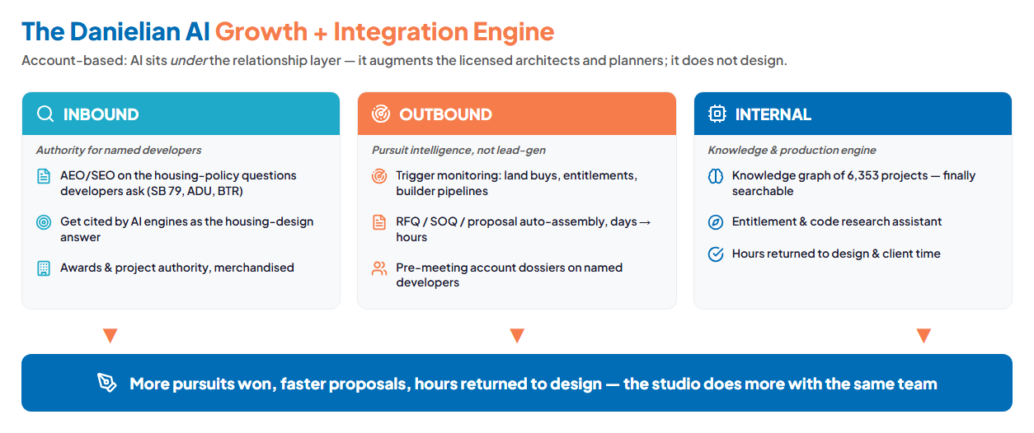
Inbound authority · Outbound pursuit intelligence · Internal knowledge & production — feeding one studio

Get cited
Authority content on the housing-policy questions developers ask (SB 79, ADU, BTR) — so Danielian is the cited expert, not a name in a broad ad.

Win the pursuit
SOQ / RFQ / proposal assembly from days to hours, precedent-matched per pursuit, with account intelligence on land buys and entitlement filings.

Free the studio
57 years and 6,353 projects, finally searchable; entitlement and code research with a head start — hours returned to design and client time.

03 The Program
03 The Program

The program is built land-and-expand and framed as EOS Rocks: a small entry that proves the lift, then a clearly-labeled expansion once it does. Here is the entry — the easy yes. The bigger build (the institutional knowledge graph, account intelligence, the entitlement assistant) comes later, once the entry proves out, and is scoped at discovery.

Entry Service | Scope | Est. Y1
My AI — Workshop + Readiness | Set the AI program as EOS Rocks; readiness baseline (one-time) | ~$5,000
My AI — Fractional AI Advisor | Program lead, governance, and the pursuit-automation pilot | ~$24,000
My SEO — Authority / AEO foundation | Authority content on the housing-policy questions developers ask | ~$12,000
ENTRY PROGRAM (Y1) | Prove the pursuit + efficiency lift, no large build | ~$41,000

Year-1 ROI vs. entry | Downside-Protected | Likely | Upside
Total estimated Y1 value | +$22,500 | +$105,000 | +$225,000
Modeled ROI | pays for itself | ~2.6× | ~5.5×
Even with zero additional pursuit wins, the studio hours the automation returns cover the entry. The expected case counts a single added win plus those hours. Projected, not guaranteed; calibrated to Danielian’s real numbers at discovery.

04 The Roadmap & Next Step
04 The Roadmap & Next Step

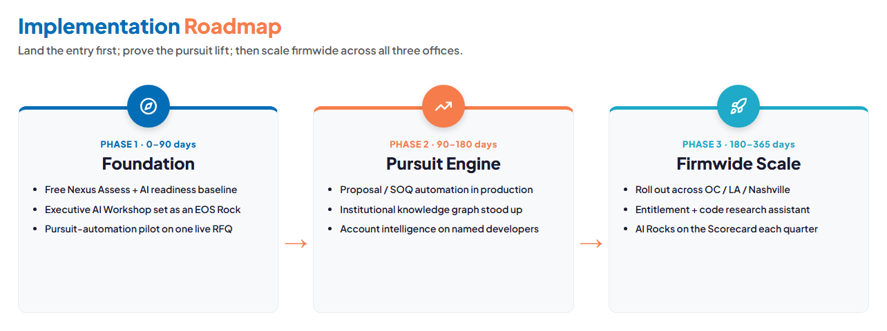
Foundation (0–90 days) → Pursuit Engine (90–180) → Firmwide Scale (180–365)

Two fronts, one local partner — five minutes apart in Irvine.
Start with a free Nexus Assess and one live-pursuit before/after — no contract, no obligation.
Use the Book a Meeting button in my signature to set up a time to discuss this and all the
AI strategies Technijian is putting into place for itself and its clients.
Ravi Jain, Technijian | rjain@technijian.com | 949.379.8499

The full AI Growth & Integration Strategy — the buyer universe, competitive landscape, capability proof, the EOS integration plan, the complete service map, and the discovery questions — is ready if you want to read further before we meet.

