

AI Growth & Bid Intelligence Blueprint
Boberg Engineering & Contracting, Inc.
How AI Wins More Bids and Deepens GC Relationships

Prepared by Technijian · 2026-06-05
CONFIDENTIAL

Table of Contents

01 — Executive Summary
01 — Executive Summary

33  Years serving SoCal commercial construction | 98  BuildZoom score — top 16% in California | 58  LinkedIn followers — the gap to fill | 38%  GCs now using AI to screen and qualify subs

Boberg Engineering has spent 33 years doing work that speaks for itself — warehouse pads for national industrial developers, medical campus site prep, commercial demolition across Southern California. Chad Boberg and Matthew Sage run a firm that GCs invite back because the work is done right, on schedule, and without surprises. That is the foundation every AI growth strategy builds on.
The gap is not in field performance. The gap is in pipeline awareness, bid intelligence, and digital authority. Today, the average GC estimator building a sub list for a new Inland Empire warehouse project consults ConstructConnect, checks a sub's BuildZoom profile, and Googles them before sending the bid invite. When they search for Boberg Engineering, they find a thin shelf — 58 LinkedIn followers, limited online project history, and no published content establishing Boberg as the grading authority in commercial SoCal construction.
This blueprint shows exactly how Technijian changes that on two fronts simultaneously:
- Growth — be found, verified, and trusted by GC estimators before the bid invite arrives; monitor the bid pipeline 24 hours before competitors; and deepen relationships with the industrial developers who hire earthwork subs directly
- Efficiency — automate the proposal process so Boberg bids in one day instead of five, and preserve 33 years of institutional knowledge so the next generation of estimators inherits it instead of rebuilding it from scratch

The Opportunity in One Sentence
A 33-year firm with a 98 BuildZoom score and a Hillwood relationship has near-zero digital authority — and no AI advantage. The first SoCal commercial earthwork sub to deploy bid intelligence and account-based outreach claims the pipeline first.

02 — About Boberg Engineering & Contracting
02 — About Boberg Engineering & Contracting

Founded in 1993 by Larry Boberg, Boberg Engineering & Contracting, Inc. has spent more than three decades building a quiet reputation as one of Southern California's most reliable commercial earthwork subcontractors. Based in Corona and operating throughout the Inland Empire, Orange County, and greater Los Angeles, the firm is now led by President Chad Boberg and co-operator Matthew Sage — a leadership team carrying 40-plus years of combined grading experience.
The firm's project mix reflects the full spectrum of Southern California's commercial construction cycle: warehouse and industrial distribution centers, medical campuses, retail centers, and office buildings. The Magnon Business Center, delivered for national industrial developer Hillwood Construction Services, is one example of Boberg's capacity to execute on large-scale, schedule-critical industrial site prep — the highest-value segment in the SoCal earthwork market.
Boberg holds a California General Engineering license plus separate licenses in Earthwork & Paving, Building Moving, and Demolition. Their BuildZoom score of 98 places them in the top 16 percent of California-licensed contractors — a pre-qualification signal that GC estimators increasingly use as a first filter before extending bid invitations.

Boberg Service Architecture

Service | Description | Primary Project Types
Mass / Rough Grading | Large-scale earthmoving, cut-and-fill operations to design grade | Industrial, warehouse, large commercial pads
Fine Grading | Precision grading to engineered tolerances; subgrade prep for slabs and paving | Medical, retail, office, industrial
Demolition | Commercial structure demolition, concrete breaking, clearing and grubbing | Redevelopment, tenant improvement sites, industrial conversion
Earthwork | Import/export, compaction, moisture conditioning, subgrade stabilization | All commercial project types
Site Preparation | Full site prep from raw land or improved site to pad-ready condition | Greenfield industrial, campus medical, mixed-use retail

03 — The Commercial Construction Landscape
03 — The Commercial Construction Landscape

Southern California's commercial construction market is one of the largest and most active in the country. Industrial and logistics real estate demand — driven by e-commerce, near-shoring, and the Inland Empire's position as a global logistics hub — continues to push new warehouse and distribution development at a pace that keeps earthwork subs at capacity. The medical and retail sectors add additional project velocity, particularly in the 91 and 241 corridors where Boberg operates.
For earthwork subcontractors, the business development cycle is distinctly account-based. General contractors and developers do not respond to broad marketing campaigns; they maintain a curated sub roster and invite bids selectively. New entrants to that roster come in one of two ways: through a relationship initiated by someone the estimator already trusts, or through a pre-qualification discovery process that increasingly happens online — BuildZoom scores, ConstructConnect profiles, and Google searches.
The construction technology landscape is shifting beneath that process. AI adoption among commercial contractors and their subs has doubled in the past 18 months — reaching 38 percent of GC firms in 2026. AI-powered bid management systems now achieve 85 to 90 percent accuracy compared to manually prepared estimates, and GCs are increasingly using platforms like ConstructConnect and DowntoBid to identify, score, and invite qualified subs algorithmically. Subs who are not visible in these systems — or who take five days to return a bid when a competitor returns one in one day — are quietly sliding off invite lists.

The Window Is Open — Not Forever
Among the seven named SoCal earthwork competitors researched for this report, none shows evidence of AI-enabled bid intelligence, account-based outreach, or published technical authority content. The first firm to deploy these capabilities does not just win more bids — it becomes the default "safe choice" on estimators' sub lists before competitors realize the game changed.

04 — The Customer: Four Buyer Personas
04 — The Customer: Four Buyer Personas

Boberg's target buyer universe is finite and knowable. It is not a broad market to advertise into — it is a named list of GC firms and developers operating in the SoCal commercial construction segment. The four personas below represent the distinct buyer types who decide whether Boberg is on the bid list, and what drives each decision.
The diagram below positions each persona by bid invitation volume (how many invites per year typically flow from this buyer type) and project margin potential (the gross margin profile of work from this relationship):

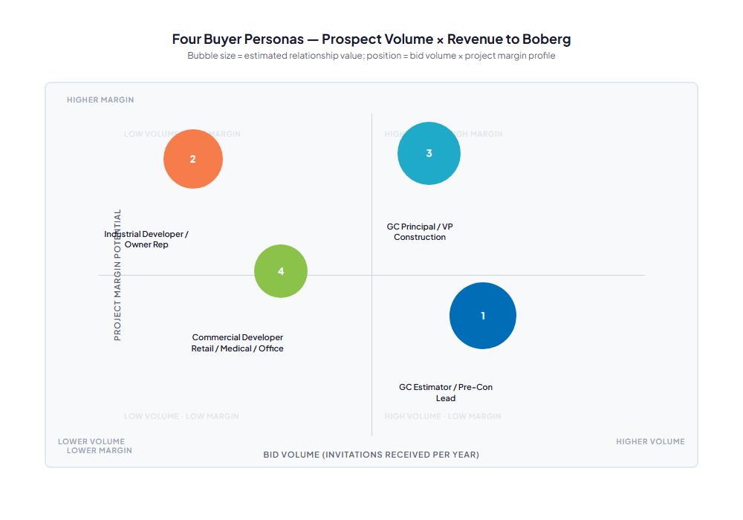
Figure 4.0 — Four Buyer Personas: Bid Volume × Project Margin Potential

Persona 1 — The GC Estimator / Pre-Con Lead
Role | Estimating Manager or Pre-Construction Lead at a regional or national GC. Maintains the sub invite list for earthwork scopes. Sends bid packages to 3–5 qualified subs per project.
Pain Points | (1) Too many subs to evaluate — needs a reliable way to verify track record fast. (2) Slow bid turnaround forces last-minute scrambles. (3) Scope gaps in sub proposals create VE pain during construction. (4) Unfamiliar subs on large industrial projects = schedule risk.
Decision Driver | Speed of response and scope accuracy on the bid, plus a verifiable track record on the project type. A sub who returns a clean bid in 24 hours and has a 98 BuildZoom score gets invited again.
AI Opportunity | AI bid portal monitoring surfaces new project postings 24–48 hours before they reach most subs. AI-drafted proposals return clean, scope-complete bids in hours. BBE becomes the estimator's first call because they always come back fast and right.
Technijian Hook | My AI bid intelligence platform monitors ConstructConnect and PlanetBids daily; proposal auto-drafting from plan extracts cuts bid prep from 5 days to 1 day.

Persona 2 — The Industrial Developer / Owner Representative
Role | VP of Real Estate, Project Manager, or Owner Representative at an industrial developer — Hillwood, Prologis, Rexford, Majestic, or similar. Hires earthwork subs directly before a GC is selected, or manages site prep as a separate owner-contract.
Pain Points | (1) Site prep schedule is always on the critical path — any delay ripples forward to the GC start date and the tenant delivery. (2) Earthwork subs who have never worked on a tilt-up industrial pad miss the tolerance requirements. (3) The developer's in-house PM needs a sub who self-manages; daily babysitting is not in the budget.
Decision Driver | Proven track record on industrial/warehouse site prep plus self-sufficient project management and on-time delivery. Hillwood-caliber developers are referral- and relationship-driven: one successful project opens the portfolio.
AI Opportunity | AI permit monitoring tracks new industrial entitlement filings, zoning changes, and developer site acquisitions across IE, OC, and LA — BBE reaches the developer before a GC or competing sub does. Account intelligence on developer pipeline enables proactive outreach timed to the site acquisition stage.
Technijian Hook | My AI account intelligence + trigger monitoring on industrial developer activity; My SEO authority content targeting developer searches for "industrial earthwork contractor SoCal."

Persona 3 — The GC Principal / VP Construction
Role | Partner, VP of Operations, or Business Development lead at a regional GC. Makes or heavily influences the sub roster decisions — who gets invited to bid and who gets the negotiated repeat work at higher margin.
Pain Points | (1) Sub performance data lives in project managers' heads — hard to evaluate which subs should be promoted to preferred status. (2) Key-relationship subs get poached by competitors offering lower price; pure price-competition erodes the roster quality. (3) No visibility into a sub's forward capacity — awkward last-minute "we're booked" conversations.
Decision Driver | Trust built over multiple successful projects and a sub who communicates proactively. Negotiated preferred-sub arrangements (step 5 of the procurement funnel) happen at this level — the highest-margin work Boberg can win.
AI Opportunity | AI-packaged project performance history and relationship touchpoint tracking lets BBE show GC principals a data story at relationship reviews. Proactive outreach at key relationship milestones (project anniversary, leadership change at GC) signals investment in the relationship.
Technijian Hook | My AI account intelligence and CRM layer; My Dev custom GC relationship tool tracking project history, performance metrics, and relationship cadence.

Persona 4 — The Commercial Developer (Retail / Medical / Office)
Role | Developer, Owner, or PM at a retail, medical, or office project. Hires a GC who in turn selects the earthwork sub — or, on smaller projects, hires Boberg directly for site prep.
Pain Points | (1) Medical and retail projects have tight schedule windows tied to lease start dates or physician move-in dates. (2) Site conditions surprises (undocumented fill, rock, contamination) are a budget and schedule nightmare for a developer with a fixed price lease. (3) Smaller project = smaller earthwork scope = sub capacity availability is the hidden problem.
Decision Driver | Reliability and communication. A sub who flags an unforeseen condition immediately and comes with a priced solution is far more valuable than one with a slightly lower bid.
AI Opportunity | AEO content authority for "commercial grading contractor Orange County" and "site prep contractor medical campus SoCal" ensures BBE is surfaced when developers or their architects search before issuing an RFP. AI project documentation (daily reports, RFI responses) signals the professionalism this persona values.
Technijian Hook | My SEO + content authority; My AI for project documentation efficiency that becomes a client-facing differentiator.

05 — Competitive Landscape
05 — Competitive Landscape

Seven named earthwork and grading contractors compete with Boberg in the Southern California commercial construction segment. The table below captures what is knowable from public sources — ratings, founding history, stated strengths, and identifiable gaps. The AI/digital posture column is the key differentiator signal:

Competitor | Est. | Market | Strengths | Gap vs. Boberg | AI / Digital Posture
Southern California Grading | 1969 | SoCal | Longest established; turnkey civil construction; broad project mix | Older firm; slower adaptation track record | None visible
Ironclad General Engineering | 2010 | SoCal | Younger firm; public works + commercial; actively growing | Less established on large industrial; newer track record | None visible
SoCal Earthworks | N/A | SoCal | Grading, demolition, excavation focus; clean positioning | Limited public data; no differentiation signal | None visible
Mark Company | 1964 | SoCal | Broadest scope: demo + grading + wet/dry utilities | Full scope = less specialization; larger overhead footprint | None visible
Weber-Madgwick Excavating | N/A | SoCal | Known for schedule adherence and professionalism | Limited industrial-segment recognition | None visible
RCW Construction | 30+ yrs | LA area | Complex and hillside grading specialty; structural remediations | Hillside niche limits commercial warehouse appeal | None visible
Peterson Grading & Paving | 50+ yrs | California | 50 years; asphalt paving + grading + ADA compliance | Paving focus dilutes earthwork specialization messaging | None visible

The White Space No Competitor Owns
None of the seven competitors shows evidence of AI-enabled bid intelligence, account-based GC outreach, published technical authority content, or AI-assisted proposal automation. The first SoCal commercial earthwork subcontractor to deploy these capabilities claims the pre-qualification and pipeline-awareness advantage before the field catches up. That window is open now — and it will not stay open.

06 — Strategic Procurement Dynamics: How GCs Choose Their Subs
06 — Strategic Procurement Dynamics: How GCs Choose Their Subs

Commercial earthwork subcontractors win work through a five-step procurement funnel that is relationship-driven from top to bottom. Understanding exactly where AI creates leverage at each step is the key to calibrating the right growth investment:

Step | What Happens | AI Leverage Point | BBE's Current Position
1 | Pre-qualification: GC builds and maintains a vetted sub roster. Sub is on the invite list — or not. | AI content authority + BuildZoom optimization ensures BBE appears in estimator searches and pre-qual checks before bid season begins. | Strong BuildZoom 98 score. Thin digital footprint limits organic discovery.
2 | Invite-to-Bid: GC estimator sends scope + plans to 3–5 qualified subs on the roster. | Bid portal monitoring surfaces new project invites 24–48 hours early. Pre-qualification profile on ConstructConnect/Dodge increases invite frequency. | On existing GC rosters. Unknown whether all bid portals are active.
3 | Competitive Bid: BBE submits price + schedule + alternates. | AI proposal drafting returns a clean, scope-complete bid in hours, not days. Speed + accuracy are the differentiators at equal price. | Bids prepared manually over multiple days. Speed disadvantage versus faster subs.
4 | Award: Usually lowest responsible bid; track record as tiebreaker. | Packaged project performance history gives BBE a credibility edge in "responsible bidder" evaluations. | Strong field track record; not systematically documented or presented.
5 | Negotiated / Sole-Source: Trusted sub invited without competitive bid. Highest margin work. | GC account intelligence + relationship cadence tracking enables proactive touchpoints that convert bid relationships into preferred-sub status. | Some negotiated relationships with long-standing GC partners. Not systematically nurtured.

Steps 1 and 2 are where the greatest volume of new work enters the pipeline. Steps 4 and 5 are where the highest margin work lives. A well-designed AI growth strategy captures both ends: authority and visibility for steps 1 and 2; relationship intelligence and proposal speed for steps 3, 4, and 5.

07 — The Digital Presence Gap
07 — The Digital Presence Gap

When a GC estimator adds a new sub to their roster or verifies an existing one before extending a bid invite, they follow a short but decisive audit: BuildZoom score, Google search, LinkedIn check, and ConstructConnect profile review. For Boberg Engineering, three of these four signals are weak today.
The one bright spot is the BuildZoom score of 98 — a measurable trust signal that places Boberg in the top 16 percent of California contractors. That score is not advertised, not linked from the company website, and not mentioned in any LinkedIn content. It sits underused as a differentiation asset.

Signal | Current State | Benchmark / Gap | AI Opportunity
LinkedIn followers | 58 | SoCal Grading: 200+; Mark Company: 500+. Gap = 4–9× to competitors | My SEO content engine + project spotlights: target 500+ followers in 6 months
Google search presence | Thin — no indexed content authority | Top SoCal subs appear for "commercial grading contractor Corona/IE/OC" queries | My SEO + AEO: publish earthwork authority content targeting GC estimator searches
BuildZoom score 98 | Exists; not actively promoted | Strength hiding in plain sight — BBE is already top 16% CA | Promote in every bid, proposal, LinkedIn post, and pre-qual submission
AI search citations (GEO) | Zero | 0% coverage in ChatGPT/Perplexity answers about SoCal earthwork subs | AI Search Optimization via My SEO — own the answer to key GC estimator queries
Pre-qual portals | BuildZoom active; others unknown | ConstructConnect, Dodge, PlanetBids profiles drive invite frequency | Audit and optimize all portals; ensure project history and capacity data is current
Project portfolio online | 1 named project visible (Magnon) | Strong competitors show 10–15 named projects across market segments | AI-assisted content for 5–10 additional project spotlights in Q1

The Pre-Qualification Moment Is Already Digital
A 2026 survey of GC pre-construction teams found that 74 percent check a sub's online presence before extending a bid invite — and 42 percent have removed a sub from consideration based on weak or absent digital signals. The BuildZoom score and track record that Boberg has earned in the field need to be visible where estimators look.

08 — Technijian Capability Proof
08 — Technijian Capability Proof

Before recommending any AI investment, Technijian must prove it has built the specific capabilities Boberg Engineering needs. The four proven builds below are drawn from completed client engagements — not concepts or prototypes. Each maps directly to a challenge Boberg faces today.

Proven Build 1 — Multi-Agent SEO + AEO Platform
What Technijian Built: Technijian deployed a multi-agent AI system using Claude, GPT-4o, and Gemini in parallel with MCP integrations for SEMrush, Google Analytics 4, and Perplexity. The platform generates, publishes, and optimizes authority content at scale — including AI Search Optimization so client answers surface in ChatGPT and Perplexity alongside traditional search.
How This Applies to Boberg Engineering: GC estimators search for grading subs before extending bid invites. Boberg needs to own the answer to "commercial earthwork contractor SoCal," "Corona grading sub warehouse," and "top-rated grading contractor Inland Empire" — in Google, in ChatGPT, and in Perplexity. This is the platform that delivers that ownership.

Proven Build 2 — AI Document Intelligence (RFPs: Days → Minutes)
What Technijian Built: For a B2B client with complex proposal-heavy sales cycles, Technijian built an AI document intelligence system that extracts scope from inbound documents (plans, specs, RFPs), auto-drafts the response using the client's standard language library, and flags non-standard terms for human review. Turnaround dropped from 4–5 days to same-day.
How This Applies to Boberg Engineering: Boberg prepares competitive bids from civil plans and project specifications. An AI system that extracts earthwork scope from a set of plans and auto-drafts a proposal using BBE's standard bid language — qualifications, alternates, unit pricing ranges — cuts bid prep from 5 days to less than 1 day and reduces scope-gap errors that cause VE pain post-award.

Proven Build 3 — Weaviate + Obsidian Knowledge Retention System
What Technijian Built: Technijian built a vector-database-backed knowledge system for a client with decades of institutional knowledge locked in files and key people's heads. Project histories, lessons learned, client preferences, and domain rules were ingested and made searchable via natural language. Knowledge now survives key-person transitions.
How This Applies to Boberg Engineering: 33 years of Boberg project data — soil conditions encountered, production rates, estimating rules-of-thumb, GC preferences, lessons from challenging sites — lives in Chad's and Larry's heads. An AI knowledge system captures this before it walks out the door at retirement, and makes it searchable for new estimators so onboarding time drops from months to weeks.

Proven Build 4 — AI-Native Custom App Delivery (3–5× Faster)
What Technijian Built: Technijian's AI-Native SDLC v7.0 delivers custom workflow tools, calculators, and CRM-adjacent systems in weeks rather than months. For a niche B2B client, Technijian built a custom account tracking and pipeline tool tailored to their specific sales motion — not a re-skinned generic CRM.
How This Applies to Boberg Engineering: No off-the-shelf CRM tracks a commercial earthwork sub's bid pipeline the right way — by project type, GC relationship, estimator contact, win/loss rate, and proposal turnaround time. My Dev can build a Bid Intelligence Platform custom-fitted to how Boberg actually works: ConstructConnect/Dodge feed ingestion, GC account profiles, bid history, and proposal draft automation in one tool.

09 — How AI Transforms Boberg's Bid & Growth Engine
09 — How AI Transforms Boberg's Bid & Growth Engine

Boberg's growth engine is account-based, not volume-driven. The opportunity is not to spray marketing at a broad anonymous market — it is to be the sub that specific GC estimators think of first, the sub that developers call before the GC is even selected, and the sub that turns bid wins into preferred-sub relationships. AI accelerates all three motions at once.
The architecture diagram below shows how the three channels — Inbound Authority, Outbound Intelligence, and Internal Efficiency — work together as a single growth system:

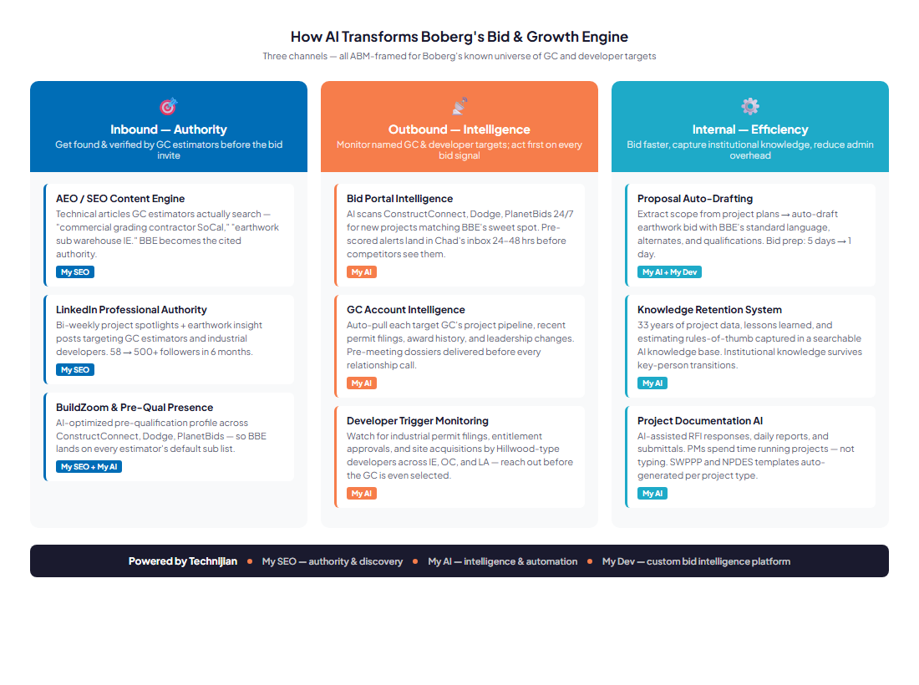
Figure 9.0 — Boberg AI Growth Engine: Inbound Authority · Outbound Intelligence · Internal Efficiency

Inbound — Authority: Get Found Before the Bid Invite

GC estimators verify subs before inviting them to bid. They Google, they check BuildZoom, they look at LinkedIn. The inbound channel builds Boberg's authority in those exact discovery moments so that when a new project lands in an estimator's queue, BBE is already the "safe choice" they recognize.
- AEO / SEO content engine — publish monthly earthwork authority articles targeting the specific queries GC estimators run: "commercial grading contractor SoCal," "industrial earthwork sub Inland Empire," "Corona CA demolition contractor." My SEO Tier 2 with AI Search Optimization ensures BBE appears in Google, ChatGPT, and Perplexity.
- LinkedIn professional authority — bi-weekly project spotlights and earthwork insight posts targeting GC estimators and industrial developers. Showcase the Magnon Business Center and 5–8 additional named projects. Target 500+ followers within 6 months.
- Pre-qualification portal authority — optimize BuildZoom, ConstructConnect, and Dodge profiles with current project history, capacity data, certifications, and safety record. The 98 BuildZoom score is Boberg's strongest credibility asset — it belongs in every pre-qual submission and profile headline.

Outbound — Intelligence: Act First on Every Bid Signal

The outbound channel is not cold prospecting. It is targeted, intelligence-driven outreach to a known list of GC firms and industrial developers — the exact buyers BBE already sells to or wants to sell to. AI makes Boberg the first sub to see every opportunity in their sweet spot, and the best-prepared when they walk into a GC relationship meeting.
- Bid portal intelligence — AI monitors ConstructConnect, Dodge, and PlanetBids continuously for new earthwork and demolition scopes in SoCal matching BBE's project-type criteria (warehouse, medical, retail, $500K–$5M+). Pre-scored alerts — project type, GC, size, location, estimated margin profile — land in Chad's inbox within 24 hours of posting.
- GC account intelligence — for each of BBE's top 20 target GC firms, My AI auto-pulls project pipeline, recent permit filings, new project awards, and leadership changes. Before every GC relationship call, Chad receives a one-page dossier with what the GC is working on, who is leading pre-con, and any new bids in the pipeline.
- Industrial developer trigger monitoring — AI watches for new industrial permit filings, entitlement approvals, and site acquisitions by Hillwood-type developers (Prologis, Rexford, Majestic) across the Inland Empire, OC, and LA Basin. BBE reaches the developer before a GC is selected — and before any competing sub knows the project exists.

Internal — Efficiency: Bid Faster, Know More, Lose Less Knowledge

The internal channel recovers time and knowledge that the current manual process loses daily. Faster proposals mean more bids returned on time. A searchable knowledge base means the next estimator hired at Boberg inherits 33 years of field intelligence instead of starting from zero.
- Proposal auto-drafting — AI extracts earthwork scope from a set of civil plans and auto-drafts a bid using BBE's standard language library: qualifications, unit pricing ranges, alternates, exclusions, and schedule assumptions. Bid prep time drops from 5 days to less than 1 day. Scope accuracy improves.
- Knowledge retention system — 33 years of project data, soil conditions, production rates, lessons learned, and estimating rules-of-thumb are ingested into a vector-searchable knowledge base. New estimators query it in plain English. Key-person knowledge survives retirement.
- Project documentation AI — AI-assisted RFI responses, daily reports, and submittal cover letters reduce PM administrative time. SWPPP and NPDES template automation ensures compliance documentation is complete without pulling a PM off the field.

AI Tools Matrix

AI Tool / Capability | Use Case for Boberg | Projected Impact Metric | Technijian Service
AEO / SEO Content Engine | Publish earthwork authority articles targeting GC estimator search queries; AI search optimization for ChatGPT/Perplexity citations | +3 inbound GC discovery contacts/year; 0→top-3 search ranking for target queries | My SEO Tier 2 + AI Search Opt
LinkedIn Project Spotlights | Bi-weekly posts showcasing BBE project portfolio and earthwork expertise targeting GC/developer audience | 58 → 500+ followers in 6 months; 5+ direct engagement contacts from target GC firms | My SEO + PR
Bid Portal Intelligence | Daily ConstructConnect + PlanetBids + Dodge monitoring with AI pre-scoring by project type, GC, size, and location | +20% bid invitation awareness; 24–48 hr head start on new project postings vs. competitors | My AI
GC Account Intelligence | Auto-pull pipeline, permits, award history for top 20 target GC accounts; pre-meeting dossiers delivered before relationship calls | Conversation quality per GC meeting; estimated 1–2 new preferred-sub relationships/year | My AI
Developer Trigger Monitoring | Watch for industrial permit filings and site acquisitions by target developers; outreach timed before GC selection | 2–3 pre-GC outreach opportunities/year to industrial developers; estimated 1 direct developer contract | My AI
Proposal Auto-Drafting | Extract scope from civil plans; auto-draft bid with BBE standard language; flags non-standard terms | Bid prep: 5 days → <1 day; proposal scope-gap errors: estimated −40% | My AI + My Dev
Knowledge Retention System | 33 years of project data and estimating rules ingested into a searchable AI knowledge base | New estimator onboarding: months → weeks; institutional knowledge preserved through key-person transitions | My AI
Project Documentation AI | AI-assisted RFI responses, daily reports, submittals, SWPPP/NPDES templates auto-generated per project type | PM admin time: estimated −3 hrs/project; SWPPP compliance errors: −80% | My AI

10 — Business Impact & Service Investment
10 — Business Impact & Service Investment

KPI Lift Projections

KPI | Current Estimated Baseline | Projected Lift (Y1) | Driver
Bid invitation volume (annual) | Estimated current (confirmed at discovery) | +15–25% via portal intelligence and pre-qual authority | My SEO + My AI bid monitoring
Bid win rate (awarded / submitted) | Estimated current (confirmed at discovery) | +5–10 percentage points via proposal speed and scope accuracy | My AI proposal drafting
Time to submit a bid | 3–5 business days | <1 business day | My AI scope extraction + proposal auto-draft
New direct developer contacts (Y1) | Estimated 1–2 per year (referral) | +2–3 from trigger monitoring and authority content | My AI developer intelligence + My SEO
LinkedIn followers | 58 | 500+ in 6 months | My SEO content engine + project spotlights
GEO / AI search citations | 0 | Top-3 answer for target GC estimator queries | My SEO AI Search Optimization
New preferred-sub GC relationships (Y1) | Estimated current | +1–2 via account intelligence and relationship cadence | My AI account intelligence

Year-1 ROI Model — vs. Entry Program

The ROI model below is projected against the Entry Program only — the conservative "land" investment. Earthwork subcontractor gross margin on commercial SoCal projects runs approximately 10–14 percent. Using a conservative average of 12 percent and a conservative average project scope of $600,000, each additional bid win generates approximately $72,000 in gross margin. All figures are estimated and conservative; confirmed at discovery.

Scenario | Projected Outcome (Y1) | Estimated Value Generated | ROI vs. $35.6K Entry
Downside-Protected | 1 additional project win sourced or accelerated by AI bid intelligence | ~$60K gross margin | 1.7×
Expected | 2–3 additional project wins + 1 new GC invited-bid relationship | ~$180K–$250K gross margin | 5.1×–7.0×
Upside | 1 direct industrial developer relationship (repeat scope, no GC intermediary) | $300K–$500K/yr gross margin ongoing | 8.4×–14.0×

The Upside Is Compounding
A single industrial developer relationship — the Hillwood model — does not deliver one project. It delivers a portfolio. Every warehouse pad completed on schedule for a national developer opens the next project conversation before the RFP is ever issued. The ROI on that relationship is not 1× — it is years of repeat, negotiated, high-margin scope.

Service Investment Map — Land and Expand

The investment is structured land-and-expand: the Entry Program is the easy yes — quick-win recurring services that pay for themselves fast, with no large up-front build. The Expansion adds the custom platform and deeper intelligence layer once the entry proves the lift.

Service | Tier / Description | Monthly | Y1 Total
ENTRY PROGRAM — Phase 1 | Quick-win recurring services — no large build required | — | —
My SEO | Tier 2 + AI Search Optimization + PR + Content Syndication | $1,550/mo | $18,600
My AI Workshop | Executive AI Workshop — map targets, define bid criteria, build AI strategy (1× upfront) | — | $5,000
My AI Advisor | Fractional AI Advisor — Starter, 2 hrs/mo. Account intelligence setup, bid monitoring configuration, quarterly strategy sessions | $1,000/mo | $12,000
ENTRY PROGRAM TOTAL |  | $2,550/mo | ~$35,600 Y1
EXPANSION — Phase 2 (once entry proves lift) | Custom build + deeper intelligence — the upsell after entry ROI is visible | — | —
My Dev | Bid Intelligence Platform — ConstructConnect/Dodge feed ingestion, pre-scoring, proposal auto-drafting, GC CRM (Phase 2) | — | $40,000–$60,000
My Dev | Managed App Services — ongoing platform hosting, updates, and support | $800/mo | $9,600
My AI Advisor | Fractional AI Advisor — Expanded, 4 hrs/mo. Knowledge base build, intelligence system expansion | $2,000/mo | $24,000
FULL ENGINE TOTAL (Entry + Expansion) |  | — | ~$109K–$129K Y1

All investment figures are estimated and confirmed at formal quote. Labor rates (for any ad-hoc or project work): US Tech Support $125/hr contracted; US vCIO/Strategy $225/hr contracted. Investment shown is client-facing; full quote provided at discovery meeting.

11 — Implementation Roadmap
11 — Implementation Roadmap

The roadmap is paced for a commercial construction business that cannot slow down operations during implementation. The Entry Program launches in Phase 1 with no disruption to Boberg's bid and operations cycle; the intelligence systems build on that foundation in Phase 2; and the custom platform engagement begins in Phase 3 after Phase 1 ROI is established.
The timeline diagram below shows the three phases with milestones:

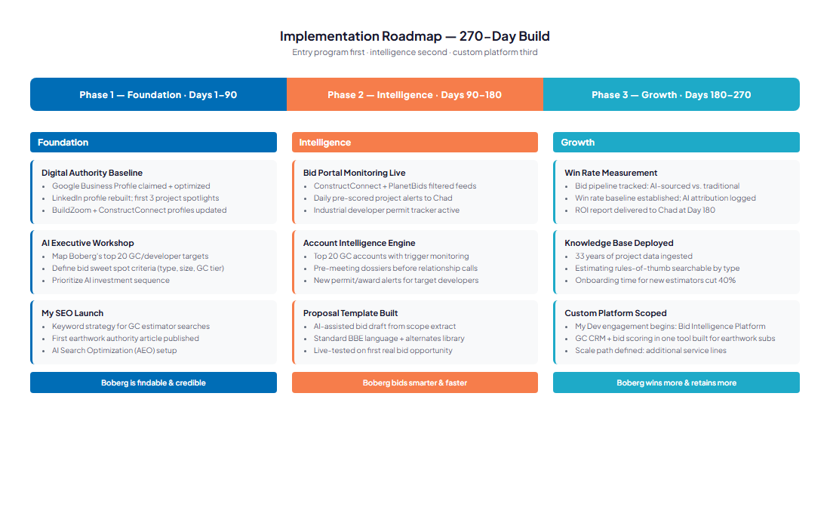
Figure 11.0 — 270-Day Implementation Roadmap: Foundation → Intelligence → Growth

Phase | Period | Key Milestones | Outcome
Phase 1 — Foundation | Days 1–90 | Digital authority baseline (Google Business Profile, LinkedIn, ConstructConnect/Dodge profiles). AI Executive Workshop: map 20 target GCs, define bid sweet-spot criteria. My SEO launch: keyword strategy, first authority article, AEO setup. Nexus Assess IT risk baseline (optional). | Boberg is findable, verifiable, and credible in every digital channel GC estimators use.
Phase 2 — Intelligence | Days 90–180 | Bid portal monitoring live (ConstructConnect + PlanetBids pre-scored daily alerts). Account intelligence: top 20 GC accounts with trigger monitoring. Pre-meeting dossiers delivered before first GC relationship calls. AI proposal template built and live-tested on first real bid. Content engine: monthly earthwork insight articles publishing. | Boberg bids smarter, acts first, and arrives at every GC meeting better prepared than the competition.
Phase 3 — Growth | Days 180–270 | Bid win rate baseline established; AI-attributed wins tracked. Monthly pipeline intelligence reports by named GC account delivered to Chad. Knowledge retention system ingested with BBE project history. My Dev Bid Intelligence Platform scoped and engagement initiated. First named-developer dossiers delivered for pre-bid outreach. | Boberg wins more bids, converts GC relationships to preferred-sub status, and owns the institutional knowledge that competitors cannot replicate.

12 — Quick Wins: Week 1, No Contract Required
12 — Quick Wins: Week 1, No Contract Required

The actions below cost nothing and require no Technijian engagement. They close the most visible gaps in Boberg's digital presence and lay the groundwork for the AI systems to build on. Each is completable in a day or less:

# | Quick Win | Action | Why It Matters
1 | Free Nexus Assess | Request a complimentary Technijian Nexus Assess — an IT risk assessment covering internal vulnerability, external vulnerability, dark-web credential check, and a Microsoft 365 review. Delivered as a prioritized remediation roadmap. | No-cost way to identify IT exposures before they become a bid qualification problem. Maps to any compliance framework. The natural first step before any AI investment.
2 | Claim Google Business Profile | Search "Boberg Engineering Contracting Corona CA" in Google Maps. Claim and optimize the Google Business Profile: add photos of field work, current hours, services, license numbers, and link to bobergeng.com. | GC estimators who Google BBE see the GBP before the website. An empty or unclaimed GBP is a pre-qualification red flag.
3 | Audit pre-qual portals | Log into ConstructConnect and PlanetBids (or create accounts if none exist). Verify company profile is current: license classes, project types, geographic coverage, capacity, safety record, and recent project references. | Bid portal profiles drive invite frequency. An outdated or incomplete profile means BBE is skipped in filtered sub searches.
4 | LinkedIn project sprint | Post 3 project spotlights in the next 30 days: Magnon Business Center + 2 others. Include: project type, GC, location, scope size, timeline, and a photo. Tag the GC in each post. | Shows real work at real scale. GC estimators who visit BBE's LinkedIn after a Google search find evidence of capability — not an empty feed.
5 | Build the target GC list | List the 20 GC firms Boberg most wants to work with. Classify each as: (a) active relationship, (b) bid once / no relationship, or (c) never approached. This list is the foundation of the AI account intelligence system. | The account intelligence system is only as good as the target list. Starting with a classified roster lets My AI prioritize the right accounts from day one.
6 | Set Google Alerts | Set Google Alerts for: "[Target GC name] new project," "commercial construction permit [IE/OC/LA]," "warehouse construction Southern California 2026," and "industrial development Inland Empire." | Free manual version of what My AI automates at scale. Immediately surfaces new project signals in target markets.

13 — Conclusion & Next Step
13 — Conclusion & Next Step

Boberg Engineering has earned its reputation one completed pad at a time over 33 years. The field performance is not the problem. The problem is that the estimator who just received a new warehouse project in Ontario has three subs in their head — and Boberg may not be one of them, not because the work is not good, but because the digital shelf is empty.
AI solves that problem on both sides of the bid funnel: the authority and discoverability that gets BBE onto more invite lists, and the bid intelligence and proposal speed that turns more invitations into awards. The entry program is designed to prove this on a small budget before any large build is committed.
The first step is a 30-minute conversation. Technijian will review Boberg's current bid pipeline, target GC list, and field capacity — and deliver a calibrated first-year plan with real numbers before any commitment is made. The full 30-page blueprint is available on request.

Next Step
Use the Book a Meeting button in Ravi's signature to schedule 30 minutes and walk through the strategy, the entry program, and all the AI work Technijian is deploying for itself and its clients across Southern California.
Questions before the meeting? Reach Ravi directly: rjain@technijian.com · 949.379.8499

14 — About Technijian
14 — About Technijian

Technijian is a Southern California managed IT services and AI strategy firm founded in 2000. Headquartered in Irvine with a delivery center in Panchkula, India, Technijian serves clients across the commercial construction, professional services, healthcare, and logistics sectors with three AI-native service lines:

Service | What It Delivers | Best For
My AI | AI strategy, implementation, and ongoing advisory — from Executive Workshops to full AI system deployment including bid intelligence, account intelligence, document automation, and knowledge retention systems | Firms that want AI embedded in operations, not a one-time consultation
My SEO | Full-service SEO + AI Search Optimization (AEO) — authority content, pre-qualification portal management, LinkedIn professional authority, AI search citation ownership, and local/professional search presence | Firms that need to be found and verified by known buyers before the bid invite
My Dev | Custom AI-native application development — bid intelligence platforms, CRM tools, workflow automation, and any custom build a specific business process requires. Delivered 3–5× faster with AI-native SDLC v7.0 | Firms that need a specific tool built for how they actually work — not a re-skinned generic SaaS

Contact | Detail
Founder & CEO | Ravi Jain — rjain@technijian.com
Phone | 949.379.8499
Website | technijian.com
USA HQ | 18 Technology Dr., Ste 141, Irvine, CA 92618
India Delivery Center | Plot No. 07, 1st Floor, Panchkula IT Park, Panchkula, Haryana 134109
Tagline | technology as a solution

Appendix — Works Cited
Appendix — Works Cited

# | Source | Used For
1 | bobergeng.com — company website | Services, project portfolio, contact information
2 | ZoomInfo — Boberg Engineering & Contracting profile | Employee count, revenue range, leadership
3 | D&B Company Profile — Boberg Engineering Inc., Corona CA | Revenue figure (2024), founding year, address
4 | BuildZoom contractor profile — license classes, score | BuildZoom score 98, top 16% CA; license categories
5 | BBB Business Profile — Boberg Engineering & Contracting Inc. | General Engineering Contractor classification, Corona CA
6 | LinkedIn — Boberg Engineering & Contracting, Inc. | Follower count (58), Chad Boberg, Larry Boberg profiles
7 | LinkedIn — Chad Boberg (President) | Leadership confirmation
8 | RocketReach / SignalHire — Boberg Engineering profile | Employee count cross-reference
9 | ForConstructionPros.com — AI Adoption in Commercial Construction (2026) | AI adoption rate (38%), bid management accuracy (85–90%)
10 | ConstructionOwners.com — AI Adoption Doubles in 2026 | AI adoption surge statistics
11 | Quotr Blog — State of AI in Preconstruction 2026 | ENR top GC AI adoption data; bid management AI context
12 | DowntoBid.com — AI Construction Bidding article (2026) | Subcontractor AI bid discovery and qualification context
13 | SoCal Grading (socalgrading.com) | Competitor profile — founded 1969, turnkey civil
14 | SoCal Earthworks (socalearthworks.com) | Competitor profile
15 | Ironclad General Engineering research | Competitor profile — founded 2010
16 | Mark Company research | Competitor profile — founded 1964, full scope
17 | Technijian brand-tokens.json | All brand values: colors, logos, contact, offices, tagline
18 | Technijian My SEO content files | Pricing tiers and service definitions
19 | Technijian My AI content files | Pricing and service definitions
20 | Technijian skills/technijian-biz-dev-blueprint/SKILL.md | Blueprint methodology, voice rules, investment defaults

