

AI Growth & Bid Intelligence
Executive Summary
Boberg Engineering & Contracting, Inc.
How AI Wins More Bids and Deepens GC Relationships

Prepared by Technijian · 2026-06-05
CONFIDENTIAL

33  Years SoCal commercial earthwork | 98  BuildZoom score — top 16% CA | 58  LinkedIn followers today | 38%  GCs using AI to screen subs

The Opportunity
Boberg Engineering has earned its reputation one completed pad at a time over 33 years. The BuildZoom score of 98 places the firm in the top 16 percent of California contractors — a trust signal GC estimators use as a first filter before sending bid invites.
The gap is not in field performance. When a GC estimator builds a sub list for a new Inland Empire warehouse project, they Google the sub, check BuildZoom, and review LinkedIn before sending the invite. What they find for Boberg Engineering today: 58 LinkedIn followers, limited online project history, no published content, and no AI advantage in the bid discovery process.

Three Forces Shaping the Market Right Now
1. AI adoption among GCs has reached 38% in 2026 — up from 17% eighteen months ago. GCs are now using AI to screen, score, and invite subs algorithmically. Subs not visible in bid portals and online searches are quietly sliding off invite lists.
2. Industrial and logistics real estate demand in the Inland Empire continues to set records. Hillwood, Prologis, Rexford, and Majestic are actively developing — and they hire earthwork subs before the GC is even selected.
3. None of the seven named SoCal earthwork competitors has deployed AI-enabled bid intelligence, account-based outreach, or published technical authority content. The first-mover window is open.

The Opportunity in One Sentence
A 33-year firm with a 98 BuildZoom score and a Hillwood relationship has near-zero digital authority — and no AI advantage. The first SoCal commercial earthwork sub to deploy bid intelligence and account-based outreach claims the pipeline first.

How AI Transforms Boberg's Bid & Growth Engine
Boberg's growth engine is account-based — a finite list of GC firms and developers who decide whether Boberg is on the bid list. AI accelerates the three motions that matter most in this model:

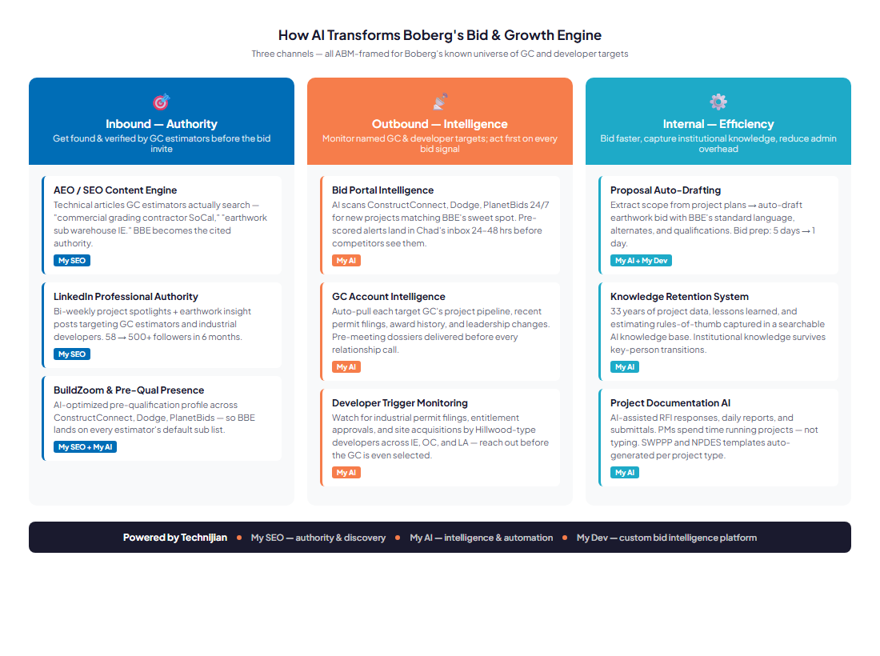
Figure 1 — Boberg AI Growth Engine: Inbound Authority · Outbound Intelligence · Internal Efficiency

Inbound — Authority: Get Found Before the Bid Invite
My SEO + AI Search Optimization makes Boberg the cited answer when GC estimators search "commercial grading contractor SoCal," "earthwork sub warehouse IE," and "Corona demolition contractor." LinkedIn project spotlights grow followers from 58 to 500+ in 6 months.

Outbound — Intelligence: Act First on Every Bid Signal
My AI monitors ConstructConnect, PlanetBids, and Dodge 24/7 — pre-scored alerts land in Chad's inbox 24–48 hours before competitors see new projects. Account intelligence on Boberg's top 20 GC targets delivers pre-meeting dossiers before every relationship call. Developer permit monitoring reaches industrial developers before a GC is selected.

Internal — Efficiency: Bid in 1 Day, Not 5
AI extracts earthwork scope from civil plans and auto-drafts proposals with BBE's standard language — bid prep drops from 5 days to less than 1 day. A knowledge retention system captures 33 years of project data, estimating rules, and lessons learned so institutional knowledge survives key-person transitions.

The Entry Program
The entry program is designed to prove the lift on a modest budget before any large build is committed. Quick-win recurring services — no custom platform required in Phase 1:

Service | Description | Monthly | Y1 Total
My SEO | Tier 2 + AI Search Optimization + PR + Content Syndication | $1,550/mo | $18,600
My AI Workshop | Executive AI Workshop — map target GC list, define bid criteria (1× upfront) | — | $5,000
My AI Advisor | Fractional AI Advisor — 2 hrs/mo. Bid monitoring setup, account intelligence, quarterly strategy | $1,000/mo | $12,000
ENTRY TOTAL | Phase 1 — no custom build required | $2,550/mo | ~$35,600 Y1

Projected ROI — vs. Entry Program
Scenario | Projected Outcome (Y1) | ROI vs. $35.6K Entry
Downside-Protected | 1 additional project win sourced by AI bid intelligence (~$60K gross margin) | 1.7×
Expected | 2–3 additional wins + 1 new GC invited-bid relationship (~$180K–$250K gross margin) | 5.1×–7.0×
Upside | 1 direct industrial developer relationship — repeat scope, no GC intermediary ($300K–$500K/yr ongoing) | 8.4×–14.0×

The expansion — a custom Bid Intelligence Platform (My Dev, $40K–$60K one-time) — is the upsell once the entry proves the lift. The full engine runs ~$109K–$129K Y1. Reserve for the discovery meeting.

270-Day Roadmap
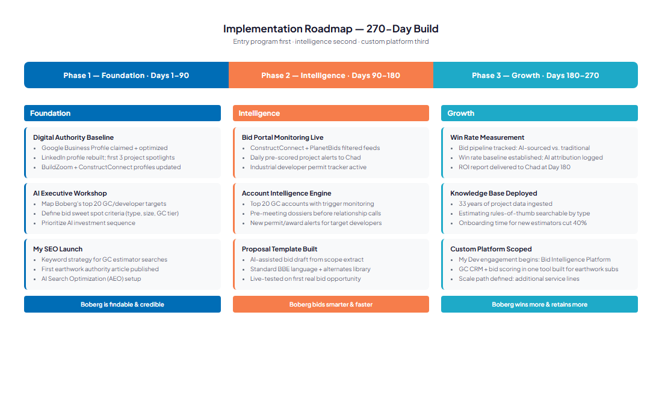
Foundation (Days 1–90) → Intelligence (Days 90–180) → Growth (Days 180–270)

Next Step
The full 29-page AI Growth & Bid Intelligence Blueprint is available on request. It includes the detailed competitive landscape, four buyer persona cards, the AI Tools Matrix, the complete Service Investment Map, and the 20-source appendix. Send a reply and it is in your inbox within the hour.
The entry program is designed as an easy first yes: $2,550/month for quick-win recurring services, no large build, and a clear ROI measurement by month six. The bigger build comes later, once the entry proves the lift.

Book a Meeting
Use the Book a Meeting button in Ravi's signature to schedule 30 minutes. We will walk through the strategy, the entry program, and all the AI work Technijian is deploying for itself and its clients across Southern California.
Questions before the meeting: rjain@technijian.com · 949.379.8499

Technijian
technology as a solution
18 Technology Dr., Ste 141, Irvine, CA 92618
949.379.8499 | technijian.com | rjain@technijian.com

