

TCI TRANSPORTATION
AI Growth & Integration Blueprint
Executive Summary

1978  Family-owned, 2 generations | 3,800+  Trucks, tractors & trailers | 26+  Facilities across 10 states | 1,500+  Team members

TCI already runs operational AI — preventative maintenance, collision mitigation, telematics. This blueprint points AI at the one place it has not yet aimed: the commercial side, where the next dollar of growth is found, won, and kept. Two pillars: own the recurring leasing core through search and account intelligence, and own the California EV / WAIRE niche the national giants treat generically. This summary covers the opportunity, the engine, the program, and the entry. The full blueprint is ready on request.

Prepared for TCI Transportation | Technijian | 2026-06-01

01 The Opportunity
01 The Opportunity

TCI wins work through 47 years of relationships, a full-service offer under one roof, and a service culture the national giants can’t match in any single market. None of that changes. What this blueprint adds is a commercial-AI layer underneath it, on two pillars at once:

 | Pillar 1 — The Recurring Core | Pillar 2 — The EV / WAIRE Wedge
The win | More full-service leases, maintenance contracts, and used-truck sales captured | Own the California zero-emission transition the giants treat generically
How | Local + answer-engine search across 26+ yards; account intelligence on fleets | Target WAIRE-obligated warehouses; EV trucks + charging + a compliance-ROI tool
AI role | Get found, surface named accounts, automate the quote and the RFP | Find obligated warehouses by truck-trip data; make the compliance math a sale

Why Now — The 2026 Window
California is legislating the EV pillar into a deadline: SCAQMD’s WAIRE rule ramps warehouse obligations through 2031, and CARB’s Advanced Clean Fleets and Advanced Clean Trucks mandates push zero-emission adoption — a buyer who needs exactly what TCI offers, in TCI’s own air basin.
The freight market rewards diversification: with carriers failing and the recovery slow, TCI’s recurring mix — leasing, maintenance, factoring, used trucks — is a resilience story it does not yet tell where buyers look.
The national giants are digitally strong but generic. The nimble, local, family-owned operator that out-modernizes regionally captures the demand and the EV niche before they localize.

02 The Engine
02 The Engine

Three motions, all aimed at the fleets, shippers, and warehouses TCI already knows — never a broad funnel. AI gets TCI found, arms the sales team, and speeds the quoting and bidding; the relationship, the yards, and the lease still close the deal.

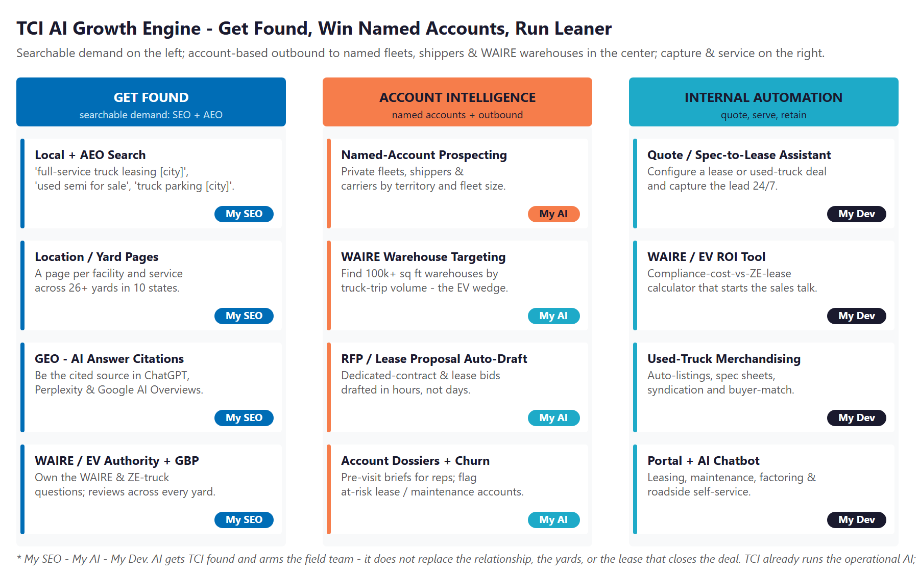
Get Found · Account Intelligence & Outbound · Internal Automation — extending the operational AI TCI already runs

Get found
Local and answer-engine search across 26+ yards: a page per facility and service, and authority content that owns the WAIRE, EV-truck, leasing, and used-truck questions buyers ask in Google and AI answers.

Win named accounts
The same public-records account-intelligence motion already in production for a Technijian client — 24 contact-ready leads in a single 75-minute run — pointed at WAIRE-obligated warehouses and named fleets, with RFP and lease-proposal automation behind it.

Run leaner
A quote / spec-to-lease assistant, a WAIRE/EV ROI tool that turns the regulation into a sales conversation, used-truck merchandising, and an AI-assisted portal across leasing, maintenance, factoring, and roadside.

03 The Program
03 The Program

The program is built land-and-expand: a small, published entry that proves the lift, then an expansion scoped at discovery once it does. We are deliberate about money — only the published price is stated as firm; the build is priced from the rate card and scoped into a fixed-price Statement of Work, never an invented number.

Entry Program (published) | Scope | Y1
My SEO — Tier 5 + AEO / PR / Syndication | Multi-location local + answer-engine search foundation; 12-mo, unlimited hours | ~$24,600
ENTRY PROGRAM (Y1) | Prove the search + capture lift, no large build to start | $2,050/mo

Expansion (scoped in discovery) | Basis — 2026 rate card | Investment
Custom AI & app build (quote-to-lease, WAIRE/EV ROI tool, portal, used-truck) | AI eng $185–$275/hr; full-stack $145–$210/hr | Fixed-scope SOW
Account intelligence & outbound + Fractional AI Advisor | My AI engagement; advisor $1,500–$3,500/mo | Set at discovery

The Return — Value at Stake
Rather than print an ROI multiple we cannot yet stand behind, we name the levers the program moves: new full-service lease and dedicated-contract wins, WAIRE-driven EV deals (a zero-emission Class 6/7 truck earns WAIRE points worth roughly $68,000 in avoided fees), used-truck unit-sales lift, and retained leasing volume.
Within five business days of a 30-minute discovery call, Technijian returns a calibrated ROI model and a fixed-scope Statement of Work built on TCI’s real per-deal economics. Prove the foundation first, then size the engine.

04 The Roadmap & Next Step
04 The Roadmap & Next Step

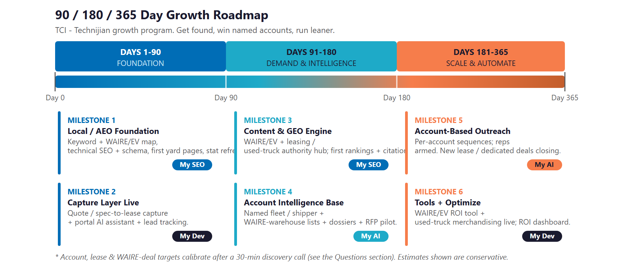
Foundation (0–90 days) → Demand & Intelligence (90–180) → Scale & Automate (180–365)

A local, family-built partner for the commercial side of TCI.
Start with five Quick Wins and one live before/after — no contract, no obligation.
Use the Book a Meeting button in my signature to set up a time to discuss this and the
AI strategies Technijian is putting into place for itself and its clients.
Ravi Jain, Technijian | rjain@technijian.com | 949.379.8499

The full AI Growth & Integration Blueprint — the buyer universe, competitive landscape, capability proof with real engagements, the complete service map, the truthful investment detail, and the discovery questions — is ready if you want to read further before we meet.

