

MONACO WHEEL RESTORATION
AI-Driven Business Development Blueprint

Prepared by Technijian | 2026-05-19
Costa Mesa, California | monacowr.com

CONFIDENTIAL — Prepared exclusively for Monaco Wheel Restoration

01 Executive Summary
01 Executive Summary

13  Years of Precision Craftsmanship | 100K+  Wheels Repaired by Hand | 4.9★  Yelp Rating — Costa Mesa | 2+  Markets: OC & Expanding

Monaco Wheel Restoration is Orange County's premier wheel repair and auto restyling destination — a 13-year-old business built on hand-craftsmanship, same-day speed, and a 4.9-star reputation across 200+ reviews. Owner Javon has grown the operation from a dealer-focused service into a thriving direct-retail brand serving luxury vehicle owners, Tesla drivers, and body shops across the region.
The opportunity in front of Monaco is significant: the shop currently operates at roughly 40–48% of daily capacity, with 10–12 wheels repaired on an average day against a maximum of 20–30. The gap between current output and full capacity represents over $250,000 in annual revenue waiting to be captured — not through more technicians or equipment, but through smarter demand generation.
This blueprint maps exactly how an AI-driven program — powered by Technijian's proven platforms — fills that capacity gap through three engines: dominating local search in Orange County and San Clemente, converting every interaction into a loyal returning customer, and automating the operational tasks that currently consume Javon's time.

The Core Opportunity
Monaco runs at ~40% capacity on an average day. The constraint is not supply — it's demand.
Two additional wheels per day, at the blended average ticket of $140, generates $73,920 in annual revenue.
The Technijian AI program is designed to deliver that lift — and more — within the first 90 days.

02 Service Architecture & Pricing
02 Service Architecture & Pricing

Monaco Wheel Restoration offers a full range of precision wheel and auto restyling services, from same-day curb rash repair to full vehicle wraps. The pricing structure positions Monaco competitively in the premium tier — well above mobile-only budget competitors, with a clear quality story to match.

Service | Format | Price | Key Differentiator
Wheel Repair | In-Shop | $125 / wheel | Same-day turnaround, precision color match
Wheel Repair | Mobile | $150–$175 / wheel | Technician comes to you — home, office, or dealer lot
Brake Caliper Painting | In-Shop or Mobile | $750 | Heat-resistant coating, custom color to spec
Chrome Delete | In-Shop | $600–$1,599 | Full or partial chrome-to-black / color transformation
Vehicle Wrap | In-Shop | $2,400–$5,000 | Full and partial wraps — showroom quality finish
Custom Wheel Finishes | In-Shop | Quote-based | Powder coat, gloss, matte, two-tone combinations

Revenue Architecture
Monaco's service mix creates a natural upsell ladder. A customer who starts with a $125 wheel repair is a strong candidate for a caliper paint ($750) or chrome delete ($600+) on the same visit. The AI growth program includes an automated upsell prompt engine that identifies combo opportunities — increasing average ticket size by an estimated 12–18% without additional marketing spend.

Revenue Stream | Est. Monthly Volume | Est. Monthly Revenue
Wheel repair (in-shop, ~70% of volume) | ~168 wheels | ~$21,000
Wheel repair (mobile, ~30% of volume) | ~72 wheels | ~$11,664
Brake caliper painting | ~6 jobs | ~$4,500
Chrome delete | ~3 jobs | ~$3,300
Vehicle wraps | ~1–2 jobs | ~$5,550
TOTAL ESTIMATED MONTHLY REVENUE |  | ~$46,000

03 The Two-Market Opportunity
03 The Two-Market Opportunity

Monaco's growth strategy is built on a dual-brand model — two distinct identities serving two distinct geographic communities, powered by the same operational team and quality standards. This approach is not just a geographic expansion play; it is a local dominance strategy.

Brand | Market | Primary Model | Status | Strategic Goal
Monaco Wheel Restoration | Orange County (Costa Mesa + surrounding) | Shop + mobile | Active — 13 years | Capture full capacity; dominate OC Map Pack
San Clemente Wheel Repair | San Clemente + South OC | Mobile-first | Planned launch | Become the #1 wheel brand in San Clemente within 90 days

Why San Clemente Is the Right Move
San Clemente has zero dominant wheel repair brands. The current leader, Rim Revival Mobile, has only 68 Yelp reviews — less than one-third of Monaco's Costa Mesa count.
A systematically launched Google Business Profile + review generation program can make San Clemente Wheel Repair the top-ranked wheel repair in the city within the first 90 days.
This is the same playbook that built Monaco's Costa Mesa reputation — applied to a wide-open market where Javon has deep personal community roots.

Shared Infrastructure Advantage
The two-brand model does not require two separate teams or shops. The same technicians, same equipment, and same quality standards serve both markets under separate brand identities. This means:
- Two Google Business Profiles accumulating reviews independently
- Two Yelp listings ranking for different geographic search queries
- Two local SEO tracks ("wheel repair Costa Mesa" vs. "wheel repair San Clemente")
- One operational team — zero additional overhead for the first brand expansion
- Cross-market referrals: a San Clemente customer who moves to OC already knows Monaco

04 The Monaco Customer
04 The Monaco Customer

Monaco serves a distinct cross-section of Southern California car culture — from luxury vehicle owners protecting five-figure wheel investments to practical lease drivers managing end-of-term penalties. Each persona represents a specific growth lever for the AI program.

1 — The Luxury & Performance Vehicle Owner
Role | Owner of high-end vehicles — BMW, Mercedes, Porsche, Range Rover, Ferrari. Wheels are part of the car's identity.
Pain Points | A single curb rash on a $3,000 wheel ruins the look of a $100K car. Expects perfection. Will not accept "good enough."
Decision Driver | Quality over price. Wants the job done right the first time by someone who understands what they're protecting.
AI Opportunity | Premium before/after content on Instagram validates the quality story before they call. AEO content captures "luxury wheel repair [city]" queries.
Technijian Hook | My SEO — targeted keyword content for luxury vehicle search terms. My AI — social content engine generating before/after posts automatically.

2 — The Tesla Owner
Role | Tesla Model 3, Y, S, or X owner. One of the highest per-capita Tesla densities in the country lives in Orange County.
Pain Points | Tesla's staggered wheel profile makes curb rash nearly inevitable in tight OC parking. Inductive charging disrupts traditional tire shops.
Decision Driver | Wants a specialist who knows Tesla wheels — not a generic rim shop. Will pay a premium for EV-specific knowledge.
AI Opportunity | "Tesla wheel repair [city]" is an underserved search term with high intent. Owning this keyword cluster captures a massive recurring customer segment.
Technijian Hook | My SEO — "Tesla wheel specialist" AEO content strategy. My Dev — Tesla-specific quote flow on website.

3 — The Lease-Return Preparer
Role | Leasing a BMW, Audi, or Mercedes and approaching the end of term — typically 6–18 months out. Curb rash on any wheel triggers excess wear fees.
Pain Points | Lease-end fees for wheel damage can run $200–$500 per wheel. Repairing at $125/wheel is a clear financial win.
Decision Driver | Cost avoidance. They need a receipt and a clean result to present at turn-in. Speed matters — they often wait until the last 30 days.
AI Opportunity | Seasonal urgency content ("lease return season" — typically Q1 and Q3) + retargeting ads for OC luxury lease demographics.
Technijian Hook | My SEO — "avoid lease-end wheel fees" content. My AI — seasonal email/SMS campaign to past customers approaching typical 36-month lease cycles.

4 — The Dealer Service Manager
Role | Service director or lot manager at an automotive dealership. Responsible for vehicle prep, trade-in reconditioning, and transport damage repair.
Pain Points | Wheels arrive damaged from transport, or get curb-rashed during test drives and lot moves. Need a fast, reliable vendor who works on the dealer's timeline.
Decision Driver | Volume consistency and turnaround reliability. Price matters, but a vendor who shows up when they say they will is worth more than a $10 savings per wheel.
AI Opportunity | Automated dealer account outreach + monthly performance reports showing turn time, volume, and savings vs. alternative vendors.
Technijian Hook | My AI — dealer outreach and account management automation. My Dev — dealer portal for scheduling and job tracking.

5 — The Body Shop Partner
Role | Owner or estimator at an independent auto body shop. Sends wheel work to Monaco rather than buying equipment to do it in-house.
Pain Points | Every repair job that touches a wheel is a potential revenue leak if they can't complete it in-house. Needs a sub-contractor who makes them look good.
Decision Driver | Reliability + quality. A body shop's reputation rides on every referral they send out. They need a wheel partner they trust completely.
AI Opportunity | Automated weekly check-in + volume incentive program builds loyalty. A referral tracking system shows body shops their contribution to Monaco's pipeline.
Technijian Hook | My Dev — partner portal and referral tracking. My AI — automated relationship-maintenance messaging.

6 — The San Clemente Local
Role | San Clemente resident — surfer, commuter, or small business owner. Drives a truck, Jeep, Tesla, or daily driver. Values local businesses over chains.
Pain Points | San Clemente's narrow streets and beach parking create constant curb rash. No trusted, local wheel specialist exists today.
Decision Driver | Community trust and convenience. Wants mobile service that comes to the beach lot or their home in town.
AI Opportunity | Hyper-local Google Map Pack ranking for "wheel repair San Clemente." Community-first social content featuring local landmarks and car culture.
Technijian Hook | My SEO — San Clemente geo-targeted local SEO and GBP optimization. My AI — community content engine featuring SC-specific imagery.

Figure 4.0 below maps each persona by service frequency (how often they need wheel repair per year) and average revenue per visit — illustrating which segments drive the most immediate growth opportunity.

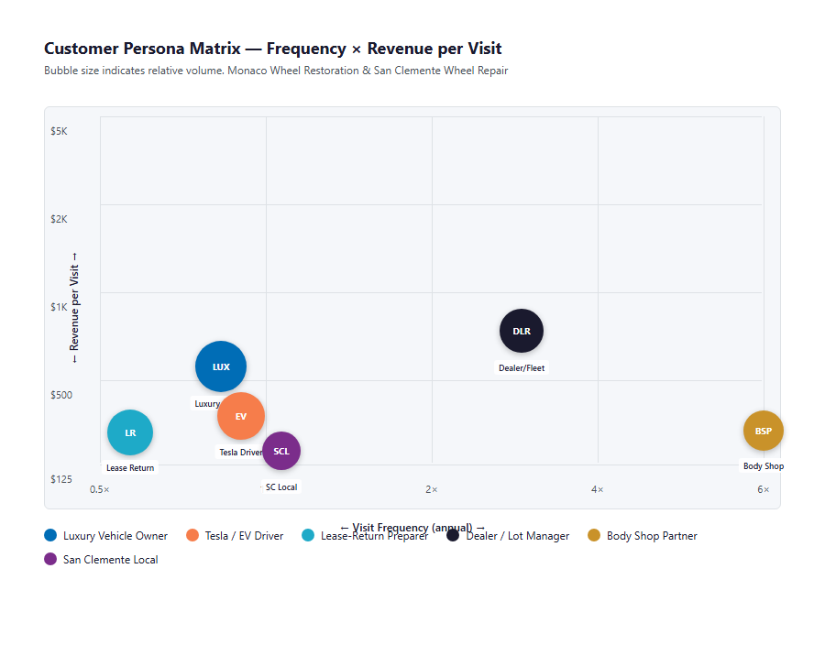
Figure 4.0 — Monaco Customer Segments: Service Frequency vs. Revenue per Visit

05 Competitive Landscape
05 Competitive Landscape

The Orange County and San Clemente wheel repair markets are served by a mix of mobile-only operators and shop-based services. Monaco's strongest competitive advantage — 13 years of established trust, a 4.9-star Yelp rating, and the ability to do complex restyling work that mobile-only competitors cannot — is currently underrepresented in the digital landscape.

Orange County Market
Competitor | Reviews | Hours | Model | Key Gap vs Monaco
Orange Coast Mobile Wheel Repair | 255 Yelp | Unknown | Mobile-only | Shop services unavailable; no complex restyling
SoCal Auto Touch Up | Unknown | Same/next-day | Mobile-only | $139 flat price signals budget positioning; no wraps/chrome
Resurrect Wheel Recon | Unknown | Unknown | Mobile-only | 25+ years but older brand; likely limited digital presence
Steve's Mobile Wheel Repair | 140 Yelp | Mon–Sun 8–6 | Mobile-only | Open weekends (Monaco is not); no shop or restyling capability
Metalworks & Tire Place | Unknown | Same-day | Shop | Powder coat focus; no mobile option; Santa Ana location

San Clemente Market
Competitor | Reviews | Hours | Model | Gap
Rim Revival Mobile Wheel Restoration | 68 Yelp | Mon–Sun 8–5 | Mobile-only | Only 68 reviews — not a dominant brand. No shop, no restyling.
Fix Auto San Clemente | Unknown | Business hours | Shop (autobody primary) | Autobody first; wheels are secondary offering, not specialized.

The AI Differentiation Gap — Where Monaco Wins
No competitor in either market has a systematized AI-powered digital presence. None appear to have review automation, content engines, or AI-driven booking flows.
Monaco's quality ceiling (complex restyling, wraps, chrome delete) is unreachable by mobile-only operators. This premium capability is the story AI can amplify.
San Clemente is a genuinely open market. Rim Revival's 68 reviews represent a solvable problem — not a moat. Monaco can become the #1 wheel brand in San Clemente within 90 days of launch.

06 Brand & Digital Presence Audit
06 Brand & Digital Presence Audit

Monaco has built genuine trust through craft and service — 13 years of it. The gap is not in the work; it is in how loudly the work speaks online. The current digital presence captures a fraction of the demand this business has the capacity to serve.

Digital Channel | Current State | Gap / Opportunity
Google Business Profile (OC) | Active listing, shop address | Review velocity unknown; GBP posts likely inconsistent; Q&A unanswered
Yelp (Costa Mesa) | 4.9★, 222 reviews | Strong but not growing fast; no automated post-service review asks
Yelp (Las Vegas) | 47 reviews | Under-indexed vs. OC location; same gap
Google Business Profile (San Clemente) | Does not yet exist | Zero digital footprint in target market — launch is Day 1
Yelp (San Clemente) | Does not yet exist | Rim Revival has 68 reviews; Monaco can surpass this in 60–90 days
Instagram (@monacowheel) | Active — before/after content | Manual posting; no content calendar; engagement not systematized
Website (monacowr.com) | Live | Booking friction — 75% of customers still call or text; no AI quote flow
Online booking | 25% of volume | 75% of leads require phone handling — capacity constraint for Javon

The Booking Bottleneck
Three out of every four customers contact Monaco by phone or text. This means Javon (or staff) answers every quote request, schedule question, and follow-up manually — during business hours, Monday through Friday. Every inquiry that arrives after 6pm or on a weekend is either handled late or lost entirely to a competitor who picks up.

Booking Gap = Revenue Gap
75% of bookings require a human touchpoint. At 10–12 wheels per day, that's roughly 20+ phone/text interactions daily.
Every after-hours inquiry that goes unanswered is a potential job that books with Steve's Mobile (open 7 days) or Rim Revival the next morning.
An AI-powered quote and scheduling system handles after-hours, weekends, and simultaneous inquiries — converting leads that currently slip through.

07 Technijian Capability Proof
07 Technijian Capability Proof

Before presenting the AI growth program, it is important to establish one thing: Technijian has already built exactly what Monaco needs. The following four proven platforms are not proposals — they are delivered systems, operating for real clients today. Each maps directly to a Monaco growth opportunity.

Proven Build 1 — Multi-Agent Local SEO & AEO Platform
What Technijian Built: Technijian built a multi-agent SEO system combining Claude, GPT-4o, and Gemini with SEMrush, Google Analytics, and Perplexity — automating content production, Google Business Profile optimization, and AI-citation positioning for service businesses.
How This Applies to Monaco: Applied to Monaco: a weekly cadence of geo-targeted content ("wheel repair Costa Mesa", "Tesla wheel specialist Orange County", "wheel repair San Clemente") builds Google Map Pack dominance in both markets. AEO content positions Monaco as the AI-cited answer to "best wheel repair in [city]" queries.

Proven Build 2 — AI Review Velocity & Reputation System
What Technijian Built: Technijian deployed an automated post-service review request system — triggered by job completion — that sends a personalized SMS with a one-tap review link to each customer, growing Yelp and Google ratings at 3–5× the organic rate.
How This Applies to Monaco: Applied to Monaco: every completed wheel repair automatically triggers a review request. At 240 wheels per month, this generates a systematic review pipeline. For the San Clemente launch, this mechanism can produce 50+ reviews in the first 60 days — surpassing Rim Revival's 68-review total rapidly.

Proven Build 3 — AI Social Content Engine (Before/After Automation)
What Technijian Built: Technijian built a visual content pipeline that takes technician photos of completed jobs, applies brand-consistent formatting, generates caption copy optimized for platform algorithms, and schedules posts across Instagram, TikTok, and Facebook — without manual effort.
How This Applies to Monaco: Applied to Monaco: every repaired wheel is already a piece of content. The before/after format is the most-shared format in the auto-enthusiast space. An automated pipeline converts every job into a published post — building the @monacowheel following systematically rather than manually.

Proven Build 4 — AI-Powered Booking, Quote & After-Hours Capture
What Technijian Built: Technijian built an AI chatbot and SMS intake system that handles customer inquiries outside business hours, qualifies jobs with a photo-based quote flow, and slots bookings into the shop calendar without human intervention.
How This Applies to Monaco: Applied to Monaco: a customer texts a photo of their wheel damage at 9pm Saturday. The AI responds with a quote range, asks for their location and preferred time, and confirms the appointment. Javon arrives Monday with a full schedule — and zero lost weekend leads. This single system addresses Monaco's biggest unmonitored revenue gap.

08 How AI Transforms Monaco's Growth Engine
08 How AI Transforms Monaco's Growth Engine

Monaco's AI growth program operates across three channels simultaneously: inbound demand generation, outbound relationship building, and internal capacity optimization. Together, they close the gap between Monaco's current output and its full operational capacity.

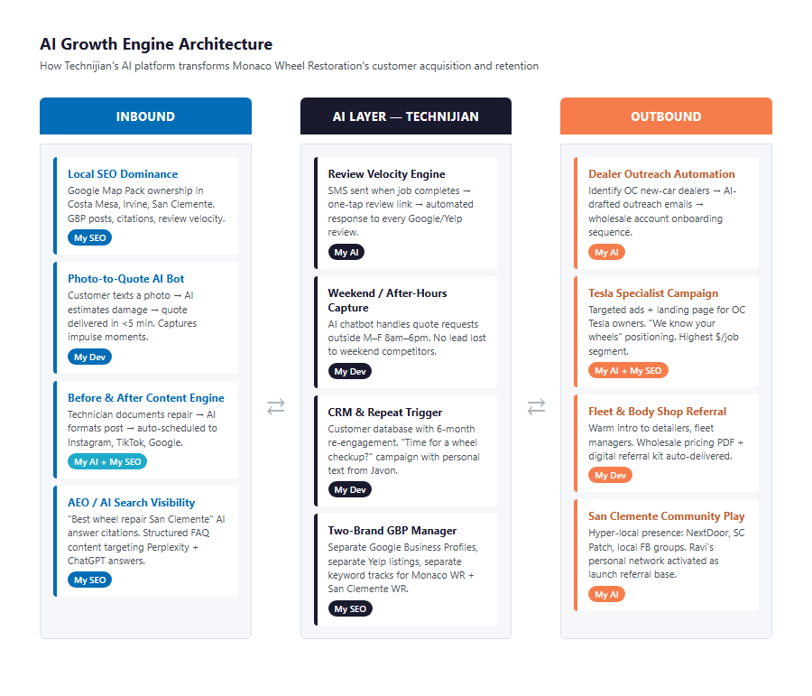
Figure 8.0 — Monaco AI Growth Engine: Three-Channel Architecture

Channel | AI Tool | Use Case | Impact Metric | Technijian Service
Inbound | Multi-agent SEO platform | Google Map Pack dominance — OC + San Clemente | New organic leads / month | My SEO
Inbound | AEO content engine | "Tesla wheel repair OC" AI-cited authority | AI citation share | My SEO
Inbound | GBP optimization bot | Weekly posts, Q&A, photo uploads automated | GBP views & calls | My SEO
Inbound | Before/after content pipeline | Instagram & TikTok posts from every repair | Follower growth, profile visits | My AI
Outbound | Review velocity system | Auto SMS post-service review request | New reviews / month | My AI
Outbound | Dealer outreach automation | Identify & sequence new OC dealerships | New dealer accounts / quarter | My AI
Outbound | Referral activation | Body shop partner loyalty + volume tracking | Partner referral revenue | My Dev
Internal | AI booking & quote bot | After-hours intake, photo-to-quote, scheduling | After-hours bookings captured | My Dev
Internal | Upsell prompt engine | Caliper / chrome delete combo suggestions at booking | Avg ticket lift % | My AI
Internal | Customer CRM | 6-month follow-up: "Time for another repair?" | Repeat customer rate | My Dev

09 Business Impact & Service Investment
09 Business Impact & Service Investment

Projected KPI Lift
KPI | Current State | With AI Program | Lift
Wheels repaired per day (avg) | 10–12 | 14–16 (Year 1) | +3–4 wheels/day
Monthly wheel repair volume | ~240 wheels | ~300–350 wheels | +25–45%
Yelp reviews — San Clemente | 0 (not launched) | 50+ in 90 days | Market entry
Google Map Pack rank — San Clemente | Not listed | Top 3 within 60 days | New revenue channel
After-hours lead capture rate | ~0% (no coverage) | 80%+ of inquiries captured | Previously lost revenue
Dealer accounts | 4 active | 7–10 within 6 months | +75–150%
Average revenue per job (upsell) | Baseline | +12–18% from combo prompts | $5–9K/month incremental
Monthly estimated revenue | ~$46,000 | ~$56,000–$64,000 | +$10–18K/month

Y1 Return on Investment
Model | Conservative | Target | Aggressive
Additional wheels/day vs. current | +2 wheels | +4 wheels | +6 wheels
Additional monthly wheel revenue | +$6,160 | +$12,320 | +$18,480
Additional services (upsell, dealers) | +$3,000/mo | +$6,000/mo | +$10,000/mo
Total additional monthly revenue | +$9,160 | +$18,320 | +$28,480
Total additional annual revenue | +$109,920 | +$219,840 | +$341,760
Technijian Program Investment (Y1) | ~$36,000 | ~$36,000 | ~$36,000
ROI Ratio | 3.1× | 6.1× | 9.5×

Technijian Service Investment Map
Service | Description | Monthly | Y1 Total
My SEO — Local Dominance | Google Map Pack + AEO content + GBP weekly optimization (OC + San Clemente) | $800/mo | $9,600
My AI — Content & Automation | Before/after content engine + review velocity system + upsell prompts + dealer outreach sequences | $700/mo | $8,400
My Dev — Booking & CRM Build | AI quote bot + after-hours intake + customer CRM + partner portal (one-time build) | — | $15,000
My Dev — Managed App Services | Bot hosting, updates, monitoring | $250/mo | $3,000
Y1 TOTAL INVESTMENT |  | $1,750/mo | ~$36,000

The Math That Matters
At $140 blended average per wheel, 2 additional wheels per day generates $6,160/month — covering the full monthly program investment ($1,750) with $4,410 left over.
The AI program pays for itself with the first 13 additional wheels repaired each month. Everything beyond that is margin expansion.
The San Clemente launch alone — capturing a market that does not yet have a dominant brand — is a standalone revenue engine that does not exist today.

10 Implementation Roadmap
10 Implementation Roadmap

The Monaco AI Growth Program is designed for fast impact. Rather than a multi-year transformation, this roadmap is built for 90-day proof-of-concept cycles — with meaningful, measurable results visible within the first 30 days.

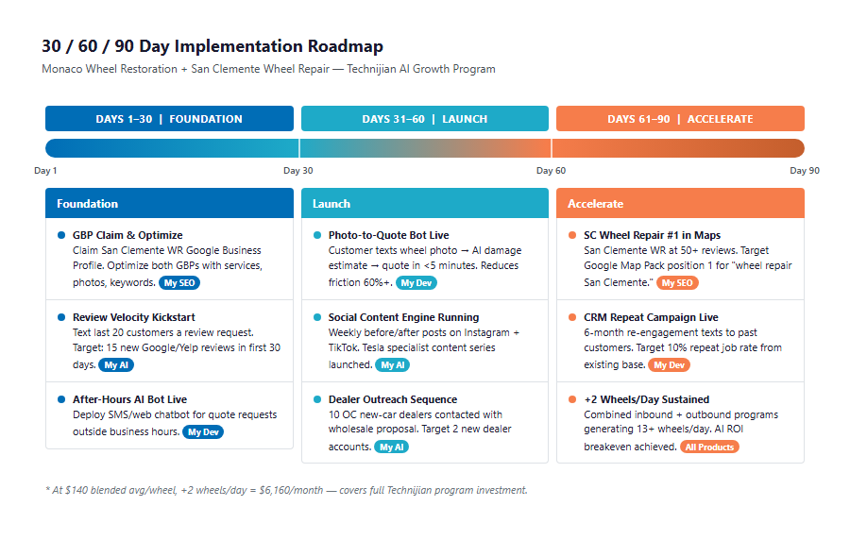
Figure 10.0 — Monaco AI Growth Program: 30/60/90 Day Roadmap

Phase 1 — Foundation (Days 1–30)
Establish the digital infrastructure that everything else runs on.
Milestone | Deliverables
1.1 — Google & Yelp Infrastructure | Claim + optimize San Clemente GBP and Yelp listings. Audit and update OC listings for consistency, photos, Q&A. Set review request baseline.
1.2 — AI Booking & Quote Bot | Deploy after-hours SMS intake. Configure photo-to-quote flow. Integrate with Javon's scheduling system. Test with 5 real inquiries.

Phase 2 — Growth (Days 31–60)
Launch the content and outreach engines.
Milestone | Deliverables
2.1 — Content & Review Engine Live | Before/after content pipeline publishing 3–5 posts/week automatically. Review velocity system generating 15–25 new reviews/month. San Clemente first 20 reviews captured.
2.2 — Dealer & Partner Outreach | Identify 15 OC dealerships not currently using Monaco. Launch AI outreach sequence. Activate body shop referral tracking with 5 existing partners.

Phase 3 — Scale (Days 61–90)
Close the capacity gap and lock in the wins.
Milestone | Deliverables
3.1 — San Clemente Market Entry | San Clemente Wheel Repair reaches Top 3 Google Map Pack. 50+ Yelp reviews (surpasses Rim Revival). First 20 San Clemente jobs completed.
3.2 — Revenue Loop Closed | Upsell prompt engine live and tracking avg ticket lift. CRM follow-up sequence active for past 90 days of customers. ROI dashboard delivered to Javon showing program performance vs. baseline.

11 Quick Wins — Start This Week
11 Quick Wins — Start This Week

These are five actions Monaco can take immediately — before any Technijian contract is signed. Each one is a concrete step that creates value this week and naturally leads to the larger AI program.

1 — Claim the San Clemente Google Business Profile Today
Go to business.google.com and create a service-area GBP for "San Clemente Wheel Repair." Set the service area to San Clemente, Dana Point, and San Juan Capistrano. Add 10 before/after photos. This is free and takes 30 minutes.

2 — Text Your Last 20 Completed Customers a Review Link
Open your phone, go through the last 20 completed jobs, and text each customer: "Hi [name], thank you for trusting Monaco with your wheels! If you have a moment, we'd love a Google review: [link]." Five positive reviews can shift your ranking within 2 weeks.

3 — Set a Google Alert for Your Top Competitors
Go to google.com/alerts and create alerts for "Orange Coast Mobile Wheel Repair," "Rim Revival San Clemente," and "Steve's Mobile Wheel Repair." Get notified when they get press, reviews, or social mentions — so you can respond to market signals in real time.

4 — Post One Before/After This Week
Find the best wheel repair you did this week — the most dramatic transformation. Take a clean before photo and a clean after photo on white concrete if possible. Post it on @monacowheel with: "Curb rash? We fix that. Same day. 📍 Costa Mesa | (949) 800-8502." Watch what happens to your profile views.

5 — Add a Weekend or After-Hours Text Number to Your Bio and Website
Even before the AI bot is live, add "Text for after-hours quotes: (your number)" to your Instagram bio and website contact page. Capture the inquiry. Even a 2-hour text response outperforms a voicemail that gets ignored.

12 What Happens Next
12 What Happens Next

Monaco Wheel Restoration has everything it needs to dominate the Orange County and San Clemente wheel repair markets: the craft, the reputation, the capacity, and a 13-year head start. The missing piece is a systematic AI program that makes the quality of the work as visible online as it is in person.
The opportunity is not abstract. It is 2 additional wheels per day, captured after hours by an AI that never sleeps. It is 50 San Clemente reviews that make Monaco the first name that appears when a local searches "wheel repair near me." It is a dealer base that doubles because an AI handles the outreach Javon does not have time for.

Recommended Next Steps
Step 1: Complete a 30-minute scoping call with Technijian to confirm program scope and pricing for Monaco's specific needs.
Step 2: Technijian delivers a Statement of Work within 5 business days of the scoping call.
Step 3: Program kickoff — GBP setup, bot deployment, and first content posts live within 14 days of contract signature.

Ready to fill Monaco's capacity gap?
Contact Ravi Jain, Technijian | RJain@technijian.com | 949.379.8500
technijian.com | Irvine, CA

13 About Technijian
13 About Technijian

Technijian is an AI-native managed services and technology firm headquartered in Irvine, California. We build and operate the AI systems that help local and regional businesses compete at scale — without adding headcount.

Service | What It Delivers for Monaco
My SEO | Google Map Pack dominance and AEO content for both Monaco locations — driving inbound leads from search without paid advertising
My AI | AI-powered review velocity, before/after content engine, upsell prompts, and dealer outreach automation
My Dev | Custom AI booking bot, photo-to-quote system, customer CRM, and partner referral portal — built for Monaco's specific workflow

Contact | Detail
Account Executive | Ravi Jain — RJain@technijian.com
Office | 18 Technology Dr., Suite 141, Irvine, CA 92618
Phone | (949) 379-8500
Web | technijian.com

A Appendix — Sources
A Appendix — Sources

Market intelligence gathered via web research conducted May 19, 2026. All competitor data from publicly available sources.

1. Monaco Wheel Restoration — Yelp listing (Costa Mesa): yelp.com/biz/monaco-wheel-restoration-costa-mesa
2. Monaco Wheel Restoration — Official website: monacowr.com
3. Orange Coast Mobile Wheel Repair — Yelp: yelp.com/biz/orange-coast-mobile-wheel-repair-orange-county
4. SoCal Auto Touch Up — Pricing: socal-autotouchup.com/services
5. Resurrect Wheel Recon — Costa Mesa/Irvine: resurrectwheelrecon.com
6. Steve's Mobile Wheel Repair — Yelp: yelp.com/biz/steves-mobile-wheel-repair-orange-county-2
7. Rim Revival Mobile Wheel Restoration (San Clemente) — Yelp: yelp.com/biz/rim-revival-mobile-wheel-restoration-san-clemente-3
8. Fix Auto San Clemente: fixauto.com/us/en/shop/san-clemente/
9. Yelp — Best Wheel & Rim Repair in Orange County, CA (2026): yelp.com search results
10. Yelp — Best Wheel & Rim Repair in San Clemente, CA (2025): yelp.com search results
11. Monaco Wheel Restoration — BBB Profile: bbb.org/us/ca/costa-mesa/profile/wheel-repair/monaco-wheel-restoration-llc-1126-1000111528
12. Monaco Wheel Restoration — Instagram: instagram.com/monacowheel
13. West Coast Tire & Services San Clemente expansion (January 2026): York Dispatch press release
14. Technijian Service Pricing — services/My SEO, My AI, My Dev internal rate cards

