

ORTHOKINETIX
powered by OrthoXpress
SEO, GEO & Lead Generation Blueprint

Prepared by Technijian | 2026-05-21
Riverside, California | orthokinetix.net

CONFIDENTIAL — Prepared exclusively for OrthoKinetix

01 Executive Summary
01 Executive Summary

2006  Serving Providers Since | 40+  Payors Contracted (Proof You Can Bill) | 2  Search Audiences: Patients + Providers | GEO  The AI-Answer Channel, Wide Open

OrthoKinetix has the things that take years to build — two decades serving providers since 2006, BOC Gold Seal accreditation, and contracts across more than forty payors and workers’-comp networks. What it does not have is visibility in search. The homepage still sits at a /site/ subfolder, and almost nothing on it ranks for the terms patients and providers actually type. Meanwhile, that demand flows every day to whoever shows up first.
Two distinct audiences are searching right now. Patients look for covered equipment — "knee brace covered by Medicare near me," "CPM machine rental Riverside," "lymphedema pump through insurance." Providers look for a partner — "stock and bill program California," "DME company for an orthopedic practice." And a third surface has opened: people increasingly ask ChatGPT, Perplexity, Google AI Overviews, and Gemini these exact questions, and those tools answer by citing whoever optimized for it. OrthoKinetix is in none of those answers today.
This blueprint is a focused SEO + GEO + Lead Generation program with three moves: get OrthoKinetix found (SEO for Google, GEO for AI answers), capture the demand (an on-site Chat.AI assistant and conversion funnels — you already know Chat.AI, so it is the capture layer here, not a product to sell you), and win the high-value accounts by name (account-based outreach powered by My AI Lead Gen). It is deliberately hybrid: broad search demand on one side, named hospital and surgery-center accounts on the other.

The Core Opportunity
Patients and providers are already searching for exactly what OrthoKinetix sells — the demand exists; OrthoKinetix simply is not capturing it.
GEO — being the source ChatGPT, Perplexity, and Google AI Overviews cite — is a brand-new channel almost no DME competitor has claimed. First mover wins compounding visibility.
The program is hybrid by design: SEO/GEO plus on-site capture for the broad searchable demand, and targeted account-based outreach for the hospital and surgery-center accounts worth winning by name.
Note on figures: OrthoKinetix’s internal metrics (web traffic and lead volume, new accounts per month, average order and account value) were not available for this draft. Every projection below is labeled estimated and calibrates to real numbers after a short discovery call — the specific questions are listed in Section 13.

02 Where the Demand Lives
02 Where the Demand Lives

Before any tactics, one question decides the whole strategy: where does OrthoKinetix’s next dollar of growth actually come from? The answer is a few distinct pools of demand — most of them searchable and largely uncaptured, plus a finite set of high-value accounts worth winning by name. The program is built to serve all of them, which is why it pairs broad search capture with targeted outreach.

Demand Pool | Who’s Looking | Example Searches | How OrthoKinetix Captures It
Patient / consumer | Patients with a prescription or a recovery need | "knee brace covered by Medicare near me", "CPM rental Riverside", "lymphedema pump through insurance" | Local + organic SEO, GEO answers, on-site capture
Provider / practice | Administrators, surgeons, office managers choosing a DME partner | "stock and bill program California", "DME company for an orthopedic practice" | Provider SEO + authority content + a consult funnel
AI-assistant (GEO) | Both audiences asking ChatGPT, Perplexity, Google AI Overviews, Gemini | "What DME suppliers do stock and bill in California?", "How do I get a CPM machine covered?" | GEO: structured answers + FAQPage schema + citations
Named high-value accounts | Hospitals, surgery centers, large ortho groups | (these do not search — they are won by outreach) | Account-based outbound (My AI Lead Gen) + field reps

Two Ways to Grow, One Program
The searchable pools are demand that already exists today — patients and providers type these queries every day, and the results (and the AI answers) point somewhere other than OrthoKinetix. SEO + GEO + on-site capture turns that traffic into leads.
The named hospitals and surgery centers worth winning do not search; they are won by targeted outreach. That track stays account-based, so the program never becomes undirected "spray-and-pray."
One note up front: because patient questions touch health information, the on-site assistant and all data handling are HIPAA-safe by design — a BAA in place, no patient data sent to public AI tools. Done right, that is a trust signal, not a hurdle.

03 The Stock & Bill Business Model
03 The Stock & Bill Business Model

OrthoKinetix is not a retail DME shop. It is a business-to-business operator that sits in the middle of a three-party transaction: it stocks devices at the provider’s office, the provider dispenses to the patient at the point of care, and OrthoKinetix bills the patient’s insurance and owns every follow-up. This matters to a growth program because the buyer (the practice), the user (the patient), and the payer (the insurer) are three different parties — so the search demand and the message that converts it look different for each, and the program meets each where they look.

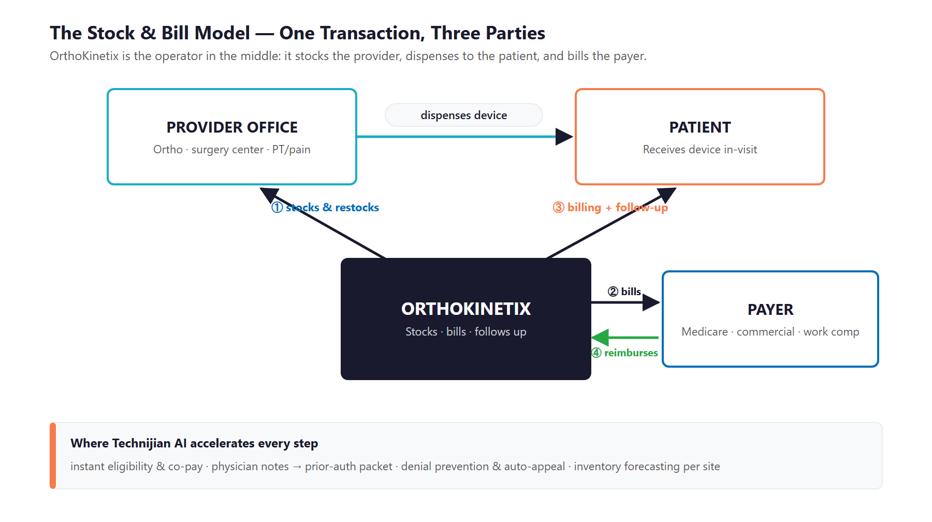
Figure 3.0 — The Stock & Bill Model: one transaction, three parties, and where AI accelerates it

Two Divisions, One Operation
Division | Customer | How It Works
Office Stock & Bill | Physician practices, ortho / PT / pain clinics, surgery centers (SoCal) | A rep monitors on-site inventory and restocks to the practice’s prescription patterns. The provider dispenses in-visit; OrthoKinetix bills insurance and owns follow-up and warranty.
Hospital Stock & Bill Division | Hospitals (nationwide) | On-site product availability, stocking programs, and dedicated field service support extended to hospital partners across the country.

What OrthoKinetix Already Does Well
The company sells on real operational strengths — each of which becomes sharper with AI behind it:
- In-house billing with upfront benefit verification and clear co-pay explanation — a differentiator AI can make instant.
- In-service training delivered directly to facilities, building the relationship that earns the next referral.
- Dedicated sales representatives who own long-term account relationships — the human core AI is meant to amplify, not replace.
- Pricing aligned to Medicare allowable amounts, with the payor breadth to actually collect on it.

Why This Model Converts Search Demand
Stock & Bill is an unusually strong offer to put in front of a searching provider: "we stock it, your team dispenses in-visit, we bill insurance and own the follow-up." That is a direct answer to a real, weekly pain.
For a patient, the message is just as concrete: get the device your doctor prescribed, in-network, without fighting the paperwork.
A strong, specific offer is what makes SEO and GEO pay off — traffic only converts when what it lands on solves the searcher’s problem. OrthoKinetix already has that offer; it simply is not visible in search yet. (Back-office automation — prior-auth and denials — is available as a later phase, but it is not the focus of this plan.)

04 The Search Opportunity — SEO + GEO
04 The Search Opportunity — SEO + GEO

Getting found now means two things, not one. SEO is being the result Google shows when someone searches. GEO — Generative Engine Optimization — is being the source the AI assistants quote when someone asks ChatGPT, Perplexity, Google AI Overviews, or Gemini the same question. The two reinforce each other: the structured, authoritative content that ranks in Google is exactly what the AI assistants pull from. OrthoKinetix is currently absent from both, while the queries below run every day.

What Patients Are Searching
Patient demand is real, local, and high-intent — a person with a prescription looking for a covered device is ready to act. These are the queries OrthoKinetix should own across Los Angeles, Riverside, San Bernardino, Orange, and Ventura counties:
Patient Search | Intent | How OrthoKinetix Wins It
"knee brace covered by Medicare near me" | High — ready to obtain | Local SEO + a covered-bracing page + a complete Google Business Profile
"CPM machine rental Riverside" | High — post-op need | Service page + a GEO answer on what is covered and how to get it
"lymphedema pump through insurance" | High — specific device | Condition page + a coverage FAQ that AI assistants can cite
"bone growth stimulator covered by insurance" | High — specific | Coverage explainer answering the exact question in plain language
"DME supplier that accepts IEHP / Medi-Cal" | High — payor match | Payor-specific landing pages naming the plans OrthoKinetix takes
"where to get a back brace after surgery" | Medium — guidance | How-to content that captures the searcher early and routes them in

What Providers Are Searching
Provider demand is lower in volume but far higher in value — one practice that adopts Stock & Bill is worth thousands of patient searches. These queries are wide open because no DME supplier has built real content for them:
Provider Search | Who’s Searching | How OrthoKinetix Wins It
"stock and bill program California" | Practice administrator | A real Stock & Bill page (not a two-sentence stub) + a consult funnel
"DME company for an orthopedic practice" | Surgeon / office manager | Provider authority content + proof from long-standing accounts
"in-office bracing dispensing partner" | Practice / clinic | Service page leading with the "we own the billing" message
"workers comp DME supplier" | WC case manager | A WC-channel page naming the networks OrthoKinetix contracts with
"hospital stock and bill DME vendor" | Materials manager | A Hospital Stock & Bill Division page built for national searches

GEO — Getting Cited by the AI Assistants
More patients and providers now ask an AI assistant before they ever open Google. They type "What DME suppliers do stock and bill in California?" or "How do I get a CPM machine covered after knee surgery?" — and ChatGPT, Perplexity, Google AI Overviews, and Gemini answer in prose, naming a few sources. GEO is the practice of becoming one of those named sources. It is the same content discipline as SEO, packaged for machines to quote: direct, plain-language answers; FAQPage schema on every coverage question; ungated explainers; and third-party citations (a complete Google Business Profile, reviews, and industry directories) that tell the models OrthoKinetix is a real, trusted answer.

GEO Is the Channel Competitors Haven’t Claimed
AI assistants are becoming the first stop for "how do I get X covered?" questions — and they cite whoever structured their content to be quotable. Almost no DME supplier has done this.
The work compounds: a single well-built coverage explainer can rank in Google AND be cited by four different AI assistants, for years, with no per-click cost.
Being the cited answer is a durable moat — far harder for a competitor to dislodge than a paid ad, and OrthoKinetix can claim it first.
All of this rests on one fix: the homepage must move off the /site/ subfolder to the root domain, and the OrthoKinetix / OrthoXpress naming should consolidate, so every page of content compounds one domain’s authority instead of splitting it (see Section 7).

05 The OrthoKinetix Customer
05 The OrthoKinetix Customer

OrthoKinetix serves a small set of distinct buyer segments — plus the patient at the end of the chain. Each is found or reached differently, and they differ meaningfully on both account volume and margin, which is why the segment matrix below uses those two axes to show where to point the SEO/GEO and the outreach effort.

1 — The Surgeon / Practice Administrator
Role | Orthopedic surgeon or the administrator who runs the practice’s operations and chooses its DME partner.
Pain Points | No time or space to manage inventory; staff buried in billing and prior-auth; denied claims that boomerang back to the office.
Decision Driver | Does this remove work and keep patients moving? Reliability and "we own the billing" matter more than a few dollars of price.
AI Opportunity | Provider SEO makes OrthoKinetix the name they find first; account-intelligence dossiers let reps walk in already understanding the practice.
Technijian Hook | My SEO — provider authority content + the Stock & Bill page they find when comparing partners. My AI Lead Gen — account-based outreach for the practices worth winning.

2 — The Hospital / Surgery-Center Materials Manager
Role | Supply-chain or materials manager responsible for on-site product availability and supplier performance at a hospital or ASC.
Pain Points | Stockouts at the point of care; multiple suppliers to manage; pressure on cost and compliance documentation.
Decision Driver | Consistent on-site availability, dependable field service, and clean compliance — a partner who never lets a case wait on a missing device.
AI Opportunity | Account-based outreach reaches named hospitals and ASCs by name; a dedicated Hospital division page captures national search demand.
Technijian Hook | My AI Lead Gen — account-based outreach to named hospitals and surgery centers. My SEO — a Hospital Stock & Bill page built for national searches.

3 — The PT / Pain-Management Clinic Owner
Role | Owner or lead clinician at a physical-therapy or pain clinic that dispenses bracing, TENS, traction, and supports.
Pain Points | Wants to dispense at point of care without becoming a billing operation; reorders and supplies are a manual chore.
Decision Driver | Turnkey dispensing with someone else owning the insurance work; fast restock so they never run out mid-treatment.
AI Opportunity | High account volume makes this a strong base for SEO/GEO inbound and on-site lead capture.
Technijian Hook | My SEO — local + GEO presence for clinics searching for a partner. Chat.AI — the on-site assistant that captures the inquiry.

4 — The Workers’ Comp Case Manager
Role | Case manager or adjuster inside a WC network (One Call, Homelink, MTI America, Orchid Medical, and others) who routes DME referrals.
Pain Points | Needs fast status, clean documentation, and no chasing; a difficult supplier makes their job harder and slower.
Decision Driver | Whichever supplier makes the referral effortless and the paperwork airtight gets the next one — and the one after that.
AI Opportunity | A modern case-manager view (instant status + documents) turns a transactional channel into a repeat-referral engine.
Technijian Hook | My SEO — a workers’-comp channel page naming the networks. My Dev — a fast case-manager status view that earns repeat referrals.

5 — The Patient (Reorders & Recurring)
Role | The end user who receives the device in-visit — and, for compression, CPM, and supplies, needs reorders over time.
Pain Points | Confusion about coverage and co-pay; reorders that depend on someone remembering to call.
Decision Driver | Clear cost up front and an easy way to reorder — the difference between a one-time claim and recurring revenue.
AI Opportunity | High-volume, lower-margin, but the front door: patients searching for covered devices are the cheapest demand to capture — if OrthoKinetix ranks and the on-site assistant converts them.
Technijian Hook | My SEO/GEO — rank and get cited for the covered-device searches patients make. Chat.AI — the assistant that answers coverage questions and captures the lead.

Figure 5.0 maps each segment by account volume and margin / strategic value — showing which buyers are the anchor accounts to win, which are high-value niches, and which represent recurring volume.

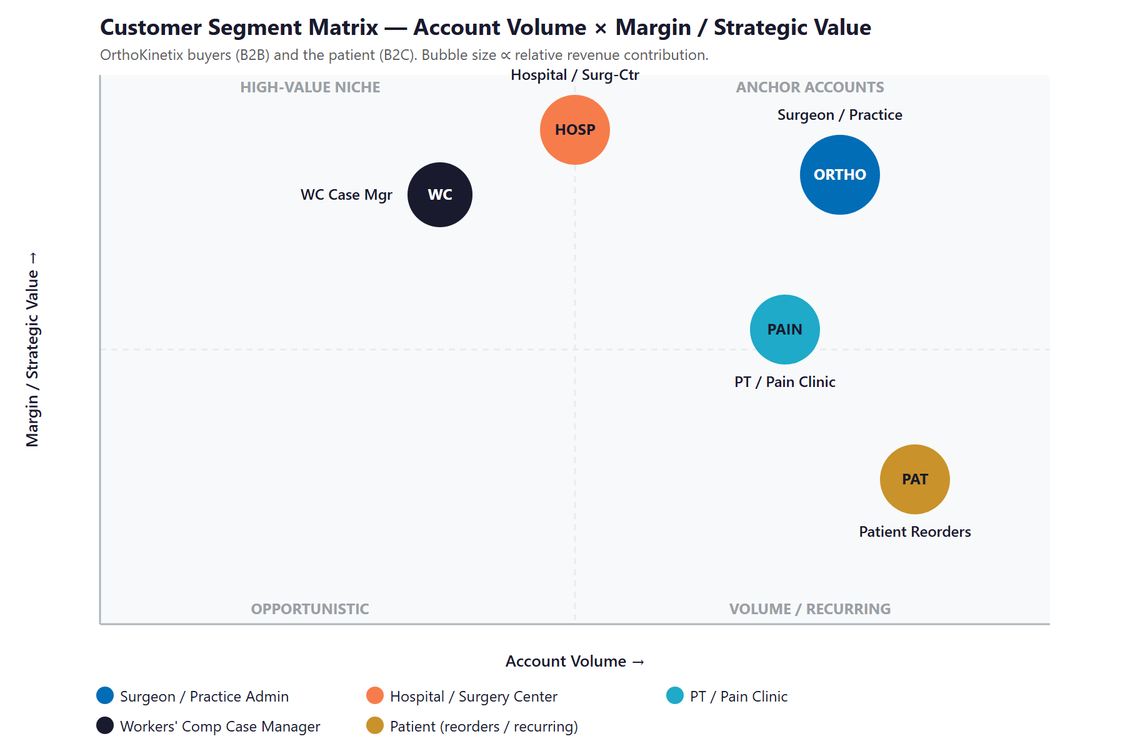
Figure 5.0 — OrthoKinetix Customer Segments: Account Volume vs. Margin / Strategic Value

06 Competitive Landscape
06 Competitive Landscape

The orthopedic DME and stock-and-bill market spans regional specialists, manufacturer-owned programs, and national O&P chains. OrthoKinetix’s edge — 20 years of provider relationships, BOC accreditation, deep payor breadth, and both office and hospital divisions — is real but largely invisible online. Nearly every competitor sells the same way: field reps and relationships, with almost no digital or AI presence. That shared blind spot is the opportunity.

Competitor | Type / Market | Posture vs. OrthoKinetix
SOS Medical | SoCal post-op / pain / rehab + custom O&P manufacturer | Direct regional rival; also manufactures custom O&P — a vertical advantage to neutralize on service and speed
Restore Motion | Orange County, est. 2007, operates CA / AZ / HI | Direct rival in the same SoCal footprint; multi-state reach
SEE THE TRAINER | National Stock & Bill for large practices + hospitals | Direct model competitor targeting the same large-practice and hospital accounts
DJO / Enovis | National manufacturer-owned stock-and-bill | Scale and owned product; can compete on price for its own lines
Breg | National manufacturer with its own stock-and-bill programs | Supplier partner AND competitor — supplies OrthoKinetix yet also sells direct programs
Hanger | National orthotics & prosthetics leader | Dominant specifically in prosthetics; less focused on broad DME stock-and-bill
MedEx PSI | Orthopedic bracing & DME services | Model competitor in bracing and DME fulfillment
AVORS Medical Group | Lancaster, CA — clinic-integrated DME | Regional, clinic-attached model

Where OrthoKinetix Wins — The White Space
Digital invisibility is universal: no competitor credibly owns Google or the AI answers for "stock and bill program California," specialty-DME partner queries, or patient coverage questions. First to build it wins compounding inbound.
No one is capturing patient search demand. Patients hunt for covered braces, CPM rentals, and pumps every day; competitors leave that traffic to chance. Local SEO + GEO + on-site capture claims it.
No one has modernized the workers’-comp case-manager experience — the exact relationship that drives repeat referrals.
Provider acquisition is gated by field-team size everywhere. Account-based outreach that multiplies a finite team’s reach is a structural advantage competitors are not pursuing.

07 Brand & Digital Presence Audit
07 Brand & Digital Presence Audit

For a 20-year, ~$5M company with a nationwide hospital division and dozens of payor contracts, the online presence materially under-represents the business. The quality of the operation is far ahead of how it shows up on screen — and that gap is the easiest early win.

Digital Asset | Current State | Gap / Opportunity
Site URL structure | Homepage lives at orthokinetix.net/site/ (a subfolder) | Move to root domain; the /site/ path hurts SEO and looks unfinished to a vetting administrator
Brand naming | "OrthoKinetix powered by OrthoXpress" — two names | Dual naming splits search authority; consolidate to one primary brand so equity compounds
Page content depth | Stock & Bill and Payor Relations pages are a few sentences | No provider-conversion content, case studies, or specialty landing pages — the buyer can’t self-educate
Site assets | Forms and PDFs dated to 2016 | Refresh signals an active, modern operation — important when "are they still current?" is a buying question
Provider lead capture | Patient appointment form only | No path for a provider (the actual buyer) to request a Stock & Bill consult or gated resource
Answer-engine presence | Effectively none | No GEO content ranking in Google or cited in AI answers for the queries patients and providers actually search
Authority / proof | Accreditation noted, little narrative | BOC Gold Seal, 20 years, payor breadth, hospital division — strong proof, barely told

The Presence Gap Is the On-Ramp
None of this requires rebuilding the business — only making the existing strengths visible and findable.
Consolidating the brand, moving to the root domain, and publishing provider-facing authority content are low-cost moves with compounding SEO and credibility returns.
These are also the natural first 90 days of the program: fix the foundation, then build the engine on top of it.

08 Technijian Capability Proof
08 Technijian Capability Proof

Before the growth program, one thing must be clear: Technijian has already built the systems OrthoKinetix needs. The platforms below are delivered and operating for real clients — not proposals. Each maps to a specific OrthoKinetix use case, and each respects the HIPAA boundary that healthcare AI demands.

Proven Build 1 — Multi-Agent SEO + GEO Platform
What Technijian Built: Technijian operates a multi-agent platform (Claude, GPT-4o, and Gemini with MCP, plus SEMrush, GA4, and Perplexity) that produces authority content, ranks it in Google, and positions clients as the cited answer inside the AI assistants.
How This Applies to OrthoKinetix: This is the core engine: own "stock and bill program California," specialty-DME queries, and patient coverage questions in both Google search and the AI answers from ChatGPT, Perplexity, and Google AI Overviews — the SEO + GEO that gets OrthoKinetix found.

Proven Build 2 — Chat.AI Conversational Capture (already in your stack)
What Technijian Built: Chat.AI — which OrthoKinetix already knows — is Technijian’s enterprise AI platform. As a website assistant it answers visitor questions in natural language around the clock and hands qualified inquiries to a person.
How This Applies to OrthoKinetix: Pointed at orthokinetix.net it becomes the capture layer for SEO/GEO traffic: it answers "is this covered by my plan?" for patients and "how does Stock & Bill work?" for providers, then captures the lead — turning visits into contacts instead of bounces, with HIPAA-safe handling for anything touching patient data.

Proven Build 3 — My AI Lead Gen: Account-Based Outbound
What Technijian Built: My AI Lead Gen is Technijian’s productized outbound engine — harvest high-fit targets from public data, enrich and score them, and deliver outreach-ready personalized sequences — replacing the Apollo / ZoomInfo subscription tax.
How This Applies to OrthoKinetix: For the named-account track it builds the list of orthopedic practices, surgery centers, and hospitals not yet on Stock & Bill (from NPI and other public sources), with a per-account dossier for each rep visit and personalized sequences — depth on the accounts worth winning, not a blast.

Proven Build 4 — AI-Native Custom App Delivery (My Dev)
What Technijian Built: Technijian’s AI-native SDLC delivers custom web apps 3–5x faster than traditional development — landing pages, funnels, and integrations built around a client’s actual process.
How This Applies to OrthoKinetix: This builds the conversion layer that SEO/GEO traffic lands on: intent-matched device and Stock & Bill pages, the "Request a consult" provider funnel, source-tagged lead routing into the CRM, and the workers’-comp status view that earns repeat referrals.

Proven Build 5 — AI Review & Reputation Engine
What Technijian Built: Technijian built an AI review and reputation system that requests, monitors, and responds to reviews across Google and the local directories that search ranks on.
How This Applies to OrthoKinetix: Reviews and a complete Google Business Profile do double duty for OrthoKinetix: they lift the local SEO that captures patient demand, and they are exactly the third-party signals the AI assistants weigh when deciding whom to cite — trust that compounds both channels.

09 The Lead Gen Engine — Capture & Convert
09 The Lead Gen Engine — Capture & Convert

The engine runs three motions at once: get found (SEO + GEO), capture and convert (an on-site Chat.AI assistant plus conversion funnels), and account-based outbound (My AI Lead Gen for the named hospitals and surgery centers). The first two capture the broad search demand at scale; the third wins the high-value accounts by name. Together they turn OrthoKinetix from invisible into the default answer — and turn that attention into booked leads and signed accounts.

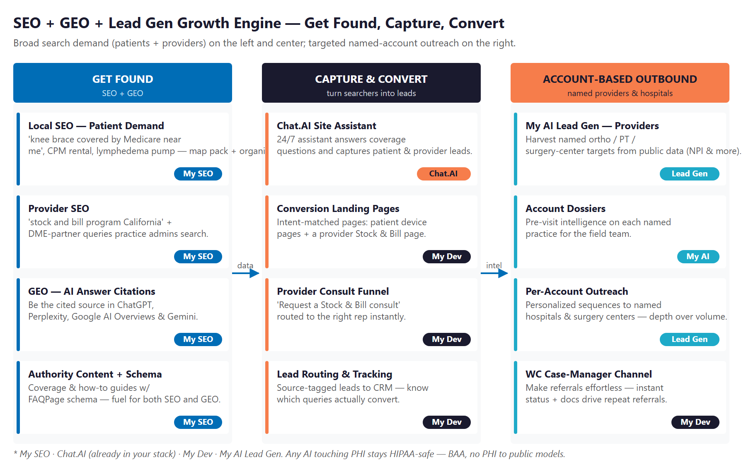
Figure 9.0 — The Engine: Get Found (SEO/GEO), Capture & Convert, and Account-Based Outbound

Motion | Play | What It Does | Metric | Technijian Service
Get Found | Local + organic SEO | Rank for patient device + local "near me" queries | Organic leads / mo | My SEO
Get Found | Provider SEO | Rank for "stock and bill California" + partner queries | Provider inquiries / mo | My SEO
Get Found | GEO — AI citations | Be the source ChatGPT, Perplexity & AI Overviews quote | AI-answer citations | My SEO
Get Found | Authority content + schema | Coverage & how-to guides with FAQPage schema | Indexed Q&As, rankings | My SEO
Capture | Chat.AI site assistant | 24/7 answers + lead capture (patient & provider) | Visitor → lead rate | Chat.AI
Capture | Conversion landing pages | Intent-matched device + Stock & Bill pages | Page conversion rate | My Dev
Capture | Provider consult funnel | "Request a Stock & Bill consult" → routed to a rep | Consults booked | My Dev
Capture | Lead routing + tracking | Source-tagged leads into the CRM | Cost per lead by source | My Dev
Outbound | My AI Lead Gen | Harvest named provider / hospital targets | Qualified accounts / mo | My AI Lead Gen
Outbound | Account dossiers | Pre-visit intelligence per named practice | Rep meetings booked | My AI
Outbound | Per-account sequences | Personalized outreach to named targets | New Stock & Bill accounts | My AI Lead Gen
Outbound | WC case-manager channel | Status + docs that earn repeat referrals | Repeat WC referrals | My Dev

The Honest Boundary
SEO, GEO, and the on-site assistant get OrthoKinetix found and turn searchers into qualified leads — that is most of the work, and it is highly automatable.
For the high-value hospital and surgery-center accounts, AI surfaces the right targets and arms the rep — but the in-service training, the trust, and the relationship still close the deal.
That honesty is the point: the plan captures broad demand at scale and makes the named-account effort sharper, without pretending software signs a stock-and-bill contract on its own.

10 Business Impact & Service Investment
10 Business Impact & Service Investment

The model below is built from public and industry benchmarks because OrthoKinetix’s internal numbers were not available for this draft. Every figure is estimated and conservative; the discovery questions in Section 13 replace these assumptions with real baselines. The ROI logic holds at almost any reasonable input, because the two levers — new accounts won and search demand captured — are large relative to the program cost.

Projected KPI Lift (Estimated)
KPI | Estimated Current | With the Program | Direction
Organic + AI-referred traffic | Near zero | Growing monthly | New top of funnel
Patient leads captured / mo | ~0 (no capture) | Steady inbound | Recurring orders
Provider consults / mo | Ad hoc | Predictable inbound | New account pipeline
GEO citations (ChatGPT, Perplexity, AI Overviews) | None | Cited for key questions | Durable visibility
Visitor → lead conversion | No funnel | Funnel + Chat.AI capture | More from same traffic
New Stock & Bill accounts / quarter | Field-team limited | Inbound + account-based | More named wins

Year-1 ROI Model (Estimated, Conservative Assumptions)
Model Input | Conservative | Target | Aggressive
New Stock & Bill accounts (Y1) | +4 | +8 | +14
Est. annual revenue per new account* | $40,000 | $40,000 | $40,000
Revenue from new accounts | +$160,000 | +$320,000 | +$560,000
Incremental patient orders from search** | +$60,000 | +$120,000 | +$200,000
Total additional annual revenue | +$220,000 | +$440,000 | +$760,000
Technijian Program Investment (Y1) | ~$105,600 | ~$105,600 | ~$105,600
Modeled ROI Ratio | 2.1x | 4.2x | 7.2x

* Placeholder per-account value pending OrthoKinetix’s actual average. ** Modeled from patient orders captured via SEO/GEO + on-site conversion; conservative against the searchable demand across five counties. All figures projected, not guaranteed.

Technijian Service Investment Map
Service | Scope | Monthly | Y1 Total
My SEO — SEO + GEO Program | Local + organic + GEO/AI-citation for patient & provider terms; content + FAQPage schema; brand + root-domain fix | $2,000/mo | $24,000
My AI Lead Gen — Account-Based Acquisition | Named provider / hospital harvesting, enrichment, and personalized sequences (Professional tier) | $3,499/mo | $42,000
My Dev — Capture & Funnel Build | Landing pages, provider consult funnel, Chat.AI assistant integration, lead routing + tracking (one-time) | — | $25,000
My AI — Executive Workshop | One-time leadership alignment + roadmap (upfront) | — | $5,000
My Dev — Managed Funnel Services | Hosting, monitoring, and ongoing conversion optimization | $800/mo | $9,600
YEAR-1 TOTAL INVESTMENT | Recurring $6,299/mo + builds |  | ~$105,600

Chat.AI is already in OrthoKinetix’s stack, so it is not a line item here — the build integrates the assistant you already have as the on-site capture layer.

The Math That Matters
Winning just four new Stock & Bill accounts in Year 1, at an estimated $40,000 each, more than covers the full program investment on its own.
Patient search demand is the cheapest demand to capture and it compounds: once OrthoKinetix ranks and gets cited, leads arrive month after month with no per-click cost.
The program is phased — start with the SEO/GEO foundation and on-site capture, prove the lead flow, then scale account-based outbound — which lowers the entry point and de-risks the spend.

11 Implementation Roadmap
11 Implementation Roadmap

The roadmap runs on a 90 / 180 / 365-day cadence: get found first (the SEO/GEO foundation plus the on-site capture layer), then build the demand engine (content, citations, and the named-account target list), then scale outbound and compound what converts. Meaningful inbound is visible inside the first 90 days; the account-based outbound is given the runway it needs.

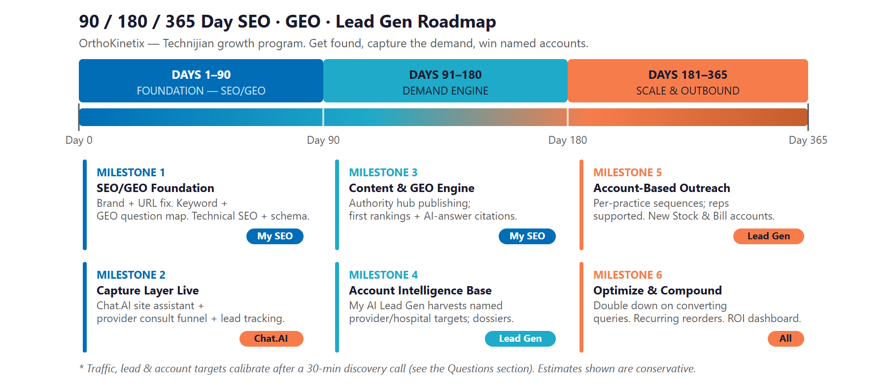
Figure 11.0 — OrthoKinetix SEO · GEO · Lead Gen Program: 90 / 180 / 365-Day Roadmap

Phase 1 — Foundation: SEO/GEO (Days 1–90)
Get the technical base right and stand up the layer that turns visits into leads.
Milestone | Deliverables
1.1 — SEO/GEO Foundation | Move the homepage to the root domain and consolidate the brand. Build the keyword + GEO-question map. Ship technical SEO, FAQPage schema, and the first priority pages — patient device pages plus the Stock & Bill page.
1.2 — Capture Layer Live | Point the Chat.AI assistant at the site to answer patient and provider questions and capture leads. Launch the "Request a consult" provider funnel and source-tagged lead tracking.

Phase 2 — Demand Engine (Days 91–180)
Publish the content that ranks and gets cited, and build the named-account target list.
Milestone | Deliverables
2.1 — Content & GEO Engine | Authority hub publishing on a steady cadence. First Google rankings for priority terms and first AI-assistant citations for the coverage questions patients and providers ask.
2.2 — Account Intelligence Base | My AI Lead Gen harvests the named provider and hospital target list (NPI + public data). First per-account dossiers delivered to the field team.

Phase 3 — Scale & Outbound (Days 181–365)
Scale the account-based outreach and compound what is already converting.
Milestone | Deliverables
3.1 — Account-Based Outreach at Scale | Personalized sequences running across the named universe; reps supported by per-account dossiers. New Stock & Bill accounts closing.
3.2 — Optimize & Compound | Double down on the queries and pages that convert. Patient reorder prompts live. ROI dashboard delivered against the Section 13 baselines.

12 Quick Wins — Start This Week
12 Quick Wins — Start This Week

Five actions OrthoKinetix can take immediately — before any Technijian engagement. Each creates value this week and leads naturally into the larger program.

1 — Fix the Homepage URL
Set up a redirect so orthokinetix.net points to the live homepage instead of orthokinetix.net/site/. This single change improves how search engines and prospective providers perceive the site — and it costs nothing but a few minutes with whoever manages the domain.

2 — Claim and Complete the Google Business Profile
Verify the Riverside Google Business Profile, add the full service description, hours, photos, and the Stock & Bill program. Referring practices and case managers do check — and a complete profile is free local visibility.

3 — Write One Provider-Facing FAQ Page
Publish a single page answering the questions administrators actually ask: "How does the Stock & Bill program work?", "Who handles billing and denials?", "Which payors do you contract with?" This is the seed of the authority content that ranks in AI answers.

4 — Add a "Provider Consult" Request to the Site
Right now the only form is for patients. Add a short "Request a Stock & Bill consult" form for providers — the buyer — so an interested practice administrator has a path to raise their hand without calling.

5 — Ask Five Long-Standing Accounts for a Testimonial
Reach out to five practices that have been with OrthoKinetix for years and ask for a short quote about what the partnership removes from their day. Provider proof is the most persuasive asset in an account-based sale — and you already earned it.

13 Questions to Calibrate This Plan
13 Questions to Calibrate This Plan

This blueprint was built from public information. The numbers in Sections 10 and 11 are deliberately conservative estimates — a short discovery call replaces them with OrthoKinetix’s real baselines and sharpens the entire program. These are the questions that move the model the most:

Topic | What We’d Confirm | Why It Matters
Web baseline | Current website traffic and where leads come from today | Calibrates the inbound traffic-and-lead model
Lead handling | Who answers patient & provider inquiries now, and how fast | Designs the capture layer and lead routing
Order & account value | Average patient order value and the annual value of a Stock & Bill account | Sets the two revenue lines in the ROI model
Account growth | New Stock & Bill accounts per month and current sales-team size | Calibrates the account-based outbound scope
Systems | Website platform (WordPress?) and the CRM in use | Defines the integration surface for funnels + tracking
Hospital division | Number of hospital accounts and states served | Scopes the national vs. regional balance of the program
Recurring revenue | Current patient reorder rate for compression / CPM / supplies | Baselines the recurring-revenue opportunity
Marketing | Who owns web/marketing today and any current ad spend | Determines where the SEO/GEO work plugs in
Brand | Is "OrthoXpress" vs. "OrthoKinetix" intentional, or consolidate? | Decides the brand and domain strategy in Phase 1
Leadership | Confirm leadership names and titles | So the final document and outreach are exactly right

How to Use This Section
None of these questions block starting — the Quick Wins and the Phase 1 foundation proceed regardless.
A single 30-minute call answers most of them and lets Technijian return a calibrated ROI model and a fixed-scope Statement of Work.
The goal is a plan built on OrthoKinetix’s real numbers — not on our conservative estimates.

14 What Happens Next
14 What Happens Next

OrthoKinetix has the hard things already: two decades of provider relationships, accreditation, payor breadth, and both office and hospital divisions. What it does not yet have is visibility — in Google and in the AI answers — and a way to capture the demand that visibility creates. Both are buildable today, on systems Technijian has already delivered.
The opportunity is concrete: patients and providers are already searching for what OrthoKinetix sells, and a focused SEO + GEO + lead-generation program turns that searching into captured leads and, for the high-value accounts, into signed Stock & Bill contracts. It captures broad demand at scale and sharpens the named-account effort — without pretending software replaces the rep who closes the deal.

Recommended Next Steps
Step 1: A 30-minute discovery call to answer the Section 13 questions and confirm program scope.
Step 2: Technijian returns a calibrated ROI model and a fixed-scope Statement of Work within 5 business days.
Step 3: Phase 1 kickoff — brand / URL fix, the SEO/GEO foundation, and the Chat.AI capture layer (HIPAA-safe) — live inside 14 days of signature.

Ready to be the answer when patients and providers search?
Contact Ravi Jain, Technijian | RJain@technijian.com | 949.379.8500
technijian.com | Irvine, CA

15 About Technijian
15 About Technijian

Technijian is an AI-native managed services and technology firm headquartered in Irvine, California, serving small and mid-sized businesses since 2000. We build and operate the AI systems that help regional businesses compete at scale — with security and compliance built in, not bolted on.

Service | What It Delivers for OrthoKinetix
My SEO | Local + organic SEO and GEO — ranking in Google and getting cited by the AI assistants — plus the authority content and brand / root-domain fix that make OrthoKinetix findable to patients and providers
My AI Lead Gen | Account-based outbound that harvests, enriches, and sequences the named providers and hospitals worth winning — supporting the field team, not replacing it
My Dev | Custom, AI-native builds — conversion landing pages, the provider consult funnel, Chat.AI capture integration, lead routing, and the workers’-comp status view

Contact | Detail
Account Executive | Ravi Jain — RJain@technijian.com
Office | 18 Technology Dr., Suite 141, Irvine, CA 92618
Phone | (949) 379-8500
Web | technijian.com

A Appendix — Sources
A Appendix — Sources

Market and company intelligence gathered via public web research conducted May 21, 2026. Firmographic details (founding year, employee count, revenue estimate, leadership) are third-party-sourced and to be confirmed with OrthoKinetix before external use.

1. OrthoKinetix — official website: orthokinetix.net/site/ (Home, About Us, Stock and Bill Program, Payor Relations, Insurances, Direct Lines)
2. OrthoKinetix — Stock and Bill Program: orthokinetix.net/site/stock-and-bill-program/
3. OrthoKinetix — Payor Relations: orthokinetix.net/site/payor-relations/
4. OrthoKinetix — Insurances / contracted payors: orthokinetix.net/site/insurances/
5. OrthoXpress / OrthoKinetix — RocketReach firmographic profile (founding year, employees, revenue, leadership)
6. OrthoXpress / OrthoKinetix — LinkedIn company profile
7. Stock-and-bill model & regulatory context — Medtrade, Breg white paper, DME industry sources
8. Competitors — SOS Medical (sosmedical.net), Restore Motion (restoremotiondme.com), SEE THE TRAINER, DJO/Enovis, Breg, Hanger, MedEx PSI (medexpsi.com), AVORS Medical Group
9. Medicare DMEPOS supplier standards — CMS / Palmetto GBA; CMS-846 & CMS-847 forms — Noridian
10. Technijian service pricing — My SEO, My AI Lead Gen, My Dev, Chat.AI rate cards; Technijian SEO + GEO strategy methodology

