

ThriveWell Schools
AI Growth Blueprint
Executive Summary
Scaling Restorative Justice & Trauma-Informed Excellence
Across California's K-12 School Districts

Prepared for Dr. Jennifer Lynn-Whaley, PhD | 2026-06-08

THE MOMENT
California's Historic Funding Window

$8B  CA Wellness Investment  (CYBHI + CCSPP) | 70%  Behavioral Referral Drop  Acquired CA Middle School | 53%  Teacher Burnout Rate  RAND 2025 | 37%  Schools Without  Formal SEL Curriculum

California has committed $8 billion to children's behavioral health and school climate — the largest investment window in state history. Districts are receiving discretionary block grants, LCFF increases, and Title IV allocations earmarked for exactly the kind of trauma-informed, restorative justice implementation that ThriveWell delivers.
At the same time, teacher burnout is at crisis levels (53% report burnout — student behavior management is the #1 driver). Counselors are overwhelmed. The school-to-prison pipeline is under legislative scrutiny. And federal grant cuts are accelerating district urgency to spend state dollars now.
ThriveWell's Position
No competitor holds the combination: Restorative Justice + Trauma-Informed Practice + School-to-Prison Pipeline Prevention + PhD-backed research credibility + implementation coaching that stays. The question is not whether this work is needed — it is. The question is how fast ThriveWell can reach the districts that most need it.

THREE MOVES
The ThriveWell AI Growth Engine
Motion | What It Does | Service
Get Found | Rank for "trauma-informed professional development California," optimize for AI-generated search answers, amplify Jennifer's "Neuroscience Behind Misbehavior" research into inbound district conversations | My SEO — Education Authority
Win Districts | Monitor named-account triggers (CYBHI grants, new superintendents, CA Dashboard flags); match ThriveWell to open grants; systematize outcome data that wins the next contract | My AI Lead Gen + Grant AI
Scale & Serve | Deliver Strong Beginnings, Trauma Foundations, and Staff Resilience virtually; remove Jennifer's geographic ceiling; give district leaders the data dashboard that renews contracts | My Dev — ThriveWell Platform

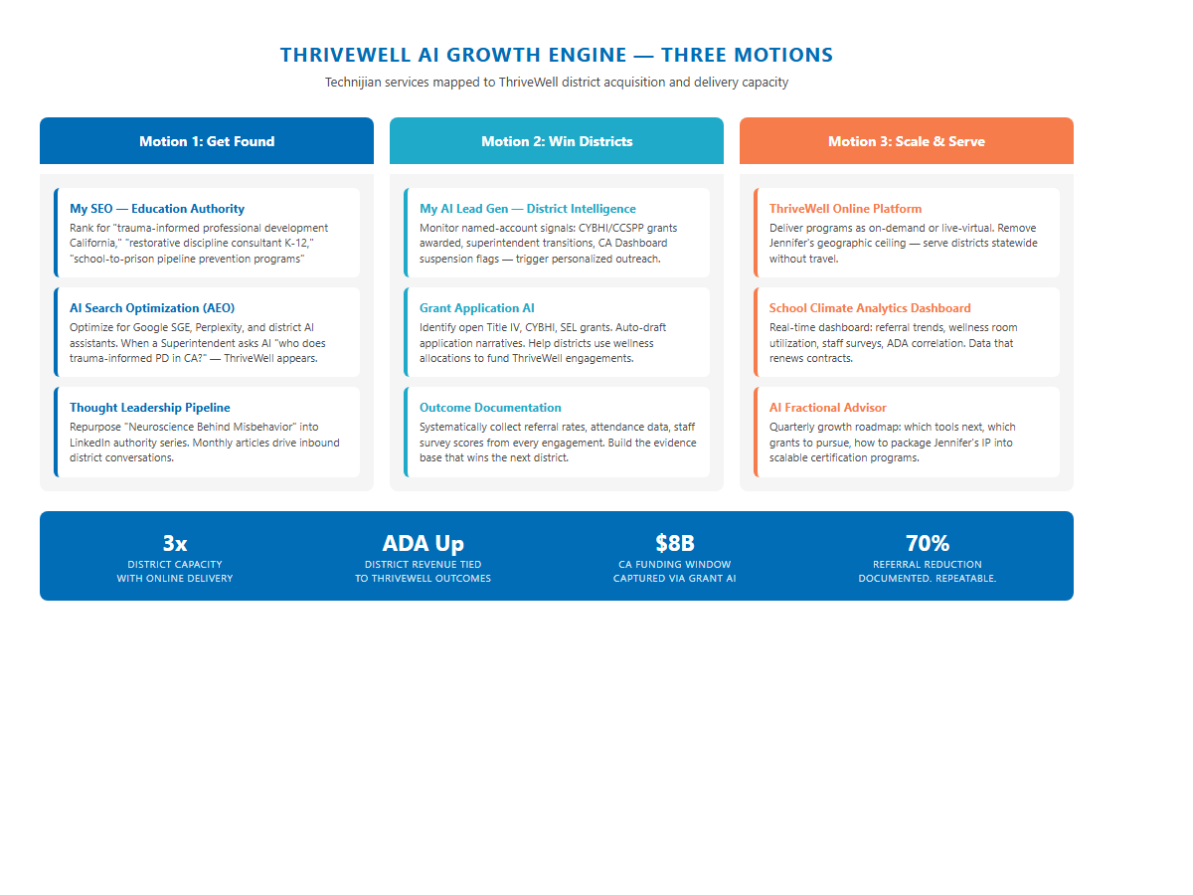
Figure 1: Three-motion AI growth engine — Get Found, Win Districts, Scale & Serve

THE INVESTMENT
Start at Entry — Expand as Growth Confirms
Phase | Services | Y1 Investment | Expected ROI
Entry (Phase 1) | My SEO Authority + My AI Workshop + My AI Fractional Advisor Starter | $34,988 | 1.7×–5.1×
Full Engine (Phase 2) | Adds: My AI Lead Gen Pro + Advisor upgrade + My Dev Platform Build + Managed Services | $135,576 | 2.7×–5.3×+

The Entry Case Makes Itself
At $34,988 for Year 1, a single new district training and coaching contract recovers the investment. The expected case — 2 to 3 new district engagements over 12 months of SEO authority-building and account intelligence — is a 3.4× to 5.1× return. Contract values shown are illustrative; ThriveWell's actual pricing determines the precise multiple.

THE ROADMAP
90-Day Foundation → 180-Day Acceleration → 365-Day Scale

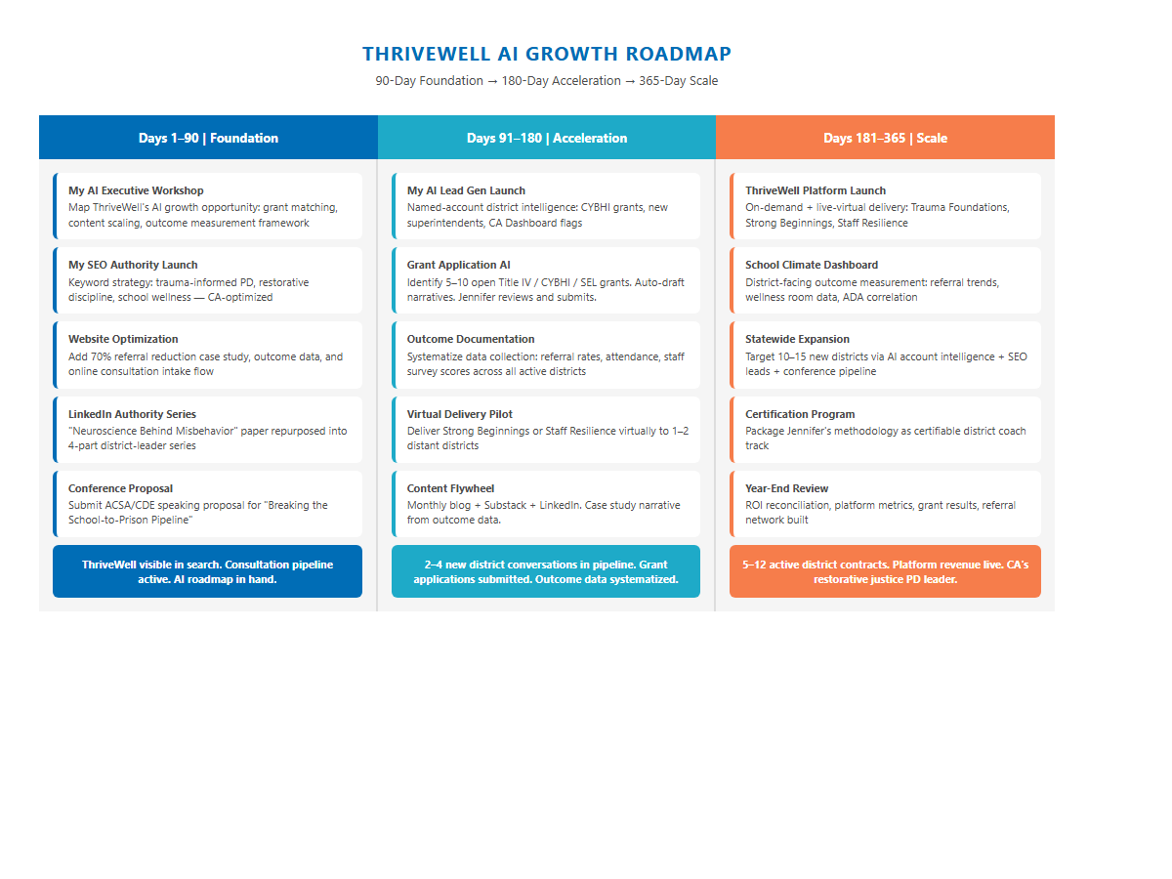
Figure 2: Implementation roadmap — get found, win districts, scale delivery

Phase | Key Actions | Outcome
Days 1–90  Foundation | AI Workshop + SEO launch + website case study + LinkedIn "Neuroscience Behind Misbehavior" series | ThriveWell visible in search. Consultation pipeline active.
Days 91–180  Acceleration | AI Lead Gen launch + Grant Application AI + Outcome documentation system + Virtual delivery pilot | 2-4 new district conversations in pipeline. Grant applications submitted.
Days 181–365  Scale | ThriveWell Platform live + School Climate Dashboard + 10-15 district targets + Certification program design | 5-12 active district contracts. Online revenue stream launched.

START THIS WEEK — NO BUDGET REQUIRED
Six Quick Wins Before Any Contract Is Signed

# | Action | Impact
1 | Add the 70% referral reduction outcome prominently to the homepage | Single sentence that changes conversion rate for every visitor
2 | Publish the Park Middle School case study (600 words) on website, Substack, LinkedIn | Organic ranking for "trauma-informed school results California" within 60 days
3 | LinkedIn series: repurpose "Neuroscience Behind Misbehavior" paper into 4 posts | Reaches Jennifer's 464+ education-professional connections; positions as thought leader
4 | Submit one ACSA or CDE conference speaking proposal | "Breaking the School-to-Prison Pipeline" session — direct access to superintendent buyers
5 | Add qualifying intake questions to the free consultation form | Triples information quality from first contact; better prepared discovery calls
6 | Claim a Google Business Profile for ThriveWell Schools in Berkeley, CA | Local SEO anchor; enables Google reviews; surfaces in K-12 consultant searches

What Happens Next
1. Review this summary and identify any corrections or clarifications.
2. Schedule a 30-minute call with Technijian to walk through the three motions and calibrate the investment.
3. Technijian scopes the entry package within 3 business days of the call.
4. My AI Executive Workshop — Day 1 — maps ThriveWell's full AI growth opportunity.

Contact: 949.379.8499 | technijian.com | 18 Technology Dr., Ste 141, Irvine, CA 92618

"technology as a solution"

