

THRIVEWELL SCHOOLS
Restorative Justice & Trauma-Informed Professional Development — Berkeley, CA
AI-Driven Growth Blueprint

Prepared by Technijian | 2026-06-08
Berkeley, California | thrivewellschools.com

CONFIDENTIAL — Prepared for ThriveWell Schools

01 Executive Summary
01 Executive Summary

$8B  CA Wellness Funding (CYBHI + CCSPP) | 70%  Referral Drop — Antioch-area Middle School | 53%  Teacher Burnout Rate (RAND 2025) | 37%  Schools Without Formal SEL Curriculum | 6  ThriveWell Program Tracks

ThriveWell Schools occupies a unique and urgent position in California's K-12 education landscape. Founded by Dr. Jennifer Lynn-Whaley, PhD — a researcher and practitioner with deep roots in criminal justice, neuroscience of behavior, and school-based trauma prevention — ThriveWell delivers what no software platform or off-the-shelf curriculum can: implementation-level coaching that shifts school culture from the inside out.
The results are documented. At an Antioch-area middle school, ThriveWell's trauma-informed practices produced a 70% drop in behavioral referrals within a single school year. The mechanism was not a program installed in isolation — it was universal staff training, ongoing coaching, and a shared accountability culture built across every adult in the building.
California has committed $8 billion in combined investment to children's behavioral health and community school partnerships. Districts are receiving discretionary block grants, LCFF cost-of-living increases, and federal Title IV allocations — all earmarked for exactly the kind of work ThriveWell does. The funding window is open now, and districts are actively searching for credible, research-backed partners.
This blueprint maps three moves: getting ThriveWell found by district leaders who are already searching for trauma-informed professional development, winning named-account district relationships through AI-assisted account intelligence and grant application support, and scaling delivery beyond in-person constraints through an online training platform that removes Jennifer's geographic ceiling.
The Core Opportunity
ThriveWell holds the uncontested corner of California's K-12 wellness market: Restorative Justice + Trauma-Informed Practice + School-to-Prison Pipeline Prevention, delivered through a PhD-credentialed implementation coach.
No software platform can replicate this. No off-the-shelf curriculum carries Jennifer's research depth. The question is not whether ThriveWell's work is needed — it is — but how fast ThriveWell can reach the districts that most need it.
Technijian's role: build the digital infrastructure that makes ThriveWell findable, scalable, and measurably effective at the speed California's funding window demands.
A note on figures: ThriveWell's internal contract values and active client count were not available at time of preparation. Every ROI projection is labeled illustrative and calibrates to real numbers after a short discovery call — the specific questions are in Section 14.

02 About ThriveWell Schools
02 About ThriveWell Schools

Field | Detail
Organization | ThriveWell Schools
Website | thrivewellschools.com
Founder | Dr. Jennifer Lynn-Whaley, PhD — Criminal Justice, Public Administration & Public Policy (American University)
Location | Berkeley, CA (serving California K-12 school districts)
Business type | B2B professional development & consulting — school district clients
Signature credential | PhD research bridging criminology, neuroscience, and K-12 education practice
Key publication | "The Neuroscience Behind Misbehavior" — foundational framework for ThriveWell's approach
Proven outcome | 70% drop in behavioral referrals at an Antioch-area middle school following district-wide implementation
Delivery model | Workshops + ongoing coaching + technical assistance; in-person primary; virtual capacity emerging
Free consultation | 30-minute discovery call available at thrivewellschools.com

The ThriveWell Approach
Jennifer's background is rare: a criminologist and public policy researcher who spent years studying the school-to-prison pipeline from the justice system side before crossing over to transform how schools prevent it. Where most professional development vendors offer curriculum, ThriveWell offers implementation — the difference between a framework teachers learn and then forget versus a cultural shift that holds through leadership transitions and budget cycles.
The approach is built on three research foundations: ACE (Adverse Childhood Experiences) science, neuroscience of behavior and brain-body states, and restorative justice principles drawn from evidence-based programs with documented impact on exclusionary discipline. These are not separate modules — they are integrated into a coherent framework that moves school adults from reactive punishment to proactive co-regulation.
What Makes ThriveWell Different
Implementation depth: ThriveWell stays — bi-monthly coaching, classroom observations, co-planning, and sustainability planning beyond the initial workshop.
Research credibility: Jennifer's PhD in criminal justice and public policy gives ThriveWell a research base that district leadership and school boards recognize as rigorous.
The prison pipeline lens: Most SEL vendors stop at student behavior. ThriveWell connects classroom discipline to juvenile justice outcomes — a frame that resonates with equity-focused superintendents and board members.

The ThriveWell Program Portfolio
Program | What It Delivers
Strong Beginnings | Restorative circles, classroom norms, and community-building for the first weeks of school — resets relational culture at the start of each year
Foundations in Trauma | Staff training in ACE science, neuroscience of behavior, and brain-body connection — the conceptual base for everything else ThriveWell does
Restorative Discipline | Shifts school culture from punitive response to accountability and restoration — reduces suspensions and exclusionary discipline referrals
Responding to Dysregulated Students | Practical de-escalation tools and co-regulation techniques for classroom teachers — what to do in the moment, not just after the fact
Staff Resilience Workshop | Burnout prevention and vicarious trauma processing for educators — addresses the staff mental health crisis that drives turnover
Improving Staff Culture | Organizational culture remediation for toxic staff environments — supports leadership teams managing interpersonal conflict and morale crises
Wellness Rooms Program | Tier I universal mental health support — physical space and protocol that absorbs dysregulated students before counselor or admin referral
Consultation & Technical Support | Bi-monthly coaching calls, classroom observations, and co-planning — implementation support that makes training stick

03 The Discipline Crisis & Mental Health Landscape
03 The Discipline Crisis & Mental Health Landscape

The Problem ThriveWell Was Built to Solve
California's K-12 schools are navigating an intersecting set of crises that compound each other: a student mental health emergency, a teacher burnout epidemic, and chronic over-reliance on exclusionary discipline that research consistently links to lower graduation rates and higher incarceration risk.
Crisis | Scale | ThriveWell Program That Addresses It
Student dysregulation & behavioral referrals | Suspension rates disproportionately impact students of color and students with IEPs | Restorative Discipline + Responding to Dysregulated Students
Teacher burnout | 53% of teachers report burnout (RAND 2025); #1 driver is student behavior management (52%) | Staff Resilience Workshop + Improving Staff Culture
Counselor overload | Recommended ratio is 1:250; CA average exceeds 1:400; most referrals are non-clinical | Wellness Rooms Program creates Tier I buffer before counselor referral
Vicarious trauma in staff | 78% of teachers cite insufficient administrative support; high turnover follows | Foundations in Trauma + Staff Culture training for administrators
School-to-prison pipeline | Students suspended even once are 3× more likely to become justice-involved | The entire ThriveWell framework — root cause intervention

The Wellness Rooms Opportunity
ThriveWell's Wellness Rooms program represents the most tangible, visible product in its portfolio. Unlike abstract professional development, a Wellness Room is a physical space students can enter — and a set of practices staff can point to when explaining the school's approach to behavior.
The program creates a Tier I universal support system that absorbs dysregulated students before they reach the counselor's office or the principal's door. Students learn self-regulation and coping strategies. Staff learn to guide rather than simply refer. Data collection built into the program tracks behavioral patterns over time — giving district leaders the outcome evidence that justifies renewal and expansion.
Legislative Tailwinds (2025–2026)
Restorative Practices in Schools Act gaining traction in Congress (Bennet, Cohen) — creates federal mandate framing for ThriveWell's core approach.
NIJ investing in restorative justice research — peer-reviewed validation is building.
California increasingly mandating trauma-informed approaches in school discipline policy — districts need implementation partners, not just guidance documents.

04 California's Historic Investment Window
04 California's Historic Investment Window

California has made an extraordinary commitment to children's behavioral health and school climate — creating the largest funding window in state history for exactly the kind of work ThriveWell delivers. Understanding how to access and align with these funding streams is among the highest-value moves ThriveWell can make in the next 12 months.
Funding Source | Scale | Relevance to ThriveWell
Children & Youth Behavioral Health Initiative (CYBHI) | $4B+ state investment | Direct funding for school-based mental health and behavioral support programs
CA Community Schools Partnership Program (CCSPP) | $4B combined | Supports wraparound services and restorative practices in community schools
LCFF Cost-of-Living Increase (FY2026) | $2.1B increase | Districts have expanded professional development budgets — discretionary
Discretionary Block Grants (FY2026) | $1.7B one-time | ADA-based allocation; fully discretionary — ideal for wellness/PD contracts
Title IV Part A (Federal) | Ongoing annual | Student support and academic enrichment — PD and school climate initiatives
Federal SEL Continuation Grants | Up to $100K per district | Competitive grants for districts expanding evidence-based SEL programs

The Urgency: Federal Cuts Accelerate State Dependency
The Trump administration has moved to cancel $168M+ in federal school mental health grants previously committed to California districts.
This creates an urgent shift: districts that were counting on federal dollars must now move faster to access state-level CYBHI and CCSPP funding — and they need credible partners who understand both the funding landscape and the implementation requirements.
ThriveWell is positioned to help districts navigate this transition. With AI-assisted grant application support, ThriveWell can identify open funding opportunities, align program descriptions to grant criteria, and help districts build the outcome data that makes applications competitive.

05 Where the Growth Lives
05 Where the Growth Lives

California K-12 Market Demand Pools
California has over 1,000 school districts. ThriveWell's serviceable market is not every district — it is the districts where the combination of funding access, equity urgency, and leadership readiness creates a high-probability buying environment. Five demand pools stand out:
Demand Pool | District Profile | Entry Trigger
CYBHI / CCSPP Grant Recipients | Any CA district awarded state behavioral health or community school funding — they now have earmarked dollars and a mandate to spend them on evidence-based programs | Grant award announcement; AI account intelligence monitors grant databases
High Suspension / CA Dashboard Red | Districts flagged on CA Dashboard's Suspension & Expulsion indicator — under board pressure to show discipline reform | Annual CA Dashboard release (fall); board meeting public comment; news coverage
New Superintendent / Cabinet Transition | New district leadership typically drives 90-day culture reset agenda — trauma-informed discipline is a flagship equity initiative for incoming superintendents | LinkedIn leadership change; EdSource / EdWeek district news; ACSA network
Teacher Burnout / Retention Crisis | Districts with documented staff turnover, union grievances, or morale incidents — the Staff Resilience + Culture programs provide immediate relief | Staff survey scores; news coverage; district budget emergency declarations
MTSS / PBIS Restructure | Districts rebuilding their Multi-Tiered Support System — Wellness Rooms and coaching fit directly into Tier I/II design | MTSS coordinator job posting; PBIS consultant engagement; district strategic plan

The growth engine is not broadcasting to all 1,000 districts. It is monitoring the 50–100 districts at any moment where one or more of these triggers has fired — and reaching them with a credible, timely offer before they find a competitor.

06 Customer Map — Five Buyer Personas
06 Customer Map — Five Buyer Personas

ThriveWell's buyer journey spans five distinct stakeholder types, from the cabinet officer who approves the contract to the classroom teacher whose buy-in determines whether training sticks. Each requires a different message — and AI-assisted account intelligence can identify which personas are active at any given district.

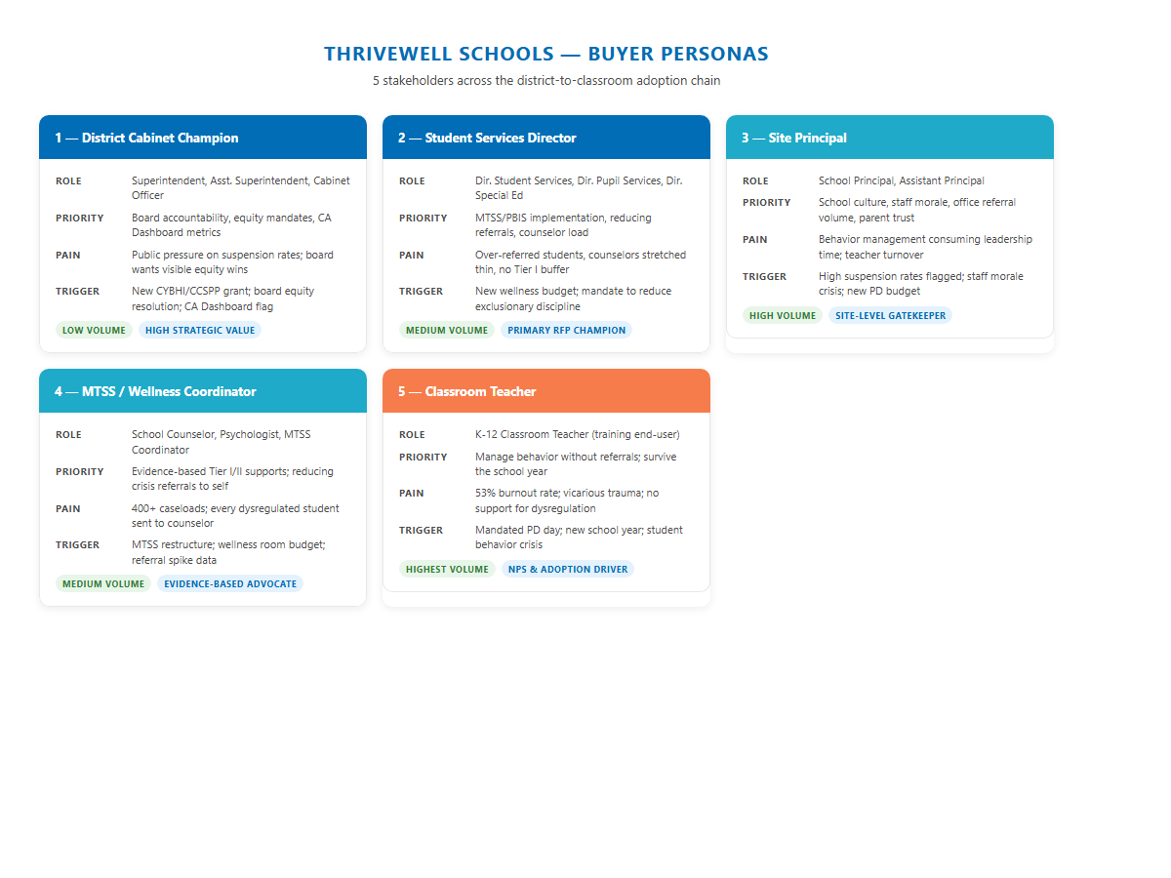
Figure 1 — Five stakeholder personas across the district-to-classroom adoption chain

1 — District Cabinet Champion
Role | Superintendent, Assistant Superintendent, Cabinet Officer
Primary goal | Board accountability on equity metrics; CA Dashboard performance; federal/state compliance
Core pain | Public pressure on suspension rates; board directives for visible equity wins; fear of CDE intervention
What triggers a conversation | New CYBHI/CCSPP grant awarded; board equity resolution passed; CA Dashboard red on Suspension & Expulsion
What they want from a vendor | Research credibility, a proven outcome they can present to the board, and a partner who understands district politics
ThriveWell's message | "A comparable middle school reduced behavioral referrals by 70% in a single year. Here's how we replicate that across your district."
Volume / Strategic Impact | Low volume (1 per district) — HIGH strategic value (drives multi-site adoption)

2 — Director of Student Services
Role | Director of Student Services, Director of Pupil Services, Director of Special Education
Primary goal | Reduce referrals to admin and counselors; build sustainable MTSS/PBIS Tier I support; protect counselor caseloads
Core pain | Over-referred students absorbing counselor time; teachers who send every dysregulated student to the office; no Tier I buffer
What triggers a conversation | New wellness/mental health budget; board mandate to reduce exclusionary discipline; MTSS restructure project
What they want from a vendor | Evidence-based Tier I program with built-in data collection; coaching for staff, not just a one-time workshop
ThriveWell's message | "The Wellness Rooms program creates a Tier I buffer that absorbs dysregulated students before they reach your counselors — with data to show what's working."
Volume / Strategic Impact | Medium volume — PRIMARY RFP champion (controls professional development budget allocation)

3 — Site Principal
Role | School Principal, Assistant Principal
Primary goal | Reduce office referrals; improve staff morale; build parent trust; survive the daily behavior management grind
Core pain | Constant behavior management consuming leadership time; burnout spreading to admin; teacher turnover driven by lack of support
What triggers a conversation | High suspension rates flagged by district; staff survey showing morale crisis; new PD day budget available
What they want from a vendor | Training teachers can use Monday morning; ongoing support, not a one-and-done workshop; visible results for parent community
ThriveWell's message | "Strong Beginnings and Restorative Discipline give your staff tools they'll actually use — and we're there for the coaching afterward."
Volume / Strategic Impact | High volume (1 per school) — site-level gatekeeper; drives staff adoption and contract renewal

4 — MTSS / Wellness Coordinator
Role | School Counselor, School Psychologist, MTSS Coordinator, Mental Health Lead
Primary goal | Evidence-based Tier I/II supports; reduce crisis-level referrals coming to them; build teacher capacity for dysregulation
Core pain | 400+ caseloads; teachers send every dysregulated student directly to counselor; no universal prevention layer
What triggers a conversation | MTSS restructure; wellness room budget available; outcome data showing referral spike to counselors
What they want from a vendor | Research-grounded framework they can champion to administration; tools teachers will actually trust and use
ThriveWell's message | "We build the Tier I system that takes the crisis volume off your plate — and gives teachers what they need to co-regulate before students reach your door."
Volume / Strategic Impact | Medium volume — evidence-based champion; often initiates the RFP or brings ThriveWell to the Director's attention

5 — Classroom Teacher
Role | K-12 Classroom Teacher (training end-user)
Primary goal | Manage student behavior without constant referrals; get through the school year without burning out
Core pain | 53% burnout rate (RAND 2025); vicarious trauma from students with ACEs; insufficient administrative support for dysregulated students
What triggers a conversation | PD day mandated by district; new school year; personal crisis with a student behavior incident
What they want from a vendor | Tools they can use immediately; practical de-escalation skills, not abstract theory; to feel supported, not judged
ThriveWell's message | "The de-escalation tools, circle techniques, and brain-based framework we teach are things you can use Monday morning — and we follow up to help you make them stick."
Volume / Strategic Impact | Highest volume (20–40 per school) — NPS and adoption driver; teacher buy-in determines whether training produces lasting culture change

07 Competitive Landscape
07 Competitive Landscape

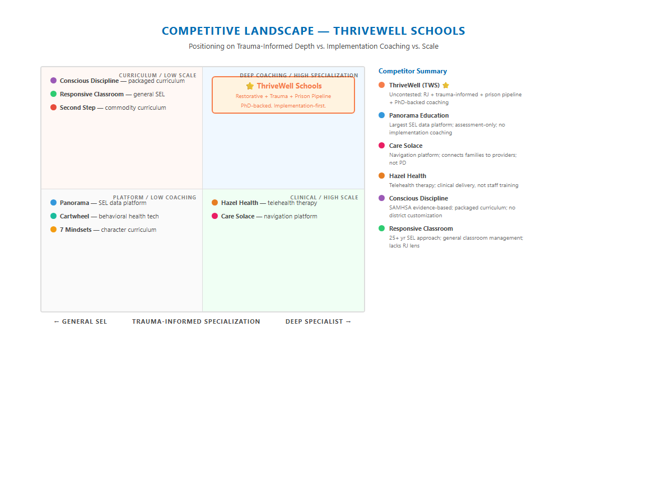
Figure 2 — ThriveWell's uncontested position: Trauma-Informed Depth + Implementation Coaching

Competitor | Focus | Why ThriveWell Wins
Panorama Education | SEL assessment & data analytics platform | Panorama measures school climate — it does not change it. ThriveWell changes the culture. Districts need both; Panorama is a complement, not a competitor.
Care Solace | Mental health provider navigation | Connects families to therapists. Not professional development. Entirely different function — no head-to-head competition.
Hazel Health | School-based telehealth therapy | Clinical service, not staff training. Districts need Hazel for high-acuity students and ThriveWell for universal Tier I prevention.
Conscious Discipline | Brain-based discipline / SEL curriculum | SAMHSA evidence-based, adult-first approach — packaged curriculum without customized district implementation or the restorative justice / prison pipeline lens.
7 Mindsets | Character development SEL curriculum | Off-the-shelf online curriculum. No trauma-informed coaching, no implementation support, no restorative justice depth.
Responsive Classroom | 25-year SEL approach | General classroom management and SEL — respected but generic. No criminal justice research lens, no school-to-prison pipeline prevention framing.
Second Step | Emotion recognition SEL curriculum | Widely adopted K-12 curriculum — commodity. Districts looking for cultural transformation, not another curriculum package, choose ThriveWell.

ThriveWell's Uncontested Position
No competitor holds the combination of: (1) restorative justice AND trauma-informed practice AND school-to-prison pipeline prevention, (2) delivered through a PhD-credentialed practitioner who stays for coaching and technical assistance, (3) with a documented 70% referral reduction outcome. This is not a crowded market. This is an open field for the right partner to dominate.

08 Brand & Digital Audit
08 Brand & Digital Audit

Channel | Current State | Priority
Website (thrivewellschools.com) | Professional and clear — "Schedule a Free Consultation" CTA is strong. Missing: outcome data prominently displayed, case studies, online training options, and a resource library that demonstrates Jennifer's research depth. | Medium
SEO / Organic Search | Low visibility. No active content marketing pipeline. Districts searching "trauma-informed professional development California" likely do not find ThriveWell on page one. | HIGH
AI Search (Google SGE, Perplexity) | Not optimized for AI-generated answers. When district administrators ask AI assistants for restorative discipline consultants, ThriveWell does not appear. | HIGH
LinkedIn (Jennifer personal) | 464+ connections — good foundation but underutilized for thought leadership. Jennifer's publication and case study outcomes should be driving regular content. | HIGH
Instagram (@thrivewell_schools) | Active — good for brand awareness among educators. Limited for B2B district decision-maker audience. | Medium
Substack (@thrivewellwithdrjenn) | Exists — underutilized. Jennifer's writing voice and research credibility are assets that deserve a larger audience. | Medium
Case Studies / Outcome Data | The 70% referral reduction at a CA middle school is ThriveWell's most powerful marketing asset — and it is not prominently visible on the website, in search results, or in thought leadership content. | HIGH
Online Training Capability | No documented online or virtual delivery option. All programs appear to require Jennifer's in-person presence — a geographic and capacity constraint that limits scale. | HIGH

The Digital Gap
ThriveWell's competitors — Panorama, Hazel Health, Care Solace — invest heavily in SEO, content marketing, and digital lead generation. They show up when district leaders search. ThriveWell currently does not.
This is not a brand weakness — it is an infrastructure gap. Jennifer's credentials, outcomes, and approach are highly differentiated. The work is to build the digital presence that carries those differentiators into the conversations that matter.

09 Technijian Capability Proof
09 Technijian Capability Proof

Technijian's work with professional services firms and consulting organizations provides direct proof of the capabilities ThriveWell needs. The following builds illustrate what Technijian has delivered — and how each applies.

Multi-Agency SEO + Authority Content System
What Technijian Built: Built SEO content pipelines and authority content programs for professional services firms in regulated industries — including California state-regulated sectors — driving first-page rankings for competitive, long-tail searches in less than 90 days.
How This Applies to ThriveWell Schools: Trauma-informed professional development is a specific, searchable need. District administrators Google it. Jennifer's credentials and outcome data make ThriveWell the strongest possible organic ranking candidate — once the content infrastructure exists to carry that credibility into search results.

AI Account Intelligence & Named-Account Monitoring
What Technijian Built: Deployed AI-driven account intelligence systems that monitor named-account trigger events — leadership transitions, regulatory filings, budget announcements, public board actions — and surface them as outreach opportunities. Used by clients in government-adjacent professional services sectors.
How This Applies to ThriveWell Schools: California school district trigger events are public information: CA Dashboard publications, grant announcements, ACSA conference speaker lists, board meeting minutes, EdSource coverage. Technijian's AI monitors these continuously and surfaces the 5–10 highest-priority district conversations each week for Jennifer to act on.

Grant Application AI & Funding Identification System
What Technijian Built: Built AI-assisted grant writing and funding identification tools for nonprofit and public-sector clients — scanning federal and state grant databases, matching program descriptions to eligibility criteria, and auto-drafting narrative sections aligned to grant language.
How This Applies to ThriveWell Schools: California's $8B funding landscape is navigable, but complex. Technijian's grant AI identifies open Title IV, CYBHI, CCSPP, and SEL continuation grants relevant to ThriveWell's programs, drafts application narratives from Jennifer's existing program descriptions, and helps districts understand how to fund ThriveWell engagements with existing wellness allocations.

Online Learning Platform & Outcome Dashboard
What Technijian Built: Designed and built custom learning management systems and outcome measurement dashboards for training and professional development organizations — including live-virtual delivery, asynchronous content libraries, participant tracking, and real-time reporting for organizational clients.
How This Applies to ThriveWell Schools: ThriveWell's in-person delivery model is Jennifer's current ceiling. An online training platform — built to ThriveWell's methodology, with Jennifer's recorded content, live virtual coaching sessions, and participant progress tracking — multiplies delivery capacity without multiplying travel. A school climate dashboard gives district leaders the data they need to justify contract renewal and expansion.

Thought Leadership & Research Amplification
What Technijian Built: Transformed existing research publications, case studies, and practitioner frameworks into multi-channel content programs — LinkedIn authority series, Substack newsletters, speaking pitch decks, and media placement — for professional services clients with strong IP but limited digital distribution.
How This Applies to ThriveWell Schools: Jennifer's "Neuroscience Behind Misbehavior" publication and the Antioch-area middle school case study are conversion-grade content waiting to be amplified. Technijian builds the content system that turns Jennifer's research credibility into inbound district conversations.

10 The ThriveWell AI Growth Engine
10 The ThriveWell AI Growth Engine

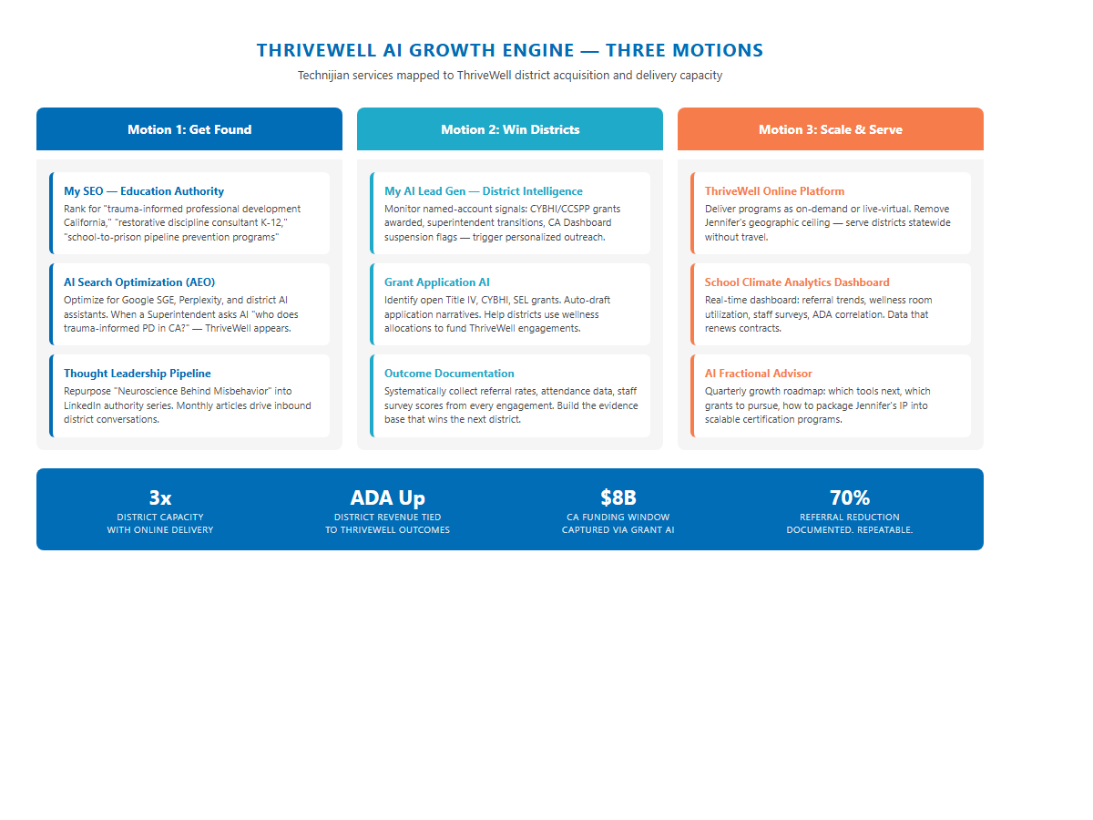
Figure 3 — Three-motion AI growth engine: Get Found, Win Districts, Scale & Serve

Motion 1: Get Found
District administrators are actively searching for trauma-informed professional development, restorative discipline consultants, and school wellness programs. ThriveWell needs to show up when they search — in Google, in AI-generated answers, and in the professional networks where district leaders learn about vendors.
Service | What It Does for ThriveWell
My SEO — Education Authority | Rank page-one for "trauma-informed professional development California," "restorative discipline consultant K-12," "school-to-prison pipeline prevention programs," "wellness rooms schools." Monthly content drives compounding organic visibility.
AI Search Optimization (AEO) | Optimize for Google SGE, Perplexity, and district AI assistants. When a superintendent asks "who does restorative discipline PD in California?" — ThriveWell appears in the generated answer.
Thought Leadership Amplification | Repurpose Jennifer's "Neuroscience Behind Misbehavior" paper into a 4-part LinkedIn series. Build a Substack content calendar. Submit speaking proposals to ACSA, CDE, and WestEd conferences.

Motion 2: Win Districts
Getting found brings inbound conversations. Winning districts requires outbound intelligence — knowing which 10 districts at any given moment have the funding, the urgency, and the leadership readiness to move. AI turns public data into a prioritized outreach list.
Service | What It Does for ThriveWell
My AI Lead Gen — District Intelligence | Monitor named-account triggers: CYBHI/CCSPP grants awarded, superintendent transitions, CA Dashboard red flags, EdSource news coverage, ACSA conference attendance. Surface the top 10 district conversations each week.
Grant Application AI | Identify open Title IV, CYBHI, SEL continuation grants. Auto-draft application narratives from Jennifer's program descriptions. Help districts use existing wellness allocations to fund ThriveWell engagements.
Outcome Documentation System | Systematically collect referral rates, attendance data, and staff survey scores from every engagement. Build the evidence base that wins the next district — and justifies contract renewal at current ones.

Motion 3: Scale & Serve
Jennifer's in-person model is ThriveWell's current ceiling. Online delivery and outcome dashboards break the geographic and capacity constraints — allowing ThriveWell to serve 3–5× more districts without 3–5× more travel.
Service | What It Does for ThriveWell
ThriveWell Online Platform | Deliver Strong Beginnings, Trauma Foundations, and Staff Resilience as on-demand or live-virtual programs. Serve districts statewide — and eventually nationally — without Jennifer traveling.
School Climate Analytics Dashboard | Real-time dashboard for district leaders: referral trends, wellness room utilization, staff survey scores, ADA correlation. Data that renews contracts and expands to additional school sites.
My AI Fractional Advisor | Quarterly AI growth roadmap: which platforms to build next, which grants to pursue, how to package Jennifer's IP into a certifiable professional development track.

11 Business Impact & Service Investment
11 Business Impact & Service Investment

How the ROI Model Works
ThriveWell's growth is measured by new district training and coaching contracts. Each district engagement is a multi-year relationship: an initial training contract, followed by ongoing coaching and technical support, and expansion to additional school sites. The investment figures below use Technijian's published service rates. District contract values are illustrative — Jennifer knows her own pricing; Technijian does not.

Entry Investment — Phase 1 (Y1)
Service | Structure | Y1 Investment
My SEO — Education Authority (Tier 2) | $1,499/mo | $17,988
My AI Executive Workshop | One-time | $5,000
My AI Fractional Advisor — Starter | $1,000/mo | $12,000
TOTAL — Entry Phase |  | $34,988

Full Growth Engine — Phase 2 (Y1+)
Service | Structure | Y1 Investment
My SEO — Education Authority (from Phase 1) | $1,499/mo | $17,988
My AI Lead Gen — District Intelligence (Pro) | $3,499/mo | $41,988
My AI Fractional Advisor — Pro (upgrade) | $2,000/mo | $24,000
My Dev — ThriveWell Platform Build | Project | $42,000
My Dev — Managed App Services | $800/mo | $9,600
TOTAL — Full Engine Y1 |  | $135,576

ROI Scenarios
The ROI model is built on new district training and coaching contracts secured as a result of Technijian's growth infrastructure. District contract values are placeholder figures — "TO CONFIRM with Jennifer" based on actual ThriveWell pricing.
Scenario | New Contracts Won | Revenue Added (est.) | Investment | Multiple
Entry — Conservative | 1 new district | $60K (est.) | $34,988 | 1.7×
Entry — Expected | 2–3 new districts | $120–$180K (est.) | $34,988 | 3.4×–5.1×
Entry — Upside | 5+ districts | $300K+ (est.) | $34,988 | 8.5×+
Full Engine — Conservative | 3 districts + platform revenue | $180K (est.) | $135,576 | 1.3×
Full Engine — Expected | 6–8 districts + platform | $360–$480K (est.) | $135,576 | 2.7×–3.5×
Full Engine — Upside | 12+ districts + online revenue | $720K+ (est.) | $135,576 | 5.3×+

The Entry Case Makes Itself
At $34,988 for Year 1, a single new district engagement — at whatever ThriveWell charges for a full-year training and coaching contract — recovers the investment.
The expected case is 2–3 new districts, which is a reasonable outcome from 12 months of SEO authority-building, AI-assisted account intelligence, and one executive workshop to sharpen Jennifer's AI growth strategy.
The upside case — 5+ new districts plus the beginning of an online revenue stream — is the 12-month target if ThriveWell executes all three motions in sequence.

12 Implementation Roadmap
12 Implementation Roadmap

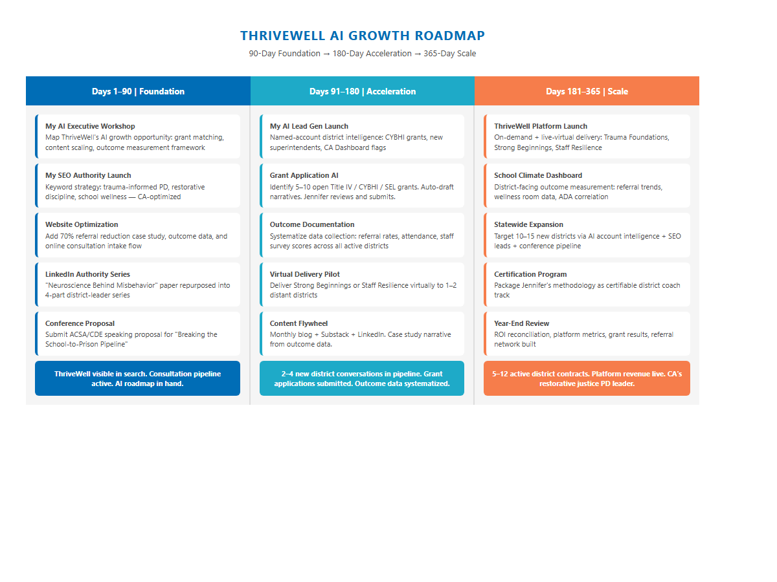
Figure 4 — 90-Day Foundation, 180-Day Acceleration, 365-Day Scale

Phase | Milestone | Owner
Days 1–90 | My AI Executive Workshop — map ThriveWell's AI growth opportunity | Technijian + Jennifer
Days 1–90 | My SEO launch — keyword strategy, website optimization, content calendar | Technijian
Days 1–90 | Case study documentation — Antioch-area middle school outcome structured for web and content | Jennifer + Technijian
Days 1–90 | LinkedIn authority content — repurpose "Neuroscience Behind Misbehavior" into 4-part series | Technijian (Jennifer reviews)
Days 91–180 | My AI Lead Gen launch — district account intelligence, weekly priority list | Technijian
Days 91–180 | Grant application AI — identify 5–10 open CA/federal grants; draft narratives | Technijian + Jennifer
Days 91–180 | Outcome documentation system — build data collection cadence for active districts | Technijian + Jennifer
Days 91–180 | Online pilot — deliver one program virtually to a distant district; test and refine | Jennifer + Technijian
Days 181–365 | ThriveWell Platform launch — on-demand and live-virtual program delivery | Technijian builds; Jennifer delivers
Days 181–365 | School Climate Analytics Dashboard — district-facing outcome measurement tool | Technijian
Days 181–365 | Statewide expansion — target 10–15 new districts via AI intelligence + SEO leads + conference pipeline | Jennifer + Technijian
Days 181–365 | Certification program design — package Jennifer's methodology as certifiable district coach track | Jennifer (Technijian supports)

13 Quick Wins
13 Quick Wins

These actions require no contract and no budget — Jennifer can begin them this week. Each one builds the foundation that paid infrastructure accelerates.

Quick Win 1 — Add the outcome data to the homepage
"A California middle school reduced behavioral referrals by 70% after district-wide implementation." This one sentence, prominent on the homepage, changes the conversion rate of every visitor. Currently invisible on thrivewellschools.com.

Quick Win 2 — Publish the case study
Write a 600-word case study: the challenge, the intervention, the outcome. Post it to the website, Substack, and LinkedIn. This single piece of content will rank organically for "trauma-informed school results California" within 60 days.

Quick Win 3 — LinkedIn authority content: 4-part series
Repurpose the "Neuroscience Behind Misbehavior" paper into a 4-part LinkedIn series: (1) what ACEs do to the developing brain, (2) why punishment fails dysregulated students, (3) what co-regulation looks like in a classroom, (4) how the 70% outcome was achieved. Jennifer's 464+ connections are largely education professionals — the audience is already there.

Quick Win 4 — Submit one ACSA or CDE conference speaking proposal
Superintendents and district directors attend ACSA (Association of California School Administrators) conferences. A 30-minute session on "Breaking the School-to-Prison Pipeline: What One District Achieved in a Year" creates both visibility and credibility with the exact buyer ThriveWell needs.

Quick Win 5 — Add an online inquiry form with intake questions
Currently, thrivewellschools.com offers a "Schedule a Free Consultation" CTA. Adding 3 qualifying questions (district size, current challenge, budget cycle) to the intake form triples the information Jennifer gets from the first contact and allows better preparation for every discovery call.

Quick Win 6 — Claim a Google Business Profile for ThriveWell Schools
A verified Google Business Profile for "ThriveWell Schools" in Berkeley, CA adds a local SEO anchor, enables Google reviews from past district clients, and surfaces ThriveWell in Google Maps results for K-12 education consultants in Northern California.

14 Questions to Calibrate This Plan
14 Questions to Calibrate This Plan

These discovery questions allow Technijian to refine the investment model, confirm the GTM motion, and identify the highest-priority first move. They are not requests for information ThriveWell is obligated to share — they are the questions that make the engagement more precise.
# | Question | Why It Matters
1 | How many active district clients does ThriveWell currently serve, and what does a typical engagement look like in terms of scope and duration? | Calibrates ROI model and defines what "capacity" means today
2 | What is the average contract value for a full-year training + coaching engagement? | Makes the ROI model precise — right now it uses illustrative placeholders
3 | Have any districts expressed interest in virtual or online delivery? Is there a waiting list of districts Jennifer cannot currently serve due to geography or calendar? | Determines urgency of online platform investment
4 | Has ThriveWell applied for any California wellness grants (CYBHI, CCSPP, Title IV) as an applicant or supported a district's application? | Calibrates grant AI priority and identifies quick grant wins
5 | Is the Antioch-area middle school case study available for public use with the school named, or should it remain anonymized? | Determines how prominently to feature the outcome in marketing materials
6 | What is the primary channel through which ThriveWell currently finds new district clients — referral, conference, or inbound search? | Determines whether SEO or account intelligence is the higher-priority first move
7 | Is there a target geography beyond California — other states, national expansion — in the 1–3 year plan? | Determines whether the platform needs to scale nationally or CA-first

15 What Happens Next
15 What Happens Next

This blueprint is the starting point for a conversation — not a commitment. The next step is a 30-minute call to walk through the three motions, answer the calibration questions, and identify which move creates the most value fastest for ThriveWell.

Step | Action | Timeline
1 | Review this blueprint and identify any corrections or clarifications | This week
2 | 30-minute discovery call with Technijian to walk through the three motions and answer calibration questions | This week / next week
3 | Technijian scopes the entry package based on discovery conversation | Within 3 business days of call
4 | My AI Executive Workshop — one day, maps ThriveWell's full AI opportunity | Day 1 of engagement
5 | My SEO launch — keyword strategy and first content pieces go live | Days 14–30
6 | Review 90-day SEO and content performance; decide on Phase 2 timing | Day 90

Ready to get ThriveWell found, seen, and funded?
Contact Ravi Jain, Technijian | rjain@technijian.com | 949.379.8499
technijian.com | Irvine, CA

16 About Technijian
16 About Technijian

Technijian is a California-based technology services firm serving businesses, nonprofits, and professional services organizations across the United States. Our work spans managed IT, cybersecurity, AI implementation, custom software development, and digital marketing — united by a commitment to technology as a solution, not a complication.
We serve clients who need a partner that understands both the technology and the domain — a firm that can build the infrastructure, implement the AI, and understand why the restorative justice lens matters. Our team includes engineers, AI specialists, marketers, and developers who build for results, not for demos.
Service Line | What It Is
My SEO | Authority SEO, AI search optimization, and thought leadership content — built for professional services firms with differentiated expertise
My AI Lead Gen | AI-driven account intelligence and named-account monitoring — surfaces the right prospect at the right moment
My AI Executive Workshop | One-day intensive: maps an organization's AI growth opportunity and produces a prioritized 12-month roadmap
My AI Fractional Advisor | Ongoing strategic AI guidance — quarterly roadmaps, tool selection, vendor evaluation, implementation oversight
My Dev | Custom software and platform development — LMS, dashboards, data tools, and web applications built to production quality
My Dev Managed | Hosting, security, uptime, and maintenance for custom-built platforms — so Jennifer focuses on clients, not servers
My IT / My Security | Managed IT and cybersecurity for professional services organizations — HIPAA-aware, compliance-ready infrastructure

Contact | Detail
Account Executive | Ravi Jain — rjain@technijian.com
Office | 18 Technology Dr., Suite 141, Irvine, CA 92618
Phone | 949.379.8499
Web | technijian.com

"technology as a solution"

A Appendix — Sources & References
A Appendix — Sources & References

Market and company intelligence gathered via public web research conducted June 2026. All financial projections, ROI models, and investment scenarios are illustrative estimates based on industry benchmarks and Technijian's published service rates. District contract values are placeholders — actual ThriveWell pricing was not available to Technijian at time of preparation. No guarantee of specific results is expressed or implied.

1. ThriveWell Schools official website — thrivewellschools.com
2. Jennifer Lynn-Whaley, PhD — LinkedIn profile (retrieved 2026-06-08)
3. RAND Corporation — Teacher Burnout Survey 2025
4. PPIC — How California Is Investing in School-Based Mental Health Services for Teens (ppic.org)
5. Blue Shield of California — California Schools & Community Leaders Step Up for Youth Mental Health, June 2026
6. K-12 Mental Health Software Vendors, Pricing & Contracts 2026 — Civic IQ Blog (civiciq.com)
7. ORI Learning — SEL Grants for Schools 2026: Funding Sources & How to Apply
8. Youth Today — What Are Wellness Rooms and Why Do Schools Need Them? (October 2023)
9. IES Regional Education Laboratory Northwest — Using Restorative Practices in Schools (January 2025)
10. Oxford Academic — Trauma-Informed Restorative Justice Practices in Schools (Community Schools, Vol. 44, Issue 2)
11. Why Me? Restorative Services — Breaking the School-to-Prison Pipeline Through Restorative Practices (2025)
12. PublicSchoolReview.com — Public Schools Supporting Student Mental Health in 2026
13. Conscious Discipline — Methodology overview (consciousdiscipline.com)
14. Wallace Foundation — Navigating Social Emotional Learning Inside Out
15. Fomcore — Wellness Rooms in Schools: A Complete Guide
16. California Department of Education — LCFF Cost-of-Living Adjustment FY2026
17. EdSource — California school district wellness funding coverage (2025–2026)

