Ravi Jain
5 Caladium
Rancho Santa Margarita, CA 92688
Phone: (714) 402-3164
Email: rjain@technijian.com

Date: April 22, 2026

Contractors State License Board
Intake/Mediation Center
P.O. Box 269116
Sacramento, CA 95826-9116

RE: Formal Consumer Complaint — Solar System Workmanship Failure
Contractor: Sunrun Installation Services, Inc. (CSLB License #750184)
Affiliated Entity: Sunrun, Inc. (CSLB License #969975)
Property: 5 Caladium, Rancho Santa Margarita, CA 92688

To Whom It May Concern:

I am submitting this written consumer complaint against Sunrun Installation Services, Inc. (CSLB License #750184) for workmanship failure at my residential property. On November 7, 2025, Sunrun technicians disconnected my solar energy system during a service visit and failed to reconnect it or notify me of the disconnection. The system produced zero exportable power for approximately five months and nine days (November 7, 2025 through April 16, 2026), resulting in documented excess utility charges of approximately $3,600.

I have attempted to resolve this directly with Sunrun. Sunrun has offered only $450 and then $500 in compensation, using a calculation methodology that is inconsistent with the Guaranteed Output provisions of my 2012 Prepaid Power Purchase Agreement. Sunrun refused my formal warranty demand of $7,500 dated April 17, 2026.

This complaint was first filed with the California Public Utilities Commission on April 20, 2026 (Commission File #726931). On April 21, 2026, CPUC Consumer Affairs Branch declined jurisdiction and specifically referred me to CSLB as the correct agency for this matter.

The detailed complaint narrative, complainant and contractor information, remedy sought, and supporting evidence (including solar production screenshots and references to utility billing records) are provided on the following pages. All statements in this complaint are true and correct to the best of my knowledge under penalty of perjury under the laws of the State of California.

Respectfully submitted,

_______________________________________
Ravi Jain, Complainant
Date: _______________________

Complaint Information

Complainant (Consumer)
Name | Ravi Jain
Property Address | 5 Caladium, Rancho Santa Margarita, CA 92688
Mailing Address | Same as property address
Daytime Phone | (714) 402-3164
Email | rjain@technijian.com
Ownership | Property owner of record
Relationship to Project | Residential customer; site owner same as complainant

Contractor
Business Name | Sunrun Installation Services, Inc.
CSLB License Number | 750184
Contact Person | Katherine Wilson (Service Pipeline Specialist, Field Performance)
Contact Phone | (619) 353-5913
Contact Email | katherine.wilson@sunrun.com
Business Address | 225 Bush Street, 14th Floor, San Francisco, CA 94104
Main Customer Phone | (855) 478-7786
Customer Email | membercare@sunrun.com

Affiliated Entity (Parent Company):
Sunrun, Inc. — CSLB License #969975 — named in both the 2012 and 2017 agreements.

Project / Contract Details
Primary Complaint Type | Workmanship
Original Contract Date | September 12, 2012
Payment Type | Prepaid Power Purchase Agreement (PPA)
Prepaid Amount | $20,000 (paid upfront in 2012 for 20-year term)
Workmanship Error Date | November 7, 2025
Outage Discovered | April 15, 2026 (upon reviewing SDG&E bills)
Emergency Repair | April 16, 2026 (2012 PPA partially restored)
2017 Costco System Status | Non-operational as of April 22, 2026
Where Work Performed | 5 Caladium, Rancho Santa Margarita, CA 92688
System Capacity | 11.16 kW combined (2012 Sunrun PPA + 2017 Costco customer-owned)

Description of Workmanship Issue
On November 7, 2025, Sunrun Installation Services technicians visited my residential property to perform service on my solar energy system. During that visit, the technicians disconnected the system and failed to reconnect it or notify me in any manner that the system had been left inoperative. I was not informed by phone, by email, by text message, or by the Sunrun mobile application.

The system (11.16 kW combined, consisting of a 2012 Sunrun-owned Prepaid Power Purchase Agreement system and a 2017 Costco customer-owned Sunrun-installed system) produced ZERO exportable power from November 7, 2025 through April 16, 2026, a period of over five months. This is documented by SDG&E NEM Meter 06688420 on Account 0036 1837 1728 9, which shows zero solar export in every Time-of-Use bucket for five consecutive monthly billing cycles. Copies of the relevant SDG&E bills are available upon request.

Sunrun's own internal records confirm the timeline: Service Case #18181148 was opened on November 10, 2025 with subject "Metering." Despite Sunrun's monitoring system detecting the failure on or before November 10, 2025, Sunrun did not send me a single communication regarding the outage for sixty-seven (67) days. The first written notice I received from Sunrun was on January 16, 2026, and even that notice described only a vague "system issue" rather than disclosing that production was at zero.

I discovered the true status of the system only by reviewing my SDG&E bills, which showed unusually high charges. When I escalated the matter by email on April 15, 2026 ("Need urgent fix"), Sunrun dispatched technicians on April 16, 2026 on an emergency basis. Those technicians told me verbally that the previous Sunrun service visit had disconnected my panels. Sunrun representative Katherine Wilson acknowledged by email on April 16, 2026 at 7:19 PM PT that a team had "went out today" — confirming that the April 16 visit was an unscheduled emergency dispatch, not a scheduled appointment.

On April 17, 2026 I submitted a formal written warranty demand requesting $7,500 in direct damages reflecting approximately $3,600 in documented excess SDG&E charges plus additional projected losses through restoration and NEM true-up. Sunrun acknowledged receipt but stated by email dated April 17, 2026 that Sunrun "cannot and will not compensate" the requested amount and that I would need to retain an attorney to access Sunrun's internal legal resolution team. That attorney-retention requirement is not economically practical for a consumer claim of this size.

On April 22, 2026, Sunrun offered $500 in compensation, calculated by dividing my original $20,000 prepaid payment by 240 months and multiplying by five months. That methodology is inconsistent with the Guaranteed Output provisions in Section 8 of the 2012 Prepaid PPA, which measures refund by kWh shortfall at the contract rate — not by a time-based slice of the prepayment. The $500 offer is also inadequate relative to the documented $3,600 in excess utility charges.

The 2017 Costco customer-owned system remains non-operational as of April 22, 2026. The mySunrun mobile application shows estimated (not real) production data for this system, indicating that Sunrun's own monitoring infrastructure cannot communicate with the 2017 system. Total April 2026 production at the property is 66.1 kWh, approximately six percent (6%) of the 1,000–1,200 kWh normally expected from an 11.16 kW system in Southern California during April. Screenshots of the mySunrun app taken April 18, 2026 and April 22, 2026 are included with this complaint.

This complaint concerns workmanship by Sunrun Installation Services, Inc. (CSLB License #750184) under an active service/maintenance relationship. CSLB License #969975 (Sunrun, Inc.) is the affiliated parent entity named in my 2012 and 2017 agreements. I am the property owner of record.

Remedy Sought
I respectfully request that CSLB take the following actions:

1. Require Sunrun Installation Services, Inc. to reimburse me approximately $3,600 for excess SDG&E electricity costs incurred between November 7, 2025 and April 16, 2026 as a direct result of their technicians leaving my solar system disconnected, and additional amounts attributable to continuing outage of the 2017 Costco system through full restoration.

2. Investigate whether Sunrun has a pattern of technicians disconnecting customer systems during service visits and failing to notify customers, which may affect many California solar customers served under Sunrun PPAs and customer-owned installations.

3. Review Sunrun's post-service customer notification procedures and whether the lack of any "system-offline" notification to customers constitutes a violation of contractor workmanship standards under Business and Professions Code sections governing licensed contractors.

4. Review Sunrun's practice of requiring consumers to retain legal counsel before accessing their internal warranty and legal resolution process, which operates as a barrier to consumer remedies on claims too small to justify individual counsel.

Contact Attempts with Contractor
I have made the following attempts to resolve this matter directly with the contractor:

April 15, 2026 | Email to Katherine Wilson: "Need urgent fix"
April 16, 2026 | In-person interaction with Sunrun technicians at the property
April 16, 2026 | Telephone follow-up (attempted)
April 17, 2026 | Formal written warranty demand via email — $7,500 reimbursement requested
April 19, 2026 | Detailed rebuttal email to Katherine Wilson (9-section letter)
April 22, 2026 | Clarification emails regarding scheduling and app status
Supporting Evidence — Solar Production Screenshots
Exhibit A — April 22, 2026, 8:21 AM PT
mySunrun app "Solar Energy Produced" chart for April 2026 at 5 Caladium, Month view. Total production for April: 66.1 kWh. Note the flat-line zero production from April 1-15 (the outage period), two solid production bars on April 16-17 (the emergency repair days), and a single DASHED "Estimated energy" bar around April 20-22. The dashed bar indicates Sunrun's monitoring system could not communicate with the 2017 inverter and substituted an estimate rather than record real production data. An 11.16 kW system in Southern California should produce approximately 1,000-1,200 kWh in April; 66.1 kWh is approximately 6% of expected monthly output.
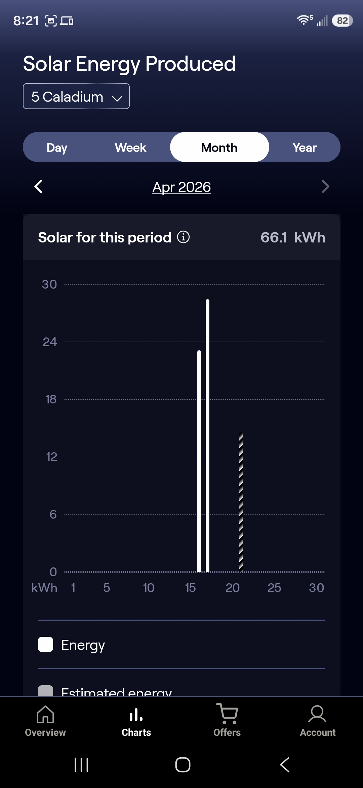

Exhibit B — April 18, 2026, 1:30 PM PT
mySunrun app system overview, two days after the emergency repair on April 16. The 2017 Costco system shows "Outlier detected" status (Sunrun's own anomaly detection flag) with Total: 0.0 kWh, indicating the April 16 repair did not hold.

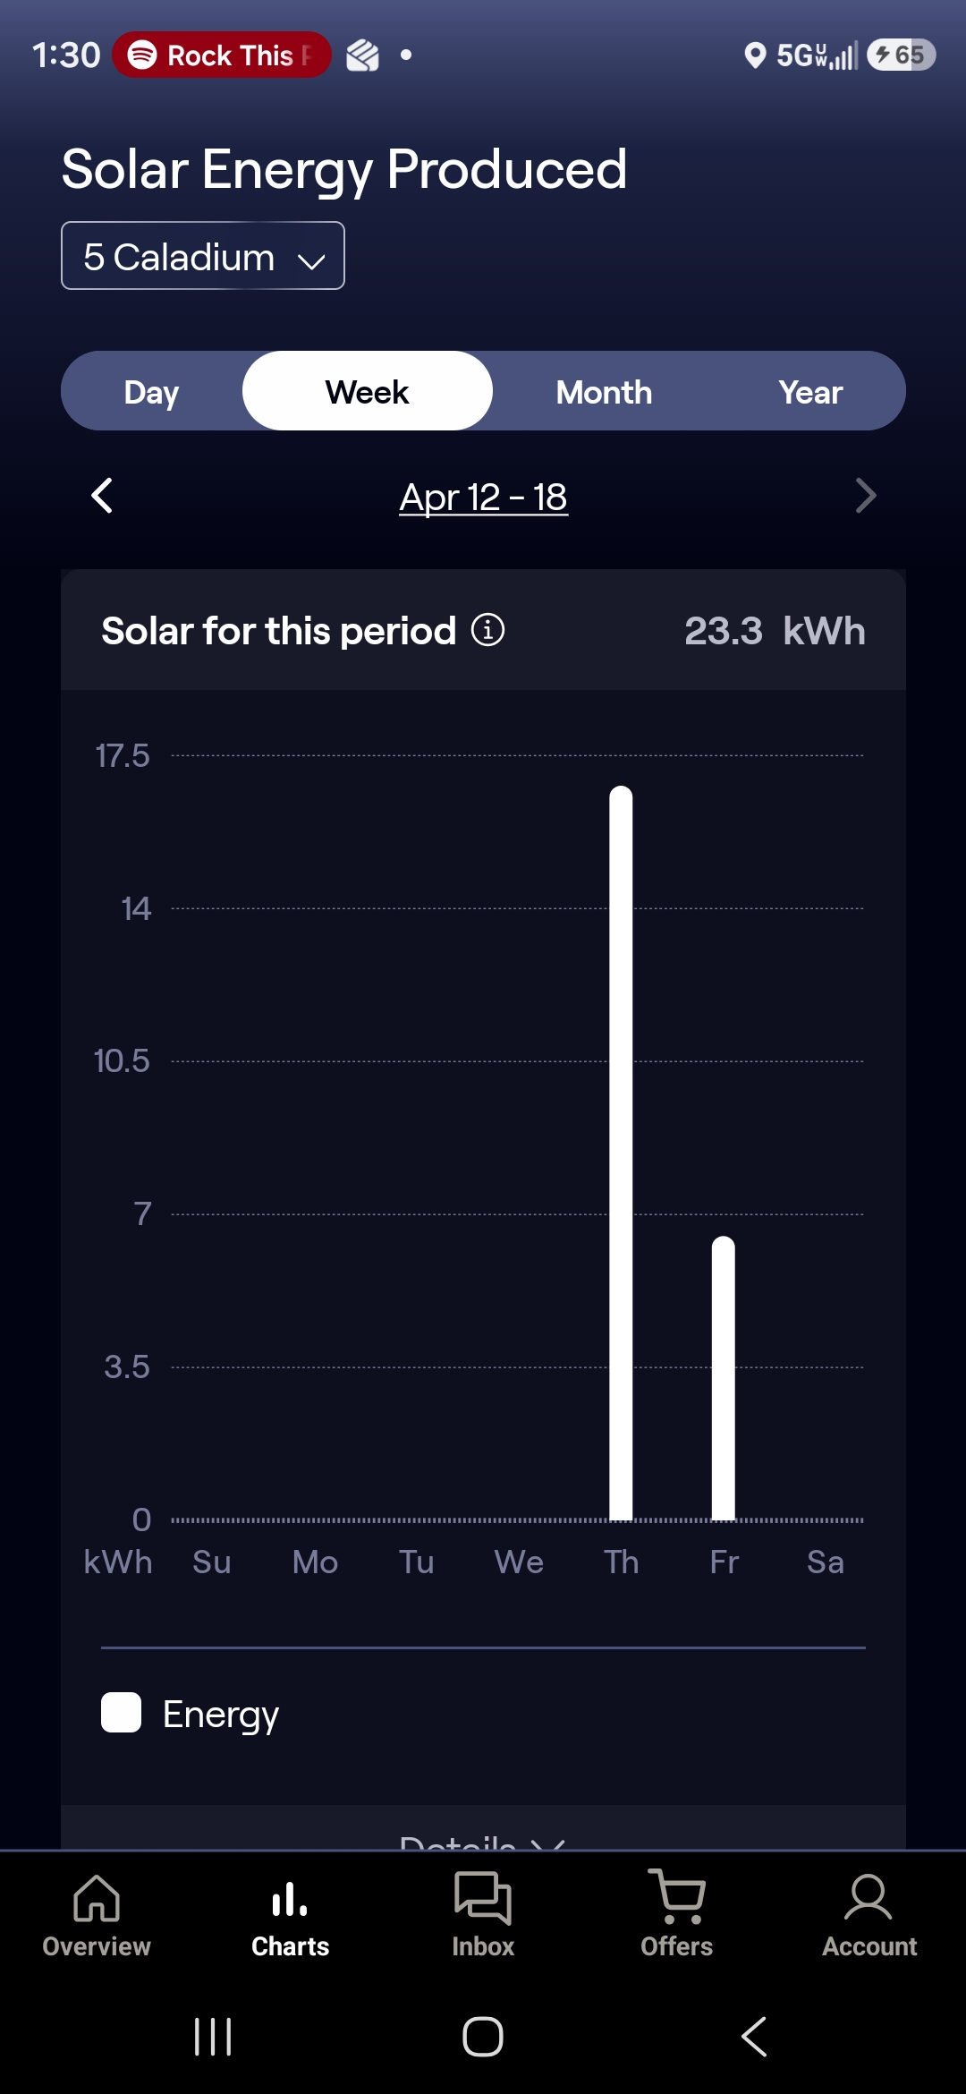

Exhibit C — April 18, 2026, 1:30 PM PT
Additional view of the 2017 system "Outlier detected" status on April 18, 2026.

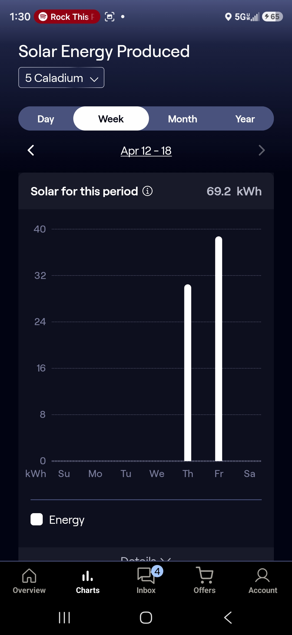

Exhibit D — April 18, 2026, 1:30 PM PT
Weekly production chart April 12-18, 2026. Bars appear only on Thursday April 16 and Friday April 17 (day of and day after the emergency tech visit), then return to zero on Saturday April 18 — two days after the alleged repair.

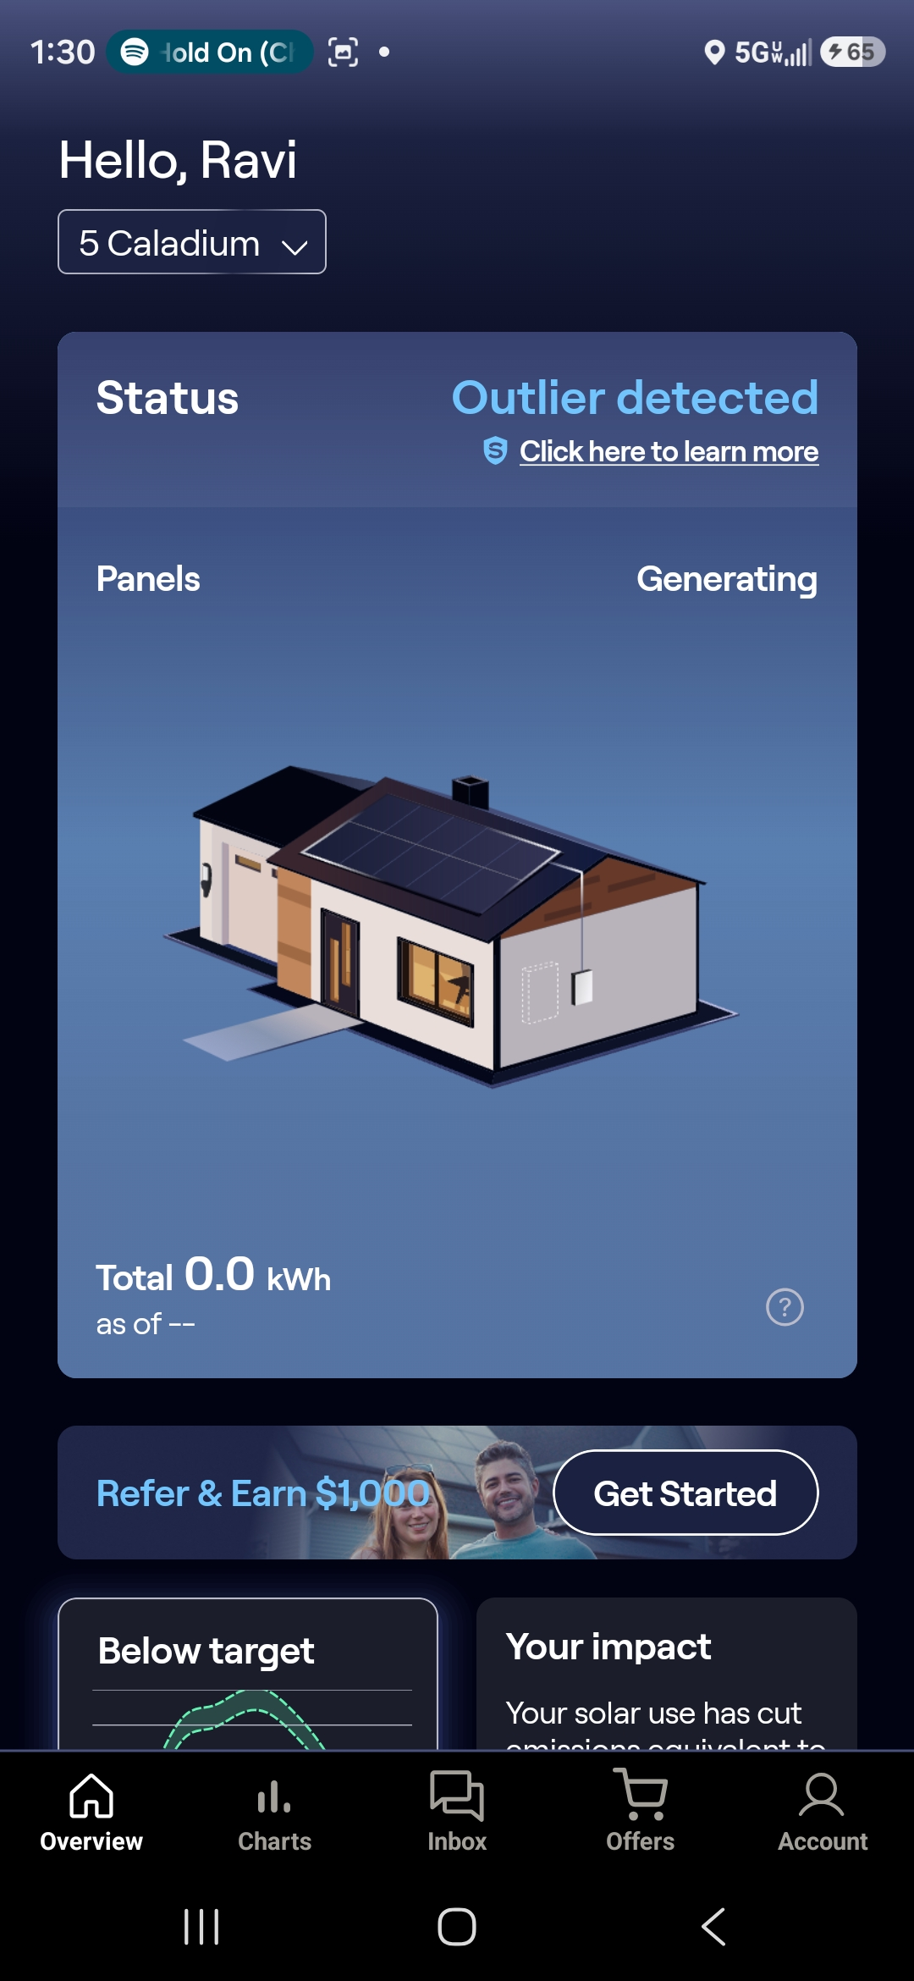

Exhibit E — April 18, 2026, 1:30 PM PT
Final April 18 view confirming the 2017 system was non-operational two days post-repair.

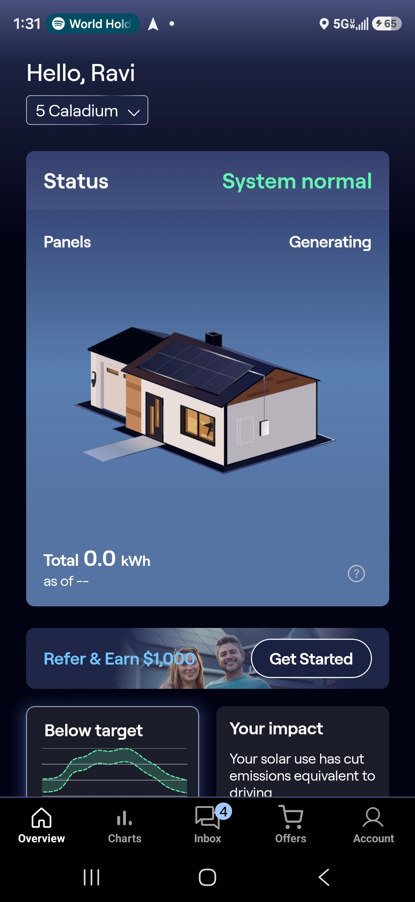

Enclosures (Separately Attached)
The following physical documents are enclosed with this complaint, each referenced by the labels below:

Enclosure 1 — 2012 Sunrun Prepaid Power Purchase Agreement (Doc PI139KV7A331V-A), executed 9/12/2012
Enclosure 2 — 2017 Costco Home Improvement Sales Contract with Sunrun Installation Services, executed 10/12/2017; PTO 3/14/2018
Enclosure 3 — SDG&E bills, Account 0036 1837 1728 9, for billing periods:
(a) October 2025, (b) November 2025, (c) December 2025, (d) January 2026,
(e) February 2026, (f) March 2026, (g) April 2026
Enclosure 4 — Katherine Wilson (Sunrun) email thread, April 15, 2026 through April 22, 2026
Enclosure 5 — Ravi Jain formal written warranty demand letter dated April 17, 2026
Enclosure 6 — CPUC closing letter, Commission File #726931, dated April 21, 2026 (jurisdiction referral to CSLB)
Enclosure 7 — mySunrun app screenshots (Exhibits A through E, also embedded herein)

Certification
I declare under penalty of perjury under the laws of the State of California that the foregoing is true and correct to the best of my knowledge.

_______________________________________
Ravi Jain, Complainant
Date executed: _______________________
Location: Rancho Santa Margarita, California

