Assignment 1 Name_______________________________
- Install the latest version of the following browsers (or the browser of your choice. ) Please check the checkbox and write down the version of your browser once you are done. You need to have at least three different browsers to test your program.
- Microsoft Edge or Safari __________________________
- FireFox or any other browser _____________________________
- Chrome ____________________________

- Please create the following folders in your main website directory.
  - doc
  - img
  - css
  - js
- Please created a HTML5 document that.(Do not use any style attribute or embedded CSS in the file)
- Named “index.html”
- Title of the document: CSCI225 Homepage of _______ (Put your name)
- Header Element(<header>)
Contains an unordered list of at least five items – nav element
        - Hyperlink to USCA main websites
        - Internal link to Assignment Section
        - Internal link to Schedule Section
        - Other links of your choice

- Main Content Area (<main> , <section> or <article>)
Contains an Introduction Section – <section> with class name introduction
  - Use h2 for Section Title “Introduction”
  - Use p for a paragraph that contains a brief introduction about yourselves.(4 to 5 sentences)
  - Use IMG to insert a picture of your choice in this section
Contains a Portfolio Section—<section> with class name portfolio
  - Use h2 for Section Title “Portfolio”
  - Contains list of your previous projects
  - Short description of your projects and technical skills involved
Contains a Schedule Section--- <section> with class name schedule
  - Use h2 for Section Title “Schedule”
  - Create a simple table to show your current course schedule. (Please do not share your real schedule if you have privacy concerns)
  - (Extra Credit) You may create a complex table as the one on the back.

- Sidebar Area (<aside>)
Use h2 for Section Title “Assignment”
Contains an ordered list of homework assignment
The first item is a link to Assignment1.docx

- Footer Area (<footer>)
Contains a Contact Information Section—use addresss element
  - Use p for Section Title “Contact Information”
  - Contains a mail to link to your email address
  - Or other contact information that you want to share with the public
  - Please do not put your cell phone and/or home address on public website
Contains a Copyright Section

- Use at least three decoration/editorial tags which were not covered in class. Tag names are ________________________________________
- You might put other information on this page as long as the contents are appropriate.
- Before you submit your file, be sure to check this checklist.
- Validator your file through http://validator.w3.org/check
- Upload index.html, Assignment1.pdf, the image of your choice to your GitHub CSCI225 repository. Please make sure you put them in the right folder.
- Test your submission ---Go to your course website http://xxxx.github.io/CSCI225 (XXXX is your GitHub username) using all three types of web browser. Make sure all links are working!

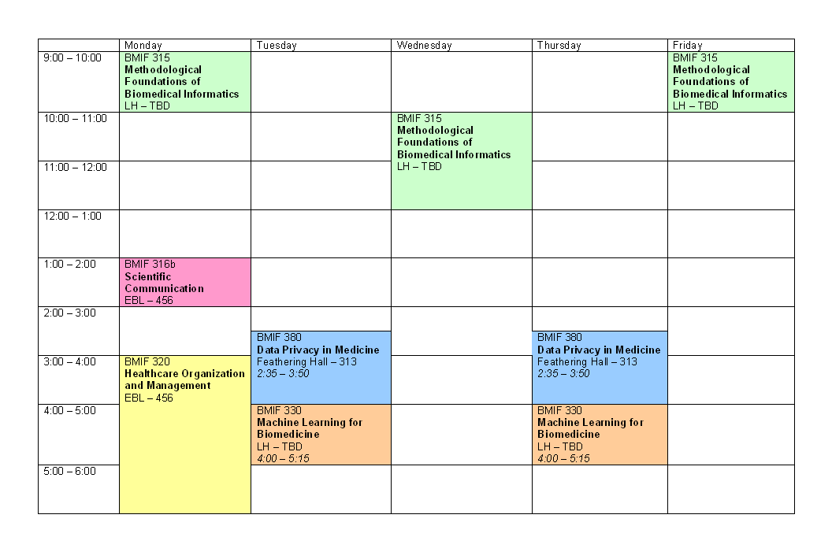
A complex course schedule sample. Use rowspan appropriately!

