**PCT Service to be Introduced in Thailand**

The PCT Service to be introduced in Thailand by TelecomAsia will be the First Public PHS Service offered outside Japan  
TelecomAsia Corporation Public Company Limited (TA) was established in 1991 after it had obtained the BTO (Build, Transfer and Operate) license from the Telephone Organization of Thailand (TOT). After five years of great effort, TA completed the installation of a 2.6 million fixed-line telephone network in the Bangkok Metropolitan Area (BMA) on September 30, 1996. Its complete digital network is considered to be one of the most modern in the world.  
  
[[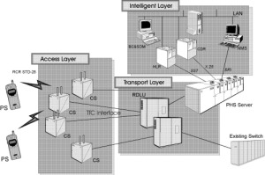](http://www.phsmou.org/newsletter/issue8/images/chart1.jpg)](http://www.phsmou.org/newsletter/issue8/images/chart1.jpg)

With the license grant by the TOT, TelecomAsia announced plans to introduce public PHS service in the Bangkok metropolitan area, which will be the first public PHS service outside Japan. The following is an outline of the PHS service planned by TelecomAsia.  
  
In Thailand, public PHS service is to be introduced slightly different from that in Japan, where the first PHS service is being operated. PHS service in Thailand will be integrated as part of a fixed-line telephone network with the same subscriber number. The service is called PCT (Personal Cordless Telephone).  
  
One universal number for an individual, which can reach them wherever they are, has been discussed over several years but has been limited to applications with a small number of subscribers. PCT service is considered to be one of the earliest network-wide solutions due to its PSTN base approach.   
  
PCT service has evolved by integrating two technologies together, Advanced Intelligent Network for number portability and Wireless Communications technology for mobility of service.  
  
[[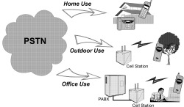](http://www.phsmou.org/newsletter/issue8/images/chart2.jpg)](http://www.phsmou.org/newsletter/issue8/images/chart2.jpg)PCT can be described as an extension service of the fixed-line telephone where the subscribers can use their cordless handset outside their premises. To apply for the service, subscribers simply purchase a PCT handset, and pay an additional fee. If there is an incoming call to the PCT subscriber, the network will check the status and location of the PCT handset and divert the call accordingly.  
  
If the PCT handset cannot be reached, the network will route the call back to the fixed line. Subscribers can also use the PCT handset at home or the office by purchasing a Home Base Unit (HBU) which is connected to any standard telephone jack. Subscribers can also use their PCT handset to make originating calls to any destination as usual from within the radio coverage area of public cell stations.  
  
PCT service is slated to begin in the fourth quarter of 1997. In Japan, PHS subscribers exceeded 5 million by the end of January 1997. PCT subscribers in Thailand are expected to reach more than 1.5 million in three to five years from the initial introduction.