Core Strengthening Workout Programs

Sample Core Workout 1

Print

1

[Cable Crunch](https://www.bodybuilding.com/exercises/detail/view/name/cable-crunch)

3 sets, 12-15 reps (30-45 seconds rest)

[[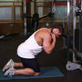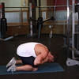](https://www.bodybuilding.com/exercises/detail/view/name/cable-crunch)](https://www.bodybuilding.com/exercises/detail/view/name/cable-crunch)

2

[Barbell Side Bend](https://www.bodybuilding.com/exercises/detail/view/name/barbell-side-bend)

3 sets, 12 reps (30 seconds rest)

[[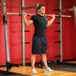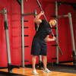](https://www.bodybuilding.com/exercises/detail/view/name/barbell-side-bend)](https://www.bodybuilding.com/exercises/detail/view/name/barbell-side-bend)

3

[Crunches](https://www.bodybuilding.com/exercises/detail/view/name/crunches)

3 sets, 12 reps (30 seconds rest)

[[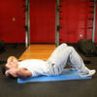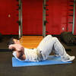](https://www.bodybuilding.com/exercises/detail/view/name/crunches)](https://www.bodybuilding.com/exercises/detail/view/name/crunches)

4

[Reverse Crunch](https://www.bodybuilding.com/exercises/detail/view/name/reverse-crunch)

3 sets, 12-15 reps (45 seconds rest)

[[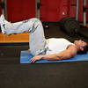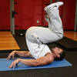](https://www.bodybuilding.com/exercises/detail/view/name/reverse-crunch)](https://www.bodybuilding.com/exercises/detail/view/name/reverse-crunch)

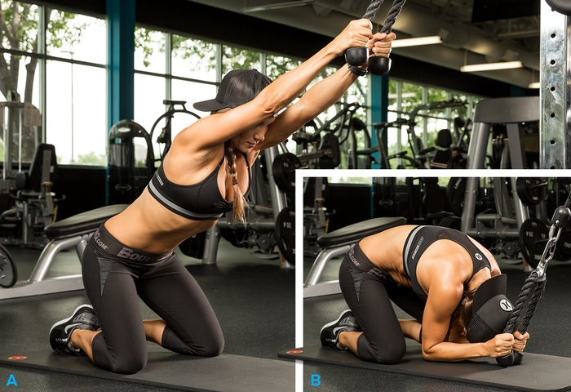

Cable Crunch

Sample Core Workout 2

Print

1

[Seated Barbell Twist](https://www.bodybuilding.com/exercises/detail/view/name/seated-barbell-twist)

3 sets, 8-12 reps (30 seconds rest)

[[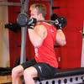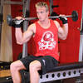](https://www.bodybuilding.com/exercises/detail/view/name/seated-barbell-twist)](https://www.bodybuilding.com/exercises/detail/view/name/seated-barbell-twist)

2

[Air Bike](https://www.bodybuilding.com/exercises/detail/view/name/air-bike)

3 sets, 12 reps (30 seconds rest)

[[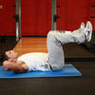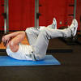](https://www.bodybuilding.com/exercises/detail/view/name/air-bike)](https://www.bodybuilding.com/exercises/detail/view/name/air-bike)

3

[Crunch - Hands Overhead](https://www.bodybuilding.com/exercises/detail/view/name/crunch-hands-overhead)

3 sets, 12-15 reps (30 seconds rest)

[[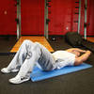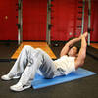](https://www.bodybuilding.com/exercises/detail/view/name/crunch-hands-overhead)](https://www.bodybuilding.com/exercises/detail/view/name/crunch-hands-overhead)

4

[Flat Bench Lying Leg Raise](https://www.bodybuilding.com/exercises/detail/view/name/flat-bench-lying-leg-raise)

3 sets, 8 reps (30 seconds rest)

[[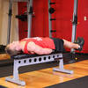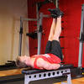](https://www.bodybuilding.com/exercises/detail/view/name/flat-bench-lying-leg-raise)](https://www.bodybuilding.com/exercises/detail/view/name/flat-bench-lying-leg-raise)

Sample Core Workout 3

Print

1

[Frog Sit-Ups](https://www.bodybuilding.com/exercises/detail/view/name/frog-sit-ups)

3 sets, 12-15 reps (30 seconds rest)

[[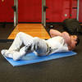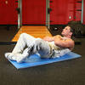](https://www.bodybuilding.com/exercises/detail/view/name/frog-sit-ups)](https://www.bodybuilding.com/exercises/detail/view/name/frog-sit-ups)

2

[Jackknife Sit-Up](https://www.bodybuilding.com/exercises/detail/view/name/jackknife-sit-up)

3 sets, 12-15 reps (30 seconds rest)

[[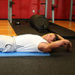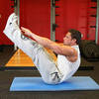](https://www.bodybuilding.com/exercises/detail/view/name/jackknife-sit-up)](https://www.bodybuilding.com/exercises/detail/view/name/jackknife-sit-up)

3

[Oblique Crunches](https://www.bodybuilding.com/exercises/detail/view/name/oblique-crunches)

3 sets, 12 reps (30 seconds rest)

[[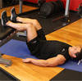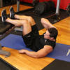](https://www.bodybuilding.com/exercises/detail/view/name/oblique-crunches)](https://www.bodybuilding.com/exercises/detail/view/name/oblique-crunches)

4

[Reverse Crunch](https://www.bodybuilding.com/exercises/detail/view/name/reverse-crunch)

3 sets, 12-15 reps (30 seconds rest)

[[](https://www.bodybuilding.com/exercises/detail/view/name/reverse-crunch)](https://www.bodybuilding.com/exercises/detail/view/name/reverse-crunch)

Sample Core Workout 4

Print

1

[Russian Twist](https://www.bodybuilding.com/exercises/detail/view/name/russian-twist)

3 sets, 12-15 reps (30 seconds rest)

[[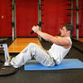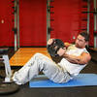](https://www.bodybuilding.com/exercises/detail/view/name/russian-twist)](https://www.bodybuilding.com/exercises/detail/view/name/russian-twist)

2

[Ab Crunch Machine](https://www.bodybuilding.com/exercises/detail/view/name/ab-crunch-machine)

3 sets, 8-12 reps (30-55 seconds rest)

[[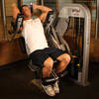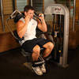](https://www.bodybuilding.com/exercises/detail/view/name/ab-crunch-machine)](https://www.bodybuilding.com/exercises/detail/view/name/ab-crunch-machine)

3

[Barbell Side Bend](https://www.bodybuilding.com/exercises/detail/view/name/barbell-side-bend)

1 set, 8 reps (each side, 30 seconds rest)

[[](https://www.bodybuilding.com/exercises/detail/view/name/barbell-side-bend)](https://www.bodybuilding.com/exercises/detail/view/name/barbell-side-bend)

4

[Crunch - Legs On Exercise Ball](https://www.bodybuilding.com/exercises/detail/view/name/crunch-legs-on-exercise-ball)

3 sets, 8-12 reps (30 seconds rest)

[[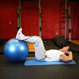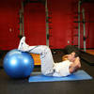](https://www.bodybuilding.com/exercises/detail/view/name/crunch-legs-on-exercise-ball)](https://www.bodybuilding.com/exercises/detail/view/name/crunch-legs-on-exercise-ball)

Sample Core Workout 5

Print

1

[Decline Crunch](https://www.bodybuilding.com/exercises/detail/view/name/decline-crunch)

3 sets, 8-12 reps (30-45 seconds rest)

[[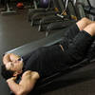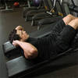](https://www.bodybuilding.com/exercises/detail/view/name/decline-crunch)](https://www.bodybuilding.com/exercises/detail/view/name/decline-crunch)

2

[Dumbbell Side Bend](https://www.bodybuilding.com/exercises/detail/view/name/dumbbell-side-bend)

3 sets, 8 reps (30 seconds rest)

[[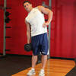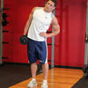](https://www.bodybuilding.com/exercises/detail/view/name/dumbbell-side-bend)](https://www.bodybuilding.com/exercises/detail/view/name/dumbbell-side-bend)

3

[Exercise Ball Crunch](https://www.bodybuilding.com/exercises/detail/view/name/exercise-ball-crunch)

3 sets, 12-15 reps (30 seconds rest)

[[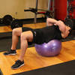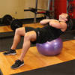](https://www.bodybuilding.com/exercises/detail/view/name/exercise-ball-crunch)](https://www.bodybuilding.com/exercises/detail/view/name/exercise-ball-crunch)

4

[Flat Bench Leg Pull-In](https://www.bodybuilding.com/exercises/detail/view/name/flat-bench-leg-pull-in)

3 sets, 12 reps (30 seconds rest)

[[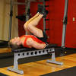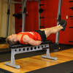](https://www.bodybuilding.com/exercises/detail/view/name/flat-bench-leg-pull-in)](https://www.bodybuilding.com/exercises/detail/view/name/flat-bench-leg-pull-in)

Conclusion

There you have it: five core strengthening workouts. I like to work my core every 2-3 days. Try rotating these 5 workouts into your workout split. These workouts sure will help you get that strong muscular core you are looking for.

Remember quality over quantity with the core. Stick with the programs listed above and you will be just fine. As always if you have any questions don't hesitate to drop me an [email](mailto:stewbid@comcast.net).