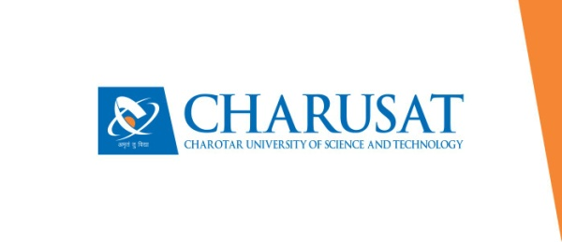

**CERTIFICATE**

This is to certify that the report entitled “Cake Boutique” is a bonafied work carried out by **Mr. Akshat Chhaya (19DIT008)** under the guidance and supervision of **Assistant Prof. Mohammed Bohra & Assistant Prof. Krishna Patel** for the subject IT251 **Java Programming (**IT) of 3rd Semester of Bachelor of Technology in **DEPSTAR** at Faculty of Technology & Engineering – CHARUSAT, Gujarat.

To the best of my knowledge and belief, this work embodies the work of candidate himself, has duly been completed, and fulfills the requirement of the ordinance relating to the B.Tech. Degree of the University and is up to the standard in respect of content, presentation and language for being referred to the examiner.

|  |  |
| --- | --- |
| Mohammed Bohra  Assistant Professor  Department of Computer Engineering  DEPSTAR, Changa, Gujarat. |  |
| Krishna Patel  Assistant Professor  Department of Computer Science and Engineering  DEPSTAR, Changa, Gujarat.  Dr. Amit Ganatra  Principal, DEPSTAR  Dean, FTE  CHARUSAT, Changa, Gujarat. | |

**Devang Patel Institute of Advance Technology And Research At: Changa, Ta. Petlad, Dist. Anand, PIN: 388 421. Gujarat**