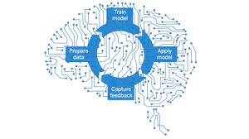

Today’s leading organizations are using machine learning–based tools to automate decision processes, and they’re starting to experiment with more-advanced uses of artificial intelligence (AI) for digital transformation. Corporate investment in artificial intelligence is predicted to triple in 2017, becoming a $100 billion market by 2025. Last year alone saw $5 billion in machine learning venture investment. In a recent survey, 30% of respondents predicted that AI will be the biggest disruptor to their industry in the next five years. This will no doubt have profound effects on the workplace.

So What Is Machine Learning?

* Automating automation
* Getting computers to program themselves
* Writing software is the bottleneck
* Let the data do the work instead!

“A breakthrough in machine learning would be worth ten Microsofts”

(Bill Gates, Chairman, Microsoft)

**Machine Learning:**

A branch of artificial intelligence, concerned with the design and development of algorithms that allow computers to evolve behaviors based on empirical data.

As intelligence requires knowledge, it is necessary for the computers to acquire knowledge.

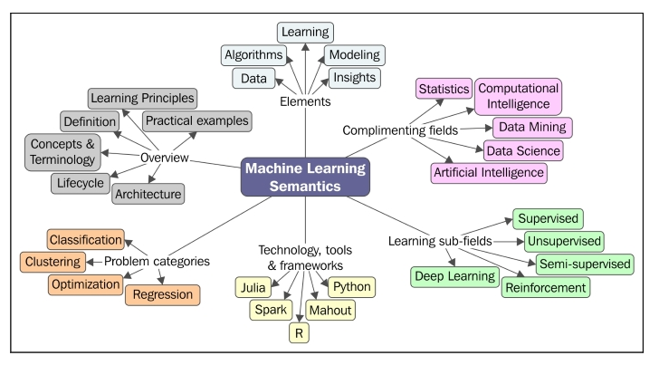

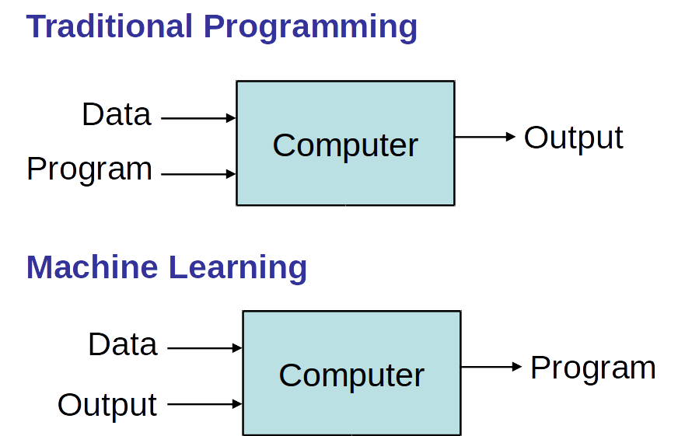

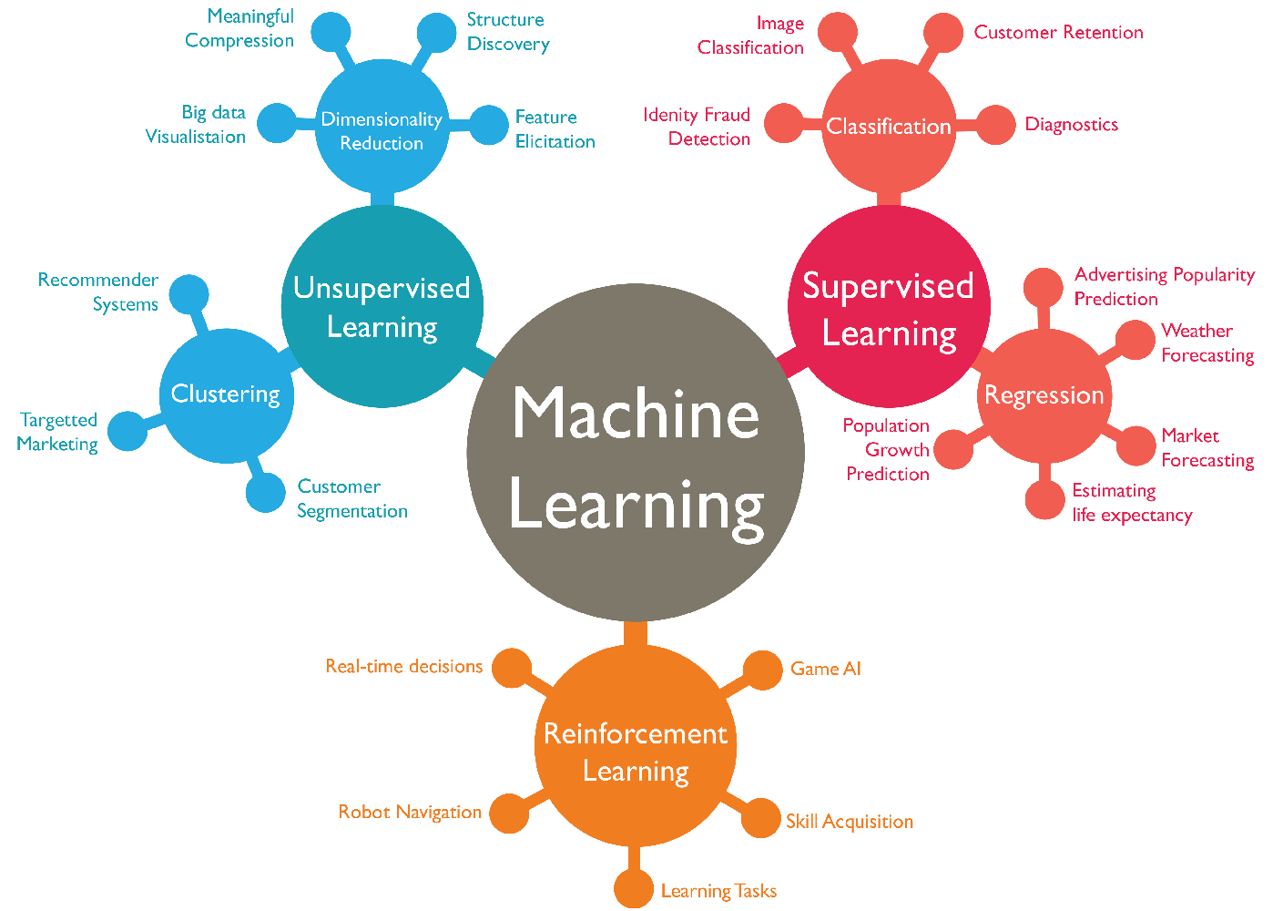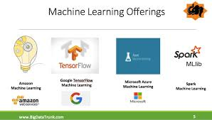

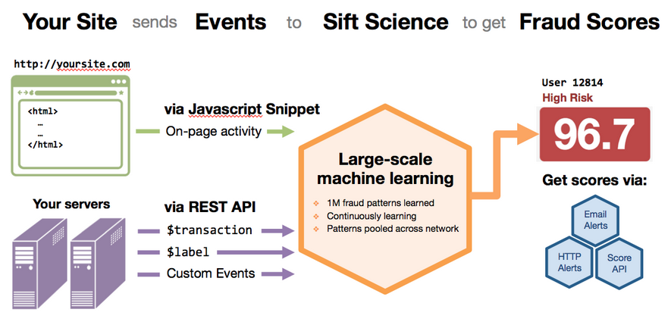

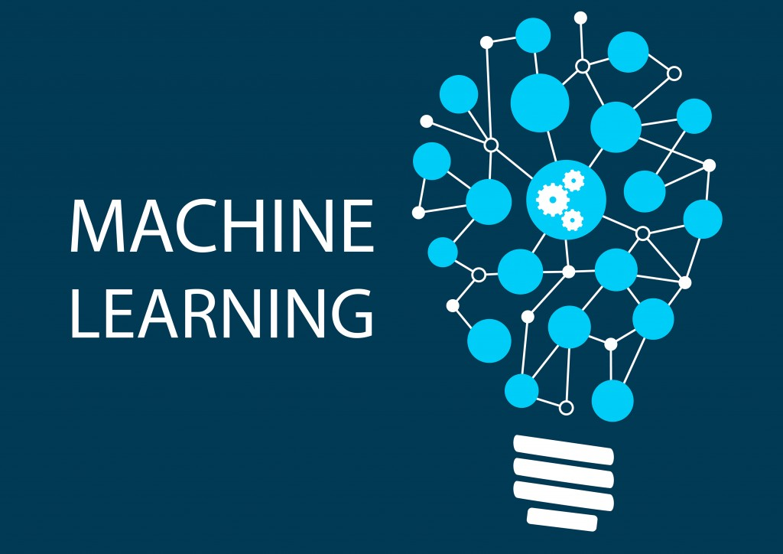

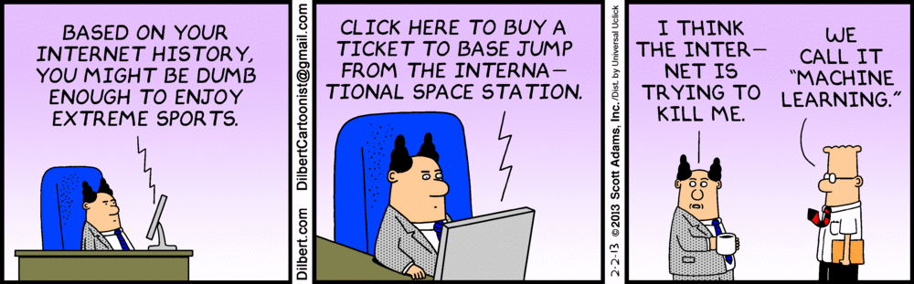

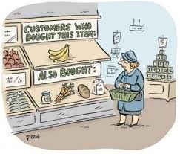

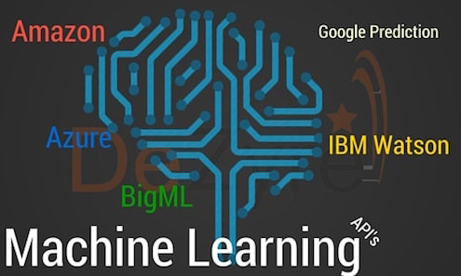

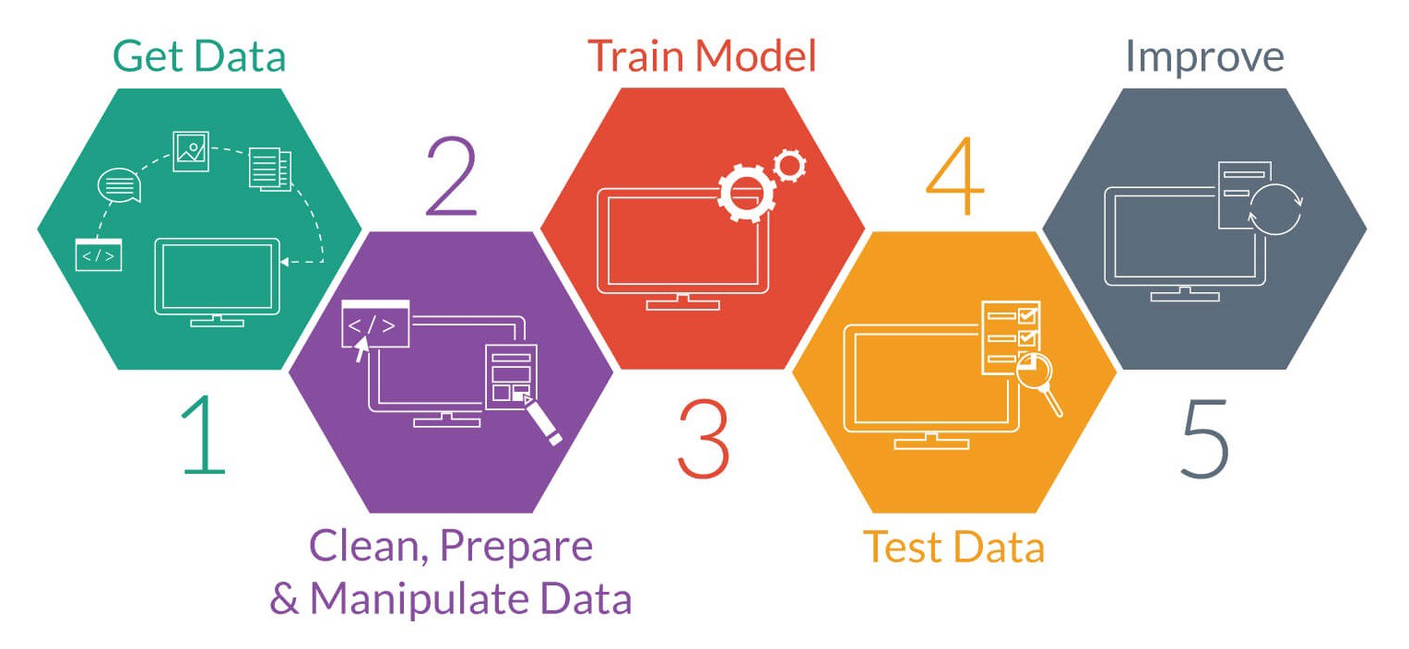

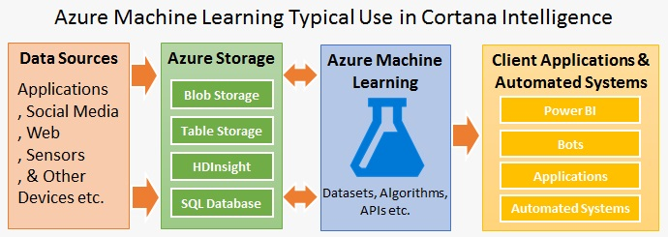

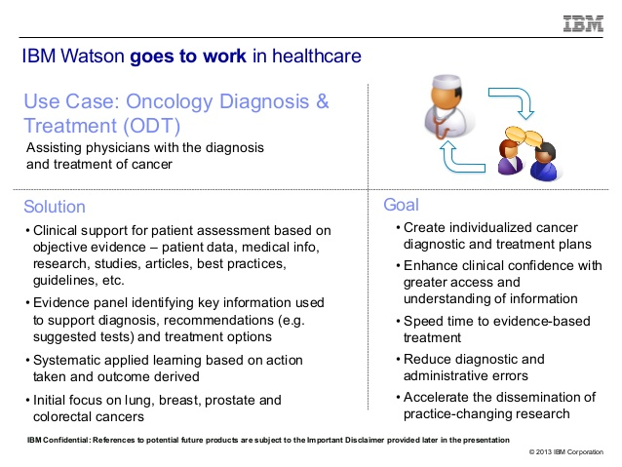

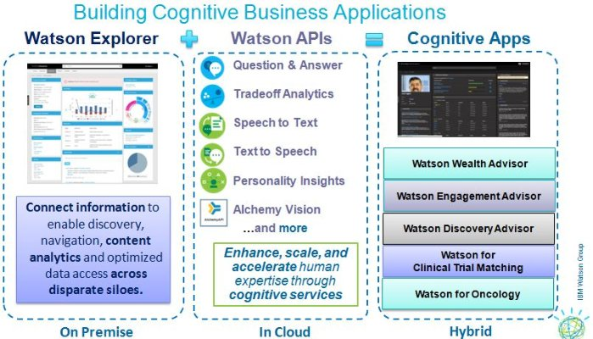

Machine Learning in Telecom

■ Customers – Behavior, Experience, Churn

■ Devices – Uptake, Performance, Failure

■ Networks – Performance, Failure

■ Campaigns – Uptake, Network Impact

■ Services – Uptake, Performance, Failure, Network Impact

▪ Customer Segmentation and recommendations Machine vs. Management Machine as tursted advisor to Management

**Open-source libraries: Widely available machine learning libraries like Google’s** TensorFlow **and** scikit-learn **make cutting edge algorithms more accessible to a wider audience of data scientists and generalist software engineers.**

1. **Marketing Personalization**

The more you can understand about your customers, the better you can serve them, and the more you will sell.  That’s the foundation behind marketing personalisation. Perhaps you’ve had the experience in which you visit an online store and look at a product but don’t buy it — and then see digital ads across the web for that *exact* product for days afterward. That kind of marketing personalization is just the tip of the iceberg. Companies can personalize which emails a customer receives, which direct mailings or coupons, which offers they see, which products show up as “recommended” and so on, all designed to lead the consumer more reliably towards a sale.

1. **Fraud Detection**

Machine learning is getting better and better at spotting potential cases of fraud across many different fields. [PayPal](http://www.informationweek.com/strategic-cio/executive-insights-and-innovation/11-cool-ways-to-use-machine-learning/d/d-id/1323375?image_number=5), for example, is using machine learning to fight money laundering. The company has tools that compare millions of transactions and can precisely distinguish between legitimate and fraudulent transactions between buyers and sellers.

1. **Recommendations**

You’re probably familiar with this use if you use services like Amazon or Netflix. Intelligent machine learning algorithms analyze your activity and compare it to the millions of other users to determine what you might like to buy or binge watch next. These recommendations are getting smarter all the time, recognizing, for example, that you might purchase certain things as gifts (and not want the item yourself) or that there might be different family members who have different TV preferences.

1. **Online Search**

Perhaps the most famous use of machine learning, Google and its competitors are constantly improving what the search engine understands. Every time you execute a search on Google, the program watches how you respond to the results. If you click the top result and stay on that web page, we can assume you got the information you were looking for and the search was a success.  If, on the other hand, you click to the second page of results, or type in a new search string without clicking any of the results, we can surmise that the search engine didn’t serve up the results you wanted — and the program can learn from that mistake to deliver a better result in the future.

1. **Natural Language Processing (NLP)**

NLP is being used in all sorts of exciting applications across disciplines. Machine learning algorithms with natural language can stand in for customer service agents and more quickly route customers to the information they need. It’s being used to translate obscure legalese in contracts into plain language and help attorneys sort through large volumes of information to prepare for a case.

1. **Smart Cars**

IBM recently [surveyed](http://www-935.ibm.com/services/multimedia/GBE03640USEN.pdf) top auto executives, and 74% expected that we would see smart cars on the road by 2025. A smart car would not only integrate into the Internet of Things, but also learn about its owner and its environment. It might adjust the internal settings — temperature, audio, seat position, etc. — automatically based on the driver, report and even fix problems itself, drive itself, and offer real time advice about traffic and road conditions.

**7.Data Security**

Malware is a huge — and growing — problem. In 2014, [Kaspersky Lab](http://www.kaspersky.com/about/news/virus/2014/Kaspersky-Lab-is-Detecting-325000-New-Malicious-Files-Every-Day) said it had detected 325,000 new malware files *every day*. But, institutional intelligence company Deep Instinct says that each piece of new malware tends to have almost the same code as previous versions — only between 2 and 10% of the files change from iteration to iteration. Their learning model has no problem with the 2–10% variations, and can predict which files are malware with great accuracy. In other situations, machine learning algorithms can look for patterns in how data in the cloud is accessed, and report anomalies that could predict security breaches.

**8.Personal Security**

If you’ve flown on an airplane or attended a big public event lately, you almost certainly had to wait in long security screening lines. But machine learning is proving that it can be an asset to help eliminate false alarms and spot things human screeners might miss in security screenings at airports, stadiums, concerts, and other venues. That can speed up the process significantly and ensure safer events.

**9.Financial Trading**

Many people are eager to be able to predict what the stock markets will do on any given day — for obvious reasons. But machine learning algorithms are getting closer all the time. Many prestigious trading firms use proprietary systems to predict and execute trades at high speeds and high volume. Many of these rely on probabilities, but even a trade with a relatively low probability, at a high enough volume or speed, can turn huge profits for the firms. And humans can’t possibly compete with machines when it comes to consuming vast quantities of data or the speed with which they can execute a trade.

**10.Healthcare**

Machine learning algorithms can process more information and spot more patterns than their human counterparts. One study used [computer assisted diagnosis (CAD)](http://www.cancernetwork.com/articles/computer-technology-helps-radiologists-spot-overlooked-small-breast-cancers) when to review the early mammography scans of women who later developed breast cancer, and the computer spotted 52% of the cancers as much as a year before the women were officially diagnosed. Additionally, machine learning can be used to understand risk factors for disease in large populations. The company [Medecision](https://www.medecision.com/) developed an algorithm that was able to identify eight variables to predict avoidable hospitalizations in diabetes patients.

11. **Drone- and satellite-based asset management**Drones equipped with cameras can perform regular external inspections of commercial structures, like bridges or airplanes, with the images automatically analyzed to detect any new cracks or changes to surfaces.

Big Companies which adopted Machine Learning

**01.**[**GOOGLE**](https://www.fastcompany.com/3067457/most-innovative-companies/why-google-is-one-of-the-most-innovative-companies-of-2017)  
For developing a photographic memory

**02.**[**IBM**](https://www.fastcompany.com/company/ibm)  
For embedding Watson where it’s needed most

**03.**[**BAIDU**](https://www.fastcompany.com/company/baidu)  
For accelerating mobile search with artificial intelligence

**04.**[**SOUNDHOUND**](https://www.fastcompany.com/company/soundhound)  
For giving digital services the power of human speech

**05.**[**ZEBRA MEDICAL VISION**](https://www.fastcompany.com/company/zebra-medical)  
For using deep learning to predict and prevent disease

**06.**[**PRISMA**](https://www.fastcompany.com/company/prisma)  
For making masterpieces out of snapshots

**07.**[**IRIS AI**](https://www.fastcompany.com/company/iris-ai)  
For speeding up scientific research by surfacing relevant data

**08.**[**PINTEREST**](https://www.fastcompany.com/company/pinterest)  
For serving up a universe of relevant pins to each and every user

**09.**[**TRADEMARKVISION**](https://www.fastcompany.com/company/trademarkvision)  
For helping startups make their mark without any legal confusion

**10.**[**DESCARTES LABS**](https://www.fastcompany.com/company/descartes-labs)  
For preventing food shortages by predicting crop yields

11.Facebook – Chatbot Army

researching [computer vision algorithms that can “read” images to visually impaired people](https://research.fb.com/category/applied-machine-learning/).

12.Twitter – Curated Timelines

Twitter’s AI evaluates each tweet in real time and “scores” them according to various metrics.

13.Yelp

Yelp’s machine learning algorithms help the company’s human staff to compile, categorize, and label images more efficiently

14. Salesforce

Salesforce Einstein allows businesses that use Salesforce’s CRM software to analyze every aspect of a customer’s relationship

Indian Companies

1.**Hotstar**:

an online media streaming platform, has over 100 million users and captures close to a billion click stream messages daily.

2.**Haptik**:

an advance chat based mobile assistant, is looking to grow it’s Machine Learning team to strengthen and expand its automation capabilities and build scalable unsupervised question answering systems across multiple domains using Natural Language Processing, ML and deep learning.

3.**McAfee:**

4.**Makemytrip**:

is changing the way india travels by creating a seamless experience for those bitten by the travel bug

5.**Amazon** is building a team of machine learning scientists at Hyderabad, who can use Machine Learning, NLP, Statistics and Optimization techniques to build the next generation of intelligent customer service technology platforms at Amazon.

When to learn

Human expertise does not exist (navigating on Mars)

Humans are unable to explain their expertise (speech recognition)

Solution changes in time (routing on a computer network)

Solution needs to be adapted to particular cases (user biometrics)

Learning involves

Learning general models from data

Data is cheap and abundant. Knowledge is expensive and scarce

Customer transactions to computer behaviour

Build a model that is a good and useful approximation to the data

Applications

* Speech and hand-writing recognition
* Autonomous robot control
* Data mining and bioinformatics: motifs, alignment, …
* Playing games
* Fault detection
* Clinical diagnosis
* Spam email detection
* Credit scoring, fraud detection
* Web mining: search engines
* Market basket analysis,

Applications are diverse but methods are generic

Types of Learning

Supervised (inductive) learning

Training data includes desired outputs

Unsupervised learning

Training data does not include desired outputs

Semi-supervised learning

Training data includes a few desired outputs

Reinforcement learning

Rewards from sequence of actions

1. Supervised Learning

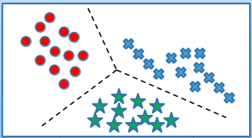

Supervised Learning AlgorithmsInput data is called training data and has a known label or result such as spam/not-spam or a stock price at a time.

A model is prepared through a training process in which it is required to make predictions and is corrected when those predictions are wrong. The training process continues until the model achieves a desired level of accuracy on the training data.

Example problems are classification and regression.

Example algorithms include Logistic Regression and the Back Propagation Neural Network.

2. Unsupervised Learning

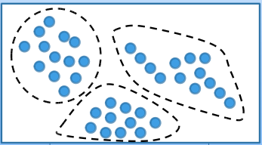

Unsupervised Learning AlgorithmsInput data is not labeled and does not have a known result.

A model is prepared by deducing structures present in the input data. This may be to extract general rules. It may be through a mathematical process to systematically reduce redundancy, or it may be to organize data by similarity.

Example problems are clustering, dimensionality reduction and association rule learning.

Example algorithms include: the Apriori algorithm and k-Means.

3. Semi-Supervised Learning

Semi-supervised Learning AlgorithmsInput data is a mixture of labeled and unlabelled examples.

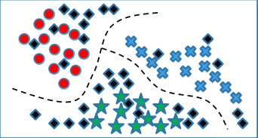There is a desired prediction problem but the model must learn the structures to organize the data as well as make predictions.

Example problems are classification and regression.

Example algorithms are extensions to other flexible methods that make assumptions about how to model the unlabeled data.

4. Reinforcement learning

Using this algorithm, the machine is trained to make specific decisions. It works this way: the machine is exposed to an environment where it trains itself continually using trial and error. This machine learns from past experience and tries to capture the best possible knowledge to make accurate business decisions.

**Some Common Algorithms:**

1. Naïve Bayes Classifier Algorithm
2. K Means Clustering Algorithm
3. Support Vector Machine Algorithm
4. Apriori Algorithm
5. Linear Regression
6. Logistic Regression
7. Artificial Neural Networks
8. Random Forests
9. Decision Trees
10. Nearest Neighbours

what’s next in machine learning trends?

### Machines That Learn More Effectively

Before long, we’ll see artificial intelligences that can learn much more effectively. This will lead to developments in how algorithms are treated, such as AI deployments that can recognize, alter, and improve upon their own internal architecture with minimal human supervision.

### Automation of Cyberattack Countermeasures

The rise of cybercrime and ransomware has forced companies of all sizes to reevaluate how they respond to systemic online attacks. We’ll soon see AI take a much greater role in monitoring, preventing, and responding to cyberattacks like database breaches, DDoS attacks, and other threats.

### Convincing Generative Models

Generative models, such as the ones used by Baidu in our example above, are already incredibly convincing. Soon, we won’t be able to tell the difference at all. Improvements to generative modeling will result in increasingly sophisticated images, voices, and even entire identities generated entirely by algorithms.