
Please e-mail completed form to NTR data management: ntr.datamanagement.fgb@vu.nl

- Applicant information:
DSR Number: |  | <To be completed by NTR data management>
Name: |  | Thomas Sollie
Country: |  | Netherlands
E-mail: |  | t.sollie@vu.nl
Mobile phone number* |  | +31636231345
Username NTR-compute** |  | Click or tap here to enter text.
I am employed by: |  | ☐NTR | ☒VU | ☐External: Click or tap here to enter text.
* to send you the access code for retrieving the data; ** If you don’t have one, leave empty
The following persons will have access to the data under the applicant’s supervision:
Name | Affiliation |  |  | Data storage location
dr. Wonuola Akingbuwa | VU |  |  | NTR compute
enter text | enter text |  |  | enter text
enter text | enter text |  |  | enter text
enter text | enter text |  |  | enter text
- Project (working) title: Sex differences and rater effects of autism polygenic score associations with quantitative autism related traits
- Please provide a short summary (max. 100 words) of your project (will be published on the NTR website after approval of your proposal)
Autism is diagnosed approximately 4 times more often in males than in females. We aim to investigate potential genetic factors contributing to this diagnostic sex ratio by examining associations between polygenic scores (PGS) for autism and autism-related traits in the general population. Analyses will be stratified by sex to explore genetic influences on autism and potential rater biases in self-, parent-, and teacher-reported traits. Autism-related traits will be assessed using ASEBA scales, ensuring consistency across different raters. We will look at the effect of rater gender by comparing mother to father reports.
- Please attach a separate analysis plan (max 3 pages) that includes the following:
- Research question(s) and/or hypotheses
- Brief background and rationale for addressing the research question in NTR (to comply with the GDPR ‘minimal dataset guideline’, include a rationale for the variables requested and the need for the specific sample composition).
- Outline of laboratory analyses (if applicable)
- Outline of statistical analyses and procedures used to address the research questions
- If you request data as part of a consortium effort please add the consortium's Analysis Plan or Standard Operating Protocol (SOP) as an appendix.

- Data requested:
Standard variables
Person information: | ☒Pseudonymized NTR ID (included by default) |  |  |  | ☒Sex
Nuclear family structure: | ☒Family ID | ☒Role in family |  | ☒Singleton/twin/multiple |  | ☐Biological relatedness  (e.g. for exclusion)
Other: | ☒ Twin related variables (e.g. zygosity, birth order, type of multiple, etc.) |  |  |  |  | ☐Extended family structure*
Study-related variables: | ☒Age at measurement |  | ☐Date of measurement
Common covariates: | ☐Educational attainment |  | ☐Adult height
* please state explicitly in your analysis plan why this is essential

Other data
☒ I am attaching a .JSON file (created with the NTR Data Showcase) with the requested variables
☐ genotype data → please fill in section 6
☐ metabolomics data → please fill in section 7
☐ methylation data → please fill in section 8
☒ polygenic scores → please fill in section 9
☐ I need the following data not (yet) incorporated in the NTR Data Showcase: (be as specific as possible, e.g. if survey data are requested please indicate from which survey waves).
Click or tap here to enter text.

- Genotype data
Please note that individual level genotype data can only be requested for analyses performed on secure NTR server under direct supervision of NTR collaborators.
I would like to request:
Imputation base: |  | ☐1000 Genomes |  | ☐HRC ☐TOPMED (older MRG10)
☐Genome wide SNP data
 | Format: | ☐Plink best-guess |  | ☐VCF ☐BGEN
☐All variants in gene: (default is imputed)
 | Chromosome: | start (bp): Click or tap here to enter text. |  | end (bp): Click or tap here to enter text. |  | Genome build: ☐37
☐(Set of) specific SNP(s): (default is imputed)
 | Chromosome: | start (bp): Click or tap here to enter text. |  | end (bp): Click or tap here to enter text. |  | Genome build: ☐37
You can also provide a .csv file as attachment with Chr, start BP + end BP (or RS id), genotyped only Y/N.
A standard set of covariates is included by default: Pseudonymized NTR ID, NTR ID father, NTR ID mother, sex, genotype platform dummies, first 10 genetic principal components, ancestry outlier dummy

- Metabolomics
For information on how to request metabolomics data, please see this document (password mtblmcs@NTR), and specify below what you need.
The following standard set of covariates is included by default: “Age”, “Sex”, “BMI”, “SmokingStatus”, “FastingStatus”, “LipidLoweringMedicationUse”, “DiabetesMedicationUse” and “BatchDummy” (if applicable). All covariates are sampled at biobank sampling. The above covariates should be included in downstream analyses as they are known confounders of the metabolic variables.
Click or tap here to enter text.

- Methylation
Illumina DNA methylation data requested#
☐450k array blood* | ☐450k array buccal ☐ | EPIC array buccal | ☐EPIC array blood (not available yet)
*The blood 450k array data are part of the BIOS consortium. To request these data, you are requested to also submit a BIOS data request: https://www.bbmri.nl/acquisition-use-analyze/bios

Other information:
☐Genome wide array data
☐Specific gene / CpG list. Please specify or attach list: Click or tap here to enter text.
☐Epigenetic clock. Please specify which clock(s): Click or tap here to enter text.
#Currently available datasets are described in the following publications: 450k array blood [PMID: 27051996]; 450k array buccal [PMID: 27051996 & 24802513]; EPIC array buccal [PMID: 33420481; 30253792]. Applicants receive access to the methylation data that have been QC’d as described in these publications.
A standard set of covariates is included by default: age at sampling, sex, recommended technical covariates (96-wells sample plate and position on the chip), cellular proportions (measured or imputed).

Polygenic scores
Please consult the file ArchiveDescription.xlsx here (password: prs@NTR) to check if your phenotype is listed. Note that PRSs of traits not listed in this file need to be generated. In this case the applicant should provide the GWAS summary statistics where the possible NTR contribution is left out, as described in RequestingPRSs.pdf (same folder).
☒ The PRSs I am requesting are listed in the archive
☒ I am requesting new PRSs and will supply the summary statistics
Please specify below or attach as a separate file.

Trait/phenotype | PMID | First author | Listed in archive?
AutismSpectrumDisorder | PMID30804558 | Grove | ☒Yes ☐No
Autism | enter text | This GWAS is unpublished and preliminary summary statistics will be requested from the authors, upon which new PRSs will be requested for the NTR. This will be done later in the analysis. | ☐Yes ☒No
enter text | enter text | enter text | ☐Yes ☐No
enter text | enter text | enter text | ☐Yes ☐No

Comments:
Click or tap here to enter text.
A standard set of covariates is included by default: “GenotypingPlatformDummy” and genotype “PC1” to “PC10” for correction of platform effects and of population stratification in downstream analyses.

- Subject selection

I would like to request data for:
☒ All available subjects with available data for at least one of the requested variables
☐ Only subjects with available data for all of the following variables (please specify):
Click or tap here to enter text.

Additional selection criteria:
☐ None
☒ Restricted subset (e.g. specific age range, only twins, only participants with genotype data, please specify):
Only participants with genotype data.

- Proposed co-authors (in proposed order)
Your project may be served by collaboration with NTR researchers with intrinsic (first-hand) knowledge about the data collection and QC processes of the dataset requested and/or conceptual and methodological expertise with regard to the research proposal. Offering involvement in shaping the data sharing request and co-authorship to such NTR researchers is encouraged. If such participation is vital, the NTR Data Access Request Committee will suggest adding such collaborative participation as part of its review process.
(shared) First: | Thomas Sollie
(shared) Last: | Tinca J.C. Polderman & Wonuola Akingbuwa
Co-authors (2nd, 3rd , … ): | Click or tap here to enter text.
- Timeline for completion and submission of manuscript
By default, the end date of the project is set to 24 months after the approval date. If you need more time, please explain and specify proposed end date.
The end date and submission of manuscript are set to 24 months after approval date.
- Additional funding
If this analysis plan is supported by other funding, please describe here: This project is part of SCANNER cohort and funded by the Dutch Research Council (NWO). Grant: NWA.1518.22.136.
- Data access fee
The data access fee is based on the size of the dataset and the type of data requested. Please provide an estimate*:
*estimate may be adjusted by NTR data management – the actual fees/waiver will be specified in the Data Sharing Agreement. | ☐ Small dataset  ☐ Medium dataset  ☐ Large dataset  ☒ Waived, applicant is a VU employee  ☐ I request a fee waiver based on collaborative involvement of NTR-VU researchers in the project (reflected in first or last authorship responsibilities for NTR and a balanced numbers of co-authors across the participating institutes)  Click or tap here to enter text.
If a data access fee applies, please provide the following:
Billing address: | Click or tap here to enter text.
Contact person finance: | Click or tap here to enter text.
E-mail: | Click or tap here to enter text.
BTW/VAT number: | Click or tap here to enter text.
Reference (if applicable): | Click or tap here to enter text.
- IRB permissions | ☐ My IRB approval; reference: Click or tap here to enter text.  ☒ NTR IRB approval; reference‡: NTR survey IRBs  ‡Consult NTR data management for the appropriate VU(mc) IRB reference

I hereby guarantee to use the data only for addressing the research question described under 4 and not for any other purposes, unless I submit a new analysis plan.

Signed Date
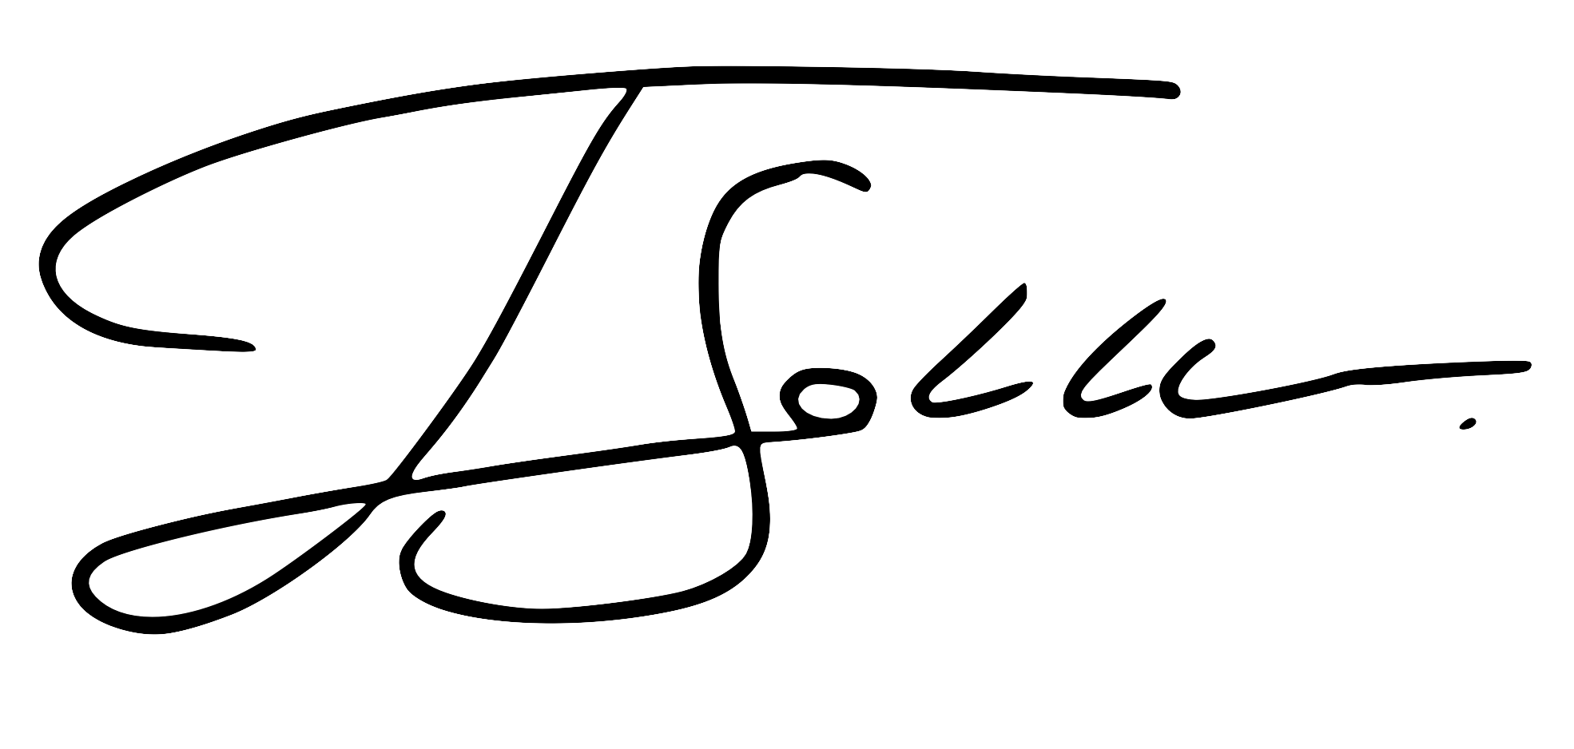 |  | 26 feb 2025

