Funduino Multi-Function Shield
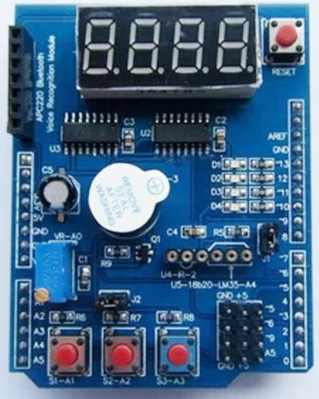

Author: Bill Brouwer
Date: November 15, 2014
Version 0.3
eMail: Bill.Brouwer@gmail.com

TABLE OF CONTENTS

1 introduction 3
1.1 Purpose and Scope 3
1.2 Related Documents 3
1.2.1 Schematic 3
2 Pin Mapping 4
2.1 Table 4
2.2 Chips 4
3 Not yet documented. 5
4 Reference Websites. 5
5 Appendix. 5
introduction

Purpose and Scope

Related Documents

Schematic
Schematic.pdf

Pin Mapping
Pin to component mapping for the Funduino Multi-function shield – K74544BS

Table

Digital Pin | Component | Description
0 |  | Receive Pin (arduino defined)
1 |  | Transmit Pin (arduino defined)
2
3~ | Piezo Buzzer
4 | 4 Digit LED Display* | Latch pin
5~ | Header Block top row | Male Header block beside switches
6~ | Header Block 2nd from top | Male Header block beside switches
7~ | 4 Digit LED Display* | Clock pin
8 | 4 Digit LED Display* | Data pin
9~ | Header Block 3rd from top | Male Header block beside switches
10~ | Led D4
11~ | Led D3
12 | Led D2
13~ | Led D1 | On the Leonardo is PWM.
Analog Pin | Component | Description
0 | 10k Variable Potentiometer | Blue.
1 | Switch S1-A1 | Left bottom button
2 | Switch S1-A2 | Middle Bottom Button
3 | Switch S1-A3 | Right Bottom Button
4 | LM 35 Header | Open for use.
5 | Header block bottom row | Male Header block beside switches

Chips

*Chips for the 4 digit LED display use 2 MC74HC595AD chips labeled U2 and U3.
The latch pin (LCHCLK) connects to chip pin 12 on both u2 and u3 chips.
The clock pin (SFTCLK) connects to chip pin 12 on both u2 and u3 chips.
The data pin (SD1) connexts to pin 14 on the u2 the SD1 pin 14 on the U3 chip daisey chains to the u2 SD0 pin 9.

Not yet documented.
- Jumper block labeled labeled J1 and J2.
- APC Blue Tooth Voice Recognition Module header
- DS18B20 temperature sensor interface
- LM35 temperature sensor interface

Reference Websites.
http://forum.arduino.cc/index.php?topic=241428.0

Appendix.

