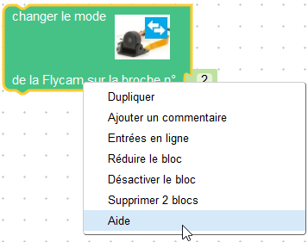
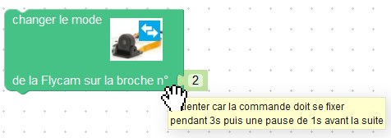
this.setColour(Blockly.Blocks.flycam.HUE);
couleur en codage hexadecimal
this.setHelpUrl(Blockly.Msg.FLYCAM_SWITCH_HELPURL);
URL d’un site d’aide
this.appendDummyInput("")
.appendField(Blockly.Msg.FLYCAM_SWITCH_TEXT)
.appendField(new Blockly.FieldImage(...
this.appendValueInput("PIN", 'Number')
.setCheck('Number')
.setAlign(Blockly.ALIGN_RIGHT)
.appendField(Blockly.Msg.FLYCAM_SWITCH_INPUT);
this.setPreviousStatement(true, null);
this.setNextStatement(true, null);
this.setTooltip(Blockly.Msg.FLYCAM_SWITCH_TOOLTIP);

