ORION

Orion is an online platform and solution for most of the on-demand businesses today that would allow to implement the dispatching/tracking system into their business processes, improve the services provided and business efficiency, reduce the business operational costs,

Table of Contents

1. Scenario, example of use.
2. Business demand. List of on-demand businesses. Market volume.
3. Platform/Overview.
4. desktop;
5. mobile App.

4. Features.

1. map/geolocation/routing;
2. chat;
3. auto notifications/reminders;
4. payment processing;
5. stats;
6. orders handling;
7. 24/7 technical support.

5. Competition.

6. Our advantages.

7. Pricing.

8. Expected revenue.

9. Technology we use.

**Content**

1. Scenario.

The ideal example of Orion use is the on-demand businesses.

1. What is On-Demand Business?

The On-Demand Business is defined as the business activity created by technology companies that fulfill consumer demand via the immediate provisioning of goods and services. Supply is driven via an efficient, intuitive digital mesh layered on top of existing infrastructure networks.

1. All businesses need:

* Quick and easy access to the customer/client
* Discoverability
* Promotion
* Reduce operational cost
* Easy and flawless contact and communication with the customers/clients
* Stable and reliable source of customers/clients
* Reliable software
* 24/7 support
* Higher quality of services provided for the lesser cost

1. Example of use Orion by on-demand business.

Let’s say you are a small mom-and-pop pizzeria and you gets an order for a pizza delivery through the app Orion you installed on your smartphone. When you accept the order the payment is processed by Orion (it checks customer’s credentials and if the data is accurate and valid the payment is successful) and disbursed to your account within a set period of time.

From this moment the order contains the geolocation of the pizza delivery guy (assigned person by the owner with the Orion application who is responsible for the pizza delivery). The customer can track the delivery of pizza from the moment when the order is accepted by owner. Each movement of the pizza delivery guy is tracked and shown on the map.

Also, customer and service provider can communicate with each other through the messaging system that is enabled for the time until the order is delivered (accomplished task) or they can call each other through the app only.

When pizza is delivered a customer may rate the service/company. Also, the chat and call option becomes disabled.

The pizzeria owner can also track the movement of his guy who’s delivering the pizza. Service provider has an option to rate the customer/client as well.

1. Business volume.

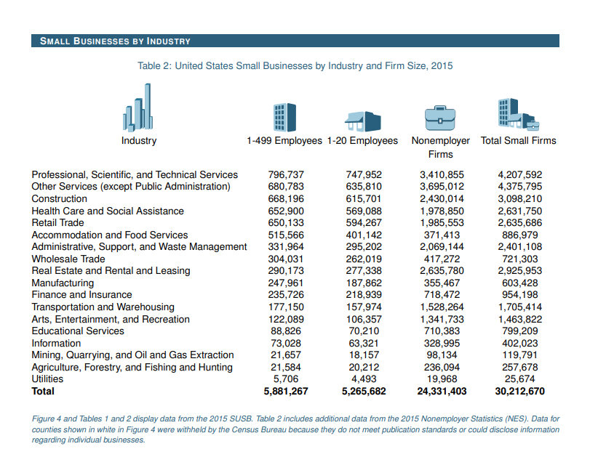

1. Examples of on-demand businesses

Examples of on-demand businesses:

* Online marketplace
* Transportation
* Housing
* Delivery
* Health/Beauty

We power all types of businesses including pickup & delivery, beauty services, health and well- being, home services, mobile workforce, repair services, etc.



1. Market volume

**Consumer spending**, or personal consumption expenditures (PCE), is the value of the goods and services purchased by, or on the behalf of, U.S. residents.

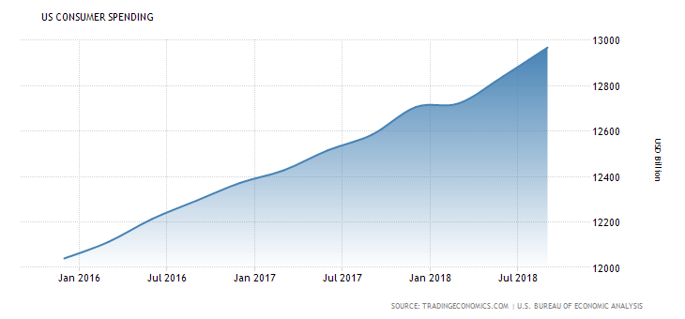

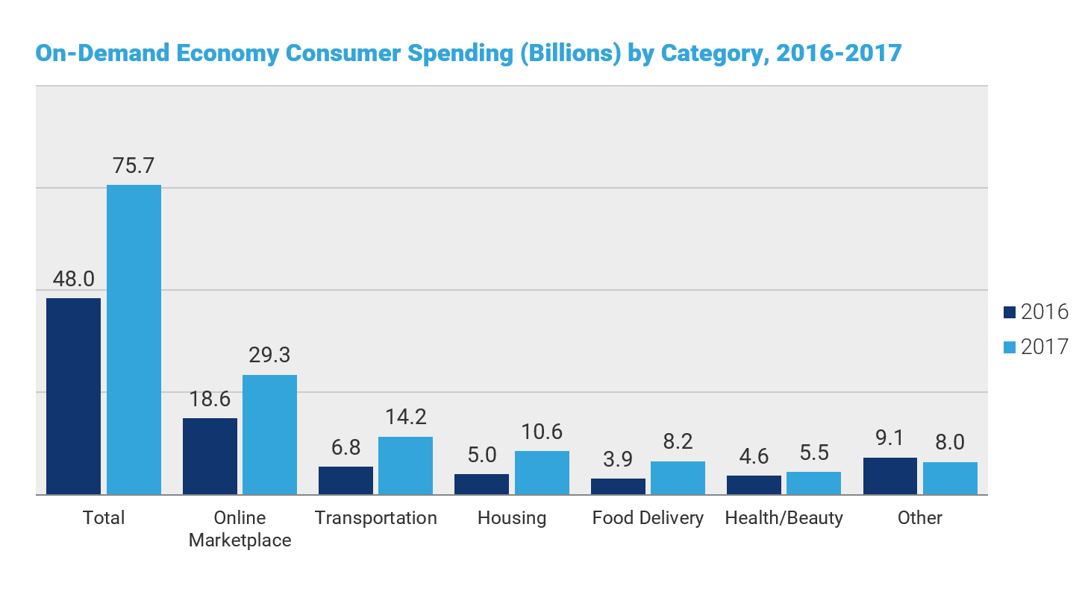

1. Platform overview
2. Orion platform consists of set of features like DB, Messaging, Security, Geo location, Stats, Payment Gateway, Service provider rating and others. The core features and functionality are common for all businesses.

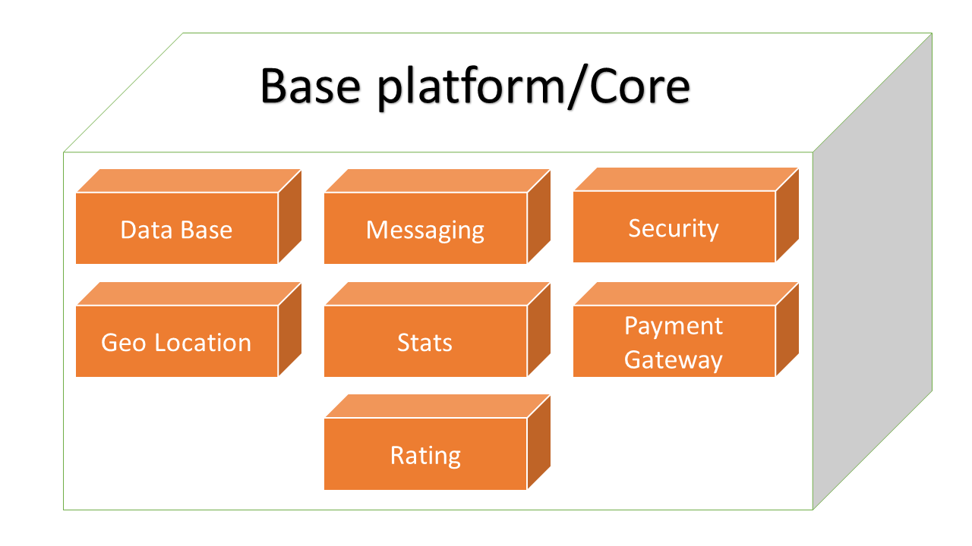

**Orion is a mobile and web-based platform. It is flexible, scalable and provides full stack of services for all businesses whose activities can be tracked.**

1. Web based platform (service provider/customer)

If you are a service provider Orion provides you the full scope of services in any browser you prefer to use and at any place in the world just having a reliable Internet connection that makes it even more comfortable for you to run your business and process orders. For tracking the location of your order delivery you or your employee (assigned person) has to have a mobile device with the Orion app installed on it in order to track the movement of the order delivery.

If you are a customer/client what you need is just log in to your account, find the business you’d like to place an order and track the position of your order delivery from the place it is located to the address you chose. Orion gives you all information in real time.

1. Mobile app (service provider/customer)

Having a mobile app gives you even more opportunities:

* It works much faster and reduces time to process your orders that are clicks away from their creating and completion
* App is the easiest and shortest way to reach your customer
* Increases customer engagement
* Reduces business costs
* Boosts profits
* Available at all times
* Use it while on the go
* Get information in real time
* Automates business processes
* No waiting time for the customer while the order is being processed and delivered
* Enhances the visibility of the brand of your business
* Makes businesses more mobile

1. Features

* Geolocation
* Payment gateway
* Messaging
* Stats
* Rating
* Security
* DB

1. Competition

* Tookan
* Lyft
* Uber
* Uber Eats

1. Advantages

* Flexible and adjustable platform for the business demand
* Custom branding
* Widgets
* Open Source
* 24/7 technical support
* Security and safety of use
* Your car/employee positioning in real time
* AI Dispatch Algorithms
* Analytics
* Billing & Disbursement
* Payment and Fraud services
* ML (machine learning) Routing and Mapping Algorithms

1. Technology we use

* MySQL
* PostgreSQL
* PHP7
* Laravel 5.6
* Redis
* Vue.js

Pub nub

Solution - for whom?

* Orion is an affordable standalone on-demand solution for any business or startup platform.
* Provides a full stack of services.
* The platform is flexible and scalable.
* Orion allows to launch your on-demand platform on both mobile and web devices.

Problems it solves

* Most of core business applications aren’t known for their scalability, flexibility, and speed.
* Company could not survive in the digital world without renovating core enterprise solution.
* Creating a new solution from the scratch is cost and time inefficient.

Market Volume