TripXML

Administration

Specifications

Thomalex, Inc.

Table of contents

1 Overview 3
1.1 Introduction 3
1.2 TripXML Access Concepts 3
2 TripXML Access Architecture 4
3 Admin Web Services 5
3.1 Customers 5
3.1.1 Schema 5
3.1.2 Web methods 6
3.1.3 Add Customer 6
3.1.4 Delete Customer 7
3.1.5 Display Customer 7
3.1.6 Enable Customer 8
3.1.7 Desable Customer 8
3.1.8 Modify Customer 8
3.2 Users 9
3.2.1 Schema 9
3.2.2 Web methods 9
3.2.3 Add User 9
3.2.4 Delete User 10
3.2.5 Display User 10
3.2.6 Enable User 11
3.2.7 Desable User 11
3.2.8 Modify User 11
3.3 Providers 12
3.3.1 Schema 12
3.3.2 Web methods 13
3.3.3 Add Provider 13
3.3.4 Delete Provider 13
3.3.5 Display Provider 14
3.3.6 Enable Provider 14
3.3.7 Desable Provider 15
3.3.8 Modify Provider 15
3.4 Profiles 16
3.4.1 Schema 16
3.4.2 Web methods 17
3.4.3 Add Profile 17
3.4.4 Delete Profile 18
3.4.5 Display Profile 18
3.4.6 Modify Profile 19
4 Admin Management Tool 20
4.1 User levels 20
4.2 Menu options 21

- Overview
  - Introduction

The TripXML middleware allows Thomalex’s customers to communicate and exchange messages with different travel suppliers.

For this exchange to work properly and securely, customers and suppliers need to be defined on the TripXML platform. Additionally, because of contractual issues, authorization levels need to be created in order to define which customer can access which supplier. For that reason, TripXML supports different levels of access defined in xml files.

In order to manage the different access levels, an administration module needs to be developed so a TripXML administrator can easily manage customers and suppliers tables.

  - TripXML Access Concepts

Here is the list of some of the TripXML concepts that allow better understanding of the access architecture that will be defined in the following chapters.

Customer: An entity that has a contract with Thomalex and is allowed to use TripXML web services. “Customer” can ba a travel agency, a travel web site, a technology company, etc… “Customer” can have from one to many users.

User: a system that queries TripXML web services in order to exchange messages with travel suppliers. “User” always belongs to one “Customer” and only one however, “Customers” can have multiple “Users”. An example of “Customer-User” relationship is a case of a technology company (“Customer”) that provides a travel web application to its own customers. Each of its customers will be defined as “User” on TripXML and each of these “Users” wll be attached to the technology company (“Customer”).

Provider: a travel supplier that provides access to its system and its functionality to TripXML users.

PCC: the PCC (Pseudo City Code) usually uniquely defines a user in a Provider system. Providers such as GDS (Amadeus, Galileo, Sabre, Worldspan) define unique PCCs for their use. Provider access rights are then attached to the PCC.

The TripXML access architecture defines Customer-Useraccess rights and which User can access which Provider.
- TripXML Access Architecture

TripXML main access entry is based on an Access Control List (ACL). The TripXML access control list (tt_acl) is a concept in TripXML security used to enforce TripXML access privileges. It is a means of determining the appropriate access rights to a given User depending on User identity. Each Customer contains an identifier (RequestorID) to its ACL. Each User contains a username and a profile.
User profiles are xml data structures that specify User rights to access certain Provider system applications. The privileges or permissions determine specific access rights, such as whether a User can excange messages with a specific Provider and the provider’s system (test or production systems).
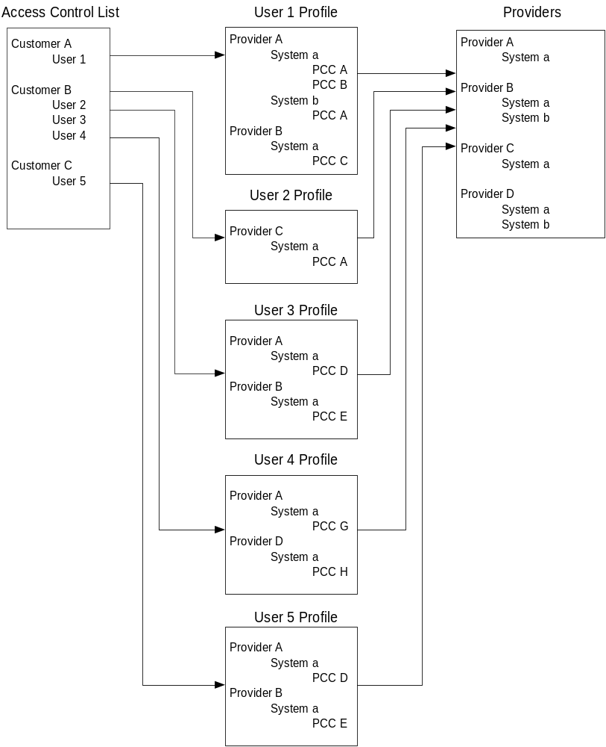
- Admin Web Services

The management of the different entities and xml table is done through TravelkTalk Admin Web Services.
  - Customers
    - Schema

The XLM file that contains the Customer and User information is located in the “TripXML”/Tables/Users folder. It is named tt_acl.xml. The different web methods for Customers and Users, read, add, modify and delete information from that file.

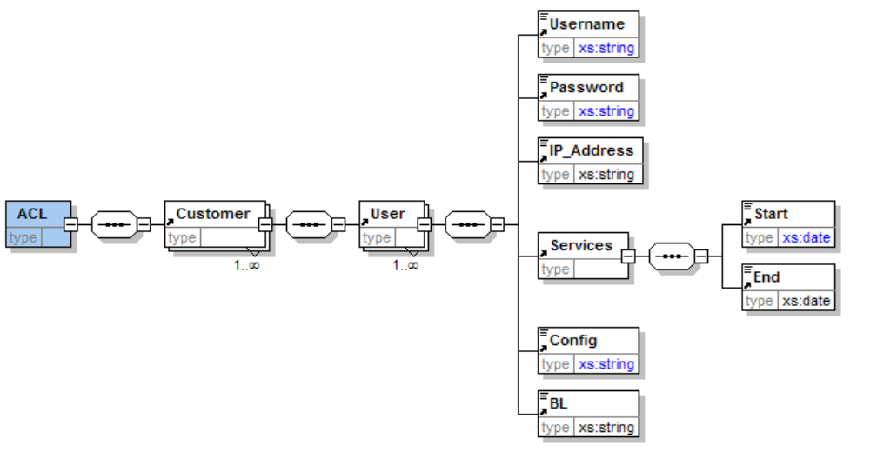

Element | Type | Description | Possible values
ACL |  | Root element
Customer |  | Contains Customer information
@Active | boolean | Indicates if the Customer is active (true) or inactive (false). | true  false
@RequestorID | string | Contains the customer’s unique identifier name. | Thomalex
User |  | Contains User information
@Active | boolean | Indicates if the User is active (true) or inactive (false). | true  false
Username | string | Contains the user’s unique identifier name. | Thomalex
Password | string | Contains the unique password assigned to the user name. | tR@v3lTalk
IPAddress | string | Contains user’s IP address authorized to access TripXML web services. | 202.158.42.12
Services | string | Contains web services start and end dates.
Start | date | Date from which the user is authorized to access TripXML web services. | 2006-04-01
End | date | Date from which the user is unauthorized to access TripXML web services. | 2006-12-31
Config | string | Name of the xml file that contains user’s profile information. | Thomalex.xml
BL | string | Name of the xml file that contains user’s business logic information. | Thomalex_BL.xml

    - Web methods

Customers web services defines all possible actions that an administrator can take on Customer entity:
- Add a customer
- Modify a customer
- Enable a customer
- Disable a customer
- Display a customer
- Delete a customer

Every web method will return a string xml with <ACL> as main tag. <ACL> element will be followed by either <Success/> element, if the transaction was successful, or <Error> element, with error description, if transaction was unsuccessful.

The url for the customers web services is located at:

http://tripxmlURL/AdminTalk/WebServices/Customers.asmx

“www.Traveltalkws.ws” can be replace by any other domain name or IP address where the TripXML server is hosted.

    - Add Customer

The wmCustomerAdd method contains one entry only:
- RequestorID.

Customer name must be unique so the web method will return an error if the RequestorID already exists in the table.

Customer is created as Active and is inserted at the end of the tt_acl.xml file.

Example of successful transaction response:
<string xmlns="http://admintalk/wsCustomersManagement"><ACL><Success/></ACL></string>

Example of error response:
<string xmlns="http://admintalk/wsCustomersManagement"><ACL><Error>RequestorID Thomalex already exist</Error></ACL></string>

    - Delete Customer

The wmCustomerDelete method contains one entry only:
- RequestorID.

Customer and all its users are deleted from the tt_acl.xml file.

Example of successful transaction response:
<string xmlns="http://admintalk/wsCustomersManagement"><ACL><Success/></ACL></string>

Example of error response:
<string xmlns="http://admintalk/wsCustomersManagement"><ACL><Error>Customer Thomalex1 not found</Error></ACL></string>

    - Display Customer

The wmCustomerDelete method contains one entry only:
- RequestorID.

Customer and all its users are returned in the xml response.

Example of successful transaction response:
<string xmlns="http://admintalk/wsCustomersManagement"><ACL><Success/><Customer Active="true" RequestorID=" CustomerOne "><User Active="true"><Username> UserOne </Username><Password> Passone </Password><IP_Address /><Services><Start>2006-03-14</Start><End>2006-12-31</End></Services><Config> CustomerOne.xml</Config><BL /></User></Customer></ACL></string>

Or, displayed with XMLSPY, for example:

<string xmlns="http://admintalk/wsCustomersManagement">
<ACL>
<Success/>
<Customer Active="true" RequestorID="CustomerOne">
<User Active="true">
<Username>UserOne</Username>
<Password>Passone</Password>
<IP_Address/>
<Services>
<Start>2006-03-14</Start>
<End>2006-12-31</End>
</Services>
<Config>CustomerOne.xml</Config>
<BL/>
</User>
</Customer>
</ACL>
</string>

Example of error response:
<string xmlns="http://admintalk/wsCustomersManagement"><ACL><Error>RequestorID not found</Error></ACL></string>
    - Enable Customer

The wmCustomerEnable method contains one entry only:
- RequestorID.

The Active attribute of Customer element is set to “true”.
If its value was already “true” no change take effect.
If the attriute Active does not exist, the Enable web method adds it to the Customer element and set it to “true”.

Example of successful transaction response:
<string xmlns="http://admintalk/wsCustomersManagement"><ACL><Success/></ACL></string>

Example of error response:
<string xmlns="http://admintalk/wsCustomersManagement"><ACL><Error>Customer Thomalex1 not found</Error></ACL></string>

    - Desable Customer

The wmCustomerDesable method contains one entry only:
- RequestorID.

The Active attribute of Customer element is set to “false”.
If its value was already “false” no change take effect.
If the attriute Active does not exist, the Enable web method adds it to the Customer element and set it to “false”.

Example of successful transaction response:
<string xmlns="http://admintalk/wsCustomersManagement"><ACL><Success/></ACL></string>

Example of error response:
<string xmlns="http://admintalk/wsCustomersManagement"><ACL><Error>Customer Thomalex1 not found</Error></ACL></string>

    - Modify Customer

The wmCustomerModify method contains:
- RequestorID
- New RequestorID

It is possible to modify the RequestorID value only.
If the new value already exists, the modify web method will reject the request.

Example of successful transaction response:
<string xmlns="http://admintalk/wsCustomersManagement"><ACL><Success/></ACL></string>

Example of error response:
<string xmlns="http://admintalk/wsCustomersManagement"><ACL><Error>Customer Thomalex1 not found</Error></ACL></string>

  - Users
    - Schema

See the Customer schemas in chapter 3.1.1

    - Web methods

Users web services defines all possible actions that an administrator can take on User entity:
- Add a user
- Modify a user
- Enable a user
- Disable a user
- Display a user
- Delete a user

The url for the users web services is located at:

http://www.Traveltalkws.ws/AdminTalk/WebServices/Users.asmx

“www.Traveltalkws.ws” can be replace by any other domain name or IP address where the TripXML server is hosted.

    - Add User

The wmUserAdd method contains one entry only:
- RequestorID
- Username
- Password
- StartDate
- EndDate
- Config
- BL

RequestorID is an existing Customer to which the User needs to be added. An error will be returned by the Add web method, if the RequestorID does not exist in the table.

User name must be unique per Customer so the web method will return an error if the Username already exists for that Customer. Two different Customers can contain users with same Username.

StartDate and EndDate must have ISO date formats: YYYY-MM-DD, for example 2006-03-09 for March, 9th 2006. Date cannot omit any number so entry such as 2006-3-9 is invalid.

Config must contain the name of the xml that will contain User’s configuration information.
The file name must be entered with extension “.xml”. If not, error “Config file must have .xml extension” will be returned.

User is created as Active and is inserted at the end of the Customer XML group.

Example of successful transaction response:
<string xmlns="http://admintalk/wsUsersManagement"><ACL><Success/></ACL></string>

Example of error response:
<string xmlns="http://admintalk/wsUsersManagement"><ACL><Error>Username Thomalex already exist for customer Thomalex</Error></ACL></string>

    - Delete User

The wmUserDelete method contains one entry only:
- RequestorID
- Username

User is deleted from the tt_acl.xml file.

Example of successful transaction response:
<string xmlns="http://admintalk/wsUsersManagement"><ACL><Success/></ACL></string>

Example of error response:
<string xmlns="http://admintalk/wsUsersManagement"><ACL><Error>Username test not found in customer Thomalex</Error></ACL></string>

    - Display User

The wmUserDelete method contains one entry only:
- RequestorID
- Username

User is returned in the xml response.

Example of successful transaction response:
<string xmlns="http://admintalk/wsUsersManagement"><ACL><Success/><User Active="true"><Username>UserOne</Username><Password>Passone</Password><IP_Address /><Services><Start>2006-03-14</Start><End>2006-12-31</End></Services><Config> UserOne.xml</Config><BL /></User></ACL></string>

Or, displayed with XMLSPY, for example:

<string xmlns="http://admintalk/wsUsersManagement">
<ACL>
<Success/>
<User Active="true">
<Username>UserOne</Username>
<Password>Passone</Password>
<IP_Address/>
<Services>
<Start>2006-03-14</Start>
<End>2006-12-31</End>
</Services>
<Config>UserOne.xml</Config>
<BL/>
</User>
</ACL>
</string>

Example of error response:
<string xmlns="http://admintalk/wsUsersManagement"><ACL><Error>Username test not found in customer Thomalex</Error></ACL></string>

    - Enable User

The wmUserEnable method contains one entry only:
- RequestorID
- Username

The Active attribute of User element is set to “true”.
If its value was already “true” no change take effect.
If the attriute Active does not exist, the Enable web method adds it to the User element and set it to “true”.

Example of successful transaction response:
<string xmlns="http://admintalk/wsUsersManagement"><ACL><Success/></ACL></string>

Example of error response:
<string xmlns="http://admintalk/wsUsersManagement"><ACL><Error>Username test not found in customer Thomalex</Error></ACL></string>

    - Desable User

The wmUserDesable method contains one entry only:
- RequestorID
- Username

The Active attribute of User element is set to “false”.
If its value was already “false” no change take effect.
If the attriute Active does not exist, the Enable web method adds it to the User element and set it to “false”.

Example of successful transaction response:
<string xmlns="http://admintalk/wsUsersManagement"><ACL><Success/></ACL></string>

Example of error response:
<string xmlns="http://admintalk/wsUsersManagement"><ACL><Error>Username test not found in customer Thomalex</Error></ACL></string>

    - Modify User

The wmUserModify method contains:
- RequestorID
- Username
- NewUserName
- Password
- StartDate
- EndDate
- Config
- BL

It is possible to modify the Username.
If the new value already exists for that Customer, the modify web method will reject the request.

If a an element is left empty in the input, its value in the file will not be replaced and will remain the same.

Example of successful transaction response:
<string xmlns="http://admintalk/wsUsersManagement"><ACL><Success/></ACL></string>

Example of error response:
<string xmlns="http://admintalk/wsUsersManagement"><ACL><Error>Username test not found in customer Thomalex</Error></ACL></string>

  - Providers
    - Schema

The XLM file that contains the Provider information is located in the “TripXML”/Tables/Users folder. It is named ttproviders.xml. The different web methods for Providers, read, add, modify and delete information from that file.

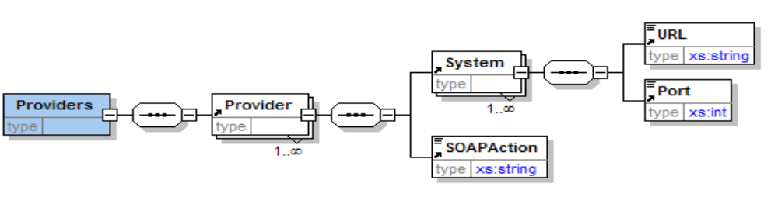

Element | Type | Description | Possible values
Providers |  | Root element
Provider |  | Contains Provider information
@Active | boolean | Indicates if the Provider is active (true) or inactive (false). | true  false
@Name | string | Contains the Provider’ unique identifier name. | Amadeus
System |  | Contains system information
@Name | boolean | Contains the system name. Only 3 values supported. | Test, Training and Production
URL | string | Contains the url of the system to connect to. | http://........
Port | string | Contains the port of the system to connect to. | 20002
SOAPAction | string | Contains the soap action required by some systems. | OTA

    - Web methods

Providers web services defines all possible actions that an administrator can take on Provider entity:
- Add a provider
- Modify a provider
- Enable a provider
- Disable a provider
- Display a provider
- Delete a provider

The url for the providers web services is located at:

http://www.Traveltalkws.ws/AdminTalk/WebServices/wsProviders.asmx

“www.Traveltalkws.ws” can be replace by any other domain name or IP address where the TripXML server is hosted.

    - Add Provider

The wmProviderAdd method contains one entry only:
- Name.

Provider name must be unique so the web method will return an error if the name already exists in the table.

Provider is created as Active and is inserted at the end of the ttproviders.xml file.

Example of successful transaction response:
<string xmlns="http://admintalk/wsProvidersManagement"><Providers><Success/></Providers></string>

Example of error response:
<string xmlns="http://admintalk/wsProvidersManagement">< Providers ><Error>Name Amadeus already exists</Error></Providers></string>

    - Delete Provider

The wmProviderDelete method contains one entry only:
- Name.

Provider and all its users are deleted from the ttproviders.xml file.

Example of successful transaction response:
<string xmlns="http://admintalk/wsProvidersManagement"><Providers><Success/></Providers></string>

Example of error response:
<string xmlns="http://admintalk/wsProvidersManagement"><Providers><Error>Provider Thomalex1 not found</Error></Providers></string>

    - Display Provider

The wmProviderDelete method contains one entry only:
- Name.

Provider data is returned in the xml response.

Example of successful transaction response:
<string xmlns="http://admintalk/wsProvidersManagement"><Providers><Success/><Provider Name="HotelClub"><System Name="Production"><URL>https://www.hotelclub.net/xml/</URL><Port/></System><SOAPAction/></Provider></Providers></string>

Or, displayed with XMLSPY, for example:

<string xmlns="http://admintalk/wsProvidersManagement">
<Providers>
<Success/>
<Provider Active="true" Name="HotelClub">
<System Name="Production">
<URL>https://www.hotelclub.net/xml/</URL>
<Port/>
</System>
<SOAPAction/>
</Provider>
</Providers>
</string>

Example of error response:
<string xmlns="http://admintalk/wsProvidersManagement"><Providers><Error>Name not found</Error></Providers></string>
    - Enable Provider

The wmProviderEnable method contains one entry only:
- Name.

The Active attribute of Provider element is set to “true”.
If its value was already “true” no change take effect.
If the attriute Active does not exist, the Enable web method adds it to the Provider element and set it to “true”.

Example of successful transaction response:
<string xmlns="http://admintalk/wsProvidersManagement"><Providers><Success/></Providers></string>

Example of error response:
<string xmlns="http://admintalk/wsProvidersManagement"><Providers><Error>Provider Amadeus1 not found</Error></Providers></string>

    - Desable Provider

The wmProviderDesable method contains one entry only:
- Name.

The Active attribute of Provider element is set to “false”.
If its value was already “false” no change take effect.
If the attriute Active does not exist, the Enable web method adds it to the Provider element and set it to “false”.

Example of successful transaction response:
<string xmlns="http://admintalk/wsProvidersManagement"><Providers><Success/></Providers></string>

Example of error response:
<string xmlns="http://admintalk/wsProvidersManagement"><Providers><Error>Provider Amadeus1 not found</Error></Providers></string>

    - Modify Provider

The wmProviderModify method contains:
- Name
- NewName

It is possible to modify the Name value only.
If the new value already exists, the modify web method will reject the request.

Example of successful transaction response:
<string xmlns="http://admintalk/wsProvidersManagement"><Providers><Success/></Providers></string>

Example of error response:
<string xmlns="http://admintalk/wsProvidersManagement"><Providers><Error>Provider Amadeus1 not found</Error></Providers></string>

  - Profiles
    - Schema

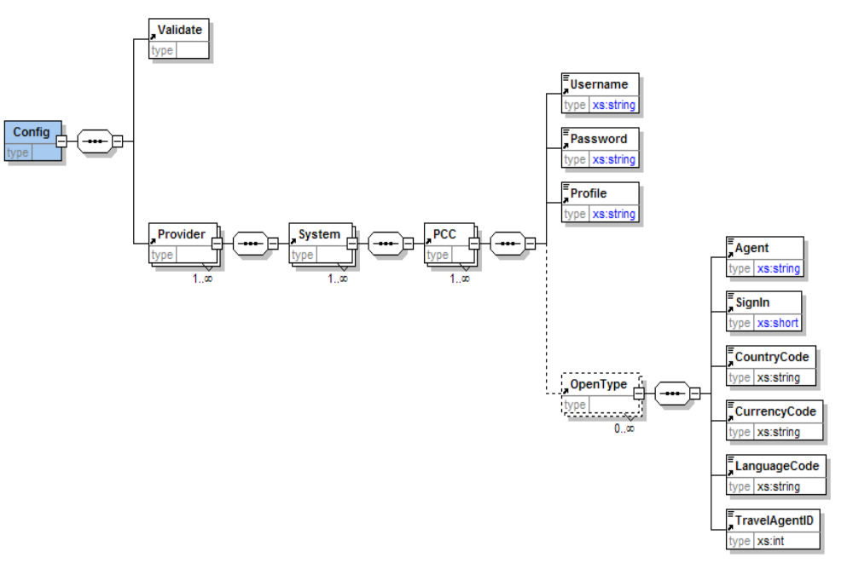

The XLM file that contains the Profile information is located in the “TripXML”/Tables/Users folder. The different web methods for Profiles, read, add, modify and delete information from the profile file.

Element | Type | Description | Possible values
Config |  | Root element
@Domain | string | Contains user’s domain | Free text
@Trace | boolean | Indicates if the messages can be traced for this profile. | true  false
@Log | boolean | Indicates if the messages can be logged for this profile. | true  false
Validate |  | Contains schema validation information.
@In | boolean | Indicates if the messages have to be validated against schema on way In. | true  false
@Out | boolean | Indicates if the messages have to be validated against schema on way Out. | true  false
Provider |  | Contains provider’s information.
@Name | string | Contains the Provider’ unique identifier name. Provider must exist in Providers file. | Amadeus
System |  | Contains system information
@Name | string | Contains the system name. System must exist for that Provider. | Test, Training or Production
PCC |  | Contains the Pseudo City Code (PCC) information.
@Code | string | Contains the Pseudo City Code (PCC) data. Can be empty. | LAS1S210D
Username | string | Contains the PCC’s username. | Thomalex_Tvk
Password | string | Contains the PCC’s password. | bluelight
Profile | string | Contains the PCC’s GDS profile data. Can be empty. | DynApolloCopy_1H1M
OpenType |  | Contains change point of sale (POS) agreements for the PCC.
@OfficeID | string | Contains the POS PCC. | ATL1S2157
@Name | string | Contains the POS PCC name. | Atlanta office 1
Agent | string | Contains the POS PCC agent initials. Can be empty. | AA
SignIn | string | Contains the POS PCC agent sign in info. Can be empty. | 0001
CountryCode | string | Contains the POS PCC country code. Can be empty. | FR
CurrencyCode | string | Contains the POS PCC currency code. Can be empty. | EUR
LanguageCode | string | Contains the POS PCC language code. Can be empty. | FR
TravelAgentID | string | Contains the POS PCC agent ID (IATA code). Can be empty. | 4566154

    - Web methods

Profiles web services defines all possible actions that an administrator can take on Profile entity:
- Add a profile
- Modify a profile
- Display a profile
- Delete a profile

The url for the profiles web services is located at:

http://www.Traveltalkws.ws/AdminTalk/WebServices/wsProfiles.asmx

“www.Traveltalkws.ws” can be replace by any other domain name or IP address where the TripXML server is hosted.

    - Add Profile

The wmProfileAdd method contains at least:
- Profile file name
- @ Domain
- Provider
  - @Name
  - System
    - @Name
    - PCC
      - @Code
      - Username
      - Password

@Trace, @Log, Validate/@In and Validate/@Out can be created false as default.
Profile can be left empty as default.

Example of successful transaction response:
<string xmlns="http://admintalk/wsProfilesManagement"><Profile><Success/></Profile></string>

Example of error response:
<string xmlns="http://admintalk/wsProfilesManagement"><Profile><Error>Profile not created</Error></Profile></string>

    - Delete Profile

The wmProfileDelete method contains one entry only:
- Profile file name.

Profile file is deleted.

Example of successful transaction response:
<string xmlns="http://admintalk/wsProfilesManagement"><Profile><Success/></Profile></string>

Example of error response:
<string xmlns="http://admintalk/wsProfilesManagement"><Profile><Error>Profile MyProfile.xml not found</Error></Profile></string>

    - Display Profile

The wmProfileDelete method contains one entry only:
- Profile file name.

Profile is returned in the xml response.

Example of successful transaction response:
<string xmlns="http://admintalk/ wsProfilesManagement"><Profile><Success/><Config Domain="CWCruises" Trace="false" Log="false"><Validate In="false" Out="false"/><Provider Name="Amadeus"><System Name="Test"><PCC Code="FLL1S1234"><Username>Customer</Username><Password>itspassword</Password><Profile/></PCC></System></Provider></Config></Profile></string>

Or, displayed with XMLSPY, for example:

<string xmlns="http://admintalk/wsProfilesManagement">
<Profile>
<Success/>
<Config Domain="CWCruises" Trace="false" Log="false">
<Validate In="false" Out="false"/>
<Provider Name="Amadeus">
<System Name="Test">
<PCC Code="FLL1S1234">
<Username>Customer</Username>
<Password>itspassword</Password>
<Profile/>
</PCC>
</System>
</Provider>
</Config>
</Profile>
</string>

Example of error response:
<string xmlns="http://admintalk/wsProfilesManagement"><Profile><Error>Profile MyProfile.xml not found</Error></Profile></string>

    - Modify Profile

It is possible to modify everything in the profile, from adding, deleting, modifying PCCs to Systems to Providers.

Example of successful transaction response:
<string xmlns="http://admintalk/wsProfilesManagement"><Profile><Success/></Profile></string>

Example of error response:
<string xmlns="http://admintalk/wsProfilesManagement"><Profile><Error>Profile Thomalex1.xml not found</Error></Profile></string>

- Admin Management Tool

The Admin Management tool is a web based application that allows a TripXML Administator to manage Customers, Users, Profiles and Providers.

The tool should offer a main menu to select the TripXML server to work with.
A database table should contain the list of servers that can be identified by name, url or IP address. Each server has to have its IP or domain name defined so the tool can connect to its services.

Example of main admin page:

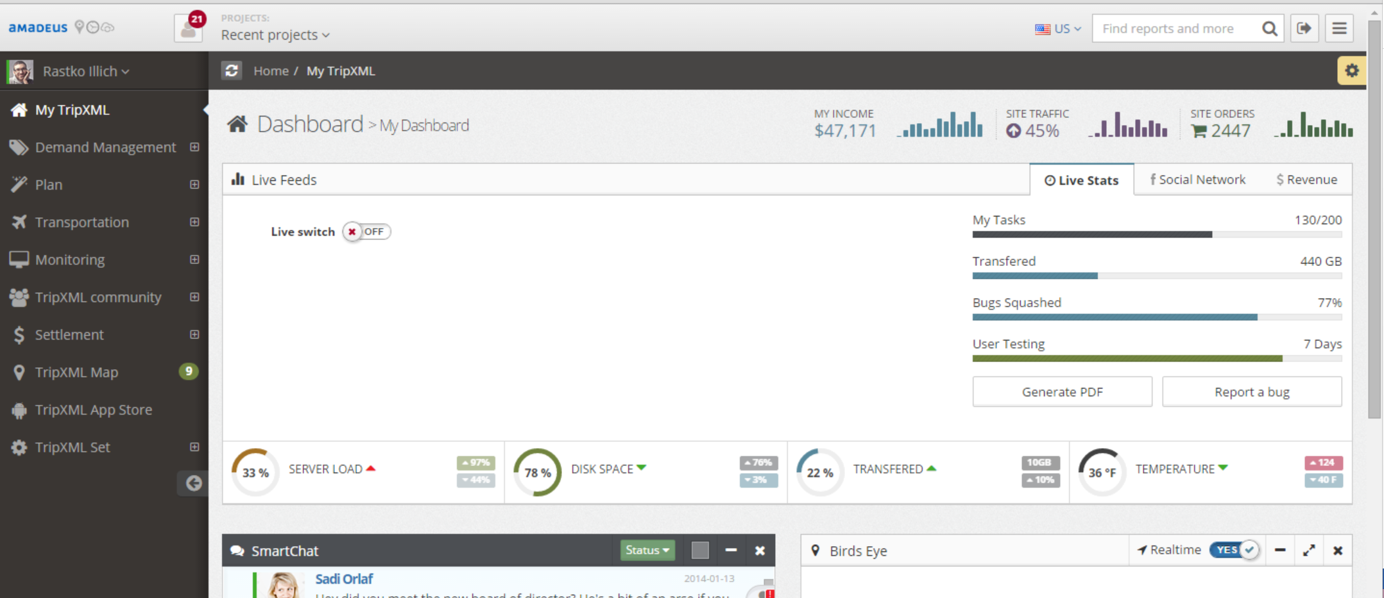

  - User levels

The admin can be accessed by various users as defined below. Users have rights that are different based on their role.

Super admin user: This is the highest level of user and this user has all rights. This user can do and see everything in the admin. Typically this user will be Thomalex staff.

Distributor admin user: This user will be assigned to Distributors of Thomalex that are reselling (distributors) TripXML. They will be able to manage and see all data related to their tripxml admin part, but they will not be able to see anything else from the other Distributors users.

Customer admin user: This will be the lowest user of the admin, with lowest rights. Typically it will be a customer, belonging to be a distributor, of a specidic occurrence of TripXML. This admin user can manage and see only information related to him and not to other customers.

In summary, super admin user manages everything and controls various Distributor admin users. Distributor admin user manage their customer part and control various Customer admin users belonging to that Distributor.

The admin will display various menu options based on admin user level that logs in.

  - Menu options

This is the list of menu options that will display on left side of dashboard. The options will be dependant on what admin user logs in (what rights admin has).

- Distributors: will allow to create/edit Distributors of Thomalex that use tripxml. Add panel will allow input Distributor name (company name) and phone number. Edit will provide list of Distributors that can be edited and deleted. This option will only be visible to Super Admin.
- Customers: will allow to create/edit Customers of a specific Distributor that use tripxml. Add panel will allow input customer name (company name) and phone number. Edit will provide list of Customers that can be edited and deleted. This option will be visible to Super Admin and Distributor Admin. When creating a new Customer, admin will have to specify to which Distributor this Customer belongs to.
- Admin Users: this option will allow to create/edit users of the admin. Information entered should be user first and last name, email, phone numer, username and password for admin access. Additionally it will contain user role. This menu option is only visible by super and distriburo admins.
The role can be:
- Super admin (only visible to super admin user)
- Distributor admin (only visible to super admin) – super admin will need to specify to which Distributor this admin belongs.
- Customer Admin (only visible to super admin and Distributor admin) – super admin will need to specify to which distributor and customer this customer admin belongs to. Distributor admin will need to specify to which Customer this customer admin belongs to.
For below options all admins can access them.
- TripXML servers: this option will allow creating/editing of tripxml server info. That info is server name and IP address (or url). The server must be attached to a specific Customer.
- TripXML Customer Profile: this option allows to create/edit customer profiles of a specific TripXML server (defined in chapter 3.1 Customers). All parameters of customer profile are defined in that chapter.
To manage customer profile using pre-defined web services use URL http://tripxmlURL/AdminTalk/WebServices/Customers.asmx where tripxmlURL is the IP address or URL of TripXML server this profile belongs to (see chapter 3.1.2 Web methods).
- TripXML User Profile: this option allows to create/edit user profiles of customer profile of a specific TripXML server (defined in chapter 3.2 Users3.1). All parameters of customer profile are defined in that chapter.
To manage customer profile using pre-defined web services use URL http://tripxmlURL/AdminTalk/WebServices/Users.asmx where tripxmlURL is the IP address or URL of TripXML server this profile belongs to (see chapter 3.2.2 Web methods ).
- TripXML Provider Profile: this option allows to create/edit provider profiles of a specific TripXML server (defined in chapter 3.3 Providers3.1). All parameters of customer profile are defined in that chapter.
To manage provider profile using pre-defined web services use URL http://tripxmlURL/AdminTalk/WebServices/Providers.asmx where tripxmlURL is the IP address or URL of TripXML server this profile belongs to (see chapter 3.3.2 Web methods).

- TripXML Profiles Profile: this option allows to create/edit Profile profiles of user of customer profile of a specific TripXML server (defined in chapter 3.4 Profiles3.1). All parameters of Profile profile are defined in that chapter.
To manage Profile profile using pre-defined web services use URL http://tripxmlURL/AdminTalk/WebServices/Profiles.asmx where tripxmlURL is the IP address or URL of TripXML server this profile belongs to (see chapter 3.4.2 Web methods).

