Step 1: Download and install Android Studio, Visual Studio Code, git.

Step 2: Set environment variable for git to access through command Line/terminal.
- C:\Program Files\Git\cmd
- C:\Program Files\Git\bin

Step 3: Open System environment set up wizard open for configurations during the installation process.

- In windows search, search for Edit the system environment variables

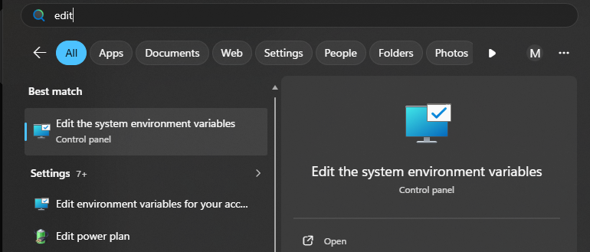

- It opens a wizard in that click the option Environment Variables
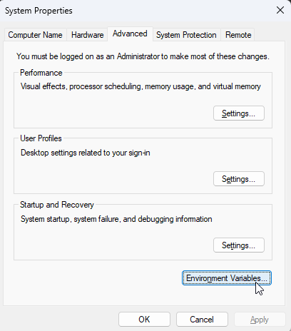

- In the new window under System Variables select the variable Path and click on Edit.
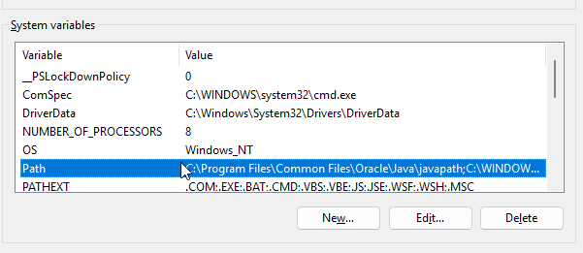

- Another new window will open to add environment variable.
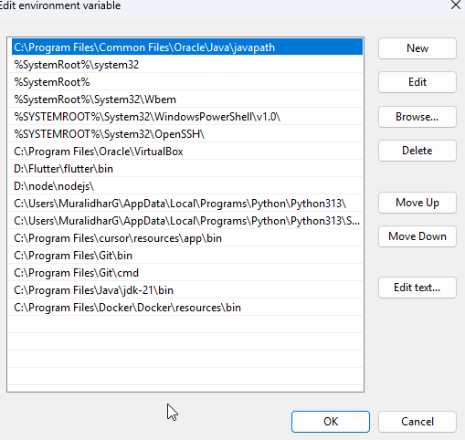

- Click on New and add the paths(we have copied in Step 2) one after another and click ok.
Step 4: In left side bar of VS Code we will have Extensions option (ctrl+shift+x)
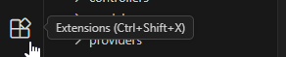
Search for Flutter and click on install (we need this extension which provides tools for flutter installation)
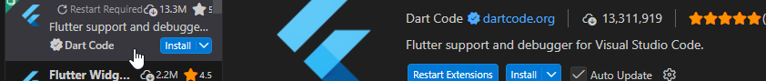
Step 5: Open Visual Studio Code application and follow below steps

- In the navigation bar on top left corner of navigate to view-> Command Palette
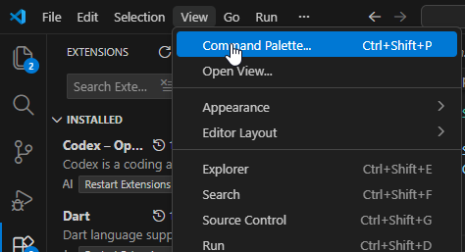

- A new popup search box will appear in that search for Flutter New Project and Select it.

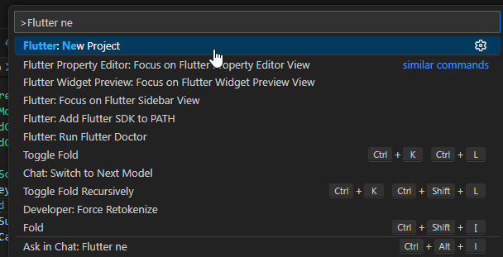

- Now you will see download SDK prompt on bottom right corner of VS Code. Click on download SDK.
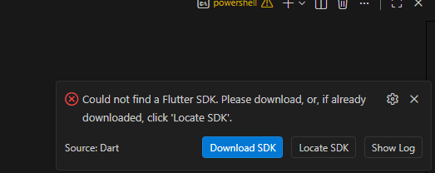

- Now it will open a file explorer window to locate a folder where we want to install Flutter.

Note : Copy and save this folder path to configure it in system environment variable as just like we did in Step 3.
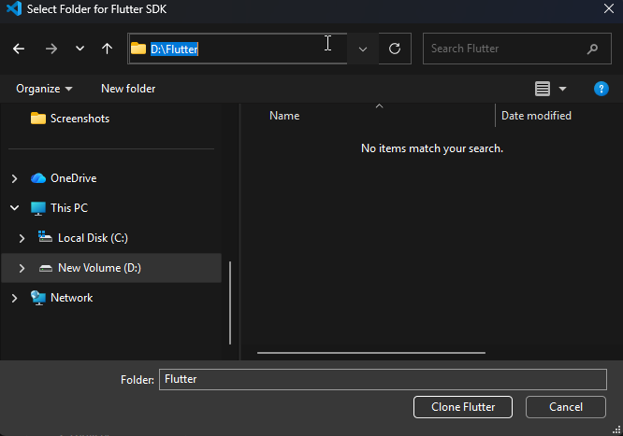

- Click on Clone Flutter and it will start downloading the required packages.

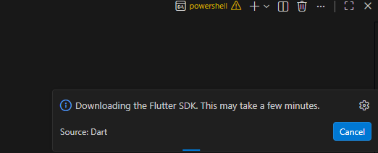

- Now we will get a new popup on bottom right corner to add the path to environment click on Add SDK to PATH.

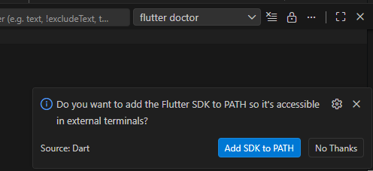

Step 6: Open Android Studio, open settings and click on search for Android SDK under Languages & Frameworks.
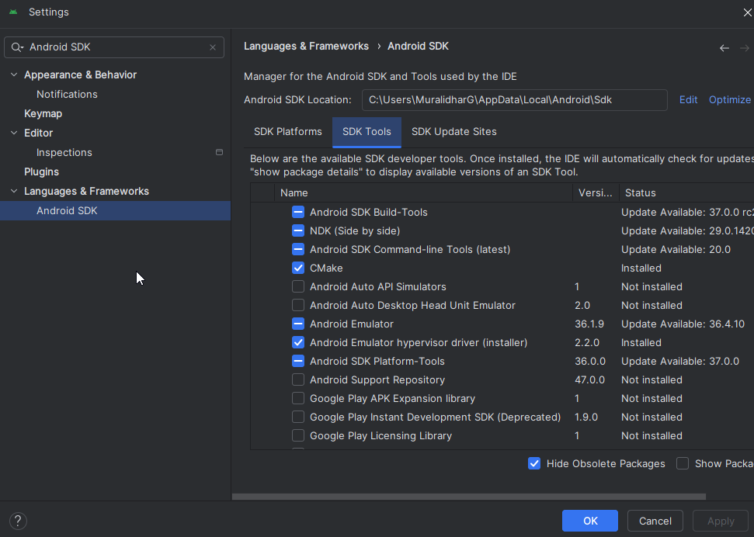

Step 7: Make sure the options which are selected above are ticked or having – symbol and click on Apply. (It takes few minutes to download the packages then click on finish).
Click OK after completion.
Step 8: On Welcome Screen click on More Actions and select Virtual Device Manger
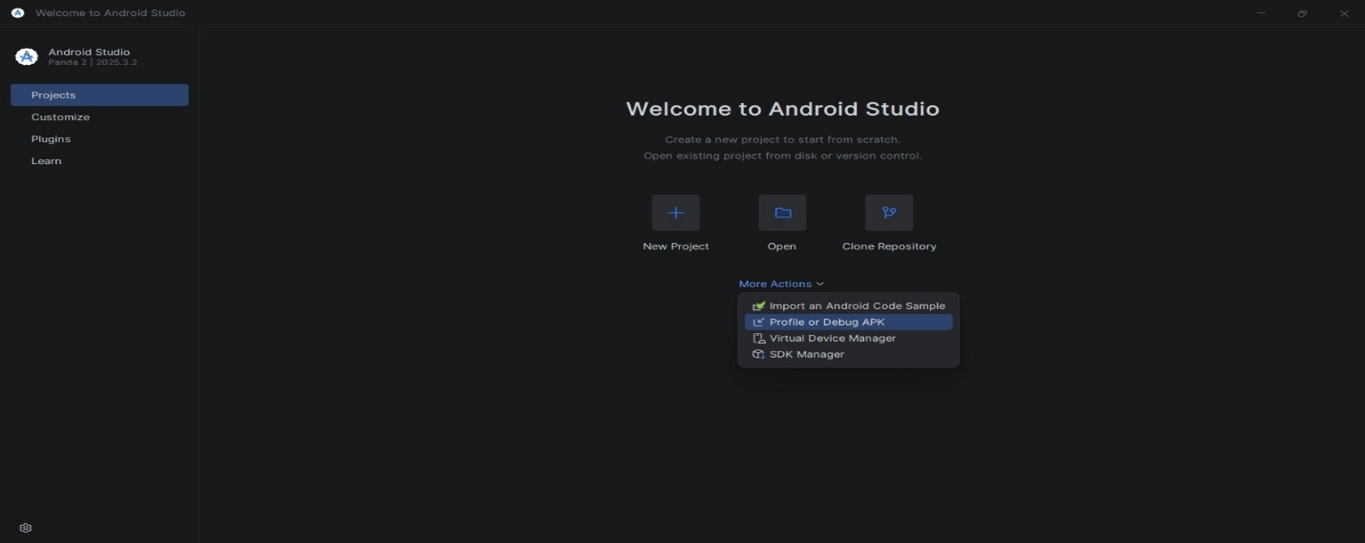
- Click on Add Device
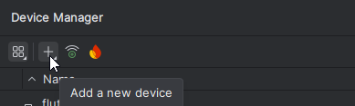
- In the next screen select a pixel phone model, click on next and then Finish to create a virtual device.
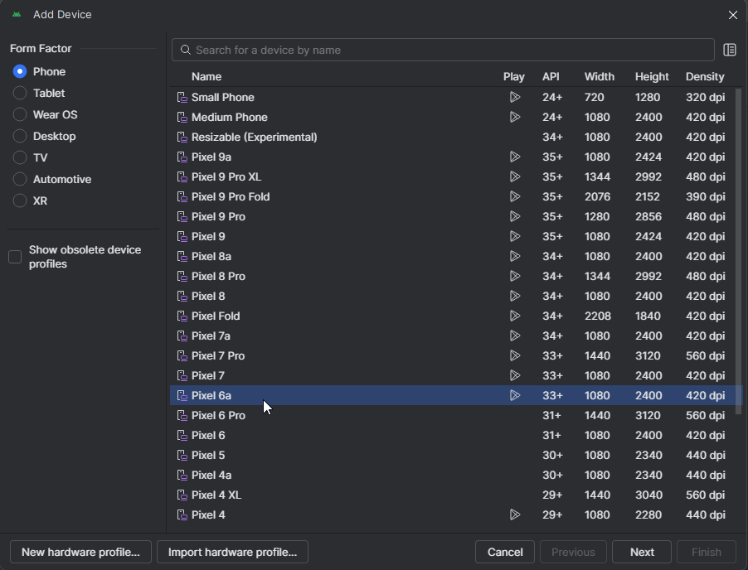

- A new virtual device will be added and run option is available on right side. Click and run the device.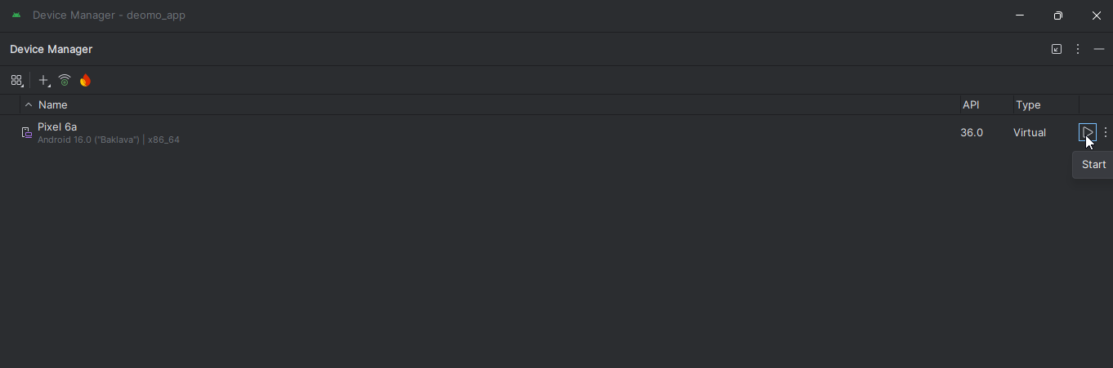
- It will load a virtual device on screen once the phone UI is loaded on screen.

Step 9: Open VS Code and Load the project Folder into it.
Step 10: In VS Code terminal run following commands
- To download the dependencies of the project.
flutter pug get
- To run the project
flutter run

this command will show the list of emulators which will list the device that we already started in Android Studio in Step 8.

From the list enter the number of our virtual device and click enter to load the app into the virtual device.

Or we can select the device from bottom right to corner as shown below
