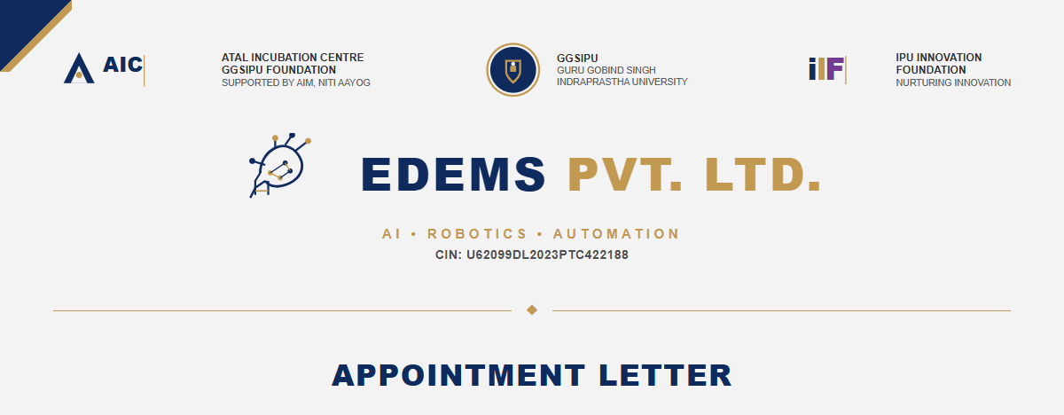
Date: 1st June 2026
To,
Vinayak Sharma
Dear Vinayak Sharma,
We are pleased to offer you the position of AI Agent Developer at EDEMS Pvt. Ltd., an AIC GGSIPU incubated startup specializing in Robotics and Artificial Intelligence. We are confident that your technical skills and background will make you a valuable addition to our team.
Your employment will commence on 1st June 2026. During your tenure, you will work closely with our engineering team to design, deploy, and refine state-of-the-art AI systems and agentic workflows.
APPOINTMENT DETAILS  • Position: AI Agent Developer  • Organization: EDEMS Pvt. Ltd.  • Employment: Full-Time, Permanent  • Joining Date: 1st June 2026  • CTC: INR 8,40,000 per annum  • Work Mode: Remote / Hybrid / On-site  • Working Hours: 9:00 AM - 6:00 PM |  | KEY RESPONSIBILITIES  ✓ AI Agent Development  ✓ Workflow Automation  ✓ LLM Integration & Prompting  ✓ Multi-Agent Orchestration  ✓ API & Database Integration  ✓ Latency & Accuracy Optimization  ✓ Edge AI & Robotics Support

TERMS & CONDITIONS
1. Confidentiality: You will protect and keep strictly confidential all company codebase, model architectures, business strategies, and proprietary information.
2. Intellectual Property: Any models, code, workflows, configurations, or solutions developed by you during your tenure will remain the exclusive property of EDEMS Pvt. Ltd.
3. Termination & Notice: Either party may terminate the employment by providing a 30-day prior written notice or basic salary in lieu thereof, subject to hand-over completion.
4. Professional Standards: You are expected to adhere to all standard workplace guidelines, report times, and collaborate closely with your respective technical lead.

