Speaker Verification on Edge Devices
Speaker Verification is a way to understand if a speaker voice matches with that of some one. For example, if I tell in my voice “Am I Saby”, the system should verify my voice and give the result (Yes/No). Often this is confused with Speaker Identification, which is a method in which the system has to guess the speaker name itself from the voice sample. For example if I tell in my voice “Can you guess who is speaking?”, then the system should respond like , “You are 95% Saby”.
The goal of this project will be start with a Speaker Verification system and then extend it to the Identification system if possible. Speaker Verification can be done in different methodologies in Machine Learning. UBM-GMM is a popular method in Machine Learning method, while with the progress in Deep Learning methods, there are many methods available which uses relevant methods to do the job. These involves using technologies like LSTM (DNN Embedding based Speaker Verification by Google), TDNN (Time Delayed Neural Network) and Frame Sub Sampling for reducing time and parameters, ResNet (Residual Network) using Squeeze and Excite techniques.
Similarly ECAPA TDNN is one method which is similar to ResNet-SE where the Squeeze and Excite Block is used to explicitly model channel interdependencies. Also in case of deep Neural Networks, it learn hierarchical features where each layer works on different level of complexity, in this method features are propagated and aggregated from these different hierarchical complexity from the TDNN. In case of TDNN, there is a Statistics Pooling Layer which takes the features from different TDNNs with channel dependent frame attention, thus focusing on different subsets of frames during each of channels statistics estimation.
Another goal of this project is to have the Speaker Verification at the Edge such that the model is lightweight and easy to run. The ECAPA-TDNN might be a complex model with lot of parameters, so it might be difficult to run at the edge. To solve this problem, model compression can be used, one of the popular methods is knowledge distillation, other than unsophisticated methods like pruning. In this concept lightweight models can be trained from large models which can be of smaller size with lesser number of parameters. Here the ECAPA-TDNN model will behave like a teacher and the student model will be our model which is supposed to run on the edge. The goal of this method will be train the student’s predictions to match that of the teachers, but this requires consistency and patience.
Here instead of training the student separately, here the process of One Step Knowledge Distillation and Fine Tuning is used simultaneously which performs better in case of Speaker Verification. This method employs a unique structured student network that has 2 branches, a non-adapter path and an adapter path depending on whether they go through adapters or not. The features passing through the non-adapter path are used for Knowledge Distillation training. On the other hand, the adapter path indicates the path of the mini-batch utilized for performing Speaker Verification.
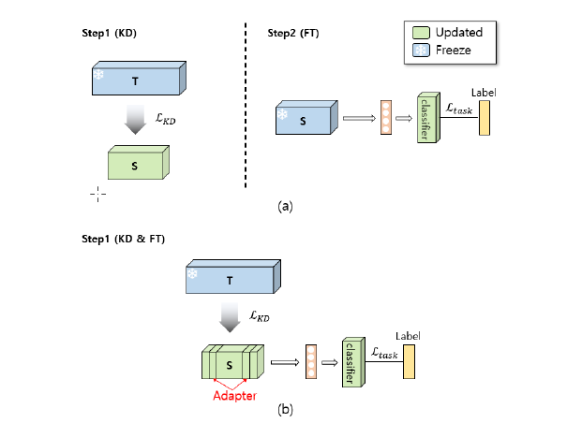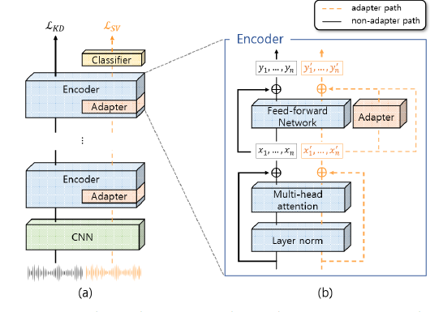

Datasets
- VoxCeleb 1
- VoxCeleb2

TDNN
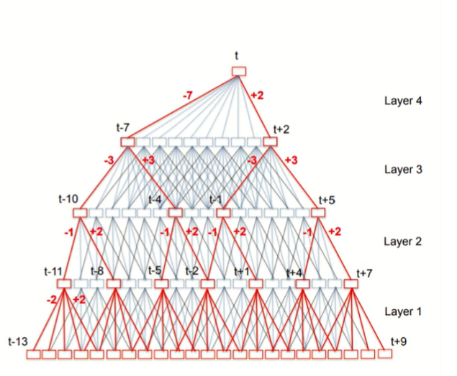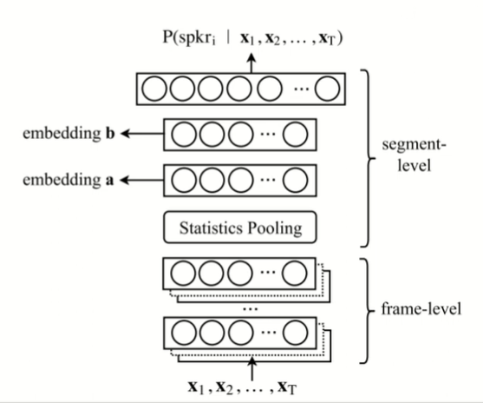

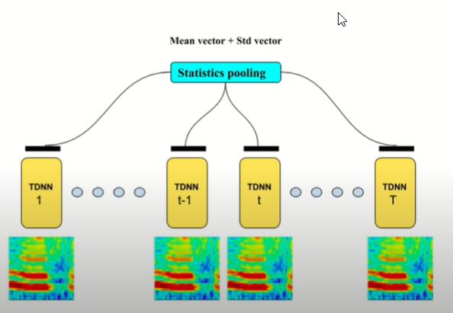

Concept of Squeeze & Excite

Architecture of ECAPA – TDNN
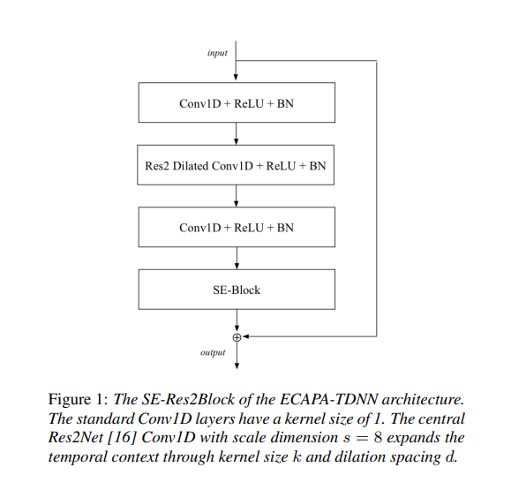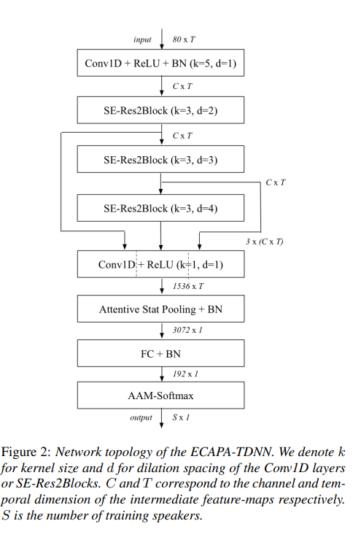

Knowledge Distillation
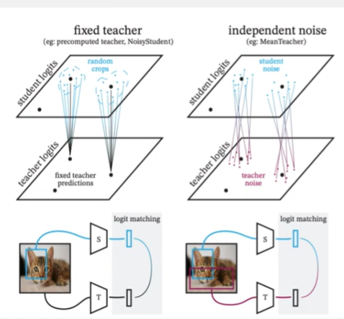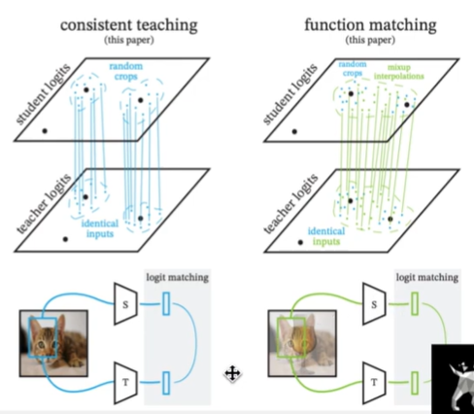
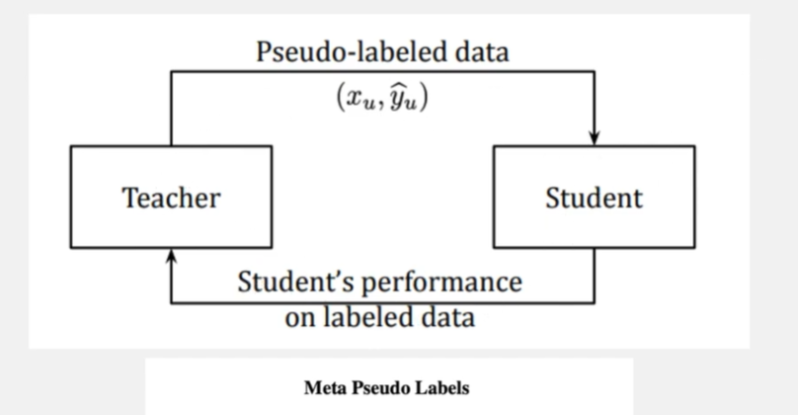

Reference Papers
- ECAPA- TDNN based Speaker Verification https://arxiv.org/pdf/2005.07143
- Design and Development of Voice OTP Authentication System
- Speaker and Digit Representation based Voice OTP System
- Knowledge Distillation: A Good Teacher is Patient and Consistent: https://arxiv.org/abs/2106.05237
- One-Step Knowledge Distillation and Fine-Tuning in Using Large Pre-Trained Self-Supervised Learning Models for Speaker Verification https://arxiv.org/pdf/2305.17394

Timelines
Phases | Works Planned | Work Achieved
- 5th October | Downloading code and set up environment | - Underastanding concept  - Reading of papers
- 12th October | Running an ECAPA TDNN model and run a speaker verification program
- 19th October | Reproduce the result of TDNN for larger dataset and analyze them + Set up knowledge distillation
- 26th October | Integrate Knowledge Distillation - Teacher Student with the ECAPA TDNN
- 2nd November | Final changes and Result analysis

Dataset Prep
- Set Up VoxCeleb dataset
- OTP dataset (0-9)
- Use College GPU if possible

Goals
- Understand the thing Start with VoxCeleb1 & ….. with Knowledge distillation – Initial benchmarking
  - Optimise for 1 network – 1 bit floating point
- Use the knowledge for OTP method
  - Knowledge distillation for Speaker Verification and also for STT (OTP conversion)

Research Topic
- Multilingual Speaker Verification Spoof Aware on Edge
- Use Partial Spoofing (Like some one records my voice “I am logging in system” and password in my system is “I am logging off in system”
- Speaker Verification Explainability (How an utterance is getting matched)
- Understand recent trensa
  - Review paper of Speech with Rajeev, Jagabandhu, Prasanna Sir, ….
  - Heizolis Group - representation
- Unsupervised speaker verification
- LLM is not explainable in nature
- NCC conference
- Prof in ____ working in Forensics speaker verification

